Engine Performance Analysis

Name: Jac Graham-Davies
Student No.: 2404810
Module: Thermodynamics and Combustion (ACHA5011)

Word Count: 2661

Contents Page
- Introduction – Page no. 1
- Component Characterisation – Page no. 2-3
- Piston Motion Analysis – Page no. 3-4
- Camshaft and Valve Motion Analysis – Page no. 4-6
- Dynamic System Assessment – Page no. 6-8
- Flowbench Testing and Data Collection – Page no. 8-10
- Data Analysis and Graphs – Page no. 10-12
- Integration with Valve Kinematics – Page no. 12-13
- Performance Assessment – Page no. 13-14
- Flow Potential and Tuning Insight – Page no. 14-15
- Conclusion – Page no. 15

Introduction
In this assignment there are two main objectives that are to be addressed. The first being a cylinder head and a valve train analysis; in this section we will be conducting a series of aims such as component characterisation, a piston motion analysis, a camshaft and valve motion analysis and finally a dynamic system assessment. The second stage of the assignment is a flow analysis and cylinder head performance section. In this section there will be Flowbench testing and data collection, data analysis and graphs, integration with valve kinematics, a performance assessment and finally flow potential and tuning insight.
Component Characterisation
To weigh each of the valvetrain components the cylinder head must be disassembled as well as any other associated components and identify each of the components. Once this was completed all the components were then individually weighed. Below is a table showing each of the individual components of the valve train with their weights for both intake and exhaust sides of the valvetrain.
Intake
Component | Weight (KG)
Camshafts | 2.123
Valves | 0.041
Springs | 0.034
Retainers | 0.01
Buckets | 0.032

Exhaust
Component | Weight (KG)
Camshafts | 2.1
Valves | 0.041
Springs | 0.034
Retainers | 0.009
Buckets | 0.032

The cylinder bore, stroke and compression ratio for the engine were also required to be measured. The table below shows the values for these data sets.
Cylinder Bore | 87.4mm
Stroke | 83.1mm
Compression Ratio | 10.8:1

Accurate measurement methods were essential to ensure reliable results. Valvetrain component masses were measured using digital scales with a resolution of ±0.01 g, which is suitable for small components, though errors could arise from vibrations or insufficient settling time. Cylinder bore and stroke were measured using vernier callipers and a micrometer with resolutions of ±0.01 mm and ±0.001 mm respectively; however, human error such as uneven applied pressure may affect repeatability. The compression ratio was calculated from bore, stroke and cylinder volume, meaning any inaccuracies in these measurements or in the calculations themselves could directly affect the final value.

Piston Motion Analysis
Using the data that has been previously collected such as crank angle as well as the stroke we are able to derive and plot piston velocity against the crank angle as well as the mean and peak piston velocity as well as the piston position against the crank angle. Below are the two graphs that correspond to this. Figure 1 shows the piston position against the crank angle, and Figure 2 shows the piston velocity against the crank angle with the mean speeds clearly visible.
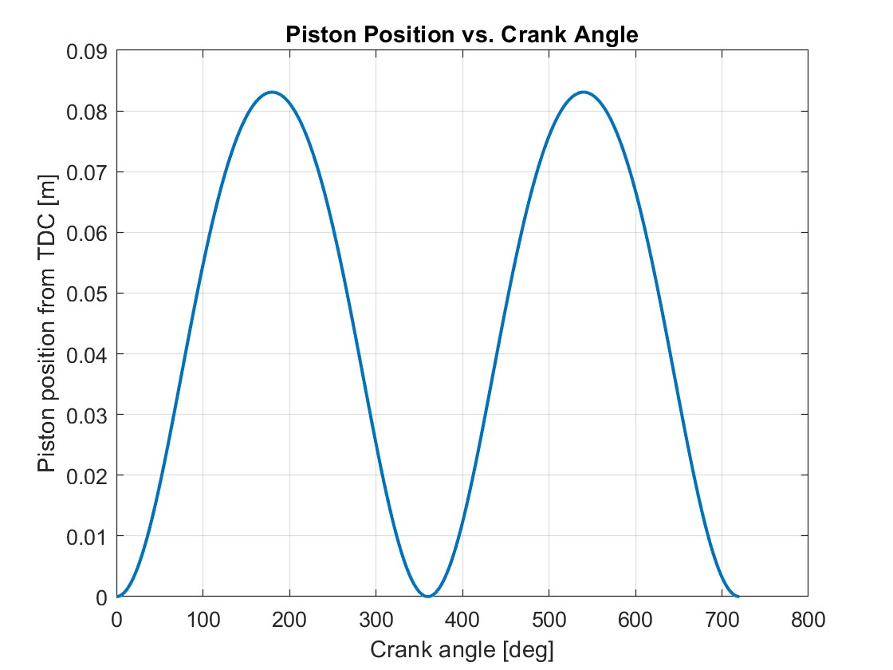
Figure 1: Piston Position vs. Crank Angle
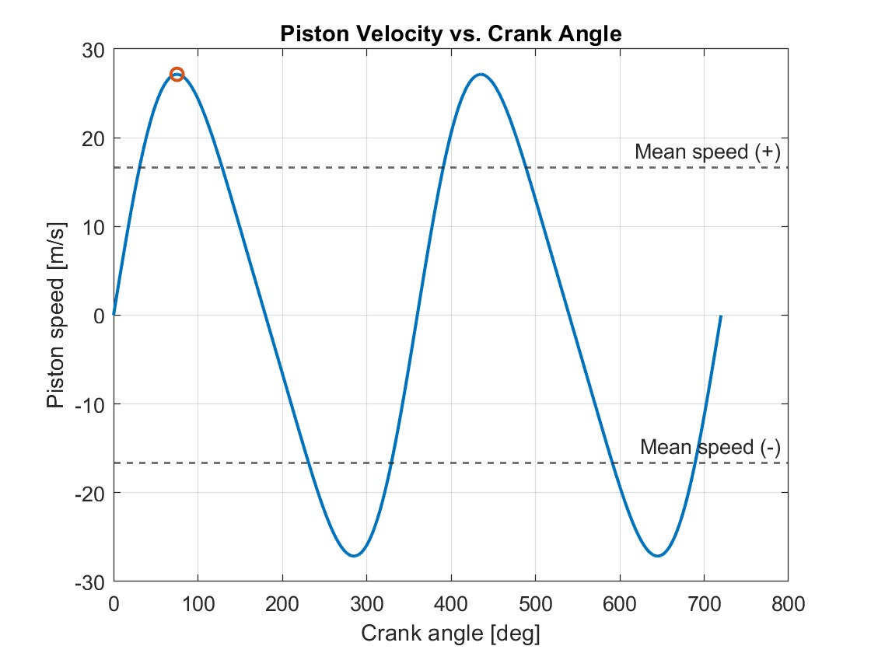
Figure 2: Piston Velocity vs. Crank Angle
Camshaft and Valve Motion Analysis
For this analysis we were required to measure the profiles of both the intake and exhaust cams manually using a dial indicator. The lobe lift was then recorded at increments of 1 degree for the full 360 degrees of the camshaft. Below is Figure 3 that shows the curves of both the intake and exhaust valve lift against the crank angle.

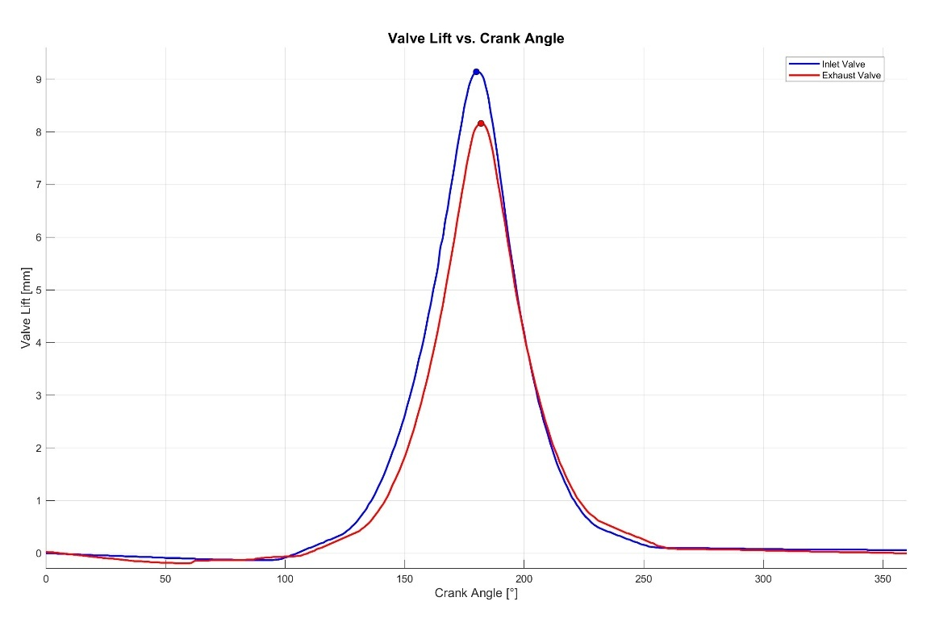
Figure 3: Valve Lift vs. Crank Angle

This data was also used to create another series of graphs. This data allowed for the creation of graphs to show valve velocity, valve acceleration and valve jerk. The first graph below shows velocity, followed by acceleration and finally jerk.
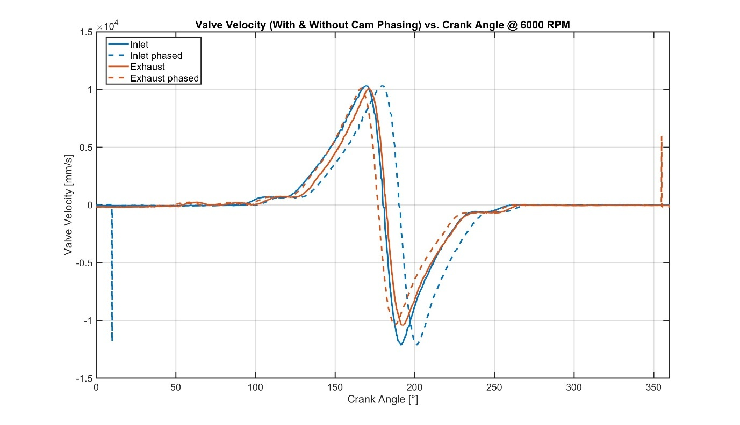
Figure 4: Valve Velocity vs. Crank Angle
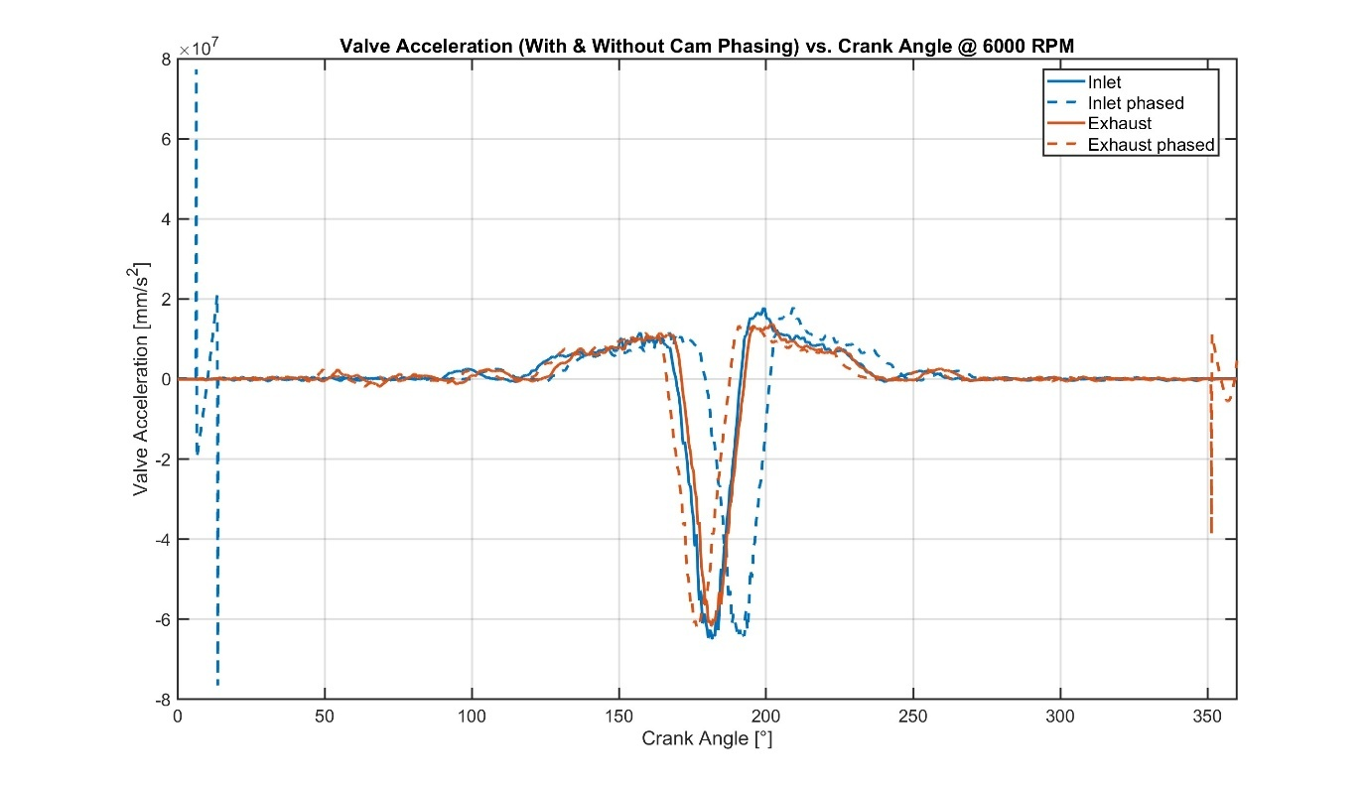
Figure 5: Valve Acceleration vs. Crank Angle
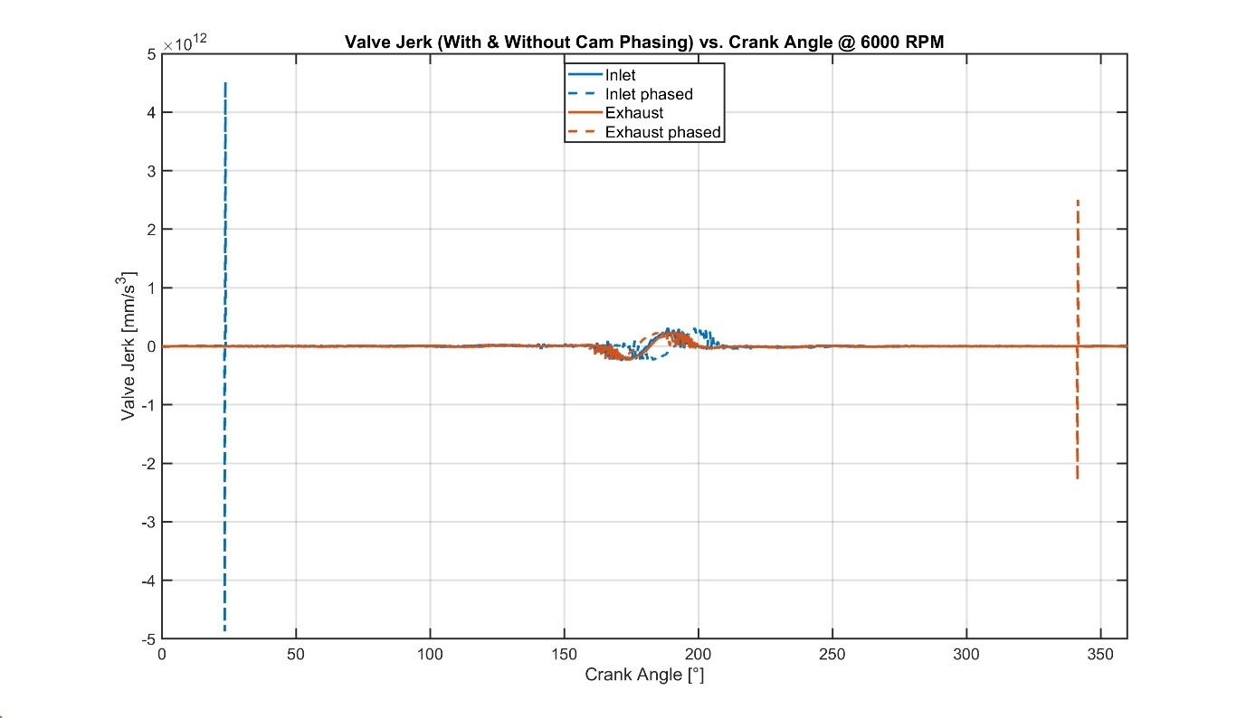
Figure 6: Valve Jerk vs. Crank Angle
Dynamic System Assessment
We are also required to estimate the Valve Float RPM. Valve float happens when the valve spring cannot keep the valve following the cam profile at high engine speeds. To estimate when this occurs, the valve train can be treated as a simple spring and mass system. The total moving mass includes the valve, retainer, one third of the spring mass, and the bucket. This gives an effective mass of about 0.094 kg for this setup. With a spring rate of 35 N/mm, the natural frequency of the system is found from the formula below:
f_{n} = (1 / (2 × π)) × √(k / m_{eff})
This gives a value of around 97 Hz. Because each valve opens once every two engine revolutions in a four-stroke engine, this frequency corresponds to roughly 11,600 rpm. In practice, valve float usually begins before the system reaches its full resonance speed, so a factor (called beta, β) of about 0.6 is applied to allow for damping and real-world effects. Multiplying 11,600 RPM by 0.6 gives an estimated valve float speed of around 7,000 RPM.
From data previously gathered we are also able to create a graph showing the piston position against the valve lift. This graph was made so we can view any possibilities of interference between the piston and the valves.
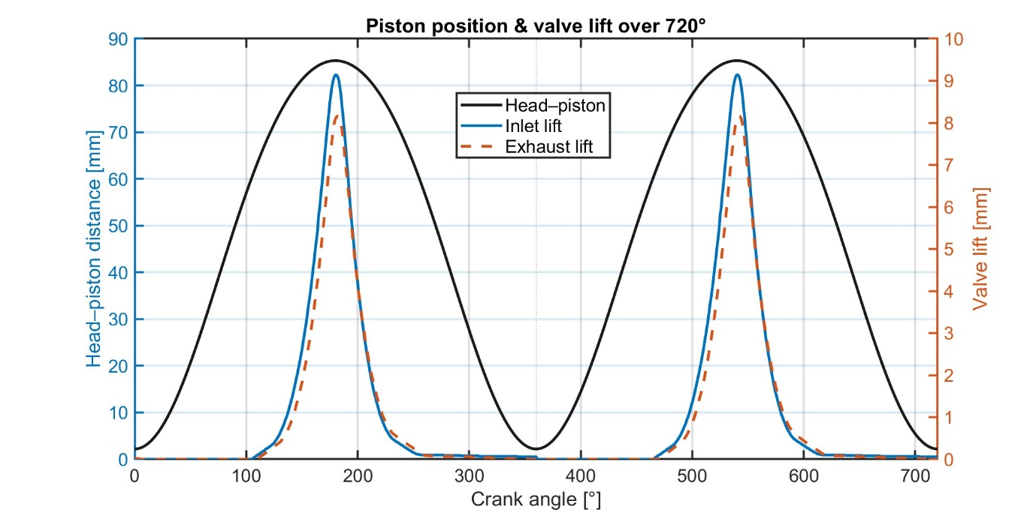
Figure 7: Piston Position, Valve Lift vs. Crank Angle
It is possible to potentially increase the mechanical rev limit as well as the float RPM by taking advantage of the use of lightweight components. By estimating the require weight saving required we can work out if the use of lightweight components is feasible.
To estimate how much lighter the valvetrain needs to be for the engine’s mechanical rev limit to increase by 25%, we started with the measured masses of the valve, retainer and bucket, which together came to about 0.083 kg on the intake side. The limiting factor for the mechanical rev limit is the point where the spring can no longer control the valve motion, so the same relationship between moving mass and acceleration still applies. Because the forces grow with the square of engine speed, lifting the mechanical limit by 25% means the effective mass must fall to roughly 64% of its original value. That puts the target at around 0.053 kg instead of 0.083 kg.
There are a series of different lightweight components that could be utilised in this scenario to meet the required weight saving. The first component are valves. The standard valves weigh in at 0.041KG. These valves are steel but can be replaced with titanium valves which have a much lower density and roughly weigh in at 0.023KG, producing a saving of around 0.018KG. The next lightweight component that could be utilised would be titanium retainers. Over standard steel retainers we could see a weight saving of around 0.005KG as standard ones weigh in at roughly 0.01KG. The final lightweight component that could potentially be used is tapered valve springs, where the base of valve is wider and tapers upwards to produce a narrower top. These tapered springs are roughly 20% lighter than the original springs bring the weight down from 0.034KG to 0.027KG, providing a weight saving of 0.007KG. With all these lightweight components, we save 0.03KG which is roughly 64% of the original valvetrain mass which feasibly allows us to increase the mechanical rev limit as well as increasing the valve float RPM.

Flowbench Testing and Data Collection
The second objective that is addressed in this assignment is the Flowbench Testing section. For this we used a SuperFlow Flowbench SF600 to test the aerodynamic flow characteristics of the Duratec 2.0L cylinder head. For this series of tests, we used the bare cylinder head and record the flow through the head with different valve lifts. This was done by periodically increasing the valve lift in increments and testing the flow. This data was then recorded and is shown in the series of tables below.
Test Setup Data
 | Diameter (mm) | Stem (mm) | Lift Increments (mm) | Effective Area (cm²) | Leakage (litres/sec) | Seat Width (mm)
Intake Valve | 35 | 5.5 | 1.75 | 18.77 | 0 | 0.99
Exhaust Valve | 30 | 5.5 | 1.5 | 13.66 | 0 | 1.84

Test Setup Data
Valve Lift/Diameter (L/D) Ratio | 0.05 | 0.10 | 0.15 | 0.20 | 0.25 | 0.30 | 0.35 | 0.40 | 0.45 | 0.50
Intake Valve Lift (mm) | 1.75 | 3.5 | 5.25 | 7 | 8.75 | 10.5 | 12.25 | 14 | 15.75 | 17.5
Exhaust Valve Lift (mm) | 1.5 | 3 | 4.5 | 6 | 7.5 | 9 | 10.5 | 12 | 13.5 | 15

Test Setup Data
Flow Range | 1 | 2 | 3 | 4 | 5 | 6
Corrected Range (Int) | 16.5 | 33.2 | 69.7 | 138.2 | 207.8 | 279.5
Corrected Range (Exh) | 19.5 | 37.1 | 75 | 148.5 | 219.6 | 284.6

Intake Valve Test Data
Test Number | 1 | 2 | 3 | 4 | 5 | 6 | 7 | 8 | 9
Test Pressure | 25 | 25 | 25 | 25 | 25 | 25 | 25 | 25 | 25
Valve Lift (A) | 1.75 | 3.5 | 5.25 | 7 | 8.75 | 10.5 | 12.25 | 14 | 15.2
Flow Range (1-6) | 2 | 3 | 4 | 4 | 4 | 4 | 4 | 4 | 4
Flow Scale Reading (%) | 88 | 76 | 52 | 63.5 | 71 | 76 | 80.5 | 83.9 | 85
Flow Scale (5./100) | 0.88 | 0.76 | 0.52 | 0.635 | 0.71 | 0.76 | 0.805 | 0.839 | 0.85
Raw Test Flow  l/s (6. x E) | 29.216 | 52.972 | 71.864 | 87.757 | 98.122 | 105.032 | 111.251 | 115.95 | 117.47
Leakage (l/s) | 0 | 0 | 0 | 0 | 0 | 0 | 0 | 0 | 0
Test Flow (l/s)  (7-8) | 29.216 | 52.972 | 71.864 | 87.757 | 98.122 | 105.032 | 111.251 | 115.95 | 117.47
Test Flow (l/s/sq cm) | 1.557 | 2.823 | 3.829 | 4.676 | 5.228 | 5.597 | 5.928 | 6.178 | 6.259

Exhaust Valve Test Data
Test Number | 1 | 2 | 3 | 4 | 5 | 6 | 7 | 8 | 9
Test Pressure | 25 | 25 | 25 | 25 | 25 | 25 | 25 | 25 | 25
Valve Lift (A) | 1.5 | 3 | 4.5 | 6 | 7.5 | 9 | 10.5 | 12 | 13.5
Flow Range (1-6) | 1 | 3 | 3 | 4 | 4 | 4 | 4 | 4 | 4
Flow Scale Reading (%) | 92 | 56 | 74.5 | 43.5 | 47 | 48.5 | 50 | 50.5 | 51
Flow Scale (5./100) | 0.92 | 0.56 | 0.745 | 0.435 | 0.47 | 0.485 | 0.5 | 0.505 | 0.51
Raw Test Flow l/s (6. xF.) | 17.94 | 42 | 55.875 | 64.598 | 69.795 | 72.023 | 74.25 | 74.993 | 75.735
Leakage (l/s) | 0 | 0 | 0 | 0 | 0 | 0 | 0 | 0 | 0
Test Flow (l/s) (7-8) | 17.94 | 42 | 55.875 | 64.598 | 69.795 | 72.023 | 74.25 | 74.9925 | 75.735
Test Flow (l/s/sq cm) | 1.313 | 3.074 | 4.1 | 4.728 | 5.109 | 5.272 | 5.435 | 5.489 | 5.543

Data Analysis and Graphs
From these tables of data we can analyse said data and produce different graphs allowing us to analyse the flow characteristics of the cylinder head and the valves. The first graph that was made was a flow rate against valve lift graph which is shown below Figure 8.
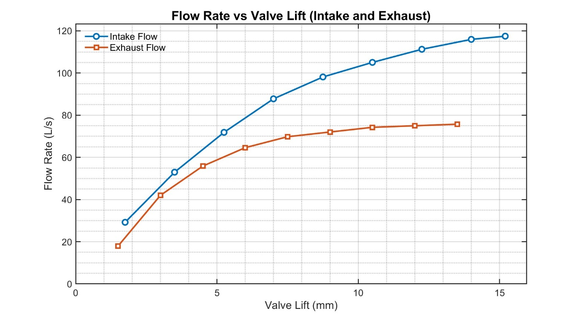
Figure 8: Flow Rate vs. Valve Lift
The second graph that we were able to make is a flow rate per unit area vs valve graph. Below Figure 9 is shown.
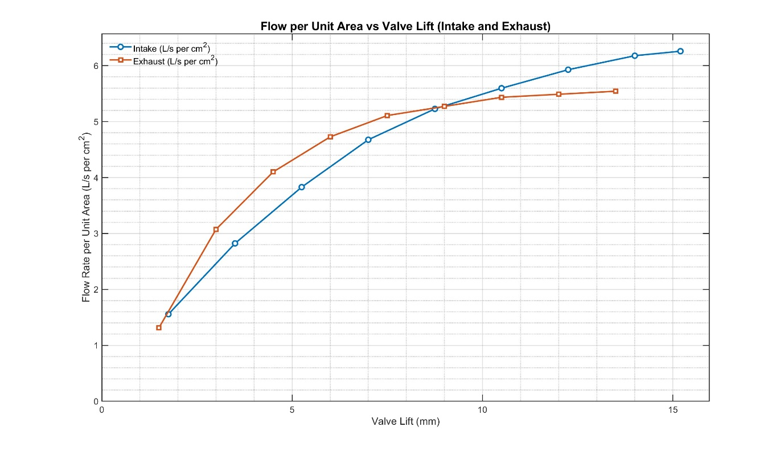
Figure 9: Flow per Unit Area vs. Valve Lift
The next graph that was made was a flow coefficient against valve lift. For this graph, we had to use the correct ideal CFM reference data. In our testing we had a test pressure of 25 and from referring to the Flowbench manual it was found out that this value was 6.33 lps/sq cm. Using this reference data, we can calculate the flow coefficient for use in the graph. Below is this graph (Figure 10).

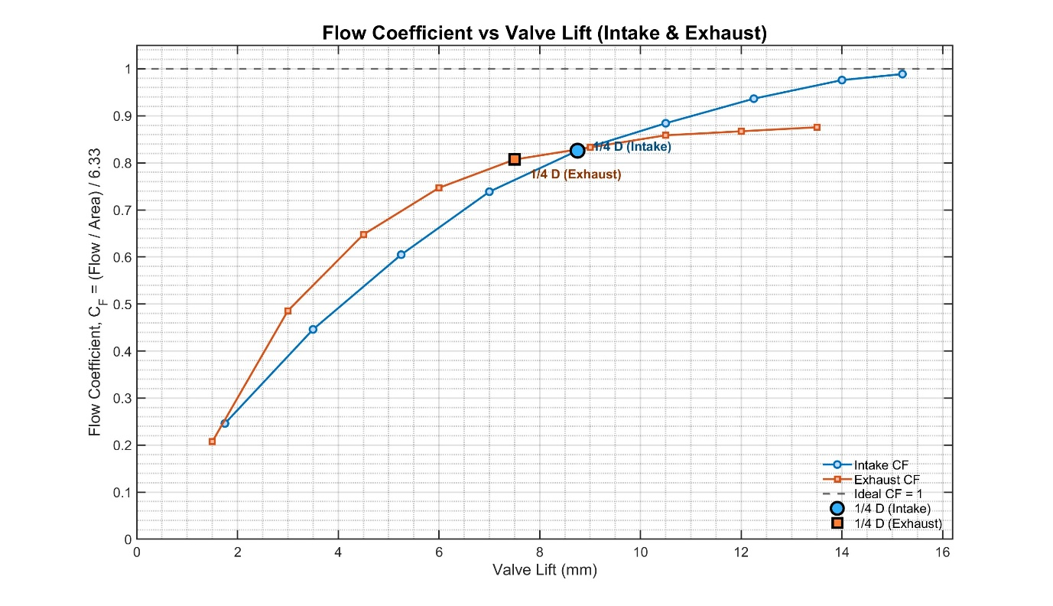
Figure 10: Flow Coefficient vs. Valve Lift
The intake and exhaust flow coefficient plots show a clear rise in CF at lower valve lifts, followed by a gradual flattening as the lift approaches higher values. This plateauing shows that the valve is no longer the main restriction to airflow. At low lifts, the curtain area around the valve seat limits the flow, so even a small increase in lift produces a significant increase in flow coefficient. Once the lift reaches roughly a quarter of the valve diameter, the flow approaches its maximum effective level, and further lift produces only marginal improvements. This behaviour shows that the port and not valve lift, becomes the main restriction beyond this point. This is important as you can see at what points extra opening of the valves gives little to no improvement in flow and what else can be done to increase flow such as porting.
Integration with Valve Kinematics
By using the data gathered in the previous half of the assignment we can plot the flow coefficient of both the intake valve and the exhaust valve against the crank angle. Figure 11 below shows the flow coefficient of the intake valve, and Figure 12 shows flow coefficient of the exhaust valve.
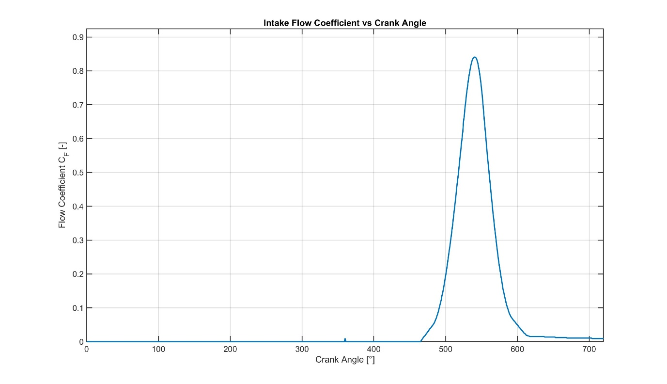
Figure 11: Intake Flow Coefficient vs. Crank Angle
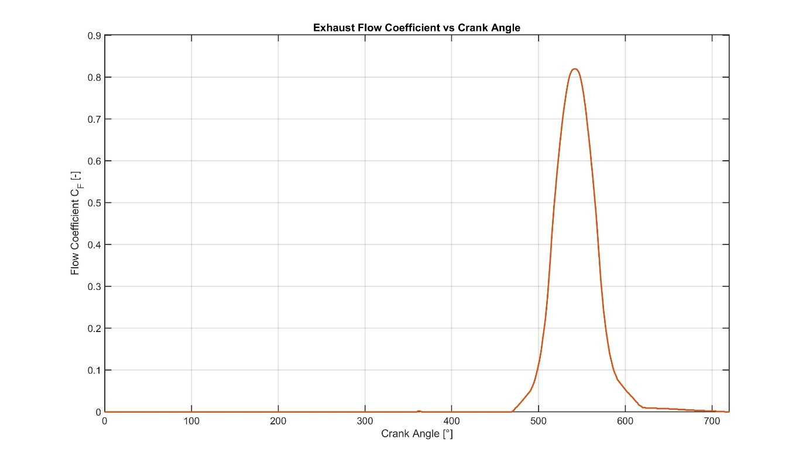
Figure 12: Exhaust Flow Coefficient vs. Crank Angle

Performance Assessment
Using data that has been previously acquired we are able to estimate the RPM at which the engine produces its maximum power. Using the mean flow coefficient, the inlet valve diameter and the engine displacement we can estimate the max RPM.
From using the mean flow coefficient which is 0.74 and flow rate per area unit which is 6.33 lps/cm² we can calculate the mean actual flow per unit area as shown: 0.74 x 6.33 = 4.68 lps/cm². From this as well as the inlet flow area per cylinder (18.77 cm²) we can calculate the flow capacity per cylinder as there are 4 cylinders in this engine: 4.68 x 18.77 = 87.8L or 0.088 m³/s. We are then able to calculate average volume flow demand at X speed with the engine displacement being 0.002 m³ (D): Average Flow = V/2 x N/60. This can then be rearranged to find N: N = 2 x 60 x 0.088 / 0.002 = 10.56 / 0.002 = 5280 RPM.
The flow-based calculations suggest maximum power at 5280 RPM, while manufacturer data for the Duratec 2.0 places the true peak closer to 6500 rpm. The calculation is based on steady Flowbench measurements taken at a fixed pressure, which does not reflect how the engine breathes under dynamic running conditions. In the real engine, effects such as inlet runner tuning, exhaust scavenging and pressure-wave timing improve cylinder filling at higher RPMs, allowing the engine to make peak power above the flow prediction. The method also assumes near ideal volumetric efficiency and ignores friction and pumping losses, which influence where the usable power curve peaks. Overall, the 5280 RPM figure should be viewed as a conservative airflow limited estimate, while the actual 6500 rpm value reflects the additional breathing efficiency gained from real world gas dynamics.

Flow Potential and Tuning Insight
The flow characteristics measured from the cylinder head suggest that this intake and exhaust port design is more towards mid-range torque than high RPM performance. The Flowbench data shows a mean intake flow coefficient of around 0.74, which is respectable for a production-based head but noticeably lower than the figures achieved by high-revving motorcycle engines or fully developed race heads, which often exceed 0.85 at comparable valve lifts (Stone, 2012). The plateauing behaviour at higher valve lifts implies that the port shape and valve curtain area reach a point of diminishing returns relatively early, which tends to favour strong cylinder filling between roughly 3000 and 6000 RPM rather than supporting the sustained airflow demanded above 7000 RPM. This is consistent with published results from similar 2.0-litre Ford Duratec engines, which generally produce peak power in the 6200–6700 RPM range unless they have extensively modified ports or aggressive camshafts (Barton, 2015). The addition of intake trumpets or a tuned manifold could provide an improvement in cylinder filling at higher speeds, not by increasing the flow coefficient, but by exploiting pressure-wave tuning. Longer runners tend to support low-to-mid-RPM torque, while shorter, larger-radius trumpets can improve high-RPM breathing by reducing entry losses and aligning the intake resonance with the required engine speed (Heywood, 1988). However, because the measured data indicates that the ports reach flow saturation relatively early, any improvement from runner tuning would be limited unless accompanied by port reshaping or increased valve lift. In practical terms, the data suggests that this head offers good drivability and usable torque, but its real-world performance ceiling is constrained by port geometry rather than valve lift alone. Similar findings have been reported in flow studies of the Honda K20A and VW FSI engines, where modest increases in cam duration and lift only produced significant gains once the port throat and short-turn radius were reworked (Miller, 2016). Overall, the measured flow profile shows potential for improvement, but without port modification the engine is unlikely to sustain efficient breathing much beyond the manufacturer’s standard peak power RPM.

Conclusion
The work in this assignment has linked basic measurements, valve train dynamics and Flowbench data to a realistic picture of how the Duratec 2.0-cylinder head performs and how it can be improved.

References
- Barton, J. (2015) Duratec Engine Tuning Guide: Airflow, Porting and Performance Development. Race Engine Journal, 12(3), pp. 44–53.
- Heywood, J.B. (1988) Internal Combustion Engine Fundamentals. New York: McGraw-Hill.
- Miller, A. (2016) ‘Cylinder Head Flow Optimisation in Modern Four-Valve Engines’, SAE Technical Paper 2016-01-1048.
- Stone, R. (2012) Introduction to Internal Combustion Engines. 4th edn. Basingstoke: Palgrave Macmillan.

