

Name: Greg Thompson
Number: 1705753
University of wales Trinity Saint David
Date: 21/01/21

Course: Built Environment Programmes – Level 5 Construction Management
Module: Project Planning for construction
Module Code: ACBA5001

Index

- Management Procedure
  - Traditional Procurement
  - Management of site
  - Sub- contractor

- Quality Management system
  - Documents generated with a Quality Management system
  - Company Process map
  - Quality Assurance
  - Aftersales

Appendix
- Communication Channel
- Company Process map
- Aftersales flow chart

Bibliography

Management Procedure

Traditional Procurement

“Procurement system is an organisational system that assigns specific responsibilities and authorities to people and organisations and defines the relationships of the various elements in the in the construction project” (P.E.D Love, 1998)

There are many forms of procurement methods such as Design and Construct, Management, Collaborative and Traditional. Traditional procurement is when the client employs consultants such as architects, surveyors, and other specialists to create the ‘Tender Package’. The design process is kept separate to the construction of the building. (Innovation, 2008 June)
With Traditional procurement the client is always fully in control of the project with the principal designer and their design team all relaying back to them.

However, Traditional procurement is not always the most effective way of procuring. As Sarhan (2013) report highlights; traditional procurement is the contrary of lean construction and is often overlooked as it separates the design phase and the construction phase causing division and often confusion on site before the project has started. (Sarahan, 2013)

Management of site

A site manager is a head representant from the Principal contractor, they will often be assisted by a quantity surveyor, Designer, supervisor, and other specialists that the project may require. The site manager oversees all sub-contractors ensuring all health and safety documents are up to date and appropriate for working on site, within the designated time scales, and working to the correct specification and drawings.

As the site manager a clear route of communication would be required, this is due to the traditional procurement method in keeping the design and build separate. However, in Robert Eadie’s (2014) report shows that 92% of contractors felt that early involvement had a significant improvement on the construction phase. It was also mentioned that there is an overwhelming feeling within the construction industry that designers lack the technical experience that is required when onsite. Therefore, with contractors having early involvement within this SA1 student accommodation project; allowing them to understand fully what detail drawings and programme of works are, will aide them in achieving a strong communication channel, being on budget and ensuring each stage of the programme of works is hit. (Innovation, 2008 June)

The site managers main objectives are to ensure the works are running parallel with the programme of works, on budget and the quality of the works is as described.

Sub-Contractor

Within the communication channel in Appendix 1, it is the principal designer’s responsibility to correspondent with all sub-contractors in time to raise any queries about the designs before they attend site. Intentions would be to send all up-to-date drawings a minimum of 2/3 weeks before their start date, this gives all parties a chance to review and alter designs if required and not affect the programme of works.

As the materials are delivered to site it is seen that the site manager should ensure all materials are of good quality and as per the specification/drawings. All concrete deliveries should come with a delivery note with specific ID codes which reference back to the strength that is required for the project. All environmental waste certificates should be collected and know where the waste is being transferred to. Often a transfer of waste note is required, this way they can show where the waste ends. This is a crucial part of adhering to the quality assurance system within the ISO 14001:2015 certification for Environmental Management system.

Due to various other projects within the university being installed poorly, it is crucial that quality control plays a major part within the site managers role. This will be done using quality monitoring checks, ensuring all sub-contractors are installing what is within the specification/drawings, having regular visits by manufactures to ensure they are happy with the installation of the product, for example when installing a flat roof, the manufacturer will send out a technical representative to pass the roof off for the guarantee. If there are any defects after the roof has been signed off the client can then go back to the manufacturer to put a claim in. this is just one way to ensure quality control from a specialist within that field of construction.

Each sub-contractor would have to complete a questionnaire pre-construction to ensure their staff have all the required certificates to work under a company with an ISO 9001. By doing this it also filters out the ‘cowboy’ contractors and there is a level of confidence when a contractor has the correct certificates, e.g. CSCS cards, Working at height, Hot works, Etc.

The Site manager would have various site forms and templates to fill out to ensure continuous quality assurance is produced throughout the project. If a contractor has any issues with drawings, then an RFI (Request for Information) would need to be sent through to the design team. If there were any issues or conflicts on site then non-conformities would be carried out and logged, following on from the non-conformities, it is good practice that a toolbox talk is then carried out to ensure all personnel on site do not make the same error or mistake. For example, not wearing a hard had when walking up the scaffolding.

Quality Management system

Along with procurement options there are also multiple quality management systems that companies can use to ensure continuous improvement and quality through decision making and work is at the highest levels at all time. These systems highly depend on the size of the company and the resources available.

A quality management system is a formalised system that documents processes, procedures, and responsibilities for achieving quality policies and objectives. (ASQ, n.d.) ISO 9001 is the international standard in Quality Management they are not specific to any industry but are a standard of the quality assurance developed by a company. (ASQ, n.d.) There are many standards that come under the ISO 9001:2015; for example, ISO 14001:2015 certification for Environmental Management system, ISO 45001:2018 Occupational Health and Safety Management System and many others. (ISO update, 2020)

Documents generated for a Quality Management System

To be able to create continuous improvement and customer satisfaction within every project requires a high level of documentation and process from the bottom of the chain to the top. Each member of the team must be aware of their roles and responsibilities to achieve these targets.

The documents that will be generated for the Quality Management system are:
- Non-conformities – these documents are when an issue or an error occurs either on site with design problems, Health and safety issues and can be as little as late deliveries. They will be logged and reviewed every so often and can be used as evidence for reasons why the project is on target financially or timely.
- Company policies – A policy that describes exactly what and how the company is run on a day-to-day basis, it would include health and safety policy, disciplinary policy, employees right to work, and many other policies which would be specific to the speciality of the company.
- Quality Management Plan including KPI tracking – Outlines exactly what the company expects and the processes that are in place to ensure quality assurance and continuous improvement is achieved.
- Standard Operating Procedures – This is in place to provide information on each role within the company and how processes are carried out, it is used for new employees or when taking on new roles.
- Forms / Templates – These will vary depending on the role within the company, Quality Monitoring check lists will be provided to most staff, especially those in leadership positions to ensure quality assurance is being adhered to.
- Communication map – These are used to ensure each member of the team knows where they are within the hierarchy chain and who to go to when problems arise.
- Appraisals – Reviewing of a team member’s contract bi-annually is crucial for quality management and quality assurance. It allows team members to speak about their role and allows the employer to mark out a progression route to keep said employee motivated within their role. (Manghani, 2011)

Company Process Map

As shown in Figure 3.0 the start and finish are both related to customer satisfaction, this is crucial for continuous improvement and review. Each member of the team should always be working within this.

Figure 3.0 is the process to create the foundations for client satisfaction. The key element within the process map is that in Green ‘continual improvement’ that is indirectly linked to every stage and each stage has its own objectives which will be closely monitored from an external and internal support team. It is reviewed at project completion or set time frame once the client feedback has been completed, new objectives can then be created based on the feedback received.

Quality Assurance

“Quality assurance is the practice of managing the way goods are produced or services are provided to make sure they are kept to a high standard” (Oxford Learner's Dictionaries , n.d.)(Oxford Learner's Dcittionaries , n.d.)

There are many ways quality assurance can be implanted within a company such as inspection arrangements, Control points, hold points, but the ones that will be most beneficial on this project will be through internal quality checks, monitoring and external checks. The internal checks would be carried out from a designated member who is qualified within the quality management system and has a good understanding of the day-to-day running of the company. These checks will simply be following the quality management procedure, ensuring that each stage is working efficiently, and people are filling the correct documentation out throughout their projects, each management role within the company will have these to carry out daily. It is imperative when creating a quality management system as it holds team members accountable for their role.

External Auditing will be carried out by the provider of the quality management system, these will not be as regular as the internal checks; usually bi-annually. They will come and give advice on how to alter the process and procedures that a company has in place which is a way of continuous improvement. They will decipher through all the internal reports and do a full review on each management role and the communication channels in place and advise on future improvements. As they are within the quality management industry, they are first to hear and implement any new regulations and standards. This is crucial for an always developing company. (Manghani, 2011)

Aftersales

The aftersales care is in relation to the soft landing of the project, this includes training in all aspects of the building including any maintenance that is required. There will also be a review section of the project to ensure the client is satisfied with the work carried. Within the O&M manual there will be instructions for products, Certificates and warranties; this should clear up any doubt the client has with the quality of the work produced. This is shown in appendix 3.

Conclusion

In conclusion, a site manager should have complete control of the sub-contractors and fully understand the scope of works for each section of the build. If the site manager is unsure on a drawing an RFI must be raised as a matter of urgency to ensure no delays or further monies are lost on the project.

All quality management monitoring checks must be completed daily, weekly and monthly when required so that there is a continuous review of how the job is being run and the improvements that can be implemented throughout the project and for any future works.

The handover of the building must be carried out with the upmost detail to ensure the client is not left short once the contractors leave site. Full training is required on all equipment internally and externally along with a full O&M manual; included within this is all guarantees, Data sheets, Safety sheets, Manuals for the products, all certificates and any other health and safety documentation that is required. This will ensure that SA1 university campus has full view of the quality of the products ensuring there are no future complaints.

Appendix 1
Clerk of Works

Client

Consultants

Principle contractor

Sub - Contractors

Architects

Engineers

Other consultants

Quantity surveyor

- - - Indirect contact upon review
Direct contact
All other specialists

M&E

Carpenters

Groundworks

Appendix 2
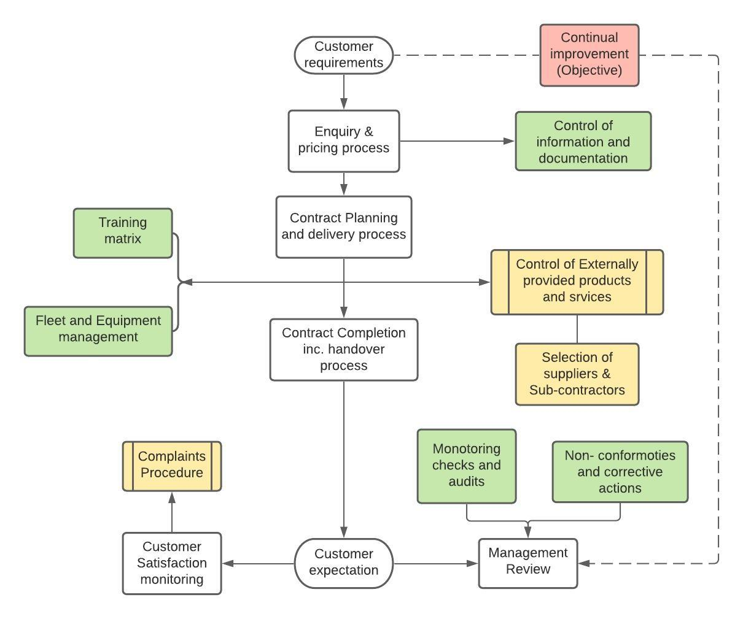
Company Process Map

Key: = Process = Start/Finish = Direct - - - - = Indirect

Red = continuous review
Yellow = Pre-identified processes
Green = Quality Management systems
White = Main Process route

Appendix 3.0
Aftersales flowchart
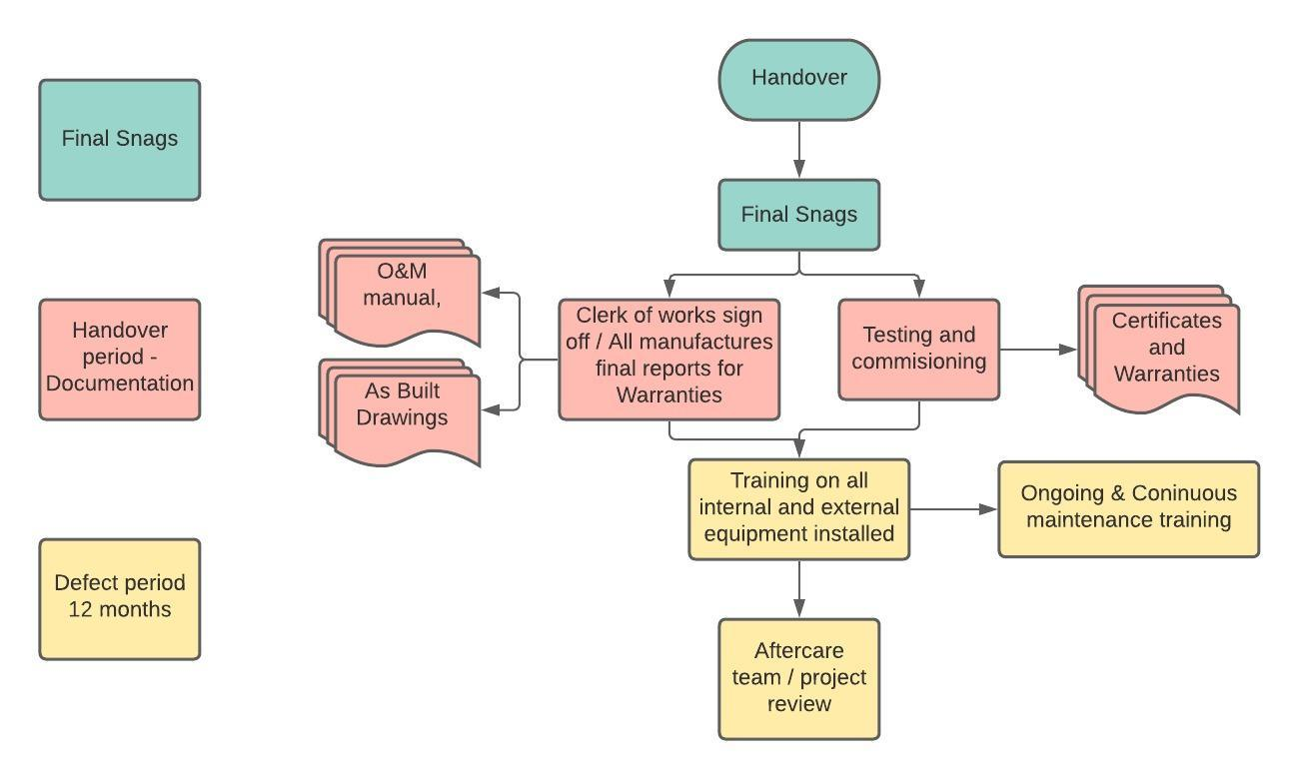
Key - = Process = Start / Finish = Documents

Bibliography
1. ASQ, n.d. What is a Quality Management System (QMS). [Online]
Available at: https://asq.org/quality-resources/quality-management-system
[Accessed 12 January 2021].

2. ASQ, n.d. What is the ISO 9000 standard series?. [Online]
Available at: https://asq.org/quality-resources/iso-9000#:~:text=ISO%209000%20is%20defined%20as,to%20organizations%20of%20any%20size
[Accessed 14 January 2021].

3. Innovation, C. C., 2008 June. Building Procurement methods, Brisbane: Construction Innovation.
ISO update, 2020. Best ISO certifictaes to help the construction industry. [Online]
Available at: https://isoupdate.com/general/3-best-iso-certifications-to-help-the-construction-industry/#:~:text=ISO%20Certifications%20ideal%20for%20the,Occupational%20Health%20and%20Safety%20Management
[Accessed 16 January 2021].

4.Manghani, K., 2011. Quality assurance: Importance of systems and standard operating procedures. 2 January , pp. 34-37.

5. Oxford Learner's Dcittionaries , n.d. Quality Assurance. [Online]
Available at: https://www.oxfordlearnersdictionaries.com/definition/english/quality-assurance?q=quality+assurance
[Accessed 15 January 2021].

6. P.E.D Love, M. &. G., 1998. Selecting a suitable procurement method for a building project.
Sarahan, s. a. F. A., 2013. Barriers to Implenting Lean Construction in the UK construction Industry , Plymouth: Faculty of Science and Technology, University of Plymouth, UK .

