

Student name: | Diya Ganguly | Student ID Number: | 2013048
Programme: | DBA-Doctor of Business Administration
Module: | Quantitative Methods
Module code: | LCDB7004 | Contribution to Overall Module Assessment (%): | 100%
Lecturer: | Dr  Theodore Panagiotidis | Internal Verifier: | John Paul Okeke
Assignment Title: | Written Report – Quantitative Research Methods | Word count (or equivalent): | 7500Words  (-/+10%)

Table of Content
Topics | Page numbers
Abstract | 1
Introduction | 1-2
Literature Review- Discussion of Consumer Behaviour Approaches and Models | 2-12
Research Position- Ontology, Epistemology and Axiology | 12-13
Methodology- Research Design and Data Collection | 13-15
Data Interpretation and Statistical Analysis- Graphical Analysis and Non-Parametric Tests | 15-31
Conclusion | 31-32
Recommendations for Future Research | 32
Reference List & Appendix | 33-36

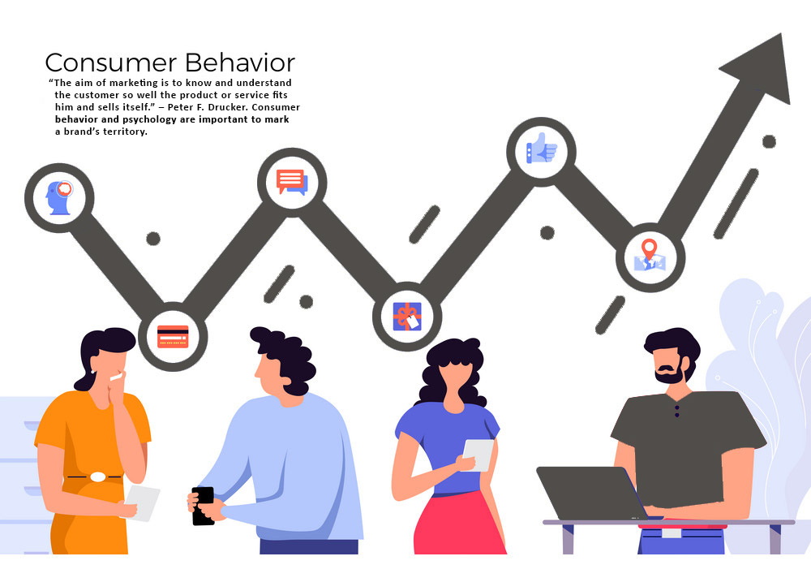
Source-(Alter Ego communications, 2021)

Project Title: - An Empirical Analysis of the factors determining the Online Purchasing Consumer Behaviourism Across Genders
Abstract:
Despite the growing interest in consumer buying behaviourism and it’s many facets, there is a lack of research on this phenomenon in the context of online consumer buying behaviour. Attending to this deficit, the present empirical study is an attempt to investigate the factors, causes and notions around purchase intentions for online purchase behaviour.
In this study (N=63), the common and recurrent buying behaviours adopted by online consumers are explored. Primary data was collected and then those real input data’s were statistically analysed using the SPSS computer application to predict and understand why consumers make the purchase that they make online. This study is principally conducted keeping the local and small businesses in mind in the UK, who have witnessed massive economic scarring due to Covid-19 pandemic. The extensive months of lockdown have obligated multiple businesses to partly and even in some scenarios completely convert as online services providers for meeting the market demand.
However, this will require businesses to identify and develop effective strategies for sustaining in the market amidst the new normal era. This also means the businesses have to effectively map out the key factors that give satisfaction or utility to customers purchasing online products, therefore needing them to understand what, where, when and how consumers buy online. Our finding in the study, reveals that online consumer buying behaviour is not just influenced by economic factors. In fact, social and psychological variables like trust towards the product and brand perception are more essential in making the final purchase decisions.
Introduction-
Dating back 300 years, early economists started to examine the rationale behind consumer buying behaviours. An early group of economists which included John von Neumann, Oskar Morgenstern, and Nicholas Bernoulli, approached the concept of consumer buying from an economic perspective and emphasised solely on the act of purchase. Based on such perspectives, the ‘Utility Theory’ emerged, which viewed consumers as ‘rational economic man’ making rational purchase decisions to satisfy their self-interest. (Schiffman, et.al., 2007)
However contemporary theorists refuted this notion and evidenced with their contemporary research findings that consumer buying behaviour apart from economic price points are also influenced by broad range of factors like brand perception, lifestyle, distinctiveness, and availability of the product etc. Besides, these models acknowledge the consumption activities beyond purchase decisions such as the activity of information search, need recognition, evaluation of alternatives, building of purchase intentions, the act of consumption and finally disposal (Erasmus,. et.al, 2001).
The current project report will solely focus on the consumer buying behaviour in the 21st century to assess how consumer behaviour has evolved through various discernible stages over the past century in the light of technology or various online shopping platforms being introduced for goods consumption.
The primary goal of any organization is to best serve or cater to their customer needs and demands. Any business which fulfils this criterion, is more successful than its competitors as satisfied buyers tend to repurchase the product. Besides, in the UK, online shopping has been evolving rapidly and has the potential for growing exponential especially after the economic havoc wrecked by the of Covid-19 pandemic for physical businesses. Thus, purpose of the study is to understand with greater internet penetration reach, and our fast-paced lifestyle, how consumers will engage towards online shopping and what factors will influence and impede their purchase decisions.
Hypothesis-
Both male and female have remarkably similar type of consumer behaviour towards online purchases.
Aim-
To understand why consumers, make the purchase they make online?
To recognize the key factors that influence consumers purchase decisions online?
To assess the difference in consumer behaviour towards online shopping between males and females.
Research Objective-
To explore the act of online buying behaviour. This involves decision making processes and perceptions one holds towards buying and using online products. Thus, the factors (both economic and non-economic) associated with online purchases will be thoroughly examined.
Problem Statement-
Online buying is the most convenient option for our face-paced busy life in today’s world. Despite some limitations, like lack of human interactions or lack of tactile experiences that are offered by physical stores, online buying has been growing exponentially. Hence in this study we were willing to explore why and what factors influence individuals to engage in online buying behaviour despite the noticeable limitations. Also, the study aims to understand how different genders respond towards online shopping.
Research Question-
Is there a discrepancy in beliefs and behaviours between males and females towards online shopping?
An empirical investigation will be carried out to understand what factors influence the act of buying behaviour online across genders.
Literature Review- Theoretical Models and Approaches of Consumer Behaviour
Today we have consumer behaviour models that helps companies understand the consumer response towards different product features, prices, and the competitive advantages the product holds over similar products in the market. However, we have come leaps and bounds in understanding what appeals a consumer and what doesn’t when it comes to understanding consumers final purchase decisions.
Such understandings of consumer purchase decisions have been facilitated by the scholarly works of many researchers who over time has developed and published influential models or theories for gauging consumer behaviour intentions.
To get a more complete view of how consumer behaviour has evolved through distinct stages over the past centuries, in this section we will analyse the traditional and contemporary paradigmatic consumer behaviour approaches that have been adopted.
Economic Model- It is one on the traditional model, adopted from the doctrine of Marshallian economics of Alfred Marshall. Like Marshall, the early or traditional economists mostly relied on understanding the economic systems, as it provides the foundation insights to understand the scarcity of resource allocation among the unlimited wants and needs of the consumers. The economic model provides such insight on consumer behaviourism which is simply born out of was born out of the Marshallian philosophy.
This is a one-dimensional model, relying on the simple assumption of purchase decisions being governed by the concept of maximising the utility. This means lesser the price of the product; more will be the quantity of purchase (i.e., price effect principle); more the purchasing power of the consumer, more will be the quantity purchased (i.e., the income effect) and lesser the price of the substitute product, lesser will the quantity of the original product purchased (i.e., substitute effect principle) (Bamossy, et al.,2016)

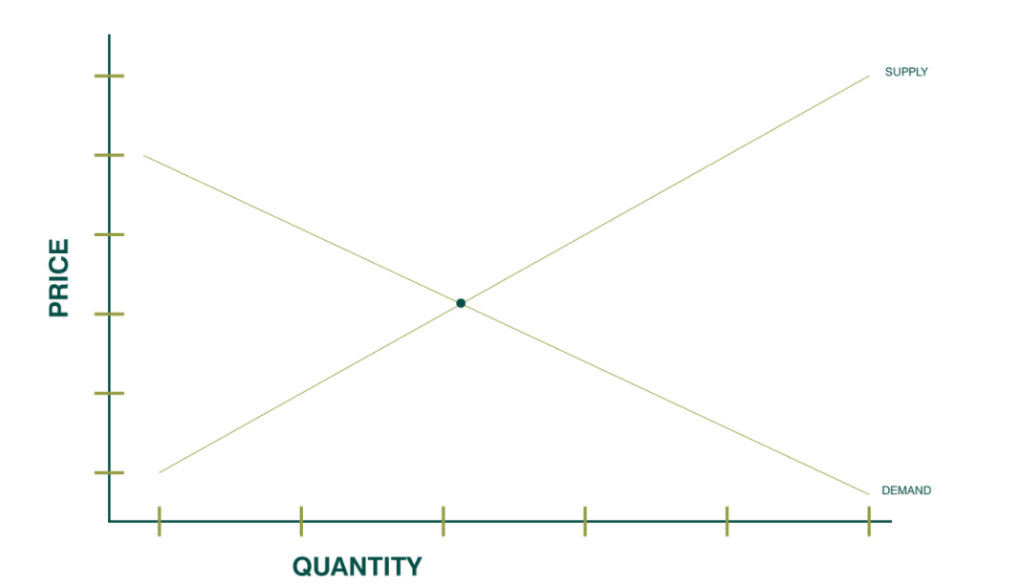
Picture Credits- Wpengine (2018) Top Consumer Behaviour Theories

The diagram above is a representation of Marshallian Economic Model that aids organizations in understanding consumer behaviour when consumers are making purchases that demands rational consideration. Hence when the income of consumers is higher, sale of the product will also be higher, given the product is authentic and not of an inferior quality.
However, this notion was rejected by the behaviourists or classical psychologists who believed that human mind is a complex entity and hence broader perspectives such as a multidisciplinary approach must be adopted for analysing consumer behaviour.
Unlike economists, the behaviour scientists and the classical psychologists were not ready to believe that a rational human being, only treats the ‘price of the product’ as the deciding factor in all his/her consumption related decisions.
Especially in today’s date and time, when an individual is living in a constantly evolving digitally advanced era and are constantly exposed to innumerable superior technologically advanced quality products or services, highly interactive media exposures, pertinent social media influencers, and efficient networking distribution centres, ‘price’ cannot be the solitary factor for analysing consumer buying behaviour.
Therefore, apart from the economics, it’s the socio-cultural factors, along with the individual needs, motives, perceptions, self-concepts, and their personalities that can altogether influence the consumer’s ultimate purchase decisions. (Bamossy, et al.,2016)
This argument led to the emergence of new consumer behaviour theories, such as learning and psychoanalytical model, that primarily relies on understanding the consumers primary needs (such as hunger, thirst, sex, shelter) and the learned needs (such as fear and guilts) in understanding consumers purchase decisions. (Bamossy, et al.,2016)
Learning models-These models proposes that every purchase intention is motivated by a drive or internal stimulus, which becomes a motive when directed towards a drive reducing objects. For instance, when hungry, a person will be driven towards food buying behaviour (for example ordering a pizza), which after consumption will reduce the internal drive of hunger (tummy filled with food or slices of pizza) and also provide contentment (feeling happy or satisfied with the pizza order).
According to learning theorists, this response of contentment (feeling) reinforces the relationship between drive(hunger) and the drive reducing stimulus object (food or pizza in this scenario) as well as the other related cues (taste and diameter of the pizza, estimated delivery time, efficiency of the website in ordering the pizza or the customer service provided by the employees in the pizza parlours taking the order and delivering the pizza etc).
In fact, when the consumers learn to link this association between stimulus and response, it becomes a habit. This habit then ultimately leads to the formation of other higher cognitive processes such as attitudes, beliefs, values, and motivations etc towards the brand or product.
This knowledge is particularly useful as it helps organizations to understand how consumers have reacted in the past and predict how consumers are going to react in similar situations in the future. Vey often it is observed that consumers experience with a product from an organization is likely to be generalised to similar or other products of the organization. Hence this helps organizations to promote associations of products with strong drives, cues, and positive reinforcement from the consumers, ultimately influencing the consumer purchase decisions. (Foxall, G.R.,1993)
Psychoanalytical models-The psychoanalytical model, on the contrary, focus more on the factor of personality. It relies on the symbolic factors in buying a product. This theory was developed by the father of psychoanalysis, Sigmund Freud in 1918, who believed human personality is the outcome of their own motivations, desires, urges and psychic energies, which is divided into three subparts: -
i) id- the storehouse of all repressed urges and motivations
ii) ego- the conscience that directs human beings to meet their urges and impulses in a socially acceptable manner
iii)super ego- the moral conscience of human mind. This is the internal representation of the strong urges and motivations that are morally approved by the external world or society.
Henceforth, it’s feasible to say that by Freud’s description of personality, human behaviour is directed by a complex set of deep-seated motives and urges. This means consumers respond to symbolic concerns as much as they respond to those of the economics and operationalities of the product. So, it’s not only the external factors like price and income of the consumers that account fully for consumers behaviours but there are also internal factors that lay deep in the psyche, which consumers are mostly unaware of. Hence Freud’s psychoanalysis model implies that products or branding strategies that contain an emotional appeal to consumer’s feelings, desires and aspirations are more effective than rational appeals. (Foxall, G.R.,1993)
Social Model- Around the same time there emerged another approach of examining the process of consumer behaviourism, popularly known as the social model, which proposes that the social agents like our friends, family members, colleagues, and our individual social status, exercises a strong influence on the buying behaviour of consumers.
In terms of luxury goods, these models might be most appropriate. Its primary assumption is that consumer behaviourism purely operates on social class and economic status of the consumers. Let’s say if one is the formal leader of the group, whose views are respected among the group and then his buying behaviour decisions will impact the group and the associated social circles. As a leader or most admired person in the group, the individual set’s certain social status or standard for the group, which the other automatically tends to follow.
This model believes consumer behaviourism is closely related to the society and its versatile groups and these social groups can be grouped into two categories. First comes the primary groups consisting of friends, family, relatives, and acquaintances and next is the secondary groups which consists of people with similar lifestyle, personality, or requirements. So, if the brand marketers through market segmentation process can figure out the common behaviour patterns of a specific group and class of buyers, then they can influence the groups buying behaviour patterns. (Foxall, G.R.,1993)

The Contemporary Consumer Behaviour Models
Howard Sheth’s Model analyses the combined impact of social, psychological, and economic aspects on consumers buying behaviours. These take into consideration a buyers perception levels, attitude and learning capacity that influences purchase decisions. This model is based primarily on four factors: -
1) Input Parameters- There parameters include both tangible and intangibles factors that can be classed into three subcategories

i)Significative Stimuli- this includes tangible product attributes, for ex- price, uniqueness, quality, uniqueness, and service effectiveness of the product.

ii) Symbolic Stimuli- this includes the intangible product attributes such as buyers’ attitude or perception towards the product/brand.

iii)Social Stimuli- these are shaped by consumers own backgrounds and social status in the society. Basically, it takes into consideration all factors that belong to the societal group and class to which a consumer belongs. (Simon, H.,1997)

2) Buyers Learning and Perceptual constructs- When a buyer receives input stimulus, then their interpretation of stimuli is based on two factors: -

- Stimulus Ambiguity-This ambiguity occurs when a person is unable to interpret the input parameters or stimulus related to the product correctly.

- Perceptual Bias- This bias is evident when the buyers interpret the product related information based on their needs and expectations. This purely depends on buyers own attitude and perception towards the brand or product.

Together these two factors influence a consumer to evaluate a product or brand as good and bad ultimately helping the consumers to either build trust towards the product or reject the product. (Simon, H.,1997)
3) Output Parameters- These refer to level of satisfaction or dissatisfaction post purchase. This is mainly important for understanding returnee consumers buying behaviour. Higher satisfactions result in elevated brand performance and dissatisfaction leads to lower brand performance as consumers has no trust towards the brand and perceive it negatively.
4) Exogeneous or External factors- this includes indirect influence exerted on the consumers decision making process such as consumers personality traits, social status, belief, culture, time pressure and necessity of purchase.
Together all these factors have a combined impact on buyer’s decision-making process and are dependent on each other.
Another significant contribution made by Howard Sheath model of buying behaviour is that along with the factors it explains the three significant stages of the buyer’s decision making or selection process. (Simon, H.,1997)
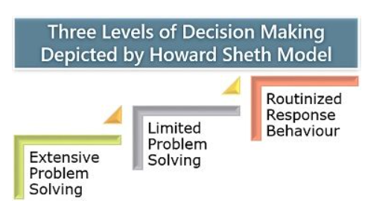
Picture Source: (Prachi, M., 2019, Howard Sheth Model, The Investors Book)
The first stage includes extensive problem solving- Customer has no perception or bias towards the brand as they are still new to the market or have extraordinarily little information on the product. Hence is in information seeking mindset at this level, willing to explore different brands available before making the final purchase decision.
The second level is limited problem solving-Has inadequate information on the brand or product and hence is willing to explore more on the product or conduct comparative analysis for alternative brands available in the market, before making the final purchase decision. The consumers can still be moulded by the brands marketing or sales personnel at this stage.
The final level is known as routinised response behaviour- This where the consumer is completely aware of the product, has knowledge about the pro and cons of their purchase decisions and have trust towards the brand or product of purchase. This is a habitual response stage, where the buyer keeps coming back to the product either due to the higher level of trust towards the brand or higher level of satisfaction with product.
Thus, the Howard Sheth model not only helps in decoding buyers mindset in making purchase decisions but also empirically emphasis on post purchase intentions and the repetitive buying behaviours of the consumers. However, these concepts are hypothetical, which are challenging to be pragmatically examined.
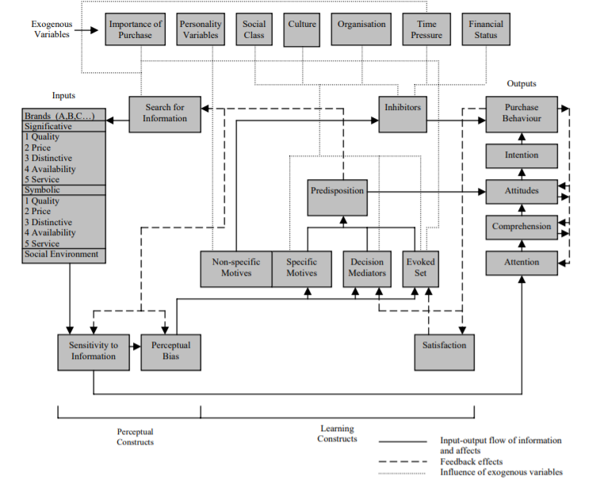
Picture Source- (Howard, J. A., et al., 1969. The Theory of Buyer Behaviour)

Reasoned Action (TRA) and Planned Behaviour (TPB) Models of Consumer Behaviour-
In the year 1980, the theory of planned behaviour, which initially started as the Theory of Reasonable Action, predicted that all consumers rely on behavioural intent. This approach was established to predict a consumer’s intention to engage in a behaviour at a given time and place. It focuses on all the behaviours over which the consumers have the ability of exercise self-control.
Martin Fishbein and Icek Ajzen in the late 1960’s, developed the Theory of Reasoned Action, out of which emerged the Theory of Planned Behaviour around 1985 (Hackman and Knowlden, 2014)
Fishbein who’s known for his influential work in the area of expectancy value models, proposed a prescriptive cognitive consumer buying behaviour model, which was based on the proposition that a person’s overall attitude towards a product is shaped by their level of trust, perception, or feelings towards the various attribute of the product. This is popularly known as ‘Fishbein Model’ which can be algebraically expressed as under; -
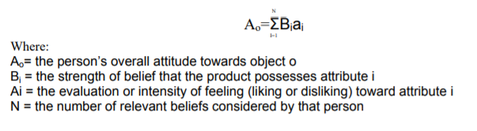
Source- (Bamossy et, al., 2006)
While the Fishbein’s Model significantly contributed to the area of cognitive skill of attitude formation, it was developed further to assess the rationale behind a consumer’s behaviour intention towards purchasing. This model later came be known as the Theory of Reasoned Action which is used to explain and predict purchasing behaviour based on attitudes, intentions, and subjective norms. (Ajzen and Fishbein, 1980)
This approach proposed a pragmatic shift some in understanding consumer behaviourism from the earlier models. Its key assumption is that all purchase behaviours are influenced by a combination of the consumer’s attitude towards the product and the subjective norms (power of other people influencing the behaviour) about the behaviour.
Both the attitude and subject norm lead to intention to perform the behaviour, which results in the purchase behaviour. However, this model does not account for people’s perception of the power they have over their behaviour, that’s where the Theory of Planned Behaviour comes in introducing the concept of control beliefs. (Bamossy, et al.,2016)
Control beliefs are beliefs about factors that either impede or accelerate consumer’s decision towards a purchase. The TPB model is simply an extension of the theory of reasoned action, which highlights the over reliance on consumer intentions to predict their purchase behaviours. Also, it suggests that the correlation between behavioural intention and actual behaviour is quite simplistic because of circumstantial limitations; hence an additional variable might be responsible for mediating the gap between purchase intentions and actual purchase behaviour. To address this gap, Ajzen in 1985, introduced an additional construct known as perceived behavioural control- which is the combined presence of factors that may eventually influence the actual buying behaviour. These factors serve as a proxy measure of the influence on actual buying behaviour as shown below. (Bamossy, et al.,2016)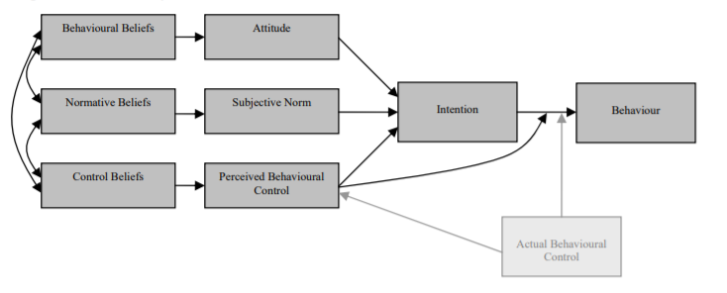
Source- (Ajzen,2006)
The Theory of Goal Directed Behaviour-
This model draws heavily on the Theory of Planned Behaviour but the only difference between these two models is that the fundamental constructs of consumer behaviourism is viewed with regards to goals/desires rather than behaviours in this model.
Understanding customer desires play an integral role in this model. This model practically explains the need of studying primary desires of the target customer market for influencing final purchase decisions and for developing services/products that will satisfy customer needs or provide the perception of the satisfaction of the customers desires. (Erasmus, et.al, 2001)
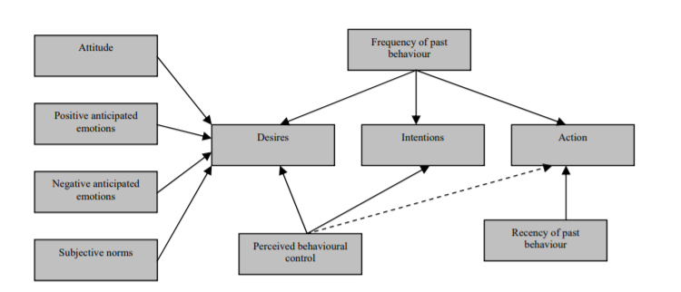
Source- (Sutton, S. (1998)

Research Philosophy- Stating Ontology and Epistemological positions
Understanding research philosophy is key for any researcher as it improves a research study by helping one to understand the research purpose, design, method, outcomes or interpretations. To be precise, it offers clarity to the researcher about the decisions that are taken during the research process which eventually end up impacting the final research outcomes.
Research philosophy furnishes the general principles of theoretical thinking, cognitive analysis, perspectives, and self-awareness, altogether which are used in obtaining the knowledge of reality, choice of research design, process of research conduction, analysis, and interpretation by the principal research investigator.
Ontology- The first branch of such research philosophy is ontology or commonly known as the ‘study of being’. This solely is concerned about the reality of nature and how human beings can acquire the knowledge of the world or it’s reality.
There are numerous sub-branches of ontology ranging from realism (i.e., one reality exists) to relativism (i.e., multiple reality exists) just as shown in the figure below.
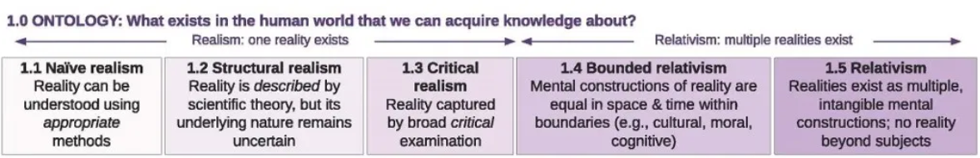
Source- (Moon. K., and Blackman. D., 2017)
In the current study, our purpose was to study consumer behaviourism in the context of AI enablers or the digital platforms that are made available for consumers to shop online. As a principal investigator of this study, I’m leaning on the relativism philosophy as I strongly believe that humans are rational beings, and their purchase decisions are shaped by various factors or variable influencers available in the market.
Therefore, there is no existence of only one single reality when it comes to online consumption behaviour, instead different individuals can be impacted by different factors when consuming products or services online.
Hence human purchase decision is relative, as it’s based on consumers experience of the product at a given time and situation. Unlike the Marshallian theory, there is no existence of one single reality which assumes that all consumer behaviour is influenced by the economic factors, instead it’s the combined effect of other social, psychological, and behavioural factors that affects a consumers final purchase decision.
Epistemology- The second branch of research philosophy is concerned with the study of knowledge commonly known as epistemology. It helps a researcher to clarify how they frame their research design in their attempt to discover knowledge about the world and its reality. It’s simply concerned about how we as living beings create knowledge.
It is also strongly associated with all the aspects of the research including its scope, authenticity and even the methods used in acquiring knowledge about the research phenomenon. Just line ontology, there are various subcategories of epistemology which differs from one another. The three most commonly known subcategories of epistemologies are as under; -
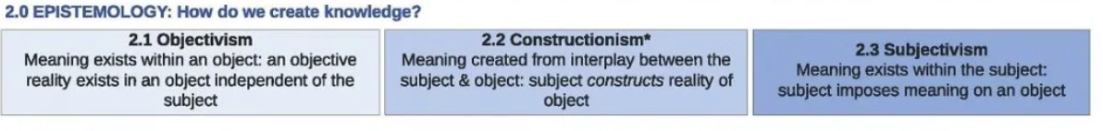Source- (Moon. K., and Blackman. D., 2017)
Our approach here is to examine the various factors that affect online buying behaviour, and in doing so we will analyse consumer behaviour empirically by running a few descriptive statistical tests. In this research a more objectivist outlook will be taken to provide numbers and measures of how people behave in a particular situation because the assumption is that there’s a kind of a fundamental truth about online consumer behaviourism that needs to be further explored.
Thus, we are bending towards an objective epistemology research philosophy to explore the idea of online consumer behaviourism. In this study we will solely focus on how human mind take into consideration different factors that impact their purchase decisions for online shopping. Thus, we intend to generate an empirical understanding of the online consumer behaviourism phenomenon. The value of such research is to examine how individuals reach a final purchase decision and what factors motivate or impeded their purchase decisions online. (Williams, D. 1998)
Axiology-
This is another dimension of research philosophy that is mainly concerned with study of value or theories on the nature of value. It incorporates ethics or theory of morality, aesthetics or theory of beauty, and various forms of value to explore what’s right or wrong for a researcher when embarking in a research process. In this project, we have been conscious about two core focus of axiological that is discussed as under;-
-to conduct an impartial and diligent research
-to explore the worthwhile science of consumer behaviourism through empirical data analysis. (Carneades.org., 2017).
As researchers, being committed to such ethics and moral values, it has helped in conducting impartial and independent investigation to uncover the different intricacies attached to online consumer behaviour. Such moral values and authenticity are key to conducting any interdisciplinary research and as well as holds wider applicability. (Deane. P., 2018)
Methodology- Quantitative Analysis
To have a better understanding of consumer behaviourism, especially in this modern era where trade and commerce has been significantly diversified via multiple platforms and artificial intelligence apps, this quantitative study was undertaken to examine the online buying behaviour.
In the twenty-first century where, online shopping has increased exponentially, this study will help us gather insights on consumer’s online buying behaviours. A descriptive study was undertaken through an online survey. A self-constructed questionnaire was devised considering the research objectives and aims. The survey consisted of 11 questions and anyone above 21 years of age was allowed to undertake the survey. Convenient non-probability sampling method has been adopted to acquire date from respondents across London region where more than 84% of e-commerce consumers reside. (Patterson, M. and Williams, D.,1998)
Data Collection-
From generations earlier to the current context, business practitioners and researchers have been forever interested in studying the phenomenon of consumer behaviourism. With digital enablers or artificial intelligence apps, consumerism has been rapidly shifting from physical to digital space. These makes this topic more intriguing, as consumers today are solely using internet for collecting product information to reading product reviews to making the final purchases for different goods or services.
Thus, our findings should assist e-commerce businesses to understand how to improve their online services or offerings for those who prefers to shop online. In this study we sought to answers to what factors impact online buying behaviour across genders. The study focuses on general purchasing behaviour of online customers, why they choose to shop online, how many online shopping websites are visited before buying, what kind of purchases are made etc. Our approach was to focus on composite categories and segments that would reflect online buying behaviours from both high as well as mid-low-income groups.
Total of 63 complete data sets were analysed out of which 32 were females and 31 were males. These valid responses were sorted, accumulated, and analysed through IBM’s SPSS software for effective statistical analysis.
Research participants-
Around 65 respondents participated out of which 63 respondents completed the entire online survey. The respondents belonged to different backgrounds, age-categories (however only above the age of 21), from distinct ethnicities, genders, and professions-including the students, home makers and retired professionals.
The sample was almost evenly divided into females and males to gather quantitative data. All the respondents had been using internet for few years and are frequent online shoppers. The questionnaire focused on online shopping behaviours across eleven categories to provide a good mix of online products, trends, and services.
The choice of these research categories was guided by previous research publications available on Google scholar website and marketing platforms on Google. All the questions were investigated across demographic groups(gender) to explore if there were any significant differences in patterns of shopping. The graphs below indicate the results of each research categories.
Overall, the research indicates that people are buying online and even Covid-19 had not been able to impede this online buying habit. In fact, online buying has exponentially increased. Also, the study reveals there are no significant differences between males and females in their patterns of shopping.
Of all the corresponding factors examined in the study, the most interesting of all was to witness that despite consumers moderate level of trust towards online purchases, online buying remains unaffected and for making purchases online, consumers are relying more on non-economic over the economic factors of price, sale, or discounts.
Data Interpretation- Graphical Analysis and Statistical Tests of Non-Parametric and Correlation
Each of the research question are analysed based on gender below. The aim of this empirical investigation is to find out whether there is any significant difference across genders when it comes to online consumer buying. The first question is related to demographics and the rest is designed on the categories attached to online shopping.
The graphs below were plotted using the SPSS software. This is an attempt to understand what impacts consumer buying behaviour online across genders.

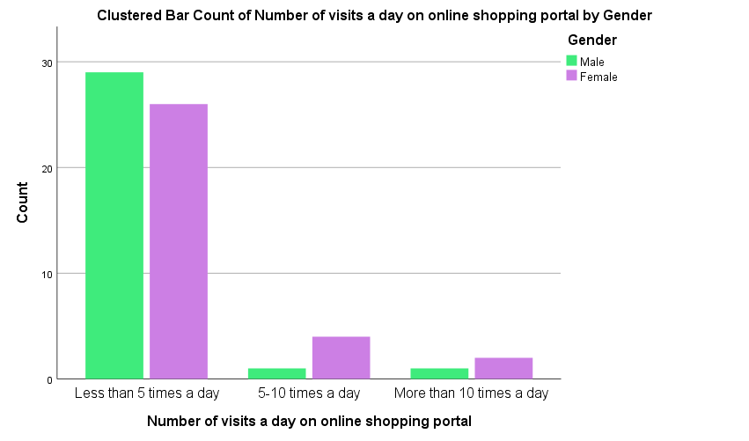

Research Question 1-The graph here is a pictorial representation of the first research question which about seeking information on number of visits made per day on the online shopping portal. The participants were allowed to choose from three responses- less than 5 times a day, 5-10 times a day and more than 10 times a day.

As the graph indicates, most participants opted for the first response (i.e. -less than 5 times a day) and more interestingly this seems to be true across genders. Hence there is no significant difference between genders when it comes to the number of visits made per day on online shopping portals.

The Bar Chart here clearly indicates that both males and females visit online shopping portals less than five times per day however in comparison with men, it seems more females like to visit online portals more than 5 times a day. However, the difference across gender is trivial rather hardly negligible.
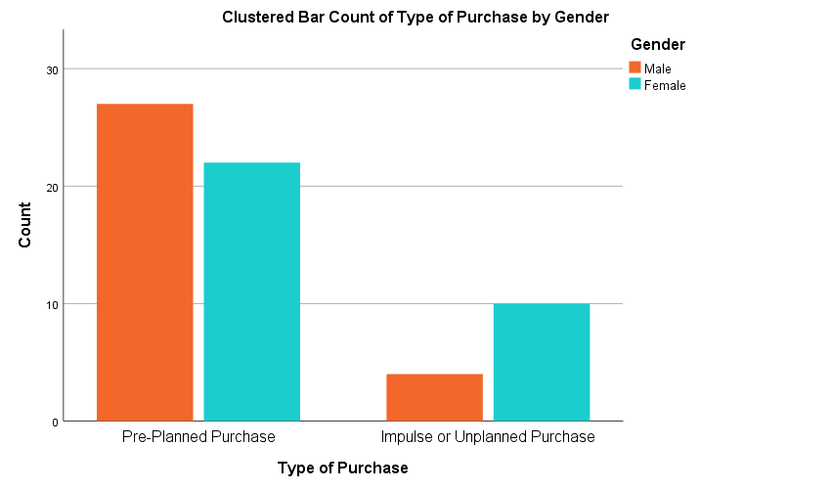

Research Question 2-

The second question was designed to explore the nature/type of purchase made online. Two alternative responses (i.e. - pre-planned and unplanned/impulse purchase) were added for participants to choose from them.

The pre-planned purchase includes groceries, medicines, domestic items whereas impulse purchase includes clothing, beauty products, fast foods, luxury items etc. Both the genders leaned towards pre-planned purchase option, indicating individuals don’t randomly buy products online, rather a lot of planning goes behind what they buy online.

This survey also reveals that some categories or products (like groceries, medicines, products of domestic uses etc) are more popular across genders over other items. This could be due to the fact that online grocery companies like Asda, Aldi, Sainsbury, Morrisons etc, operates in the region of London, UK, where this survey was conducted.

The current finding pinpoints the significance of understanding the nature of purchase in order to fully understand the phenomenon of consumer online buying behaviour. This knowledge can be useful for marketing managers/campaigners/influencers or e-commerce platforms in selling their respective products online.

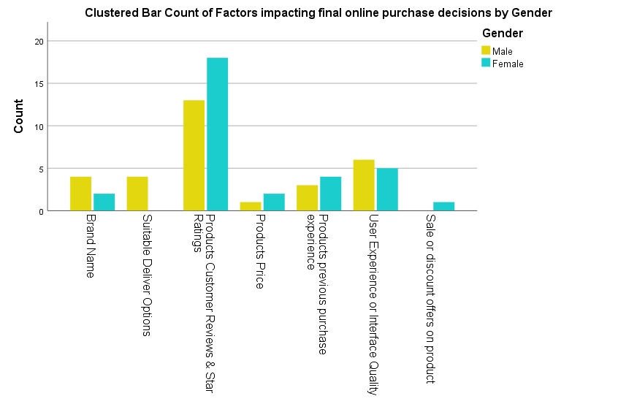
Research Question 3-

The third question was designed to examine what factors ultimately impact online purchase decisions. This is a significant question as the study aims to find out if non-economic factors play a stronger role than economic factors in impacting consumers purchase decision online and the Bar Chart above clearly indicates such is the case.

Out of the seven options- Brand Name, Suitable Delivery Options, Customer Reviews and Star Ratings, Product Price, Previous purchase experience, Interface Quality or User Experience and Sale or Discount offers on products.

The survey asked respondents to indicate the factors that influence their purchase decisions among the seven options provided. The least liked factor was price and discount offer on products which were the only two economic factors added in this question. The most liked factor across both genders were customer reviews and star ratings on the product clearly indicating the level of influence these ratings and reviews have on online consumers.

Thus, it’s fair to mention that consumer behaviourism is closely related to the society and it’s versatile social groups which consists of people with similar lifestyle, personality, or requirements, hence online platforms or sellers must be mindful of the ratings and customer reviews they are getting on their products, as it can make or break their deal with the consumers.

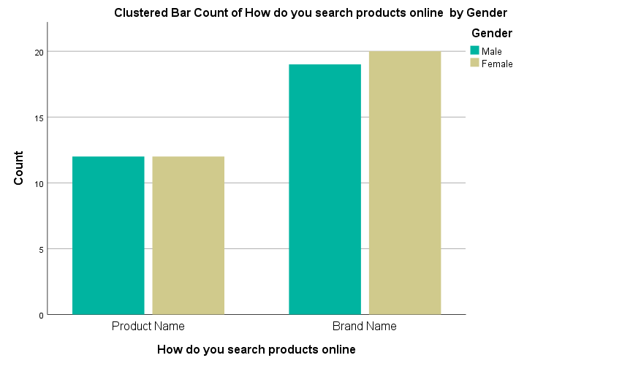
Research Question 4-

The fourth question was designed to examine how consumers search their products, and the Bar Chart above reveals that across genders consumers tend to search through brand name.
This finding is in concurrence with Freud’s psychoanalysis model of human behaviour, which implies that products or branding strategies that contain an emotional appeal to consumers feelings, desires and aspirations are more effective than rational appeals. (Foxhall, G.R.,1993)
A significant number of people in this study have revealed that brand holds a significant value in their lives and once a sense of trust is created with a brand, a customer tends to stick to that brand for various purchases.
Although it’s time effective to search with product name, consumers still search by product name as a sense trust or belongingness is created with that brand. For instance- when searching for milk -consumers type Cravendale skimmed milk instead of just searching by skimmed milk. This shows consumers already know the brand or has heard of it or are looking specifically for that brand to go directly to their website.
Hence more the reason for online sellers or business owners to build a brand that ideally associated with positive conations for the consumers.

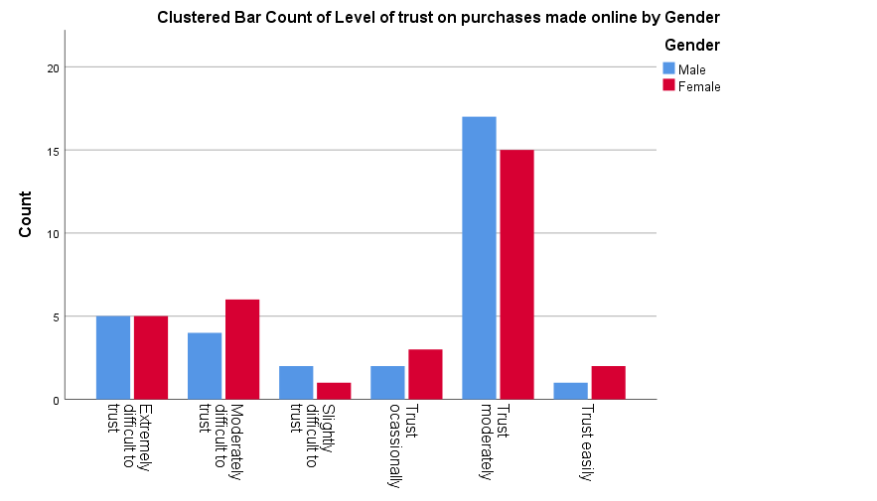

Research Question 5-

The fifth question was designed to examine consumers level of trust towards online purchase decisions. The Bar Chart above indicates levels trust do not vary across genders.

Total six options were listed in the research question including- Extremely Difficult to trust, Moderately Difficult to trust, Slightly Difficult to trust, Trust Occasionally, Trust Moderately and Trust easily.

The options were arranged in an ascending order from low to higher level of trust. Both males and females opted mostly for the ‘Trust Moderately’ option as there might be some scepticism about the functional mechanisms of e-commerce and its intra-transparent processes and effects. (Bhattacharya, R. and Devinney, T.M., 1998)

However, the data below suggests that despite such scepticism that leads to moderate levels of trust, the online buying behaviour is not affected. This may be due to the fact that online shopping is time saving and convenient as it offers a wide range of different products.

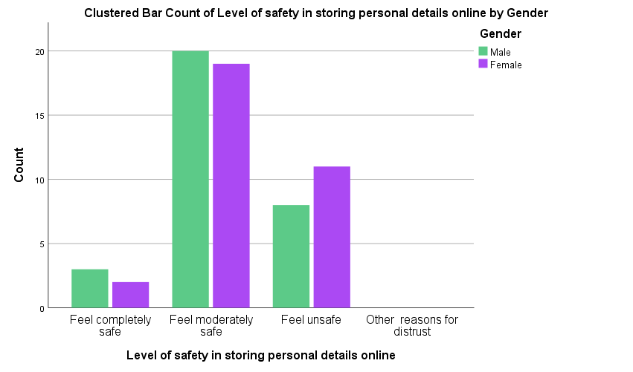

Research Question 6-

The sixth question was designed to analyse consumer’s level of safety towards online purchases.

The four options included in this research category are as follows- Feel Completely Safe, Feel Moderately Safe, Feel Unsafe and Other Reasons for Distrust.

Across genders consumers opted for two responses mostly i.e., Feel Moderately Safe and Feel Unsafe indicating certain level of dangers are perceived by consumers when shopping online.

Although shopping online provides consumers with widest choices and saves considerable amount of time and energy, it’s not free of risks. Most common risks attached to online e-commerce are frauds resulting from making unsecured webpage payments, using websites with fake goods and emails that do not exist or receiving goods that do not match the product advertised online etc.

Thus, there should be more consumer awareness or education on safe online buying to reduce such frauds for protecting the online community and its consumers. (Westbrook, R.A. 1983)
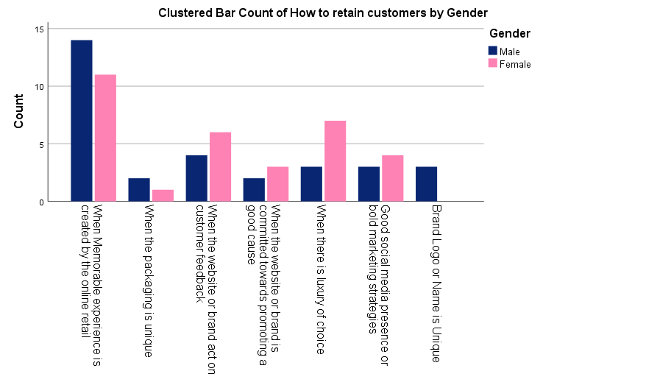

Research Question 7-

The seventh question was designed to assess the factors that retain consumers towards online purchases.

The respondents were allowed to choose from the following categories of- Unique Brand Logo or Name, Brands Good Social Media presence or bold marketing strategies, Luxury of choices, Brands promoting or committed towards promoting good cause, Brands acting towards customer feedbacks or reviews, Products with unique packaging and Brands committed towards creating Memorable Shopping Experience.

Most respondents across genders opted for the option of Brands committed towards creating Memorable Shopping Experience. This finding is in accord with Howard Sheth’s consumer buying model which states that consumers are enticed by significative and symbolic attributes of the product. The same holds true for the online products, as indicated the current study.

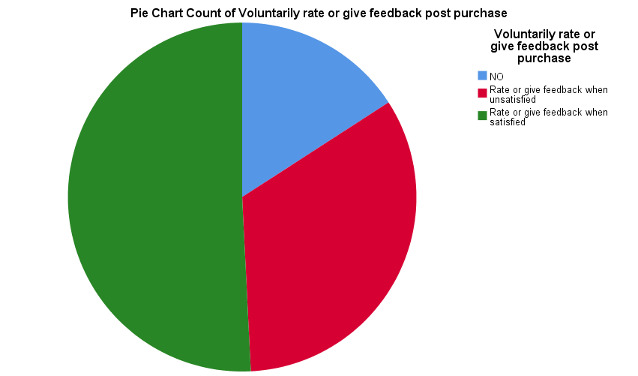

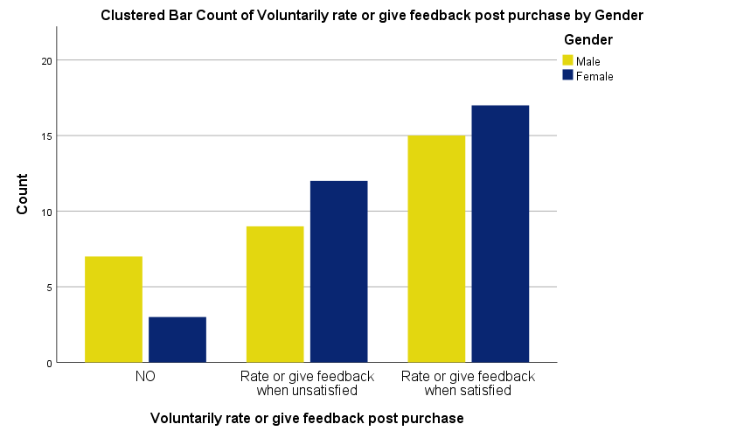

Research Question 8-

The research category above was designed to assess the intention of consumers who provides feedback post purchase. As from our previous categories we have witnessed, significant level of individuals who buy online, prefer to read reviews and ratings prior to their purchase and hence a pie chart was plotted to illustrate numerically what proportions of online consumers provide feedback online.
The respondents were allowed to choose from the following categories of- NO- (meaning do not provide feedback Post-Purchase) and Yes- (meaning provide feedback Post-Purchase). The respondents who pressed yes were directed towards two categories to illustrate why or when they provide feedback. The two options were- Yes provide feedback when satisfied with the product Or Yes provide feedback when unhappy with the product.
Further a Bar Chart was plotted to showcase that across genders consumers provide feedback when they are satisfied with the product. This is an eye opener as there is a common misconception that consumers only inclined to provide feedback when they are unsatisfied with the product. This knowledge is useful for service providers to categorically understand what pleases or dissatisfies their customer base, in order to improve their product or services.

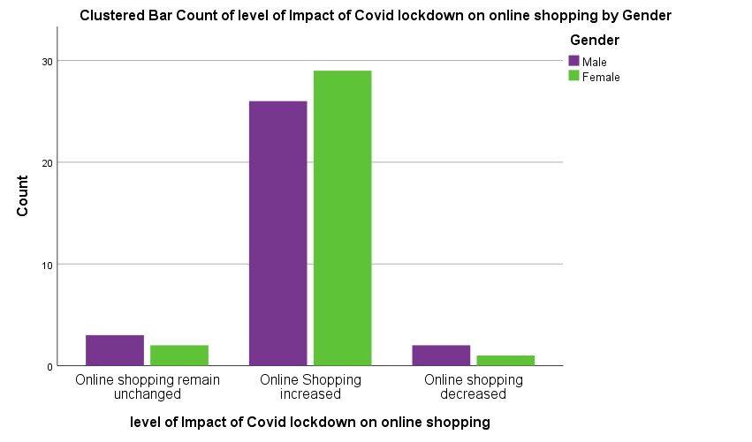

Research Question 9-
The research category above was designed to explore the impact of Covid-19 on the online shopping. This study was undertaken when UK was wrapped under the ferocious second wave of Covid-19 and hence this category was included to assess Corvid’s impact on online buying behaviour.
Although all the essential shops were kept open throughout the lockdown period, the online shopping still exponentially increased. It was anticipated that when all other social activities were restricted apart from essential shopping, individuals would prefer to step out for shopping for some respite, but it was surprising to see that individuals still preferred to purchase online.
This shows that despite having time on their hands, families still opted to shop online for the convenience it offers. Also, the main drivers of online shopping could potentially be the ease of price comparison, free shipping offers, avoiding crowds and salesman, convenience of having all products in one place etc. (Pavur, R.J. 2000)

Graphical Analysis to review what factors impact purchase decisions and how it helps in retaining the customer base for the brands

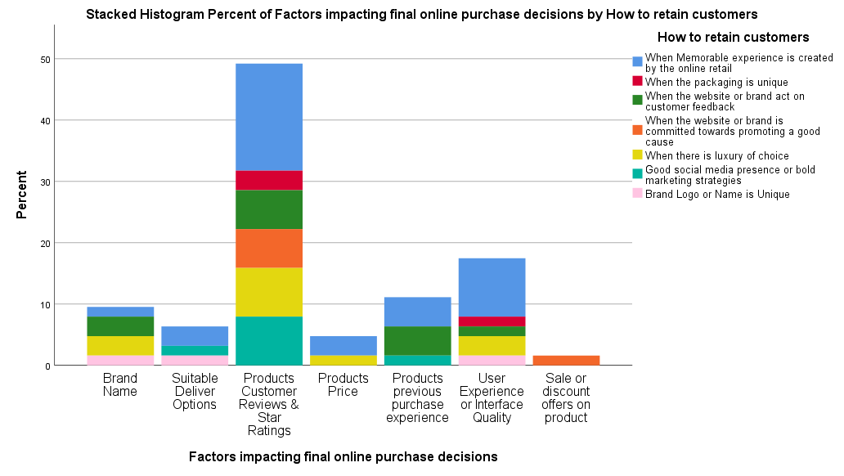

Reviewing the key factors impacting online purchase decisions-

Above is a percentage graph, indicating the key factors influencing online purchase decisions. Our finding suggests that despite the impact of Covid-19 and across genders consumers are progressively shifting to online buying.

Thus online service providers should aim at improving their online offerings as there some general advantages attached to it such as convenience of product selection through good quality user interface, option of suitable delivery like free-shipping, customisation, availability of original products which are only available online but not elsewhere, ease of viewing and comparing product prices and most importantly as the data shows above is the ease and abundance of information access of the product ratings and customer reviews which help customers make final purchase decisions. (Hagger, M. & Chatzisarantis, N. 2007)
Graphical Analysis on consumers level of trust on purchases made online vs types of purchases made online

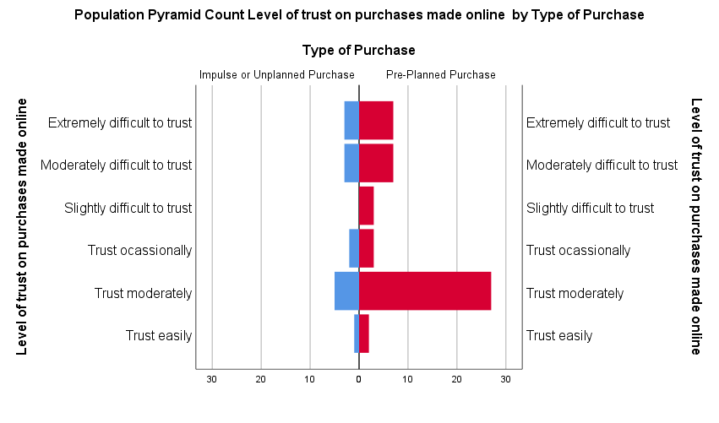
The above Population Pyramid Chart is comparison between Level of trust and Type of Purchases made by consumers online. The level of trust seems to be slightly better towards planned purchases. This may be due to the reason that consumers who makes planned purchase sticks to specific products or brands, with whom there is sense trust, belongingness, loyalty and even reciprocity. Thus, the levels of trust are moderate for planned purchases over impulse purchases.
This also goes onto show that consumers indulge in both pre-and-post-purchase evaluations that may come in form of comparing products to other products, considering product prices, their brand values or even reading product reviews. However, for post purchase evaluation much of the decision may lie in the performance of product itself, however the role brand in creating a satisfactory experience for the consumer must not be underestimated.
(Kraeuter, G., S. 2002)

Non-parametric Tests- Tests of Correlation

Correlations
 |  |  | Level of trust on purchases made online | Level of safety in storing personal details online | level of Impact of Covid lockdown on online shopping
Kendall's tau_b | Level of trust on purchases made online | Correlation Coefficient | 1.000 | -.330** | .033
Kendall's tau_b | Level of trust on purchases made online | Sig. (2-tailed) | . | .004 | .773
Kendall's tau_b | Level of trust on purchases made online | N | 63 | 63 | 63
Kendall's tau_b | Level of safety in storing personal details online | Correlation Coefficient | -.330** | 1.000 | .080
Kendall's tau_b | Level of safety in storing personal details online | Sig. (2-tailed) | .004 | . | .509
Kendall's tau_b | Level of safety in storing personal details online | N | 63 | 63 | 63
Kendall's tau_b | level of Impact of Covid lockdown on online shopping | Correlation Coefficient | .033 | .080 | 1.000
Kendall's tau_b | level of Impact of Covid lockdown on online shopping | Sig. (2-tailed) | .773 | .509 | .
Kendall's tau_b | level of Impact of Covid lockdown on online shopping | N | 63 | 63 | 63
Spearman's rho | Level of trust on purchases made online | Correlation Coefficient | 1.000 | -.382** | .038
Spearman's rho | Level of trust on purchases made online | Sig. (2-tailed) | . | .002 | .767
Spearman's rho | Level of trust on purchases made online | N | 63 | 63 | 63
Spearman's rho | Level of safety in storing personal details online | Correlation Coefficient | -.382** | 1.000 | .086
Spearman's rho | Level of safety in storing personal details online | Sig. (2-tailed) | .002 | . | .501
Spearman's rho | Level of safety in storing personal details online | N | 63 | 63 | 63
Spearman's rho | level of Impact of Covid lockdown on online shopping | Correlation Coefficient | .038 | .086 | 1.000
Spearman's rho | level of Impact of Covid lockdown on online shopping | Sig. (2-tailed) | .767 | .501 | .
Spearman's rho | level of Impact of Covid lockdown on online shopping | N | 63 | 63 | 63
**. Correlation is significant at the 0.01 level (2-tailed).

The above test is the non-parametric tests of correlations- Spearman’s rho and Kendall’s Correlation coefficient tests.
Both these tests indicate that there is an inverse relationship between level of and level of safety towards storing personal information online. This clearly indicates that despite feeling unsafe to store personal information online, people still trust online shopping moderately.
Thus, the level of safety of the consumers has a trivial role in impacting consumers trust towards making any purchase online. More interestingly, the impact of covid-19 lockdown on making online purchases is also not related to the level of trust consumers hold towards online shopping. Thus, there are other moderating factors that play a greater role over level of trust in impacting consumer’s purchase decision online.

Non-Parametric Tests-

Hypothesis Test Summary
 | Null Hypothesis | Test | Sig. | Decision
1 | The distribution of Level of trust on purchases made online is the same across categories of Gender. | Independent-Samples Mann-Whitney U Test | .859 | Retain the null hypothesis.
2 | The distribution of Level of trust on purchases made online is the same across categories of Gender. | Independent-Samples Kruskal-Wallis Test | .859 | Retain the null hypothesis.
3 | The distribution of Level of safety in storing personal details online is the same across categories of Gender. | Independent-Samples Mann-Whitney U Test | .413 | Retain the null hypothesis.
4 | The distribution of Level of safety in storing personal details online is the same across categories of Gender. | Independent-Samples Kruskal-Wallis Test | .413 | Retain the null hypothesis.
5 | The distribution of level of Impact of Covid lockdown on online shopping is the same across categories of Gender. | Independent-Samples Mann-Whitney U Test | .981 | Retain the null hypothesis.
6 | The distribution of level of Impact of Covid lockdown on online shopping is the same across categories of Gender. | Independent-Samples Kruskal-Wallis Test | .981 | Retain the null hypothesis.
Asymptotic significances are displayed. The significance level is .050.

Independent-Samples Mann-Whitney U Test

Level of trust on purchases made online across Gender.

Independent-Samples Mann-Whitney U Test Summary

Total N | 63
Mann-Whitney U | 484.000
Wilcoxon W | 1012.000
Test Statistic | 484.000
Standard Error | 67.471
Standardized Test Statistic | -.178
Asymptotic Sig.(2-sided test) | .859

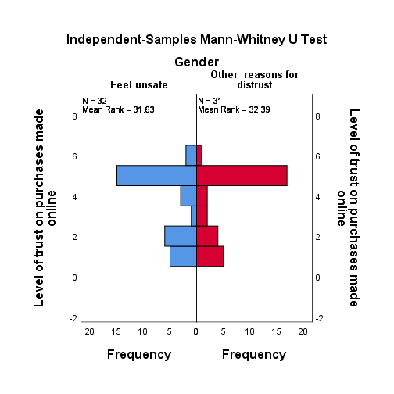

Level of safety in storing personal details online across Gender

Independent-Samples Mann-Whitney U Test Summary
Total N | 63
Mann-Whitney U | 547.000
Wilcoxon W | 1075.000
Test Statistic | 547.000
Standard Error | 62.360
Standardized Test Statistic | .818
Asymptotic Sig.(2-sided test) | .413

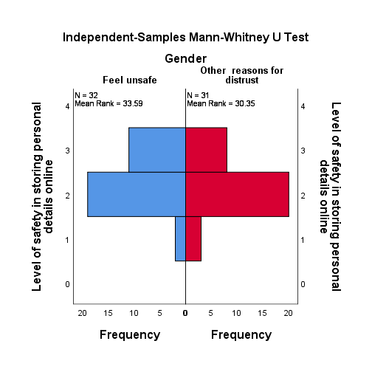

Level of Impact of Covid lockdown on online shopping across Gender
Independent-Samples Mann-Whitney U Test Summary
Total N | 63
Mann-Whitney U | 497.000
Wilcoxon W | 1025.000
Test Statistic | 497.000
Standard Error | 42.043
Standardized Test Statistic | .024
Asymptotic Sig.(2-sided test) | .981

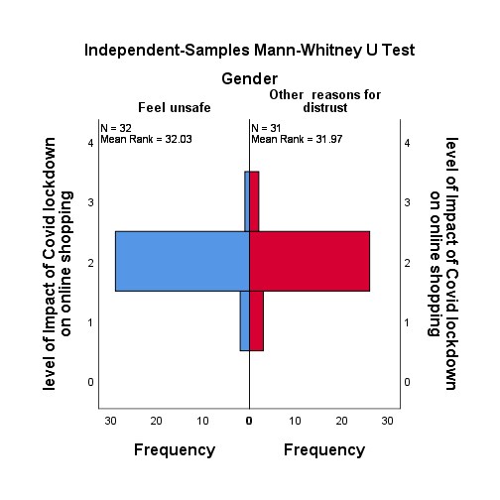

The above tests are the non-parametric tests of Hypothesis Testing’s. Both the

Independent-Samples Kruskal-Wallis Test and Independent Sample Mann-Whitney U-Test was performed using the SPSS software.

The outcome of such tests is stated as under; -

- The distribution of Level of trust on purchases made online is the same across categories of Gender. The Z score = 0.859 and the level of Significance is 0.05 which means that the Sig.=0.859>0.05, indicating that there is no significant difference between the level of trust across genders. Hence the Null Hypothesis is retained.

- The distribution of Level of safety in storing personal details online is the same across categories of Gender. The Z score = 0.413 and the level of Significance is 0.05 which means that the Sig.=0.413>0.05, indicating that there is no significant difference between the level of safety across genders. Hence the Null Hypothesis is retained.

- The distribution of level of Impact of Covid lockdown on online shopping is the same across categories of Gender. The Z score = 0.981 and the level of Significance is 0.05 which means that the Sig.=0.981>0.05, indicating that level of Impact of Covid-19 lockdown on online shopping has been the same across categories of Gender. Hence the Null Hypothesis is retained.

The outcomes have also been depicted above through the graphical analysis of the Independent Sample Mann-Whitney U Test

Conclusion-
The current study is primarily undertaken to understand consumer behaviour of online shoppers through a self-devised questionnaire of 63 respondents from the city of London, United Kingdom.
The survey reveals that consumers shop online for accessible varieties of products, suitable delivery options and because product reviews and ratings are made available for the customers purchasing products online.
The study has also revealed that customers are retained by an organisation when they try and create a memorable shopping experience for their consumers thus indicates the significance of non-economic factors for influencing online shoppers as well as retaining them.
Both male and female have remarkably similar type of consumer behaviour towards online purchases as they both genders prefer suitable delivery options, prefer to read customer reviews and ratings before online purchase and purchase from brands that have created memorable experiences or positive experiences for them before.
Both also make pre-planned purchases online and mainly acquire information about their purchases from product ratings and reviews.
However, most consumers are concerned with cyber security or holds moderate level of trust about the security of the online payment system, however this does not impede consumers from buying products online.
To summarise, our findings suggest that security and privacy concerns are not the single biggest drivers for online consumerism, in fact contrary to our popular notions, these factors did not impede level of online purchases.
Also, non-economic factors like customer reviews, ratings, convenience of product selection and suitable options of delivery like free-shipping and customisation play greater role in convincing the customers to make that final purchase. (Wolfing Barger, M. and Gilly, M.C. 2001)

Recommendations for future Research-
The current study does have some limitations that need to be acknowledged and addressed in future research studies.
First, although these sample study provides us a good understanding of the online consumer purchase behaviour among males and females, they may not provide insights into the behaviour of other gender groups like agender, androgyne, bigender and cisgender.
Secondly, this survey was solely conducted on people residing in inner and greater areas of London, which is quite well placed in terms of online shopping services compared to other areas of London.
Finally, for future studies, this can be replicated on bigger sample groups with various income levels to obtain responses from different income categories to get a more holistic understanding of online consumerism across different socio-economic groups in the twenty first century.

References
Erasmus, A. C., et, al. (2001). “Consumer decision-making models within the discipline of consumer science: a critical approach”, Journal of Family Ecology and Consumer Sciences. 29, pp. 202-210 [Accessed: 07 March, 2021]
Hagger, M. & Chatzisarantis, N. (2007) “Social Psychology of Human Purchase Behaviour” McGraw-Hill International [Accessed: 15 April, 2021]
Sutton, S. (1998) “Predicting and explaining intentions and behaviour: how well we are doing? Journal of Applied Social Psychology, 28, pp. 1317-1318 [Accessed: 27 April, 2021]

Carneades.org., (2017). What is value theory? (Axiology and Theory of Value). Online (video: 5 minutes) Available at : https://www.youtube.com/watch?v=YLXTOyKz6eY [Accessed: 15 March, 2021]

Williams, D. (1998). Paradigms and problems: The practice of social science management. Society and Natural Resources, 11, 3: 279-295. (DOI): 10.1080/08941929809381080 [Accessed: 15 March, 2021]

Deane, P., (2018) A guide for interdisciplinary researchers: Adding axiology alongside ontology and epistemology Integration and Implementation Insights Available at: https://i2insights.org/2018/05/22/axiology-and-interdisciplinarity/ [Accessed: 15 March, 2021]

Bamossy, GJ., (2016) Consumer Behaviour: A European Perspective, Journal of Applied Social Psychology Available at: https://lib.hpu.edu.vn/handle/123456789/29231 [Accessed: 12 March, 2021]

Foxall, G.R., (1993) Consumer behaviour as an evolutionary process. European Journal of Marketing, 27(8), pp. 46. [Accessed: 15 March, 2021]

Kraeuter, G. S., (2002) The Role of Consumers' Trust in Online-Shopping. Journal of Business Ethics 39, 43–50. Availableat:https://doiorg.ezproxy.uwtsd.ac.uk/10.1023/A:1016323815802 [Accessed: 20 April, 2021]

Bhattacharya, R. and Devinney, T.M., (1998) A Formal Model of Trust Based on Outcomes, Academy of Management Review 23(3), 459–474. [Accessed: 30 March, 2021]
Wolfing Barger., M. and Gilly, M.C. (2001), Shopping online for freedom, control, and fun, California Management Review, Vol. 43 No. 2, pp. 34-55. [Accessed: 27 April, 2021]
Pavur, R.J. (2000) Information quality of commercial website. McGraw-Hill, Singapore, p. 114 [Accessed: 07 May, 2021]
Westbrook, R.A. (1983), Value-percept disparity: an alternative to the disconfirmation of expectations theory of consumer satisfaction, Advances in Consumer Research, Vol. 10, pp. 256-61. [Accessed: 27 April, 2021]
Alter Ego Communications (2021) Consumer Behaviour theory Available at: https://www.google.com/url?sa=i&url=https%3A%2F%2Fwww.alterego360.in%2Fblog%2Fconsumer-behavior%2F&psig=AOvVaw3AQFPa7Q_aaTLsrV-WQ8vo&ust=1620424335418000&source=images&cd=vfe&ved=0CA0QjhxqFwoTCIi9mqaFtvACFQAAAAAdAAAAABAn [Accessed: 30 April, 2021]
Al-Suqri, Mohammed & Al-Kharusi, Rahma, (2016) Ajzen and Fishbein's Theory of Reasoned Action (TRA) (1980). Business Intelligenc : Concepts, Methodologies, Tools, and Applications, pp.1980–1995 [Accessed: 20 April, 2021]
Wpengine (2018) Top Consumer Behaviour Theories Available at: https://www.google.com/search?q=consumer+behavior+theory+MODELS&tbm=isch&ved=2ahUKEwiIko-o77XwAhUIKhoKHSXUBygQ2-cCegQIABAA&oq=consumer+behaviour [Accessed: 15 March, 2021]
Moon. K., and Blackman. D., (2017) A guide to ontology, epistemology, and philosophical perspectives for interdisciplinary researchers Available at: https://i2insights.org/2017/05/02/philosophy-for-interdisciplinarity/ [Accessed: 07 April, 2021]
Prachi, M., (2019) Howard Sheth Model, The Investors Book Available at: https://theinvestorsbook.com/howard-sheth-model.html [Accessed: 30 March, 2021]
Howard, J. A., et al., (1969) The Theory of Buyer Behaviour Available at: http://eprints.bournemouth.ac.uk/10107/1/Consumer_Behaviour_Theory_-_Approaches_&_Models.pdf [Accessed: 15 March, 2021]
Appendix-
Snapshot of Research Question Designed Using the Qualtrics Software


