

INTRODUCING THE MODERN WORKPLACE - REPORT
Organizational Structure and Culture - Apple Inc


Student’s name: LOIS DOLEA
Student ID: 2219572
Course codename: LCBB4003
Professor’s name: Dr Hoang Dang Nguyen
Date of submission: 24/04/2023

Table Of Contents
Apple Inc. 3
Introduction: 3
Origin 3
Organizational Structure 4
History of Apple's Organizational Structure 4
Types of Organizational Structure at Apple 5
Advantages of Apple's Organizational Structure 5
Disadvantages of Apple's Organizational Structure 6
Organizational Culture of Apple 6
History of Apple's Organizational Culture 6
Key Values of Apple's Organizational Culture 7
Impact of Apple's Organizational Culture on Organizational Performance 7
Challenges to Apple's Organizational Culture 7
1. How are the organization structure and culture related to its performances? 8
How are its employee motivated? 9
Conclusion 10
References List 11

Apple Inc.

Introduction:
In the highly competitive world of business, organizations need to have a strong structure, culture, and motivated workforce to achieve their goals and stay ahead of their competitors. This report focuses on Apple, a company that has become well-known globally for its inventive products and operates across multiple countries in the technology industry. and services. We will explore how Apple's organizational structure, culture, and employee motivation strategies have contributed to its success and allowed it to keep its position as a market leader in the IT industry. By analyzing these factors, we can gain valuable insights into how organizations can optimize their structure, culture, and employee motivation to improve performance and achieve their goals in today's dynamic business environment.

Origin
Apple In 1976, Steve Jobs, Steve Wozniak, and Ronald Wayne established the company with a primary focus on creating personal computers. However, as time passed, the company's operations expanded to include other areas. other areas such as consumer electronics, software development, and online services (Gallagher, 2023). Apple's commitment to innovation and design has been a driving force behind its success. The company is known for developing products that are easy to use and navigate, which has helped establish its reputation. They are both aesthetically pleasing and highly functional. With the introduction of iconic products like the Macintosh, iPod, iPhone, and iPad, Apple has become one of the most recognizable brands in the world (History.com, nd 2023).

As Apple grew and expanded into new markets, the company's organizational structure evolved to accommodate these changes. In the early days, Apple had a flat organizational structure, with a small team of employees working closely together. However, as the company grew, it became necessary to adopt a more hierarchical structure to manage the increasing number of employees and departments. Today, Apple has a functional organizational structure, with various departments such as Product design, engineering, marketing, and financial management, each headed by a senior manager. This structure allows Apple to efficiently manage its operations and react swiftly to changes in the market and technology. Moreover, it provides clear lines of communication and accountability, enabling employees to work collaboratively towards achieving the company's goals.

Organizational Structure
Apple's organizational structure is one of the key factors that have contributed to its success. The company has evolved from a small start-up to a multinational corporation with a complex organizational structure. In this section, we will examine Apple's organizational structure in detail, including its history, types of structure, and advantages and disadvantages.

History of Apple's Organizational Structure
When Apple was first founded in 1976, it had a flat organizational structure. “Steve Jobs, Steve Wozniak, and Ronald Wayne were the only employees, and they worked together in a small office” (Article organizational culture how Apple is organized for Innovation, nd). As the company grew, it became necessary to adopt a more hierarchical structure. In the 1980s, Apple introduced a divisional structure, which was organized around specific product lines. This structure allowed Apple to manage its operations more efficiently and respond quickly to changes in the market.
In the 1990s, Apple's organizational structure became more decentralized, with a focus on cross-functional teams. This approach allowed for greater collaboration and communication among employees and departments. Today, Apple has a functional organizational structure, which means that each department is responsible for a specific function (Cuofano, 2023).

Types of Organizational Structure at Apple
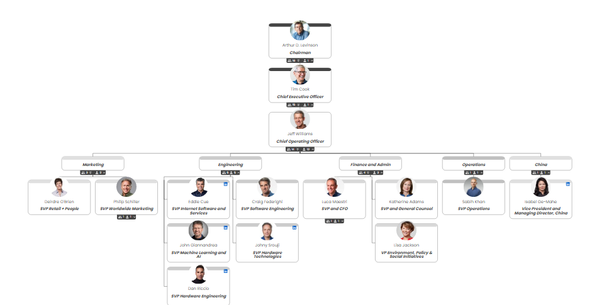

Apple's organizational structure is a functional structure. This type of structure groups employees by job function, Apple manages various departments, including design, engineering, marketing, and finance, each of which is overseen by a senior executive accountable to the CEO, Tim Cook. Such an organizational framework enables the company to handle its operations proficiently and respond promptly to the evolving market and technological trends.
Another type of organizational structure used by Apple is a divisional structure (Apple's corporate structure, nd). This structure is used for specific product lines or business units. For example, the iPhone division is responsible for the development and marketing of Apple's iPhone product line.

Advantages of Apple's Organizational Structure
One of the key advantages of Apple's functional structure is that it promotes innovation and creativity. Each department has a specific role to play in the development of new products, and employees are encouraged to share their ideas and contribute to the development process. This approach has resulted in the creation of some of the most iconic products in the world, including the iPhone, iPad, and MacBook.

The functional structure also allows for efficient management and decision-making. Each department is responsible for a specific function, which allows for clear lines of communication and accountability. This structure enables Apple to respond quickly to changes in the market and technology, as each department can focus on its area of expertise.

Disadvantages of Apple's Organizational Structure
One of the main disadvantages of Apple's functional paradigm is that it can lead to a lack of communication between departments. Each department is focused on its area of expertise, which can make it challenging for employees to collaborate and share information across departments. This can lead to a lack of innovation and creativity if employees are not exposed to different perspectives and ideas.
Another disadvantage of Apple's functional structure is that it can be bureaucratic and slow-moving (Patrick Gleeson, 2019). Each department has its own hierarchy, which can lead to delays in decision-making and a lack of agility in response to changing market conditions.

Organizational Culture of Apple
Apple's organizational culture is one of the most talked-about in the business world. It is known for its innovative and creative culture that has enabled the company to develop some of the most iconic products in the world. In this section, we will examine Apple's organizational culture in detail, including its history, key values, and impact on organizational performance.

History of Apple's Organizational Culture
Apple's organizational culture can be traced back to its founder, Steve Jobs. Jobs was known for his passion for design and his commitment to innovation. He believed in creating products that were not only functional but also beautiful and easy to use. This philosophy has been a driving force behind Apple's organizational culture. In the early days of Apple, Jobs created a culture of collaboration and creativity. He encouraged employees to challenge the status quo and take risks (2014). He also believed in a flat organizational structure, where employees had direct access to him and could share their ideas and feedback.

Key Values of Apple's Organizational Culture
Apple's organizational culture is based on a set of key values that guide the company's actions and decisions. These values include:

Innovation: Apple is known for its innovative and creative products that have transformed the technology industry.
Simplicity: Apple products are known for their simplicity and ease of use, which has helped to make them accessible to a wide range of users.
Quality: Apple is committed to producing high-quality products that are built to last.
Design: Apple products are known for their sleek and modern design, which has become a hallmark of the company's brand.
Customer focus: Apple is committed to providing an exceptional customer experience, which includes excellent customer service and support. (Le, 2023).

Impact of Apple's Organizational Culture on Organizational Performance
Apple's organizational culture has had a significant impact on the company's performance. It has helped to drive innovation, creativity, and collaboration, which has enabled Apple to develop some of the most iconic products in the world. It has also helped to create a sense of loyalty among employees and customers, who are drawn to the company's values and commitment to quality. Apple's organizational culture has also helped to create a strong brand identity (Le, 2023). The company's focus on design and simplicity has helped to differentiate it from its competitors and has contributed to its success in the marketplace.

Challenges to Apple's Organizational Culture
Despite the many benefits of Apple's organizational culture, there are also challenges that the company faces (Meyer, 2022). One of the main challenges is maintaining the culture as the company grows and evolves. As Apple has become a larger and more complex organization, it has become more difficult to maintain the same level of collaboration and creativity that was present in the early days of the company.
Another challenge is ensuring that the culture remains inclusive and diverse. While Apple has made progress in this area in recent years, there is still work to be done to ensure that all employees feel valued and included.

How are the organization structure and culture related to its performances?
Organizational structure and culture are both critical components that are closely related to organizational performance. The arrangement of tasks, duties, and decision-making power among departments and employees describes the organizational structure. In contrast, organizational culture pertains to the collective values, attitudes, beliefs, and behaviors that shape and influence the workplace environment and promote employee interactions and decision-making within an organization.

The organizational structure can impact organizational performance by influencing how tasks are completed, communication flows, and how decisions are made. A well-designed organizational structure can help to improve efficiency, reduce duplication of effort, and improve overall productivity. It can also help to ensure that employees are working towards the same goals and objectives, which can enhance collaboration and teamwork. However, a poorly designed organizational structure can have the opposite effect, leading to confusion, conflicts, and inefficiencies. It can also impact employee morale, motivation, and job satisfaction, which can negatively affect organizational performance.

Organizational culture can also impact organizational performance in several ways. A strong and positive organizational culture can create a sense of belonging and purpose among employees, which can improve motivation and engagement. It can also enhance communication, trust, and teamwork, which can lead to better decision-making and problem-solving.
On the contrary, an adverse or toxic organizational culture can result in reduced motivation, decreased employee turnover, a generally unfavorable work atmosphere and reduced productivity. It can also impact customer satisfaction and brand reputation, which can have a long-term impact on organizational performance.
In the case of Apple, the company's organizational structure and culture have played a critical role in its success. The company's flat organizational structure has enabled employees to have direct access to leadership and has encouraged collaboration and innovation. The company's culture of creativity, simplicity, and customer focus has helped to create a strong brand identity and a loyal customer base. These factors have all contributed to Apple's strong financial performance and market position.

How are its employees motivated?
Apple has been known for its ability to motivate and engage its employees, which has been a significant factor contributing to the company's success (Joseph, 2023). There are several ways in which Apple motivates its employees, including:

Incentives and Rewards: Apple offers its employees a range of incentives and rewards to motivate and engage them. These include performance-based bonuses, stock options, and other financial incentives. Apple also provides its employees with excellent benefits, such as health insurance, retirement plans, and discounts on Apple products.

Culture of Innovation: Apple has and always promotes a culture of innovation, which encourages employees to take risks, experiment, and push the boundaries of what's possible. This approach creates an exciting and challenging work environment that motivates employees to be creative and come up with new ideas.

Career Development Opportunities: Apple offers its staff chances for professional growth through initiatives such as mentorship, job rotation, and training programs. These opportunities help employees to grow and develop professionally, which can enhance their motivation and engagement.

Collaborative Work Environment: Apple's collaborative work environment also contributes to employee motivation. The company's flat organizational structure and emphasis on teamwork create a sense of community and shared purpose among employees, which can enhance their motivation and engagement.
Mission-Driven Culture: Apple's mission is to design products and services that enrich people's lives, and this mission-driven culture motivates employees to work towards an ultimate company goal. Employees feel a sense of pride and purpose in their work, which can enhance their motivation and engagement.

Conclusion
This report has discussed how Apple's organizational structure, culture, and employee motivation contribute to the company's success. Apple's collaborative and innovative culture, along with its mission-driven approach to employee motivation, has created a highly engaged and motivated workforce. The report highlights the importance of these factors in achieving organizational goals and remaining competitive in the business world.

References List
Apple's corporate structure [interactive chart] (no date) Organimi. Available at: https://www.organimi.com/organizational-structures/apple/ (Accessed: April 20, 2023).
Article organizational culture how Apple is organized for Innovation (no date). Available at: https://www.apple.com/careers/pdf/HBR_How_Apple_Is_Organized_For_Innovation-4.pdf (Accessed: April 20, 2023).
Cuofano (2023) Apple organizational structure in a Nutshell, FourWeekMBA. What is The FourWeekMBA. Available at: https://fourweekmba.com/apple-organizational-structure/
Gallagher, W. (2023) Apple was founded 47 years ago, on April 1, 1976, AppleInsider. Available at: https://appleinsider.com/articles/20/04/01/apple-was-founded-44-years-ago-on-april-1-1976 (Accessed: April 20, 2023).
Joseph, R. (2023) Apple's employee engagement strategies: Decoding The secret, Empuls. Available at: https://blog.empuls.io/apple-employee-engagement-strategy/ (Accessed: April 20, 2023).
Le, T.N. (2023) Inside Apple's company Culture: Collaborative and inspiring, Grove HR Solution. Grove HR. Available at: https://blog.grovehr.com/apple-company-culture (Accessed: April 20, 2023).
Meyer, P. (2022) Apple Inc.'s Organizational Culture & its characteristics (an analysis), Panmore Institute. Available at: https://panmore.com/apple-inc-organizational-culture-features-implications (Accessed: April 20, 2023).
Patrick Gleeson, P.D. (2019) Benefits & disadvantages of a functional organizational structure, Small Business - Chron.com. Chron.com. Available at: https://smallbusiness.chron.com/benefits-disadvantages-functional-organizational-structure-11944.html (Accessed: April 20, 2023).
Steve Jobs originally envisioned the iPhone as mostly a phone (no date) History.com. A&E Television Networks. Available at: https://www.history.com/news/iphone-original-size-invention-steve-jobs (Accessed: April 20, 2023).
The real leadership lessons of Steve Jobs (2014) Harvard Business Review. Available at: https://hbr.org/2012/04/the-real-leadership-lessons-of-steve-jobs (Accessed: April 20, 2023).

