Project Planning

Engineering management
Beng Automotive, Motorsport & motorcycle Engineering
Beng Mechanical, Manufacturing and Energy Engineering
Lecture: Mark Standford
Submission Deadline:23/11/2025
Submission Date: 23/11/2025

ACHA5012
Ethan Davies
Word Count:
2405602
2251/2500
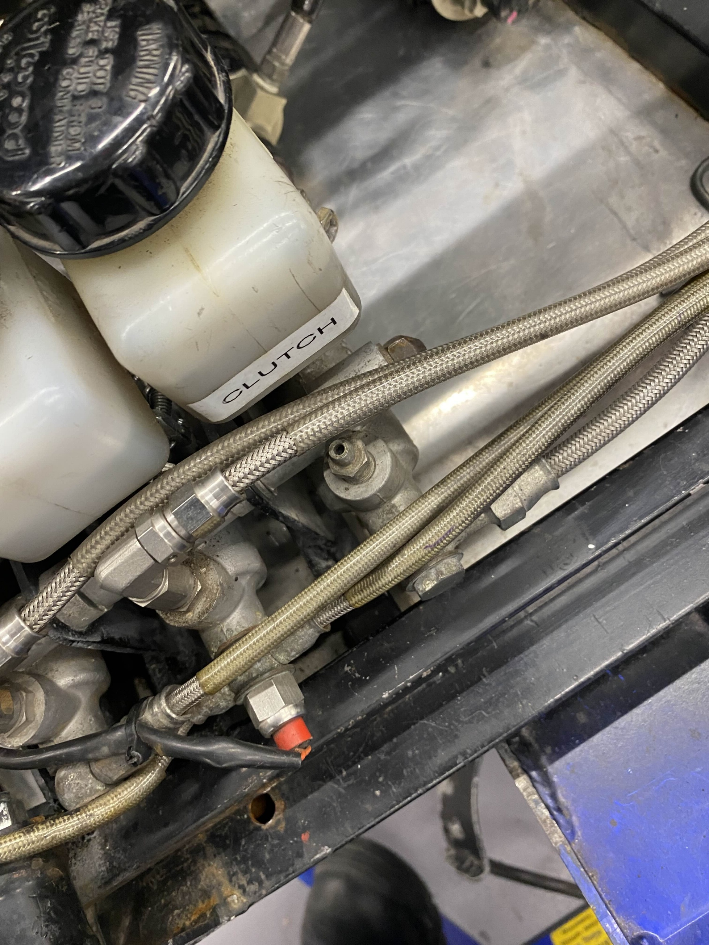


1.0 Contents Page
1.1 Table of Contents
ACHA5012 1
1
1.0 Contents Page 2
1.2 Table of Figures 3
1.3 List of Tables 3
2.0 Introduction (5%) 4
2.1 Project Overview 4
2.2 Rationale 4
2.3 Objectives with measures of success 4
3.0 Team Roles 5
3.1 General Team Roles (10%) 5
3.2 Personal role (Conceptual Leader) 5
3.2.1 Belbin’s Model 6
4.0 Overall tasks & Project Plan 7
4.1 Group tasks 7
4.2 General Group Gantt Chart 9
4.3 Own Tasks (25%) 9
4.3.1 Complete the Mira Car Tutorials 9
4.3.2 Understand Fundamentals of Aerodynamics 9
4.3.3 Understand Aerodynamic Devices 9
4.3.4 Curate Collection of Designs 10
4.3.5 Ansys Methodology 10
4.3.6 Style of Concept Design 10
4.3.7 Concept (Regulations) 10
4.3.8 Presentation 10
4.3.9 Further Develop the Conceptual Car & Aero Testing Conceptual Car 10
4.3.10 Finalise Concept Car 11
4.3.11Enter Findings into Project Report 11
4.4 Personal Tasks Summary 11
4.5 Personal Gantt chart 12
4.6 Preliminary Bill of Materials 12
4.6.1 Cost Summary 13
5.0 Project milestones (12.5%) 15
5.1 Own Significant Gateway (12.5%) 15
6.0 Risk Management (10%) 17
7.0 Evaluation 18
7.1 Conclusion 18
7.2 References (5%) 19

1.2 Table of Figures
Figure 1:General Group Gantt Chart 9
Figure 2: Personal Gantt Chart 12
Figure 3: Risk Management Table 17
Figure 4: Risk Management Matrix 17

1.3 List of Tables
Table 1: General Team Roles 5
Table 2: Belbin's Model 6
Table 3: General Group Tasks 7
Table 4: summary of personal Tasks 11
Table 5: Project Milestones 15
Table 6: Significant Gateway Table 15

2.0 Introduction (5%)

2.1 Project Overview
The Morgan Aero project is a creative and analytical approach to designing aero devices and a whole new bodywork for the Morgan car chassis. The first and main team is the Morgan Plus 4 Team. They are responsible for designing, testing, and reviewing the aero devices for the current Morgan body work in efforts to improve the current car aerodynamically. On the other hand, the Concept team is responsible for fully redesigning a new bodywork that needs to fit around the current chassis of the Morgan.
To start the Mogan Aero Project, the whole team needs to learn the fundamentals of aerodynamics and learn a new software called ANSYS. Ansys is the foundation of the whole project, as all work within the project revolves around this software. This is all in the personal time of the students of UWTSD to learn and understand, as the project is not a weekly scheduled course. The only scheduled time for the group project on the students' timetables is their weekly meeting with their project manager. (The project manager is a lecturer at UWTSD.)

2.2 Rationale
The Purpose of the project is to improve upon the current Plus 4 Morgan regarding its aerodynamics. It will also give the students experience with working in a team, as within the motorsport industry, teamwork is an essential part of that job and can not be avoided.
Furthermore, there are two aims of the project. The first is creating aerodynamic devices that improve the current Morgan car, in hopes that they can be made and placed on the current Morgan at UWTSD. The aero devices also need to not compromise airflow to cooling systems. The second aim of the project is to create a new and improved bodywork that can fit around the current Morgan Chassis. This new bodywork needs to allow for the current mechanical and non-mechanical components to still function without modification and provide the chassis with a new look and better performance.

2.3 Objectives with measures of success
During this project, the teams will decide a target for their designs to reach for their design to be considered a success. The Plus 4 Team (Aero Device Team) will be successful once they have compiled an effective aero package for the current Morgan car. The Plus 4 Team want to work with the Morgan endurance project so that they have the possibility of making their designs for the endurance race that the Morgan will be competing in.
Additionally, the Concept Team will be successful once they have a fully defined and modelled concept car that improves on the Current Morgan car in theoretical performance. The concept car will most likely not be made; however, the team needs to make the concept to the standards of a real Concept car for the project’s success.

3.0 Team Roles

3.1 General Team Roles (10%)
Table 1: General Team Roles
Names | Roles | Responsibilities
Ryan Williams | Project Leader | The project leader will ensure that all teams work as efficiently as possible while communicating deadlines. The team leader will be responsible for overseeing the full development process of both the conceptual team and the current Morgan plus 4 team. The team leader will also be responsible for creating the main documentation, such as the presentation and any technical report, to prove the team's development process.
Ethan Davies | Conceptual Leader | The conceptual leader will oversee the direction of retrofitting the Morgan Plus 4 chassis with a GT coupe-type style bodywork. The Conceptual Leader should try to keep with the Morgan way of creating bodywork while trying to gain maximum performance. The Conceptual Leader will be responsible for communicating the process to the team to the project leader.
Tom Holland | Morgan Plus 4 Leader | The Morgan Plus 4 leaders will oversee improving the current bodywork, which is one of the Morgans within the workshop at UWTSD. This means adding additions that will improve the overall handling and performance of the vehicle, such as a rear wing, splitter, diffusers, etc. The Morgan Plus 4 Leader will be responsible for communicating the process to the team and the project leader.
Dominic Walton | Technical Director (Conceptual) | The Technical Director in each team will be responsible for the CFD methodology and setting performance goals, such as the desired increase in downforce and reduction in drag, working closely with the leader of their respective team.
Oscar Price | Technical Director (plus 4) | The Technical Director in each team will be responsible for the CFD methodology and setting performance goals, such as the desired increase in downforce and reduction in drag, working closely with the leader of their respective team.
Alexandros Griffiths | CFD Engineer (Conceptual) | The CFD Engineer will design and perform CFD analysis on the area they are working on during that time. Trying to reach the targets that have been set, if not, why, so we can write it up for the final report. Even if it doesn’t work, it's still valuable information for us to learn from.
Luca Gray | CFD Engineer (Plus 4)
Ryan Williams | CFD Engineer (Plus 4)

3.2 Personal role (Conceptual Leader)
My role as the conceptual Leader is not only to be another group member but also to lead half the team. Therefore, they need to be a good team member working with the group, but also take on the responsibilities of a leader. I oversee two other members of the team who will be designing the new bodywork. As the conceptual leader, I will need to be the one who drives the vision of the bodywork, keeping everyone moving forward. Furthermore, I need to guide the others' technical decisions during the design phase of the project. Lastly, it is my responsibility to constrain data and ideas into a coherent project direction.
As a group, we used the Belbin teamwork behaviour test to see who was best suited to each role of the project. I scored high in Plant and Complete Finisher (see Belbin’s Model). As I scored high in plant, it means I am likely to be highly creative and good at solving problems in unconventional ways. The strengths of my plant behaviour are that I am creative and imaginative. However, a weakness of a plant style of behaviour is that I might be too preoccupied to communicate effectively and can be forgetful. Moreover, as I scored highly in Complete Finisher as well. This means I like to polish and scrutinise errors, subject the whole project to high standards. The strengths of a Complete Finisher are that I like to search for errors and make the project polished. However, this means I can be inclined to worry about the project and be accused of perfectionism.
To combat the negatives of my Behaviours, I need to ensure that I keep up to date with tasks so that I do not forget important steps or milestones. This is why I will keep updating a personal Gantt chart throughout the project. Furthermore, as a Complete Finisher, I need to keep my perfectionism in check and make sure that it is used only when accuracy is imperative to success.

3.2.1 Belbin’s Model
Table 2: Belbin's Model
 | Implementer | Coordinator | Shaper | Plant | Resource Investigator | Monitor Evaluator | Team Worker | Complete Finisher
LOW  0 – 33% | 0 - 6 | 0 - 6 | 0 - 8 | 0 – 4 | 0 -6 | 0 -5 | 0 - 8 | 0 - 3
AVERAGE  33 - 66% | 7 – 11 | 7 – 10 | 9 – 13 | 5 – 8 | 7 – 9 | 6 – 9 | 9 - 12 | 4 – 6
HIGH  66 – 85% | 12 – 16 | 11 – 13 | 14 – 17 | 9 – 12 | 10 – 11 | 10 – 12 | 13 - 16 | 7 – 9
VERY HIGH  85 – 100% | 17 - 23 | 14 - 18 | 18 - 36 | 13 - 29 | 12 - 21 | 13 - 19 | 17 - 25 | 10 - 17
STUDENT SORE | 11 | 9 | 11 | 9 | 8 | 8 | 10 | 7

4.0 Overall tasks & Project Plan

4.1 Group tasks
Table 3: General Group Tasks
Task | Description
Complete Mira Car tutorials | The Whole Group needs to complete the Mira car tutorial videos that Tim Tudor has provided. This will give the team the fundamental understanding of the Ansys software and how to create an accurate methodology to simulate the current Morgan car and their possible conceptual designs.
Understand the fundamentals of aerodynamics | The Team needs to have a good understanding of the fundamentals of aerodynamics so they can make informed decisions later in the project and waste time with choices that will either give the opposite outcome to their goal or choices that will not work at all.
Understand Aerodynamic Devices | The team needs to have a good understanding of aerodynamic Devices. For example, wings, spoilers, and diffusers, as this will be key knowledge when designing these aerodynamic devices
Curate Collection of Designs | The teams will draw designs around the Morgan chassis so they can make sure their designs fit around the car as well as properly convey the detentions and characteristics of their designs to the group. This will also help the group determine where they want to take their designs in the future.
Ansys Methodology | As a group, the team must develop an Ansys methodology accurate to the Mira test data. This will ensure that any further use of Ansys with other geometries should be accurate to real-world tests, in theory. This is critical for the success of the project.
Style of Concept Design | The concept team will decide on a concept style that will serve as the basis for moving forward with their project. This style will be on the lines of a saloon GT car using the Morgan base.
Plus 4 Design Morgan Style | The plus 4 team will decide on what areas of the current Morgan car they want to develop and improve. This includes aero devices and possible changes to the Morgan car for racing.
Concept (Regulations) | The concept team will design their concept car around a race regulation so that the car is realistic and plausible.
Plus 4 (Regulations) | The Plus 4 team will be improving the current Morgan car in accordance with their chosen regulation so that the car is able to race.
Presentation (whole Group) | In December of 2025, the whole group will present their findings and progress to an audience, sharing all their knowledge on their current choices and the future of the project
Further Develop the Conceptual car | In January 2026, the Conceptual Team will take their baseline design and continue their development, which means finding problem areas of their design and fixing them and even reshaping the baseline design if needed. This means taking a design, testing it, then evaluating what the design choice has done and whether the team will continue with that design choice.
Design Aero Devices around the Morgan car (plus 4 Team) | In January 2026, the Plus 4 Team will design aero devices for different parts of the current Morgan car, which will follow a similar process to the Conceptual car development, where they will design an aero device, test it, and then evaluate the design choice. Then deciding how to move forward.
Finalise Concept Design | In February 2026, the Concept Team should have a finished Concept Design that they are happy with and have made all the design changes needed. They will then spend significant time refining that design, whether that’s aerodynamically or the model’s surfaces.
Finalise Plus 4 Design | In February 2026, the Plus 4 Team should have a finished modified Morgan design. They will spend significant time refining and possibly creating their aero devices.
Enter Findings into Project Report | Throughout the entire course of this project, the Entire team will be adding to a shared project report that will be submitted to the lecturers in March.

4.2 General Group Gantt Chart

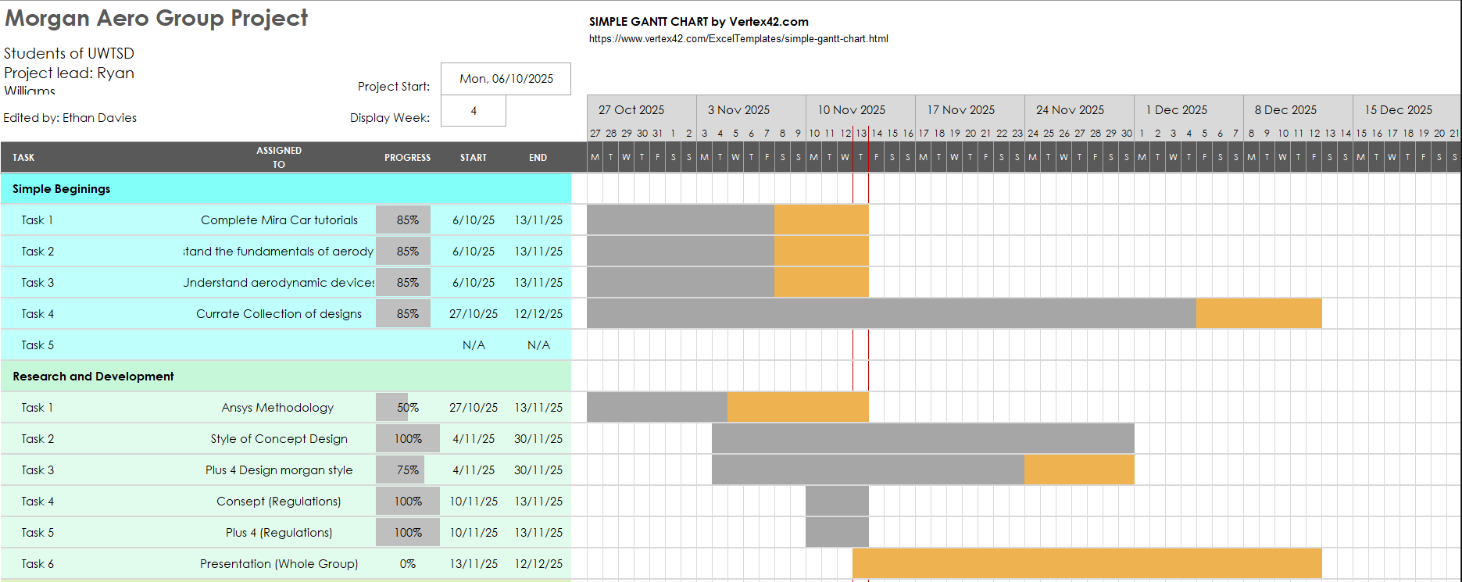
Figure 1:General Group Gantt Chart

4.3 Own Tasks (25%)

4.3.1 Complete the Mira Car Tutorials
For the Morgan Aerodynamic project, I, as well as the rest of the group, understand the Ansys software. Ansys is a CFD (Computational Fluid Dynamics) Software that I will use throughout the whole course of the project. Our lecture has provided videos of him working through the Mira car. These videos are for the benefit of the group, as without them, it would take exponentially longer to learn Ansys. Being a fairly simple task, this should only take two weeks; this task can only take one week. However, the team is leaving extra time to help each other if someone is struggling or they have technical difficulties.

4.3.2 Understand Fundamentals of Aerodynamics
I must understand the basic principles of aerodynamics, as that information will lay the groundwork for any design or method I attempt. Furthermore, as team lead, it is also my responsibility to ensure my team is also doing research for the mentioned topic and can understand the material. This is a fundamental task, so a fair amount of time needs to be dedicated. Along with a once-a-week meeting with an aerodynamics lecture and further research done outside of university hours, this task should take roughly six weeks to complete.

4.3.3 Understand Aerodynamic Devices
Having an understanding of aerodynamic devices is essential as they will be the main drive of progressing a baseline design model. I need to understand how these devices use the air flowing through and around them so that the project moves along the correct pathway. This task is tied too the understanding of aerodynamics, meaning this can be completed at the same time as the previous task. Taking slightly less time but still important to the project, four weeks is an appropriate amount of time.

4.3.4 Curate Collection of Designs
I will also contribute to the development of a portfolio of concept designs that the team will build over the course of the project. This will also involve me generating and refining these ideas. Also, it allows me to articulate my design ideas, define design dimensions, and annotate designs with key information.
This means that I can clearly communicate the functional and aesthetic aspects to the rest of the conceptual team. With respect to the Belbin model, as a complete finisher, this will also allow me to direct my perfectionism, so it doesn’t become overbearing to the team.

4.3.5 Ansys Methodology
Developing an Ansys Methodology involves refining multiple settings within Ansys; therefore, the methodology has been split among the group. I am responsible for developing the meshing methodology. This is what represents fully 3D objects and controls the airflow in a specific location around the body of an object. To refine the mesh methodology, I will be running each mesh type, changing its numerical values linearly each time to find which setup’s coefficients match the experimental data that has been provided. This should only take the whole group 3 weeks to complete and refine the Methodology.

4.3.6 Style of Concept Design
Designing a whole concept coupe design is an intimidating task, which is why the team needs to agree on one style of bodywork and keep in line with that chosen to ensure deadlines are met. My responsibility is not only to contribute to discussions concerning the body work but also to make sure the team keeps in line with their design choices. Only diverting if a design choice is not meeting our requirements. The team wants to have this design choice confirmed by the December presentation milestone, which should take four weeks.

4.3.7 Concept (Regulations)
It is my responsibility to read through the chosen regulations to ensure any decisions I make are even allowed or viable to begin with. Moreover, I must schedule a meeting with the concept team so we can go through the regulations and race series, so we can all be in agreement on which set of regulations we will use for the rest of the project. To space this time out and make it fit around everyone’s schedules, it will span over four weeks, around the rest of the current work.

4.3.8 Presentation
The presentation is a key milestone for the group, and my responsibility as Concept Team lead is to ensure that the Concept Team has a fully prepared concept development section. Furthermore, the information being delivered to the audience and the project manager is of high quality and up to the expectations of the project manager. The creation and Planning of the presentation will be over a three-week period. The first week will be gathering and finalising the concept designs and data. The second week will focus on structure and the presentation content, along with visuals. The third week involves rehearsal of my section of the presentation and a quality check of everything discussed in the presentation.

4.3.9 Further Develop the Conceptual Car & Aero Testing Conceptual Car
After the December break, the Conceptual Team will spend significant time Further Developing their baseline design. This entails taking the baseline car running aero testing so the team can define problem areas that need to be assessed. This will allow the Concept Team to create a design that continues to improve over time. This currently has no planned time, as it is unknown how long this development will take.

4.3.10 Finalise Concept Car
When finalising the Concept Car, my responsibility is to ensure that the concept team’s design meets our success criteria and has improved on the baseline designs. Furthermore, I need to review all concept designs, compare their CFD results and feasibility, while also prioritising performance. I also need to make sure that the designs fit the chassis and regulation constraints. As well as allowing space for mechanical components to remain functional.
I also need to collaborate with the other members of the concept team to identify any areas that can be improved and what remains flexible for change. Recording all specifications of the designed geometry so that the Concept car can be recreated by another if necessary. Once this is done, I need to be confident in signing off on the design, marking the end of the project.

4.3.11Enter Findings into Project Report
In the final report, the sections have been divided among each team member in their respective teams. Allowing them to add to the report with all the information gathered during the whole course of the Morgan aerodynamic project.

4.4 Personal Tasks Summary
Table 4: summary of personal Tasks
Task | Description | My Contribution | Hours Expected | Total Cost
Complete Mira Car Tutorials | (See Table 3: Group Tasks.) | Watch the tutorial videos | 2 Weeks | £2417.58  22 hours a week with 9 weeks between the start and the presentation  Date
Understand Fundamentals of Aerodynamics | - | Research of fundamentals | 6 Weeks
Understand Aerodynamic Devices | - | Research and possible testing | 4 Weeks
Curate Collection of Designs | - | Drawing designs over the Morgan Chassis | Whole course of the project
Ansys Methodology | - | The development of the Ansys Methodology is experimenting with the meshing for the geometry of the Mira car | 3 Weeks
Style of Concept Design | - | Choose what type of saloon GT car the design will be based on | 4 weeks
Concept (Regulations) | - | Talk with the Concept team to choose a set of Regulations | 4 weeks
Presentation | - | This will be given to an audience where the group will present their work and findings | 3 weeks
Below Starts from January 2026
Further Develop the Conceptual Car | - | My responsibility is to take the baseline body work created by me and the team and progressively improve the design over time. | 6 weeks | These tasks need to be completed together at the same time
Aero testing | - | Every improvement of the baseline car needs to be tested and refined through testing. | 6 weeks | These tasks need to be completed together at the same time
Finalise Concept Car | - | Once the team has improved to baseline enough where it has achieved what was set at the beginning of the test phase. | 1-1.5 weeks
Project Report | - | Curate the final report where all findings and design phases are laid out, as well as goals, progress, and findings. | Whole course of the project

4.5 Personal Gantt chart
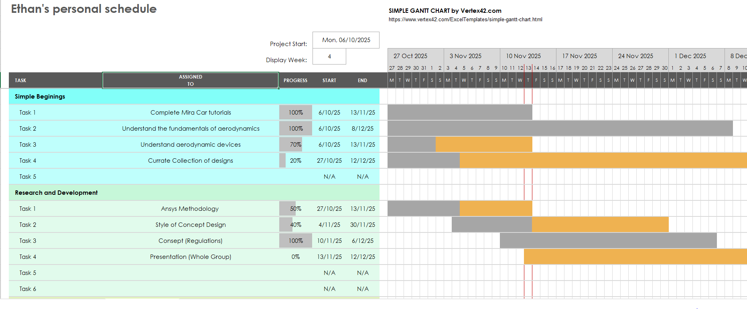
Figure 2: Personal Gantt Chart

4.6 Preliminary Bill of Materials

Type | Item | Quantity | Unit Cost | Total Cost | Rational
Testing | Full-Scale Wind Tunnel | 2 day | £1,100-£1,850/day | £2,200-£3,700 | Used on the final design once it's been made, one test day for the Concept Team, and another for the Plus 4 Team
Testing | Model size Wind tunnel | 1 | £0 | £0 | University of Wales Trinity St David already owns a model-scale wind tunnel
CFD / Software | Ansys | 7 | £10,000-£320,000+ | £0 | 7 people in this project, and the UWTSD already has multiple copies of Ansys, so no extra spending is needed
CAD / Modelling | SolidWorks | 7 | £5,823-£8,938 | £0 | UWTSD already own multiple copies of SolidWorks, so no extra cost
Prototyping | 3D printer | 1 | £519-£2,649 | £0 | Rapid prototyping of a scaled version of the aero devices and concept body work. This can be used in the smaller wind tunnel. UWTSD already own multiple 3D printers
Prototyping | 3D printing Filament | 5 | £7.99-£384.99 | £0 | Prototyping and scale models. UWTSD already has Filament
Safety / PPE | PPE | 7 Sets of PPEs |  | £0 | UWTSD already has most of the equipment needed for Health & Safety.

4.6.1 Cost Summary

Low-cost student approach utilising free, open-source software used for Computational Fluid Dynamics (CFD). With no access to a commercial wind tunnel. Has an estimated subtotal of £700 - £3,000. However, if a commercial wind tunnel, prototyping, and multiple test cycles are incorporated, the overall estimated subtotal would increase to approximately £2,500 - £6,000. This is expected due to renting a facility for testing.
Maintaining a balance between the cost of materials and the rental of hardware is essential to ensure the team can keep to a realistic budget that would be viable throughout the development phase. Key tools such as a CFD software (e.g. Ansys) and CAD platforms (e.g. SolidWorks) are crucial to the progression of the project. Without these resources, the project cannot move forward.
Additionally, as the project spans several months, cost variations of 10-20% must be anticipated due to material price changes. Furthermore, a risk that comes with rental test facilities is that test facilities can have hidden costs if technical difficulties arise or the booked time is exceeded. This is why the consideration of cost variations must allow for flexibility.
Overall, Accurate budgeting and control over the total cost are crucial to maintain the project's feasibility.

5.0 Project milestones (12.5%)
Below are the project milestones (as known on November 17th, 2025) in order from October 2025 to March 2026.
Table 5: Project Milestones
Milestone | Description | Planned Date  (DD/MM/YY) | Success Criteria
M-01 | Mira Car Tutorials | 19/10/2025 | Each member of the group must have completed the Mira car tutorial videos, as they teach the basic knowledge to use the Ansys software.
M-02 | Aerodynamic Fundamentals | 12/11/2025 | Understanding the fundamentals means each team must be able to explain their aero designs with the knowledge they curate.
M-03 | Ansys methodology | 12/10/2025 | The Methodology must be within a 5% accuracy of the Mira experimental data or have fewer than 20 counts for each coefficient.
M-04 | Style of Designs | 12/12/2025 | Each team in the group must agree on the direction of the design so that they can move in the best course for the project.
M-05 | Presentation | 12/12/2025 | This is where we present our findings and choices to an audience.
M-06 | Aero Testing Designs | 12/1/2026 | This is a crucial point, as this milestone has the most development and changes in each team's designs.
M-07 | Finalise Designs | 15/3/2026 | The team needs to finish their designs with rationales and detailed annotations.
M-08 | Project Report | 23/3/2026 | By the end of the project, we should have a fully completed Project report that details everything about the project.

5.1 Own Significant Gateway (12.5%)
Table 6: Significant Gateway Table
Gateway | Description | Planned Date  (DD/MM/YY) | Success Criteria
G-01 | Ansys methodology | 12/10/2025 | Completed and accurate Ansys methodology:  Domain size, Meshing, Turbulence models, and prism layers. No one can progress if the methodology is not accurate
G-02 | Style of Designs | 12/12/2025 | The teams need to of a clear idea of what designs they want and what those designs look like, as they cannot progress if they don’t have that end goal set.
G-03 | Presentation | 12/12/2025 | The presentation is the first Deadline of the project, which is at the end of the term. This marks the halfway point of the project and shows the progress the group has made.
G-04 | Finalise Designs | 15/3/2026 | Once the designs have been finalised, it means that the project is coming to an end and that both teams have reached their set targets, and no more innovation will take place.
G-05 | Project Report | 23/3/2026 | The project report must be completed throughout the project. Everyone needs to contribute to the report, or no one can succeed and the whole project.

6.0 Risk Management (10%)
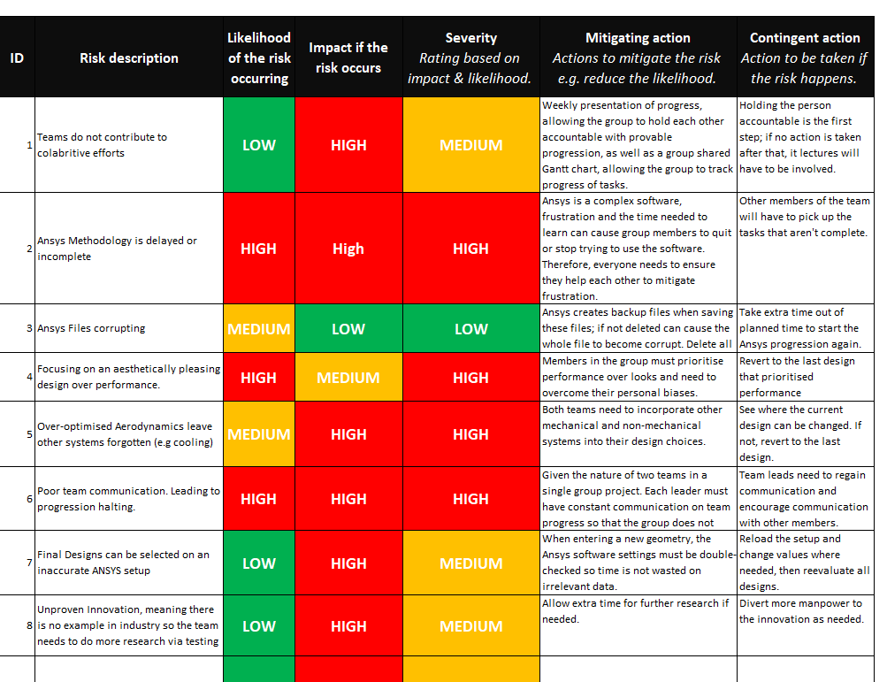
Figure 3: Risk Management Table
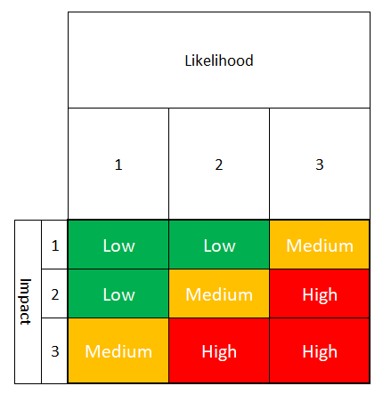
Figure 4: Risk Management Matrix

7.0 Evaluation

7.1 Conclusion
In conclusion, this report has set out a structured plan for delivering the Morgan Aerodynamics project to the desired result. The report has outlined both the overall group approach as well as the student’s personal responsibilities as the Conceptual Team Lead for each task listed for the project. The project’s Objective is to improve the aerodynamics of the baseline Morgan Plus 4 car, at the University of Wales Trinity St David (UWTSD), through testing and developing aerodynamic devices that can be added to the current bodywork work as well as testing and developing a new bodywork, with success measured against performance targets set by the members in the group.
Furthermore, by identifying team roles and who best fits them with a teamwork behaviour test (Belbin's model), the group will be able to have an effective team structure. The creation of a project timetable, shown in the Gantt charts, both general and personal, will allow the project to keep a significant track of task progression.
Additionally, the group generating a risk management table will allow the teams to identify problem areas that risk the progression of the project. Implementation of the mitigation strategies will minimise the impact of technical or personal problems. All presented in this report will allow the group to meet the expectations of the University of Wales Trinity St David.

7.2 References (5%)
Belbin (2025). The nine Belbin team roles. [online] Belbin. Available at: https://www.belbin.com/about/belbin-team-roles [Accessed 23 Nov. 2025].
https://www.facebook.com/andy.turner.545 (2022). Wind Tunnel testing. Save on average 15-30 watts - ATP Performance Cycle Coaching. [online] ATP Performance Cycle Coaching. Available at: https://atpperformance.uk/wind-tunnel-testing/ [Accessed 23 Nov. 2025].
SOLIDX - Empowering teams to bring their product development process to one platform. (2023). Instant SOLIDWORKS Price UK - SOLIDWORKS Simplified. [online] Available at: http://solidx.co.uk/pricing/?ppc_keyword=%27solidworks%20license%20cost%27&gad_source=1&gad_campaignid=20796180892&gbraid=0AAAAAqXcOfwsPIfuR5I2JkcUjdzq9RDax&gclid=CjwKCAiA24XJBhBXEiwAXElO34ndxbvYG9Me6cAMV_wWIyMrN8vpMnBREiHHKk-wUrLaw-NDpGC36xoCYswQAvD_BwE [Accessed 23 Nov. 2025].
SUNLU UK Store. (2025). Search: 187 results found for ‘filament’. [online] Available at: https://sunlu.co.uk/search?q=filament&options%5Bprefix%5D=last&sort_by=price-descending&filter.v.price.gte=&filter.v.price.lte= [Accessed 23 Nov. 2025].
www.vendr.com. (n.d.). Vendr Pricing: Premium Intelligence & Premium Procurement Plans. [online] Available at: https://www.vendr.com/pricing [Accessed 23 Nov. 2025].

