Programme: BA International Hotel Management
Module: Foreign Languages & Cultural Awareness
Module code: BMIH5003
Assignment Title: Portfolio 4 components

Table of Contents
1 Component 1: Professional reflection 2
2 Component 2: Training Plan 4
3 Component 3 - Student self-reflection 6
4 Component 4 – Training presentation (5 Minutes) 8
5 References 11

Component 1: Professional reflection
Scenario: At the Mercure North Cardiff through the breakfast hours, a Front-of-House (FoH) employee who can be referred to as Sara, has a clash of cultures with a guest who happens to be Japanese. As Sarah walks to the table to take the guest's order, she observes that the guest appears reluctant and doesn't seem to look at her face directly. By the way, the guest does not show any sign of interest or courtesy, Sarah becomes a little nervous but decides to enter the taker. Nevertheless, the waitress perceives that the guest is reluctant about several dishes on the menu and does not speak the language clearly in English. On the flip side, cultural misunderstandings can happen in a plethora of ways, especially in a multicultural setting like the one found in hotel restaurants (De Carlos et al. 2019). Here, the misinterpretation is caused by the variety of communication patterns and cultural norms. In Japanese culture, people show respect, humility, and shyness by looking down and not looking straight in the eyes rather than a sign of rudeness or disinterest. Moreover, the uneasiness with food might be due to taste preference variations or lacking familiarity with Western breakfast products.
Looking back at this case, I am now aware of the significance of cultural sensitivity and good communication which can help me to deal with the the mistake in future. Initially, I need to develop a thorough understanding of different cultural practices, behaviours, and communication styles as well as how guests engage with the F&B. This might involve participating in cultural sensitivity training sessions or searching for resources on intercultural communication (Ting-Toomey and Dorjee, 2018). it could be enrolling into language learning classes or studying language books and other resources. In third place, I must learn to accept actively the guests' requirements and preferences, especially in cases when there are language or cultural obstacles. This covers the non-verbal cues like body language and facial expressions to pick and therefore alter methods of interaction. With this, I also watch out for the non-verbal cues (body language, facial expressions) that can indicate the guest's comfort level and if needed, I change my approach. Consequently, cross-cultural understanding and effective communication in F&B interactions lead not only to improved and delightful guest experiences but also to stronger professional relationships and contribute to a great work environment.

Component 2: Training Plan
Training Plan: Improving Cross-Cultural Communication Skills
Objectives:
- Make the employees of the food & beverage sector understand more about the different cultural practices, norms, and communication styles.
- Provide staff with the language skills necessary to communicate effectively with guests of different cultural backgrounds (Jhaiyanuntana and Nomnian, 2020).
- Active listening skills will help to understand guest needs and preferences, particularly in intercultural issues.
- Create a hospitable environment that is sensitive towards guests of different cultural backgrounds.
Key Points:
Cultural Sensitivity Training:
- Implement the interactive workshops or seminars on cultural sensitivity and awareness for F&B staff.
- Research the central ideas, standarts and styles of communication in the hospitality sector (Kaihlanen et al. 2019).
- Apply case studies and practical examples to expose the core of cultural understanding and dealing with guest service.
- Help generate a communication and self-awareness process about prejudices..
Active Listening Skills Training:
- Put active listening techniques, especially in the F&B area for training sessions, and discuss the role of nonverbal cues and empathy in communication.
- Improve communication skills by role-playing different cultural encounters.
- Develop a feedback and coaching process to practice employees to listen adequately and to provide necessary changes to satisfy guests' expectations in F&B.
- Encourage staff to practice seeking clarification and ask open-ended questions to get a better insight into guests' viewpoints and predilections.
Language Proficiency Development:

- Offer language courses or learning resources, especially for the languages commonly used by hotel visitors.
- Show F&B staff ways to exploit and develop their language skills with role-playing and language exchange.
- Highlight the vital role of basic greetings and phrases in guests' native languages, which are dominated by Japanese, Mandarin, Spanish, and so on.
- Grant rewards or appreciation to the staff who are capable of communicating in multiple languages.
Creating an Inclusive Work Environment:
- Build a culture of respect and feeling inclusive within the hotel environment, through regular communication and team-building sessions.
- Recognize and celebrate cultural differences among personnel, asking them to talk about their backgrounds and experiences.
- Encourage employees to embrace diversity and inclusion using inclusive language guidelines and holding cultural competency trainings for all of the new workers.
- Help the staff who do not cope with cross-cultural communication, including some tips to overcome cultural misunderstanding (Shore et al. 2018).

Component 3 - Student self-reflection
This part will utilize the Gibbs reflective cycle to understand cultural awareness in hospitality.
Description: Initially, my perception of cultural sensitivity in the hospitality industry was confined to the significance of respecting guests' cultural doings and changing service to suit their needs. Nevertheless, as I worked through my third-year placement at the , many events helped me realize what leadership is all about.
Feelings: First of all, I was full of confidence in dealing with a cross-cultural encounter since I have acquired a good understanding of this subject from my prior knowledge and experience. Additionally, I had moments of uneasiness and unease when I engaged with foreign cultural practices and languages, worrying that I could do or say something that might cause offence or confusion to others.
Evaluation: Eventually, I came to the understanding that cultural sensitivity means more than a couple of superficial mannerisms or adjustments. The fact is cultural awareness is not only about recognizing and tolerating differences but also making the effort to learn and appreciate a new way of thinking. I noticed the behavior of an international guest from Japan who did not look into my eyes and seemed uncomfortable while we were serving breakfast. It is not immediately clear to me if it is only rudeness or disrespect on his side. While once I looked at my stereotypes from a critical point and listened to my colleagues, I could see that this little gesture might mean humbleness or respect in old Japanese people (Kawaguchi-Suzuki et al. 2019). As we are in this situation, my preconceptions and prejudices are exposed as fallible and this makes me treat others sensitively and with curiosity.
Analysis: I realized through this journey that cultural sensitivity is a complex, sometimes even a dynamic process, which implies self-acceptance, openness, humility and unceasing education. I have discovered that my cultural heritage and implied bias may shape the way I understand others’ behavior; therefore, self-knowledge and care for reflectivity are of utmost necessity in cross-cultural contacts. Moreover, I realized that skills of communication, active listening and empathy are very powerful for taking out cultural boundaries and creating good relations with guests (Calloway-Thomas et al. 2017).
Conclusion: Finally, the vision of cultural consciousness in the hospitality industry in this has been shaped thanks to the experiences I have had. I know now how important cultural empathy is not only in making the guests happy but also in developing a mutually respectful and inclusive partnership with guests from different origins. With that in mind, I am equally dedicated to broadening my cultural competence and using my acquired skills in the provision of memorable and fulfilling experiences for both visitors and workers.
Action Plan: To build on my cultural knowledge as well as my competence, I will look for different immersion and educational opportunities including language courses, cultural sensitivity training and intercultural exchanges. I also hope to develop a routine of reflection and self-assessment, becoming mindful of my personal biases and prejudices to always act towards cross-cultural experiences with humility and understanding.

Component 4 – Training presentation (5 Minutes)

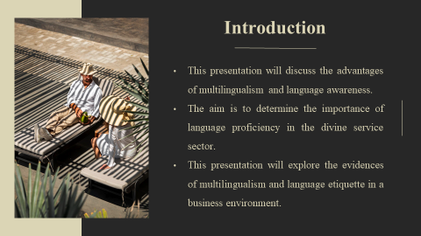
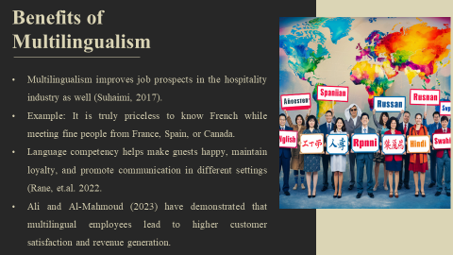
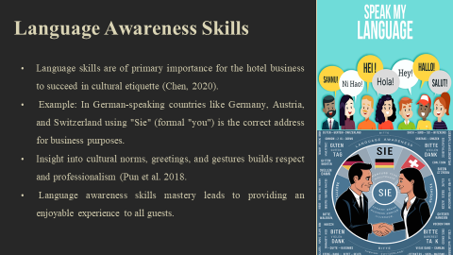
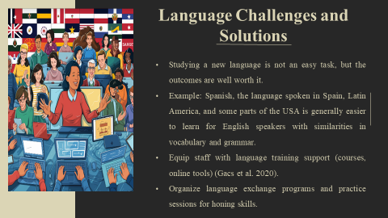
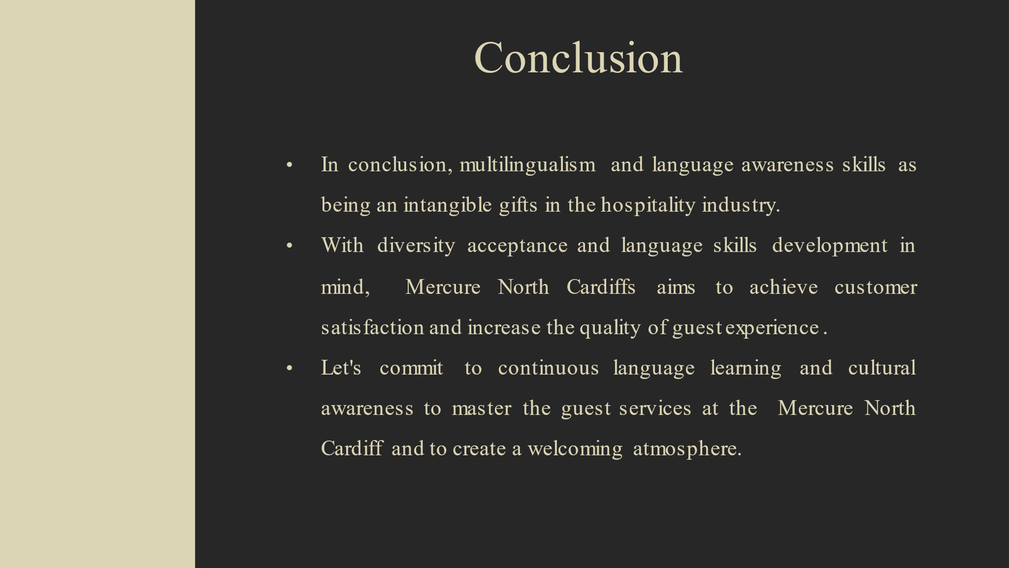
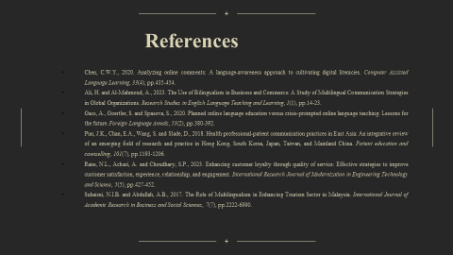


References
Ali, H. and Al-Mahmoud, A., 2023. The Use of Bilingualism in Business and Commerce: A Study of Multilingual Communication Strategies in Global Organizations. Research Studies in English Language Teaching and Learning, 1(1), pp.14-23.
Calloway-Thomas, C., Arasaratnam-Smith, L.A. and Deardorff, D.K., 2017. The role of empathy in fostering intercultural competence. In Intercultural competence in higher education (pp. 32-42). Routledge.
Chen, C.W.Y., 2020. Analyzing online comments: A language-awareness approach to cultivating digital literacies. Computer Assisted Language Learning, 33(4), pp.435-454.
De Carlos, P., Alén, E., Pérez-González, A. and Figueroa, B., 2019. Cultural differences, language attitudes and tourist satisfaction: A study in the Barcelona hotel sector. Journal of Multilingual and Multicultural Development, 40(2), pp.133-147.
Fong, E.H., Ficklin, S. and Lee, H.Y., 2017. Increasing cultural understanding and diversity in applied behaviour analysis. Behaviour Analysis: Research and Practice, 17(2), p.103.
Gacs, A., Goertler, S. and Spasova, S., 2020. Planned online language education versus crisis‐prompted online language teaching: Lessons for the future. Foreign Language Annals, 53(2), pp.380-392.
Jhaiyanuntana, A. and Nomnian, S., 2020. Intercultural communication challenges and strategies for the Thai undergraduate hotel interns. PASAA: Journal of Language Teaching and Learning in Thailand, 59, pp.204-235.
Kaihlanen, A.M., Hietapakka, L. and Heponiemi, T., 2019. Increasing cultural awareness: a qualitative study of nurses' perceptions about cultural competence training. BMC Nursing, 18, pp.1-9.
Kawaguchi-Suzuki, M., Law, M.G., Prisco, J., Head, K., Fu, L., Yumoto, T., Kamei, J., Yang, M., Cheng, K.J. and Hogue, M.D., 2019. Cultural sensitivity and global pharmacy engagement in Asia: China, Japan, South Korea, and Taiwan. American Journal of Pharmaceutical Education, 83(4), p.7214.
Kenesei, Z. and Stier, Z., 2017. Managing communication and cultural barriers in intercultural service encounters Strategies from both sides of the counter. Journal of Vacation Marketing, 23(4), pp.307-321.
Pun, J.K., Chan, E.A., Wang, S. and Slade, D., 2018. Health professional-patient communication practices in East Asia: An integrative review of an emerging field of research and practice in Hong Kong, South Korea, Japan, Taiwan, and Mainland China. Patient education and counselling, 101(7), pp.1193-1206.
Rane, N.L., Achari, A. and Choudhary, S.P., 2023. Enhancing customer loyalty through quality of service: Effective strategies to improve customer satisfaction, experience, relationship, and engagement. International Research Journal of Modernization in Engineering Technology and Science, 5(5), pp.427-452.
Shore, L.M., Cleveland, J.N. and Sanchez, D., 2018. Inclusive workplaces: A review and model. Human Resource Management Review, 28(2), pp.176-189.
Suhaimi, N.I.B. and Abdullah, A.B., 2017. The Role of Multilingualism in Enhancing Tourism Sector in Malaysia. International Journal of Academic Research in Business and Social Sciences, 7(7), pp.2222-6990.
Ting-Toomey, S. and Dorjee, T., 2018. Communicating across cultures. Guilford Publications.

