DEVELOPING WORKPLACE CRITICAL THINKING

(BMSW5101)

RASHEDA BEGUM (1814351)

DR OBINNA NKWOCHA

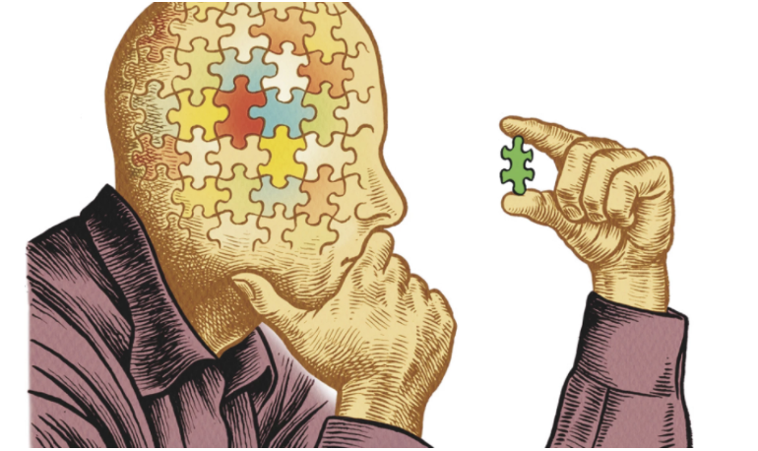

Table of contents

Title | Page
1.Introduction | 3
2.Traits theory of Leadership explained | 4-5
3. Assumptions and Critiques of the management theory | 5-7
4. Traits theory of leadership in the workplace with examples | 8-10
5. Recommendations | 11
6. Reflection on Critical Thinking Skills | 12-14
7. References | 15

1.Introduction

In our everyday life, we use our critical thinking skills to make decisions and judgements. Critical thinking is a self-sufficient thinking that endeavours to reason in a fair-minded way (Elder, 2007). We cannot take everything as face value; to avoid manipulation, deception and confusion it is in our human nature to use rational tools, to be able to analyse and assess to come to a satisfactory conclusion.
In 1941, Edward Glass defines critical thinking in three sections, attitude, knowledge and the skills in applying methods. It is necessary to be able to recognise the problems to be able to interpret the data provided, to evaluate the arguments in respect to the given evidence to be able to investigate the possible outcomes to be able to come up with a conclusion.
In the same manner, critical thinking is also important in the workplace, reasons need to be justified, all pros and cons evaluated before decisions made. Employees provided with narrow space for personal growth and development as companies expand can only reward those that can gain from convolution (Tripathy, 2020). Employers have the role to view different problems such as conflict; finding the right candidate for instance, have to withstand the inductive and deductive reasoning to achieve the best outcome for the business requirements.
This report will discuss the Traits theory of Leadership. The report will include the background of the theory, discussing the main assumptions and critiques. Finally, it will reflect how useful the theory is within a workplace.

2.Traits theory of Leadership explained.

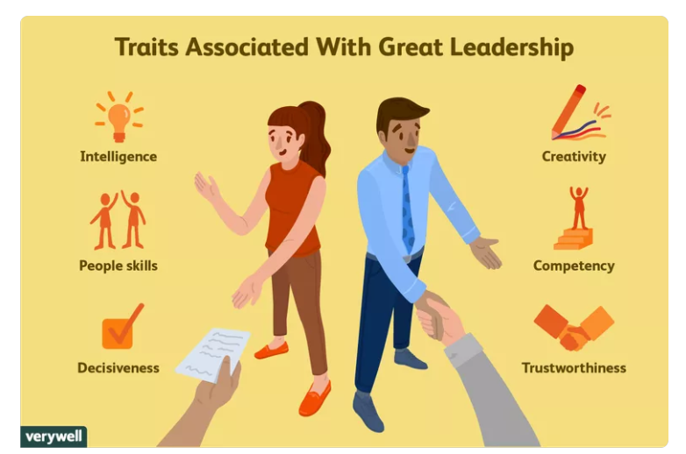

The Trait theory of Leadership, identifies the specific traits, a trait is a specific characteristic. The character trait is an asset to a person’s behaviour, often classified with expressive adjectives such as patient, impatient, faithful, hard- working or even envious.
The Trait theory of Leadership based on the great man theory, what traits or characteristics make a great leader. The Great Man Theory, individuals are born with or without the essential traits to be a leader. The Trait theory first proposed by Thomas Carlyle in the 1800’s. Although prior to Carlyle, Gordon Allport in 1936, came across this theory and discovered that there are over 4000 words in the English dictionary that describes the personality traits. Allport, considered these as building blocks. Allport claimed that there are three classes of traits.
- Cardinal traits – Allport suggests that these traits come later in life, the traits which a person organises his entire life. These traits are important, as they often become an identification for the person, for example a person known specifically for these traits fir example kindness, intelligence, greed.
- Central traits – These traits demonstrate the foundation of the individual’s personality. Examples of central traits: shy, anxious, low self-esteem.
- Secondary traits – The way in which one acts or conducts oneself when in a particular circumstance for example, getting shy when meeting new people.

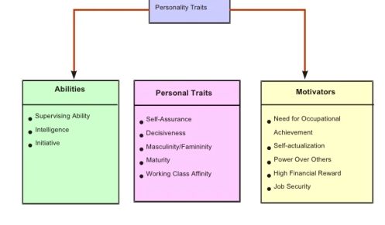
The trait theory takes a meticulous approach in its analysis of leaders, as suggested in the Great Man theory this theory also speculates that the leader’s personal traits are crucial to leadership success (Meha8, 2015).

3. Assumptions and Critiques of the management theory

This theory, based on the assumption that people are genetically inherited with traits some that are well – matched leadership. The aim of the theory is to bring to light specific leadership and personality traits and characteristics that will demonstrate the likelihood of success or failure of a leader (Kelly,1974).
Research has the trait theory, has identified assumptions of leadership accomplishment are embedded in the characteristics by the individuals. There are many positive connections between effective leadership and personality traits such as intelligence, extroversion. This clearly indicates that individuals that arise as leaders can come across a variety of situations and tasks.
The theory generalises the reality that, effective leaders all have in common a pattern of personal characteristics, which will reinforce their ability to prepare toward a shared vision.
These traits include elements of personality and motives including skills, capabilities and behaviour in social relationships. Effective leadership contemplates both characteristics inherited some that learned through attributes. This used to differentiate leaders from non-leaders and by understanding; the importance of these traits can help organisations select and train and develop leaders.
Through assumptions and studies of trait leadership, most leadership traits arranged into four groups:
- Personality – Effective leadership correlated with patterns of behaviour such as adaptability and comfort. Dispositional tendencies such as motives and values.
- Demographic – Gender has received far more attention in terms of leadership. Scholars have found that gender is not a determining demographic trait as both gender leaders are equally effective.
- Task competence – How individuals approach and execute a performance task.
- Interpersonal attributes – In 2011, Hoffman and other scholars have included traits such as extroversion and agreeableness are included in how leaders approach to social interactions.

Although the assumptions believe that one was inherited with the characteristics to be a leader or not and that most of these traits lead to leadership, may not be agreed by other scholars and look deep into the matter and that there may be more to a leader than just inheritance of traits.
Trait theorists assume that every trait applies to all people, all traits exist along a continuum and all individuals are placed somewhere on that continuum. For example if the trait is empowering, the individual will either be empowering or not empowering. Trait theorists assume that there are fundamental reasons for the consistency of human behaviour.
Raymond Cattell, 1954 identified 16-source traits that he considered the core of personality. He believed that his findings, study human behaviour predicted when in certain situations.

Although the assumptions believe that one was inherited with the characteristics to be a leader or not and that most of these traits lead to leadership, may not be agreed by other scholars and look deep into the matter and that there may be more to a leader than just inheritance of traits.
The field of leadership has struggled to understand what leadership exactly is, under what conditions or situations is it effectively exercised, in addition to leadership traits, skills and knowledge how you explain the leadership process (Bass, 1990; Yukl, 2006).
Leadership substantially viewed as one of the most compound of social process. The present theories of leadership proposed over the last half – century based practically on behaviour and interactions like doing traits, competencies or styles (Daft, 2008).
Other authors find that leadership is also a consequence of subtle and largely invisible inner feelings and thoughts (Badaracco, 2002). These authors argue that visible behaviour is evident of effective leaderships in organisations while focusing on the images, visions, and values of the organisation in reality (Burrell & Morgan, 1994).

4. Traits theory of leadership in the workplace with examples

The traits theory is about individual’s who acquire certain traits that guide to leadership, it believes that certain individuals have inherited this trait and will become leaders and those that have not will not.
To a certain extent, this is true in the past we have had great leaders both male and female leading countries others leading a particular group or area, but it has not been clear that these individuals born with these traits as majority of these leaders were not from a well- known or well off background. For example, Mahatma Ghandi known to be a great leader as he was empowering and inspired the nation by his philosophy of non-violence, he used this philosophy to free India from the British ruling. He shared his vison with the people around him and endured a lot to get his message understood. Sometimes social pressures have created strong leaders to portray social issues and bring awareness.

This theory is very useful in the workplace, as you need people that have strong characteristics to be able to lead by example the organisations visons and values. Some people by nature have these traits and they build these personalities from a younger age, as they get older they are more confident and full of competence. They are able to make inductive and deductive decisions with valid reasoning. These individuals will strive to go that extra mile and will bring in positivity to motivate others; their ability to lead in a fair manner will go in their favour with colleagues.
Having these traits from inheritance is also not necessary to become a leader, as Maslow’s hierarchy of needs demonstrates that the motivation starts from the bottom level, each level is important however it is not required that you fulfil the first need to get to the second (Mcleod, 2018).

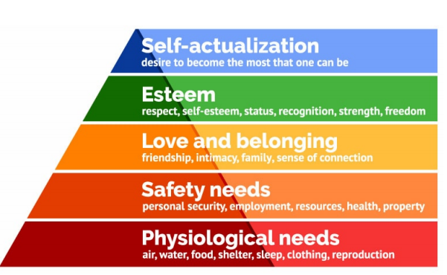

In the same way, a person’s traits can change or improve in a timely manner. Sometimes a particular circumstance or situation will trigger off certain characteristic to change that tasks can be fulfilled.
Maslow’s theory explains that one must carry through the first level in order to go to the second, but what if self-actualisation has more priority in the workplace, and then the individual will look to changing him/herself in the desire to wanting that role or position because at that moment the extrinsic factor from the organisation will empower them. As Allport (1936), mentioned one of his building blocks: secondary traits where the individual acts or conducts oneself when in a particular circumstance for example, speaks in confidence when presenting a team brief.
However, it is not just about inheriting these traits, but one must change according to the environment at work and the task given, it may be adequate to have a list of characteristics that resemble you to be the leader, but leadership requires a little bit more. Assertiveness, a social and communication skill that is required when you have to lead by example, the trait to judge and make decisions, to be able to change according to the business needs.
Although some traits of characteristics may be naturally part of an individual, there is no obstruction for further training and development to acquire further skills to be able to perform well which leads to job satisfaction. The traits of leadership has no limits and one can attain furthermore expertise in that field.

In the current diverse society, individuals that are in the higher positions in the workplace are those who acquire or have acquired these leadership skills.
A Customer Service Line Manager who works in company with over £217.5m revenues a year will have traits of leadership characteristics in order for her to run her department. Her goals and visons will be clear; she will have the confidence and moral to boost motivation through her team in order to get the best out of them. Without these traits, she cannot utilise her skills for effective leadership. The individual from the beginning will have a sense of wanting and a desire for winning and will pass these inspirations to her team; as well being passionate, she will also have the eye for detail and notice any changes, have authority to amend necessary tasks. Through training and development, she will develop rule out any gaps in the job role, through motivational vehicles, she will encourage team members to bring out the best in them. This will encourage job satisfaction.

5. Recommendations

I have concluded that the Trait theory of Leadership, according to my findings is all about the key characteristics one holds in order to become a leader. Either an individual has inherited these traits or they have not. However, studies show that it is not enough for an individual to have some traits other common factors can influence on acquiring certain characteristics, this can be in many forms: the environment surrounding the individual, the pressure from an extrinsic factor that enables the individual to enhance other characteristic. The need and desire of wanting something can change the way one thinks and can improve social skills.
Although many or all individuals that are in a higher position within an organisation must have some traits of leadership, for them to carry out the vison of the company. Certain skills needed to motivate the team to perform their best; however, leadership skills if not acquired by inheritance acquired through training and development.
The trait theory of leadership will always have an important role today, tomorrow and in the future, the characteristics or traits will always be the ones that stand out in the crowd.

6.Reflection on Critical Thinking Skills

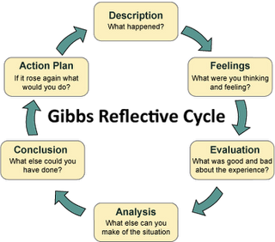

In my first term of my second year at university, we have covered this topic called Developing Workplace Critical Thinking and my lecturer was Dr Obi.
I know level 5 is going to be harder and will be more constructive, due to the pandemic we are doing this course online. This module dealt with all aspects of critical thinking, the background to critical thinking, the philosophy and the psychology approach. The modules covered:
- Introduction to critical thinking
- Logical reasoning
- Beliefs, values and Attitudes
- Developing arguments
- Workshop
- Validating evidence
- Casual reasoning
- Theories of management
The module was in depth had a lot of content to cover and Dr Obi did this very easily, and got us engaging in class activities as well as discussions.
My favourite topic was Beliefs, values and attitudes as it gave me the opportunity to participate in class discussions on certain aspects of the topic like when we discussed people believing in superstitious things. I cannot say that I do not believe in them myself but I try not to make it a habit or ponder of it. I got involved in the discussion on Values and how social media plays a major part in people’s lives and how certain people will show what they want to portray to others, having that Instagram life, when in reality it is the total opposite. At first, I was very worried that I will not manage to digest all the information given to me but the lessons designed in orderly manner so everything was covered but it did not feel overwhelmed.

I used the Gibbs Reflective Cycle (1988) to identify and analyse my journey on this module. At first little over whelmed, with all the information provided and I was confused on the actual topic, critical thinking? What is this? Although I use critical thinking methods in everyday life scenarios, for one moment my mind went blank. Inductive reasoning and deductive reasoning again a tool I use but I had never come across the names of these reasoning’s. Talking about critical thinking and taking, this to a broader platform when we discussed beliefs, values and attitudes was a revelation and as we discussed this in class, was a very informative lesson.
Before taking part in this module, I never thought about my critical thinking, I have made impulse decisions, but never actually considered the inductive and deductive reasons.
The course has made me more vigilant in the way I think and the decisions I make and why I make them, I have started to consider twice before a conclusion and do not take rash decisions.

References

https://ahokiecares.wordpress.com/2015/12/06/theory-analysis/
Badaracco, Jr, J.L. Leading quietly: An unorthodox guide to doing the right thing. Boston, MA: Harvard Business School Press, 2002.
Bass, B.M. Handbook of leadership: Theory, research, and managerial implications, 3rd edn. New York: The Free Press, 1990.
Burrell, G. & Morgan, G. Sociological paradigms and organisational analysis. Hampshire: Arena, 1994 reprint
https://canadacollege.edu/dreamers/docs/Maslows-Hierarchy-of-Needs.pdf
Daft, R.L. The leadership experience, 4th edn. Mason, OH: Thompson South-Western, 2008.
Edward M. Glaser, An Experiment in the Development of Critical Thinking, Teacher’s College, Columbia University, 1941
https://polipapers.upv.es/index.php/MUSE/article/view/12925
Praveen Shrestha, "Trait Theory of Personality," in Psychestudy, November 17, 2017, https://www.psychestudy.com/general/personality/trait-theory.
Richard Paul and Linda Elder, The Miniature Guide to Critical Thinking Concepts and Tools, Foundation for Critical Thinking Press, 2008
https://www.technofunc.com/index.php/leadership-skills-2/leadership-theories/item/trait-theory-of-leadership-2
The Trait Theory Approach. http://oer2go.org/mods/en-boundless/www.boundless.com/management/textbooks/boundless-management-textbook/leadership-9/trait-approach-69/the-trait-theory-approach-345-3943/index.html

