Assignment 2

Written Assignment

Module Name: Managing People

Module code: LCBB5004

Student: Mariana Larisa Neagoe (1921885)
Lecturer: Piyumika Gamage

Contents
INTRODUCTION 3
MAIN BODY 4
Causes and effects of employee attrition within the Nursing Industry in the UK 4
CAUSES OF NURSES ATTRITION 4
EFFECTS OF NURSES ATTRITION 6
MONETARY AND NON-MONETARY RETENTION SCHEMES USED BY NHS FOR NURSING PROFESSIONALS 7
MONETARY RETENTION SCHEMES 7
NON-MONETARY RETENTION SCHEMES 8
SHORT TERM AND LONG TERM RECOMMENDATIONS TO IMPROVE NURSE RETENTION IN NHS 10
Short-term methods to improve NHS nurses retention 10
Long-term methods to improve NHS nurses retention 11
CONCLUSION 11
REFERENCES 12

INTRODUCTION

The NHS nursers attrition is a major problem in UK Health sector and this report comes to analyse from HR point of view the causes and the effects of this issue, how NHS is trying to tackle it, via monetary and non-monetary schemes. How efficient those schemes are and what methods can be recommended on short-term and long-term will be revealed briefly through this report.
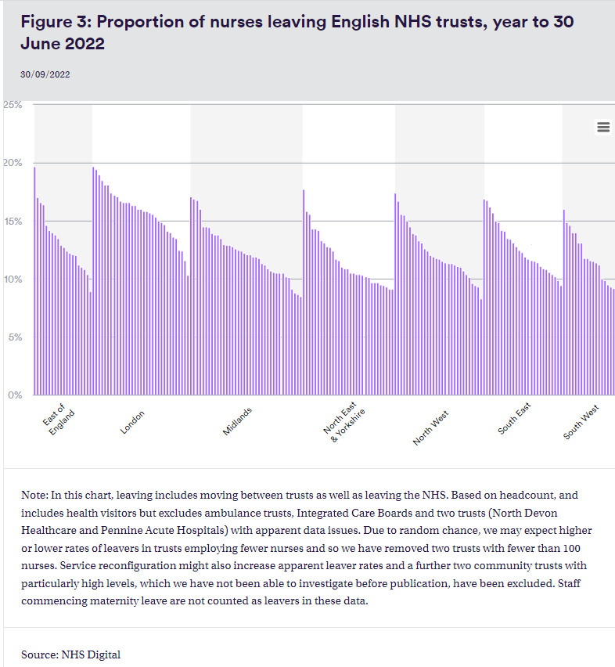
For England as we can see in the below chart, one of eight nurses are leaving the active service in South West, 12,3%, in North West, North East and Yorkshire the ratio is one in nine (10,9%).

MAIN BODY

Causes and effects of employee attrition within the Nursing Industry in the UK

So far, one in six nurses leaved in 2022, the higher average leaver rates being registered in community provider trusts – 16,8%, the services that they provide are district nursing and community physiotherapy, second in place are the care trusts, the leave rate is 14,7% - one in seven nurses leaves. The lowest leave rate is registered in the non-specialist acute trusts, with 11,8% and 12,4% for multi-service acute. (Palmer & Rolewicz, 2022).

CAUSES OF NURSES ATTRITION

- Every week, in NHS was registered a number of over 400 workers that left their activity due to their broken work-life balance in the last year.
The staff is complaining of burnout and post-traumatic stress disorder after the last 2 year in which they literally fought against Covid-19.
- Wellbeing is a common concern for NHS employees. Due to staff shortages the lack of free time is evident and is affecting the remaining NHS workers, especially the experienced ones.
- Another reason, equally important is the fact that the NHS nurses fell undervalued, exhausted and they feel that the mangers do not appreciate the fact that they are working under lots of pressure conditions.
- Lack of career development – Over 70% of students or new qualified nurses and midwives feels like they are not very well prepared to face critical situation, especially due to Covid pandemic period when they had a poor learning experience.
The pressure that NHS nurses is facing at the beginning of their career as a result of NHS inadequate support is a main reason of leaving for almost 60% of leavers. (Barnes, 2021).
- Lack of reward – four out of five NHS workers would live their job due to payment concerns. NHS staff is struggling with the increased inflation and they are struggling with day-to-day living cost. Their poor pay increases made more staff to turn to foodbanks to get help in feeding their families. Also, the level of debt is highly increased among NHS staff nurses and all this combined together with an acute sense of being undervalued by the government and their employers, are a good reason for more than 2000 people to leave their position as NHS workers.

- Unfair treatment (discrimination, bullying, harassment) – an NHS Survey from 2019 shows that more that 15% of ethnic minority staff was discriminated at work by a manager, supervisor or other colleague which is more than double compared to the white staff.
- Brexit is another factor that led to the loss of EU nurses this being translated through more job pressure and increased workload, reasons enough for leaving the job.

EFFECTS OF NURSES ATTRITION

The fact the NHS experienced nurses are leaving and the young ones does not feel motivated to keep the job is affecting the Trust not only economically but also the patients are loosing the trust in the care they are entitled through NHS and many times they opt for treatment in the private area or even out of UK.
- More than ¼ of the adults said that they or at least someone from their family received a care service of bad quality due to the workforce issues.
- HR department struggle to find replacement for the nurses which gave up their job.
- The staff leaving, vacancies are creating extra costs as they need to offer overtime or they need to hire staff from agencies which is more expensive in order to fill the gap.
NHS trust is incurring several cost when people are terminating their contract: severance pay, unused leave benefits and even early retirement.
Also, the cost with advertising, recruitment, hiring processes together with the training of new staff should not be neglected. For instance, the cost of replacing a fully experienced and trained nurse is £12,000 and agency nurse cost per year is £100,000.
- The new hired nurses lack of experience is affecting the patient care quality as well as the productivity.
- When the employees are leaving the organization they might not pass the whole information to the new recruited and there are specific organizational processes which will probably be missed.
- On a long run, a high turnover rate may also have a negative impact on the remaining nurses affecting their quality of work, attendance and overall satisfaction at the workplace. The ones that will have to step in to fill the gap or the lack of experience of new colleagues will feel tired and not motivated.

MONETARY AND NON-MONETARY RETENTION SCHEMES USED BY NHS FOR NURSING PROFESSIONALS

MONETARY RETENTION SCHEMES

In order to avoid the difficulties in people’s ability to access NHS services, a poor care quality or health results, the Trust is trying to attract professionals by offering them monetary incentives.
- NHS used ‘Recruitment and retention premia’ over the last years in order to attract and retain the staff. 1 in 174 hospital is receiving this premia and it sums up to almost 30 million/year.
- Only in 2016/2017 NHS spent over 107 million pounds to address the staff shortages and to keep the NHS service at a higher standard. This amount was spent on ensuring the staff from private health care agencies.
- ‘London weighting’ is also a form of recruitment and retention premia. In 2021, almost 990 millions pound were allocated for staff who was entitled at a ‘high cost area’ supplement.
- Starting with this year, the Government accepted the request of Health and Social Care Department to offer a pay rise to all NHS staff. Nurses are part of the convention and they will receive at least 1400 pounds this year, backdated to April 2022. The basic average wage will rise from 35,600 to 37,000 pounds for experienced nurses while the newly qualified ones will receive an increment of 5,5% and they will go from £25,655 to £27,055.
- An NHS Foundation Trust from Mid and South Essex is using a premium that would determine the nurses to work for minimum 12 months after the payment. The staff will be offered a 10% premium of their wages every 6 months and after 2 years of employment.
The bonus will be returned if the nurse is deciding to leave the business within one year following the payment.
- NHS is offering a ‘golden hello’ recruitment scheme where nurses are receiving a first payment of 1000 ponds after the six months of employment and after one year of working for NHS, they will receive an anniversary payment of 2000 pounds. (McKay, 2023).
- NHS is paying minimum £5000/year to support the undergraduate and postgraduate student nurses with their studies. The good news is that they won’t need to repay it.

NON-MONETARY RETENTION SCHEMES

12,400 nurses will join NHS due to ongoing support of the Trust in the areas that are deeply affected by the nurses turnover rate.
- NHS is offering staff career development programs for those who are able to provide high return on investment. It offers a career development that will motivate the nurses to keep their job. This programs will improve their skills which will enable them to operate at a high level of professional practice and to offer a qualitative care service to all the patients.
- NHS enhanced the multi-professional credentials to give clinicians the opportunity to acquire fresh, officially acknowledged skills in particular competency areas. The Advanced Level Nurse Practitioner Certificate for Advanced Clinicians in Emergency Medicine from the Royal College of Nursing and the Royal College of Emergency Medicine is one of the credentials NHS created with their partners.
- NHS aims to build a modern workplace culture for the NHS that promotes flexibility, well-being and career growth while stepping up our efforts to combat harassment, bullying and other forms of discrimination. The Social Partnership Forum has launched a significant initiative on bullying and harassment.
- The NHS just introduced a brand-new initiative to reduce violence. They will collaborate with law enforcement and prosecutors to achieve prompt prosecutions, enhancing staff training on how to handle violence, and providing prompt psychological care for staff members who have been harmed. From 2019 through 2020, NHS will invest up to £2 million yearly in these programmes to lessen workplace violence, bullying, and harassment.
- Respect, equality, and diversity are at the centre of strategies for a change in NHS culture. The Trust is tackling these concerns through their Workforce Racial Equality Standards from the viewpoint of BAME employees. The required adjustments will not be able to be implemented in two years, so NHS England will invest an additional £1 million each year to extend that work through 2025.
- Enhancing the health and well-being of staff and managing sick leave by expanding the NHS health and well-being framework.
- Support flexible working, including determining the percentage of jobs declared flexible. Next year, with the introduction of e-roster technology and related applications, it will be possible to communicate in advance the preferred shift pattern.
NHS is determined to solve the nurses vacancy and for this put in place several strategies.
Nevertheless, this task is not that easy and they need Government support in order to overcome the issues created by nurses shortages.
Their strategies are articulated and well presented, the fact that they manage to convince the Government to accept the pay rise for their staff shows that they are on the right track.
Fighting against the rising cost of living and the galloping inflation is almost impossible, nevertheless through the ‘Recruitment and Retention’ premia they are offering, HNS trust is trying to maintain and provide a good care service to the patient and a good morale to their staff.

SHORT TERM AND LONG TERM RECOMMENDATIONS TO IMPROVE NURSE RETENTION IN NHS

NHS nurses are an important part of NHS workforce and it has been proved that nurses shortages is deeply affecting the whole Trust as a business, including their customers represented here by the patients.

Short-term methods to improve NHS nurses retention

- NHS nurse had shown dedication and commitment during COVID and now NHS should support nurses wellbeing to make sure they will keep up the good work. Wellbeing at work is achieved when people are satisfied with their job, they receive recognition from others and they maintain a good working relationship. (Armstrong, 2017).
- A good way to support nurses workforce is to recruit nurses from outside the UK, they will bring their expertise and will enrich the patient experience within NHS.
- NHS should uphold the idea of creating bespoke multidisciplinary teams by the help of Additional Roles Reimbursement Scheme.
- A simplified recruitment process that will speed up the process of hiring, making sure that it is fair and inclusive.
- Organize open days where student nurses will have the opportunity to take the pulse of working in hospital as a real time experience.

Long-term methods to improve NHS nurses retention

- In order to retain dedicated and professionally engaged nurses and midwives, continuous professional development and internal career development opportunities are essential.
- Staff training and education should be prioritised. NHS trust should look for funding opportunities ant national and regional level. NHS managers need to learn how to communicate with the staff, make them feel that their expertise count.
- Flexible working and flexible retiring scheme are essential for nurses comfort and mental health as their work-life balance will be improved.
- In order to motivate and retain their staff NHS has to offer pride and meaningful recognition to the employees. This will boos the morale, job satisfaction and the perception of the patients.
This recognition can be sone for instance celebrating a significant career milestone or a good performance at work, appreciate the good feedback.

CONCLUSION

NHS nurses attrition is a complex topic and NHS leaders are trying for years to address this issue. If we take into consideration the last events, BREXIT, COVID pandemic, the challenge is big and quite complex.
The economical situation, the menral health and overall wellbeing of the nurses are affected by the recent events and NHS has to come up with strategies that are supposed to make their professional life meaningful and easier.
Not always is possible as this process is affected by several factors but the strategies that NHS is putting in place lately gives hopes that the shortages issues can be addressed and nurses and patients will receive what they are entitled to.
.

REFERENCES

Armstrong, M. (2017) Armstrong’s handbook of human resource management practice. 14th ed. London, England: Kogan Page.
Barredo, E. (n.d.), The pros and cons of nurse turnover and retention, causes and solutions, Tinehealth.com. Available at: https://tinehealth.com/2017/04/26/the-pros-and-cons-of-nurse-turnover-and-retention-causes-and-solutions/ (Accessed: April 30, 2023)
Department of Health and Social Care (2022) NHS staff to receive pay rise, Gov.uk. Available at: https://www.gov.uk/government/news/nhs-staff-to-receive-pay-rise, (Accessed: April 24, 2023).
Barnes, A. (2021) Many nurses and midwives feel unprepared and unsupported in first roles, UNISON National. Available at: https://www.unison.org.uk/news/2021/08/many-nurses-and-midwives-feel-unprepared-and-unsupported-in-first-roles/, (Accessed: April 30, 2023).
England, N. H. S. (2023, Support the NHS to attract and retain more people, working differently in a compassionate and inclusive culture, Nhs.uk. Available at: https://www.england.nhs.uk/publications/business-plan/our-2022-23-business-plan/1-support-the-nhs-to-attract-and-retain-more-people-working-differently-in-a-compassionate-and-inclusive-culture/, (Accessed: April 18, 2023).
Farrah, M. (2022), The NHS staff retention review: It’s costs and impacts, Available at: https://www.nurses.co.uk/blog/the-complex-costs-of-failing-to-retain-nhs-staff/, (Accessed: April 21, 2023).
McKay, J. (2023) Hospitals consider nurse ‘retention payments’ to aid recruitment, NursingNotes. Available at: https://nursingnotes.co.uk/news/workforce/hospitals-consider-nurse-retention-payments-to-aid-recruitment/, (Accessed: April 21, 2023).
NHS Employers , (n.d.), Improving the retention of registered nurses and midwives. Available at: https://www.nhsemployers.org/publications/improving-retention-registered-nurses-and-midwives, (Accessed: April 19, 2023).
Palmer, B., Rolewicz, L. (2022), Peak leaving? A spotlight on nurse leaver rates in the UK, Available at: https://www.nuffieldtrust.org.uk/resource/peak-leaving-a-spotlight-on-nurse-leaver-rates-in-the-uk, (Accessed: April 20 , 2023).
Palmer, B., Rolewicz, L. (2022), Placed at a premium? The use of recruitment and retention pay supplements to address staffing shortfalls. Available at: https://www.nuffieldtrust.org.uk/research/placed-at-a-premium, (Accessed: April 20, 2023).
Palmer, B., Rolewicz, L. (2022), The long goodbye? Exploring rates of staff leaving the NHS and social care , Available at: https://www.nuffieldtrust.org.uk/resource/the-long-goodbye-exploring-rates-of-staff-leaving-the-nhs-and-social-care, (Accessed: April 20, 2023).
Plan, N. L. T. and White, J. (2022) 5. Supporting our current NHS staff, NHS Long Term Plan. Available at: https://www.longtermplan.nhs.uk/online-version/chapter-4-nhs-staff-will-get-the-backing-they-need/5-supporting-our-current-nhs-staff/, (Accessed: April 21, 2023).
RCM, (2022), Four out of five NHS staff say pay is main reason they would quit their jobs . Available at: https://www.rcm.org.uk/media-releases/2022/june/four-out-of-five-nhs-staff-say-pay-is-main-reason-they-would-quit-their-jobs/, (Accessed: April 19, 2023).
Savage, M. (2022) “Stressed NHS staff in England quit at record 400 a week, fuelling fears over care quality,” The guardian, 26 February. Available at: https://www.theguardian.com/society/2022/feb/26/stressed-nhs-staff-quit-at-record-rate-of-400-a-week-fuelling-fears-over-care-quality, (Accessed: April 21, 2023).
The King’s Fund (2020) , “A long way to go”: ethnic minority NHS staff share their stories, Org.uk. Available at: https://features.kingsfund.org.uk/2020/07/ethnic-minority-nhs-staff-racism-discrimination/index.html?gclid=CjwKCAjwo7iiBhAEEiwAsIxQEfuxlxzOvt5YQOmNmarIgMNPjQ4tzUkk86JrUYAPa57XvNN9Q9tJQhoC7IcQAvD_BwE, (Accessed: April 23, 2023).

