
Master of Business Administration
Marketing Management
LCMB7024

Assessment Component 1 - Marketing Environment Analysis

Selected Organisation- TATA Steel

Lecturer's name: Taonga Kaonga Sobere-Snithers

Student name: Mohammad Adnan Khan

Student ID: 2612128

Word count: 2500(±10%)

Submission date: 22nd, Oct 2026

Table of Contents
Introduction 3
Analysis of the marketing environment- PESTEL analysis 3
Economic factors 4
Technical factors 5
Environmental factors 5
Strategic growth and competitive positioning 6
Application of the ANSOFF Matrix 6
Suggested initiative for growth: Verified and sustainable low-carbon steel 7
Implementing and measuring performance 8
Competitive advantage and strategic risk factors 9
Managerial and professional reflection 9
Rationale for strategic decisions 9
Limitations and information required 10
Implications for senior management 10
Conclusion 10
Reference list 12

Introduction
The global metal industry has experienced a major transformation in recent times due to the emerging trend of transforming towards lower-carbon steel due to growing environmental awareness (Saha and Mandal, 2025). Tata Steel has been selected in this study due to its significant presence in the Indian market, aggressive decarbonisation commitments, and international operations.
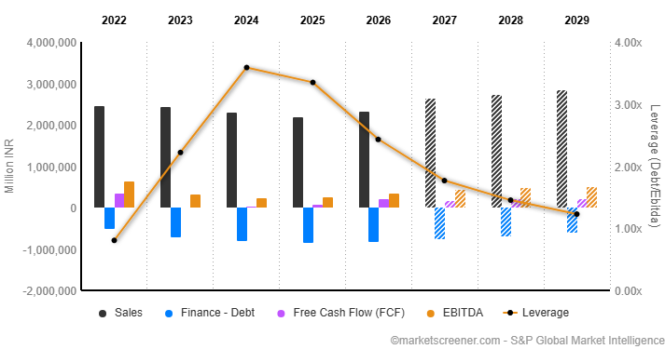
Figure 1: Financial results of Tata Steel. Source: (Market Screener, 2026)
In financial year 2024-2025, Tata Steel obtained INR 218,543 crore, earnings before interest, taxes, depreciation and amortisation (EBITDA) of INR 25,802 crore, and crude steel production of 30.92 million tonnes (Tata Steel, 2025). However, despite better production, the revenue stream experienced a hit, as a 5% reduction was recorded due to restricted international realisation. Using PESTLE analysis, the external market of the business has been analysed. Moreover, using the Ansoff Matrix analysis, the possible growth strategy of the business is analysed. Lastly, managerial implications and limitations of the study have also been discussed.

Analysis of the marketing environment- PESTEL analysis
From the PESTLE analysis framework, the economic, technology, and environmental factors have been selected here for the analysis.

Economic factors
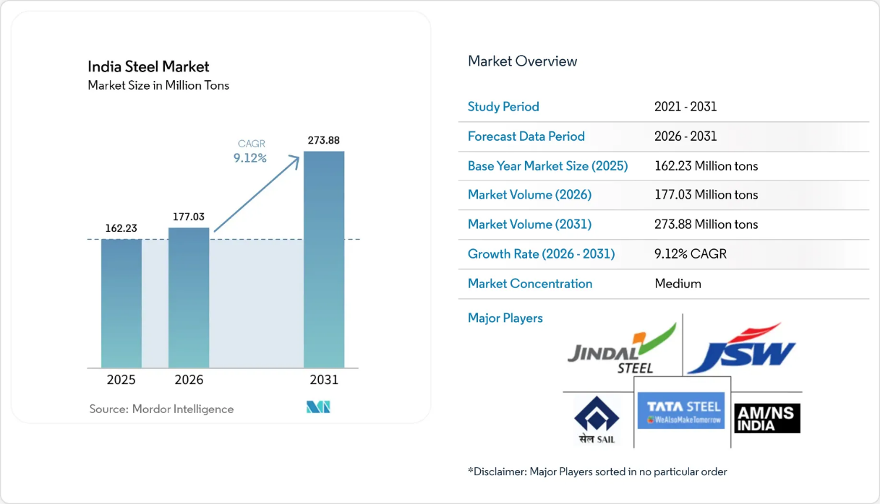
Figure 2: Market size of Tata Steel, Source: (Mordor Intelligence - Energy, Chemicals & Materials Practice, 2023)
The economic condition of a country directly influences the affordability for customers, that determine their willingness to pay (Lima, Ferreira and Leal, 2022). For low-carbon production, Tata Steel should also consider the economic condition in the country. The business has been able to develop a market size of 162,23 million tonnes of steel in 2025, which is expected to reach 273.88 million tonnes in 2031 with a CAGR of 9.12% (Mordor Intelligence - Energy, Chemicals & Materials Practice, 2023). However, the recent revenue decline of the business demonstrates its exposure to lower prices of steel and volatility in the market. Other determinants like financing costs, energy prices, and availability of raw material and competition from international steel manufacturers also create extensive pressure on the returns on investment.
Despite customers with environmental awareness valuing lower-carbon steel, actual purchase might not be maximised due to economic volatility in India (Yan et al., 2023). Therefore, Tata Steel should validate the demand fast through a pilot project and a phased rollout before extensive production. It will help limit its exposure to uncertainty present in the economic conditions in the market.
Tata Steel faces a balancing act between decarbonisation spending and keeping profits healthy while prices stay affordable for customers. India's growing steel market opens doors for maximising investment on decarbonisation related initiatives. Swingy commodity prices and sky-high transformation costs can erode investment payback. And customers often want greener steel products without paying extra for them. The company ought to test real demand with pilot contracts, run contribution-margin numbers. Only commit capital once both ecological gains and commercial returns hold up.

Technological factors
EAF (Electric Arc Furnace) production is possible for steel manufacturing businesses to decrease carbon emissions through technological innovation. In addition, improved sorting of scrap, renewable energy, optimisation in operational processes, and monitoring emissions through a digital interface are possible through technical innovation (Kishore, Sheikh and Hadi, 2024). The investment of Tata Steel and alternative stream manufacturing illustrates its potential to reach beyond incremental improvement in operations
Nevertheless, in the Indian market, technological adoption includes high dependence on suitable scrap and electricity (Sindakis and Showkat, 2024). Additionally, the direct reduction process based on hydrogen also requires significant investment and substantial restructuring of the infrastructure. Therefore, the management needs to perform a comparative evaluation of the investment in technology against life-cycle emissions, scalability, and technical performance.
Technology is the make-or-break factor in whether Tata Steel can slash emissions without compromising quality or output efficiency. EAF-based methods suggest real promise for cutting direct greenhouse gas output. Results hinge on electricity supply, scrap metallurgical grade, and plant infrastructure readiness. The steep capital bills and unresolved tech risk can also postpone expected financial returns. A disciplined path involves comparing alternatives through lifecycle emissions, operating costs. Growth capacity ahead of any full-scale commitment.

Environmental factors
The most significant influence in the external environment is environmental pressure, which might impact the strategy of Tata Steel in terms of the transition towards lower-carbon steel manufacturing. In India, almost 149.6 million tonnes of crude steel were produced in 2024 (World Steel Association, 2025). This reinforced the industrial demand. However, it also increased the level of emissions during production despite improvement in emission intensity.
Tata Steel reported its emission intensity of approximately 2.22 tonnes per ton of crude steel in 2024-2025. The management has also reported a target for reducing 10 to 15% of such emissions before 2030 and to achieve net zero emissions before 2045 (Tata Steel, 2023). It has been a potential differentiation strategy for referring to the production of lower-carbon products.
The transformation of Tata Steel towards EAF technology in the UK also demonstrates its opportunities. The strategy of the business has been to use the 3.2 million tonne per year facility to substitute conventional steel production. Nevertheless, the advantage of the facility is dependent on carbon intensity, availability of scrap, and product specifications. Therefore, it is important for the business to evaluate product-based life-cycle emissions. Instead of considering EAF production an automatic sustainable choice in all contexts.
Environmental considerations carry special weight since tightening climate rules shape production strategy, stakeholder trust. Picking up choices made by buyers. Tata Steel has a real chance to stand out with independently verified emissions cuts, though higher absolute output could wash out intensity gains. Vague environmental messaging backed by thin evidence risks tarnishing the company’s reputation. Hence, it becomes essential to track both absolute figures and intensity metrics, map product-level lifecycle burdens. Share only substantiated environmental advantages.

Strategic growth and competitive positioning

Application of the ANSOFF Matrix
The Ansoff Matrix framework offers four potential growth strategies to an organisation, considering whether products or markets should be existing or new (Ferreira and de Sá Moscoso, 2024). According to this framework, the growth strategy for Tata Steel is presented below.
Table 1: Ansoff Matrix.
Ansoff strategy | Application to Tata Steel | Strategic assessment
Market penetration | Increase sales of existing steel products to current customers. | Relatively low risk.  However, it offers limited differentiation in a competitive market.
Market development | Introduce existing steel products into new geographical markets or industrial customer segments. | Attractive where customer demand and environmental regulations support lower-carbon procurement.
Product development | Develop and market verified lower-carbon steel products to existing customers. | Preferred strategy: combines customer relationships with environmental differentiation
Diversification | Enter unrelated businesses or substantially new markets. | Higher risk and less directly connected to the immediate decarbonisation challenge
Source: (Belavadi and Kulkarni, 2026)
Considering the suggestions for growth through this framework, product development is the most feasible growth strategy for Tata Steel. The reason it is preferred as management can build new products based on its existing production capability, distribution network, and large network of industries. Nevertheless, the commercial success through product development relies on demonstrating that sustainable-carbon products deliver measurable value to customers. Instead of predicting that buyers will automatically accept higher prices due to environmental considerations.

Suggested initiative for growth: Verified and sustainable low-carbon steel
Tata Steel needs to develop a differentiated portfolio that will include lower-carbon steel merchandise. These will be supported by verified and independent emission-related data, customer-specific applications, and transparent specifications. This recommended strategy needs to include multiple considerations, including efficiency in production, greater utilisation of scrap, using renewable energy, and investing in lower-emission technologies (Belavadi and Kulkarni, 2026).
Firstly, Tata Steel needs to establish a baseline benchmark for product-level emissions. Each product unit should disclose the intensity of emissions, evaluation boundaries, and verification methods. This would help to improve compatibility with alternative products, which will strength in confidence of the customers instead of focusing on non-evidenced sustainability claims.
Secondly, Tata Steel should also prioritise industrial customers through its measurable decarbonisation objectives. The industrial clients like construction businesses, automotive producers, and contractors for infrastructure projects will be an appropriate target segment, as their supply chain emissions would benefit from the low-carbon product (Sindakis and Showkat, 2024). However, there will be a need for trials to select customers, considering their willingness to pay a higher price, repeat purchase, and technical acceptance before further commercial expansion.
Being selective in market development is also suggested to senior management. In markets where suppliers’ selection is influenced by measurable environmental disclosure will be more feasible. Additionally, markets where the political support for lower-emission procurement is present will be the target market. Only based on ambitious environmental policies in certain markets alone will not justify selecting any target country.
This suggested strategy is closely aligned with Porter's different strategies. According to this theory, competitive advantage is gained by a business not only exclusively through leadership and organisational capability, but using distinctive value proposition (Ferreira and de Sá Moscoso, 2024). Therefore, Tata steel, we need to combine both its measurable environmental performance and technical expertise. It should also maintain consistency in merchandise quality, reliable delivery, and collaborative relationships with customers.

Implementing and measuring performance
A three-stage implementation process is suggested
Stage one
Validating, establishing an emissions baseline, selecting priority clients, and conducting pilot testing will be done in the first stage. Additionally, life cycle, emission assessment, feasibility, checking in production, and predicting willingness of customers to pay before large-scale expansion will be done (Ferreira and de Sá Moscoso, 2024).
Stage two
The product development strategy will be implemented selectively. Expansion of products that illustrate higher customer acceptance and have the potential to offer more viable commercial returns will be preferred. In addition, the supply agreements will be preferred to develop in the longer term where possible. The production will be also aligned with higher scrap availability, and regulatory requirements will be maintained during electricity supply.
Stage three
Differentiation strategy will be strengthened in this stage by improving disability of product differentiation and obtaining independent verification. In addition, collecting customer feedback will be implemented in this stage to refine any specifications in the products.
Possible indicators will be used to assess performance, including intensity of emission and absolute emission, contribution, margins, sales of low carbon products, customer retention, and operational resilience, including availability of scrap, cost of renewable energy, and reliability in delivery. Such indicators will be effective in connecting the environmental results with the commercial performance of Tata Steel.

Competitive advantage and strategic risk factors
The potential competitive advantage of Tata Steel depends on the common production scale, existing customer relationships, business reputation, ability of technological investment, and authentic or credible environmental information. This integrated capacity would be more difficult to imitate compared to any sustainability advertisement.
However, there are three risks associated with the strategy. Production of low-carbon steel is subject to increased costs, as customers can show a negative willingness to pay additional premiums. Limited availability of scrap and renewable energy also might create constraints in the supply chain (Sen et al., 2022). In addition, inconsistency in emission methodology also can hinder credibility of the new product. In order to eliminate such hazards, the management of Tata Steel needs to ensure phased rollout of the capital investment. Additionally, diversified sourcing should be prioritised to ensure less dependence on certain suppliers.

Managerial and professional reflection

Rationale for strategic decisions
Tata Steel has been selected as the business case in the study as it has immense scale of business in the international market along with established relationships with different suppliers of steel. Hence, it provides irrelevant case to examine the relationship between promotional strategy, marketing, relationships, and environmental change. The financial result of the business demonstrates that despite strong production ability and volume, pressure is consistent on margins and revenues. Therefore, decarbonisation should complement operational proficiency instead of substituting it.
The PESTEL framework was selected as it helps to present a systematic assessment of the macro environment of a business. In this case, the environmental factors received high emphasis because of their ability to directly influence technology used in production and sustainable business position. The other factors explained the overall external factors, utilising which a business can obtain commercial value while considering environmental well-being as a central focus.
Product development was recommended as it helps to build new capabilities using existing expertise to align business deliverables with emerging customer expectations.

Limitations and information required
Fundamentally, this analysis depends on desk-based study and secondary information. It has not conducted interviews with managers working in the procurement process or customers. Therefore, the research is not able to evaluate the actual willingness to pay, the size of the low-carbon steel market, or the possibility of the pilot projects being converted into contracts. Corporate sustainability reporting also needs to be carefully interpreted. Prior to the finalised investment, a consultant needs to obtain verified emission-related data, forecasted data about customer purchases, competitor performance, and life-cycle assessments.
Additionally, detailed estimates of the availability of renewable energy and scrap are also required. Hence, interviewing major target buyers would be effective to test demand predictions. Additionally, financial modelling would also be effective to investigate capital expenditure, possible operating costs in operations, profit, margins, or sensitivity to transforming prices of lower-carbon steel.

Implications for senior management
The senior management of Tata Steel should consider lower-carbon steel as a growth opportunity that is commercially testable instead of any branding exercise. Operations, marketing, procurement, and finance departments should distribute responsibilities to align transformative requirements of customers, investment returns, and technical feasibility.
Success of the project should be measured through evidence-based reduction in emission levels, profitable growth in sales, and repeat purchases from customers. In case the pilot project fails to meet its objectives, the senior management should revise target segments, pricing, or timing for implementation before full-scale investment.

Conclusion
It is concluded that the transition of Tata Steel towards lower carbon steel ensures differentiation. However, it does not guarantee mandatory competitive advantage. Therefore, discipline should be maintained in the product development strategy through offering credible evidence about environmental performance, validated demand among target customers, and regulatory awareness.

Reference list
Belavadi, N. and Kulkarni, G.S. (2026). Forging a zero-carbon future: Tata Steel Ltd.’s sustainability transformation in an emerging market. Emerald Emerging Markets Case Studies, [online] 16(1), pp.1–9. DOI:10.1108/eemcs-06-2025-0349.
Ferreira, A.P.P.F.S. and de Sá Moscoso, M.M.B.P. (2024). The importance of the Ansoff matrix for the study of the information services market. The Canadian Journal of Information and Library Science, [online] 47(2), pp.78–84. DOI: https://doi.org/10.5206/cjils-rcsib.v47i2.17432.
Kishore, K., Sheikh, M.N. and Hadi, M.N.S. (2024). A critical analysis of electric arc furnace (EAF) slag for sustainable geopolymer concrete production. Materials Today Sustainability, [online] 29(1), p.101064. DOI: 10.1016/j.mtsust.2024.101064.
Lima, F., Ferreira, P. and Leal, V. (2022). The role of energy affordability in the relationship between poor housing and health status. Sustainability, 14(21), p.14435. DOI:10.3390/su142114435.
Market Screener (2026). Tata Steel Limited: Financial data forecasts estimates and expectations | tatasteel | INE081A01020 | MarketScreener India. [online] MarketScreener India. Available at: https://in.marketscreener.com/quote/stock/TATA-STEEL-LIMITED-6491942/finances/ [Accessed 12 Oct. 2026].
Mintel (2024). Consumer perspectives on eco-friendly packaging: An Indian context | Mintel. [online] www.mintel.com. Available at: https://www.mintel.com/insights/packaging/consumer-perspectives-on-eco-friendly-packaging-an-indian-context/ [Accessed 12 Oct. 2026].
Mordor Intelligence - Energy, Chemicals & Materials Practice (2023). India Steel Market Size & Share Analysis - Growth Trends and Forecast (2026 - 2031). [online] Mordor Intelligence. Available at: https://www.mordorintelligence.com/industry-reports/india-steel-market [Accessed 12 Oct. 2026].
Saha, A.K. and Mandal, A.K. (2025). Towards a low-carbon steel industry in India: Decarbonization strategies and environmental impact assessment. Journal of The Institution of Engineers (India) Series D, 1(1). DOI:10.1007/s40033-025-00923-9.
Sen, R., Bandyopadhyaya, R., Bansal, S. and Sio, S. (2022). Decarbonization and Environmental Planning Roadmap for Rourkela Steel City. [online] Nitrkl.ac.in. Available at: https://dspace.nitrkl.ac.in/dspace/handle/2080/3756 [Accessed 12 Oct. 2026].
Sindakis, S. and Showkat, G. (2024). The digital revolution in India: Bridging the gap in rural technology adoption. Journal of Innovation and Entrepreneurship, [online] 13(1), pp.1–28. DOI:10.1186/s13731-024-00380-w.
Swarup, R. and Ganesan, K. (2025). Sustainability is a natural part of India’s consumer journey—Not a marketing ploy. [online] Bain. Available at: https://www.bain.com/insights/sustainability-is-a-natural-part-of-indias-consumer-journey-not-a-marketing-ploy/ [Accessed 12 Oct. 2026].
Tata Steel (2023). Tata Steel Annual Report 2023-2024. [online] Tatasteel.com. Available at: https://www.tatasteel.com/investors/integrated-report-2023-24/climate-change-report.html [Accessed 12 Oct. 2026].
Tata Steel (2025). Tata Steel Reports Consolidated EBITDA of Rs 25,802 crores for FY2025. [online] Tatasteel.com. Available at: https://www.tatasteel.com/newsroom/press-releases/india/2025/tata-steel-reports-consolidated-ebitda-of-rs-25-802-crores-for-fy2025/ [Accessed 12 Oct. 2026].
World Steel Association (2025). December 2024 crude steel production and 2024 global crude steel production totals. [online] worldsteel.org. Available at: https://worldsteel.org/media/press-releases/2025/december-2024-crude-steel-production-and-2024-global-totals/ [Accessed 12 Oct. 2026].
Yan, D., Wang, C., Sun, T. and Wen, D. (2023). The impact of service experience on sustainable customer engagement: The mediation of green perceived value and customer satisfaction. Corporate Social Responsibility and Environmental Management, 31(3). DOI:10.1002/csr.2685.

