Bethan T James
MODULE CODE: BMPF7200

TITLE: Practitioner Research Proposal

Submission date: 12th April 2021

4098 words

Contents
- Introduction and Rationale
- Indicative Literature Review
- Indicative Methodology
- Ethical, Consent and Legal Considerations
- References
- Appendices
  - Copies of the GL Emotional Literacy questionnaires

- Introduction and Rationale
Research question – Do relational interventions positively impact on long term educational engagement and attainment of young people who have experienced adverse childhood experiences?
Since the introduction of compulsory education and the welfare system there has been Government emphasis on compensatory education and improving the educational outcomes for children who live in poverty. However, there has been little effective research into what interventions actually have the most significant positive impact on long term educational outcomes (Boothby N, 2012) for socially disadvantaged children. Historically research has tended to focus on deprivation studies: comparative studies that endeavour to identify and measure the negative impact poor early childhood attachment and institutionalised care has on child development compared to being raised within a family (Shannon, 2013). It is only in recent years following the extensive Adverse Childhood Experiences (ACE) Study (Felitti VJ A. R., 1998) and its enormous impact on adult health that social researchers and educators have considered interventions that may repair and compensate for ACEs.
Current data indicates that 14% of adults in Wales were exposed to 4 or more adverse childhood experiences (Bellisi MA, 2015) and this can have a significant impact on their daily functioning (table 1), their long-term educational outcomes, and their long term mental and physical health (table 2).
Table 1: Public Health Wales 2015 (Bellisi MA, 2015)
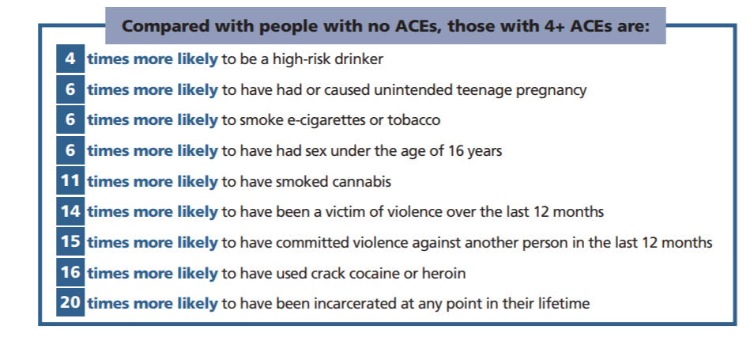
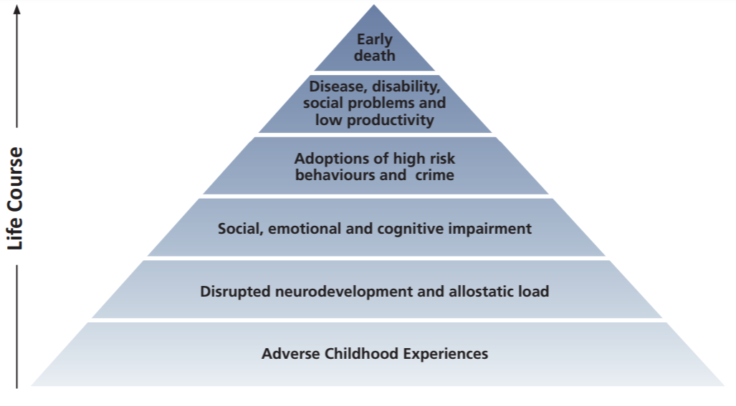

Table 2: Public Health Wales 2015 (Bellisi MA, 2015)

Children who have 4 or more adverse childhood experiences (ACEs) are more likely to: leave school without a qualification, have substance misuse problems, be engaged in domestic violence, have mental health problems, be homeless, go to prison (Bellisi MA, 2015). Despite concerns raised for many years there has been little robust research exploring interventions that would change this trajectory for vulnerable groups of children (Evans R, 2017).

The human, social and financial cost of adverse early childhood experiences is being

emphasised by Welsh Government (Hughes K, 2018) who are asking local

authorities and health boards to consider interventions to limit, modify and address

its impact. There are a range of compensatory wellbeing interventions being

promoted that largely focus on enhancing wellbeing; but research remains sparse in

relation to their long -term impact on educational engagement and attainment. To improve

wellbeing nurturing, relational and restorative models are being introduced across a range of

educational and care services for children who have experienced disadvantage

(Walker A J, 2015). But to date there is limited analysis of that data or any quantitative research into the impact of such interventions on educational engagement and attainment.

Public Health Wales (2016) along with much existing research, highlights the poor emotional literacy, low self-esteem and poor mental health of children experiencing ACEs (O'Higgins A, 2015). An analysis of the national statistics demonstrates poor educational and long-term outcomes for ACE experienced children in relation to access to adult mental health services, offending and economic status (Evans R, 2017). However, resilience studies in terms of ACEs outlines a range of protective factors that can mitigate the harm of ACEs. Many of these include having relationships and strong attachments with individuals within families, schools and/or communities. Children who indicated that they had ‘one significant nurturing adult relationship’ were less likely to experience the long-term negative impact of 4 or more ACEs.

The power of relationships in developing resilience to ACEs is supported by Modern Attachment Theories, Poly vagal Theories and Trauma Informed therapeutic models (see Table 3).

If nurturing relationships with a caring, responsive adult creates resilience for children with more than 4 ACEs, offenders in institutions, and trauma and PTSD survivors the rationale of my research is that this ‘resilience’ should also improve pupil engagement and attainment. Without a nurturing, responsive attachment at home children can find that relationship in teachers, friends and community leaders. If vulnerable children have poor relationships that impact on emotional wellbeing, in turn leading to poor educational attainment (Ferguson H B, 2012), it makes sense that improving the relationships and wellbeing may have a positive effect on attainment.

- Indicative Literature Review
There are large scale surveys (in excess of 10,000 subjects) carried out that link early adverse experiences to mental and physical illnesses in later life. Through these ACE studies it is now commonly accepted that 4 or more ACEs have a significant negative impact on positive life outcomes in relation to physical and mental wellbeing. The ACE agenda is influencing social policy, education curriculum and welfare programmes across Wales.
In the USA 8,506 adults (aged 19–92 yrs) completed a questionnaire about adverse childhood experiences (ACEs). Seven categories of ACEs were studied: psychological, physical, or sexual abuse; violence against mother; or living with household members who were substance abusers, mentally ill or suicidal, or ever imprisoned. The number of categories of ACEs was then compared to measures of adult risk behaviour, health status, and disease. Results show that more than half of the subjects reported at least 1, and 25% reported more than 2 categories of ACEs. There was a graded relationship between the number of categories of ACEs and each of the adult health risk behaviours and diseases that were studied. The 7 categories of ACEs were strongly interrelated and subjects with multiple categories of ACEs were likely to have multiple health risk factors later in life (PsycINFO Database Record (c) 2019 APA (Felitti VJ A. R., 1998)
In Wales the Welsh Adverse Childhood Experience (ACE) and Resilience Study interviewed approximately 2,500 adults (aged 18-69 years) across Wales in 2017.The Survey was undertaken to examine individual and community factors that may offer protection from the harmful impacts of ACEs on health, well-being and prosperity across the life course. Resilience is described as the ability to overcome serious hardships such as those presented by ACEs. The survey measured access to various sources of resilience in both childhood (personal, relational and community resources; social and leisure activities; relationships with adults) and adulthood (current personal, relationship and community resources; social and leisure activities; expectations of support from services; perceived financial security; and community culture and traditions). The survey also measured participants’ exposure to eleven ACEs during childhood. (Public Health Wales (Bellisi MA, 2015)

All Wales national statistical data indicates that the numbers of children per 10,000 of the children’s population with 4 of more ACEs is of concern. Welsh Government highlight the financial cost of this, the poor educational outcomes, and the longer-term effects on emotional wellbeing (Welsh-Government, 2019). been reducing while the average across Wales has been increasing. Many interventions have focused on bridging the gaps in learning in the form of educational ‘catch-up’ programmes. However, they have not delivered significant improvements in attainment or closed the attainment gap (Mannay D, 2015). Financial support provided to local authorities such as the RAISE (Raising Achievement and Individual Standards in Education) programme and the recent Pupil Development Grant (Gov.Wales, 2019) have all failed to significantly improve educational outcomes for the most vulnerable learners. Numerous qualitative research studies have focused specifically on identifying perceived social barriers to pupil engagement in school such as bullying, negative labelling and social stigma (Mannay D, 2015). Others identify widespread systems failings with adults having little or no aspiration for them educationally (Ferguson H B, 2012).

Interventions that are gaining popularity in schools in response to this research are ‘relational trauma informed models’ that support and encourage relationships, empathy and nurturing in the classroom. Some of these models have been around for decades. The Trauma Recovery Model (Trauma-Recovery-Model, 2019) is being used in youth offending services and specialist schools for children with behaviours that challenge. Dix (2017) and Olsen (2014) outline how relationships in small special schools can promote re-engagement of disengaged youth in learning arguing that when adults demonstrate nurture and empathy children feel safe to learn (Dix P, 2017) (Olsen K, 2014). Strategies that Louise Bomber (Bomber L M, 2007) and Kim Golding (Golding K, 2008) (Golding K F. J., 2012) have been using to facilitate adopters and foster carers to support children with attachment disorders are now being adapted for classroom settings. But there is little quantitative research in this area, success being recorded in the form of case studies and personal accounts.
Research since the 1940s into institutionalised care has repeatedly indicated that children who have experienced maltreatment have distinct difficulties with social and emotional understanding (Luke N, 2013) and poor mental health (Germine L, 2015) in childhood. Social inclusion difficulties, social understanding and the ability to engage in functional relationships often persist into adulthood (Felitti VJ A. R., 1998). In recent years there has been growing research to indicate that actively implementing strategies that improve emotional wellbeing for children may increase their ability to engage in learning and subsequently improve educational outcomes (Banerjee R, 2016). These relational trauma informed models will underpin the Wellbeing Curriculum for 2022 in schools in Wales (Wales.gov, 2019) and will aim to place social and emotional wellbeing at heart of curriculum. However, the impact of these interventions is still largely unresearched (McLaughlin C, 2015).
Health, wellbeing, social inclusion and emotional literacy contribute towards academic attainment and engagement (Gutman, 2012). It appears that improving wellbeing may be the key to educational success for children in care as there is a positive association between improved educational attainment and improved wellbeing (Public Health England, 2014). Welsh Government has taken on board this message and aim to implement a Wellbeing Curriculum in 2022 (Wales.gov, 2019) and local authorities are being asked to explore wellbeing measurement tools in order to assess pupil wellbeing. In Carmarthenshire this will be the GL Emotional Literacy Questionnaire (GL Assessment, 2019). The impact of early neglect can have a negative impact across areas of cognitive and social development and early traumatic childhood experiences and are associated with poorer educational outcomes (O'Higgins A, 2015). Exposure to abuse and neglect in early childhood is associated a range of developmental and social problems that may impact on educational attainment and contribute to mental health problems, difficulties with relationships and the development of interpersonal skills (Terren-Sweeney M, 2008) .
Within the context of abuse and neglect (significant ACE factors) abused and neglected children under attain in educational settings when compared to children who have not experienced abuse and neglect (D Berridge, 2012). The imperative is therefore to establish meaningful interventions that can redress the poor early childhood experiences and further research is required to provide evidence-based interventions that informs professional practice in educating vulnerable children to reach their full potential (Pecora, 2012).

TABLE 3: Summary: Relevant Theory and Research
Related Theoretical Context
- Adverse Childhood Experiences- Public Health Wales 2015,2 016
- Polyvagal Theory- Porges 2017
- Modern Attachment Theory- Schore 2017
- Resilience Studies- Bellis et al 2018 and Public Health Wales 2016
- Trauma Informed Practice (Kessler, 2017)
- Socio-emotional Learning- Goleman 1994
There are some links to:
Sociocultural theory- Vygotsky (1978)
Pychosocial development- Erikson (1998)
Recent Relevant Research UK
Bellis MA, Hughes K, Ford K, Hardcastle KA, Sharp CA, Wood S, Homolova L, Davies A 2018. Adverse Childhood Experiences and sources of childhood resilience. BMC Public Health 18:792
N= 2,452 via survey and follow up interview. Having a role model and supportive friends was associated in 66% reduction in adjusted prevalence of poor childhood health.
It acknowledges that little has been done to adopt widescale ACE informed models at school and evaluate their impact.

Children and Youth Services Review Volume 77 (2017) pp86-93
N= 26 Children ‘chose’ to engage in learning once they were in ‘stable and fulfilling relationships’ with adults including teachers and carers. The type of ‘relationship’ was not prescriptive.
The study did not consider whether improved pupil engagement then impacted on attainment.

Greenhalgh R, Fflur S, Donnelly K, Kirkaldie H, Mc Donnell L Developmental Child Welfare 2020 vol 2(2) pp75-91 Sage
N= 64 staff were trained in relational models across 4 sites. The study measured whether the confidence in teaching staff would improve following the training.
It did not consider whether the training had an impact on pupil engagement or attainment.

Evans R, Brown R, Rees G, Smith P 2017 British Educational Research Journal vol 43 No 1 pp68-94 Cardiff University CASCADE.
PRISMA systematic review of 12 interventions. 5 reported an effect on academic skills. One intervention ‘Head Start’ measured teacher-student relationships. At 6 months post baseline there was a significant effect on attainment (p<.01).
The review concluded that it was difficult to make any claims as to the most effective intervention due to the variable quality of the studies.
Recent Relevant Research
Crosby SD, Somers CL, Day AG, Zammit M, Shier JM, Baroni BA, 2017 NY USA
N=141 females on probation with high ACE scores. Reduced ‘trauma symptoms’ were observed where students had positive attachments at school and where schools had received trauma aware training.
There was no consideration as to whether this then led to improved pupil engagement or attainment.

Brown SM, Shillington AM 2016 http://dx.doi.org/10.1016/j.chiabu.2016.11.006 Colorado State University USA
N= 1054 ages 11-17 yr olds. Standardised Adolescent Wellbeing Survey.
Findings- protective adult relationships moderated the relationship between Adverse Childhood Experiences and substance misuse but not delinquency.
There was no analysis of longer-term impact of protective adult relationships on educational engagement or attainment.

Johnson B,2008. Teacher- Student Relationships which promote resilience at school. British Journal of Guidance and Counselling November Vol 36, No4 pp385-398. Australia.
N=130 pupils. The South Australian longitudinal resilience project. Teachers used a screening tool to identify resilient and non-resilient behaviours. Children were interviewed and identified a number of everyday interactions that helped them cope with adversity.

- Indicative Method

The study will utilise a Mixed Methods approach. There is a significant amount of data

collected by Local Authorities for Welsh Government on vulnerability and educational

attainment that is largely descriptive and unanalysed. Initially, in order to provide a context

for the study into the impact on relationships on engagement and attainment of vulnerable

learners (children with 4 of more ACEs) secondary data shall be analysed. Consideration will

be given to identify patterns in Wales and Carmarthenshire and whether they mirror those of

the ACE studies in 2015 (Bellisi MA, 2015). StatsWales compares nationally

collated data for children who have social vulnerabilities in terms of adverse childhood

experiences (ACEs) and those pupils who haven’t. Welsh Government monitors a range of

data from schools and social care services across Wales which is available from

StatsWales.

Carmarthenshire County Council holds anonymised comparative data for

children who have social vulnerabilities in terms of adverse childhood experiences (ACEs)

and those pupils who haven’t. Standardised GL Emotional Literacy Questionnaire

(GL Assessment, 2019) is used across schools in Carmarthenshire as baseline data

for monitoring emotional literacy and wellbeing. Comparative analysis will indicate

whether there is a significant difference between the emotional literacy of pupils who

have experienced ACEs and those who have not. For 6 years schools in Carmarthenshire

have been implementing relational models of learning in their secondary school. Secondary

data analysis will investigate the difference in the educational attainment of children with

4+ACES in schools that have implemented relational models and those who have not.

Statistical analysis would indicate whether attainment is significantly improved or not.

A special school for children with 4+ACEs in Carmarthenshire is just beginning to implement

relational educational models. Baseline data will be taken to establish wellbeing,

engagement, attainment and the quality of relationships. The implementation of relational

educational methods in terms of staff training, policy, procedure, interactions will be

monitored. Tracking data will be regularly reviewed over the period of 12 months. The data

will form a casestudy monitoring the impact of the relational model on pupil engagement and

attainment.

Table 4: Summary of Method
    - Secondary Data Analysis

Will set the wider context of ACEs and the impact on educational attainment.

- National Statistics Wales- Comparisons in attainment and wellbeing – 4 x ACEs and no ACEs
- Carmarthenshire County Council- Comparisons in wellbeing scores for pupils with ACEs and no ACEs
- Comparisons of attainment levels of secondary pupils with 4+ACEs that utilise relational educational models in Carmarthenshire schools and for those who don’t.
    - Case study- Specialist SEBD School for Vulnerable Children (N=36 pupils)
- All pupils have more than 4 ACEs
- Baseline assessments of wellbeing, engagement and attainment will be taken for pupils.
- Proactive relational models will be promoted across the school: Training for staff, Regular Check-ins, Key Adult model, Relational Play, Trauma Informed models.
- Over a 12month period the emotional literacy of pupils will be tracked using a GL Emotional Literacy Screening Tool and this will be compared to whether pupils report that they have significant relationships/ or not with adult staff.
- Engagement and attainment data will be collected.
- Statistical analysis of the before and after data will indicate whether the difference is significant.

- Ethical, consent and legal considerations
National data is accessible to all and the generalisations made from it can, if not presented in ways that emphasises the complex social nature of the experience of care, present a marginalised and negative picture (Byrne D, 2002) . Quantitative national data demonstrates that children with 4+ACEs underachieve academically when compared to their peers. Publicising this underachievement with 4+ ACEs go on to university, gain employment and lead productive lives and national comparative data does not emphasise this. There is a danger that the national focus on the negatives of ACEs can contribute to reinforcing negative stereotypes. Children and young people cannot consent to national data being used in a range of comparative ways so the researcher must be aware of any negative or damaging repercussions the presentation of the data may have. Researchers need to reflect on their roles in the research process from a position of power (Leavy P, 2019).

For the case study children and parents will need to consent to their data being used for the study, even though it will be anonymised. As adults in position of social power parents and children may not feel they can say no to us when we ask for consent. When gaining consent from children and families it is important that the consent is informed (Gray D E, 2014) and presented in a way that they fully understand how it will be used. As the researcher I will ensure that they are sensitive to the power dynamics and protect them from any pressure to comply.
Efforts need to be made to ensure that the sample is large enough to ensure anonymity (Gray D E, 2014). The sample of children in the case study is small (36 children) but children’s names will not been recorded. Average scores will be collated at a school level and the original profile is held by the school as part of their wellbeing monitoring programme. In social research into disadvantage poverty, neglect, inequality is observed objectively from a point of researcher power and social privilege. Within explicit value-based research there is a need to have a social dialogue that considers the impact of research on the wellbeing of participants (HUMPHREYS K.L., 2017) and to consider improvement and repair where possible.
There is a moral duty in relation to safeguarding the wellbeing of children. All children who indicate that they have low Emotional Literacy will be offered a compensatory programme, regardless of which sample group they are in. Low GL score is indicative of low self esteem and social communication problems. Once this has been identified by a professional it would be unethical not to offer support to the child to address this. Researchers need to be mindful that participants may need to be supported by access to additional support services (Mackenzie N, 2006).Research can facilitate social change, empower individuals, change communities, and influence policy (Shannon, 2013) and it in value based social research Shannon (2013) argues that any learning that indicates that interventions may improve outcomes for vulnerable citizens should be considered for implementing positive social change.

References
Banerjee R, M. C. (2016). Promoting emotional health, well-being, and resilience in primary schools. . Cardiff: Public Policy Institute for Wales.
Bazalgette L., R. T. (2015). Achieving emotional wellbeing for looked after children: a whole system approach. London: NSPCC. Retrieved from . NSPCC Cymru/Wales briefing. London: NSPCC Retrieved from https://www. nspcc.org.uk/globalassets/documents/research-repo
Bellisi MA, A. K. (2015). Adverse Childhood Experiences and their impact on health-harming behaviours in the Welsh adult population. Wales: Public Health Wales.
Bomber L M. (2007). Inside I am Hurting . London: Worth.
Boothby N, B. R. (2012). Coordinated and evidence-based policy and practice for protecting. Child Abuse and Neglect 36, 743– 751.
Byrne D. (2002). Interpreting Qualtative Data. London: Sage.
D Berridge. (2012). Educating young people in care: What have we learned? Children and Youth Services Review, 34 ( 6 ), 1171 – 1175.
Dix P. (2017). When Adults Change Everything Changes. Cornwall: Indpendent Thinking Press.
Evans R, B. R. (2017). Systematic review of educational interventions for looked-after children and young people: Recommendations for intervention development and evaluation. Cardiff: DECIPHer.
Felitti VJ, A. R. (1998). Relationship of childhood abuse and household dysfunction to many of the leading causes of death in adults. American Journal of Preventative Medicine 14 (4), 245-258.
Ferguson H B, W. K. (2012). Educating children and youth in care: A review of barriers to school progress and strategies for change. Children and Youth Services Review,34 (6), 1143 – 1149.
Germine L, ,. D. (2015). Childhood adversity is associated with adult theory of mind and social affiliation, but not face processing. London: PLoS One 10(6) e0129612.
GL Assessment. (2019, November 24). Emotional Literacy. Retrieved from GL Assessment Tools: https://www.gl-assessment.co.uk/products/emotional-literacy/
Golding K. (2008). Nirturing Attachments. London: Jessica Kingsley.
Golding K, F. J. (2012). Observing Childrne with Attachment Difficulties in School. London: Jessica Kingsley.
Gov.Wales. (2019, November 17). Pupil Development Grant: allocations for looked after children. Retrieved from Wales.Gov: https://gov.wales/pupil-development-grant-allocations-looked-after-children
Gray D E. (2014). Doing Research in the Real World. London: Sage.
Gutman, L. V. (2012). The impact of pupil behaviour and wellbeing on educational outcomes. London: DFE.
Gutman, L. V. (2012). The impact of pupil behaviour and wellbeing on educational outcomes. . London: DFE.
Hughes K, F. K. (2018). Sources of resilience and their moderating relationships with harms from adverse childhood experiences. Wales: Public Health Wales .
HUMPHREYS K.L., N. C. (2017). Signs of reactive attachment disorder and disinhibited social engagement disorder at age 12 years: Effects of institutional care history and high-quality foster care. . Development and psychop.
Kessler, R. (2017). www.tandfonline.com. Retrieved from www.tandfonline.com: https://www.tandfonline.com/doi/full/10.1080/20008198.2017.1353383
Leavy P, H. A. (2019). Contemporary Feminist Research from Theory to Practice. New York: Gulford Press.
Luke N, B. R. (2013). Differentiated associations between childhood maltreatment experiences and social understanding: a meta-analysis and systematic review. Developmental Review 33(1), 1–28.
Mackenzie N, K. S. (2006). Research dilemmas: Paradigms, Methods and Methodology. Issues In Educational Research, Vol 16, 193-205.
Mannay D, S. E. (2015). Understanding the educational experiences and opinions, attainment, achievement and aspirations of looked after children in Wales. Cardiff: Welsh Governmen.
McLaughlin C. (2015). The connected school: a design for well-being—supporting children and young people in schools to flourish, thrive and achieve. London: Pearson.
O'Higgins A, S. J. (2015). What is the relationship between being in care and the educational outcomes of children? Oxford: Rees Centre for Research in Fostering and Education.
Olsen K. (2014). The Invisible Classroom. New York: Norton .
Pecora, P. J. (2012). Maximizing educational achievement of youth in foster care and alumni: Factors associated with success. Children and Youth Services Review 34, 1121 – 1129.
Public Health England. (2014). The link between pupil health and wellbeing and attainment: a briefing for head teachers, governors and staff in education settings. London: London: Public Health England.
Shannon, P. (2013). Value-Based Social Work Research: Strategies for Connecting Research to the Mission of Social Work. Critical Social Work Vol. 14, No. 1, pp105.
StatsWales. (2019, November 20). https://statswales.gov.wales/Catalogue/Education-and-Skills. Retrieved from https://statswales.gov.wales/Catalogue.
Terren-Sweeney M. (2008). Predictors of Problematic Sexual Behavior Among Children With Complex Maltreatment Histories. London: Sage.
Trauma-Recovery-Model. (2019, nov 13). Trauma Recovery Model. Retrieved from Trauma REcovery Model: http://www.traumarecoverymodel.com/?p=215
Wales.gov. (2019, October 23). Draft Curriculum for Wales. Retrieved from HWB.Gov.Wales: https://hwb.gov.wales/draft-curriculum-for-wales-2022/a-guide-to-curriculum-for-wales-2022/
WalesNewsOnline. (2020, January 15). Carmarthenshire Leads the Way in Supporting Families to Stay Together. Retrieved from Wales News Online: https://walesnewsonline.com/carmarthenshire-leads-the-way-in-supporting-families-to-stay-together/
Walker A J. (2015). Adverse Childhood Experiences: How Schools Can Help. Journal of Child and Adolescent Psychiatric Nursing 28, 68-69.
Welsh-Government. (2019). Improving Outcomes for Children - Ministerial Advisory Group Report. Cardiff: Welsh Government.

https://statswales.gov.wales/Catalogue/Health-and-Social-Care/Social-Services/Performance-Measures/quantitativesocialservicesperformancechildren-by-measures

https://gov.wales/sites/default/files/publications/2018-03/raising-the-ambitions-and-educational-attainment-of-children-who-are-looked-after-in-wales-one-year-on.pdf

https://www.gl-assessment.co.uk/products/emotional-literacy/

- Appendices: A. Copies of the GL Emotional Literacy questionnaires


