University of Wales Trinity Saint David
Wales Institute of Science & Art



Motorcycle Geometry Analysis and Dynamic Handling Investigation
Motorcycle Technology (ACHA4003)

Sam Stainsby
2305051
December 2023
Contents
1 Introduction 2
2 Geometry Data 3
3 Gear Ratios and Speed/Power 9
4 Conclusion 14
5 Reference List 15

Introduction
In this essay there will be an explanation of multiple areas of two analysed motorcycles, including the geometry (trail, rake angle, wheelbase), Gear ratios: and how the two motorcycles will act under different forces, and handling characteristics of the motorcycles.

Geometry Data
For the Kawasaki ZXR 750’s geometry data, we need to know the rake and trail of the bike. To find out the rake, and to help us further with the other geometry data, we measured the bikes in the workshop and can use our information to place on a motorcycle schematic diagram for easy visualisation as shown below in figure 1:
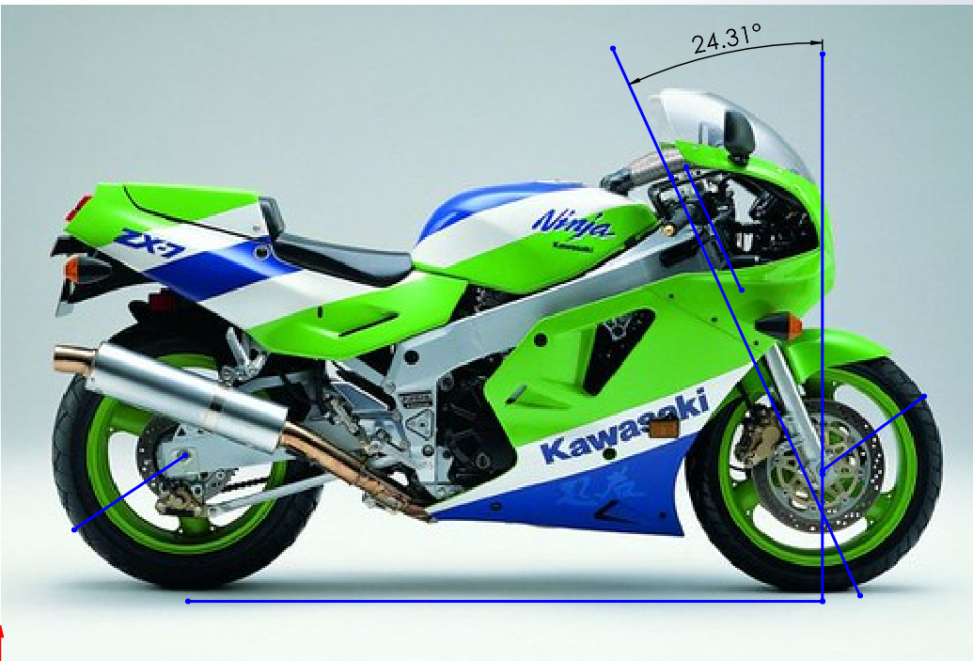
Figure 1: Kawasaki ZX 750 (adapted from Motoplanete)
To calculate trail we can use this equation: $\left(R*Sin\left(θ\right)-◯\right)/Cos(θ)$
After inserting my values = $\frac{290*Sin\left(24.31\right)-27}{Cos\left(24.31\right)}$
=$\frac{119.39-27}{0.911}$ = $\frac{92.39}{0.911}$ = 101.42mm
In order to find out the centre of gravity for any motorcycle, we need to know: the load on the rear wheel, the total weight of the motorcycle, and the wheel base. Knowing this, we can then work out the Kawasaki ZXR 750’s COG, using the following equations:
- Wr = Load on Rear Wheel
- Wt = Total Weight of Motorcycle
- L = Wheelbase
- WRlifted = Load on Rear Wheel when lifted on block
- Θ = Angle of lifted bike (= sin-1(height of block/L))
- Rav = Average wheel radius
$XCoG=\frac{(Wr*L)}{Wt} YCoG=\frac{L*\left(Wr-Wrlifted\right)}{Wt*Tanθ }+Rav$
So for the CoG:
$$XCoG=\frac{\left(89.80*1.44\right)}{191.9}=0.674m$$
$$YCoG=\frac{1.44*\left(89.80-78.65\right)}{191.9*Tan(25.9) }+0.296=0.470m$$
For the CoG with a rider:
$$XCoG=\frac{\left(138.8*1.44\right)}{272.95}=0.732m$$
$$YCoG=\frac{1.44*\left(138.8-111.20\right)}{272.95*Tan\left(25.9\right)}+0.296=0.596m$$
With these centre of gravity calculations, we can clearly see that the CoG whilst lifted moves back by 0.058m and up by 0.126m.
We can also do the percentage split of the load on each wheel, using these equations:
- Wb = Wheelbase
- Wf = Load on front wheel
- Wt = Total weight
- Wr = Load on rear wheel
$$\%f=\frac{Wb-XCoG}{Wb}*100 and \%r=\frac{XCoG}{Wb}*100$$
Or
$$\%f=\frac{Wf}{Wt}*100 and \%r=\frac{Wr}{Wt}*100$$
So the calculations for no rider are:
$$\%f=\frac{1.44-0.674}{1.44}*100=53.20\%$$
$$\%r=\frac{0.674}{1.44}*100=46.80\%$$
Or
$$\%f=\frac{102.1}{191.9}*100= 53.20\%$$
$$\%r=\frac{89.80}{191.9}*100=46.80\%$$
The calculations with a rider are:
$$\%f=\frac{1.44-0.732}{1.44}*100= 49.16\%$$
$$\%r=\frac{0.732}{1.44}*100=50.84\%$$
Or
$$\%f=\frac{133.50}{272.95}*100=49.16\%$$
$$\%r=\frac{138.80}{272.95}*100=50.84\%$$
From these calculations we can see that without a rider the percentage split of load his higher on the front by 6.40%, compared to when there is a rider where the load shifts to the rear, being a higher percentage by 1.68%. The rider shifts the load from the front by 4.04%.

These calculations will be the same for the Aprilia RS 660 (Shown below in figure 2), with its values put in place, as shown below.
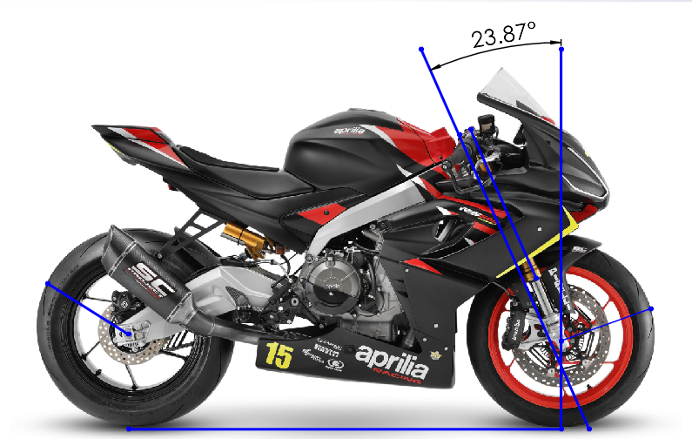
Figure 2: Aprilia RS 660 (Adapted from Hancock, 2021)
Just as with the Kawasaki, we need to calculate the trail (all equations used will be the same as previous):
Trail = $\frac{\left(295*Sin\left(23.87\right)-28\right)}{Cos\left(23.87\right)}$ = $\frac{91.38}{0.914}=99.98mm$
Next we need to find the CoG for the Aprilia, below are the calculations:
Firstly for CoG without a rider:
$$XCoG=\frac{(74.50*1.386)}{158.85}=0.650m$$
$$YCoG=\frac{1.386*\left(74.50-62\right)}{158.85*Tan\left(26.99\right)}+0.300=0.514m$$
And for CoG with a rider:
$$XCoG=\frac{(125.60*1.386)}{239.9}=0.726m$$
$$YCoG=\frac{1.386*\left(125.60-93\right)}{239.9*Tan\left(26.99\right)}+0.300=0.670m$$

From this data we can see that the CoG moved back on the X-axis by 0.076m and up on the Y-axis by 0.156m.
Now we can figure out the percentage load split between the front and rear:
Percentages for load without a rider:
$$\%f=\frac{1.386-0.650}{1.386}*100=53.1\%$$
$$\%r=\frac{0.650}{1.386}*100=46.9\%$$
Or
$$\%f=\frac{84.35}{158.85}*100= 53.1\%$$
$$\%r=\frac{74.50}{158.85}*100=46.9\%$$
Percentages for load with a rider:
$$\%f=\frac{1.386-0.726}{1.386}*100= 47.62\%$$
$$\%r=\frac{0.726}{1.386}*100=52.38\%$$
Or
$$\%f=\frac{114.60}{239.9}*100=47.62\%$$
$$\%r=\frac{125.60}{239.9}*100=52.38\%$$
Looking at the split percentages, we can see that the load splits without the rider has a difference of 6.2%, and when we add the rider, there is a difference in load splits of 4.76%. The load on the rear increases by 5.48% when we add a rider. Moving more load onto the rear will lead to higher tyre wear.

Gear Ratios and Speed/Power
Using manuals from the workshop, we can find the gearing ratios of the RS 660 and the ZXR 750, and calculate the total speed from these ratios, we can then determine the max possible speed by calculating the force acting against the motorcycle. Below are the excel tables for the ratios of the ZXR 750:
We are looking at the maximum speeds achievable from all gears, with a rpm limit of 12,000. The calculation needed for all max speeds is as follows:
$$\frac{RPM*60*\frac{Input gear}{output gear}*\frac{Primary in}{Primary out}*wheel dia*Pi}{1000}*\frac{Front sprocket}{Rear sprocket}$$

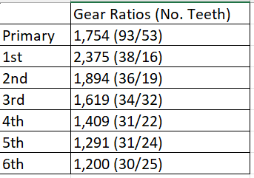
Figure 3: Gear Ratios for ZXR 750
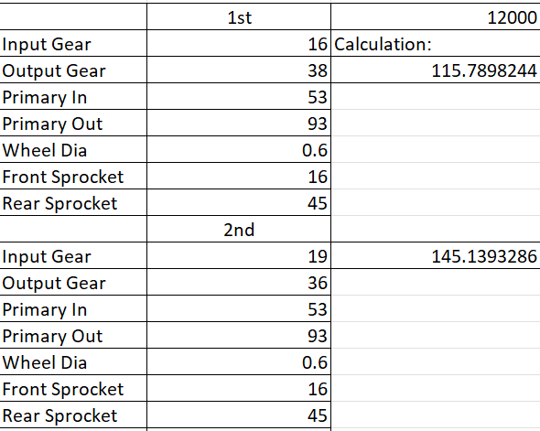
Figure 4: Data for 1st and 2nd Gear with Max Speed in Km/h

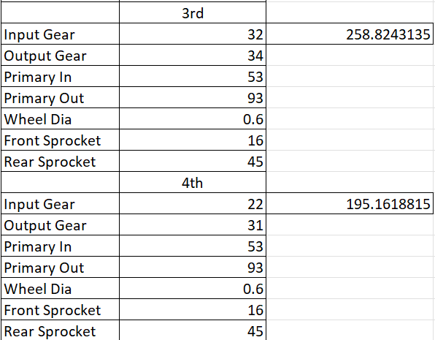
Figure 5: Data for 3rd and 4th Gear with Max Speed in Km/h
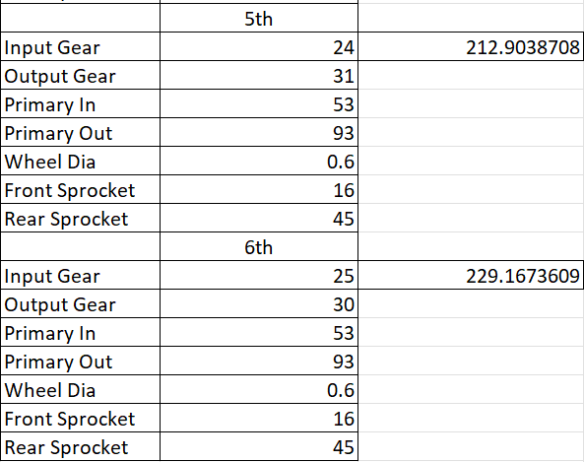
Figure 6: Data for 5th and 6th Gear with Max Speed in Km/h
Assuming that the motorcycle is travelling at the fastest possible velocity (229.17Km/h), we can then work out its resistance to motion, and that will let us know the force required to reach this top speed. We need to figure out the frontal area, which I have calculated to be 0.135m².
To calculate the aero drag force, we need to use the equation: $Fd=\frac{1}{2}ρ*Cd*A*V^{2}$ as well as the equation for a rolling resistance: $Fw=0.02*m*g$ and finally we will assume a gradient and thus need the equation for resistance due to gradient: $Fp=m*g*Sinθ$ and as I do not know the drag coefficient of the Kawasaki we will have assume it to be 1.8 (The Engineering Toolbox, 2004); we will also assume that in the test conditions that the air temperature is 20°C, so the air density (ρ) is 1.167kg/m³. And finally assume that the gradient is 7.5°.
Knowing this we then need to convert 229.17km/h into m/s: $229.17*\frac{1000}{3600}=63.66m/s$. This will make our calculation for aero drag force and rolling resistance to be: $(0.5835*1.8*0.135*{63.66}^{2})+(0.02*272.95*9.81=574.62+53.55=628.17N.$
We can then calculate the force needed to gain this speed with a gradient of 7.5°. This will be: $628.17+(272.95*9.81*Sin\left(7.5)\right)=977.67N$

For the RS 660, the maximum RPM is less than that of the 7XR 750, at 10,500RPM. However the calculation used is the same. The gear ratios for the RS 660 are as shown below:
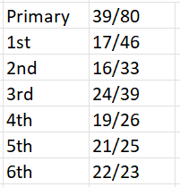
Figure 7: Gear Ratios for RS 660
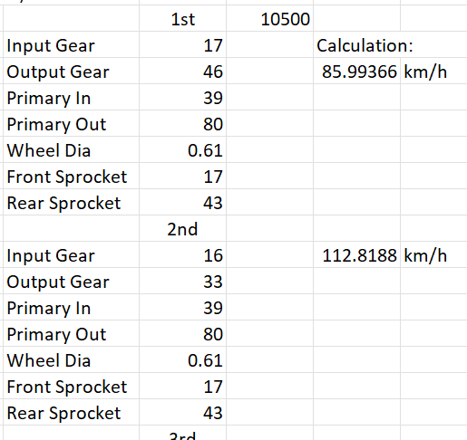
Figure 8: Data for 1st and 2nd Gear with Max Speed in Km/h
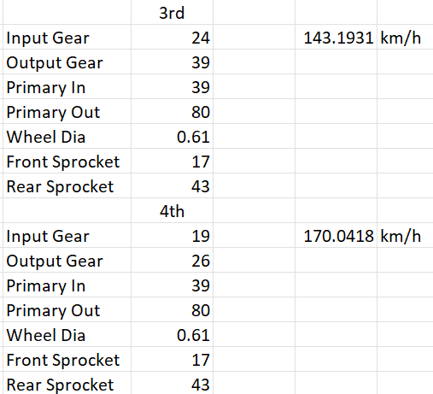
Figure 9: Data for 3rd and 4th Gear with Max Speed in Km/h
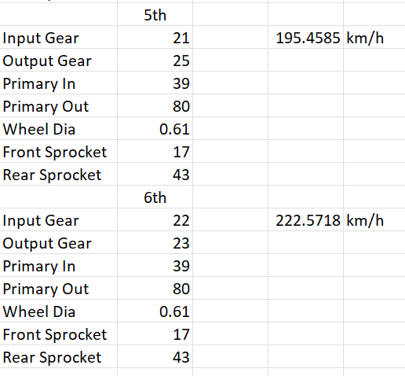
Figure 10: Data for 5th and 6th Gear with Max Speed in Km/h

For the RS 660 we can do these same calculations. We assume the same density, same drag coefficient and also same gradient. We can also assume the motorcycle is going at its fastest speed of 222.57Km/h, and I have calculated the frontal area to be 0.173m². We will have to again convert the Km/h into m/s, which will be: $222.57*\frac{1000}{3600}=61.83m/s$. This means the calculations will be as follows: $\left(0.5835*1.8*0.173*{61.83}^{2}\right)+\left(0.02*239.9*9.81\right)=741.71N$
And with a gradient of 7.5°, the calculation will be: $741.71+\left(239.9*9.81*Sin\left(7.5\right)\right)=1048.89N$.
From these calculations, we can see that the Kawasaki ZXR 750 requires less force than that of the Aprilia RS 660 to gain its top speed with a difference of 113.54N on flat ground and with a gradient, a difference of 71.22N.

Conclusion
This essay shows that there are multiple differences between the newer and older styles of motorcycle, even though the Kawasaki ZXR 750 has a higher top speed calculated from its gear ratios, the smaller Aprilia RS 660 only lacks in top speed by around 7Km/h, this is due to the weights of the motorcycles being almost 40Kg apart, the ZXR 750 being 191.9Kg and the RS 660 is 158.85Kg. With the calculated Centre of Gravity (CoG) being similar in terms of the X axis but almost 0.2m different on the Y axis, it shows that the weight distribution on the older ZXR 750 gives the bike a little more control under braking, whilst the RS 660 opts slightly toward more load transfer.

Reference List
∙ The Engineering ToolBox (2004). Drag Coefficient. [online] Available at: https://www.engineeringtoolbox.com/drag-coefficient-d_627.html [Accessed 20 December 2023].

∙ Hancock (2021) 'Aprilia RS660 Trofeo Race Bike Officially Revealed', Visordown, Available at: https://www.visordown.com/news/general/aprilia-rs660-trofeo-race-bike-officially-revealed. (Accessed 10 December 2023).
∙ Motoplanete, 'Kawasaki ZXR 750 Stinger H1 1989', Motoplanete, Available at: https://www.motoplanete.com/kawasaki/2469/ZXR-750-STINGER-H1-1989/contact.html. (accessed 8 December 2023).

