Name: Katherine Perez
Your Student Number: 1921322
Your Module Title: Marketing Management
Assignment Title: Assessment 2
Your Module Lecturer’s name: Tushara Balendran

1. MACRO AND MICRO MARKETING ANALYSIS OF MCDONALDS
INTERNAL ANALYSIS
McDonald’s logistics includes; the procurement and shipment of raw materials in to suppliers, the procurement and shipment of finished goods between the suppliers and the distribution centre, together with the warehousing at each distribution centre, the ordering and the delivery to restaurants of all food, packaging and operating supplies.

EXTERNAL ANALYSIS
Our world is getting concern on environment issue and business operating here should not just care for profit, but careful usage of world resources for sustainable development and care for environment safety and health for our future generation. Imagine millions of people purchase from fast food operator and how is the impact to world environment by throwing away those hard to recycle packaging.

MARKET POSITION
The threat of substitute is high in the fast food market due to the strong competition and the increasing amount of ready to eat foods. The threat of new entrant is low in the fast food industry because of the amount of competition with the big players in the market. Porter’s five forces model is used as the tool to analyze the market competition in the European and the middle east market.

MARKETING STRATEGY AND MIX
While doing the research on the five Ps, McDonald’s relationship marketing is also examined, that is viewed as an asset and the company’s marketing goal is to attract, maintain, and enhance customer relationships. Considering the diverse range of culture, custom in different countries, McDonald’s has localized its marketing communication strategy using different promotion and advertisement. It is called “McDonald’s Plan to Win” which was to put the company’s concentration on the five drivers of exceptional customer experiences – Product, People, Place, Promotion and Price.

PERFORMANCE MEASUREMENT
Recently McDonald’s acquired Boston Market Chicken restaurants, the Donatos pizza chain and Chipotle Mexican Grill. Officially McDonald&#39;s names three elements in their strategy to be the world’s best quick service restaurant: People (being the best employer), Customers (providing them excellence) and System Growth (for owner operators, suppliers and company). Recently McDonald&#39;s acquired Boston Market Chicken restaurants, the Donatos pizza chain and Chipotle Mexican Grill.

McDonald’s PESTEL/PESTLE Analysis

Political Factor Affecting McDonald’s
In relation, governments have evolving public health policies, which present a threat and an opportunity for the restaurant chain business. This PESTEL/PESTLE analysis also identifies governmental guidelines for diet and health as a threat and an opportunity for the restaurant chain business. In relation, governments have evolving public health policies, which present a threat and an opportunity for the restaurant chain business.

Economic Factor Important to McDonald’s
The slow but stable economic growth of developed countries is an opportunity for McDonald’s to grow and increase the stability of its restaurant chain business. The slow but stable economic growth of developed countries is an opportunity for McDonald’s to grow and increase the stability of its restaurant chain business.

Social/Sociocultural Factor Influencing McDonald’s Business Environment
McDonald’s corporate social responsibility strategy and stakeholder management initiatives partially counteract the negative effects of such social trends on the business.

Technological Factor in McDonald’s Business
Advances in food technology should be utilized to improve the product offerings and attract customers who may feel distanced by the ‘junk food’ tag attributed to McDonald’s foodstuff. Based on the technological trend of increasing sales through mobile devices, the company can expect revenue growth through mobile channels.

Ecological/Environmental Factors
In this aspect of the PESTELPESTLE analysis, the ecological external factors highlight corporate social responsibility opportunities, although McDonald’s also needs to further diversify its supply chain to address the effects of changes in climate conditions.

Legal Factor
McDonald’s Corporation must consider the following legal external factors in its industry environment:
- Increasing health regulations in workplaces and schools (threat)
2.Increasing animal welfare regulations (threat & opportunity)
3.Rising legal minimum wages (threat) Health regulations impose limits on the accessibility and availability of fast food in some workplaces and schools.

PESTEL/PESTLE Analysis of McDonald’s Corporation – Recommendation
Regarding the threat of cultural diversity, it is recommended that McDonald’s improve the flexibility of its international operations to ensure that menu items match target consumers’ preferences.

Five Forces Analysis Example: McDonald
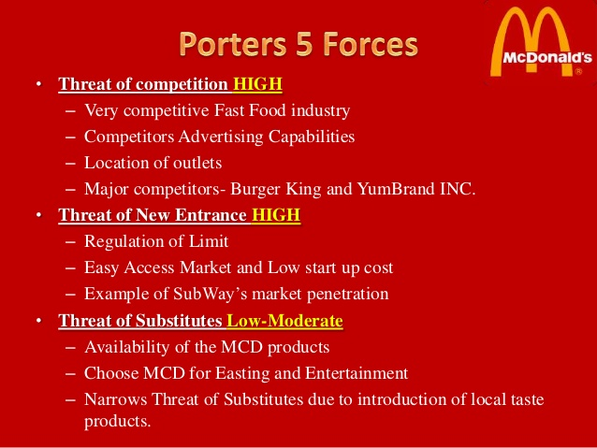

The threat of substitute is high in the fast food market due to the strong competition and the increasing amount of ready to eat foods. The threat of new entrant is low in the fast food industry because of the amount of competition with the big players in the market. Porter’s five forces model is used as the tool to analyse the market competition in the European and the middle east market.

- SWOT ANALYSIS OF MCDONALDS
Strengths of McDonald’s
•It has a wide range of products, starting from burgers, smoothies, shakes, ice cream and snacks items vary from place to place.
•It provides the food items according to the region, like in India the consumption of non-veg items are relatively low.

Weakness of McDonald’s

- There is negative publicity about the products that McDonald&#39;s sell are fast food and contains a high amount of fat, carbohydrates, salt and sugar.
- Can start developing the supply chain for the related products in the market so that they can generate revenue from other segments as well.
- The competition in the market is very high, the market is more saturated and intensity of competition is high
- In the new product segments the company have to compete with the market leaders such as Starbucks and Subway.

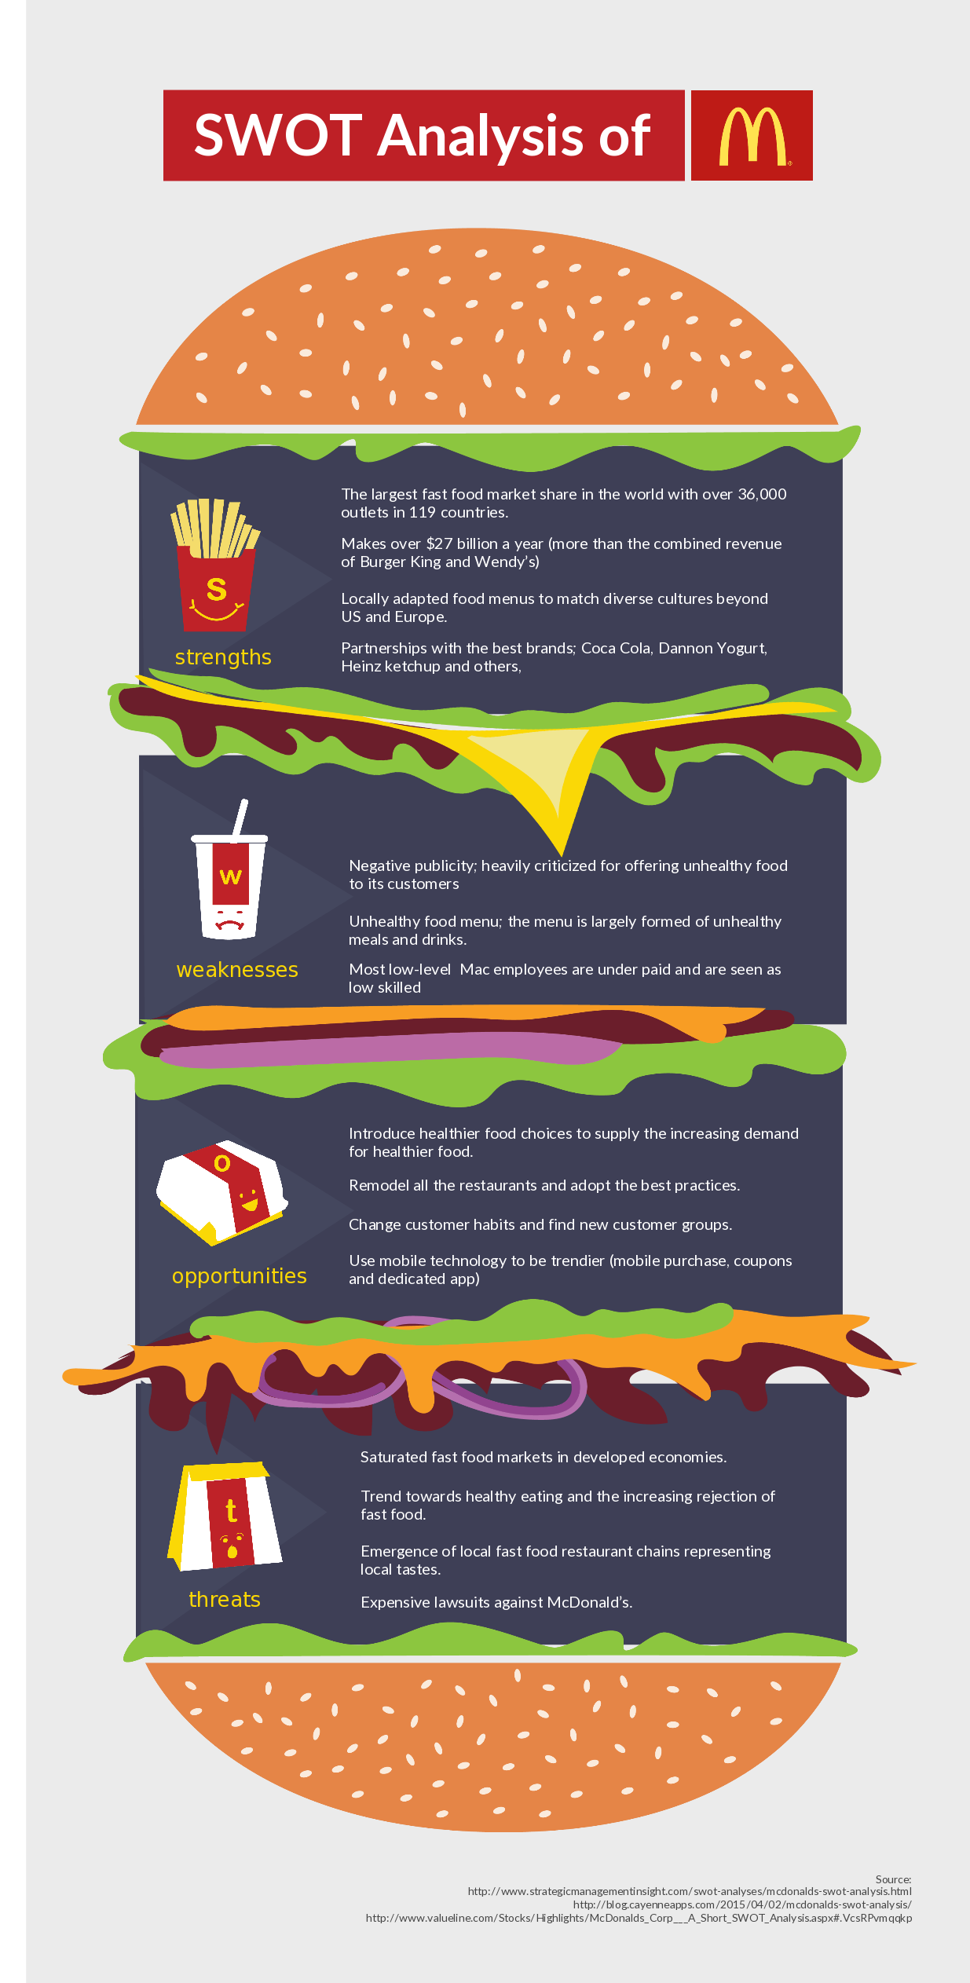
SEGMENTATION, TARGETING AND POSITIONING MCDONALDS
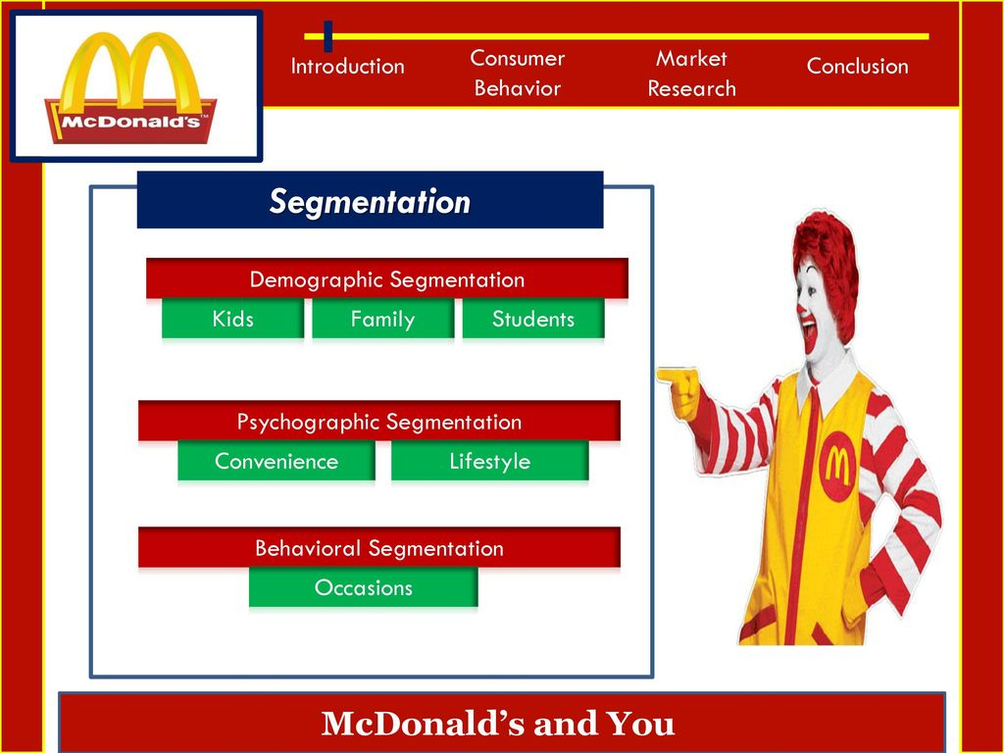

MC Donald’s respect cultural differences in their respective countries, In US people tend to have beef rather than chicken and in India, China people don’t like to have beef, so Mc Donald’s has more chicken items on their menu. Donald’s has introduced Mc Spaghetti to its menu and in the Middle East its has introduced Mc Arabia.

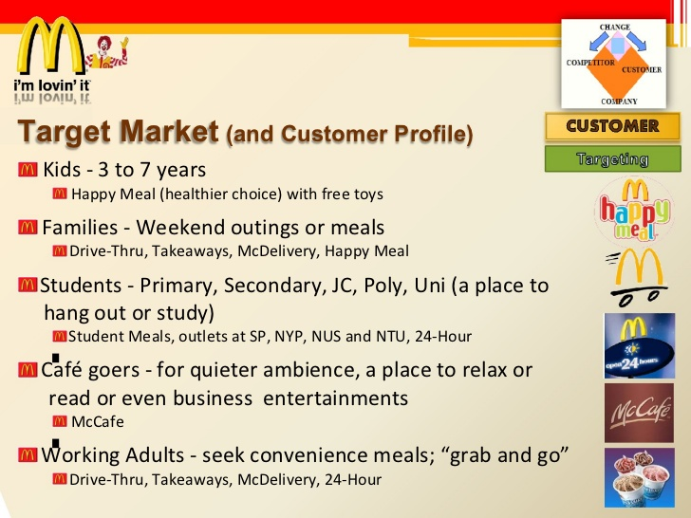

MC Donald’s all day breakfast has been on the menu for a long time is has started newly in Australia and New Zealand to serve breakfast lovers during the whole day.

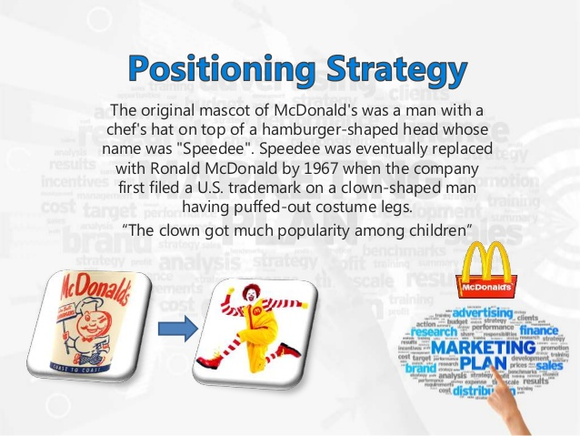

On finalizing the market segments that the company wants to target, the marketer’s next step is to design a marketing program (also known as the marketing mix) that will resonate with the target market or markets. Shadow on the billboard shows what’s being served at Mc Donald’s; the second image is a giant egg that breaks into half between 6.30 am to 10.30 pm indicates that Mc Donald’s serves breakfast this differentiation from the organization makes them position their brand in consumers mindsets.

McDonald's Marketing Mix (4Ps) Strategy

Product in the Marketing mix of McDonalds
As a food service business, McDonald’s has a product mix composed mainly of food and beverage products. But even with all this change, McDonald’s kept to their philosophy, providing quality food and a quality service in a fast and easy environment and with this philosophy they maintained their place in the market.

Price in the Marketing mix of McDonalds
“McDonald’s overall pricing objective is to increase market share.” (Vignali, 2004) With the original research that was done to create a successful marketing strategy, McDonald’s Corporation researched the demand, competitor’s position in the market and the cost of creating the product and created a price that will create a customer demand. Thus, this element of McDonald’s marketing mix highlights the importance of bundle pricing and psychological pricing to encourage customers to buy more products.

Promotions in the Marketing mix of McDonalds
McDonald’s uses the following tactics in its promotional mix, arranged according to significance in the business: In this element of its marketing mix, McDonald’s Corporation emphasizes advertising as its main approach to promote its products. There are four ways to promote a product in the world of marketing; advertising, direct marketing, sales promotions and public relations.

Place in the Marketing mix of McDonalds
For example, the company’s mobile apps for iOS and Android let customers claim special deals, find restaurant locations, place orders, and pay for such orders involving participating McDonald’s restaurants. Using these marketing strategies and maintaining the goal of providing quality service and food in an inviting environment at a fast and easy pace, will allow McDonald’s to remain on top of the market of fast food retailers.

4. RECOMMENDATIONS
If McDonald’s can develop more and more in Asia, it is a huge advantage for company to gain market share. However, customers are not pleased at the idea of waiting in long lines and insufficient employees to handle the volume of customers. At the market which has high market share and very huge number of customers such as USA, Canada or United Kingdom, this issue occurs more frequently.

5. REFERENCES
Baines, P Fill & Page, K 2008, Marketing, Oxford University Press, Oxford.
Ballantyne, D Christopher, M and Payne, A 2003, ‘Relationship marketing: looking back, looking forward’, Marketing Theory, vol. 3, no. 1, pp. 159-166.
Harker, M and Egan, J 2006, ‘The past, present and future of relationship marketing’, Journal of Marketing Management, vol. 22, no. 1, pp.215-242.
Jones, T and Sasser, W 1995, ’Why satisfied customers defect’, Harvard Business Review, vol.1, no. 1, pp. 88-89.
Lagrosen, S and Lagrosen, Y 2003, ‘Management of service quality-differences in values, practices and outcomes’, Managing Service Quality, vol. 13, no. 5, pp. 370-381.
Mouzas, S Henneberg, S and Naude, P 2007, ‘Trust and reliance in business relationships’ European Journal of Marketing, vol. 41, no. 9, pp. 1016-1032.
Narayandas, D 2005, ‘Building loyalty in business markets’, Harvard Business Review, vol. 2, no. 1, pp. 1-9.
Payne, A and Frow, P 2005, ‘A strategic framework for Customer Relationship Management’, Journal of marketing, vol. 69, no. 4, pp. 167-176.
Thomas, J & Earl, S 1995, ‘Why Satisfied Customers Defect’, Harvard Business Review, vol. 1, no. 3, pp.1-15.
Ahmed, S. (2017). China’s Footprints on the Global Economy: Remarks delivered at the Second IMF and Federal Reserve Bank of Atlanta Research Workshop on the Chinese Economy. U.S. Federal Reserve System.
Anaf, J., Baum, F. E., Fisher, M., Harris, E., & Friel, S. (2017). Assessing the health impact of transnational corporations: A case study on McDonald’s Australia. Globalization and Health, 13, 7.
Coombes, R. (2004). McDonald’s profits drop and Mars abandons king size bars. BMJ : British Medical Journal, 329(7470), 820.
Gillespie, A. (2007). PESTEL analysis of the macro-environment. Foundations of Economics. Oxford University Press.
Housing Industry Association (2011). An Introduction to PESTLE Analysis. HIA Ltd.
McDonald’s Corporation – Company Overview.
McDonald’s Corporation – Form 10-K.
Murphey, M., & Gause, R. (1974). UCF Research Guides: Industry Analysis – PESTLE Analysis. Business Horizons, 17(5), 27-38.
Roper, K. (2012, November). BIM Implementation: PESTEL Drivers & Barriers (Cross-national Analysis). In World Workplace 2012. IFMA.
U.S. Department of Agriculture – Economic Research Service – Food Service Industry – Market Segments.
Yüksel, İ. (2012). Developing a multi-criteria decision making model for PESTEL analysis. International Journal of Business and Management, 7(24), 52.
U.S. Global Change Research Program – Regional Climate Information & Modeling.

