
Name: Akashdeep
Student id: 2223250
Module Title: | Dissertation
Module Code: | LCMB7020
Course: | MASTER OF BUSINESS ADMINISTRATION IN General Management
Dissertation Topic: | Examining the increasing scope of entrepreneurship in the UK and implication in driving competition and productivity
Lecturer: | Dr. Jaya Gopalkrishnan


Master’s Degrees by Examination and Dissertation
Declaration Form.
1. This work has not previously been accepted in substance for any degree and is not being concurrently submitted in candidature for any degree.
Signed : Akashdeep
Date : 08/02/2024

2. This dissertation is being submitted in partial fulfilment of the requirements for the degree of Master in Business Administration.
Signed : Akashdeep
Date : 08/02/2024
3. This dissertation is the result of my own independent work/investigation, except where otherwise stated.
Other sources are acknowledged by footnotes giving explicit references.
A bibliography is appended.
Signed candidate : Akashdeep
Date: 08/02/2024

4. I hereby give consent for my dissertation, if accepted, to be available for photocopying, inter- library loan, and for deposit in the University’s digital repository
Signed Akashdeep
Date : 08/02/2024

Supervisor’s Declaration.
I am satisfied that this work is the result of the student’s own efforts.
Signed: Dr. Jaya Gopalkrishnan
Date: 08/02/2024

University of Wales: Trinity Saint David
E-Thesis Deposit Agreement

Details of the Work
I would like to deposit the following item in the digital repository maintained by the University, and/or in any other repository authorized for use by the University:

Title: Examining the increasing scope of entrepreneurship in the UK and implication in driving competition and productivity

This item is a product of my own research endeavours and is covered by the agreement below in which the item is referred to as “the Work”. It is identical in content to that deposited in the Learning Resources Centre, subject to point 4 below.
I agree that the University of Wales: Trinity Saint David may electronically store, copy or translate the Work to any approved medium or format for the purpose of future preservation and accessibility. The University is not under any obligation to reproduce or display the Work in the same formats or resolutions in which it was originally deposited.
UW: TSD Digital Repository
I understand that work deposited in the digital repository will be accessible to a wide variety of people and institutions, including automated agents and search engines via the World Wide Web.
I understand that once the Work is deposited, the item and its metadata may be incorporated into public access catalogues or services, such as national databases of electronic theses.

I agree as follows:
- That I am the author or have the authority of the author/s to make this agreement and do hereby give the University of Wales: Trinity Saint David the right to make available the Work in the way described above.
- That the electronic copy of the Work deposited in the digital repository and covered by this agreement, is identical in content to the paper copy of the Work.
- That I have exercised reasonable care to ensure that the Work is original, and to the best of my knowledge, does not breach any laws including those relating to defamation, libel and copyright.
- That I have, in instances where the intellectual property of other authors or copyright holders is included in the Work, gained explicit permission for the inclusion of that material in the Work, and in the electronic form of the Work as accessed through the open access digital repository, or that I have identified and removed that material for which adequate permission has not been obtained and which will be inaccessible via the digital repository
- That University of Wales: Trinity Saint David does not hold any obligation to take legal action on behalf of the Depositor, or other rights holders, in the event of a breach of intellectual property rights, or any other right, in the material deposited.
- That I undertake to indemnify the University of Wales: Trinity Saint David against all actions, suits, proceedings, claims, demands and costs occasioned by the University in consequence of any breach of this agreement

Signature: Akashdeep
Date: 08/02/2024

Acknowledgement
I like to convey my deepest appreciation to my supervisor Dr Jaya Gopalkrishnan for guiding and providing feedback throughout this study.
I am indebted to my colleagues and friends who supported me and assist me in gathering prerequisites for my study. Finally, I am grateful to my family for helping me complete my education and supporting me throughout the journey.
Your Signature: Akashdeep
Date:08/02/2024

Abstract
There are several opportunities for entrepreneurship in the UK market. Therefore, challenging factors such as lack of proper decision-making ability, lack of skilled workforce are adversely affecting business. Using disruptive innovation, improving the employee skill and knowledge through education and training programs and being consumer focused, the enterprises can increase competitiveness and performance in business.
The introduction has set focus by highlighting background information about scope of entrepreneurship in the UK. Focus has been given on examining both implication of entrepreneurship in the UK.
Followed by the introductory chapter, the literature review chapter has set the scene by cross evaluating contemporary literature surrounding the topic area. Describes methodology and tools used in the overall search work for finding the current scope of entrepreneurs in the UK. The scope and competition of entrepreneurs in the UK has been investigated by the collection of mixed data through Interview and survey. Adoption of appropriate research philosophy is important for evaluating the reality and nature of collecting data from the entrepreneurs of the UK. This chapter provides considered ethical consideration during development of the mixed research through survey and interview in for finding the current scope of entrepreneurs in the UK.
In data analysis, the research has followed the NVIVO analysis in which thematic content analysis has been applied. In these, themes and sub-themes have been developed by focusing on entrepreneurship influence on productivity and competitiveness, future predictions in entrepreneurship and support from governments through policies and initiatives. The research uses SPSS for the derivation of primary quantitative data for development knowledge about the factors that influence the business competitiveness and productivity of entrepreneurs in the UK.

Acknowledgement
I like to convey my deepest appreciation to my supervisor Dr Jaya Gopalkrishnan for guiding and providing feedback throughout this study.
I am indebted to my colleagues and friends who supported me and assist me in gathering prerequisites for my study. Finally, I am grateful to my family for helping me complete my education and supporting me throughout the journey.
Your Signature: Akashdeep
Date:08/02/2024

Table of Contents
Acknowledgement 6
Abstract 7
Acknowledgement 8
Chapter 1: Introduction 14
1.1 Introduction 14
1.2 Background 14
1.3 Rationale 16
1.4 Problem Statement 16
1.5 Aim 18
1.6 Objective and Question 18
1.7 Methodology Overview 19
1.8. Research Gap 20
1.9 Significance of the Research 20
1.10 Structure of Report 21
Chapter 2: Literature Review 23
2.2 Importance of entrepreneurship 24
2.3 The increasing scope of entrepreneurship in the UK 26
2.4 Government efforts amd support for entrepreneurship in the UK 31
2.5 Impact of Covid-19 on entrepreneurship 32
2.6 Implications for entrepreneurship in the UK 34
2.7 Future of Entrepreneurship in the UK 37
Chapter 3: Research design and Methodology 40
3.1 Introduction 40
3.2 Research Philosophy 40
3.3 Research approaches 41
3.4 Research design 42
3.5 Research Strategy 42
3.5.1 Type of Investigation 44
3.5.2 Choices 44
3.5.3 Time Horizon 45
3.6 Sampling method 46
3.6.1 Sample type 46
3.6.2 Sample size 46
3.6.3 Sampling method 46
3.7 Data collection method 47
3.8 Data analysis plan 47
3.9 Ethical considerations 48
3.10 Research limitations and Accessibility issues 48
3.11 Summary 48
Chapter 4: Data analysis and discussion 50
4.1 Introduction 50
4.2 Data analysis plan 51
4.3 Findings of the research 52
4.4 Data interpretation and analysis 53
4.5 Discussion 77
4.6 Summary 80
Chapter 5: Conclusions and recommendations 81
5.1 Introduction 81
5.2 Conclusion 81
5.3 Recommendations 84
5.4 Research Limitations 86
5.5 Future research suggestions 87
References 89
Appendices 99
Appendix 1: Survey Analysis 99
Appendix 2: Interview analysis (NVIVO) 109
Google form question 114

List of Figures
Figure 1.1: Entrepreneurial Attitude in UK 9
Figure 1.2: Total Early-Stage Entrepreneurial Activity 10
Figure 3.1: Concept of research approaches 30
Figure 3.2: Concept of research strategies 32
Figure 3.3: Time horizon for the research 34
Figure 4.1: NVIVO output on entrepreneurship influence with innovation and disruption 42
Figure 4.2: Under-skilled technological staff as a challenge for entrepreneurship 43
Figure 4.3: Percentage of business operations in the UK being innovation active 44
Figure 4.4: NVIVO output on entrepreneurship and its future predictions 46
Figure 4.5: NVIVO output on entrepreneurship related to government policies and initiatives 47
Figure 4.6: Percentage Analysis of UK economic growth is crucial for the entrepreneurship 50
Figure 4.7: Determination of frequency of key parameters associated with successful entrepreneurship 51
Figure 4.8: Impact of entrepreneurship on societal change in the UK 52
Figure 4.9: Percentage Analysis of entrepreneur’s contribution in increase of national income of the UK 54
Figure 4.10: Determination of Change in entrepreneur’s landscape of the UK 55
Figure 4.11: Percentage Analysis of Entrepreneurs ecosystem depends on SMEs, start-up and joint venture 56
Figure 4.12: Determination of Entrepreneurs impact on UK market dynamic and competition 57
Figure 4.13: Percentage Analysis of Challenges causing Entrepreneurs disruption in UK 58
Figure 4.14: Determining agreements of Lower entry barrier for start-ups creates competition 59
Figure 4.15: Determining UK entrepreneur’s contribution for Customer satisfaction and experience 61
Table 4.16: Percentage Analysis of importance of innovation for UK entrepreneurs 62
Figure 4.17: Determination of UK entrepreneur’s success at productivity 63
Figure 4.18: Determination of Correlations 63
Figure 4.19: Determination of MODEL Summary 64
Figure 4.20: ANOVA 64
Figure 4.21: Determination of Coefficients 64

Chapter 1: Introduction

1.1 Introduction
Entrepreneurship remains the main engine powering job creation, growth, and innovation across the world, in the face of rising global economic instability. This dynamic catalyst propels the birth of new firms and the enlargement of the existing ones, creating jobs, market competition etc. Amidst the globalization, technological progress and integrated marketing, the recruitment strategies of industries change in nature becoming entrepreneurial - the ventures which drive massive economic progress. The transformative power of entrepreneurship is not a contemporary phenomenon but is centuries old, adapting to changing global economies’ landscapes. Fundamentally, entrepreneurship is the process of the realization of goals and enterprise creation, which includes innovativeness, proactivity, and risk-taking. This initiative is not only about the societal alteration but also raises the economies by introducing new technologies, increasing the life quality, and providing access to products and services. In the United Kingdom, entrepreneurship has redefined economic and innovation landscapes; this is evident from the major increase in business startups. This surge brings out the UK’s determination to realise innovation and entrepreneurship. British entrepreneurial landscape displays a clear correlation between the startup and SME importance in the national economy and the entrepreneurship - driven competitiveness of the country. The introduction will highlight entrepreneurship as the backbone of economic dynamism and innovation, focusing on the case of the UK.

1.2 Background
The meaning of entrepreneurship has travelled the full historical path, experiencing a considerable transformation from its relatively early form to what it has become now, a major pillar of the modern economy. Historically entrepreneurship has been associated with the innovation process, taking risks to start a business and ultimately use business opportunities for market exploitation. The development of the idea illustrates society's ever-changing priorities, new technological breakthroughs, and economic conditions. Scholars such as Park (2017) have described this evolution, pointing out that entrepreneurship has appeared in many forms which have developed second to and in response to their era's economy type.
The recent decades have seen the advent of globalization, technological innovations as well as integrated marketing strategies which have disrupted the state of industrial recruitment and economic growth (Ratten, 2023). The transformations have put into focus the critical role of entrepreneurship in economic growth, innovation, and competitiveness. Entrepreneurs are the opprobrium of their inventiveness, which brings forth the creation of new businesses and as well accounts for market competition, new jobs, and wealth creation. This shift is noticeable most specifically in the UK, where the entrepreneurial ecosystem has undergone a wholescale change (Europa, 2017).
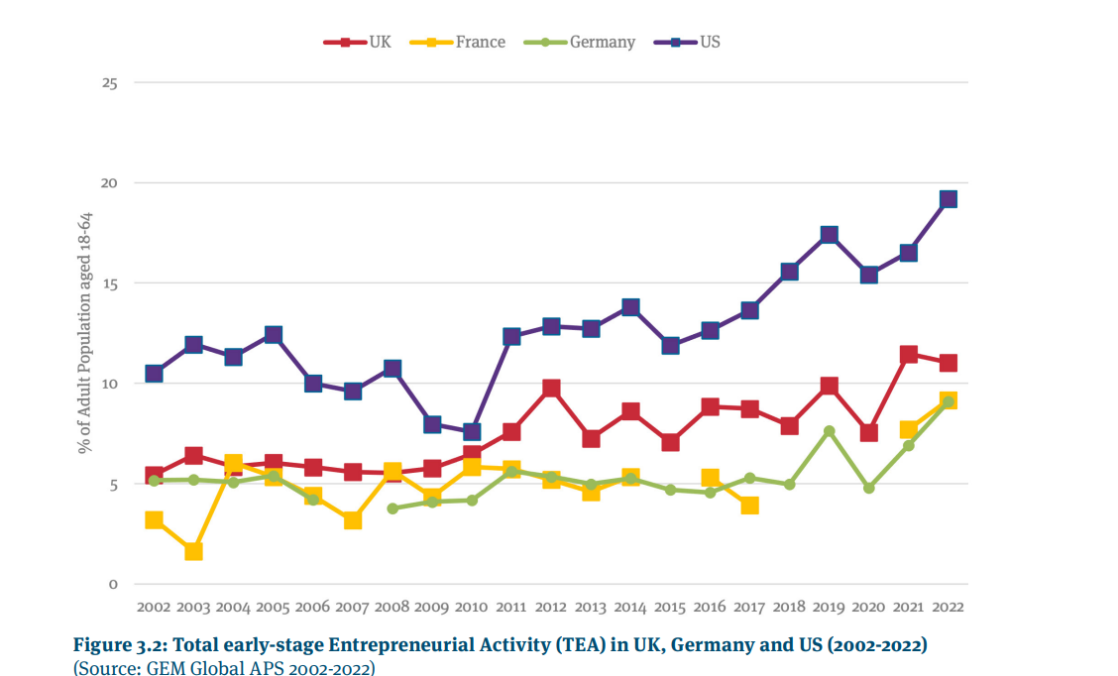

Figure 1.1: Entrepreneurial Attitude in UK
Source: Hart, et al., (2023)
The UK has become known as a leading case of how entrepreneurship can transform into a nation's economic and technology landscape. It is estimated to be 590,000 just in 2017 (Forbes, 2022) on the UK businesses which illustrates an intrepid entrepreneurial spirit. One of the factors supporting this entrepreneurship boom is a business-friendly climate which rates among the most technologically innovative, upskilled, and supportive of entrepreneurship among major European economies. The distinguishing feature of modern economic systems is their dynamic nature driven by a variety of businesses - small businesses, startups, and innovative ventures in the UK. This background highlights the transformative effect of entrepreneurship in relation to economic structures, in particular, resilience and growth of the British economy.

1.3 Rationale
The research of entrepreneurship within the UK's economic system is crucially needed since its influence on the country's economic growth, innovation, and competitiveness is very unique and remarkable. With the burgeoning economic uncertainties, understanding and exploiting the potential of entrepreneurship is now more pressing than ever before. The UK where startup businesses have increased, and the business-friendly environment makes an interesting case in how entrepreneurship promotes economic development. This study seeks to explore the unique features of entrepreneurship, including innovation, risk taking and proactivity, which lead to the birth of the new firm, creation of market competition and generation of wealth. Considering the dynamic nature of the UK entrepreneurial ecosystem, which includes many SMEs and innovative start-ups, studying these s detailed (edited) problem will contribute understanding of the role of entrepreneurship in stimulating economic resilience and growth. Knowing these dynamics is essential for policy makers, entrepreneurs and scholars who want to create an environment that supports successful entrepreneurs and in essence economic growth.

1.4 Problem Statement
Entrepreneurship, as an acknowledged major driver of economic growth and innovation, is characterised by the gaps in the knowledge of its multiple roles within the UK’s economy. The transformative character of entrepreneurship, which is determined by global economic shifts, technological breakthroughs and altered market trends presents both challenges and opportunities for comprehensive investigation. Particularly, the existing literature is missing a holistic assessment of how the peculiar features of entrepreneurship, i.e., innovation, autonomy, and risk-taking (Park, 2017) (Prince et. al., 2021), impact the economies’ resilient and competitive spirit in the era of growing global uncertainties.
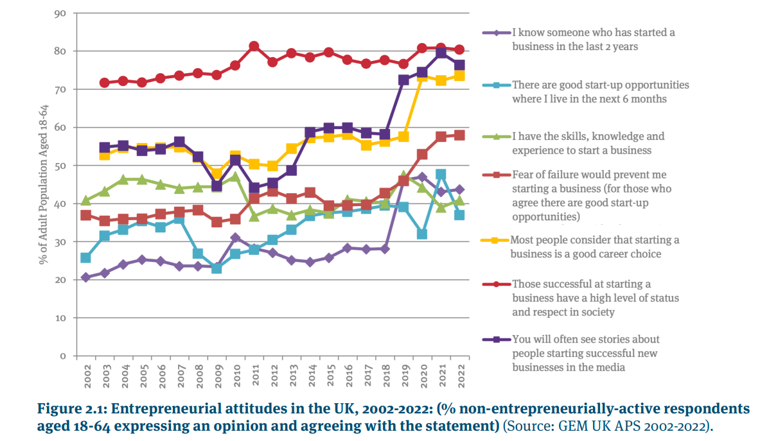

Figure 1.1: Entrepreneurial Attitude in UK
Source: Hart, et al., (2023)
It appears that both males and females perceive good start-up opportunities in the coming six months in UK, though they have a consistently large gap between them. Females and males perceived start-up opportunities sharply decreased in 2022(Hart, et al., 2023). There was an increasing fear of failure among females in 2022, whereas it declined marginally among males. Since the Global Financial Crisis (GFC) recession, fear of failure has increased in both cases (Hart, et al., 2023).
Also, though the great expansion of business are startups in the UK and its favourable position for entrepreneurial activities (Forbes, 2022) is recognised, there is a demand to know how these elements translate into sustained economic growth and innovation. The difficulty is in the gap between the theoretical frameworks of entrepreneurship and their practical implementation in the UK's specific economic situation which leads to a continuous debate on the features and characteristics of British entrepreneurship. In this paper we want to fill some of the blanks on the subject by looking at the specific channels through which entrepreneurship affects development, employment, competition in the market and wealth generation in the UK.

1.5 Aim
The main purpose of this work is to disclose the critical function of entrepreneurship in promoting economic growth, innovation, and competitiveness in the United Kingdom. This study builds on the evolving dynamics of entrepreneurship in the scholarly realm explained by scholars like Park (2017) and the economic impact evident from works such as those by Forbes (2022), to provide a broad understanding of how entrepreneurship builds the UK's economy. It will explore the attributes of entrepreneurship which stimulate firm creation, intensify competition in the markets and speed up wealth creation, thereby providing explanations for how entrepreneurship contributes to economic prosperity of the UK.

1.6 Objective and Question
The research aims to achieve the following objectives:
- To analyze the evolution of entrepreneurship in the UK, focusing on the way historical trends and recent developments have impacted the current entrepreneurial context. The aim of the first objective is to put the growth of the entrepreneurship within the wider economic and scientific transformations that happened at a global scale and particularly in the UK.
- To analyze the features of entrepreneurship that drive economic competitiveness and innovation in the UK, primarily being traits of innovation, risk-taking, autonomy, and future orientation (Park, 2017; Prince et al., 2021). This entails looking into how these attributes materialize in the UK's entrepreneurial enterprises and their influence on economic development.
- To evaluate the effect that entrepreneurship has on job creation, market competition and wealth dispersion within the UK. This also involve assessing the extent to which entrepreneurship results into the creation of new firms, disrupting the existing markets and the improvement of the UK’s economic stability and competitiveness.
- To examine the influence of the UK’s business environment on promoting entrepreneurship through support mechanisms, policies, and economic conditions stated to be favourable for the venture development (Forbes, 2022). The post investigation outcome will be based on the findings of business environment development and sustainability continuum. This should include factors like performance gaps, performance evaluation, relationships development i.e. resource efficiency, flexibility, excellent financial reporting, and
Guided by these objectives, the research will address the following questions:
- What has been the transformation of the idea and the practice of entrepreneurship in the UK and what historical and current factors have determined this transformation?
- Which features of entrepreneurship play the biggest role in stimulating the economy and innovation in the UK?
- How does entrepreneurship shape job creation, market competition, and wealth generation in the English market?
- How does the UK business environment either facilitate or limit the growth of entrepreneurship, and what policies could further facilitate entrepreneurial activity?

1.7 Methodology Overview
The research methodology of this study is integrative approach a combination of inductive and deductive approaches. Such an approach is a holistic one, which considers both data- and theory- driven analysis.
The study will commence in the data induction period by collecting data from different sources, such as business registries, entrepreneurial surveys for example, the GEM, and economic reports for the United Kingdom. The main aspect of the data collection is related to the number of startups, the rate of business survival, and the UK economy contribution from new companies. The analysis that follows looks for patterns and themes within the data, e.g. correlations between entrepreneurial activities and economic growth indicators.
Starting with these patterns, empirical generalizations will be made that form the ground of theorizing the influence of entrepreneurship in the UK economy. Through such deductive approach the theories will be anchored to the observed data which serves as a solid platform for the formulation of further hypotheses.
Having played the analytical method, the deductive method will come into action, where hypotheses developed from the existing theories will be tested. It includes a particular level of concentration, for instance, the effect of some entrepreneurial traits on business success ratios. Dataset collection for this phase can be in form of surveys, interviews or case studies of UK-based entrepreneurial ventures. The sequel analysis will establish if the data supports or disputes the hypotheses leading to further enhancement of the theories.
The research will sustain a constant dialectic between theory and the data in all stages of this process, thus allowing for constant refinement and validation of different findings throughout this research. This conceptual architecture will allow the UK economy to be studied systematically and hence more profoundly, producing fact- based, trust-worthy insights on the impact of entrepreneurship.

1.8. Research Gap
Extensive research has delved into the role of entrepreneurship in economic growth, yet a noticeable void exists in the distinct comprehension of how entrepreneurship’s varied features specifically lead to economic resilience and competitiveness within the context of UK Many studies generalise entrepreneurial impact without looking at the UK economic, cultural, and policy environments where entrepreneurial activities are embedded and embedded in (Audretsch et al., 2019). In addition to that, if there is an increasing number of startups in UK (Forbes, 2022) there is a lack of research regarding their long-term impact on market competition and innovation (Allas et al., 2021).
This study aims to fill these gaps from the perspective that the UK’s entrepreneurial ecosystem which consists of a combination of SMEs, startups and innovative ventures stimulates national economic dynamics and how that relates to national productivity and innovation trends. This study is important as it could influence policy making, support entrepreneurship programs and be the starting point for future studies which is a new point of view about the economic effects of UK entrepreneurship (NatWest Group, 2022).

1.9 Significance of the Research
This research has manifold significance which spans a wide spectrum of UK's economic demography. For policymakers, the findings will constitute empirical evidence for programs development that would foster the growth of entrepreneurship and economy. The study brings out the attributes and the forces that define the UK entrepreneurial ecosystem, and through such information, targeted policies can be formulated to foster business creation, innovation, and growth thus an enhancement of the nation’s global competitiveness (Audretsch et al., 2019).
Small business communities which include start-ups and SMEs have a lot to gain from greater insight into what dictates success in the UK’s entrepreneurial environment. The findings of this research can help entrepreneurs develop their strategies that are linked to established drivers of growth and innovation, hence more wealth could be generated as well as creation of jobs as suggested by high startup rates and the supportive business environment (Forbes, 2022).
This project will contribute academically to the general knowledge base by filling the gaps which exist in the literature about the economic impact of entrepreneurship in the UK. It will give a comprehensive assessment that incorporates data-driven findings with the theoretical perspectives, thus setting up the stage for a strong foundation for future research.

1.10 Structure of Report
The dissertation is organized into five key chapters, each serving a distinct purpose in the exploration of entrepreneurship's role in the UK economy:
Chapter 1: Introduction
Chapter 1 of the dissertation lays the groundwork for exploring entrepreneurship as an aspect of economic growth and innovation, mainly the UK context. It spells out the aims, objectives and questions researched toward to.
Chapter 2: Literature Review
The literature review integrates thebody of knowledge of existing studies on entrepreneurship as well as evaluates the burgeoning literature on the same topic.
Chapter 3: Methodology
The research design, qualitative methodology are explained in this chapter, further, the inductive and deductive grounded theory form the basis of data gathering and the subsequent analysis.
Chapter 4: Discussion and Analysis
Here, the findings are thoroughly scrutinized. The data collected through different methods is analysed leading to hypotheses testing. The findings are then discussed under the backdrop of the entrepreneurial landscape of the UK.
Chapter 5: Conclusion and recommendation
In final chapter the conclusions are made based on the findings of the study, showing the implications for theory and practice. It also gives suggestions to policymakers, entrepreneurs and future research and points the limitations of the study.

Chapter 2: Literature Review
To foster economic growth, drive innovation, and boost competitiveness, entrepreneurship plays a crucial role. Entrepreneurship has been expanding rapidly in the United Kingdom (UK), impacting a wide range of sectors. A literature review conducted here explores how entrepreneurship contributed to increasing productivity and competition in the UK in a multifaceted manner.
Figure 2.1: Conceptual framework
“EXAMINING THE INCREASING SCOPE OF ENTREPRENEURSHIP IN THE UK AND IMPLICATIONS IN DRIVING COMPETITION AND PRODUCTIVITY”

“Importance of entrepreneurship”

Implications for entrepreneurship in the UK

Impact of Covid-19 on entrepreneurship

“Increasing scope of entrepreneurship in the UK”

Government efforts amd support for entrepreneurship in the UK

Future of Entrepreneurship in the UK

creating jobs and driving economic growth

Higher bankruptcy rates
Business closures

gender gap in the UK economy
(Source: Created by author)

2.2 Importance of entrepreneurship
Doran, et al., (2018) stated that a different measure of entrepreneurship is examined in this paper to determine whether they can explain economic growth. The study analyses the contributions of entrepreneurship to Gross Domestic Product (GDP) per capita by using 14 different entrepreneurship indicators. This study also explores whether entrepreneurship is more important in high-income countries compared to middle- and low-income countries. During 2004–2011, 55 unbalanced countries have been included in this study. A principal component analysis was used to condense fourteen indicators of entrepreneurship into three components. Economic growth is then assessed through regression analysis using these three entrepreneurship components. High-income countries exhibit entrepreneurial attitudes that stimulate their GDP per capita, whereas middle- and low-income economies exhibit entrepreneurial activity that negatively impacts their GDP per capita.
Meyer & Jongh, (2018) noted that entrepreneurship contributes to sustained economic growth and development by creating jobs, increasing spending in markets, transferring knowledge, and creating employment. It has been found that very few empirical studies have examined the relationship between these three variables. As such, this study aims to identify and emphasize entrepreneurship's contribution to growth and development in the economy. An analysis of secondary time series data from 2005 to 2016 was conducted using a quantitative research design. Germany, the Netherlands, Hungary, Belgium, and Poland comprised the study area in the European Union (EU). Entrepreneurship, economic growth, and development appear to be inextricably linked. There are different factors contributing to economic development and growth in each country, as well as varying results. Although the Dutch, Hungarian, and Polish economies demonstrate entrepreneurial climates that are flourishing during the period under analysis, the analysis of their economies for the period under consideration reveals healthful economic and social environments(Meyer & Jongh, 2018). German and Belgian studies, however, point to subdued entrepreneurial growth. These findings suggest that the growth of the SME sector, particularly in transition economies, should be centralized as an important focus area for improving economic and social growth prospects.
Westhead & Wright, (2013) entrepreneurship looks at the important role entrepreneurs play in a capitalist economy and considers their history in terms of promoting economic development. They can create innovative change by transforming existing firms and exploiting new opportunities. While entrepreneurs can often prove to be panaceas for economic woes, this isn't always realistic. The magnitude of the problem has been overestimated. Even though entrepreneurship is attracting increasing interest and activity, considerable debate still surrounds the concept of entrepreneurs.
Toumazou, (2023)shopify entrepreneurs have ranked the UK fourth in the world for their entrepreneurial impact, according to a new index. A study conducted by Deloitte in partnership with Deloitte found that UK entrepreneurs contributed £14.3 billion to the GDP in 2022, grew exports by 8% and supported over 78,000 jobs directly. British Business Bank's Start Up Loans program and government expansions of tax relief are responsible for the UK's entrepreneurial success.
A staggering 98% of UK businesses are small businesses, making up the economic backbone of the country (IW Capital , 2019). A fantastic range of innovative ideas and SMEs that drive the private sector forward are provided by the entrepreneurialism of the UK's business leaders and founders. SME support is a key component of the UK economy, as they employ approximately 16 million people in the country, a number that is growing three times faster than that of large corporations. Growth and job creation in the domestic economy will play a crucial role in a post-EU economic landscape (IW Capital, 2019).

2.3 The increasing scope of entrepreneurship in the UK
Myers, (2014) Imperial has ranked the UK fifth in the world for entrepreneurship, while Europe's economy has become Europe's most entrepreneurial. Entrepreneurial attitudes and abilities have improved in the UK, which is the reason for the rise in the ranking. Compared to other leading countries, UK entrepreneurial aspirations remain relatively weak when it comes to innovation, risk-taking, and international orientation. Research shows that the UK is the most entrepreneurial economy in Europe and has a strong entrepreneurial profile in all areas. As far as UK entrepreneurs are concerned, their greatest strength is providing unique products or services that no other business is currently offering. According to the Index, UK businesses rank second after the US and Denmark. Entrepreneurial opportunities in the UK are also plentiful, as well as highly educated and skilled entrepreneurs. Risk capital, international business ventures, and start-up skills were the UK's relative weaknesses. Since the last report, UK support for entrepreneurs has improved, resulting in an improvement in entrepreneurship performance. For example, the UK Government provides start-up businesses with loans, advice, and mentoring through its start-up loan scheme. 30,000 new businesses were supported by the scheme by 2015 after having lent £120 million today to entrepreneurs seeking business funding. Generally, UK entrepreneurs perform well in entrepreneurship, according to the researchers. The private sector employed 27.5 million people in the UK at the beginning of 2023, according to government statistics, compared to 5.83 million in public services. At the beginning of 2023, small businesses accounted for 48% of the UK's business population, while small firms accounted for 61% (Higginbotham, 2024).
As of today, the number of private companies in the United Kingdom is approximately 5.55 million, which represents a two million increase from 3.47 million at the turn of the century. Over 4.48 trillion pounds worth of turnover is generated by the private sector as a whole, which employs around 27 million people(Statista, 2023). A total of more than one million businesses were registered in London in 2021, and the city was also the most start-up-frenzied, with 92.8 new firms per 10,000 people. BP and Tesco were bidding for the second and third-highest revenue positions, respectively, among UK-based companies. Shell had the highest revenue by a wide margin. As a result, the Bank of England has raised interest rates sharply due to high inflation, which peaked at 11.1% in October 2022. These factors may increase the likelihood that business investment will remain low going forward(Statista, 2023).
Blanchflower & Shadforth, (2007) analyzed the factors affecting entrepreneurship in the UK and their consequences. By international standards, the UK's self-employment rate is high, but it has fluctuated over the years. The changes in taxation rules and financial liberalization have led to large movements in self-employment, especially in the construction industry. Compared to employees, self-employed people earn less on average. Self-employed individuals are more likely to be males; immigrants; work in construction or financial activities; hold an apprenticeship; live in London; work long hours; and are more likely to be happy and content with their jobs. The estimates suggest that entrepreneurs who receive gifts and inheritances are more likely to become self-employed, consistent with the existence of capital constraints. Self-employment has also been found to be increasing because of rising house prices. Neither real GDP nor national happiness seem to be correlated with changes in self-employment.
Grinevich & Abreu, (2013)stated that there is an increased scope of academic entrepreneurship in the UK. Academic entrepreneurship literature focuses primarily on patent-based activities such as spinouts and licensing, but the author argues it should also include other informal commercial and non-commercial entrepreneurial activities. Academic activities beyond teaching and research that are innovative, accompanied by risk, and lead to financial rewards are considered entrepreneurial to us. The academic literature and TTOs often overlook informal activities in disciplines such as social sciences, the humanities, and the creative arts. An updated survey of UK academics has provided micro-data on more than 22,000 scientists, social scientists, and arts and humanities scholars. Additionally, financial and logistical support for entrepreneurial activities is provided at the institutional level to complement the data.
Lee, et al., (2023)Although there has been increased interest in crises within the field of entrepreneurship, the interplay between them remains unclear. It may also depend on the specific circumstances surrounding the crisis to determine the outcome of one type of crisis versus another. Additionally, we have included recent studies that looked at COVID-19 from an entrepreneurial perspective to provide a comprehensive review of crises beyond political, natural, and financial crises. Crisis-based entrepreneurship has been shown to increase significantly after a crisis, according to research. New firms driven by necessity, however, could negatively affect sustainable development in the economy. As a result, low-education and low-capital entrepreneurs do not experiment with new ideas like opportunity-oriented entrepreneurs but rather focus on easy and quick start-ups. Global and local crises are stabilized with tax credits, loans, and subsidies provided by governments. A positive impact of entrepreneurship requires certain conditions to be met. There is a need for a shift in the theoretical focus from one that tracks how many entrepreneurial activities there are during a crisis to one that evaluates the quality of such activities, particularly over the long term.
Dadwal & Farouq, (2018)discussed that there has been little research on entrepreneurship and the role it plays in economic growth in comparison to other factors primarily because of the difficulty in measuring entrepreneurship. While economic literature and models have been able to address a variety of elements of economic growth, entrepreneurs are rarely considered. In terms of economic advancement, factors such as knowledge, human capital, and physical capital don't fully explain what makes a country prosperous. Based on a regression model, this report assessed how entrepreneurship influences economic growth in the UK. Using GDP per capita as the dependent variable, the model measured economic development each year. Several start-ups and unemployment rates were independent variables in the study. According to the analysis, unemployment hurts economic growth and is the most significant variable in the research. The economy movement was not adequately affected by the estimated model. This study also found no significance for the self-employment coefficient. In conclusion, the study found that entrepreneurship has no significant effect on economic growth.
Summerfield, (2020) stated that economic growth, investment, inflation, interest rates, and availability of infrastructure are the most commonly defined macroeconomic determinants of entrepreneurship. As Summerfield, (2020) notes, there is a positive correlation between health expenditures, infrastructure investment, and education spending and the number of start-ups. The factors that enhance entrepreneurial activities can be categorized as push factors or pull factors. Economic recession, job loss, job dissatisfaction, low family income, challenging working conditions, and job dissatisfaction are some of the key factors that push workers away. Ratten, (2023) describes pull factors as needs for autonomy and self-actualization, wealth creation, and social status and power enhancement. Both push and pull factors can enhance entrepreneurial activity in some instances. The most common reason for entrepreneurship, according to Chester, (2023) is unemployment. Prince, et al., (2021) reported that people create new enterprises because of social-cultural factors. Based on, the fear of failure, the perception of capabilities, and role models are the most significant social factors. Entrepreneurs with high social skills had wider, more extensive networks of contacts (Pittaway, et al., 2017).
Ospina & Rodriguez, (2022) there appears to be some evidence that graduates are making important contributions to start-ups with strong R&D-intensive cultures. UK policymakers are aiming to create a high-growth, innovative economy and a nation with a vibrant economy. This will rely in part on start-ups with high R&D intensity. Graduate entrepreneurs tend to work in industries that have a high R&D activity, but we are not able to capture their full contribution to R&D. Identifying and supporting graduate entrepreneurs is critical to navigating complex R&D markets.
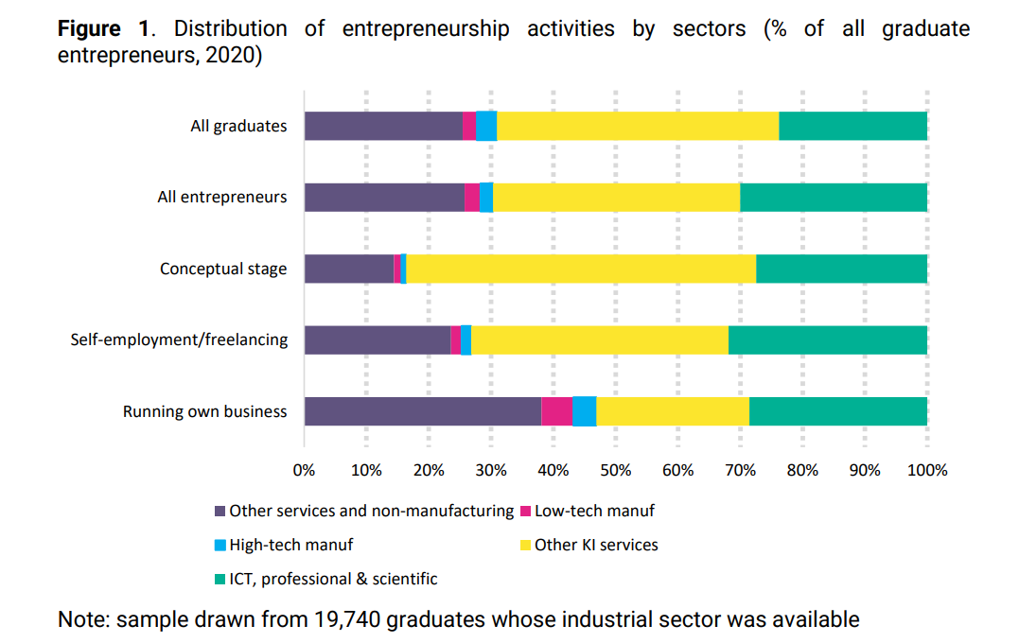
Source: Ospina & Rodriguez, (2022)

2.4 Government efforts amd support for entrepreneurship in the UK
Varady, et al., (2015) granting power devolution to local governments and promoting self-help efforts, the UK national government implicitly targets high-capacity communities. There is a strong opposition to this form of targeting among UK academics. Several measures have been introduced by the government to devolve authority to councils and communities, including the Localism Act 2011, which provides greater control to communities over local decisions. Providing public service reforms by local authorities and encouraging private and community entrepreneurship, with an emphasis on local economic growth, community-led regeneration, and local government reforms. As part of urban regeneration, community enterprises (CEs) - social enterprises run by locals for the benefit of their communities - are gaining prominence.
(Henley, 2021) the number of self-employed people in the UK has increased significantly since the financial crisis. While self-employed individuals have lower social insurance levels, they are at a greater risk of income volatility. There are a number of factors that contribute to individuals' transitions into self-employment, both positive and negative. There has been little research on whether private-sector businesses promote employee entrepreneurial transmission. In this paper, evidence has been re-evaluated. Rather than outright job loss, rising self-employment in the UK may be a reflection of reduced job quality and a result of increased flexibility. According to the paper, education has asymmetrical effects on self-employment entry depending on the source. It concludes by saying that reduced attachments provide an alternative explanation of the 'entrepreneurial transmission' effect, which results in higher self-employment rates among employees in smaller organizations. As the gig economy grows, growing concerns are being raised about the impact of the gig economy on work experience.
Ramlogan & Rigby, (2013) examine how SMEs perform as measured by sales turnover, employment, and survival after they've participated in a government-funded advisory program. The study points out that while government investment in soft support is considerable, the methods employed in evaluating these measures are limited in scope and rarely focus on measuring additionality. The asymmetric information situation caused by market failures resulting in SMEs not seeking advice from the private sector created the rationale for the program. which justified the government to operate a subsidized service of higher quality. According to the analysis, firms used outside consultants more frequently than a control group, and this had a positive impact on their performance. In addition, the scheme was developed to promote entrepreneurship in regions as part of the UK's Regional Economic Strategy (RES), which was adopted in 2008. In the North East of England, this policy operated through several mechanisms, the most important of which was the Entrepreneurs Forum, a private organization that had been promoting entrepreneurship in its capacity before the introduction of the RES.

2.5 Impact of Covid-19 on entrepreneurship
Brown, et al., (2020) argued that the current COVID-19 crisis is impacting key sources of entrepreneurial finance in the United Kingdom. Considering the need for face-to-face interaction between entrepreneurs and investors, entrepreneurial finance may be highly sensitive to such a shock due to its relational nature. This post examines real-time equity investment data to test this conjecture. Nearly 500 deals were recorded during the first quarter of 2016 as the volume of new deals surged rapidly. In recent years, the number of deals have dropped significantly to approximately 350 each quarter, a phenomenon some attribute to Brexit, a factor that has reduced public sector investments in early-stage ventures. These equity deals have expanded substantially in size during this period, especially in 2017 and 2019, when their value grew by 62.5% and 25.6%, respectively(Brown, et al., 2018). Overall, equity deals in the UK have become much larger and lumpier over the last decade. After the outbreak of the COVID-19 pandemic, we observed a significant decline in the number of new equity transactions in the United Kingdom. The most acutely affected type of entrepreneurial finance appears to be seed financing, which typically goes to the smallest and least sophisticated start-ups facing the greatest challenges in securing financing.
Hart, et al., (2023)Over the next three years, 29% of working-age individuals in the UK intend to start or engage in entrepreneurial activity, an increase over 2020. Over the past year, this has steadily increased. GEM APS conducted in the UK in 2022 faced another volatile backdrop of geopolitical events, resulting in cost-of-living crises, high inflation, and falling output in an economically stagnant country. The turbulent political climate in Q3 was exacerbated by the resignation of the UK's Prime Minister in summer. Those factors combined with the pandemic and the UK's exit from the EU led to a loss of business confidence in an economy already struggling to recover. Government entrepreneurship programs, the ease of obtaining financing for entrepreneurs, and physical infrastructure conditions in the UK in 2022 were statistically significantly less favorable than in France and Germany.
(Huggins & Williams, 2011)Economic development policy has increasingly placed regions at the forefront. Despite this, regional economic strategies continue to be controversial. Using entrepreneurship and enterprise development as a tool for improving regional competitiveness, this paper examines whether regional policies in less competitive regions account for issues relating to entrepreneurship. An analysis of relevant policy documents and interviews with policy makers informs its examination of policies adopted by the UK Labour government 1997–2010. A multidimensional entrepreneurship policy is found at the regional level, with policies encompassed across both economic and social dimensions. The enterprise policy-making process remains relatively undifferentiated across the regions despite considerable policy activity in these areas. It is becoming more and more important to foster regional innovation ecosystems as opposed to cluster facilitation as a form of regional policy. The long-term nurturing of communities is sacrificed in favor of short-term output measurement by regional policymakers.
Greene & Patel, (2013) stated that increase the availability of long-term lending for UK small businesses, which is noticeable by its absence in the UK market, by using the retail financial system. Competitive pricing should be maintained for such products, but applications should be based on longer-term objectives such as job creation, innovation, and national interests. As with the US SBA, a UK SBA would also need legislative authority. As a result of Small Business Service's inability to lead on enterprise support, the UK program ended up closing as a result of its lack of authority. There would need to be a clear and sufficient role for a UK SBA across the government and within the industry. These problems could be addressed more coherently with a UK SBA, which would provide the anchor needed to address them. There will inevitably be challenges, as the US's Small Business Administration and the UK's Small Business Service have shown. It is hoped that, if the UK learns from these experiences and learns progressively rather than revolutionary, past mistakes can be avoided and small businesses can benefit in the long run.

2.6 Implications for entrepreneurship in the UK
Cowling & Dvoulety, (2023) discussed that a total of £759 million has been loaned to 82,809 new start-ups since 2012 through the UK start-up loan scheme. Despite the Covid-19 crisis, SUL continued to support new businesses. In their study, the authors examine whether entrepreneurs launching businesses during the COVID-19 crisis differed from those launching businesses before the outbreak. There are numerous differences between both groups of entrepreneurs, as shown in the study. There are more graduates, older entrepreneurs, and more people who made the transition from full-time waged or inactive employment to COVID-19. In addition, they tend to be more likely to set up businesses in manufacturing companies than in service sectors before Covid-19. Last but not least, they lend much more to start-ups at the outset. It is possible that they realized an underlying ambition to run their own business through the Covid-19 crisis and started new businesses. In general, survival and growth are both characterized by these characteristics.
Manchanda, (2013) smaller companies and start-ups often see government schemes as (perhaps necessarily) complex, and therefore cannot engage with and benefit from them, especially when compared with larger companies that possess the human resources and in-house funding to do so. This experience has been shared repeatedly by the Green Deal, where there are many forms to complete and boxes to check before any action can be taken. People have stated that Green Deal services are "all sorted out by big companies." It was pointed out that to mainstream residential retrofit, small builders needed to be trained up so that they could incorporate retrofit into their normal conversations and work for clients – however the perception is that small builders are not able to engage and therefore this mainstreaming opportunity is being missed. Small businesses should be trained and supported to understand and benefit from national schemes by simplifying them and providing training and support. Many interviewees suggest that governments don't do enough to involve small businesses in green initiatives.
Heckernoon, (2023) stared that it can be a challenging and exciting experience to start a business in the United Kingdom. Many startups, however, face a variety of challenges that can hamper their growth and success. Founders invest their funds, seek grants, and find their first private investors in the pre-seed stage. This stage represents 60-70% of startups' failure. It is common for this stage to require funding between $50,000 and $200,000. It is difficult for startups to secure adequate funding in the UK. Many startups face high-interest rates and strict repayment terms when trying to find investors who will invest in their businesses. Further, startups have a difficult time competing with more established, larger companies for funding. In the UK, many industries are already saturated, and there is a mature market. As a result, startups find it difficult to distinguish themselves from established players. Several years after the Brexit vote, the UK economy has been in significant economic uncertainty. Investors and consumers have become more cautious about spending, resulting in a challenging environment for startups(Martínez, 2009). It is no secret that startups in the UK are subject to stringent regulations and bureaucratic procedures. Regulating a business can be expensive and time-consuming, such as complying with employment law(Payrow, 2023). It can be difficult for startups to focus on growing their businesses because of this strain.
In a recent review of entrepreneurship and crisis, Doern et al. (2019) focused on the particular challenges and issues faced by entrepreneurs and self-employed people during adverse economic times. The nexus is influenced by several factors. They include the size, scope, and duration of the crisis, as well as its cause, whether human behavior, natural disasters, or economic factors caused it. Individual entrepreneurship is moderated by the stage of the business development, enterprise size, the skills and experience of the entrepreneurs, the resources available, and the methods for utilizing these resources to mitigate the effects of the crisis (Doern et al., 2019). The macro and meso levels of an adverse event can lead to higher bankruptcy rates and business closures (Dutta, et al., 2021)than the number of new business registrations, resulting in a decrease in entrepreneurial activity on the whole. Even the opposite scenario can occur when businesses start up more frequently during challenging times than when people quit, leading to even higher engagement in entrepreneurship.

2.7 Future of Entrepreneurship in the UK
Kuratko & Audretsch, (2022)stated that thriving economy depends on gazelles, unicorns, and decacorns (businesses worth $1 billion to $10 billion). The number of ventures that were valued at $1 billion or more by venture capitalists has increased to more than 700 since 2021, and the trend is continuing. A 2008 study found that in developed economies, small- and medium-sized enterprises (SMEs) contribute up to 55% of the GDP and over 90% of businesses. The economy of developed countries is driven by small firms, so it is clear that they are the pillar of the economy. Nevertheless, the entire world of entrepreneurship seems to be drifting slowly away from its focus on smaller companies and toward a relatively small number of large tech companies. Entrepreneurship has now become the lens through which giant corporations are viewed. A concept of entrepreneurial hustle will be necessary in the future because uncertainty is greater than ever before. It appears that crowdfunding will continue to grow rapidly in the coming years. Every entrepreneur in every industry has a greater opportunity to succeed and grow by investing in newly created venture concepts thanks to everyday people's ability to invest in new ideas.
Allas, et al., (2021) discussed that the UK's new trade relationship with the EU, plus post-pandemic recovery, are creating future growth opportunities. For businesses hoping to take advantage of these opportunities, the following three strategies are crucial: bold moves, granularity, and flexibility. A flexible and agile approach to execution will be needed to support these strategies. Business models that are flexible and forward-looking will capture the most growth in the UK as it moves into a new era. A company that is proactive in investing in its ability to remain at the forefront of events, regardless of the outlook, will draw lessons from the turbulence of the past year and incorporate them into its plans.
Clarkson, (2022) stated that a new report by Virgin Money forecasts that small businesses in the UK will be run by avatars in 2050. A UK futurologist believes small businesses will become global businesses by default, with virtual specialists working across time zones, languages, and locations, regardless of their location. Business owners will also be able to communicate in real-time with the implants because the implants will be able to translate words in real-time, enabling them to speak any language. By 2050, business owners will be ‘human computers’ with advanced cybernetic implants to give them instant access to information. In the future, entrepreneurs will be able to take photos and record video using robotic eyes, download and upload information using brain-to-computer interfaces, and use embedded microchips to unlock doors and help facilitate financial transactions. Within five years, 85% of UK small businesses say they are interested in adopting new technologies that will save them time, which will allow them to reinvest and plan more effectively for the future.
Sheatwork, (2023)discussed that creating jobs and driving economic growth are two major contributions women entrepreneurs make to the UK economy. Innovation, growth, and change in the UK are driven by women entrepreneurs. Women are breaking barriers, reshaping industries and making their mark in diverse sectors in the UK thanks to a thriving ecosystem and supportive business environment. Entrepreneurs in the UK are fueling economic progress through their determination, resilience, and creativity. Every stage of a woman-led business' journey is accompanied by less funding than those headed by men, according to the Rose Review. It is reported that women have less capital to begin a business than men, are less informed about funding options, and are less likely to borrow money. A new round of funding for both new and existing customers, the Funding is intended to lower the gender gap in the UK economy by bringing new lending into the economy. It will be open to anyone with a business plan who is planning to start one, regardless of whether they are bank customers or not.

Chapter 3: Research design and Methodology

3.1 Introduction
Research method is important for identification of required tools and techniques in examining the scope of development to entrepreneurs in the UK. The methodology chapter is important for critical evaluation of required resources in data collection about the entrepreneurs’ development opportunities in the UK by gaining competitive advantage. Thus, the methodology chapter is important for improving reliability and transparency in the current research with evaluation of its methodological limitation.

3.2 Research Philosophy
Research philosophy refers to the framework developed for analysing basic data corresponding to the research objectives. The current investigation about the scope and competition faced by the entrepreneurs in the UK has been developed through analysis of social factors of positivism philosophy. There are four types of research philosophies such as “positivism, interpretivism, realism and paradigm”. According to Park et al. (2020), “positivism research philosophy” is crucial for developing reliability in data collection by focusing on research objectives through analysis of social perspectives. The current research considered positivism philosophy over other research philosophies due to its advantage of neutral measurement from the collected data to analysis scope of entrepreneurs in the UK. The scope of entrepreneur’s growth and competition in the UK has been analysed in the current research through accurate prediction that is possible with the positivism philosophy. Therefore, the current research has been conducted based on positivism philosophy in getting data accuracy from reliable sources to evaluate scope of entrepreneurship development in the UK.

3.3 Research approaches
Identification of research approaches is important for evaluating the relationship of theoretical concept and research findings corresponding to entrepreneurship growth in the UK. The current research has been developed with the consideration of an “inductive approach” for developing the research aspects followed by theory formulation. The key advantage of applying an inductive approach over others is its efficiency of describing raw textual data into summary for identifying scope of development to entrenurs in the UK. Thus, this current investigation on growth of entrepreneurs in the UK with gaining productivity and competitive advantage has been developed with an inductive approach.
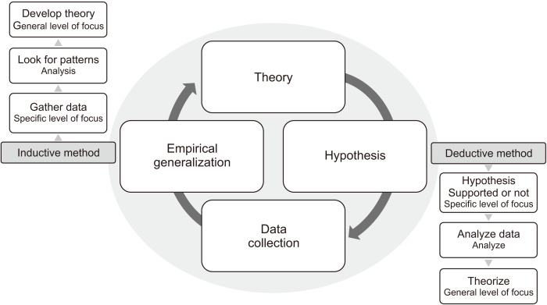

Figure 3.1: Concept of research approaches
(Source: Kim, 2021)
Research approaches are developed based on the structure of the research from hypothesis generation to theory formation related to the research objectives. According to Kim (2021), the inductive approach is effective for collection of relevant data corresponding to the research aim with theory generation from the findings. Therefore, the scope of development and competitive advantage of entrepreneurs of the UK has been identified with an inductive approach through evaluation of relevant data.

3.4 Research design
Research design is important for finding the research hypothesis through effective data analysis by using the empirical data. Integration of logical ways of examining the increasing scope of entrepreneurs in the UK for gaining competitive advantage through productivity is a key advantage of research design. The research problem in finding the scope of entrepreneurs in the UK has been formulated with the application of descriptive research design procedure. As per the view of Doyle et al. (2020), descriptive research design is important for developing meaningful data interpretation by relating to the research hypothesis. Descriptive design has been selected over other design processes for its advantage of relationship development between research variables in examining scope and support for entrepreneurship in the UK. Henceforth, the descriptive design process is justifiable in developing credible conclusions based on the scope of entrepreneurship growth in the UK.

3.5 Research Strategy
Research strategy refers to the overall planning process of the investigation by guiding, monitoring and executing the research objectives. Research strategy is important for providing direction to the investigation in examining the increasing scope of entrepreneurs in the UK by gaining competitive advantage through productivity. There are three types of research strategies such as “primary, secondary, and mixed” strategies to find accurate data corresponding to research objectives (Islam and Aldaihani, 2022). The current investigation about the increasing scope of entrepreneurs in the UK for gaining competitive advantage through productivity has been developed with “mixed strategy”. Thus, development scope and growing competition for entrepreneurship in the UK market has been investigated based on mixed strategy with the collection of broader data scale.
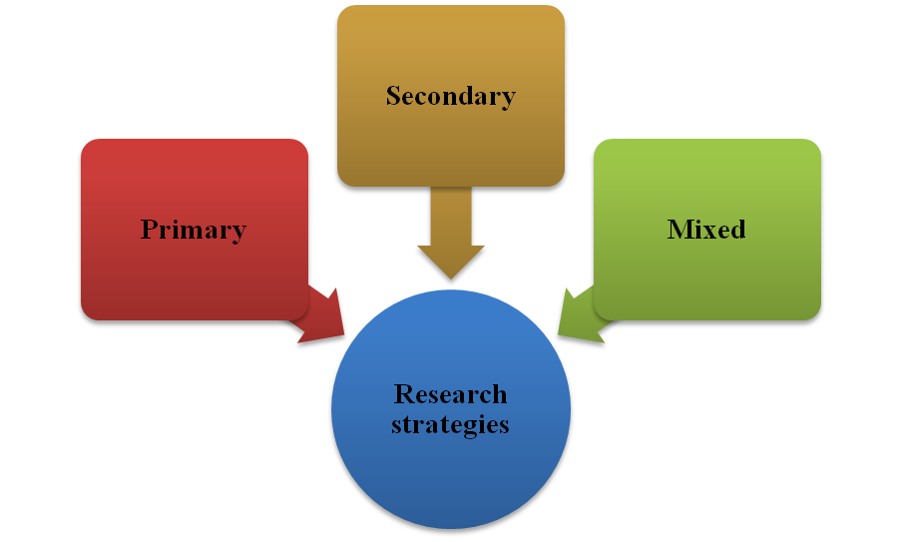

Figure 3.2: Concept of research strategies
(Source: Self-created)
Application of mixed strategy provided advantage of stronger interference in examining the increasing scope of entrepreneurs in the UK for gaining competitive advantage through productivity. According to Vivek and Nanthagopan (2021), mixed strategy considers both quantitative and qualitative data for examining the research objectives through stronger interference. This current investigation about scope of entrepreneurs in the UK market has been conducted based on mixed strategy over others strategic choices due to its advantage of better data coverage. Mixed research is significant for providing effective data interpretation techniques corresponding to the collected data from the entrepreneurs’ growth scope and competition in the UK. Hence, the current investigation has been conducted based on a mixed strategy with increasing scope of application and its outcomes for developing scope of entrepreneurship in the UK.

3.5.1 Type of Investigation
The investigation type defines specific processes and tools in finding data corresponding to the entrepreneurs’ growth scope and competition in the UK. The current research has been developed with both quantitative and qualitative investigation with the selection of a mixed strategy for identifying competitive stress faced by the entrepreneurs in the UK. Current scope of entrepreneurs in the UK has been investigated using a survey through Google Scholar with a questionnaire consisting of 21 questions. The qualitative survey has been conducted through interviewing over 5 entrepreneurs from the UK to achieve research objectives The investigation type has been selected as an interview and survey for gaining broader aspects of productivity and competitive advantage faced by entrepreneurs in the UK market.

3.5.2 Choices
Analysis of applied methods of this current research estimates data analysis approaches corresponding to the collected entrepreneur’s data from the UK. The current investigation has been developed with the choice of “positivism research philosophy” for its advantage of understanding the social world corresponding to entrepreneurship in the UK. Examination of current scope of entrepreneurs in the UK has been formulated with the choice of inductive approach. The adoption of an inductive approach is significant due to contextual flexibility in identifying research hypotheses based on entrepreneurship scope and challenges in the UK. This current research has been developed with the choice of descriptive design process due to its advantage of comprehensive analysis with the collected data sources by reflecting research hypotheses. Moreover, descriptive design is significant in finding behavioural attributes of a particular selected population in examining the scope of increasing competitive advantage by entrepreneurs of the UK. The mixed strategy has been developed within the current investigation of scope of entrepreneurs in the UK due to its significance of deeper understanding of data insights. Therefore, the identified choices in the current research process are significant to describe the broader aspect of entrepreneur’s problems and scope in the UK.

3.5.3 Time Horizon
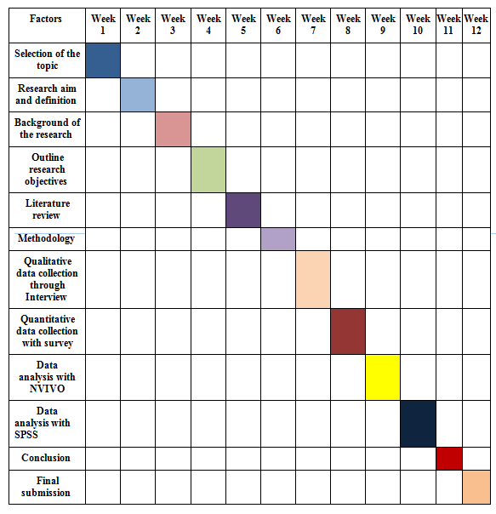

Figure 3.3: Time horizon for the research
(Source: Self-created)

3.6 Sampling method

3.6.1 Sample type
The sampling method is significant in identifying the key respondents for examining the scope of development of entrepreneurs in the UK. The “random sampling method” has been applied for survey and “convenience sampling” for interview in the current research for investigation of scope of entrepreneurs in the UK. Adoption of random sampling is significant in removing response biases in the collected responses through survey method in current investigation of entrepreneur scope in the UK. Thus, application of convenience sampling is significant for collecting convenient responses from participants of entrepreneurs in the UK.

3.6.2 Sample size
Sample size of the current investigation has been determined through the responses of the survey and interview for collection of quantitative and qualitative data respectively. The in-depth interview has been conducted over 5 entrepreneurs in the UK to identify scope of development and face challenges. The current research has been developed with the sample size of 20 respondents from entrepreneurs of the UK for the survey method. Thus, this current research work has been developed with the 5 successful entrepreneurs for interview and 20 random entrepreneurs as respondents for the survey with mixed data collection.

3.6.3 Sampling method
Sampling method of this current investigation for examining scope and competition of entrepreneurs has been developed by considering enterprises from the UK as samples. The in-depth interview process has been conducted with 5 successful entrepreneurs in the UK market with an interview transcript of 5 questions. The survey has been conducted by considering random sampling with 20 entrepreneurs from the UK market with a questionnaire of 21 questions in Google form. Thus, the current investigation has been formulated with random sampling for selecting the respondents in interview and survey.

3.7 Data collection method
The current investigation has been led by considering both the quantitative and qualitative data for examining scope of development for entrepreneurs in the UK. According to Ali (2020), adoption of only quantitative data increased complexity by gaining external insight of research problems. This current investigation eliminates the issue of biassed external insight of research problems responding to entrepreneurship scope in the UK with qualitative data from interview and quantitative data from survey method. The survey has been conducted based on the key concept, challenges and opportunities faced by the selected 20 respondents for collecting quantitative data. On the other hand, qualitative data provided contextual insight from historical sources to identify the research problem (Mezmir, 2020). The interview has been developed based on the key aspect of competitive advantage and growth opportunities faced by entrepreneurs in the UK for collecting qualitative data. Therefore, the current investigation of entrepreneurship scope in the UK has been developed with mixed data by eliminating limitations of individual quantitative and qualitative data.

3.8 Data analysis plan
The data analysis plan followed in this research is the primary quantitative and primary qualitative method for the identification of the scope present in the UK market for the UK entrepreneur. The research is based on the SPSS for the analysis of the primary quantitative data related to the competitive stress faced by the entrepreneurs in the UK. As mentioned in the report of Milovanović and Perišić (2020), interpreting obtained data from the SPSS program is associated with descriptive statistics and correlation functions related to a study. On the other hand, the research has incorporated NVIVO for the analysis of primary qualitative data for developing themes and subthemes. Thus, statistical calculation in SPSS helps in the determination of the experience of UK entrepreneurs and helps to increase scope for business development.

3.9 Ethical considerations
- The research maintain the ethical aspect in the collecting data by the implication of Data Protection Act 2018 to prevent unlawful collection of primary data (legislation.gov.uk, 2024)
- The data privacy of the 20 responses is maintained in the collection of primary data related to the personal experience of enterprises in the UK economic growth.
- The use of authentic primary qualitative and quantitative data is collected from 20 entrepreneurs through direct communication to limit the risk of biases

3.10 Research limitations and Accessibility issues
The research provided information about the impact of change in the UK market on the business productivity and competitive advantage of entrepreneurs through primary quantitative and qualitative analysis respectively. However, the primary quantitative and primary qualitative method though the use of NVIVO along with SPSS is a time taking process that creates an impact on meeting the deadline. Thus, the time taken due to application of NVIVO and SPSS for collection of primary data is the limitation of this research. Thus, the accessibility of 20 participants for collection of primary data has faced issues due to time constraint about large UK population for meeting the aim of the research.

3.11 Summary
It can be concluded that use of primary quantitative and qualitative methods is used to meet research aim for analysing scope in economic growth of UK on business of entrepreneurs. The methodology chapter is important for evaluation of primary data collected about the entrepreneur’s development opportunities in the UK. Thus, the ethical consideration in collecting and data-driven findings ensures broadening of research scope with proper maintenance of authenticity.

Chapter 4: Data analysis and discussion

4.1 Introduction
The chapter focuses on the analysis of the data to evaluate the increasing scope of entrepreneurship in the UK and the way its implications drive towards productivity. The application of primary qualitative and quantitative information has been used to accumulate authentic information related to the research topic. The primary quantitative data analysis is developed by using SPSS software and the qualitative data analysis is conducted by using NVIVO software. Effective data analysis helps in analysing the experience of UK entrepreneurship for demonstrating the business scope. Further, proper discussion of the collected information is developed to enhance the research relevancy correctly.

4.2 Data analysis plan
Data Analysis Plan
Primary Quantitative
Content analysis with themes and sub-themes
SPSS
NVIVO
Survey Analysis
Interview Analysis
Primary Qualitative
21 Participants
20 Close-ended questions
Influence of entrepreneurship on competition and productivity
Prediction for the future of entrepreneurship in the UK
Government policies and initiatives supportive entrepreneurship

4.3 Findings of the research
4.3.1 Findings derived through NVIVO software (Refer to Appendix 2)
From the primary qualitative findings with NVIVO, it is derived that the concept of entrepreneurship and its increasing scope in driving competition and productivity is conceptualised with themes and sub-themes. A theme related to the influence of entrepreneurship on business competition and productivity defines that entrepreneurship is associated with innovation and disruption. Another theme based on future prediction on entrepreneurship in the UK focuses on technical advancement, sustainability and social responsibility and market evolution and growth. Besides, in the data findings, the research has examined the scope of entrepreneurship in terms of competition and productivity by focusing government policies and initiatives. The theme related to government policies and initiatives has been analysed with key aspects such as financial support and incentives, entrepreneurial ecosystem enhancement and economic growth facilitation.
The sub-theme related to innovation and disruption is covered with the understanding of influx of innovation and disruptive innovation and challenging norms encountered by entrepreneurs. In terms of productivity sub-theme, the research includes a detailed understanding of vibrancy in productivity, productivity streamlining and increase, employment opportunity, efficiency and growth. Market innovation and market dynamism are the concepts that deliver key strategic focus for analysing the competitiveness of being entrepreneurs in the UK. With this theme and sub-themes, the research examines entrepreneurship and its importance for productivity and competitiveness in the UK market. In order to fulfil the understanding of future predictions on entrepreneurship, technological advancements with tech-driven entrepreneurial future, digital transformation and the surge of AI and green technology are essential. The research analyses sustainable entrepreneurship and green innovation growth, to establish the relationship between innovation and sustainability for promoting scopes of entrepreneurship.
From the NVIVO analysis, it has been found that financial support and incentives can be incorporated by entrepreneurs through government and investor assistance. Such assistance leads to benefits like tax relief for investment, incentives and R&D funding, loans and mentoring support and comprehensive funding. With this, entrepreneurs can enhance the business ecosystem through grants, mentorship and infrastructure, expanding economic supply, digital upgrades and others. In addition to that, the finding section determines that economic growth facilitation for entrepreneurial activities covers new policies and economic implication and supply-side expansion.
4.3.2 Findings derived through SPSS
The SPSS is based on 21 questions to find the experience of entrepreneurs about the impact changing market scenario of the UK on business productivity. Thus, research selected 20 entrepreneurs as respondents for answering 21 questions for the finding based on primary data.

4.4 Data interpretation and analysis
4.4.1 Primary qualitative content analysis through NVIVO
Influence of entrepreneurship on competition and productivity
Entrepreneurial activities are recognised as essential business practices that raise productivity and eventual competitiveness in current economies. Entrepreneurs accelerate and facilitate structural changes by integrating disruptive innovation within innovation-driven economies.
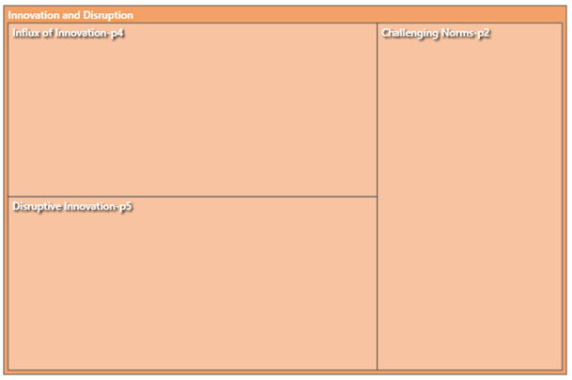

Figure 4.1: NVIVO output on entrepreneurship influence with innovation and disruption
(Source: Self-created)
Disruptive innovation is a type of advanced technology development which assists entrepreneurs make informed decision-making within productivity. As stated by Zheng et al (2021), current entrepreneurs in the generation of disruptive innovation must have the blockchain ability in intensively refining and iterating blockchain technologies. Not only existing entrepreneurs, new entrepreneurs also get higher assistance from innovation and disruption. In the present global circular economy, disruptive innovation influences new entrepreneurial start-ups in entering new markets, with innovative products, services and sales and marketing (Sehnem et al. 2022). However, challenging norms in entrepreneurial innovation inherently involve risk-taking, inadequate decision-making and lack of technological understanding from entrepreneurship. All these risks or challenges can be present in modern entrepreneurship due to some barriers like lack of high-skilled workers. As per the UK government report, it was estimated that by the end of 2030, the country would experience the presence of around 7 million under-skilled workers (GOV.UK. 2021). Thus, it is indicated that the UK entrepreneurs would face barriers in establishing and managing disruptive innovation due to the potential presence of under-skilled workers.
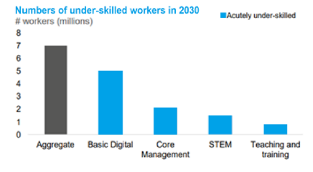

Figure 4.2: Under-skilled technological staff as a challenge for entrepreneurship
(Source: GOV.UK. 2021)
With innovation and disruption, entrepreneurial activities impact productivity with higher employment opportunities, rising efficiency and growth and economic invigoration. As evidence, it is reported that around 45% of UK business operations were innovation active between 2018 and 2020, and the number tends to be rising every year (GOV.UK. 2021). The report also states that entrepreneurs from large business operations are more likely to promote innovation, as compared to SME entrepreneurship. It indicates that embracing disruptive innovation and technologies help entrepreneurs be cost-effective with cheaper products and services like process automation.
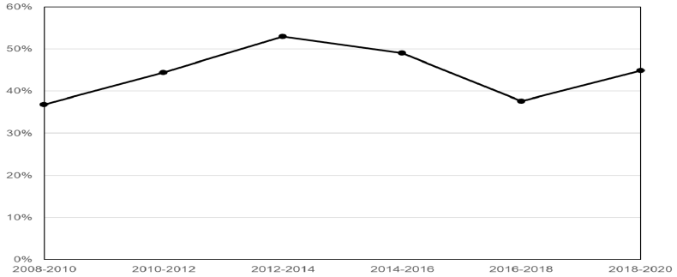

Figure 4.3: Percentage of business operations in the UK being innovation active
(Source: GOV.UK. 2021)
Entrepreneurship in modern businesses poses a direct influence on streamlining productivity and managing vibrancy in productivity. Entrepreneurial ecosystems considerably focus on distinguishing relevant eco-factors creating sustainable and vibrant productivity within business operations. As opined by Kansheba (2020), productive entrepreneurship and its activities directly and indirectly contribute to economic growth through increased production level in organisations. For instance, entrepreneurs take decisions on productivity such as price-setting, inventory and logistics, and customer value creation. Therefore, productive entrepreneurship brings market innovation and market dynamism, leading to competitive boost. For instance, after encountering a loss in 2021, Greggs Plc decided to adopt a ‘two-pronged focus’ on product development and digital innovation (Jefferson, 2021). In production innovation, the organisation has introduced a ‘click-and-collect’ facility for customers and personalised product choices to improve availability of products with standard quality. As an outcome of entrepreneurial decisions on production and innovation, Greggs Plc achieved around 23% year-on-year sales growth, with around 24% market share in the UK bakery and confectionery market. Eventually, it is evident that entrepreneurial activities establish differentiated customer behaviour and market performances, through competitive forces.
Prediction for the future of entrepreneurship in the UK
The above theme related to the influence of entrepreneurship on productivity and competitiveness shows disruptive innovation as a major determinant. Appropriate implication of disruptive innovation has a future potential impact on entrepreneurship in the form of technological advancement. In the future, businesses have a high-impactful future through tech-driven entrepreneurship, leading to the introduction of advanced technologies like AI, green technology and so on. Discovering existing and emerging technologies generate potential business value, which could help entrepreneurs recognise and match future scope in the modern circular economy.
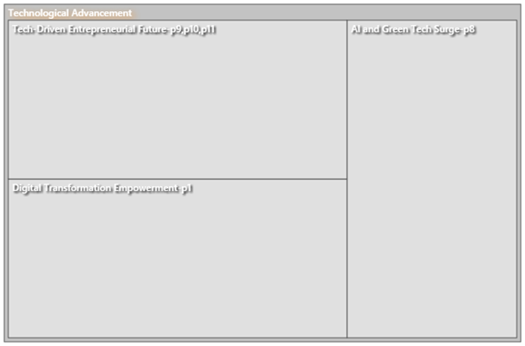

Figure 4.4: NVIVO output on entrepreneurship and its future predictions
(Source: Self-created)
Artificial Intelligence (AI) and green technology have been considered as the future of entrepreneurship, related to innovation and disruption. Chalmers et al (2021) have viewed that AI enables entrepreneurs to use machines and equipment that can process large chunks of unstructured data by using complex and adaptive algorithms. The application of AI is being adopted by modern entrepreneurs by sensing potential future impacts such as reduction of human errors, automated activities, faster decision-making and effective big data handling. As evidence, a report states that in 2023-2024, the AI market value in the UK is worth over £16.9 billion, expecting to reach more than £803 billion by 2035 (Forbes, 2023). Green technology is another future potential aspect for entrepreneurship in the current global economy, which is directly related to sustainability. With situation-based and rational decision-making, entrepreneurs would be effective in reducing GHG emissions, improving water and air quality and saving energy costs. Therefore, the application of green technology leads entrepreneurs towards sustainable entrepreneurship, with green innovation growth. For instance, Greggs Plc, as a sustainable enterprise in the UK, has introduced Eco-shop for growing green technology or innovation in the future. The entrepreneur adopted new advanced solutions such as recyclable flooring, air-assisted toilets, solar control glass and others, with the purpose of nurturing green innovation and developing sustainable entrepreneurship (Holland, 2023). Therefore, through the NVIVO analysis, it is analysed that the relationship between entrepreneurship and productivity and competitiveness lies in dynamic sector growth with future trends of AI and green innovation.
Government policies and initiatives supportive entrepreneurship
The NVIVO framework has established the content relating to the fact that entrepreneurship is well-supported by government policies and initiatives. Governments set programs and initiatives in order to assist entrepreneurs in the field of business technique, finance, and marketing so that they can accelerate and adopt necessary changes in operations.


Figure 4.5: NVIVO output on entrepreneurship related to government policies and initiatives
(Source: Self-created)
A modern economy featuring well-functioning legal systems, integrated policies and free and open markets promotes capital formation, cost saving, and long-term investment (Bradley et al. 2021). Supports like tax relief for investment, funding and incentives and loans and mentoring can be related to the development of entrepreneurship. For instance, ‘Venture Capital Trusts’ are the investment funds in which entrepreneurs can establish investment with tax benefits. The UK government has initiated the “Capital Gains Tax relief’ scheme under which entrepreneurs can get 50% of tax reliefs up to the investment amount of £200,000 (GOV.UK. 2023). Apart from that, the government has taken supportive actions for entrepreneurs in the form of issuing incentives within funding. Besides, the government has introduced a scheme named “The Future Fund” that supports UK-based enterprises subject to equal match funding from different private investors. The entrepreneurs in the country can get support from the government during the financial crisis and income pressure. As an outcome, government support and initiatives are encouraging investors and entrepreneurs with innovation and investment with adequate mentorship and financial infrastructure.
4.4.2 Primary quantitative analysis through SPSS
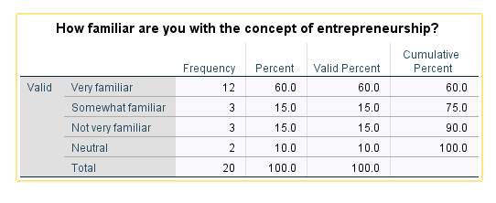
Table 4.1: Determination of familiarity with concept of entrepreneurship
(Source: SPSS)
The above depicts that about 60% of the respondents are familiar with entrepreneurship and 15% of participants are not familiar with it within the UK population.
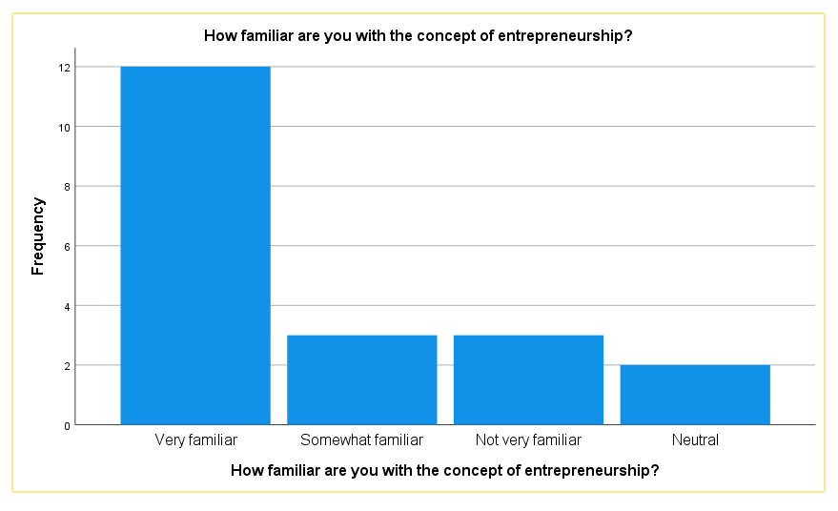

The above bar graph provides information about the concept of entrepreneur within the UK population. The graph shows that the majority of the participants are aware about the concept of entrepreneurship in the UK; however few participants are not very familiar with this concept.
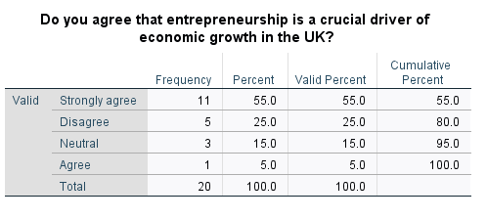
Table 4.2: Percentage of agreement on UK economic growth is crucial for the entrepreneurship
(Source: SPSS)
The above table depicts that 55% of the participants strongly agree that the economic growth of the UK is important for the business development of entrepreneurs. 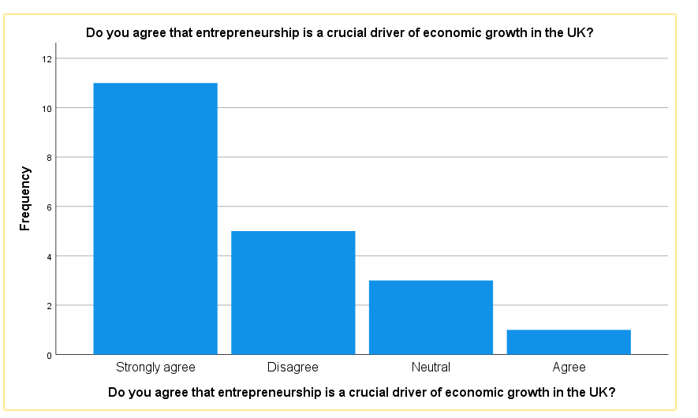

Figure 4.6: Percentage Analysis of UK economic growth is crucial for the entrepreneurship
(Source: SPSS)
The above figures show the maximum number of participants strongly agrees that the economic growth of the UK provides scope for the business development of entrepreneurs for future growth.
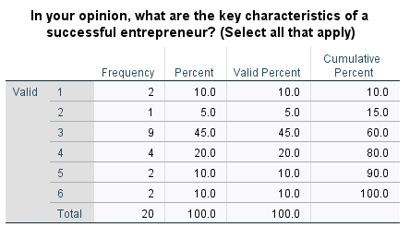
Table 4.3: Determination of frequency of key parameters associated with successful entrepreneurship
(Source: SPSS)
The above table shows that 45% of respondents agree that innovation of the business is the key character for successful entrepreneurship. The table depicts that 20% of the total responses agrees that Risk-taking attitude is the important characteristic of successful entrepreneurship.
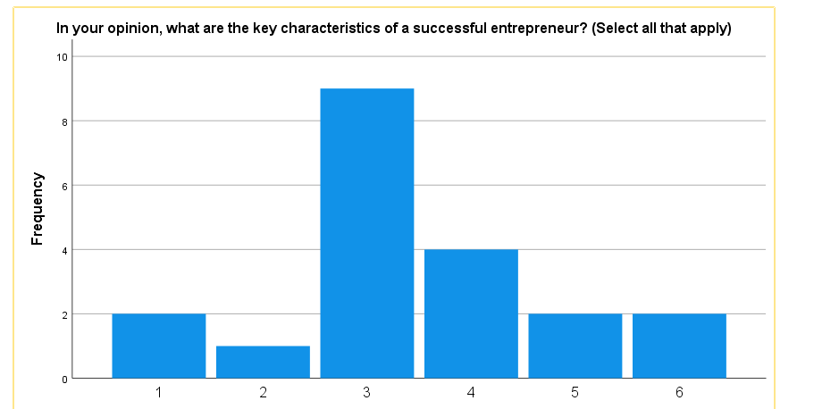

Figure 4.7: Determination of frequency of key parameters associated with successful entrepreneurship
(Source: SPSS)
The analysis of the above figure stated that innovation is an important character of successful entrepreneurship for enhancing the market growth of business in the UK. The risk taking initiative of successful entrepreneurship helps in getting greater scope in the UK market.
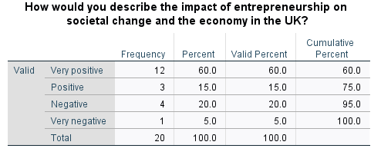
Table 4.4: Determination of entrepreneurship impact on societal change in the UK
(Source: SPSS)
The table depicts 60% of the respondents stating entrepreneurship has an impact whereas 20% participants think entrepreneurship has a negative impact on social change and economic growth of the UK.
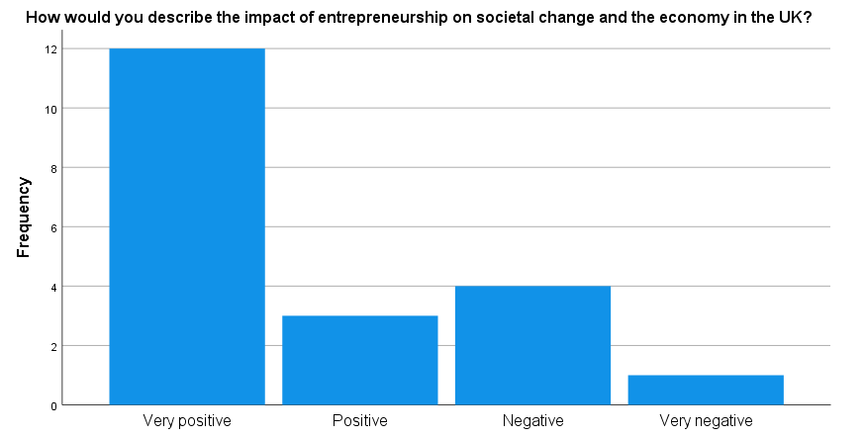

Figure 4.8: Impact of entrepreneurship on societal change in the UK
(Source: SPSS)
The above figure depicts that higher responses stated that entrepreneurship has a positive impact on social change and economic growth of the UK.
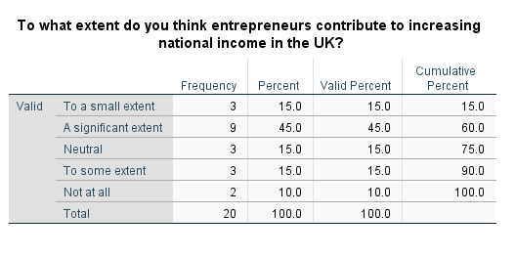
Table 4.5: Percentage Analysis of entrepreneur’s contribution in increasing of national income of the UK
(Source: SPSS)
From the above table it can be depicted that 45% respondent think entrepreneurs have a significant role in the development of the UK national income. The cumulative percentage of having high significance is 75% whereas participant response for no role in national income growth is 100%.
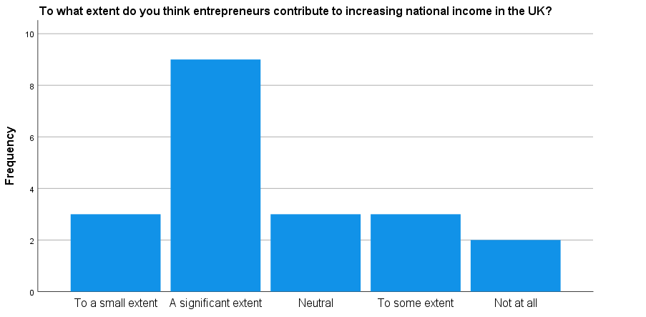

Figure 4.9: Percentage Analysis of entrepreneur’s contribution in increase of national income of the UK
(Source: SPSS)
The figure shows the entrepreneurs had a significant role in the increase of national income by contributing in the UK. However, few participants think entrepreneurs had a role in the national income of the UK.
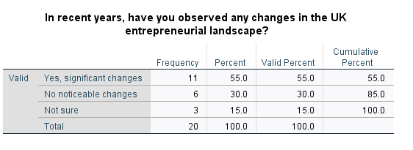
Table 4.6: Determination of Change in entrepreneur’s landscape of the UK
(Source: SPSS)
The above table depicts 55% thinks the entrepreneur landscape of the UK has a significant change in the market size.

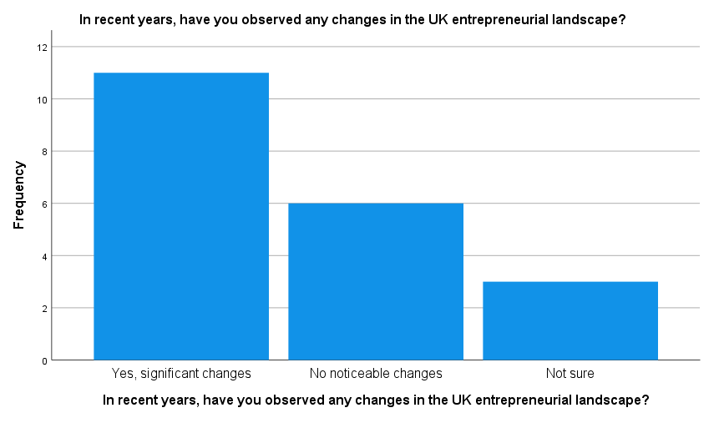

Figure 4.10: Determination of Change in entrepreneur’s landscape of the UK
(Source: SPSS)
The above figure shows the majority responses agree that the significant change has occurred in the entrepreneur’s landscape of the UK. On the other hand, respondents show disagreement about the change in entrepreneur’s landscape.

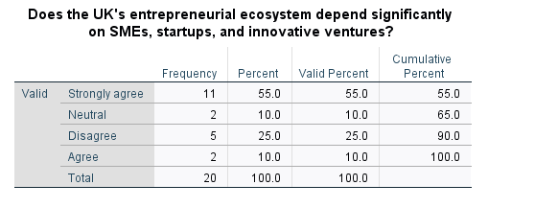
Table 4.7: Percentage Analysis of Entrepreneurs ecosystem depends on SMEs, start-up and joint venture
(Source: SPSS)
The above table depicts 55% responses agreeing that the UK Entrepreneurs ecosystem has high dependency on SMEs, start-ups and joint ventures.
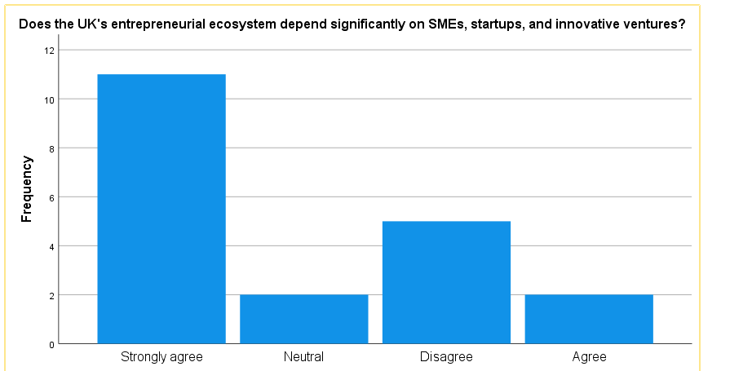

Figure 4.11: Percentage Analysis of Entrepreneurs ecosystem depends on SMEs, start-up and joint venture
(Source: SPSS)
The figure shows a higher number of responses showing agreement in dependency of UK entrepreneurs on SMEs, start-ups and joint ventures.
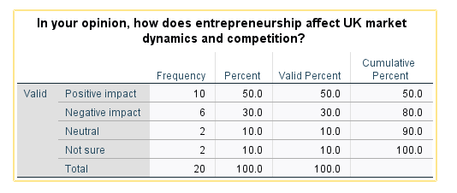
Table 4.8: Determination of Entrepreneurs impact on UK market dynamic and competition
(Source: SPSS)
The above table depicts that 50% participants agree and 10% disagree that UK market dynamic and competition has a positive impact on the business development of Entrepreneurs.
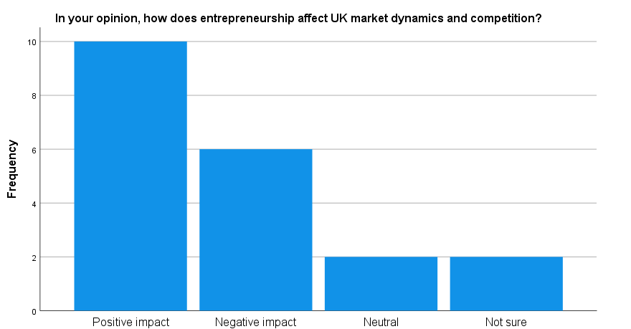

Figure 4.12: Determination of Entrepreneurs impact on UK market dynamic and competition
(Source: SPSS)
The analysis of the above figure shows that the high number of participants agrees that the UK market dynamic and competition provide positive scope for the entrepreneurs. On the other hand few participants think entrepreneurs have least influence by the dynamic and competitive character of the UK market.
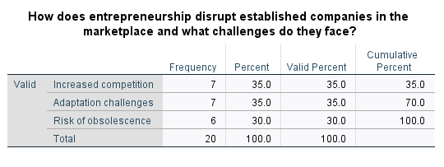
Table 4.9: Percentage Analysis of Challenges causing Entrepreneurs disruption in UK
(Source: SPSS)
The above table depicts that 35% of the participants think increasing competition and issue in adapting challenge create challenge for UK entrepreneurs.
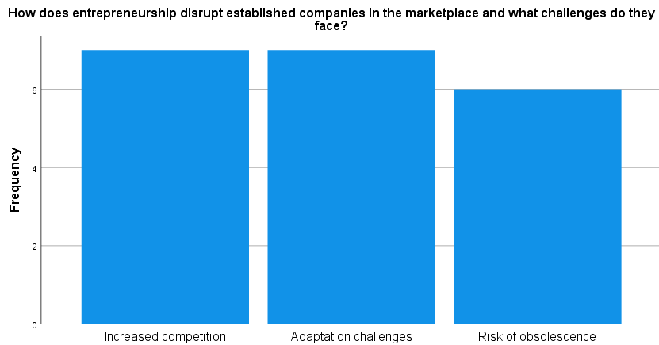

Figure 4.13: Percentage Analysis of Challenges causing Entrepreneurs disruption in UK
(Source: SPSS)
The above figure describes that high level of competition and issue in adapting challenges leads to creation of barriers for UK entrepreneurs. On the other hand, few customers think the risk of obsolescence creates barriers for the UK entrepreneurs.
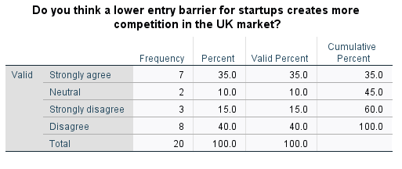
Table 4.10: Determining agreements of Lower entry barrier for start-ups creates competition
(Source: SPSS)
The above table shows 40% of the participants disagree and 35% strongly agrees that lower entry barrier create high competition for the UK entrepreneurs.
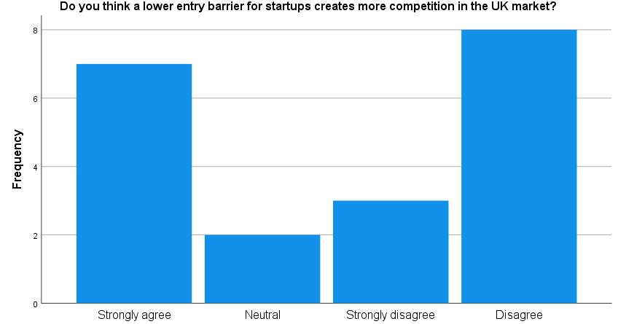

Figure 4.14: Determining agreements of Lower entry barrier for start-ups creates competition
(Source: SPSS)
The above graph shows the lower entry barrier in the UK market creates issues for the business development of entrepreneurs due to high competition.
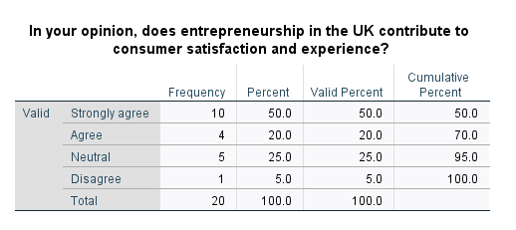
Table 4.11: Determining UK entrepreneurs contribution for Customer satisfaction and experience
(Source: SPSS)
The above table shows 50% participants agree that UK entrepreneurs have a high contribution to customer satisfaction.
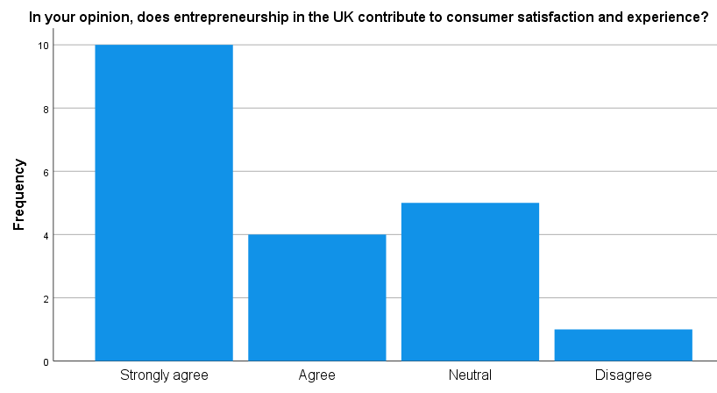

Figure 4.15: Determining UK entrepreneur’s contribution for Customer satisfaction and experience
(Source: SPSS)
The figure shows that the majority of the participants agree that entrepreneurs have a contribution towards customer experience.
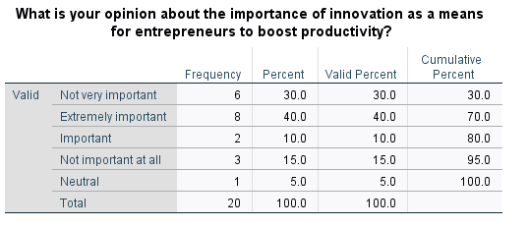
Figure 4.12: Percentage Analysis of importance of innovation for UK entrepreneurs
(Source: SPSS)
The above table depicts that 40% participants think innovation is extremely important for UK entrepreneurs.
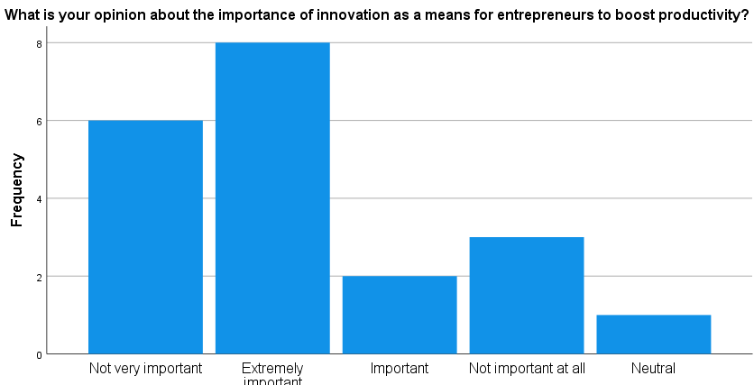

Table 4.16: Percentage Analysis of importance of innovation for UK entrepreneurs
(Source: SPSS)
The above graph shows majority participants think innovation is important for attracting customers by UK entrepreneurs.
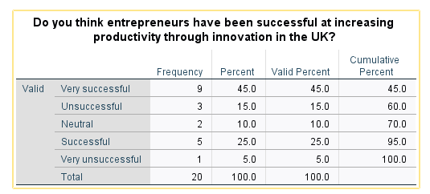
Table 4.13: Determination of UK entrepreneur’s success at productivity
(Source: SPSS)
The above table depicts 25% participant agrees UK entrepreneurs are highly successful at increasing productivity through innovation.
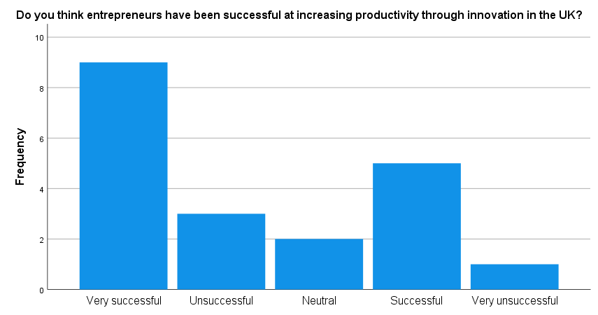

Figure 4.17: Determination of UK entrepreneur’s success at productivity
(Source: SPSS)
The figure shows the majority of the participants agree UK entrepreneurs incorporate innovation for success.
- Correlations
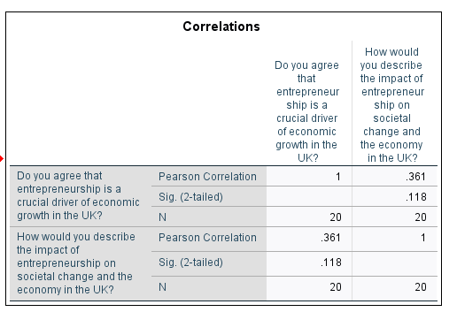

Figure 4.18: Determination of Correlations
(Source: SPSS)
The correlation between question 2 and question 5 has correlation as it shows the Sig value of 0.118 in the above table.
- Regression
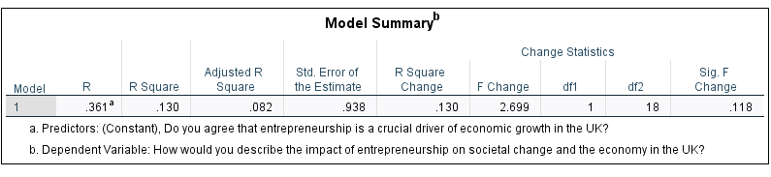

Figure 4.19: Determination of MODEL Summary
(Source: SPSS)
The above graph shows the effective R Squared value of 0.130 leads to high linking among the variable.
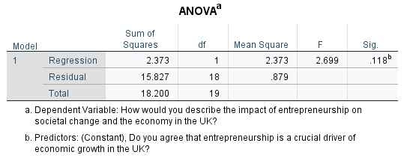

Figure 4.20: ANOVA
(Source: SPSS)
The above table shows that value in sum of squares is 18.200 depict overall quantitative findings are valid and effective.
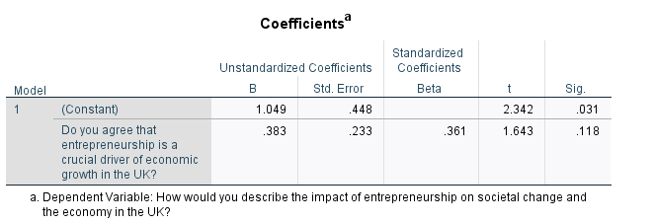

Figure 4.21: Determination of Coefficients
(Source: SPSS)
The above graph shows sig value regarding the role of entrepreneur in the economic growth of the UK is 0.118 defining dependent and independent of variable.

4.5 Discussion
The research has used NVIVO software to analyse the primary qualitative findings of the research. The content analysis helped in developing knowledge on the increasing scope of UK entrepreneurs by managing organisational productivity successfully. Entrepreneurs in the modern era are always focused on using innovation and advanced technologies in business to develop more business opportunities in the UK market. The number of start-up businesses is rising in the UK market due to effective technological innovation and the implementation of effective business strategies within the market. On the other hand, large businesses are focused on using innovation to increase production and economic growth more effectively (Kansheba, 2020). Small businesses are also taking initiatives to apply new technologies and innovative approaches in the business to promote production and service processes effectively. Besides that, the entrepreneurs help in managing the decision-making process of the business and help in managing the business production. As a result, it helps the entrepreneurs in enhancing the production and profitability of the company by implying opportunities.
In addition, the use of advanced technology helps in assisting entrepreneurs in the decision-making process of the business effectively. Innovation and description play an effective role in increasing the business opportunities for entrepreneurs. However, it not only helps the existing entrepreneurs but also assists the new entrepreneurs of the business. On the contrary note, entrepreneurship influences the sustained economy of the country by ensuring new jobs, employment and market spending. As a result, it helps new entrepreneurs enter a new business to develop the business and grab the business opportunities perfectly (Meyer and Jongh, 2018). Moreover, it helps in increasing the production and service process of the business more effectively in the new market. Enhancement of advanced technologies such as “AI, machine learning, and algorithms” can reduce human error and develop automation more effectively (Chalmers et al. 2021). The use of green technology can be effective for the entrepreneurs for the future improvement of entrepreneurship and increase sustainability. On the other hand, entrepreneurs also can confront some significant challenges while expanding a new business in the market. Lack of technological knowledge and expertise among entrepreneurs can affect in developing the business growth appropriately. The knowledge barriers can be a major problem in building entrepreneurial activities and successful business growth. Moreover, proper enhancement of entrepreneurial education is necessary to enhance the capabilities of the entrepreneurs and achieve all the success in an effective way. It may help in increasing the production process and revamp the economic condition of the country appropriately.
The discussion is based on the primary quantitative data analysis by using the SPSS software and it helps in identifying the opinion of the UK entrepreneurs on the start-up business within the country. The major population of the country have proper knowledge and concept of entrepreneurship and the way it is influencing the economic condition of the country. Besides that, the participants agreed that the economic growth of the UK is directly influenced by entrepreneurial engagement and productivity. In addition, the risk-taking attribute among the entrepreneurs helps in enhancing the business growth of the country and developing the business growth more effectively. On the other hand, high social skills and self-actualisation of entrepreneurs also allow them to build effective businesses and increase their wealth perfectly (Ratten, 2023). Besides that, innovation and technological advancement within the business by the entrepreneurs also help in improving the business growth. Technological innovation is the major key characteristic of entrepreneurial business enhancement and its influence on business productivity. Entrepreneurs play an effective role in changing social perspectives and improving the economic condition of the country. The development of entrepreneurial scope may help in improving the national income of the UK more effectively and revamp the growth of the country more effectively.
In addition, entrepreneurs have a positive impact on the economic development of the country which influences social changes. Enhancement of the positive changes delivers positive outcomes for the UK’s economy. On a contrary note, entrepreneurs have a significant role in improving the national income of the UK and enhancing business growth more effectively across the country. The development of entrepreneurial skills and innovation increases the market size and improves the socio-economic condition within the country. The entrepreneurial landscape has changed due to effective innovation and disruption by entrepreneurs. The entrepreneurs are also dependent on the “start-up, SMEs and joint ventures” for expanding the growth of the organisation and enhancing scope to increase productivity for further growth. Proper knowledge of start-ups and a strong intensive R&D culture also help in enhancing new business more effectively (Ospina and Rodriguez, 2022). Increasing competition and market growth help the organisation in developing production and profitability in an effective manner. The competitive advantages in the business increase the business scope and positivity among the entrepreneurs to increase successful business growth. Increasing competition can be a challenge for the entrepreneurs to manage the business growth in an effective manner. Hence, adaptation of changes and technological upgradation are necessary to reduce the competitive issue and increase business scope more effectively. Effective knowledge and skills of the entrepreneurs help in delivering proper contributions to the customer satisfaction level and enhance the business growth more effectively. Besides that, granting support from the UK government and encouragement for the entrepreneurs' community help in developing the business growth in an effective way. As a result, the number of self-employed people is increasing day by day, which may influence the financial crisis within the country (Henley, 2021). However, it can be seen that innovation plays an effective role in the entrepreneurs to develop business opportunities more effectively in the UK market. Entrepreneurs play an effective role in enhancing the economic growth of the country by improving production and management.

4.6 Summary
The chapter concluded the effectiveness of entrepreneurship and its scope in the business development of the UK market. It has applied “primary qualitative and quantitative information'' to collect appropriate information on the scope of entrepreneurship in the UK market. SPSS software was used to conduct the primary quantitative data analysis and the NVIVO software is used for qualitative data analysis. The use of effective software helps in enhancing the data relevancy of the research and accumulating more authentic information related to the research topic. The discussion helps to contrast the findings and analysis of the research more effectively and increase the research relevancy in an effective way.

Chapter 5: Conclusions and recommendations

5.1 Introduction
Globalisation, emergence of innovative technologies, and greater marketing integration are creating scope for entrepreneurs. Entrepreneurship is contributing to the economic development of the UK significantly. Entrepreneurship is recognised as proactive and innovative spirit and the risk-taking approach; modernisation is the driving force of entrepreneurship. The UK is identified as one of the largest entrepreneurial economies in the globe. The UK economy is highly dependent on the small business and there is a number of scopes in the market for entrepreneurship in coming years. Observing and analysing the increasing entrepreneurship scope in the UK and implications to drive competition and more productivity this chapter based on the data this chapter concludes the discussion. Evaluating the evidence-based discussion it has given several recommendations to enhance productivity in entrepreneurship in a competitive landscape. Further, the limited and future scope of this study have been illustrated precisely.

5.2 Conclusion
Entrepreneurship performance in the UK is growing with more people identifying that there are a number of opportunities to start a new business. The UK is considered as the most favourable market for starting a new business than other major economies in Europe. Regarding the commitment of creative approach and innovation, engaging workforce, modernisation the UK has a business-friendly environment that is motivating the new entrepreneurs. The entrepreneurship environment has been changed in significant ways throughout the last few years in various ways. Startups, SMEs, innovative ventures are constituting a huge part of the entrepreneurial ecosystem in the UK. Despite the fundamental concepts, various kinds of enterprises are emerging aiming to capitalise the efforts in producing something meaningful or valuable to respond to the evolving needs of the people. Broader entrepreneurial concepts beyond the traditional framework are helping to bring positive societal change. Applying new technologies into business the entrepreneurs are engaging to bring sustainable growth in the nation.
The entrepreneurs are facing increasing risks for the high market competition and a disruptive nature can be noticed. The competition has become higher in terms of the product or service quality and the changing business model. Therefore, the monopolies in the market are also creating several restrictions to the growth of new business.The ability to enhance productivity rate and competitiveness is directly connected with the consumer satisfaction level. Entrepreneurs are required to create a positive customer experience to increase the total productivity rate.
For exploring new opportunities, the application of technology and innovation plays a significant role to business. Currently, about six million of private companies are operating throughout the UK market, which is about two million increases from the turn of the century. These new businesses are significantly contributing to creating employment and economic growth of the country. However, the risk is increasing due to the changing demand in the market and high competition. Although the environment for entrepreneurship is friendly in the UK, it has remained relatively less significant to take risks, innovate and focus on the global market than other leading economies. Improving the rank, the entrepreneurship attitude of UK and abilities is emphasising to grow. The presence of highly educated entrepreneurs can improve the economic condition of the country using disruptive technologies. Apart from that, the government of the UK is supportive of the growth of entrepreneurship. Act and provisions are providing control to the communities over the local decision. Different schemes and acts accepted by the government are helping to increase the scope of entrepreneurship in the UK market. The support by the government is necessary for revival of these businesses in the post pandemic period. Equity transactions declined in the Covid period. Brexit has emerged as a notable factor that minimised the investment of the public sector in the early-stage venture. This has significantly affected the finance of the new entrepreneurship. Concerning the gap, the role of the government seems important to create stability in the entrepreneurship environment. Events like business closure and increasing bankruptcy rate decreases the registration rate of the new entrepreneurship.
The size of the crisis, duration, cause and the mitigation scope must be noticed by the individual entrepreneurs. The resource availability and the capacity to utilise these resources in an optimal manner determines the success of the entrepreneurship. It is evident that business is the major pillar of the UK economy. The trade relationship of the UK with the European Union, efforts by the government are creating opportunities for entrepreneurship. The government approach to build a supportive entrepreneurial ecosystem in the UK can motivate the entrepreneurs to step into the competitive market. Granularity, bold moves and flexibilities are needed to utilise this significant scope. The primary data-based research has become beneficial to this study for highlighting the major challenges and the crucial factors for success of entrepreneurship. The observation and discussion incorporating primary data seems useful to make informed decisions in this study. The findings clearly exhibit that entrepreneurial activities refers to the essential business practice that aims to increase productivity and competitiveness within the current economy. Applying disruptive technologies and government support the entrepreneurs can follow structural growth. Implementing structure, the prevailing challenging norms for entrepreneurial innovation can be tackled. The lack of employee knowledge is another significant issue for entrepreneurship growth. Finding exhibits that the disruptive technology is an important factor for ensuring continual growth of enterprises in the UK. focusing on innovation the customer expectations can be managed effectively.

5.3 Recommendations
Enhancing entrepreneurial aspiration is immensely important as the high growth and innovative entrepreneurship participates in the development of the nation with its quality. Strategic direction is required to achieve entrepreneurship successfully within this modern highly competitive marketplace. Aiming long-term growth of entrepreneurship, it is necessary to remain focused on the opportunities and possible risks. Several recommendations are given that can be beneficial to increase the scope of entrepreneurship and gain more productivity managing high market competition.
- Being more consumer-centric
Businesses need to focus on the evolving demand and expectations of the customers in today’s competitive marketplace. Customers are no longer a simple number, instead today's customers are connected, empowered and engaged having a vice in the direction of a company. Being highly-consumer focused companies can ensure continuous productivity. Emphasising on the preferences of the consumer and designing the marketing activities according to their preferences business can expand the consumer research in the competence landscape (Letierce and De Blas, 2023). The high competitiveness in entrepreneurship in the UK can be managed by focusing on consumer satisfaction effectively. The number of start-ups is increasing every year, however huge numbers are declined just within a few years of the starting due to market monopolies, financial issues, and immense competitiveness. Incorporating customers to make business decisions may gain more benefits such as higher customer retention, boost sales. Creating value for value business ensures higher profitability rate in a significant manner.
- Focus on innovation and disruption
Following disruptive innovation entrepreneurs can build existing services or products that are more affordable and accessible to the customers. The disruptive innovation can be beneficial to new companies that emerge in a market having a lucrative presence of industries. The immense market competition in the UK can be tackled effectively by incorporating disruptive innovation in business practice. The upcoming shift in the market can be managed effectively using disruptive solutions. Following tech-driven business and including innovative business models the new entrepreneurs can grab the opportunities within the UK market. Disruptive innovation can enable technology that refers to the faster process of the business. Streamlining the growth by making optimal usage of available resources or to be more consumer-centric the disruptive innovation has a crucial role. It will help to make informed decisions for business. Disruptive innovation influences business in a positive way. The disruptive innovation improves the firm’s performance increasing the speed and quality of business (Wang et al. 2023). Thus, the inclusion of the innovation can act as the mediating role and supporting institution to growth of business. Facilitating a greater performance, new entrepreneurs can focus on disruptive innovation strategies.
- Increasing knowledge of employees with training and development
The lack of employee skill is a notable issue for entrepreneurship. The enterprises can create a relevant “learning and development budget” for upgrading the skills of the employees. Challenging factors behind the entrepreneurial innovation consist the lack of risk-taking ability, lack of understanding about technology, improper decision-making. The decision making can be improved and better collaboration can be developed increasing the knowledge of employees. Providing sufficient options of learning, focusing on the e-learning opportunities, digital literacy and the skill of the employees can be increased. Applying group mentoring the budget of the employee training can be managed. The group mentoring will help to bring individuals together. It will help to build better capability of the employees and foster a sense of collaboration in the team. Leading the employee performance, it will help to increase the performance of the organisation.
Involving employees into the peer-to-peer learning process the employee knowledge can be enhanced. Enterprises are required to enhance the engagement of employees to assure greater productivity to business. Fostering disruptive innovation, enabling technology and employee knowledge is crucial. Upgrading the skills and improving knowledge is continuous progress and to achieve greater opportunities in business the employee knowledge enhancement is immensely important for business. Stimulating the productive behaviour of the employees the knowledge improvement is necessary aspects of the business Basahal et al. 2022). The increasing productivity of the employee will help to fulfil the specified objectives and goals of business. Trained employees will create value in business leading the consistent performance. It will help to increase the performance and competitiveness of the firm and assures long-term success.

5.4 Research Limitations
The research focuses on analysing the data on the developing scope of entrepreneurship with the implication of driving competition and productivity. The research uses primary quantitative and qualitative data to find the data collected and conduct the entire research process perfectly. The research has collected information through surveys from 20 responses to identify the major scope of entrepreneurship in the UK market. However, the research can enhance the number of responses for accumulating data on a vast entrepreneurial group to develop more research accuracy. The lack of responses for the research is considered one of the significant limitations of the research (Sallam et al. 2023). Besides that, the research can collect secondary qualitative information to analyse the existing data on the scope of entrepreneurship in the business and revamp the business condition more effectively.
The lack of secondary data for the research is also a major limitation for the research as it can provide knowledge on opportunities for entrepreneurs in the UK market. The researcher has gathered information from a limited number of responses due to less time and it is also a limitation of the research. In addition, collecting data from a vast number of participants can reduce biased views on the research topic (Taylor et al. 2023). The limited number of participants can share biased views on entrepreneurship scope in the UK market.

5.5 Future research suggestions
The research has used primary quantitative and qualitative data collection processes by using SPSS and NVIVO software to collect more authentic information on entrepreneurial opportunities in the UK market. For further improvement of the researcher, the researcher needs to focus on evaluating the appropriate timeline to manage the entire research process perfectly. As a result, it may help in collecting information by managing the time and increase research relevancy perfectly (Ali et al. 2023). Besides that, the application of the correct research method is necessary to develop the entire research appropriately and achieve all the research objectives in an effective manner.
In addition, it is required to address the limitations of the research properly for further development of the research and enhance the research success. The researcher needs to focus on taking proper action on the policies and regulations of the research to conduct it more effectively (Hinterleitner et al. 2023). As a result, it helps in developing the entire research successfully by achieving its objectives. Hence, the development of proper research objectives and using accurate methods are necessary for research to make it more successful and achieve the goals in a perfect manner. In future, putting more emphasis on scope of entrepreneurship through rigorous review of last 5–10-year articles, can help in obtaining new ideas for entrepreneurs of the UK.

References
Allas, T., Atsmon, u. & Goodman, A., 2021. Facing the future: How UK businesses can thrive in the next normal. [Online]
Available at: https://www.mckinsey.com/featured-insights/europe/facing-the-future-how-uk-businesses-can-thrive-in-the-next-normal
Allas, T., Atsmon, Y., Goodman, A. & Simmons, V., 2021. Facing the future: How UK businesses can thrive in the next normal. [Online]
Available at: https://www.mckinsey.com/featured-insights/europe/facing-the-future-how-uk-businesses-can-thrive-in-the-next-normal
Audretsch, D. B., Cunningham, J. A. & Donald F. Kuratko, 2019. Entrepreneurial ecosystems: economic, technological, and societal impacts. The Journal of Technology Transfer , p. 313–325.
Blanchflower, D. G. & Shadforth, C., 2007. Entrepreneurship in the UK. Foundations and Trends in Entrepreneurship, 3(4), pp. 1-18.
Brown, R., Mawson, S. & Mason, C., 2018. Working the crowd: Improvisational entrepreneurship and equity crowdfunding in nascent entrepreneurial ventures.. International Small Business Journal, 36(2), p. 169–193.
Brown, R., Rocha, A. & Cowling, M., 2020. Financing entrepreneurship in times of crisis: Exploring the impact of COVID-19 on the market for entrepreneurial finance in the United Kingdom. International Small Business Journal: Researching Entrepreneurship, 38(5).
Chelsea Corporate , 2023. 6 of the UK’s Fastest Growing Industries to Buy Into. [Online]
Available at: https://chelseacorporate.com/buying-a-business/6-of-the-uks-fastest-growing-industries-to-buy-into/#:~:text=While%20restaurants%20were%20hit%20hard,growing%204.2%25%20in%20a%20year.
Chester, A., 2023. 11 reasons to start a business in the UK. [Online]
Available at: https://www.ukpostbox.com/blog/11-reasons-to-start-a-business-in-the-uk-2023#:~:text=The%20UK%20ranks%20highly%20on,resources%20to%20help%20businesses%20succeed.
Clarkson, N., 2022. What will entrepreneurship look like in the future?. [Online]
Available at: https://www.virgin.com/about-virgin/latest/what-will-entrepreneurship-look-like-in-the-future
Cowling, M. & Dvoulety, O., 2023. Who is brave enough to start a new business during the Covid-19 pandemic?. Baltic Journal of Management, 18(3).
Dadwal, S. & Farouq, T., 2018. The Impact of Entrepreneurship on Economic Growth and Development in the UK. International Journal of Enterprenuership Management Innovation and Development, 2(2), pp. 116-146.
Doern, R., Williams, N. & Vorley, T., 2019. Special issue on entrepreneurship and crises: business as usual? An introduction and review of the literature. Entrepreneurship & Regional Development, 31(5), pp. 400-412.
Doran, J., McCarthy, N., O’Connor, M. & Nsiah, C., 2018. The role of entrepreneurship in stimulating economic growth in developed and developing countries. Cogent Economics & Finance, 6(1).
Dutta, S., Parahoo, S. K., Harvey, H. L. & Afzal, M. N. I., 2021. “A conceptual understanding of entrepreneurial motivation, employment creation, and supporting factors on micro-, meso- and macro-level entrepreneurship. World Review of Entrepreneurship, Management and Sustainable Development, 17(1), pp. 56-76.
Europa, 2017. How does innovation lead to growth?. [Online]
Available at: https://www.ecb.europa.eu/ecb/educational/explainers/tell-me-more/html/growth.en.html
[Accessed 27 june 2017].
Farouq, T. & Dadwal, S., 2018. The Impact of Entrepreneurship on Economic Growth and Development in the UK. International Journal of Enterprenuership Management Innovation and Development , 2(2), pp. 116-146.
Forbes, 2022. UK innovation. [Online]
Available at: https://www.great.gov.uk/international/content/investment/why-invest-in-the-uk/uk-innovation/#:~:text=A%20global%20innovation%20hub&text=Around%20590%2C000%20new%20businesses%20were,major%20economies%2C%20according%20to%20Forbes
Greene, F. & Patel, P., 2013. ENTERPRISE 2050 Getting UK enterprise policy right. Federation of Small Businesses, pp. 1-33.
Grinevich, V. & Abreu, M., 2013. The nature of academic entrepreneurship in the UK: Widening the focus on entrepreneurial activities. Research Policy , 42(2), p. 408–422.
Hart, M. et al., 2023. Global Entrepreneurship Monitor : UK Report 2022/23, s.l.: s.n.
Heckernoon, 2023. Top Challenges Faced by UK Startups. [Online]
Available at: https://hackernoon.com/top-challenges-faced-by-uk-startups
Henley, A., 2021. The rise of self-employment in the UK: entrepreneurial transmission or declining job quality?. Cambridge Journal of Economics, 45(3), p. 457–486.
Higginbotham, D., 2024. Overview of the business sector in the UK. [Online]
Available at: https://www.prospects.ac.uk/jobs-and-work-experience/job-sectors/business-consulting-and-management/overview-of-the-business-sector-in-the-uk
Huggins, R. & Williams, N., 2011. Entrepreneurship and regional competitiveness: The role and progression of policy. Entrepreneurship & Regional Development, 23(9), pp. 907-932.
IW Capital , 2019. THE IMPORTANCE OF ENTREPRENEURSHIP TO THE UK ECONOMY. [Online]
Available at: https://iwcapital.co.uk/the-importance-of-entrepreneurship-to-the-uk-economy/
Kuratko, D. F. & Audretsch, D. B., 2022. The future of entrepreneurship: the few or the many?. Small Business Economics , Volume 59, p. 269–278.
Lee, Y., Kim, J., Mah, S. & Karr, A., 2023. Entrepreneurship in Times of Crisis: A Comprehensive Review with Future Directions. Entrepreneurship Research Journal.
Manchanda, S., 2013. Green Entrepreneurship in London Barriers and Opportunities, s.l.: The London Sustainable Development Commission.
Martínez, J. A. B., 2009. Entrepreneurship Policies and New Business Performance and Growth: An Empirical Analysis Based on Manufacturing Industries. Environment and Planning C: Politics and Space, 27(2).
Meyer, N. & Jongh, J. d., 2018. The Importance of Entrepreneurship as a Contributing Factor to Economic Growth and Development: The Case of Selected European Countries. Journal of Economics and Behavioral Studies, 10(4), pp. 287-299.
Myers, M., 2014. UK rises to fourth most entrepreneurial economy in the world. [Online]
Available at: https://www.imperial.ac.uk/news/162146/uk-rises-fourth-most-entrepreneurial-economy/
Myers, M., 2014. UK rises to fourth most entrepreneurial economy in the world. [Online]
Available at: https://www.imperial.ac.uk/news/162146/uk-rises-fourth-most-entrepreneurial-economy/
NatWest Group, 2022. Global Entrepreneurship Monitor - UK entrepreneurship on the up. [Online]
Available at: https://www.natwestgroup.com/news-and-insights/news-room/press-releases/economic-analysis/2022/sep/global-entrepreneurship-monitor-uk-entrepreneurship-on-the-up.html
Ospina, J. V. & Rodriguez, M., 2022. An insight report into the UK's Graduate Entrepreneurs. National Centre for universities and businesss, pp. 1-26.
Park, C., 2017. A study on effect of entrepreneurship on entrepreneurial intention: Focusing on ICT majors. Asia Pacific Journal of Innovation and Entrepreneurship, 11(2), pp. 159-170.
Payrow, 2023. Top Challenges Faced by UK Startups. [Online]
Available at: https://payrow.com/blog/top-challenges-faced-by-uk-startups
Pittaway, L., Ferrier, M., Aïssaoui, R. & Mass, P., 2017. Trends in Entrepreneurship Education: Innovation Infrastructure. Researchgate.
Prince, S., Chapman, S. & Cassey, P., 2021. The definition of entrepreneurship: is it less complex than we think?. International Journal of Entrepreneurial Behavior & Research, 27(9), pp. 26-47.
Ramlogan, R. & Rigby, J., 2013. The Impact and Effectiveness of Entrepreneurship Policy. Nesta Working Paper, pp. 1-39.
Ratten, V., 2023. Entrepreneurship: Definitions, opportunities, challenges, and future directions. Global Busiess and Organizational Excellence, 42(5), pp. 79-90.
Sheatwork, 2023. Women entrepreneurship in the UK is a powerful force. [Online]
Available at: https://sheatwork.com/women-entrepreneurship-in-the-uk-is-a-powerful-force/
Statista, 2023. Business enterprises in the UK - Statistics & Facts. [Online]
Available at: https://www.statista.com/topics/6848/businesses-in-the-uk/#topicOverview
Statista, 2023. Business enterprises in the UK - Statistics & Facts. [Online]
Available at: https://www.statista.com/topics/6848/businesses-in-the-uk/#topicOverview
Summerfield, R., 2020. The impact of social entrepreneurship on economic growth. [Online]
Available at: https://www.financierworldwide.com/the-impact-of-social-entrepreneurship-on-economic-growth
Toumazou, A., 2023. How entrepreneurial is the UK?. [Online]
Available at: https://www.linkedin.com/news/story/how-entrepreneurial-is-the-uk-5651564/#:~:text=Conducted%20in%20partnership%20with%20Deloitte,supporting%20over%2078%2C000%20jobs%20directly.
Toumazou, A., 2023. How entrepreneurial is the UK?. [Online]
Available at: https://www.linkedin.com/news/story/how-entrepreneurial-is-the-uk-5651564/#:~:text=Conducted%20in%20partnership%20with%20Deloitte,supporting%20over%2078%2C000%20jobs%20directly.
Varady, D., Kleinhans, R. & Ham, M. v., 2015. The potential of community entrepreneurship for neighbourhood revitalization in the United Kingdom and the United States. Journal of Enterprising Communities People and Places in the Global, 9(3), pp. 253-276.
Westhead, P. & Wright, M., 2013. The importance of entrepreneurship. Oxford Academic .
Ali, A., 2020. Quantitative Data Analysis. University of Sindh, pp.1-10.
Basahal, A., Jelli, A.A., Alsabban, A.S., Basahel, S. and Bajaba, S., 2022. Factors influencing employee productivity–A Saudi manager’s perspective. International Journal of Business and Management, 17(1), pp.39-51.
Doyle, L., McCabe, C., Keogh, B., Brady, A. and McCann, M., 2020. An overview of the qualitative descriptive design within nursing research. Journal of research in nursing, 25(5), pp.443-455.
Islam, M.A. and Aldaihani, F.M.F., 2022. Justification for adopting qualitative research method, research approaches, sampling strategy, sample size, interview method, saturation, and data analysis. Journal of International Business and Management, 5(1), pp.01-11.
Kim, S.M., 2021. Inductive or deductive? Research by maxillofacial surgeons. Journal of the Korean Association of Oral and Maxillofacial Surgeons, 47(3), pp.151-152.
legislation.gov.uk. 2024. Data Protection Act 2018 Available at: https://www.legislation.gov.uk/ukpga/2018/12/contents/enacted [accessed on 07 February 2024]
Letierce, C. and De Blas, M.D.M., 2023. Sustainable Entrepreneurs: How to Propose a Differentiation Strategy Based on Your Venture Mission. EntreprendreInnover, 54(1), pp.70-85.
Mezmir, E.A., 2020. Qualitative data analysis: An overview of data reduction, data display, and interpretation. Research on humanities and social sciences, 10(21), pp.15-27.
Milovanović, M. and Perišić, J., 2020. Advantages and limitations of using SPSS in teaching statistics. MEFkon 2020 INNOVATION AS AN INITIATOR OF THE DEVELOPMENT “INNOVATIONS IN THE FUNCTION OF DEVELOPMENT”, p.274.
Park, Y.S., Konge, L. and Artino Jr, A.R., 2020. The positivism paradigm of research. Academic medicine, 95(5), pp.690-694.
Vivek, R. and Nanthagopan, Y., 2021. Review and comparison of multi-method and mixed method application in research studies. European Journal of Management Issues, 29(4), pp.200-208.
Wang, C., Guo, F. and Zhang, Q., 2023. How does disruptive innovation influence firm performance? A moderated mediation model. European Journal of Innovation Management, 26(3), pp.798-820.
Zheng, L.J., Xiong, C., Chen, X. and Li, C.S., 2021. Product innovation in entrepreneurial firms: How business model design influences disruptive and adoptive innovation. Technological Forecasting and Social Change, 170, p.120894.
Sehnem, S., Provensi, T., da Silva, T.H.H. and Pereira, S.C.F., 2022. Disruptive innovation and circularity in start‐ups: A path to sustainable development. Business Strategy and the Environment, 31(4), pp.1292-1307.
GOV.UK. 2021. UK Innovation Survey 2021: Report covering the survey period 2018 to 2020. Available at: https://assets.publishing.service.gov.uk/government/uploads/system/uploads/attachment_data/file/1074069/UK_Innovation_Survey_2021_Report.pdf [Accessed on: 7 February 2024].
Kansheba, J.M.P., 2020. Small business and entrepreneurship in Africa: the nexus of entrepreneurial ecosystems and productive entrepreneurship. Small Enterprise Research, 27(2), pp.110-124.
Jefferson, M. 2021. Greggs sharpens digital focus as it refreshes five-year strategy.MarketingWeek. Available at: https://www.marketingweek.com/greggs-digital-transformation/ [Accessed on: 4 February 2024].
GOV.UK. 2021. Evidence for the UK Innovation Strategy. Available at: https://assets.publishing.service.gov.uk/media/615d98e2d3bf7f5603ecef19/evidence-for-innovation-strategy.pdf [Accessed on: 4 February 2024].
Chalmers, D., MacKenzie, N.G. and Carter, S., (2021). Artificial intelligence and entrepreneurship: Implications for venture creation in the fourth industrial revolution. Entrepreneurship Theory and Practice, 45(5), pp.1028-1053.
Forbes, (2023). UK Artificial Intelligence (AI) Statistics and Trends In 2024.Available at: https://www.forbes.com/uk/advisor/business/software/uk-artificial-intelligence-ai-statistics-2023/ [Accessed on: 4 February 2024].
Holland, F. 2023. Greggs opens its first Eco Shop to test out sustainable in-store initiatives. Food Matters Live.Available at: https://foodmatterslive.com/article/greggs-opens-first-eco-shop-trial-sustainable-in-store-initiatives/ [Accessed on: 4 February 2024].
Bradley, S.W., Kim, P.H., Klein, P.G., McMullen, J.S. and Wennberg, K., 2021. Policy for innovative entrepreneurship: Institutions, interventions, and societal challenges. Strategic Entrepreneurship Journal, 15(2), pp.167-184.
GOV.UK. 2023. Tax relief for investors using venture capital schemes. Available at: https://www.gov.uk/guidance/venture-capital-schemes-tax-relief-for-investors#:~:text=You%20can%20get%20Capital%20Gains%20Tax%20relief%20on%2050%25%20of,an%20asset%20before%20you%20invest. [Accessed on: 2 February 2024].
Sallam, M., Salim, N., Barakat, M. and Al-Tammemi, A., 2023. ChatGPT applications in medical, dental, pharmacy, and public health education: A descriptive study highlighting the advantages and limitations. Narra J, 3(1), pp.e103-e103.
Taylor, P.A., Reynolds, R.C., Calhoun, V., Gonzalez-Castillo, J., Handwerker, D.A., Bandettini, P.A., Mejia, A.F. and Chen, G., 2023. Highlight Results, Don't Hide Them: Enhance interpretation, reduce biases and improve reproducibility. NeuroImage, 274, p.120138.
Ali, O., Abdelbaki, W., Shrestha, A., Elbasi, E., Alryalat, M.A.A. and Dwivedi, Y.K., 2023. A systematic literature review of artificial intelligence in the healthcare sector: Benefits, challenges, methodologies, and functionalities. Journal of Innovation & Knowledge, 8(1), p.100333.
Hinterleitner, M., Knill, C. and Steinebach, Y., 2023. The growth of policies, rules, and regulations: A review of the literature and research agenda. Regulation & Governance.

Appendices

Appendix 1: Survey Analysis

Appendix 2: Interview analysis (NVIVO)
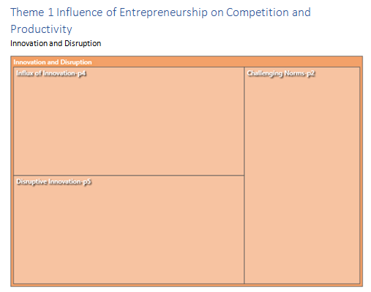
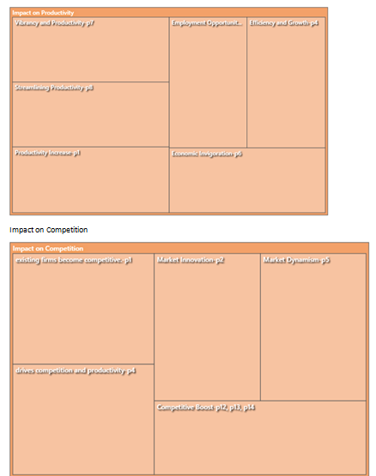

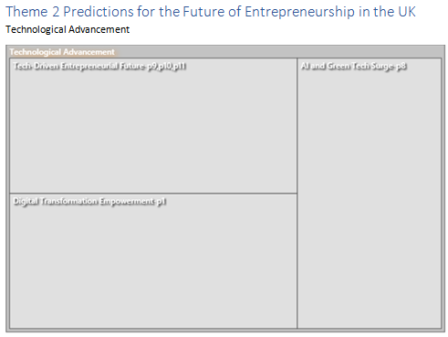
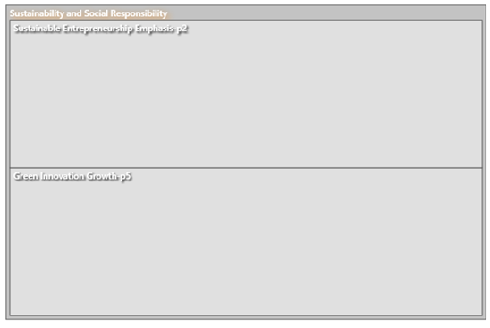
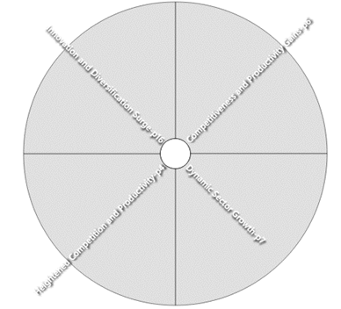
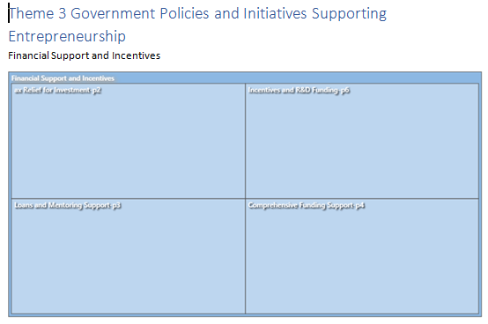
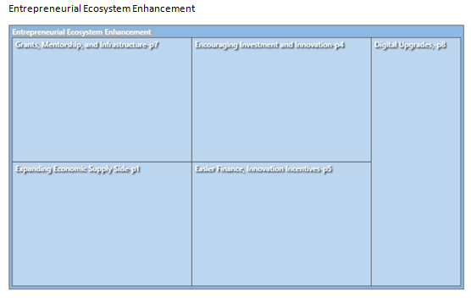
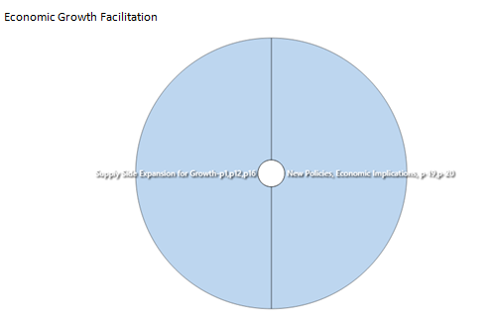

Google form question
- How familiar are you with the concept of entrepreneurship?
Very familiar
Somewhat familiar
Neutral
Not very familiar
Not familiar at all
- Do you agree that entrepreneurship is a crucial driver of economic growth in the UK?
Strongly agree
Agree
Neutral
Disagree
Strongly disagree
- In your opinion, what are the key characteristics of a successful entrepreneur? (Select all that apply)
Innovation
Risk-taking
Proactivity
Autonomy
Adventurousness
- How would you describe the impact of entrepreneurship on societal change and the economy in the UK?
Very positive
Positive
Neutral
Negative
Very negative
- To what extent do you think entrepreneurs contribute to increasing national income in the UK?
A significant extent
To some extent
Neutral
To a small extent
Not at all
- In recent years, have you observed any changes in the UK entrepreneurial landscape?
Yes, significant changes
Yes, some changes
No noticeable changes
Not sure
- Does the UK's entrepreneurial ecosystem depend significantly on SMEs, startups, and innovative ventures?
Strongly agree
Agree
Neutral
Disagree
Strongly disagree
- In your opinion, how does entrepreneurship affect UK market dynamics and competition?
Positive impact
Neutral
Negative impact
Not sure
- How does entrepreneurship disrupt established companies in the marketplace and what challenges do they face?
Increased competition
Adaptation challenges
Risk of obsolescence
- Do you think a lower entry barrier for startups creates more competition in the UK market?
Strongly agree
Agree
Neutral
Disagree
Strongly disagree
- In your opinion, does entrepreneurship in the UK contribute to consumer satisfaction and experience?
Strongly agree
Agree
Neutral
Disagree
Strongly disagree
- What is your opinion about the importance of innovation as a means for entrepreneurs to boost productivity?
Extremely important
Important
Neutral
Not very important
Not important at all
- Do you think entrepreneurs have been successful at increasing productivity through innovation in the UK?
Very successful
Successful
Neutral
Unsuccessful
Very unsuccessful
- Is new technology helping entrepreneurial endeavors become more productive?
Major role
Minor role
Neutral
No role
Not sure
- How would you rate the overall impact of entrepreneurship on the productivity of the UK's economy?
Unproductive
1
2
3
4
5
Extremely Productive
- Based on your perception do you believe that the UK is set to have plenty of startup opportunities over the next six months?
Strongly believe
Believe
Neutral
Do not believe
Strongly do not believe
- Has the Global Financial Crisis (GFC) recession increased entrepreneurs' fear of failure in the UK?
Strongly agree
Agree
Neutral
Disagree
Strongly disagree
Option 6
- Do you believe the UK provides sufficient support and resources for entrepreneurs to thrive?
Yes
No
Maybe
- Among the challenges facing UK entrepreneurs today, what do you perceive as the most important?
Limited access to funding
Regulatory hurdles
Intense market competition
Lack of skilled workforce
- Is entrepreneurship in the UK challenging for established businesses because it is so dynamic and disruption

