
Expanding the jewellery business into the asian market
Choice of country: Indonesia

November 6, 2019
University of Wales Trinity Saint David

Written by :
Zhuoer Tan (1901688)
Siping Xue (1904774)
Seroja Ruslan (1903964)
Hongli Shang (1904764)

Executive Summary [Zhuoer Tan(1901688)]
This handout is going to talk about the preparation research of this business in Asian market.
Two main parts are considered in the analysis.

The first part is the general analysis of the Asian market. First of all, through theoretical analysis, there are great cultural differences in different regions. Emphasising the skills and competencies is required in international business communication and is important to the organization's potential business. In addition, through language, communication and some cultural beliefs, the potential failures in international business relationships are analysed.

The second part first analyses the reasons of choosing Indonesia. For example, the gap between the rich and the poor is shrinking. Moreover, there is a strong consumer market and abundant natural resources. By looking at the benefits that the organization should expect, it is possible to clarify what they should do, what the goals are and what they really want, and understand the consumer's preferences to meet market needs. Gifting is essential in international business. Due to the religious beliefs in Indonesia, many gifts were found to be unacceptable to them.

The handout concluded why Indonesia is the best choice for Jewellery Retail group expansion and the appropriate methods must be used to achieve the goal of expansion, including mutual respect, appropriate gifts, building credibility and proper expectations.

Table of Contents
Executive Summary [Zhuoer Tan(1901688)] 1
1. Introduction [Siping Xue (1904774)] 3
2. General Analysis of Asia 4
2.1 Cultural Differences [Zhuoer Tan(1901688)] 4
2.1.1 Context of Culture 4
2.1.2 Hofstede's Cultural Dimensions Theory 4
2.2 The Required Skills and Competencies [Siping Xue (1904774)] 5
2.2.1 The Importance of Building Relationships 5
2.2.2 Skills and Competencies of Building Relationships 5
2.2.3 Appropriate Approaches to Build Successful Relationships 6
2.3 Potential Failures in a Business Relationship [Seroja Ruslan (1903964)] 6
2.3.1 Language Barrier 6
2.3.2 Different Communication Styles 6
2.3.3 Offensive Symbols 7
3. The country of Choice- Indonesia 8
3.1 Benefits the Organisation Should Expect to Achieve [Seroja Ruslan (1903964)] 8
3.1.1 Growing Middle Class 8
3.1.2 Strong Domestic Consumption 8
3.1.3 Strong Business Relationships 8
3.1.4 Substantial Jewellery Consumption 8
3.2 Gift Giving in Indonesia [Hongli Shang (1904764)] 9
4. Conclusion [Hongli Shang (1904764)] 11
Bibliography 12

1. Introduction [Siping Xue (1904774)]
In international business communications, a significant number of skills and competencies are needed to build successful relationships. Generally, building strong and stable relationships can generate considerable profits (Zaefarian, et al. 2017). However, this communication needs to analyse not only the foreign markets and products, but their cultural differences, theory of gift-giving and model of communication effectiveness. In addition, it is significant to take all considerations of Asia into account, and finally choose a best country to cooperate with (Pratt, 2008).
This handout analyses the required skills and competences of international business communications, applies Gerard Hofstede’s cultural dimensions theory, cultural differences and gift-giving theory. Finally, make a decision of choosing ideal country to enlarge jewellery business.

2. General Analysis of Asia

2.1 Cultural Differences [Zhuoer Tan(1901688)]
In this section, the cultural differences between Asia and the UK will be analysed using Hall's high-context and low-context cultures theory and Hofstede's cultural dimensions theory. Based on cultural differences, product design will be considered and analysed.

2.1.1 Context of Culture
According to Hall's theory (Pacific, 2019), UK belongs to the low-context cultures, where they speak more directly (Carolina, 2014). Most Asian countries are high-context cultures such as China and South Korea. They explain by speech, gestures and implied meaning (Carolina, 2014).

2.1.2 Hofstede's Cultural Dimensions Theory
- Power Distance Index (PDI): UK has a lower PDI. There is a relatively low inequality of power distributed among the people (Culture matters, 2019). In Asia PDI is high, there is a big gap between people in power and their subordinates (Hofstede, 1973).
- Individualism and collectivism (IDV): UK is individualistic, advocating that interests of the individual should be achieved over the state or social groups (The Free Dictionary, 2019). Most countries in Asia belong to collectivism, their individual cohesion and group prioritize over themselves.
- Masculinity and femininity (MAS): The UK index is high. For Long-term orientation, Asia generally has a higher score. The UK is at a medium level (Hofstede, 1991).
- Indulgence and restraint (IND): The UK is indulgent and they can meet and enjoy life relatively freely. Most countries in Asia are restrained and they need to comply with social regulations (Hofstede, 2019).

2.2 The Required Skills and Competencies [Siping Xue (1904774)]

2.2.1 The Importance of Building Relationships
For the external aspect, great relations can provide huge opportunities (Askopinion, 2018). For example, if jewellery business is expanded in Asia, it will be possible to open joint ventures with local companies (Cao, et al. 2018). For the internal aspect, costs can be reduced by cooperating closely with manufacturers, retailers and suppliers, because demand can be predicted more accurately to produce in case to oversupply.

2.2.2 Skills and Competencies of Building Relationships
To analyse the competences of building relationship, a model of communication effectiveness is applied (see Fig.1, Griffith, 2002).
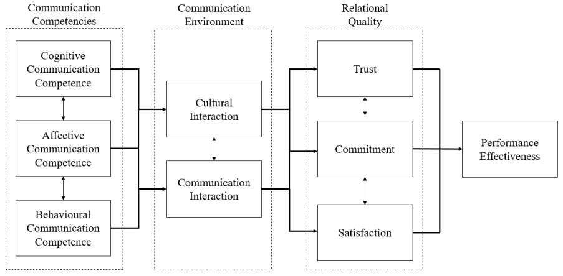
Fig.1 A model of communication effectiveness (Griffith, 2002)
Throughout this model, three competences are needed to build relationships. Cognitive competence helps understand international business subtly, affective competence determines people’s willingness to accept and respond to communication, and behavioural competence indicates behavioural flexibility and communication authenticity (Kim, 1991).
Those three competences are key to cultural and communication interactions. When improving all skills, trust can be built, commitment can be made, needs can be satisfied. Therefore, relationships can be built.

2.2.3 Appropriate Approaches to Build Successful Relationships
After applying communication effectiveness model, there are several appropriate approaches to build successful relationships.
- Develop mutual respect: Building mutual esteem is significant for growing relationships. Especially in international business, knowing how people greet to each other is basic but very essential (Ali, 2015).
- Send thoughtful gifts: Recognize partners’ or consumers’ culture and taste, send appropriate and not expensive gifts when meeting (Veem, 2017).
- Build credibility: Be authentic and visible to partners and customers, let them know what you do so that they can trust you more (Askopinion, 2018).
- Set the right expectations: Accept what you can do, and never exaggerate your ability to others because it is related to reputation and integrity (Ali, 2015).

2.3 Potential Failures in a Business Relationship [Seroja Ruslan (1903964)]

2.3.1 Language Barrier
Potential language barrier may be an issue when doing business in Asia. As most people in Asia are non-native English speakers and only speak it as a second language, they may have a limited vocabulary and poor pronunciation (Browaeys and Price, 2015). This can cause miscommunication among their business counterparts (Sayer, 2013).

2.3.2 Different Communication Styles
Some cultures in Asia have different conversational styles compared to westerners. In Japan, it is not about what you say but how you say it (Trucker, 1971). Since Asian countries tend to have a big power distance, relationships are distinctly defined and strong hierarchies are in place (Hofstede and Bond, 1988). Work may not get done properly if the supervisors do not clear instructions to their subordinates (Farh, et al. 1991).

2.3.3 Offensive Symbols
Different areas of Asia subscribe to different beliefs. Some countries with a Muslim majority may take offence in jewellery with crosses as it goes against their religion. Selling a cross necklace in countries such as Brunei would deter customers from buying from the brand (Leong, 2018). As for countries such as China, where superstition is big, it is taboo to have their names in red colour as it symbolises death (Ming, 2016). However, specific symbols in the UK are not of concern when it comes to jewellery products.

3. The country of Choice- Indonesia
Through detailed analysis, the suggested Asian country to expand the jewellery business is Indonesia. Indonesia is located in the South East Asia region (Andaya, 2019), which is rich in main raw materials for jewellery such as copper, gold, nickel and diamonds (Oec world, 2017). There are many benefits that the organisation can expect to achieve when doing business in Indonesia.

3.1 Benefits the Organisation Should Expect to Achieve [Seroja Ruslan (1903964)]

3.1.1 Growing Middle Class
As of recent years, the wage gaps between rich and poor in Indonesia are slowly closing in (Efendi, et al. 2019). Indonesia’s economic outlook continues to be positive, with domestic demand being the main driver of growth (World Bank, 2019). A growing middle class implies a bigger ability for Indonesian customers to purchase the jewellery.

3.1.2 Strong Domestic Consumption
Indonesia has a strong domestic consumption mainly because they are the largest economy in South East Asia. With a population of 264 million, Indonesia has a huge market that can benefit the company in a way of a large volume of customers (World Bank, 2019). This means that setting a business in Indonesia would be fruitful because of their good economy.

3.1.3 Strong Business Relationships
In Indonesia, the negotiation behaviour has elements of relationship building and task orientation which would suggest that relationship building is important in Indonesia (Gray, 2019).

3.1.4 Substantial Jewellery Consumption
Jewellery in Indonesia is expected to continue to sell well due to the fact there is an increased state support for creative industries such as jewellery production in Indonesia (Euromonitor.com, 2019). This means that the Indonesian market is interested in buying jewellery.

3.2 Gift Giving in Indonesia [Hongli Shang (1904764)]
In Indonesia, giving gifts is regarded as an effective way to start a business. Generally, they prefer carefully wrapped gifts which are presented by the right hand rather than the left. They also tend to refuse them at first to avoid losing face (Veem, 2017).
Considering different ethnics and religions such as Muslim, Hindu and Chinese Indonesian (See table1), there is also different etiquette of gift giving in Indonesia (FactsofIndonesia, 2017).
- Muslim. Indonesia is the home of the largest Muslim group in the world (FactsofIndonesia, 2017). It will not be welcomed if a gift is alcohol or pork. Moreover, any food substances must be Halal according to their belief. (Veem, 2017)
- Hindu. It is a major religion in Indonesia (Veem, 2017). They would not like to receive beef and alcohol. (FactsofIndonesia, 2017)
- Chinese Indonesian. For this group, they dislike gifts in number four which are not lucky in their perspective. Besides, any sharp items like scissors are regarded as signals to server the relationship (FactsofIndonesia, 2017).
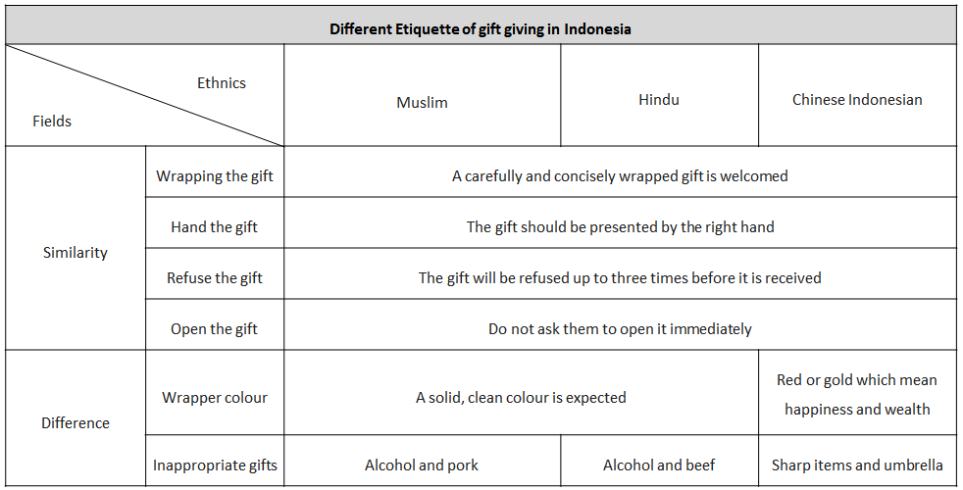
Table 1: Different Etiquette of gift giving in Indonesia (Source: Data for Veem (2017); FactsofIndonesia (2017))

Meanwhile, giving gifts is an ethically problematic issues in business (Fritzsche,2005). Therefore, how appropriate is gift-giving needs to be considered.
- Be feasible. Givers always focus on the moment of gift exchange while recipient focus on the gift ownership (Galak, et al. 2016). Based on it, gifts should be feasible for the recipients rather than surprising but hard to exact the value.
- Not be expensive. An expensive gift may be regarded as a bribe in order to influence the judgement or conduct of a person in a position of trust (Merriam-Webster Dictionary,2017). Therefore, a safe gift will not be too expensive in Indonesia (Veem,2017).

4. Conclusion [Hongli Shang (1904764)]
Considering the positive outlook of Indonesia’s economy, the huge market and the strong business relationship (World Bank,2019), Indonesia is an ideal choice for the Jewellery Retail group.
However, based on Hall’s and Hofstede’s theories, there may be potential barriers in relationship building with Indonesian partners (Hofstede and Bond,1988). The following four specific approaches are to avoid them in communication.
- Mutual respect development. Respecting the esteem of each other is significant for international business (Ali,2015).
- Gift-giving. It is widely used in business relationship building (Fisher, 2005; Bruhn, M.,1996). An appropriate gift is a positive start of a business relationship. Besides, using right approaches to keep it appropriate.
- Credibility building. Keeping the information visible is the matter (Askopinion, 2018).
- The appropriate expectations setting. Be honest about competences is related to the reputation of a company (Ali, 2015).
In conclusion, international business communication is inevitable if the jewellery group expands its business overseas. With proper approaches, they can achieve it successfully in Indonesia.

Bibliography
Academic Resources:
1) Browaeys, M. and Price, R. (2015). Understanding Cross-Cultural Management. 3rd ed. Harlow, United Kingdom: Pearson Education Canada, pp.289 - 293.
2) Hofstede, G. & Bond, M. (1988). The Confucius connection: From cultural roots to economic growth. Organizational Dynamics, 16, 4-21.
3) Cannon, J. and Crowcroft, R. (2009). A dictionary of British history. 2nd ed. Oxford University Press, p.144.
4) Ricklefs, M. (2001). A history of modern Indonesia since c.1200. 3rd ed. Basingstoke: Palgrave; Stanford University Press, p.379.
5) Wood, E. (1972). Mind and politics, An approach to the meaning of liberal and socialist individualism. Berkeley, Los Angeles, London: Univ. of California Press, p.6.
6) Hayek, F. (1994). The road to serfdom. United States of America: The University of Chicago Press, pp.17, 37–48.
7) Hofstede, G. (1991). Cultures and organizations. London: McGraw-Hill.
8) Chichester, W. (2000). C. Grönroos Service management and marketing (2nd edition)
9) Bruhn, M. (1996). Business gifts: A form of non-verbal and symbolic communication. European Management Journal, 14(1), pp.61-68.
10) Fisher, J. (2007). Business marketing and the ethics of gift giving. Industrial Marketing Management, 36(1), pp.99-108.
11) Zaefarian, G., Thiesbrummel, C., Henneberg, S.C., Naudé,P. (2017). Different recipes for success in business relationships. Industrial Marketing Management, Volume 63, Pages 69-81.
12) Huang, S., Crotts, J. (2019). Relationships between Hofstede's cultural dimensions and tourist satisfaction: A cross-country cross-sample examination. Tourism Management, Volume 72, Pages 232-241.
13) Griffith, D. A. (2002). The role of communication competencies in international business relationship development. Journal of World Business, Volume 37, Issue 4, Pages 256-265.
14) Paul, M. (2018). "The Ambiguities of Religious Freedom in Indonesia". The Review of Faith & International Affairs., pp.16 (1): 85–96.
15) Fritzsche, D. J. (2005). Business ethics: A global managerial perspective. New York’ McGraw Hill Irwin.
16) J. Galak, J. Givi, E.F. Williams (2016). Why certain gifts are great to give but not to get: A framework for understanding errors in gift giving. Current Directions in Psychological Science, 25 (6) (2016), pp. 380-385
17) Browaeys, M. and Price, R. (2015). Understanding Cross-Cultural Management. 3rd ed. Harlow, United Kingdom: Pearson Education Canada, pp.289 - 293.
18) Efendi, R., Indartono, S. and Sukidjo, S. (2019). The Relationship of Indonesia’s Poverty Rate Based on Economic Growth, Health, and Education. International Journal of Multicultural and Multireligious Understanding, 6(2), p.323.
19) Farh, J., Dobbins, G. and Cheng, B. (1991). Cultural relativity in action: a comparison of self-ratings made by Chinese and U.S. workers. Personnel Psychology, 44(1), pp.129-147.
20) Sayer, I. (2013). Misunderstanding and Language Comprehension. Procedia - Social and Behavioral Sciences, 70, pp.738-748.
21) Kim, Y. Y. (1991). Intercultural communication competence: A systems-theoretic view. In S. Ting-Toomey & F. Korzenny (Eds.), Intercultural communication competence (pp. 259–275).
22) Pratt, C. B. (2008), Public Relations Review, Volume 34, Issue 2, Pages 203-204.
23) Cao, L., Navare, J., Jin, Z. (2018). Business model innovation: How the international retailers rebuild their core business logic in a new host country, International Business Review, Volume 27, Issue 3, Pages 543-562.
24) Carolina, R. (2014). Encyclopedia of diversity and social justice. 1st ed
25) Wood, E. (1972). Mind and politics, An approach to the meaning of liberal and socialist individualism. Berkeley, Los Angeles, London: Univ. of California Press, p.6.

Websites:
1) World Bank. (2019). Overview - The World Bank in Indonesia. [online] Available at: https://www.worldbank.org/en/country/indonesia/overview [Accessed 30 Oct. 2019].
2) Ming, Y. (2016). A Chinese Taboo: Never Write Other People’s Names Using Red Ink - Vision Times. [online] Vision Times. Available at: http://www.visiontimes.com/2016/06/02/a-chinese-taboo-never-write-other-peoples-names-using-red-ink.html [Accessed 30 Oct. 2019].
3) Pacific.edu (2019). [online] Available at: https://www2.pacific.edu/sis/culture/pub/Context_Cultures_High_and_Lo.htm [Accessed 30 Oct. 2019].
4) Smit, C. (2012). Power Distance or PDI. [online] Culturematters.com. Available at: https://culturematters.com/power-distance-index-examples/ [Accessed 31 Oct. 2019]
5) Hofstede, G. (2019). "Dimensionalizing Cultures: The Hofstede Model in Context".[online] Scholarworks.gvsu.edu. Available at: https://scholarworks.gvsu.edu/cgi/viewcontent.cgi?article=1014&context=orpc [Accessed 31 Oct. 2019].
6) FactsofIndonesia (2017). Gift Giving Etiquette in Indonesia-Customs. [online] Available at: https://factsofindonesia.com/gift-giving-etiquette-in-indonesia [Accessed 30 Oct. 2019]
7) Veem (2017). The Etiquette of Gift Giving in Indonesia. [online] Available at: https://www.veem.com/library/the-etiquette-of-gift-giving-in-indonesia/ [Accessed 30 Oct. 2019]
8) Askopinion (2018). How to Build Strong Business Relations? [online] Available at: https://askopinion.com/how-to-build-strong-business-relations [Accessed 31 Oct. 2019].
9) Ali, L. (2015). 5 Considerations for building strong international business relationships - Trade Ready. [online] Available at: http://www.tradeready.ca/2015/trade-takeaways/5-considerations-building-strong-international-business-relationships/ [Accessed 31 Oct. 2019].
10) Pew Research Center (2011). Muslims and Islam. [online] Available at: https://www.pewresearch.org/topics/muslims-and-islam/ [Accessed 31 Oct. 2019].
11) Merriam-Webster Dictionary (2017). Bribe. [Online] Available at: https://www.merriam-webster.com/dictionary/bribe [Accessed 1 Nov. 2019].
12) Andaya, B. (2019). Introduction to Southeast Asia. [online] Asia Society. Available at: https://asiasociety.org/education/introduction-southeast-asia [Accessed 5 Nov. 2019].
13) Gray, N. (2019). Building the Relationship is the Key to Business Success in Indonesia. [online] Navigating a Multi-Cultural Globe. Available at: https://nathanhgray.wordpress.com/2010/08/24/building-the-relationship-is-the-key-to-business-success-in-indonesia/ [Accessed 5 Nov. 2019].
14) Leong, M. (2018). 11 Things That Are Illegal in Malaysia. [online] Culture Trip. Available at: https://theculturetrip.com/asia/malaysia/articles/11-things-that-are-illegal-in-malaysia/ [Accessed 5 Nov. 2019].
15) Trucker, P. (1971). What We Can Learn from Japanese Management. [online] Harvard Business Review. Available at: https://hbr.org/1971/03/what-we-can-learn-from-japanese-management [Accessed 5 Nov. 2019].
16) 1.4.6 - Context of Cultures: High and Low. [online]
Available at: https://www2.pacific.edu/sis/culture/pub/Context_Cultures_High_and_Lo.htm
[Accessed 30 Oct. 2019].
17) Smit, C. (2012). Power Distance or PDI. [online] Culturematters.com. Available at: https://culturematters.com/power-distance-index-examples/ [Accessed 31 Oct. 2019].
18) Hofstede, G. (2019). "Dimensionalizing Cultures: The Hofstede Model in Context".[online] Scholarworks.gvsu.edu. Available at: https://scholarworks.gvsu.edu/cgi/viewcontent.cgi?article=1014&context=orpc [Accessed 31 Oct. 2019].

