

Joshua Banfield
P143898
Juan Ferriz Papi

Case Study

Introduction
Planning and organising a construction site has many aspects that need to be considered. These might include:
- Locations of cranes with radii and capacities.
- Site offices.
- Welfare facilities.
- Off-loading and storage areas.
- Sub-contractor facilities.
- Car parking.
- Entrances, temporary roads, separate pedestrian access.
- Vehicle wheel washing facilities.
- Hoarding details.
- Signage.
- Temporary services:

These needs to be organised from who does what, plant required for each step of the build, conditions and limits of the plant being used. One of the most important on the building sites is health and safety which plays a part throughout the building life cycle, these will be limited by the environment aspect.

Site Layout
The site layout is the first things to be planed and set into place, it will be planed before the construction program as this will determine the activates times and its order, this will allow any implications that may arise to be altered to allow a smooth build.
Time and consideration of the best site layout possible is to be under taken, this may range from site access, positioning of safety barriers for the public, equipment need to deal with the building task in hand and the positioning of the crane needed to complete the job in hand. This is because it will help to keep the project time scale down to a minimum without the need for unnecessary delays to the build. (please see site logistics plan)
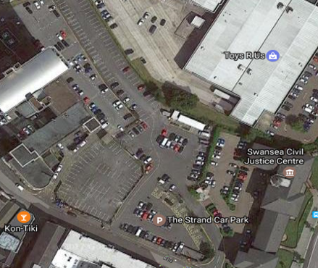
The layout of a confined city centre site needs careful consideration, not only to work efficiently but to work without disputing what is going on around the site layout. All aspects will need to comply with regulations of the city council, correct permits will be needed.
As can be seen from the site location, there is the local BT tower which could hinder the type and positioning of the sites crane, along with this it is in a tight urban area with to the top of the site sits a large 4 story building with many other building in proximity and next to a busy main road in and out of Swansea. (please see site logistics plan)

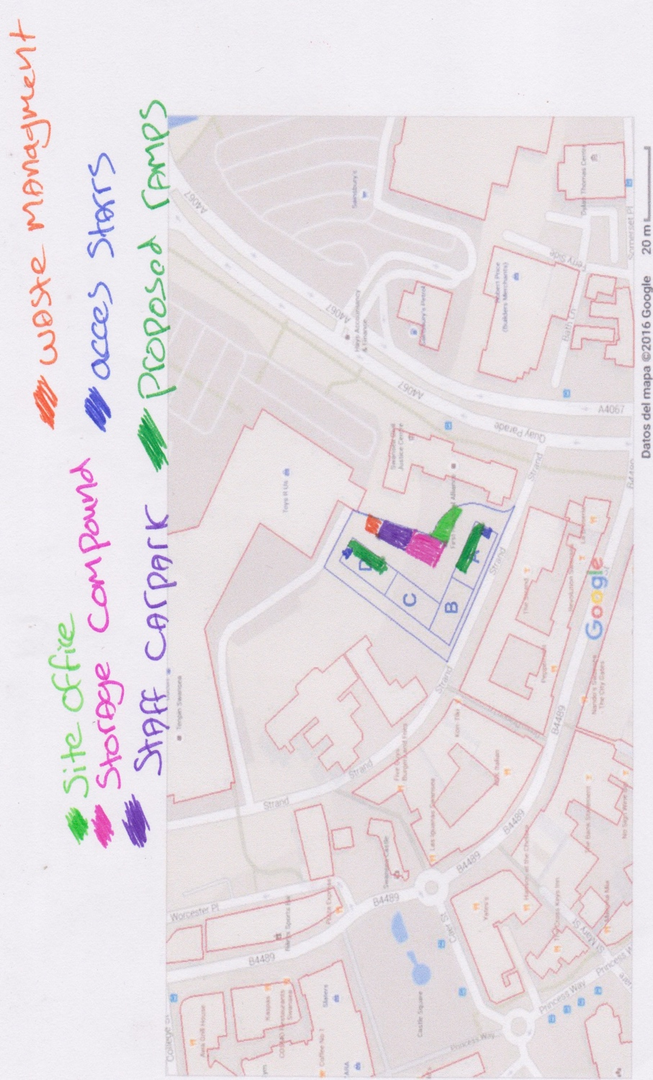

Site logistics plan.

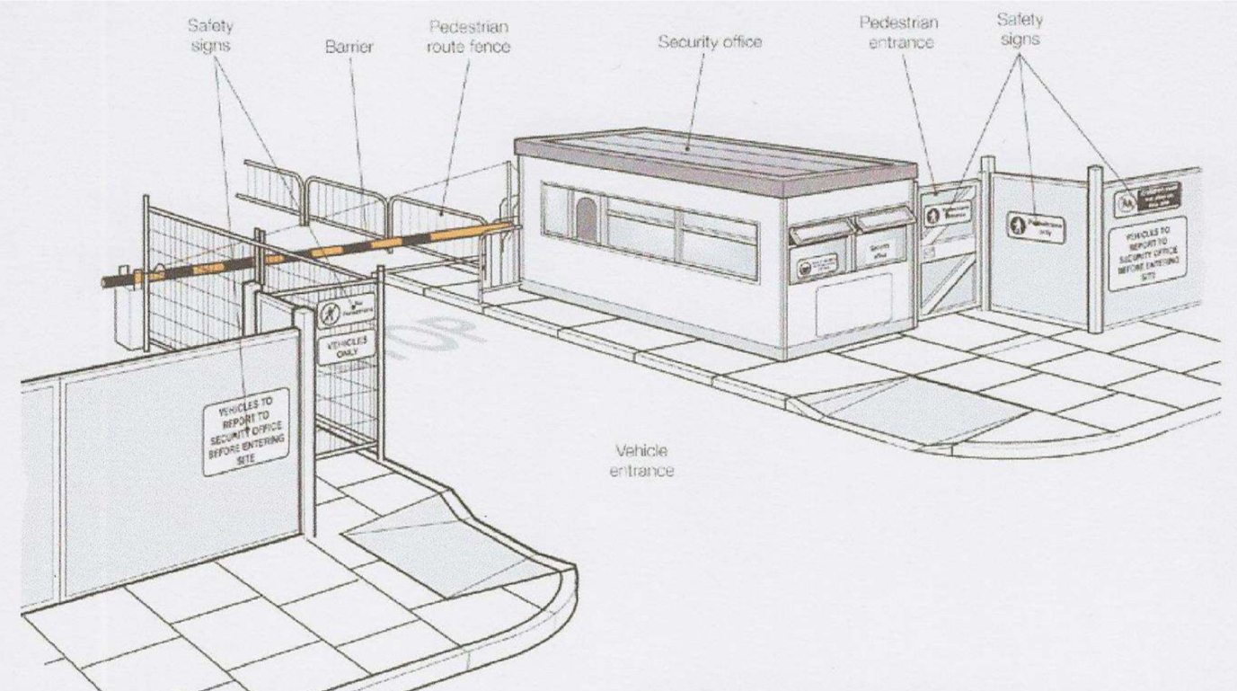
(General Site entrance to ensure safety and the correct people can enter a site).

RAMPS
The access roads must be adapted to the type of vehicle and load that will use it:
- The width of the roadway
- Radius at the corners
- Slope or grade

These are the main factors that need to be considered when the ramp is designed, to make sure that the ramp is safe for the duration of its use.

So, the assumes high of the basement floors would be 6-7m, so if the maximum decline of 12% is permitted for work vehicles it would mean the ramp would be 28.23m long.

So, the assumes high of the basement floors would be 6-7m, so if the maximum decline of 8% is permitted for pedestrians, it would mean the ramp would be 42.69m long. As this would not be feasible to do as the ramp would drastically take up space needed to work and alternative solution would be better suited. The solution to this may be a walk way in the form of steps or a lift. This would create a save working environment for works and separating them form site traffic (picture below).

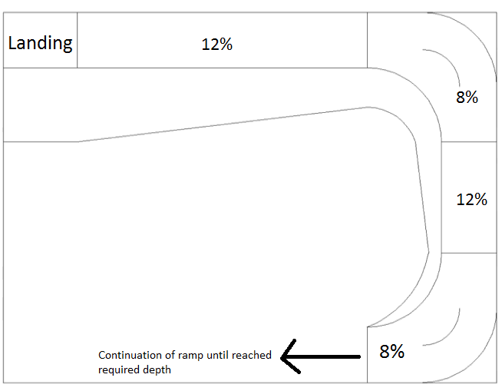
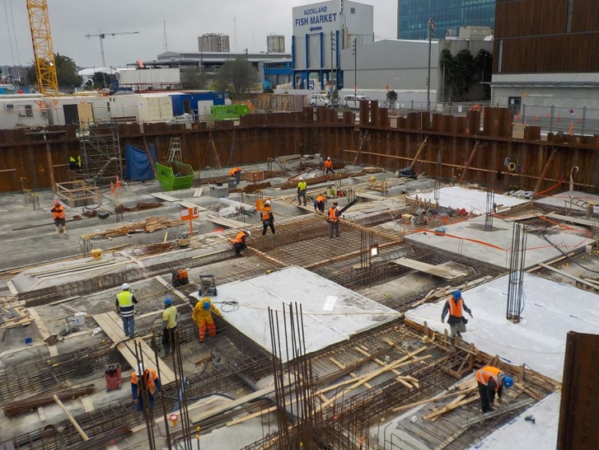

Cranes

The type of crane to be considered depends on the size on the site it is working on as it needs to reach all areas in length and in height. It must also be able to be maneuverer onto the site and be practical in use. Two cranes can be considered for a site if needs be. There will be many implications with doing this. Such as the consideration of them not crossing over one another or working at the same height needs be taken care of, caution should be taken to ensure that the cranes booms do not cross over one another.

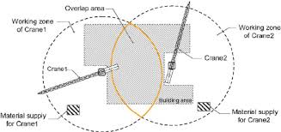

There are several types of cranes that can be considered for the job, many of them have different features and working ability’s.
Crane type
Type of crane | uses | Pros | Cons
Mobile crane/vehicle mounted | Low rise buildings, for lighter work on the building site. | - Can be moved around to suit needs of the contractors. | - Low reach capacity  - Cannot go off road  - Low load bareing.
Tower crane | High rise buildings, Static (unable to move once set up) | - Long reach .  - Can go high.  - Can lift a havey weight. | - Needs a serdy base  - Takes time to assemble  - High cost

A suitable option for the project in hand would be to use a mobile crane until the raft foundation is put in place within the footprint of the build. Then the erection of two tower cranes will be erected in the footprint of the building site these will be used for the remainder of the project, as a mobile crane would not have the weight cpatity or the boom length to cover the whole construtiction site. Two Self-supporting static tower crane has been chosen as they are particularly suitable for confined city centre sites and give good area coverage. They are self-supported with just the need for a good ground anchor at its base. These will also have the reach allowing them to be used to the full site area, for unloading of building materials.
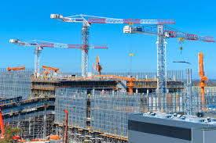
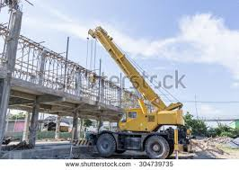
mobile crane- Tower crane-

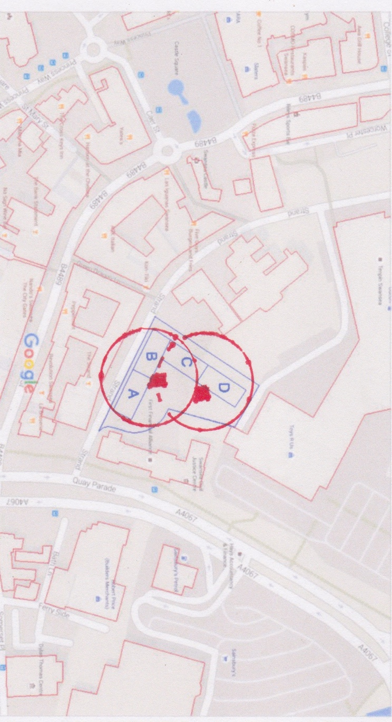

Crane positioning on the side allowing them to reach every inch of the site.

The cranes positioning is vital, and should be planned on the site layout plan to where the location the tower cranes will be. Their positioning has been decided on its practicality of use and the abilities of the crane. The area they can reach has been taken into consideration as well as its positioning so they do not get in the way at any stage of the construction process without the need of it to be moved. Maybe, it is useful to have a dedicated labour team to unload and distribute materials directly to their point of use (avoid double handling). As there are two cranes that has been considered, these must be made so that one crane will not go in to path of the other. Due to the cranes poisoning an over siling license must be obtained due to the fact they may need to travel above the road. (please see site logistics plan)


Another option for a crane to be positioned in a lift shaft of building A,B,C or D could be taken into consideration to allow for the building to carry on being built without interference by the crane or having to move the crane allowing for more space on the building site. If this option is used there should be a few things that are taken into consideration, Significant area around the cranes will be put in place to allow for movement of the cranes from forces such as the wind. (Shapiro, 2010) This will ensure that when the crane moves due to weight being bared on the crane, or natural forces, the crane will not be damaged or the construction work will not be damaged, considerable room should be given to allow this and the removal of the crane once the works are complete.
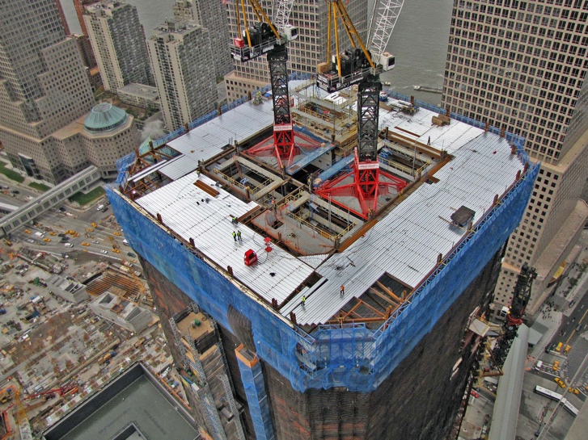
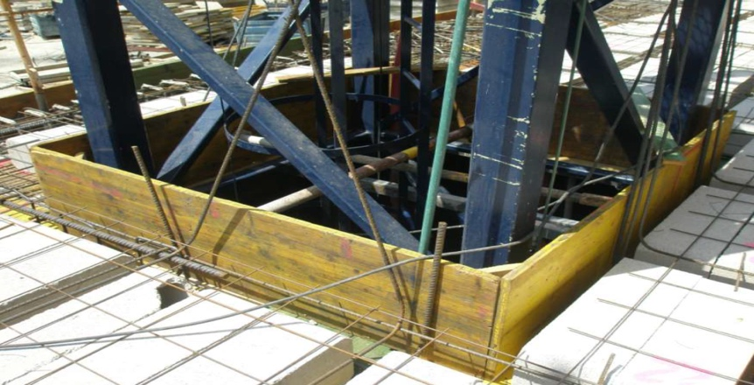
(Photo Juan power point)

Conditions That having cranes on site to make them the most affective and useful they can be,
- Must cover all the area of the construction.
- Able to take materials from storage.
- Preferable not to cross over administration buildings and facilities, nor any other existing buildings.
If we have several cranes these rules must not be broken
- They will have different heights.
- Jibs mustn't cross over any mast.
- The counter jibs of lower cranes mustn’t cross the way of others.

In order to make sure that the correct crane is selected you need to take several thing into account-
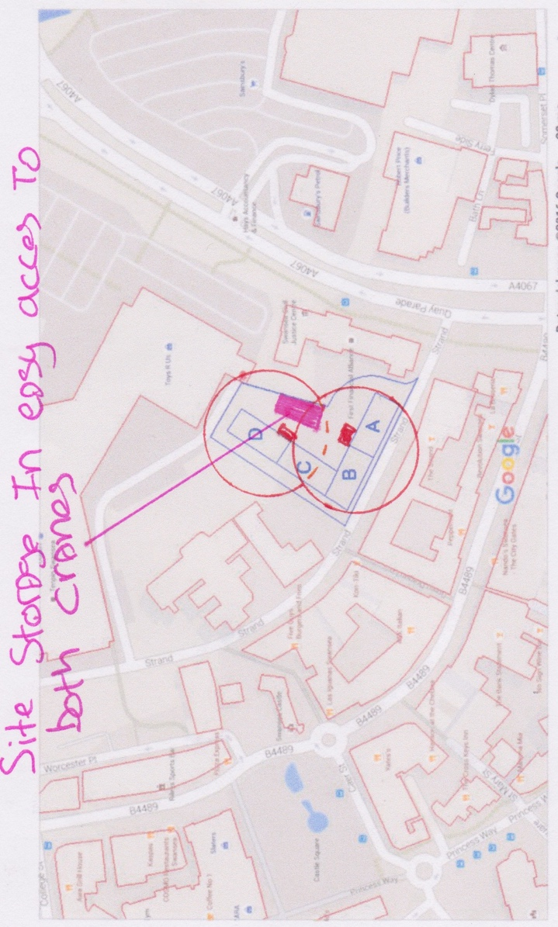
- The maximum length to achieve
- The maximum capacity to rise

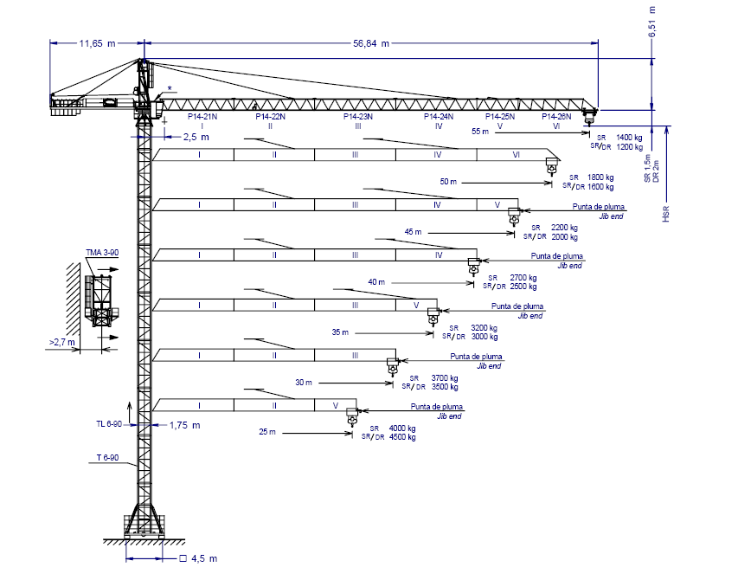

The following crane will be used to carry out several task-

Works | Weight | Can the crane lift?
Fixing steel beams | 28.2kg/m  40mx28.2kg=1128kg | Yes tower crane suitable to lift to the desired height
Placing pre-cast concrete flooring | 236kg per pre-cast slab | Yes tower crane suitable to lift to the desired height
Moving general site material | Ranging from small equipment to larger items | Yes tower crane suitable to lift to the desired height
Unloading and loading of equipment | Ranging from pallets of materials, ranging weights | Yes tower crane suitable to lift to the desired height

Offices and Welfare
The site offices and welfare facilities will be housed within the detail of the site plan. This area will be fully segregated from all construction activities. This area will be for guests to the site and will be where the facilities will be for staff.

The welfare will comprise of several basic elements.
- Office space.
- Kitchen facilities, water (hot and cold).
- drying room.
- toilet facilities.
- washing facilities.
- first-aid facilities, accident book.
- Storage facilities for small items of plant and a lock up.

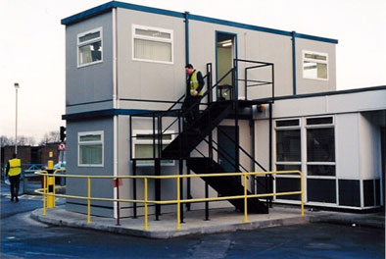

The site compound and site office will be a controlled area, this will have a check-in system to ensure that only authorised personnel can access the site (please see site logistics plan). The site will also have controlled working hours. Normal site working hours will be between the hours of 0700 am and 1800 pm Monday to Friday, Saturday hours will be 0800 am to 1300 pm. HGV deliveries will not be permitted on to the site during the peak periods (8.30 am-9.30 am and 4.30 pm-5.30 pm) this is to reduce traffic constraints and ensure a safer working area.

Deliveries and storage zone

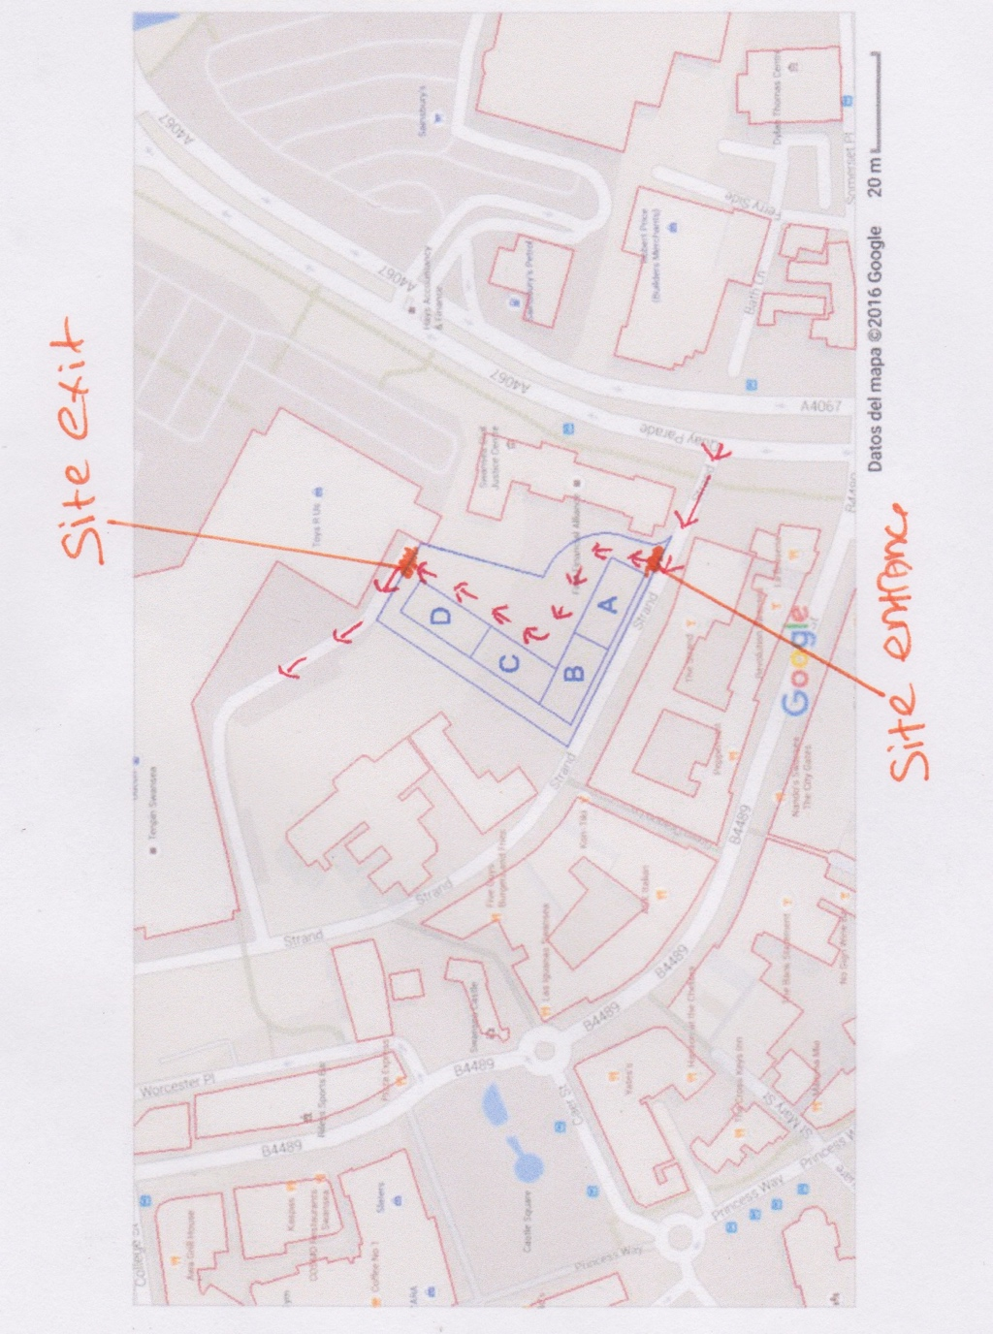
Deliveries will have a scheduled time to avoid traffic build up on the strand road. The deliveries will enter the site and drive to a designated parking spot to unload. All deliveries must be offloaded within the designated offloading area, any mechanical lifting form cranes, hi-ab or forklift will be used in that area to avoid injury to workforce. Vehicles will need to be cleaned before entering back onto the public highway, Car and van parking for workforce and visitors away from working area. Perimeter fencing and security staff (avoid theft or vandalism), Store similar materials together and establish the conditions for storage such as, cement and plaster. Dry zone and timber carpentry which is not exposed to climate conditions.
(please see site logistics plan).
Work force and public safety

A great emphasis will be placed on public safety; several procedures will be implemented to the safety of the public these will include-

- Maintain a fully enclosed site via fencing. (please see site plan)
- Outside boundaries will be inspected and maintained or even changed daily.
- All visitors to be inducted.
- Dust and noise monitoring.
- Signage to identify hazards.
- Provision of correct PPE
- Correct rights to be on site (CSCS Card).
Waste
To comply with health and safety regulations the site will be kept clean and well organized always with a site waste organization plan put in place. Waste products will be put into designated containers which split each type of waste onsite, where this isn’t possible on site due to space, it should carried out at the correct facilities (located on site plan).
Separation of waste will also need to take place as good working practice. It can also keep costs of rubbish removal down.
The law says you must keep every part of your construction site in ‘good order’ and every place of work clean. The objective is to achieve what is usually called a good standard of ‘housekeeping’ across the site.
In addition, all contractors must plan, manage and monitor their work so it is carried safely and without risks to health. This includes careful planning on how the site will be kept tidy and housekeeping actively managed. (HSE.GOV)

A waste management licence will be implemented for all deposits, recover or disposed of controlled waste. Waste specialist carrier will be registered with the waste regulation authority for compliance.
- Work areas - make clearing waste a priority for all trades.
- Skips - waste materials need storing safely before their removal from the site so make sure that you allow sufficient space for waste skips and bins. Plan where the skips can be positioned and how often they will need to be collected;
- Waste within buildings - consider waste generated inside the building and whether you need to provide wheeled bins or chutes etc. to enable it to be brought out of the building safely;

Conclusion

A well-planned and managed project will give the workforce better information; this is particularly useful to sub-contractor as they will know what days they need to be there and for how long. With a good project plan in place.
A well thought out project plan will also help when it comes to deliveries, every delivery can be planned for when it is needed. It can create a safer working environment for the workforce and the whole site. Have the correct crane in the right place can help with moving the material and making sure that double handing of material and good does not happen allowing for a more productive work force on site. Details are important with in a project plan, therefore every task should be within the plan.
Site layout planning can affect productivity and is crucial to project success. Site layout planning for each project becomes unique. Affected by many uncertainties variables And variations, site layout planning is a typical multi objective problem. As a site manager I will be left with the details of organizing every aspect of the construction site from ordering material to making sure the correct plant and machinery are on site, this will also include the crane which is the main archer of the construction site and is used for every part of the build. As a well set up site will leads to a productive site with less hazards and safer area to work.

References
http://www.hse.gov.uk/construction/safetytopics/storage.htm
[Accessed 11/1/2018].
Langdon, D., 2018. SPON's. 130 ed. s.l.:Taylor and Francis.
https://moodle.uwtsd.ac.uk/pluginfile.php/124458/mod_resource/content/1/Site%20layout.pdf[Accessed 11/1/2018].

