Matthew Satterthwaite
Student: 1910496

DSP and Communications

Document: Simulation of Modulation Techniques

Effects of White Noise

3 March 2021

Contents
Contents ii
1 Introduction 1
1.1 Background 1
1.2 Requirements 1
1.3 Experiment Methodology 1
2 Modulation Methods 2
2.1 Amplitude Shift Keying (ASK) 2
2.2 Phase Shift Keying (PSK) 2
2.4 Quadrature Amplitude Modulation (QAM) 3
3 Components 4
3.1 Random Signal Generation 4
3.2 Modulation 4
3.3 Noise Block 4
3.4 Demodulation 5
3.5 Filter 5
3.6 Oscilloscope 5
3.7 Bit Error Rate (BER) Calculation 6
4 Simulation Circuits 6
4.1 ASK 6
4.2 PSK 6
4.3 QPSK 7
4.4 QAM 7
5 Simulation Result 8
5.1 ASK 8
5.2 PSK 9
5.3 QPSK 10
5.4 QAM 11
6 Conclusion 12
6.1 Quality 12
6.2 Discussion 13
6.2 Accuracy 14
7 References 15

List of Figures
Figure 1-1: Circuit Basics 1
Figure 2-1: ASK Modulation [5] 2
Figure 2-2: PSK Modulation [8] 2
Figure 2-3: QPSK Modulation [10] 3
Figure 2-4: 16-QAM [11] 3
Figure 2-5: 64-QAM [11] 4
Figure 3-1: Noise Block Changes 4
Figure 3-2: Filter Designer 5
Figure 3-3: Scope Example from PSK Circuit 6
Figure 4-1: ASK Circuit. 7
Figure 4-2: PSK Circuit 7
Figure 4-3: QPSK Circuit 8
Figure 4-4: QAM 8
Figure 5-1: ASK Simulation Results 9
Figure 5-2: PSK Simulation Results 10
Figure 5-3: QPSK Simulation Results 11
Figure 5-4: QAM Simulation Results 12
Figure 6-1: Quality Graph Comparison 13
Figure 6-2: Full QPSK Example 14

List of Tables
Table 5-1: ASK Simulation Results Table 8
Table 5-2: PSK Simulation Results Table 9
Table 5-3: QPSM Simulation Results Table 10
Table 5-4: QAM Simulation Results Table 11

Introduction

Background

There are a number of different digital modulation methods for use in communication systems.

At this very moment, communication systems have never been more important due to the increasing demand for remote working and digital communication methods.

For a digital communication channel to be reliable and successful, the noise should be kept to an absolute minimum.

Requirements

Electronic noise in this context is an unwanted signal that is imposed upon a wanted signal and might be heard as cracking, humming or hissing sounds. [1] it can also cause breakages in the signal meaning you only receive parts of the message.

An electronic designer will spend great effort into reducing such noise [2]. This document is going to investigate the different methods used by electrical engineers and compare the results.

Experiment Methodology

For this experiment, a circuit for each type of modulation method will be created within SIMULINK. [3]

Each circuit will follow the same basic principles, shown below in Figure 1-1.

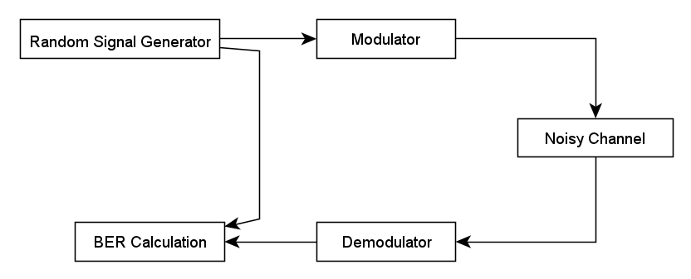
Figure 1-1: Circuit Basics

Each circuit will be simulated 8 times and an average failure rate taken between 0 and -30dB. Any average that is higher than 35% will be considered a partial failure for the purpose of this test. Anything over 50% will be considered a complete failure. These figures are for this experiment only.

Modulation Methods

Amplitude Shift Keying (ASK)

ASK is a type of modulation which utilized binary data in the form of variations in the signal’s amplitude [4]. The variation in amplitude will usually vary between two discrete levels, 1 and 0. When a binary signal is 1, the carrier wave will have amplitude. When a binary signal is 0 the carrier wave has zero amplitude. This is explained below in Figure 2-1.

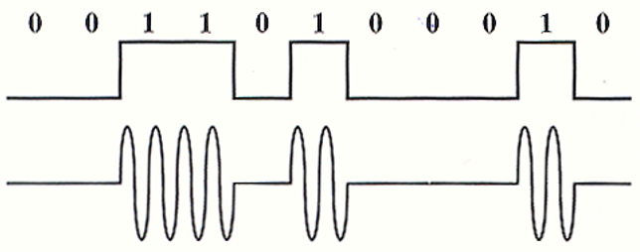
Figure 2-1: ASK Modulation [5]

Phase Shift Keying (PSK)

PSK is a digital modulation method that sends data by changing the phase of the carrier wave in accordance with the signal being modulated [6].

As with ASK, PSK is used to represent digital data like binary digits 0 and 1 [7]. Once the data changes from a 1 to zero, or zero to a 1 the phase shifts 180° and will create a “W” or “M” shape within the carrier wave.
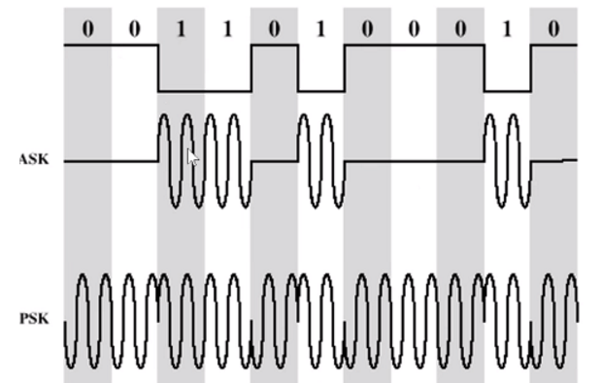
Figure 2-2: PSK Modulation [8]

Quadrature Phase Shift Keying (QPSK)

A more advanced method of modulation, QPSK allows a higher data rate due to it having double the bits per symbol as Ask or PSK. Utilizing double digits such as 00,01,10 and 11, QPSK increases the efficiency of the bandwidth by two. [9]

Shifting phases differently to standard PSK, QPSK can change between four angles. These are 45°, 135°, 225° and 315°.
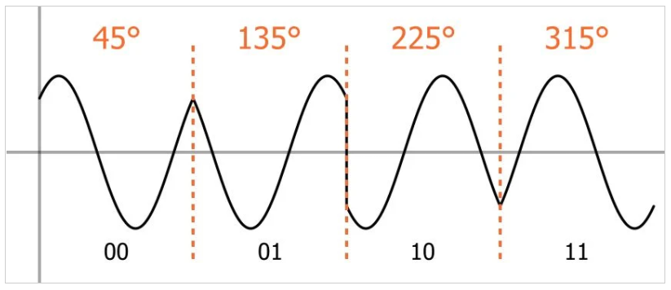
Figure 2-3: QPSK Modulation [10]

Quadrature Amplitude Modulation (QAM)

QAM can be viewed as a combination of both PSK and ASK.

QAM is able to vary the amplitude with the phase and can be used as 16 or 64-QAM.

16-QAM contains four bits per symbol and each point is represented below by a blue point on the graph.
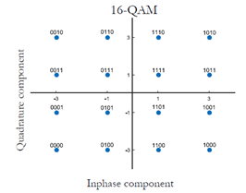
Figure 2-4: 16-QAM [11]

64-QAM contains more bits per symbol. This is a large increase in the quantity of data able to transfer, but the points are much closer together. This leave them far more susceptible to interference. [12]

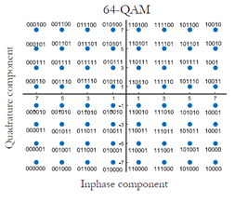

Figure 2-5: 64-QAM [11]

Components

Random Signal Generation

Bournoulli Binary Blocks will be used to generate random signals within the ASK and PSK circuits. This will create a random data bit to simulate digital communication systems. Since the signal will be binary, there is no requirement for bit converters within this simulation.

Modulation

A Modulator is a circuit that can combine two signals that can later be pulled back apart and the information extracted. [13]

Noise Block

For this simulation, an additive white gaussian noise block will be used. This will allow noise to be deliberately added and removed from the simulation. This enables the user to analyze the performance of the modem circuit at differing noise levels.
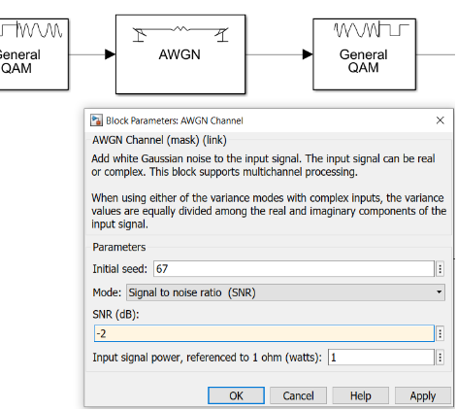
Figure 3-1: Noise Block Changes

Demodulation

This component has the opposite effect to the modulator. The demodulator will interpret the carrier wave signal and convert it back to the signal it started as. This is the point at which error rate can be calculator because the signal may be converted incorrectly if the system has interference or noise present.

Filter

Filters are used in communications systems to isolation the system and suppress noise. They are designed to choose a required frequency range and detach the unwanted ones. [14]

SIMULINK has a filter designer, which was used for this experiment. The filter specifics are shown below and was consistent throughout.

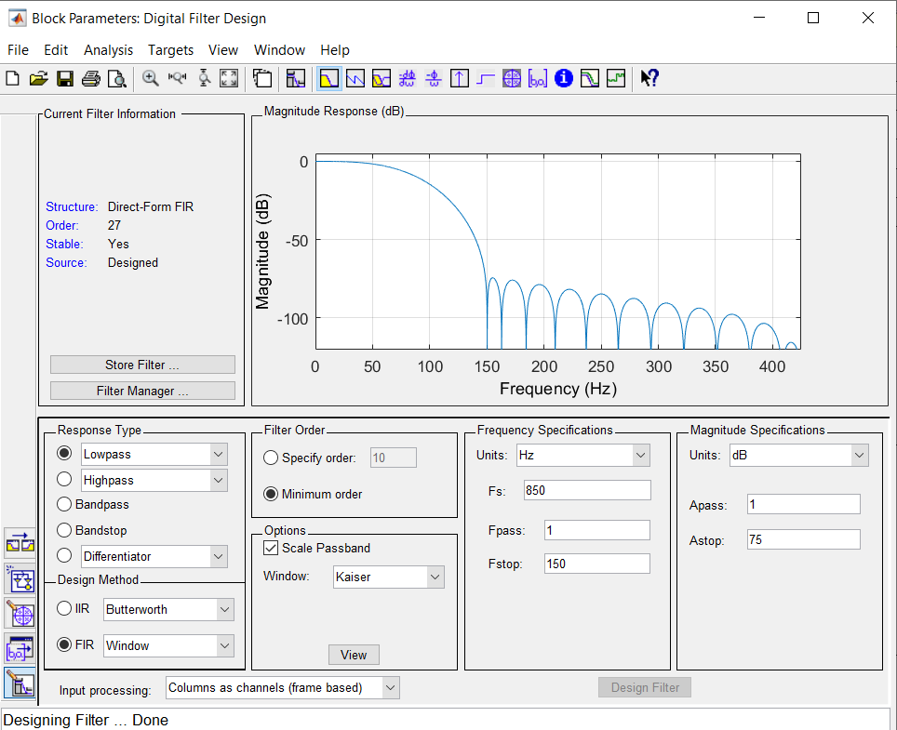
Figure 3-2: Filter Designer

Oscilloscope

A “scope” is a piece of test equipment used to display variations in signals within an electronic system.
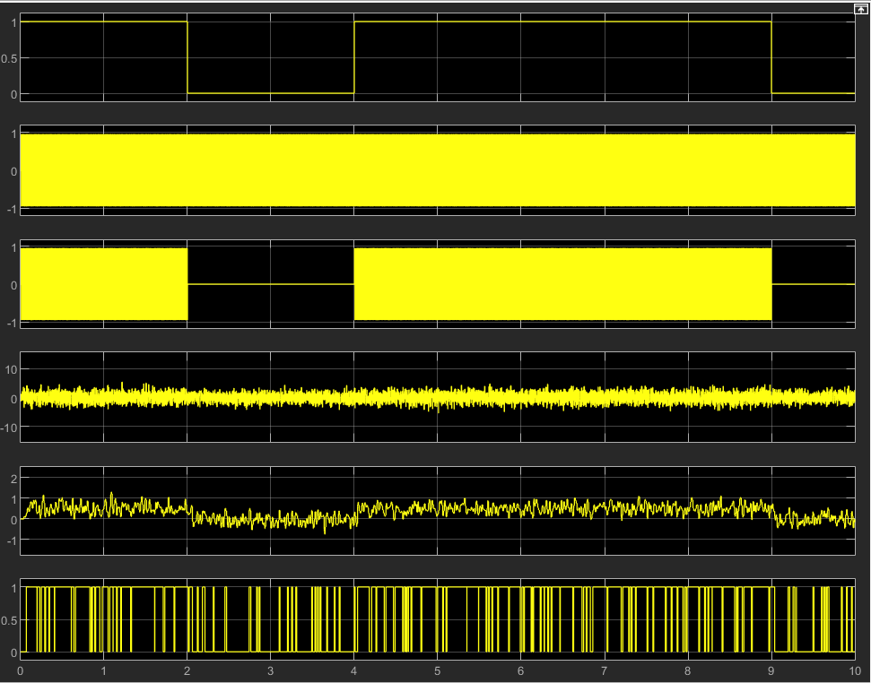
Figure 3-3: Scope Example from ASK Circuit

The sample above from taken from the ASK circuit shown in Figure 4-1. From top to bottom it shows the source signal coming in – at row 1 - and combining with the sign wave at row 2 before passing through the modulator at row 3. Row 4 shows the introduction of White noise to the system with row 5 showing the work that the filter is doing to remove the interference before the signal is demodulated at row 6.

Bit Error Rate (BER) Calculation

Within the SIMULINK software this block will accept one input from the source signal, and one from the signal being received.

The sent signal comes straight from the signal generator to the TX port which in this case is the Bernoulli binary block. The received signal goes through the whole system and into the RX port.

The calculation for working out the error rate involves dividing the number of bits with error by the total number of bits sent.

$$BER=\frac{Number of bits with error}{Number of bits sent}$$

The number will be given as a percentage, which is the number that will be taken 8 times during the experiment to get an average.

Simulation Circuits

ASK

Figure 4-1 shows the circuit layout for the ASK circuit used during this experiment.

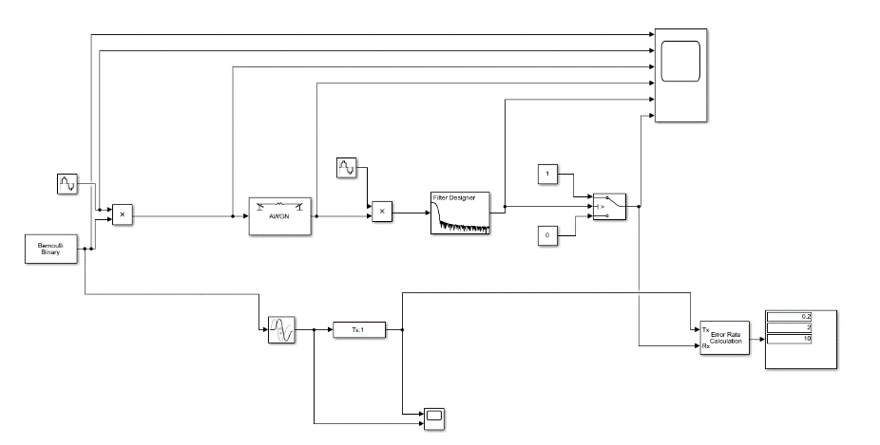
Figure 4-1: ASK Circuit.

PSK

Figure 4-2 displays the PSK circuit used for this experiment. The circuit itself is almost identical to the ASK circuit apart from the very start, which includes two sine waves rather than 1.
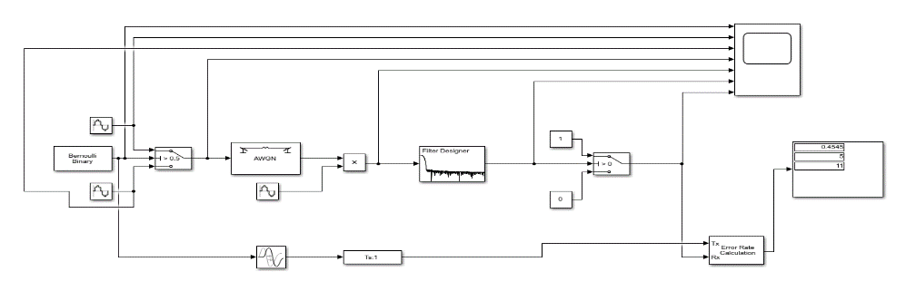
Figure 4-2: PSK Circuit

QPSK

Figure 4-3 displays the QPSK circuit used for this experiment. The link between the signal generator and error rate calculator can be seen bypassing the circuit components. This would be the “sent” signal.
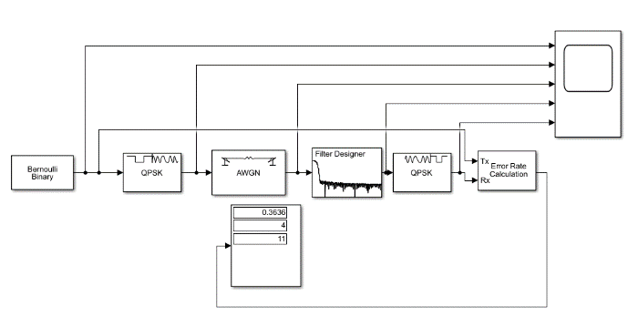
Figure 4-3: QPSK Circuit

QAM

Figure 4-4 shows the QAM circuit, which is identical to the QPSK circuit apart from the specific QAM modulator and demodulators shown either side of the white noise.
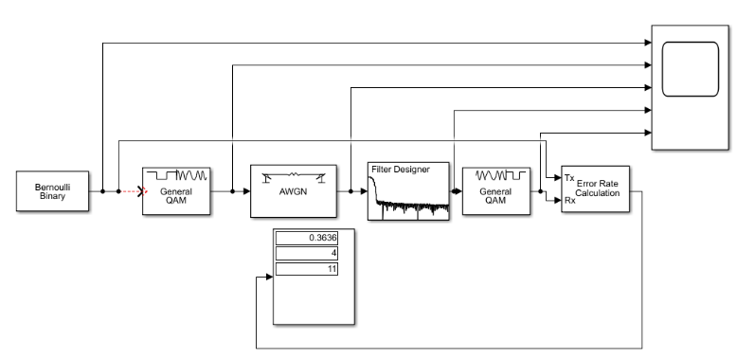
Figure 4-4: QAM

Simulation Result

ASK

The results of 8 ASK simulations between 0dB and -30dB are shown below.

Table 5-1: ASK Simulation Results Table

It can be seen above that the first failure happened at -26dB. Interestingly -30 averaged below the 35% failure mark.

Figure 5-1: ASK Simulation Results

This plotted graph shows that the failure rate increases with greater noise or interference at a fairly even rate, staying relatively close to the trendline shown in white.

PSK

The results of 8 PSK simulations between 0dB and -30dB are shown below.

Table 5-2: PSK Simulation Results Table

PSK returned fewer failures and managed to remain satisfactory up after -28dB before increasing rapidly over the failure threshold at -30dB.

Figure 5-2: PSK Simulation Results

The above graph shows that there are zero failures up to -4dB and that the rate of failures against the SNR projects a line that deviates away from the trendline quite erratically.

QPSK

The results of 8 QPSK simulations between 0dB and -30dB are shown below.

Table 5-3: QPSM Simulation Results Table

It can be seen from the table above that QPSK failed as early as -8dB and continues failing throughout the experiment.

Figure 5-3: QPSK Simulation Results

The graph above shows failure from as early as -6dB. The rate continued to climb to around a 45% failure rate where it began plateau. The author input -50dB as a trial and the process returned a 53% failure rate which would show that soon after -30dB the failure rate would again increase. One test during the 50dB trial returned a 100% failure.

QAM

The results of 8 QAM simulations between 0dB and -30dB are shown below.

Table 5-4: QAM Simulation Results Table

The table above shows that even with zero noise, the QAM returns quite a poor result which marginally falls under the partial failure threshold. Several tests returned a 100% failure.

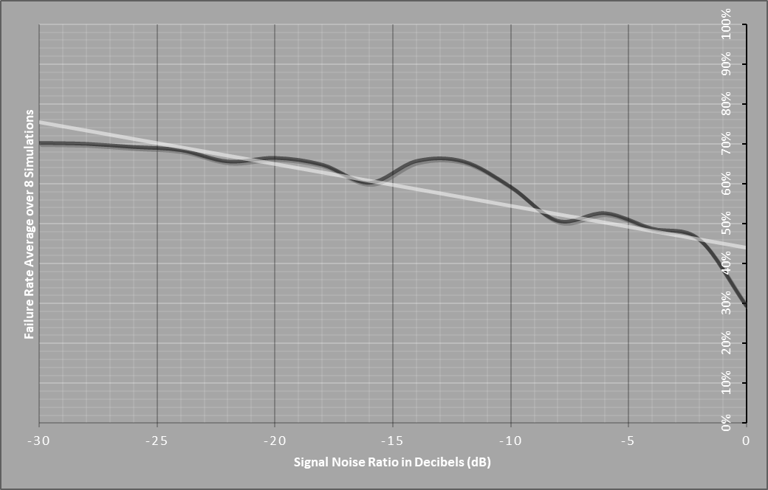
Figure 5-4: QAM Simulation Results

This graph shows that with the immediate introduction of noise, partial failure occurs. Complete failure occurs as early as -6dB and the trend line continues to climb. The author is confident, that given a greater range of test data a complete failure would be seen at around -60 to -70dB.

Conclusion

Quality

A direct comparison between all four methods is shown below at 4 identical points to shown the failure rates.

Table 6-1: Quality Comparison

Table 6-1 above shows that – without considering the amount of data being transmitted – PSK offers was the purest and most error free method of communication throughout this experiment.

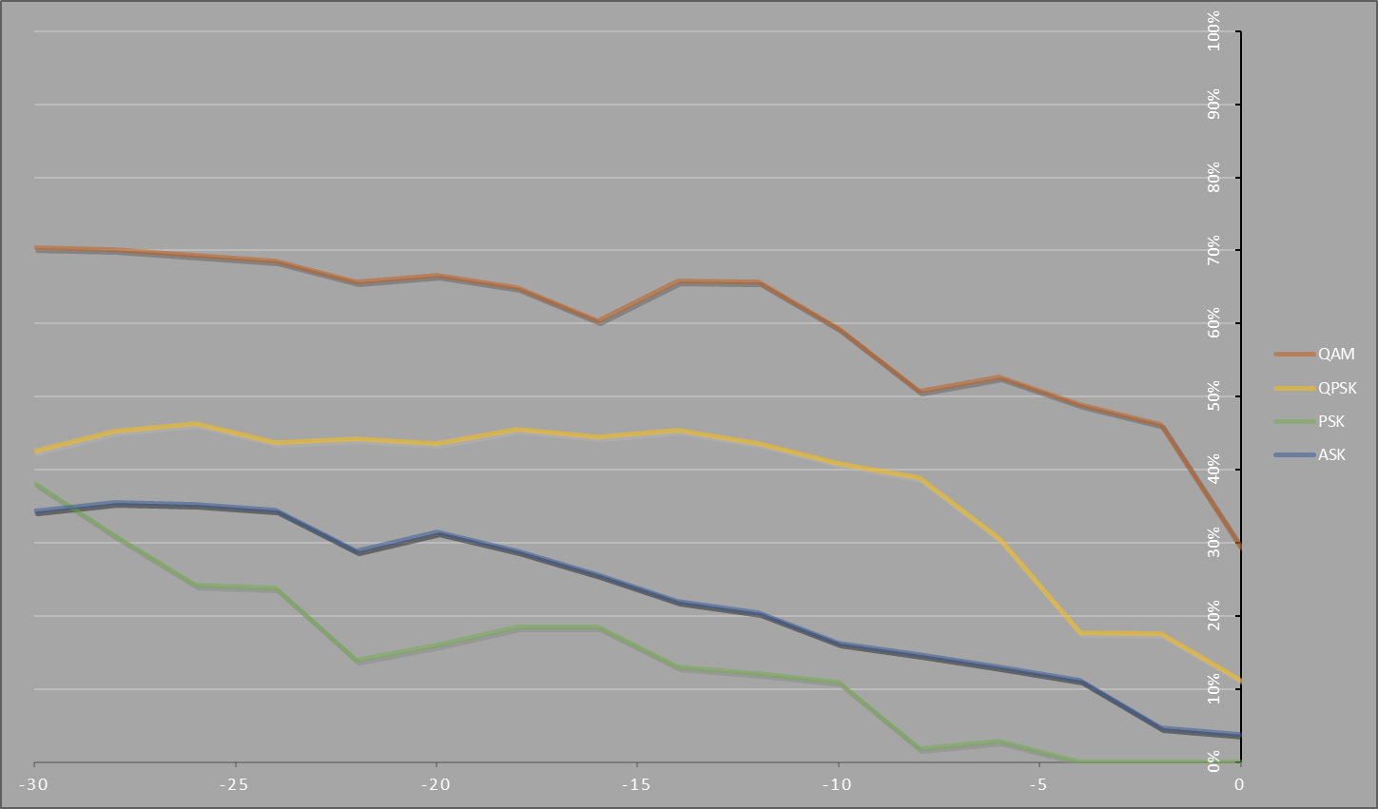
Figure 6-1: Quality Graph Comparison

For larger data transfers, QPSK performed better than QAM which failed as soon as noise as introduced. The effect of noise on the QPSK system levels and shows a similar trend to PSK and ASK after -15dB. Despite having a higher bit error rate than the two mentioned, QPSK offers larger data transfer which results in the bandwidth use being more efficient.

Discussion

For methods involving small amounts of data transfer the author would recommend using a PSK system against an ASK System.

During these modern times where communication is increasingly important, the desired solution would require greater amounts of transferable data to make the most of the bandwidth available.

QAM offers easily the most space for your data but returns a far greater bit error rate. The more data you try to send through QAM, the closer together the points in the QAM diagram become, leaving them susceptible to noise interference.

Both QPSK and QAM blocks were designed using premade blocks that SIMULINK offers within its parts library. There is a possibility - that with a more comprehensively designed system with the inclusion of filters (shown below) – the results could be slightly different and error rates.
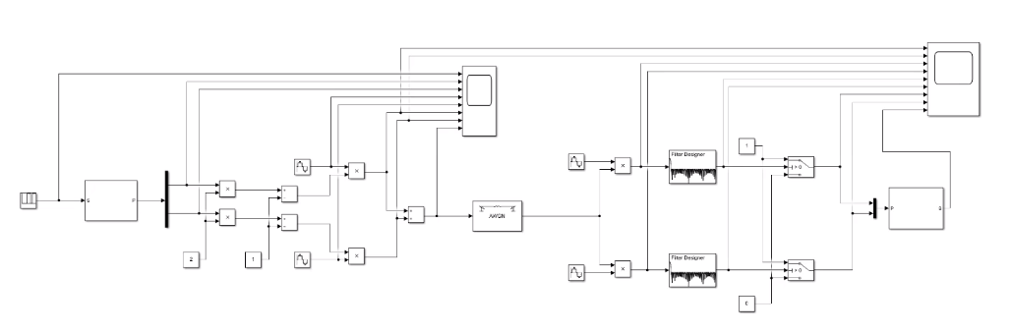
Figure 6-2: Full QPSK Example

If the experiment were to be repeated, each system would be designed with unique and circuit specific filters that offer a fair starting point at a low level of interference. This would offer a shared start datum that would make thew graphical representations more relatable to one another.

For this reason, it is unreliable and unrealistic to compare between all four methods, just between the ASK vs PSK and then QPSK vs QAM as two different methods of small and large data transfer systems.

Accuracy

To increase the accuracy next time the author would increase the number of variants tested during each noise level by delaying the transmission, allowing more test data within the time frame.

The author would also increase the noise range to -50dB, whilst reducing the distance between the to -1dB. This would also increase test data, resulting in much more accurate results.

References

[1] | W. R. a. A. BOLOZDYNYA, "Electronic Noise," Science Direct - Emission Tomography, 2004. [Online]. Available: https://www.sciencedirect.com/topics/engineering/electronic-noise.
[2] | O. Bishop, "Understand Electronics," Second Edition, 2001. [Online]. Available: https://www.sciencedirect.com/topics/engineering/electronic-noise.
[3] | MathWorks, "Simulink," Mathworks, [Online]. Available: https://uk.mathworks.com/products/simulink.html?requestedDomain=. [Accessed 03 03 2021].
[4] | TutorialsPoint, "ASK," SimplyLearning, [Online]. Available: https://www.tutorialspoint.com/digital_communication/digital_communication_amplitude_shift_keying.htm. [Accessed 03 03 2021].
[5] | Tmatlantic, "ASK - Amplitude Shift Keying," [Online]. Available: https://www.tmatlantic.com/encyclopedia/index.php?ELEMENT_ID=10420.. [Accessed 03 03 21].
[6] | E. Coach, "PSK," ElectronicsCoach.com, [Online]. Available: https://electronicscoach.com/phase-shift-keying.html. [Accessed 04 03 21].
[7] | Tecnopedia, "Explaining PSK," Communication, [Online]. Available: https://www.techopedia.com/definition/1701/phase-shift-keying-psk. [Accessed 03 2021].
[8] | S. Mosey, "Basic Encoding Techniques," Ordnance Munitions and Explosive - DSP and Comms Lecture, UWTSD, 2021.
[9] | K. R, "QPSK Modulation," All about circuits, [Online]. Available: https://www.allaboutcircuits.com/technical-articles/quadrature-phase-shift-keying-qpsk-modulation/.. [Accessed 03 03 21].
[10] | R. Keim, "Quadrature Phase Shift Keying (QPSK) Modulation," All About Circuits, 17 August 2016. [Online]. Available: https://www.allaboutcircuits.com/technical-articles/quadrature-phase-shift-keying-qpsk-modulation/.
[11] | N. Mathura, "QAM in Matlab," Gaussian Waves.com, 10 2012. [Online]. Available: https://www.gaussianwaves.com/2012/10/qam-modulation-simulation-matlab-python/.. [Accessed 03 03 21].
[12] | S. Mosey, "Advanced Modulation," UWTSD - OME , Swansea, 2021.
[13] | W. B. B. Hons, "Modulators," Science Direct, 2000. [Online]. Available: https://www.sciencedirect.com/topics/engineering/modulators.
[14] | El-Pro-CUS, "active filters," [Online]. Available: https://www.elprocus.com/types-active-filters-and-applications/#:~:text=Active%20filters%20are%20used%20in%20communication%20systems%20for,a%20required%20frequency%20apparatus%20and%20detach%20unwanted%20ones.. [Accessed 03 03 21].
[15] | Tmatlantic, "Phase Shift Keying," [Online]. Available: https://www.tmatlantic.com/encyclopedia/index.php?ELEMENT_ID=10478. [Accessed 03 03 21].

