Introduction
Digital innovation has become increasingly pivotal in transforming professional practices within the post-16 and further education sectors, with technological integration presenting both innovative opportunities and complex challenges. This assignment critically examines the role of digital innovation within professional practice, specifically focusing on its application in language learning contexts within further education settings. By exploring the intersection of technology and pedagogical approaches in post-16 education, the research will provide a comprehensive assessment of digital tools’ potential to enhance educational methodologies (Kryukov and Gorin, 2017).

Through a comprehensive literature review, the research will systematically explore the multifaceted ways digital tools can support and enhance language education, specifically emphasising Welsh language learning in post-16 education environments. The literature review will explore various digital platforms, applications, and technological interventions that have demonstrated potential in post-16 language learning contexts. By synthesising current research, the study aims to identify and recommend the most effective digital tools suitable for implementation within further education classrooms.

Professional standards and pedagogical frameworks specific to the post-16 education sector will be critically assessed to ensure that technology interventions align with established educational guidelines. Practical application forms a core component of this research, whereby the selected digital innovation will be strategically applied in a post-16 classroom setting to support and assess students’ knowledge of the Welsh language.

A critical perspective will be maintained throughout, acknowledging both the transformative potential and inherent limitations of digital technologies in post-16 language education. Student feedback will be integral to this evaluation, providing qualitative insights into the efficacy and user experience of the implemented digital innovation. By adopting a nuanced and reflective approach, this assignment seeks to contribute to the ongoing debate surrounding digital innovation in professional educational practice within the post-16 education sector.

The role of creativity and Digital Innovation
A study by Eslit (2023) found that the post-pandemic era has brought significant changes in education, including in language learning and acquisition. Key emerging themes include an increased reliance on technology, the rise of self-directed learning and the importance of fostering social connection within the learning environment. These changes highlight the transformative impact of digital innovation on education and underscore the need for new pedagogical approaches. For language educators, this evolution presents both challenges and opportunities, requiring the integration of technology into instruction practices, the encouragement of learner autonomy, and the creation of collaborative, interactive learning experiences. This study suggests that digital innovation is largely beneficial but requires careful implementation and support. The effectiveness of digital tools depends on their integration into teaching practices, as well as on the readiness and skills of educators and learners. By addressing gaps in digital literacy and creating opportunities for collaboration, digital innovation can alleviate the pressures of language learning while offering a dynamic, supportive educational environment (Eslit, 2023).

A study by Metz and Metz (2021) highlights that asynchronous digital learning, especially when integrated with active learning strategies, can yield positive educational outcomes. Dental students showed more favourable perceptions of prerecorded lectures that incorporated active engagement activities compared to traditional lecture recordings. These perceptions included greater motivation, confidence, and ability to pay attention to the material, demonstrating the potential of asynchronous methods to create meaningful learning experiences. Although unit exam scores were similar between online and face-to-face traditional lectures, the use of active learning strategies led to significantly higher exam performance, particularly in face-to-face settings. This underscores the importance of incorporating active collaborative learning opportunities within asynchronous formats to optimise their effectiveness. While asynchronous digital learning cannot fully replicate some aspects of face-to-face interaction, the study suggests it is a valuable approach, especially when well-designed to promote engagement (Metz and Metz, 2021). It calls for further research to refine active learning strategies in online environments, reinforcing the need to tailor digital education to students’ needs for greater impact.

Although research supports the benefits of asynchronous digital classrooms, limitations have also been identified. Zolfaghari Mashhadi and Reza Kargozari (2011) argue that asynchronous digital classrooms can feel cold and impersonal, lacking the interactive experience of a traditional classroom. It requires significant student initiative, as instructors may find monitoring and managing student engagement harder during virtual sessions. Distractions are easier to succumb to when students are not directly visible to the instructor. Additionally, the flexibility offered by asynchronous learning does not always guarantee better academic outcomes. Some students struggle with time management and self-regulation, hindering their success. Technical barriers, such as limited access to reliable internet or insufficient digital literacy, may further impede participation, particularly for learners unfamiliar with managing computer files or software effectively (Zolfaghari Mashhadi and Reza Kargozari, 2011).

These challenges suggest that while asynchronous digital learning provides opportunities for self-paced and flexible education, it demands a higher level of self-motivation and external support to address its inherent difficulties.

Duolingo is a language-learning platform presented in a quiz-like format using gamification to engage users. It allows learners to study a second language independently, offering flexibility to practice anytime and anywhere. This makes it particularly effective for students with varied schedules, as it is a mobile-assisted approach that accommodates diverse learning environments (Duolingo, 2022). The platform’s gamified design, incorporating rewards and interactive challenges, is widely appreciated for increasing motivation and enjoyment in learning. Research by Loewen et al (2019) indicates that regular use of Duolingo can lead to measurable improvements in second language proficiency, with positive correlations between time spent on the app and language learning outcomes. Participants often report its flexibility as a significant advantage, enabling them to progress at their own pace.

However, Duolingo is not without its challenges. Some users experience variability in motivation and occasional frustration with instructional materials, particularly when they feel misaligned with their learning needs.

Despite these limitations, the tool remains a highly accessible and engaging resource that supports language acquisition, complementing traditional methods and fostering independence in learners (Loewen et al., 2019).

Quizizz is an online platform that uses gamification to engage students in learning through quizzes. It is often used in classrooms to reinforce concepts and engage student participation (Help Centre, 2024). A study by Degirmenci (2021) reviewed the impact of Quizizz in the context of English language teaching, highlighting its positive effects on student engagement and learning outcomes. According to the study Quizizz helps to make learning easier for students by providing an interactive and enjoyable experience. Both teachers and students expressed favourable perceptions of the tool, citing its ability to motivate students and support active learning.

While Quizizz has been shown to have a positive effect on student engagement and learning Niek and Abdul Aziz (2022) found that there are notable limitations to its effectiveness, particularly in terms of fairness and learner experience. One major issue is the varying internet speeds among students, which can affect their ability to access and answer questions promptly. Students with slower internet connections may face delays, resulting in lower scores despite answering questions correctly. This can create an inequitable learning environment. Another concern is the timer feature, which can induce anxiety and cause students to rush through their answers. This pressure may lead to mistakes and lower performance, affecting the overall learning experience (Niek and Abdul Aziz, 2022).

Despite these drawbacks, the effectiveness of Quizizz as a learning tool depends largely on how it is integrated into the classroom. Teachers must be mindful of these limitations to ensure that Quizizz remains an effective and equitable tool for all learners.

Collaborative learning is a pedagogical approach that emphasises the importance of students working together in groups to achieve shared learning goals. Research by Laal and Ghodsi (2012) found that collaborative learning not only enhances cognitive skills but also fosters social interaction and emotional development. A significant advantage of collaborative learning is its ability to improve communication and conflict resolution skills, as students regularly engage in discussions, work through problems, and support each other’s learning (Webb, 1982).

Moreover, collaborative learning has been shown to develop higher-level thinking skills. As students actively engage in discussions and receive immediate feedback from peers, they are encouraged to think critically, challenge each other’s ideas, and refine their understanding. This process not only helps students develop cognitive skills but also promotes responsibility for their own learning, fostering greater student autonomy (Webb, 1982). In addition to cognitive and academic benefits, collaborative learning has emotional and social advantages. Diversity in a collaborative setting encourages students to understand different viewpoints and manage conflicts constructively. Furthermore, the cooperative nature of collaborative learning can reduce anxiety and increase confidence, creating a supportive and inclusive environment that helps students feel more engaged and valued (Laal and Ghodsi, 2012).

Through this combination of academic, social, and emotional support, collaborative learning provides a comprehensive approach to learning that can lead to more meaningful and lasting educational outcomes.

A study by Barker, Garvin-Doxas and Jackson (2002) highlighted several limitations of collaborative learning. The researchers found that competitive culture, characterised by guarded behaviour and informal hierarchies, often led to negative social dynamics that hindered effective collaboration. This defensive climate, which emphasised competition and judgements over cooperation and empathy, created barriers to fostering teamwork. They argued that this culture needed to be addressed before meaningful learning could occur.

Further limitations of collaborative learning were identified in a 2004 survey conducted by Bower and Richards (2006) with undergraduate students. Although students strongly valued group work, with an average rating of 5.2 out of 6 for its importance, they also highlighted time constraints as a significant issue. Many students reported spending more than the prescribed 12 hours per week on coursework, with some dedicating more than 25 hours. The administrative and communicative overheads of group projects were seen as potential deterrents, especially in an environment where students already felt pressed for time.

In addition, some students expressed concerns about the potential for group work to lead to conflict, as well as the challenge of balancing group collaboration with individual study. Although students recognised the value of collaborative learning in fostering problem-solving skills and reducing frustration, they also cited the advantages of working alone, such as fewer distractions and more control over the pace of work (Bower and Richards, 2006).

These limitations suggest that while collaborative learning offers numerous benefits, such as improving communication skills and fostering deeper learning, it requires careful design to address these challenges and ensure its effectiveness.

In conclusion, integrating digital innovation into the classroom presents a dynamic opportunity to enhance language learning by promoting collaboration and engagement. The findings from various studies highlight the benefits of using digital tools such as quizzes, gamified platforms like Quizizz, and self-directed learning recourses like Duolingo. These tools foster student engagement, enhance motivation, and provide flexibility, but also come with challenges such as issues with internet access, technical difficulties, and potential anxiety induced by timed activities. A collaborative approach will be implemented in the classroom to mitigate these drawbacks and optimise the learning experience. By encouraging students to work together synchronously, as highlighted by research on collaborative learning, the classroom will foster academic growth and promote social interaction, emotional support, and critical thinking. This approach aligns with the literature's emphasis on creating inclusive learning environments that encourage autonomy while addressing the inherent limitations of digital learning. Therefore, a collaborative quiz-based activity will be the primary method of integrating digital innovation, enhancing both individual and collective learning outcomes.

Selection and Justification of appropriate teaching tool(s) / resources
Incorporating digital innovation into teaching aligns closely with Vygotsky’s Zone of Proximal Development (ZPD), which emphasises the importance of providing appropriate support to help learners progress from what they can do independently to what they can achieve with guidance. The ZPD highlights the value of collaboration and scaffolding, which has influenced my decision to use a digital quiz and encourage students to work collaboratively in teams. Research has shown that learning is enhanced when students are supported through tasks that challenge them just beyond their current abilities, particularly when social interaction and teamwork are involved (Seiersten and Berg, 2017).

The collaborative nature of the quiz encourages students to work together, supporting one another’s learning and sharing knowledge to bridge their gaps. This approach is supported by studies that emphasise learning in communities of practice, where teachers and students engage in tasks collaboratively. For example, research has shown that collaborative learning helps students develop social support systems and promotes a deeper understanding of diversity among peers and teachers (Panitz, 1999). By working together, students can model and practice cooperative behaviours, establishing a positive learning atmosphere and creating strong learning communities. On a psychological level, collaborative learning increases students’ self-esteem and reduces anxiety, providing a supportive environment where cooperation is valued over competition (Panitz, 1999). It also fosters positive attitudes toward the learning process and teachers. Academically, collaborative learning encourages critical thinking, active participation, and improved classroom results. The use of collaborative assessment techniques also allows for a more comprehensive understanding of students’ progress and contributions (Johnson, 1989). This approach fits well with my goals, as it aligns with Vygotsky’s Zone of Proximal Development. By using collaborative learning, I can facilitate a more interactive and inclusive learning experience that encourages reflection and responsibility, helping students not only succeed individually but also support each other in their learning journey (Laal and Ghodsi, 2012).

I chose to use the TPACK model in my teaching because it offers a comprehensive framework for integrating technology, pedagogy, and content knowledge. It helped me design my lesson activity and assessment to enhance students’ confidence in taking part in the Welsh activity. The model supports the development of ‘digital pedagogues’, enabling students to use innovative tools such as their mobile phones, tablets or laptops to create an engaging and reflective learning experience. By encouraging collaborative knowledge creation and reflective practices, TPACK aligns with my goal of fostering an interactive and dynamic teaching strategy. Additionally, using TPACK as a framework allowed me to analyse learning outcomes effectively and better understand the conceptual space needed to implement digital pedagogies (Maor, 2016).
Below I have included my TPACK diagram:
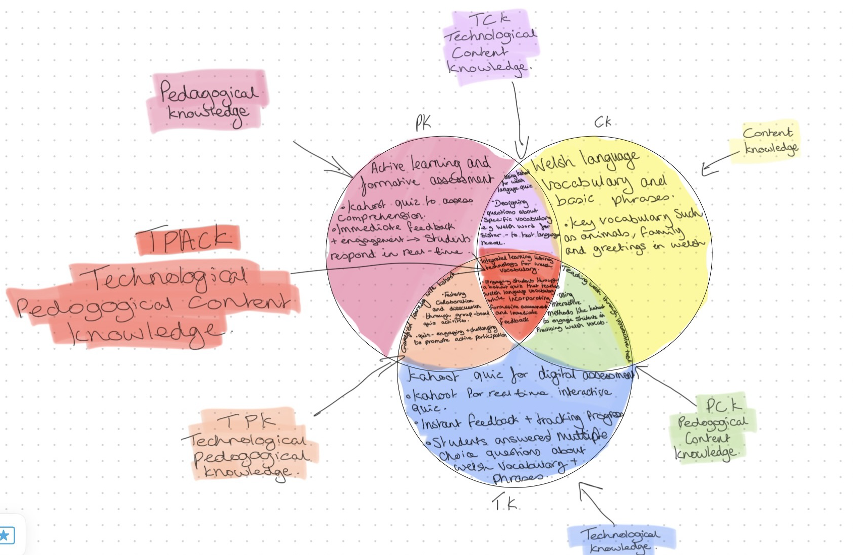

By using digital innovation in my classroom, I am aligning my practice with the Professional Standards for Further Education (FE) Teaching in Wales (Welsh Government, n.d), particularly in areas such as commitment to learners, collaborative relationships, and critical reflection. Integrating technology into teaching enhances learner engagement and supports diverse learning needs, which are key components of these standards.

The commitment to learners and their well-being standard emphasises creating a supportive, inclusive environment. By incorporating digital tools such as collaborative learning platforms like group quizzes, I can better support individual learning preferences and create opportunities for students to engage with the material in ways that meet their needs (Estyn, 2023). This also aligns with the value and promotion of diversity and inclusion, as digital tools allow for more personalised and accessible learning experiences, fostering a more inclusive classroom (Welsh Government, 2019).

Using digital tools also supports the standard of building positive and collaborative relationships. Digital technologies, like collaborative platforms, enable students to work together, share ideas, and support each other’s learning, enhancing teamwork and peer relationships, which is a crucial aspect of professional standards. This approach also encourages students to take shared responsibility of their learning and assessment, in line with the strategic processes and approaches standard, allowing them to take ownership of their progress (Digital 2030 Wales, 2023).

Furthermore, digital innovation enables critical reflection on my values, knowledge, and skills. By using data-driven insights from digital tools, I can assess the effectiveness of my teaching and identify areas for improvement, supporting ongoing professional development and reflective practice.

In summary, by integrating digital innovation into my teaching, I am fulfilling the professional standards set for post-16 teachers in Wales, particularly by fostering an inclusive, collaborative, and reflective learning environment that prepares students for digital demands of the future. This approach aligns with the goals outlined in the Digital 2030 Wales Framework and the Professional Standards for Teaching and Learning in Wales (Wales Government, 2019).

By using digital innovation in the classroom, I am following the Digital 2030 Wales Framework, which sets clear standards for integrating digital skills and tools in education. This framework encourages the development of a digital culture where both staff and students take ownership of their digital learning. Using digital tools like quizzes and collaborative activities, I am supporting learners in developing critical digital skills and enhancing their overall learning experience. These tools help students to actively engage in their learning and work together, fostering collaboration, which is a core component of the framework (Welsh Government, 2019).

Additionally, my use of digital tools aligns with the learner skills and learner progress objectives outlined in the framework, as they provide students with the opportunity to assess and improve their digital competencies. By incorporating digital quizzes, I am encouraging students to take responsibility for their learning while also supporting each other, which is in line with the collaborative learning approach emphasised by the framework (Gokhale, 1995). This approach also fits within the enhanced learning objective, where technology is used to create a more interactive, engaging, and effective learning environment (Welsh Government, 2019).

Incorporating these tools not only helps students build their digital capabilities but also helps me maintain a supportive, technology-driven learning environment, ensuring that my teaching practices comply with and contribute to the goals of the Digital 2030 Wales.

I have chosen to use Kahoot as my digital innovation tool because it is highly engaging, interactive, and well-suited to my setting of assessing Welsh language knowledge among my university peers. The platform’s gamified structure makes learning enjoyable while fostering collaboration through team-based participation. By organising students into teams with one Welsh speaker in each, I am creating a supportive environment where peers can learn from each other. This approach aligns with Vygotsky’s Zone of Proximal Development, as the Welsh-speaking team members support the learning of those with less knowledge, facilitating progress through collaboration.

This tool works well for my setting because it encourages active learning and reduces the anxiety often associated with assessments. By sharing responsibility within teams, students can engage more comfortably, building confidence in their language skills. Additionally, Kahoot provides immediate feedback, which sparks discussion within teams about correct answers, further enhancing their knowledge.

Using Kahoot also allows me to integrate digital innovation into my teaching, which supports the Digital 2030 Wales Framework. This ensures that my peers develop digital competencies while improving their knowledge of Welsh, aligning with professional and educational priorities. Overall, Kahoot is an effective tool for fostering collaboration, inclusion, and active learning, making it an excellent fit for my setting.

Application of the chosen learning tool(s)
Lesson plan: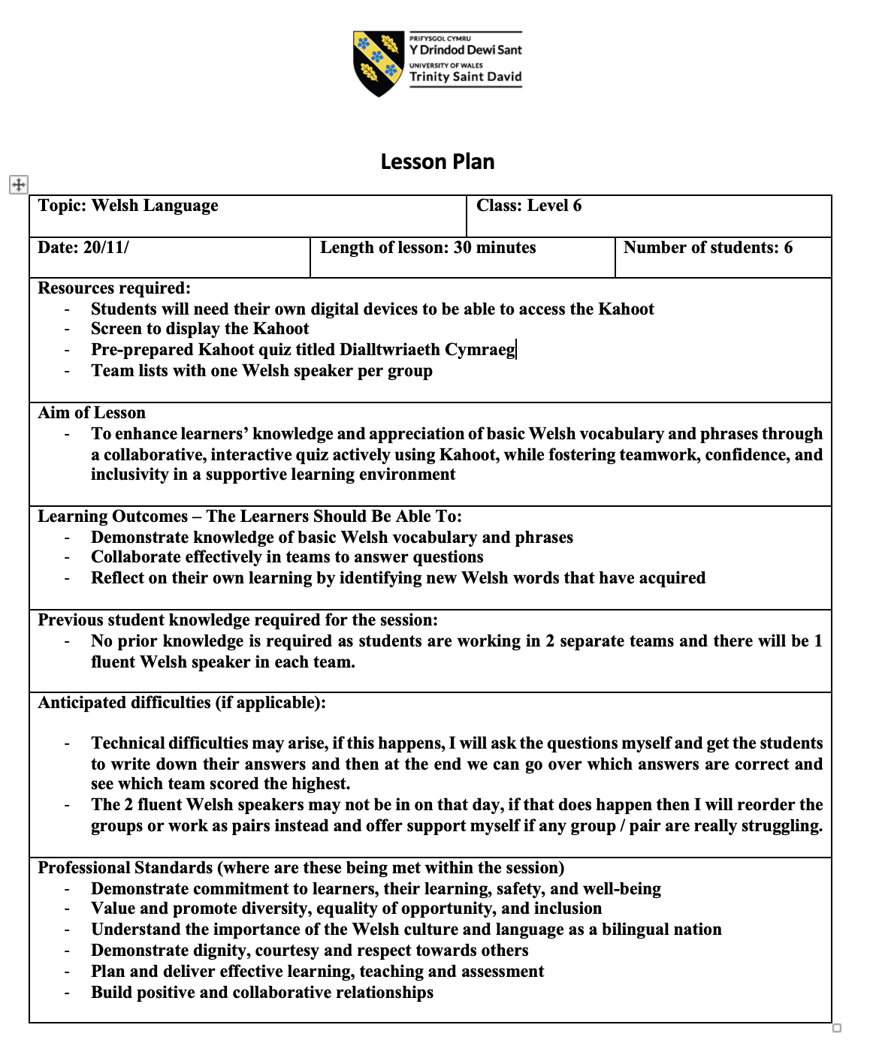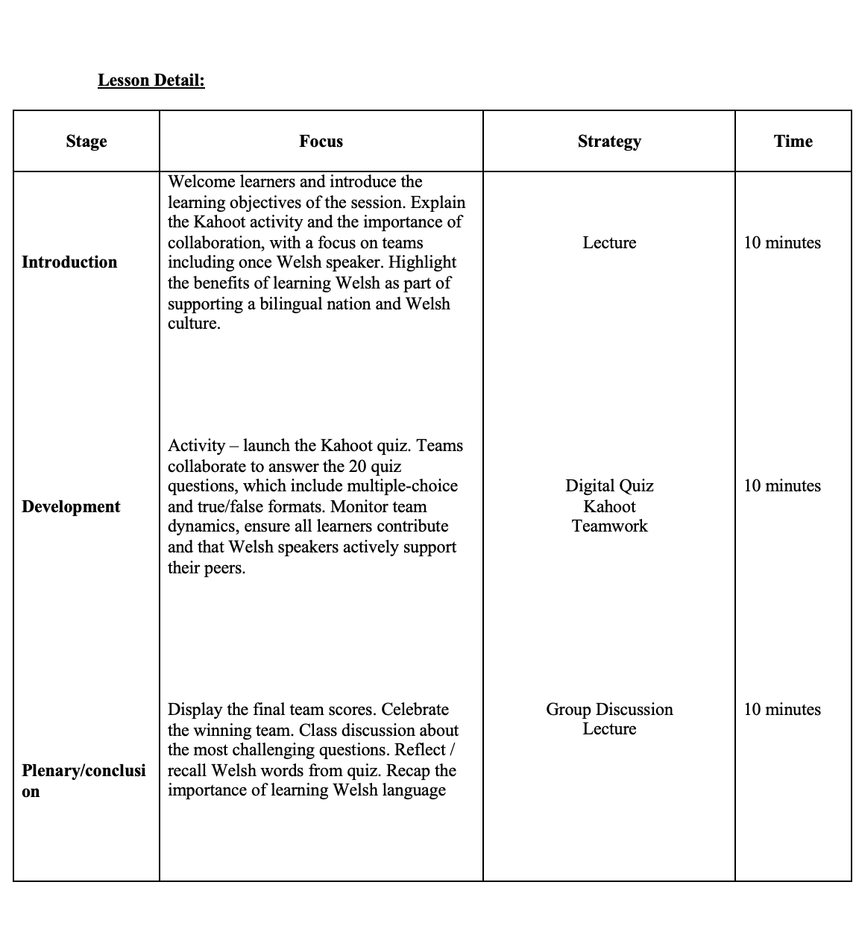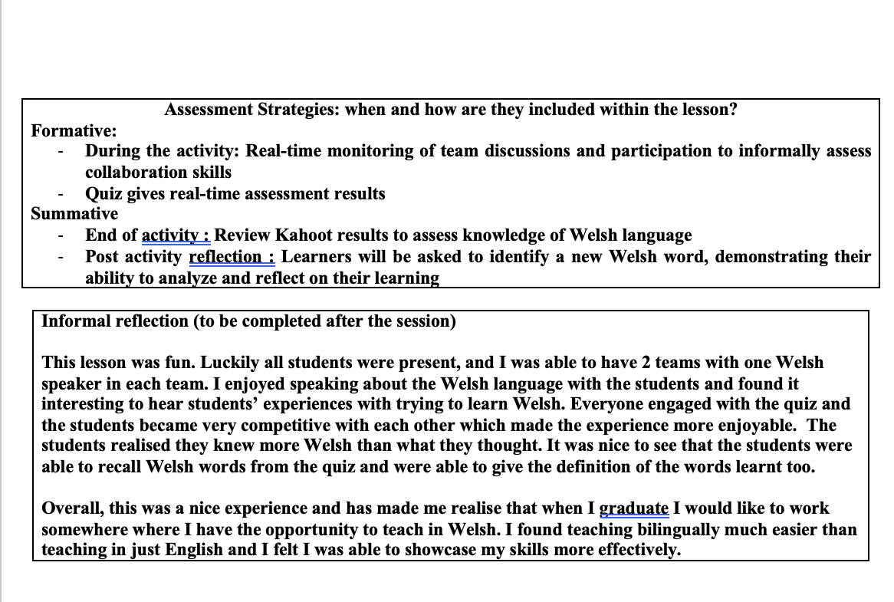

Photos presenting and using the tool :
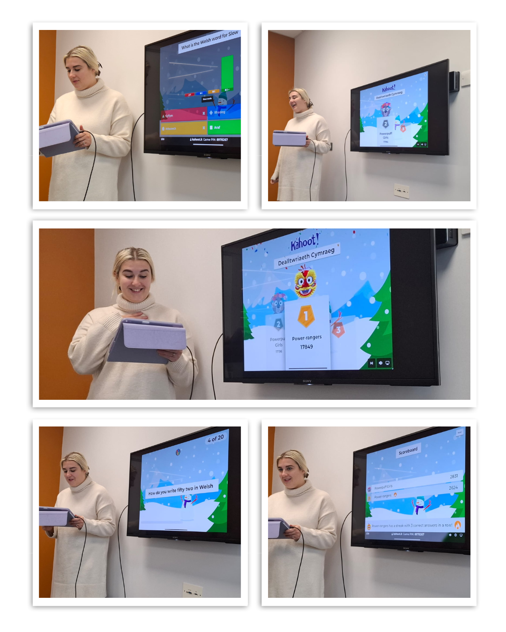Due to using a TV screen, I had to use a HDMI to connect my iPad. Due to this I stood right at the front of the class and ensured the students were close enough for me to hear their discussions. I read all the questions out loud to give the students more time to think of the answer, I also did this as I used Welsh words in some of my questions and wanted to make sure no one would struggle to understand the questions as reading in English and welsh are very different.

Setting up the tool:

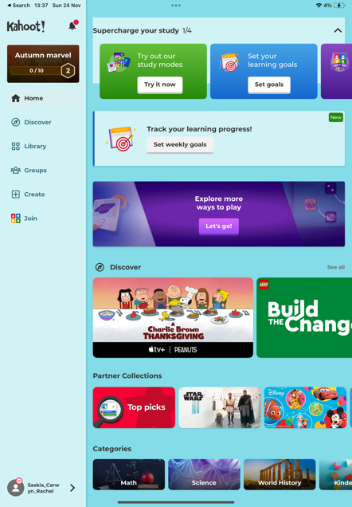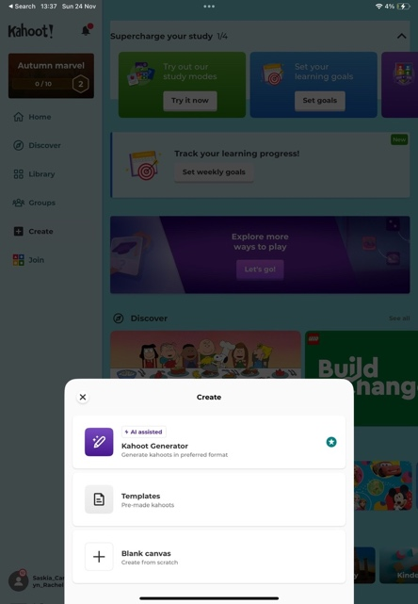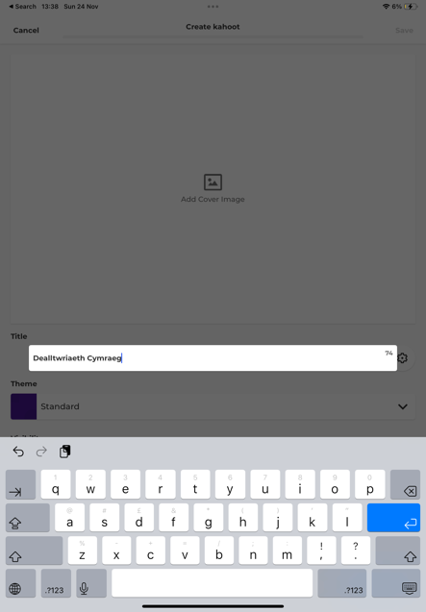

- To create my Kahoot, I followed a systematic process to ensure it was engaging, inclusive, and tailored to assess Welsh knowledge effectively. I began by downloading and opening the Kahoot app on my iPad. Once inside I clicked “Create Kahoot” and selected a blank canvas to design the quiz from scratch. I titled the quiz “Dealltwriaeth Cymraeg” to reflect its focus on Welsh language knowledge.
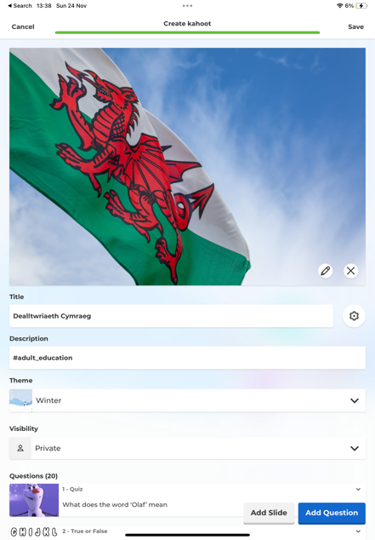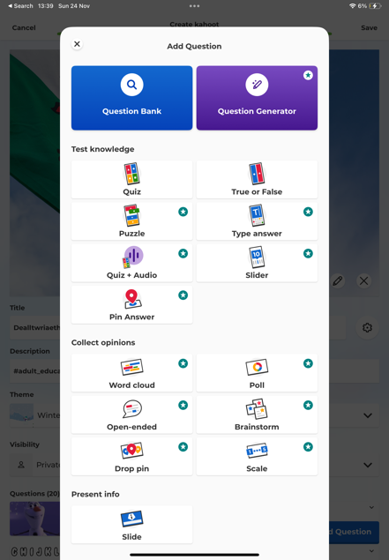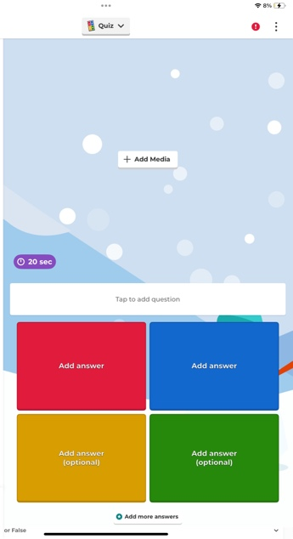
- For the quiz content, I opted for a combination of multi-choice questions and true-or-false statements. This variety was intentional, as it helps to keep participants engaged while catering to different levels of familiarity with the language. To create an inviting and visually appealing environment, I chose a winter theme for the background. I also incorporated simple and clear images throughout the quiz. These design choices were made with the knowledge that learning a language can feel daunting, and I wanted to maintain an atmosphere that was uplifting and low-pressure.
- The quiz comprised of 20 questions that tested various aspects of the Welsh language. Each question was designed to challenge the participants while being achievable with team collaboration. For example:
- What does the word olaf mean (multiple choice).
- The letters V, K, Q, and Z are not in the Welsh alphabet (true/false).
- What does the saying ‘hwyl fawr’ mean? (multiple choice).
- ‘Dydd Sul’ is what day of the week? (multiple choice).
- Starting with spring what is the correct order of the seasons (multiple choice).

By carefully balancing the complexity of the questions, I aimed to ensure that all participants, regardless of their Welsh knowledge could contribute meaningfully to their teams.

At the end of the quiz, we reviewed the results, celebrated the top-performing team, and engaged in a reflective discussion about the most challenging questions. I asked my peers if anyone could recall at least one word they hadn’t known before the lesson. This feedback was incredibly encouraging and reinforced the quiz’s value as both an assessment and a learning tool.

Overall, the design and delivery of this Kahoot allowed me to meet my objectives of assessing Welsh understanding while fostering collaboration and inclusivity among my peers. It also provided a fun and interactive way to build confidence in using the Welsh language.

In the images below there is a small green circle with a white tick in it, these are the correct answers.

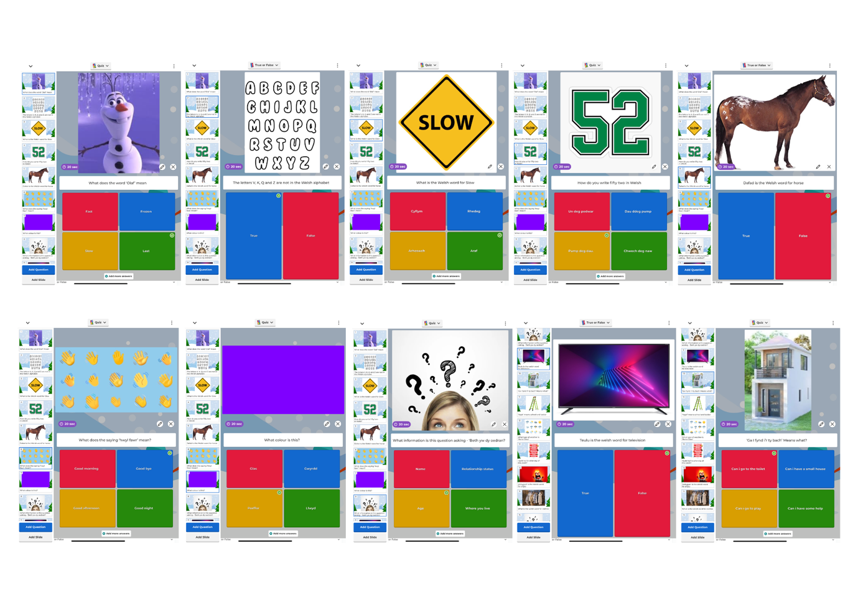
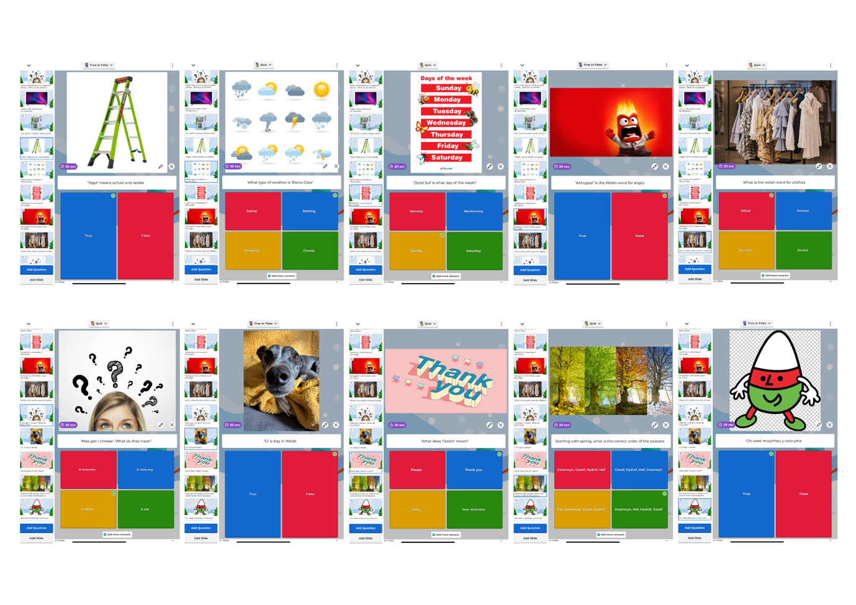

Evaluation and Reflection

This section provides a critical evaluation of the use of the digital tool in my lesson, structured using Gibbs’ Reflective Cycle. By following this framework, I will reflect on my own experience systematically, examining what went well, what could be improved, and the lessons learned. This approach allows for a deeper analysis of the effectiveness of the digital tool while considering its impact on both student engagement and learning outcomes. Through this reflective and evaluative process, I aim to identify practical insights that can inform and enhance my future practices.

Description
The lesson aimed to assess students’ knowledge of the Welsh language through Kahoot, a quiz-based digital tool. There were 20 questions in the quiz that were either multiple-choice or true/false. Students worked in teams to answer questions, combining competitive and cooperative learning. The students were divided equally into two groups, ensuring that each team included one fluent Welsh speaker. This arrangement promoted collaboration and allowed students to benefit from peer support, as the fluent speakers could assist their teammates in understanding and answering the quiz questions.

Feelings
I felt confident and enthusiastic during the lesson, especially as I observed students engaging with the content and collaborating effectively. Seeing their excitement and focus reinforced my decision on the value of incorporating a digital tool like Kahoot. Teaching in Welsh was particularly fulfilling, as it gave me a deeper sense of connection to the subject matter. However, I did have some underlying concerns about whether all students would find the activity beneficial or enjoyable, given the diversity of learning preferences.

Evaluation
The activity had clear strengths. Kahoot worked seamlessly, and its gamified structure helped foster collaboration and critical thinking. Student feedback was overwhelmingly positive: they described the lesson as fun and informative, and some even reported retaining Welsh words from the quiz days later, suggesting that the tool supported learning retention effectively. The light and upbeat atmosphere contributed to high levels of engagement.

However, I recognise that not all students may respond equally to gamified tools. While many students thrived in the competitive setting, some might prefer quieter or more reflective learning approaches. Additionally, the simplicity of a quiz-based tool like Kahoot may not be as effective for teaching more complex or nuanced topics.

Analysis
This experience highlighted how digital tools can serve as powerful aids in fostering engagement and collaboration. Kahoot’s gamified design tapped into students’ competitive instincts, which significantly enhanced their motivation and participation. However, it also underscored the need for flexibility in my teaching approach. Digital tools are not a one-size-fits-all solution and should be carefully matched to the content and learners’ needs. Over-reliance on such tools could risk undermining deeper analytic discussions or alienating learners who prefer traditional methods.

Conclusion
I learned that integrating digital tools successfully requires thoughtful planning and adaptability. Student engagement can be enhanced by incorporating elements of competition and collaboration, but these must be balanced to accommodate different learning styles. This lesson also reinforced my confidence in teaching through the medium of Welsh and my ability to create an engaging learning environment.

Action plan
In future lessons, I will continue to use digital tools like Kahoot but will also explore complementary methods to ensure inclusivity for all learners. I will strive to balance gamified activities with opportunities for deeper reflection and discussion. Additionally, I plan to seek student feedback regularly to refine my approach and ensure that digital innovations enhance the learning experience rather than overshadow it. I will also consider how to adapt digital tools for more complex topics, potentially integrating follow-up tasks that encourage deeper analysis.

Conclusion

This assignment has critically explored the integration of digital innovation in the post-16 education sector, specifically using Kahoot as a tool to assess students’ knowledge of the Welsh language. By drawing on academic research and reflecting on my practical teaching experience, I have examined the effectiveness of digital tools in fostering student engagement, promoting collaboration, and enhancing retention.

The implementation of Kahoot demonstrated how gamification and collaborative learning can create a dynamic and inclusive classroom environment. The division of students into teams, each supported by a fluent Welsh speaker, encouraged peer-to-peer learning and critical thinking. Student feedback combined with my own reflections, highlighted the tool’s ability to meet learning objectives while maintaining a positive and enjoyable atmosphere. However, critical evaluation has also underscored the need to recognise the diverse responses of learners to digital tools, emphasising the importance of adaptability and balance in teaching practices.

Through this process, I have gained valuable insights into the practical and theoretical aspects of integrating technology in education. I have learned that while digital tools can significantly enhance learning experiences, their effectiveness depends on thoughtful implementation and alignment with lesson objectives. Moreover, the competitive and collaborative nature of the activity proved particularly effective in engaging students, a strategy I plan to employ in future lessons.

Overall, this experience has reinforced the potential of digital innovation in education while also highlighting the importance of reflective practice. By critically evaluating both successes and limitations, I am better equipped to integrate digital tools effectively, tailoring my approach to the needs of diverse learners and ensuring that technology serves as a meaningful complement to traditional pedagogical methods.

Reference list
Barker, L., Garvin-Doxas, K. and Jackson, M. (2002). Defensive climate in the computer science classroom. Technical Symposium on Computer Science Education. doi:https://doi.org/10.1145/563340.563354.
Bower, M. and Richards, D. (2006). Collaborative learning: Some possibilities and limitations for students and teachers. (online) pp.79–88. Available at: https://citeseerx.ist.psu.edu/document?repid=rep1&type=pdf&doi=ba6892126f1a1023c9279444100c3c5103ac1ebe.
Degirmenci, R. (2021). The Use of Quizizz in Language Learning and Teaching from the Teachers’and Students’ Perspectives: A Literature Review. Language Education and Technology, (online) 1(1), pp.1–11. Available at: https://langedutech.com/letjournal/index.php/let/article/view/12/1 (Accessed 30 Nov. 2024).
Duolingo (2022). About Us. (online) Duolingo. Available at: https://www.duolingo.com/info (Accessed 30 Nov. 2024).
Eslit, E. (2023). Unveiling the Cognitive Depths: Delving into Language Learning and Acquisition Amidst the Post-Pandemic Era. (online) pp.1–20. Available at: https://files.eric.ed.gov/fulltext/ED628255.pdf (Accessed 27 Nov. 2024).
Help Center. (2024). What is Quizizz? (online) Available at: https://support.quizizz.com/hc/en-us/articles/203610052-What-is-Quizizz.
Kryukov, V. and Gorin, A. (2017). Digital technologies as education innovation at universities. Australian Educational Computing, (online) 32(1), pp.1–14. Available at: https://www.researchgate.net/publication/320096163_Digital_technologies_as_education_innovation_at_universities (Accessed 27 Nov. 2024).
Laal, M. and Ghodsi, S.M. (2012). Benefits of Collaborative Learning. Procedia - Social and Behavioral Sciences, (online) 31, pp.486–490. doi:https://doi.org/10.1016/j.sbspro.2011.12.091.
Loewen, S., Crowther, D., Isbell, D.R., Kim, K.M., Maloney, J., Miller, Z.F. and Rawal, H. (2019). Mobile-assisted language learning: A Duolingo case study. ReCALL, (online) 31(3), pp.293–311. doi:https://doi.org/10.1017/s0958344019000065.
Maor, D. (2016). Using TPACK to develop digital pedagogues: a higher education experience. Journal of Computers in Education, (online) 4(1), pp.71–86. doi:https://doi.org/10.1007/s40692-016-0055-4.
Metz, C.J. and Metz, M.J. (2021). The benefits of incorporating active learning into online, asynchronous coursework in Dental Physiology. Advances in Physiology Education, 46(1). doi:https://doi.org/10.1152/advan.00110.2021.
Niek, M.Y.W. and Abdul Aziz, A. (2022). The Use of Quizizz as an Online Teaching and Learning Assessment tool in an ESL Classroom: A Systematic Literature Review. International Journal of Academic Research in Progressive Education and Development, (online) 11(1), pp.1083–1092. doi:https://doi.org/10.6007/ijarped/v11-i1/11929.
Seiersten, N. and Berg, A. (2017). DIGITAL DRAWING DEMYSTIFIED: EXPLORING A CREATIVE ZONE OF PROXIMAL DEVELOPMENT. (online) pp.1–5. Available at: https://oda.oslomet.no/oda-xmlui/bitstream/handle/10642/5379/1275%2bSeiersten%2bBerg.pdf?sequence=1&isAllowed=y (Accessed 29 Nov. 2024).
Webb, N.M. (1982). Group composition, group interaction, and achievement in cooperative small groups. Journal of Educational Psychology, 74(4), pp.475–484. doi:https://doi.org/10.1037/0022-0663.74.4.475.
Welsh Government (2019). Digital 2030 A strategic framework for post-16 digital learning in Wales 2019. (online) gov.wales, Wales: Welsh Government, pp.1–31. Available at: https://www.gov.wales/sites/default/files/publications/2019-06/digital-2030-a-strategic-framework-for-post-16-digital-learning-in-wales.pdf (Accessed 29 Nov. 2024).
Welsh Government (n.d.). Professional standards for further education and work-based learning leaders in Wales | Educators wales. (online) educators.wales. Available at: https://educators.wales/leaders-professional-standards (Accessed 29 Nov. 2024).
Zolfaghari Mashhadi, V. and Reza Kargozari, M. (2011). Influences of digital classrooms on education. Procedia Computer Science, (online) 3, pp.1178–1183. doi:https://doi.org/10.1016/j.procs.2010.12.190.

