Working with Data map Wales Data (formerly Lle)

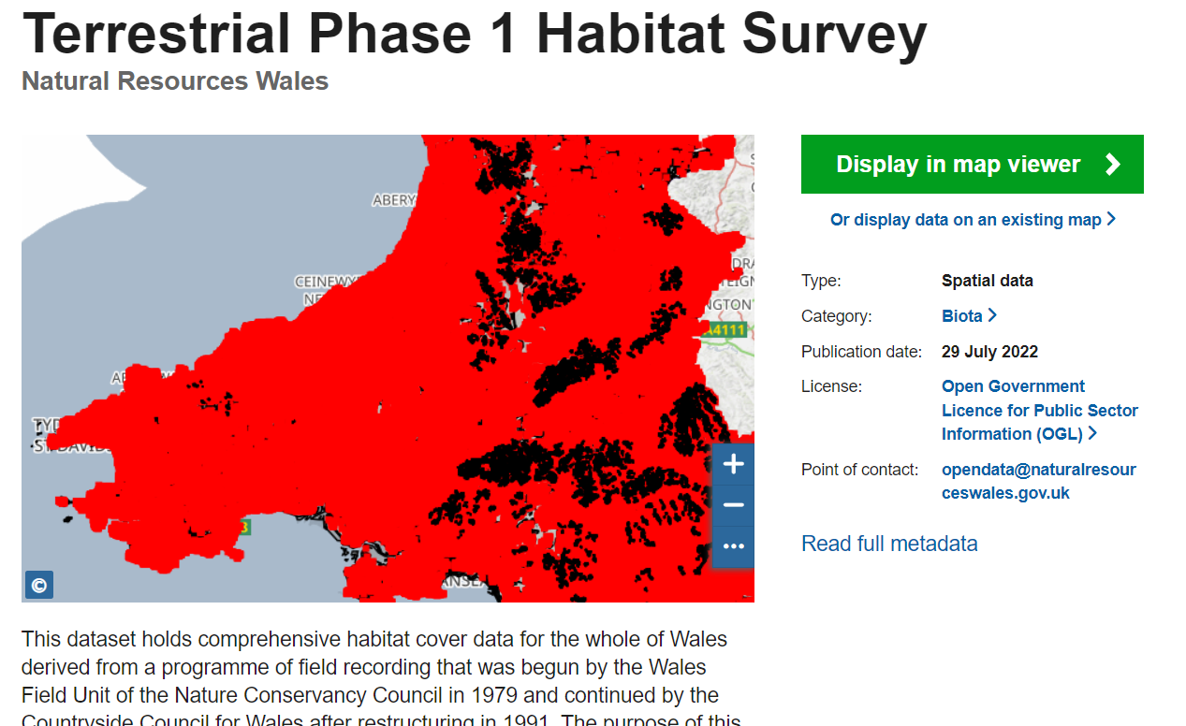

https://datamap.gov.wales/layergroups/geonode:nrw_terrestrial_phase_1_habitat_survey

Downloading Data From Datamaps Wales

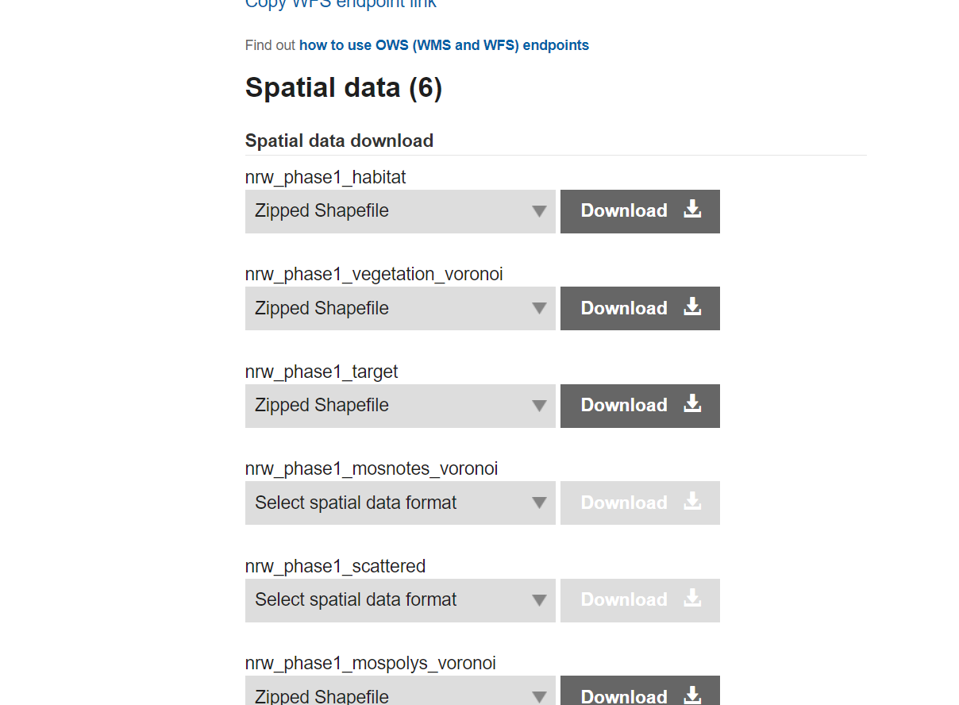

There are lots of formats available, but a shape file is probably the best.

Copy your files to a suitable directory and unzip them. They will form their own directory with the same name and the files will look like this:

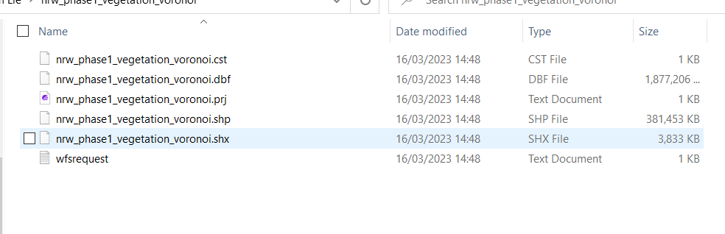
If you move a shape file you must move all the additional files otherwise you will lose data index registration etc.

Working with the maps in QGIS

If you open the file, you will see we have the whole of Wales. This this is a very large data set it can sometimes be difficult to work with when you have lots of data and lots of layers. So the first thing we need to do is select or area of interest and turn this into its own layer we can then use this area as our selection point. We will need to select feature by free hand tool this will allow us to capture the polygons within our area of interest we can then save them to a new layer.

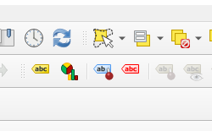

Once we have made a selection we need to save our new layer so that we can use it

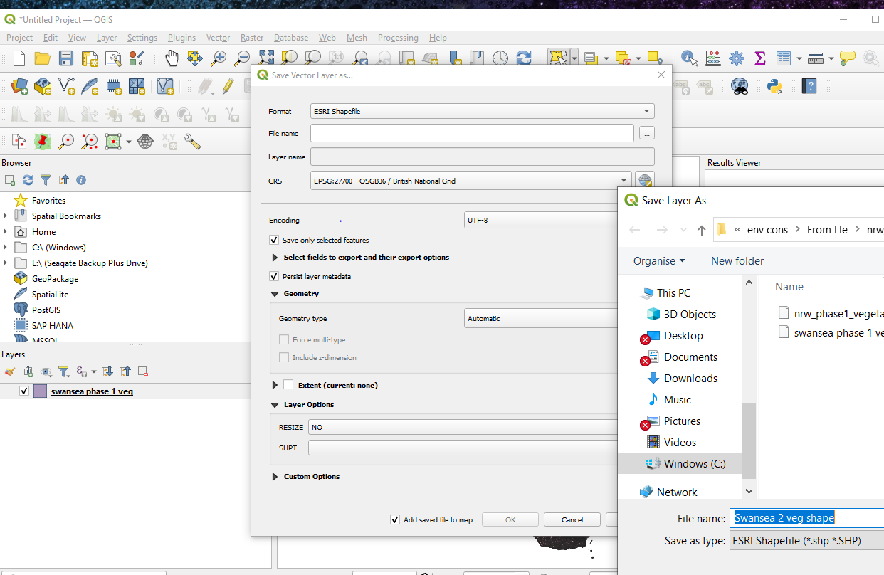

We now have a smaller area to work with.
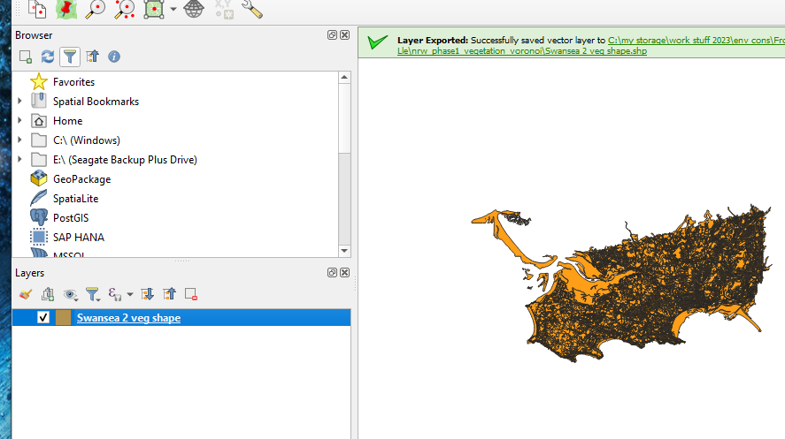

This new layer will have all the original attribute data attached to the remaining polygons.

Notice we still have the Phase 1 habitat codes:

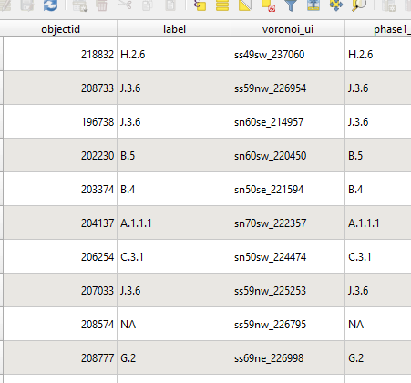
Nest we need to add some styles use this link
https://www.fscbiodiversity.uk/qgis-mapping-styles-uk-habitats

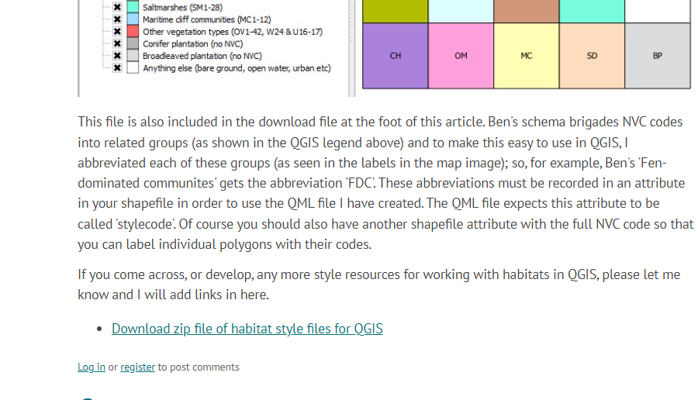

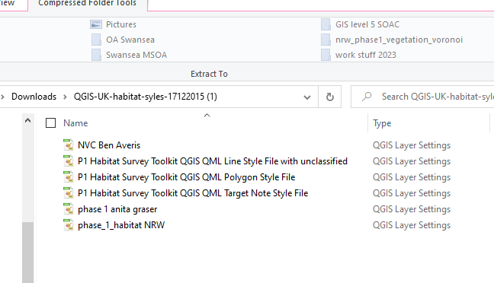

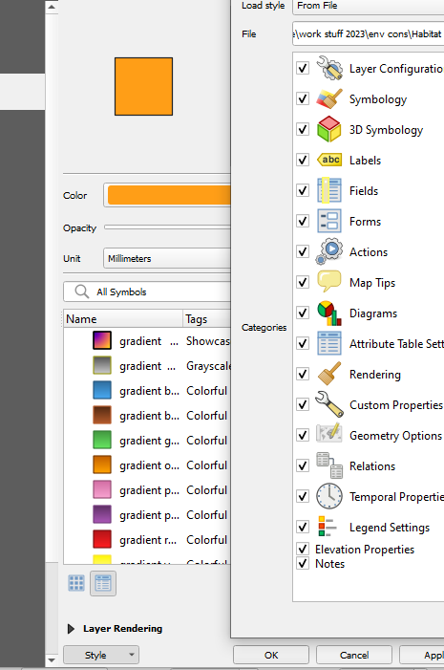

Once you've loaded the style sheet you will see a list of appropriate symbology for our phase one habitat management plans in your area of interest. I've chosen the Polygon symbology although you will notice there are some files from NRW. The symbology data is supplied with pcode heading we do not have a pcode in our attribute table and you will notice that in the attribute table we have several phase 1 codes labels and different methods of suggesting the data types within the Polygon. For our purposes we need to scroll down to the theme_S heading as this contains the link between the pcode from the symbology table that we want to link into our map.

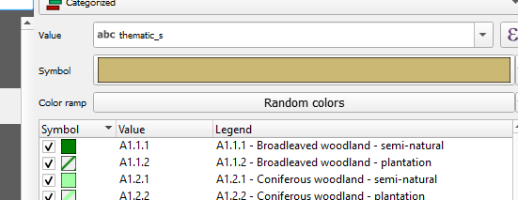

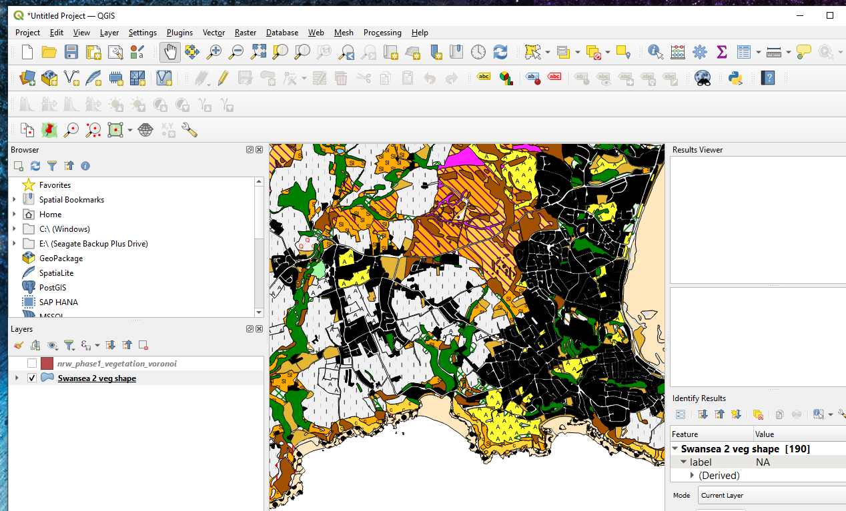
The final result.

We can use this technique on other map layers where appropriate symbology or themes are provided.

Select area by feature or Single click

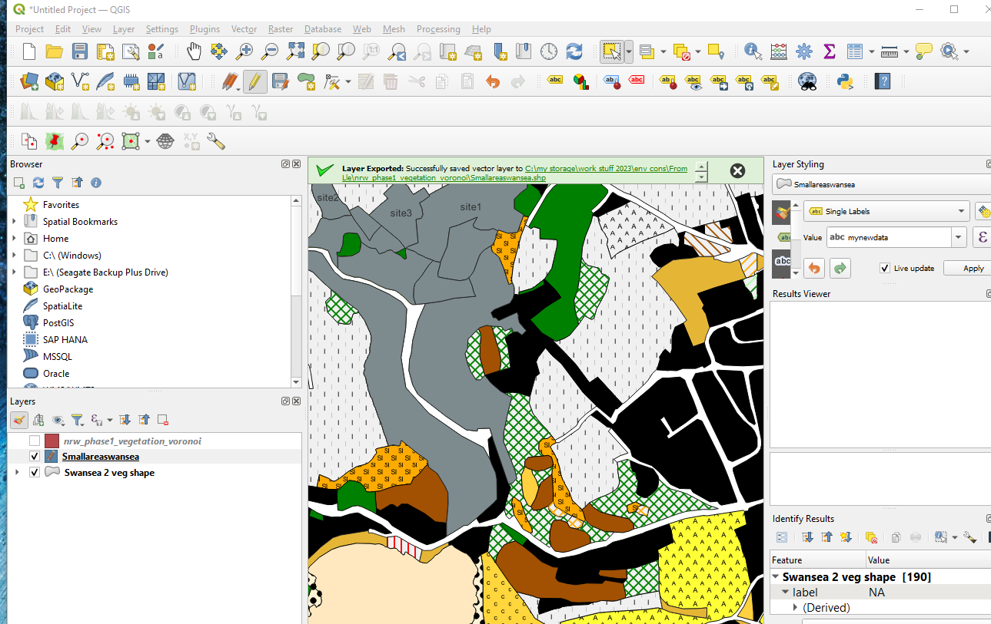

Following on from our small area data selection we can also select individual polygons for a more detailed inspection open area. this is a manual data selection and once we have collected several polygons for our study we can again use the above techniques and save this as another layer. This will allow us to work with the attribute table where we can set this to edit mode and add or take away data fields to enhance our study area.

