University of Wales Trinity Saint David
Wales Institute of Science and Art


Engineering Management ACHA5012

Mohammed Nasir Mahmood
2003929
05/11/2024
Contents
1 Introduction 1
2 Team Members and Roles 2
3 Tasks And Timings 3
4 List Of Tasks 3
5 Milestones For The Project 3
6 Areas Of Concern 3
7 Summary With Gannt Chart 3
8 References 3

Introduction
In this report I will be discussing and explaining my role within my group project this year. I will be looking into all the different aspects and areas that make a team successful in their endeavours. Along with this I will also be looking at things on a more individual and personal level and I will be looking into and talking about my own individual responsibilities and my role within my team. The areas and tasks I’m looking into and performing and what I need to add and contribute to help my group be successful in our goal.

For our group project we have been tasked to design an active rear wing for a Morgan Plus 4 (Shown in Figure 1)

Figure 1. Morgan Plus 4 (Morgan Motor Company website)
In this project there are several individual areas and departments. With this in mind it’s vital that all team members cooperate and communicate- with each other. And we all utilise each other’s attributes and strengths to come together to create an effective active rear wing for the pre-selected vehicle. So not only do we meet with all the regulations and rules. But to also create a rear wing that meets the team’s performance expectations.

Team Members and Roles
In the team there is a total of eight team members. The team members are as follows:
.Myself (Mohammed Nasir Mahmood)
.Alex Griffiths
.Jacob Gough
.Nevin Jyothis
.Angel Stanley
.Jacob Ling
.James Evans
.Emily Dawes
With all eight members listed above. There are five different areas in the project. They are as follows. Aerodynamics & CFD, Structural Design (FEA) & Manufacturing, Vehicle Dynamics/Simulation, Control Systems & Mechanics, Project Management.
I alongside Alex we have both teamed to work together in the aerodynamics section. Alex is working on the CFD side whilst I will be conducting the Wind tunnel testing, and we are collaborating and working together to ensure that the theories and avenues explored in the digital world. Corollate to real world performance and that there is no discrepancy between digital values and results and real-world performance.
Emily and Angel are collaborating in the simulations department together. They will be using VI Grade and other simulation programs to simulate how the vehicle behaves during operation and the affects of the wing in different vehicle attitudes and situations. And communicating with the aero department to feedback their findings. This will help with developments and direction.
Nevin and Jacob Gough are both working together in the Structural Design area. They will both be responsible for producing models and alongside this. They’re also going to be looking into the structural rigidity and safety of the rear wing. They will be looking at the forces the wing will be subjected to and what loads it will need to withstand to remain safe and stable.
Jacob ling and James are working together in the Control Systems and Mechanics. Jacob is managing and taking charge of the Simulink and MATLAB side of things. James oversees the mechanics side of things. Looking at and evaluating the different type of motors and electronics that are suitable for use on then wing to help achieve our desired outcomes.
Alex will also be responsible for overseeing and managing the project overall ensuring things are on track and targets will be met and deadlines reached in time.
For my role within the aerodynamics department. Specifically, the Wind-Tunnel testing. There are skills needed. Such as being confident within my skills set. Being confident in using complex software such as CFD. And being confident in using and being able to operate the wind tunnel. Looking at and referencing Belbin’s teamwork model. There 3 areas. There are action roles, thinking Roles, and People Roles. For action I Need to be a shaper and a implementer. In the Thinking Roles. I need to implement the Evaluator traits. And for the teamwork area it’s vital I implement all the values. Coordinator, Team Worker, Investigator. It’s Vitas the aerodynamics depart is the first point of the project. And we are the first point of contact withing the project. We have the responsibility to dictate the direction the project takes. But this means that it’s vital that we keep good relations with all the other departments and team members to work together efficiently. Good, honest and open communication and listening skills are key.

Group Tasks And Timings
As this is a group project and there are several sub-sections and departments. It’s vital that all the different areas are tracked and monitored.
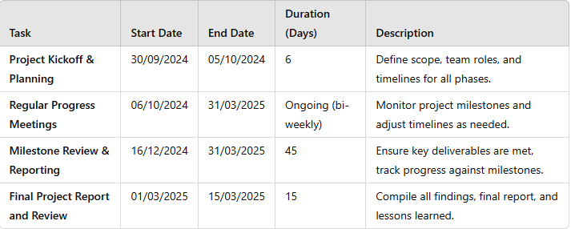

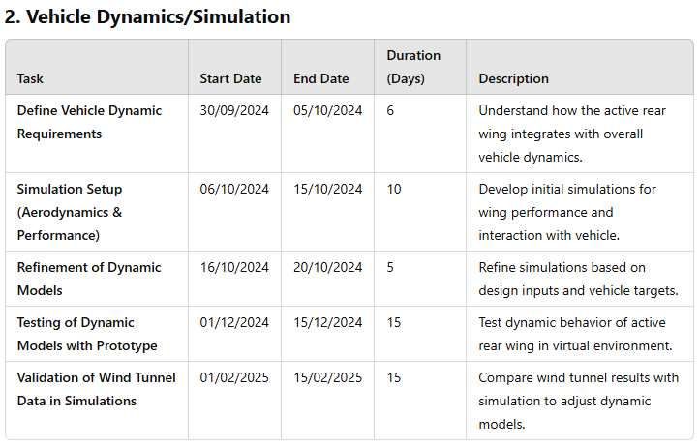
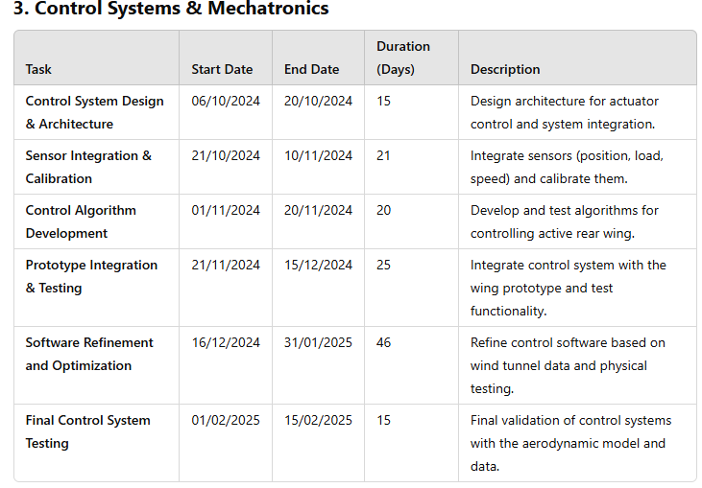

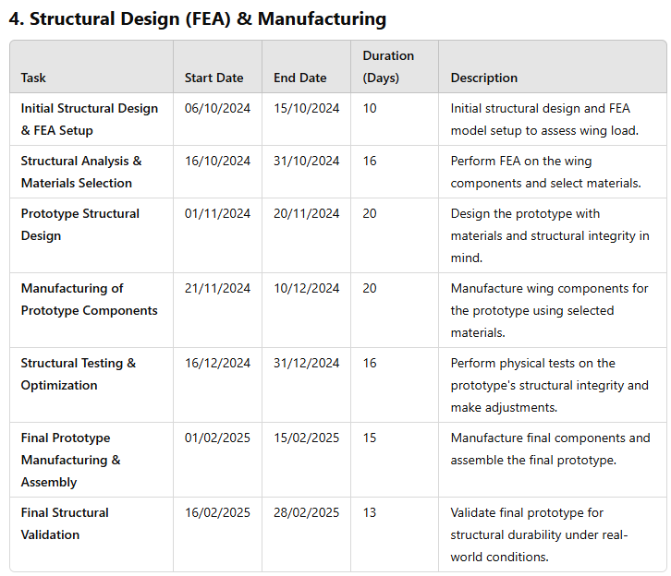
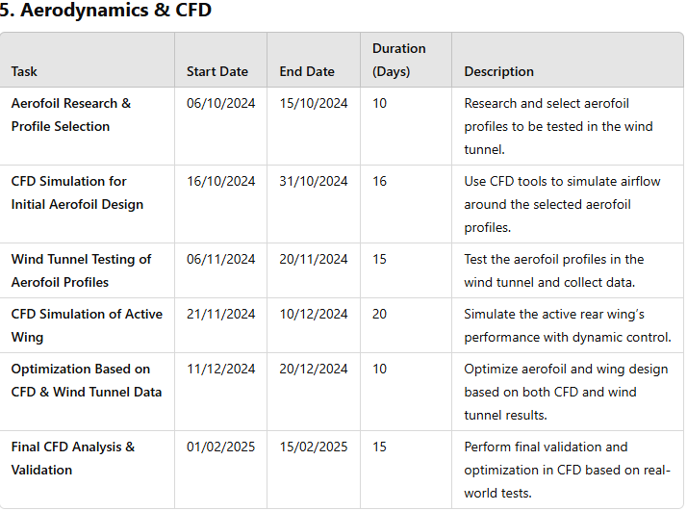

List Of Tasks and Costs
As mentioned in the previous section. As there are two of us on the aerodynamics area of the project loads and areas have been split. This also gives us freedom to also explore and look into different concepts and ideas for the project.
After discussions with Alex, we decided to take the following route. Alex will take on the responsibility of CFD whilst I will be responsible for conducting and carrying out all the wind tunnel testing.
Below is a table I have created outlining all the tasks I will have to undertake to fulfil my objectives and my area to put forward and contribute to the team.
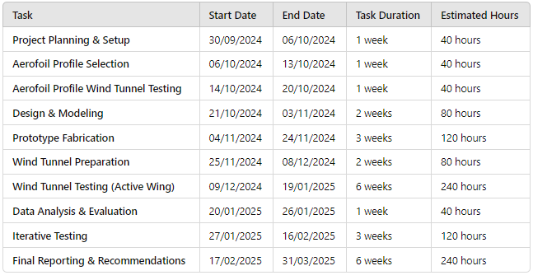
Along with this as there is a £10,000 budget. There are costs occurred with my area and the testing I’m carrying out. The following costs are for the
Wind Tunnel- £5385.95
CBM- Manufacturing models- £10-25
These are the costs I would have to incur. The wind tunnel would be the biggest expense leaving less than half the budget. So it’s vital to make sure all the data collected is correct and accurate is crucial and vital considering the investment in equipment needed to carry out my tasks and roles for wind tunnel testing

Milestones For the Project
Ther are several Milestone that are and will be significant during the course of the project. With these milestones can also be used as a measurement to track the progress of the project.
Testing and selecting the right actuators for the rear wing will be a crucial milestone. Another one from the simulation department will be to get data from the simulation that validates what our CFD and wind tunnel runs have told us. That will help the structure team understand the loads and forces the rear wing will be subjected to. From the CFD side of things another milestone will be testing the different wing profiles. This will be major as it will lead to decisions on which direction we take forward as a group.
For my area the milestones that are crucial are the following. Testing the base vehicle in the wind tunnel. Another milestone will be testing out the wing profile that my colleague has chosen. And testing it in the wind tunnel. And comparing the findings from the wind tunnel and CFD to compare.
A gateway is the wing profile testing. To test it at different angles of attack and wind tunnel speeds. It’s crucial. Without this choosing a wing profile and being confident in the decision the project cannot move forward.

Areas Of Concern
For my area there are areas that are of concern. Although both me and Alex have both split up the workload for our area. For both of us there are areas of concern that can cause a disruption and halt the progress of the whole group project.
For the area I’m overseeing. Which is the Wind Tunnel testing element of the aerodynamics department there are two things that are of concern that can cause. One thing that is of concern is that the CFD data and wind tunnel data does not correlate and there are discrepancies in data from the CFD simulations and or the wind tunnel.
Another area of concern is for me is getting the wrong scale model of the wing profile for the wind tunnel.
For the first problem that I mentioned above. A way to ensure or to at least try to minimise the risk as much as possible. Would be to consciously keep active conversation wit Alex on the CFD simulations to make sure that things area calibrated correctly. The same can be said about the wind tunnel making sure the equipment is correctly calibrated and set up will greatly reduce the risk of getting data that has discrepancies. Also asking for help and asking for someone else to overlook and check to make sure the wind tunnel is being set up and calibrated correctly would help. Having a second pair of eyes overlooking can help by bringing a different perspective to point out if anything is being done incorrectly.
For the issue regarding getting the incorrect scale model. The ways in which this can be avoided is making sure that when the CAD model of the wing is being sent off to the CBM Manufacturing department that the correct scale has been selected and specified with them. Also speaking to them in person or through email to communicate and double check that the correct model scale has been selected to be manufactured for wind tunnel testing. This kind of open communication and double checking can greatly reduce the chances of misunderstanding and reduce the risk of getting the incorrect scale model manufactured.

Summary With Gannt Chart

References
Mark Sanford, lead author. Lecture WK1, WK2, WK3, WK4, WK5, WK
Belbin, M. (2010) The nine belbin team roles, Belbin. Available at: https://www.belbin.com/about/belbin-team-roles (Accessed: 05 November 2024).

