Catalin Ionel Mirica 1920075
UNIVERSITY OF WALES TRINITY SAINT DAVID
A critical evaluation of the impact ‘customer relationship management’ has on an organisations’ performance
REPORT

Executive Summary
The report analysed Tesco’s ethics and sustainable policies. The research made in the area of ethics revealed the fact that Tesco is not entirely following its own Code of Conduct, and many stakeholders are accusing the company of multiple breaches. Tesco, however, did not respond to the allegations and made the company be on top 3 companies that are not ethical in the UK. However, the company’s focus on sustainability was supported by multiple sources and Tesco is on the second place, first place going to Morrisons which is faster at implementing sustainable changes. Tesco is using the Clubcard to improve the customers’ loyalty and it is still a successful method.
The report recommended that Tesco address the ethical allegation to increase its CRM and tried to adapt their sustainability plans faster, like Morrisons.
Contents
Executive Summary 1
Introduction 2
Findings 2
Ethics Policies and Practices 2
Sustainability Policies and Practices 3
Building loyalty 5
Conclusion 6
Recommendations 7
Appendices 8
References 10

Introduction
The critical evaluation of the impact of CRM on Tesco’s performance has been requested by the Chief Executive Officer of Marketing Week, which is an online journal produced by Tesco. The report is due to be completed on the 25th of February 2022. The report’s purpose is to investigate the CRM policies and practices of Tesco by looking at policies and practices in areas like ethics, sustainability, segmentation and loyalty ladder, but also by comparing them with policies and practices from two different competitors, in this case Asda and Morrisons.
The arguments and conclusions made within this report will be supported by evidence provided by relevant articles where the topics of the report were analysed and are relevant, books, which will be used to support with academic evidence every argument or theory regarding ethical and sustainable practices, as well as the annual reports of companies such as Tesco, Asda and Morrisons, to compare what the companies are reporting versus what the external sources are reporting, in order to draw relevant conclusions.
The report will look at some of the most important areas within a company, the ethics policies and practices to be able to outline the moral and ethical stance of the organisation, and to have a better understanding about how this is used in Customer Relationship Management, then sustainability policies and practices, where a comparison between Tesco and Asda and Morrison will be made. After that, the report will look at how Tesco is building a loyalty and if the company is succeeding at improving its Customer Relationship Management. The report will finish with all the conclusions drawn based on every area and will provide suitable recommendations for the company to improve its Customer Relationship Management.

Findings

Ethics Policies and Practices
Nowadays, every business must abide to a certain set of rules and policies to ensure that every action of any company is compliant to the standards imposed not only by the governments, but by the Human Rights as well (Cragg, 1997). The concept of business ethics is widely taught and studied all around the world, to ensure that all the managers are compliant and make ethical decisions, that do not affect in a negative way the population, to ensure a healthy environment for everyone and fair chances at having a successful business for everyone (Stark, 1993).
In the company’s Code of Business Conduct (2022) (Appendix 1), Tesco declared that there are four areas that they are looking to excel, which ensure that every stakeholder is taken into consideration when there are decisions to be taken, as well as when ensuring transparency and fairness. The code is showing how Tesco is looking after their customers, work together, trade fairly and protect their reputation. By looking further into every area, Tesco is looking after customer by ensuring that the prices and the marketing are both clearly stated, they endure a high standard of food, products and services and they protect the data of every colleague and customer by following the GDPR regulations. The ‘work together’ area is represented in Tesco by health and safety regulations used to ensure a safe workspace, by equal opportunities which involve inclusion and diversity at the workplace, and respect, fair treatment and dignity. Moreover, by their code of ‘trading fairly, Tesco is stating in their Code of Business Conduct that they have competition laws to endure that every supplier gets a fair chance, they included sanctions and export controls to make sure that every supplier is compliant, they respect the human right and ethical trading, have laws in place that protects suppliers for any unfortunate event and own brands and intellectual property. Lastly, Tesco is protecting their own reputation by not using any fraudulent action and not taking bribery, make sure that there is no conflict of interest with any supplier, make constant charitable donations, have accurately accounting and the company does not practice money laundering and does not practice market abuse. All these guidelines set the norms for what every shareholder must expect from collaborating with Tesco – transparency, protection of data, fairness and inclusivity, which have an enormous impact over the company’s Customer Relationship Management, because if these guidelines are not respected, the customers might choose to shop elsewhere, the suppliers might choose to work with other supermarkets and the employees to work at one of Tesco’s competitors.
Moreover, by looking at the Code of Conduct, this suggest that the company adhere to the Stakeholder theory, also known as Freeman theory, which states that all stakeholders of a company can affect and can be affected by the company’s achievements and plans (Freeman, Harrison, Zyglidopoulos, 2018), and that every stakeholder can have a legitimate claim on Tesco.
At the same time, all these guidelines are making Tesco accountable for the company’s actions and makes the company to be responsible for every breach of any of these ethical guidelines imposed by the company itself, as there were many arguments that the company is not compliant with none of its shareholders, as they stated in their Code of Conduct.
Some of the ethical issues that Tesco has been accused of were raised by the direct suppliers (Butler, 2015), where they complained about the fact that Tesco had multiple delays in payments, they changed the terms of the contracts without giving notice in advance, raised unjustified charges for the suppliers if a customer complained about a products, demanded contributions for the costs of multiple marketing campaigns and the company failed to compensate the suppliers accordingly.
These actions were not commented publicly by the representants of Tesco, meaning that the company failed to offer transparency to the public, as it was stated in their Code of Conducts (Greenecofriend, 2021) and their Customer Relationship Management was affected, because recently, the customers voted Tesco as being one of the least ethical supermarkets in the United Kingdom (Appendix 2), along with Asda and Sainsbury (Carter, 2021), despite being the supermarket with the biggest market share (Appendix 3) in between January 2017 and January 2022 (Statista, 2022).
At the same time, Tesco had past ethical issues with the customers as well, as the company was publicly held accountable is 2011 for selling the data over the shopping habits of more than 16 million customers which were members of the Clubcard, making over £53 million and breaching the data protection guidelines (Poulter, 2011). However, these past issues were still not addressed by Tesco, but nowadays the company is making visible efforts to improve its Customer Relationship Management. One example of that is the fact that Tesco became the first larger supermarket in the United Kingdom that included braille cards for visually impaired customer for Valentine’s Day (Mitchell, 2022) and launched a Blue Monday campaign for over 60 charities which included a donation of £300,000 (Mitchell, 2022). The Customer Relationship Management has been impacted by these as well, as Tesco is still a leader on the market, with a huge market share, meaning that the customers are still happy to shop here.

Sustainability Policies and Practices
Tesco’s vision over sustainability is represented by the company’s Little Helps Plan (Tesco Plc, 2022). The Plan is focused to help the world be a better place by looking at four areas, similar to their Code of Conduct. The first area of concern is represented by People, more precisely by looking over colleagues, offer diversity and inclusion and respect the Human Rights. The second area of the Plan is represented by the Products, where Tesco made a promise to its customers to offer healthy and sustainable products, pay attention at the packaging and become more aware of the food waste and find a solution to reduce it. The third chapter of the Plan is allocated for the entire Planet, as the company is determined to help reducing the factors that are affecting the environment in a destructive way, while promoting the farming and a sustainable agriculture. Lastly, the Plan is focused on Places by the company’s constant actions of giving back to the community, have multiple charity partnerships and ensure the food redistribution.
The plan was built to be compliant with the United Nations Sustainable Development Goals, and Tesco engages in global challenges that are put in place to create a sustainable future, as well as actively contribute to the fulfilment of SDG’s (Corporate Tesco, 2022).
In the past few years, Tesco has been an active support of the Circular economy, which ensures that the resources are recycled and reused, to fully maximise the potential of the resources and cut the costs, help the environment recover and create a sustainable future (Upadhyay, Kumar, Nur, 2012).
Tesco’s Little Helps Plan Report for the financial year 2021/2021 (2021) included the company’s progress over the plan’s ambitions, and the company announced that the more than 1 billion pieces of plastic has been removed, 171 stores in the United Kingdom now have soft plastic recycling points and the target is that every Tesco store to include one, Loop became one of the partners in trying to introduce the reusable packaging and more than 2000 tonnes of unnecessary packaging has been reduced within a year. In addition to the company’s report on the progress made on sustainability, there are also a couple of other actions worth mentioning. Mitchell (2021) made a series of articles that were focus on sustainability actions at Tesco, and the journalist was able to find that the Perfectly Imperfect initiative was able to save 44000 tonnes of waste, all with the help of the customer that were able to buy fruits and vegetables at not-so-great quality, with a potential of being expired. At the same time, the company has been recognised by His Royal Highness the Prince of Wales for its actions towards a sustainable future, and it was awarded the Terra Carta Seal. The journalist also mentioned the company’s plan to have net zero emissions from products and suppliers by 2050 and the introduction of a cleaning range which can be refilled, with the prediction that more than 60m of pieces of plastic will be saved every year.
Even with all the actions made by Tesco to became more sustainable, the company is constantly losing the battle of the most environmentally responsible retailer to Morrisons, which is awarded constantly at the best and most responsible company in the United Kingdom (Nazir, 2019). The reason behind that is that Morrisons works faster and implements its sustainable plans much faster than any other company, for example they already introduced reusable grocery paper bags, loose fruit and vegetable sections and they already got rid of unnecessary plastic.
On the other side, when compared to Asda, Tesco is currently in a better position, because Asda is being constantly accused of not being sustainable, as they have an increased rate of pollution and toxics products used in every category of products, along with the fact that the company abuses the human rights, it is not diverse and inclusive and braking animal rights as well (Ethical Consumer, 2022).

Building loyalty
An effective marketing segmentation means that the market must be split into different segments based on different criteria, which can be very diverse, the company must understand the needs of every segment and what the potential from every segment might desire, and the company must ensure that they have a product of a service that will meet both the needs and the wants of the segment, and that the product will be promoted using market strategies to ensure that the product or the service will reach the target (Wind, Bell, 2007).
The Loyalty Ladder is a known scheme in marketing that is following a customer’s journey from thinking to become a customer, step known as prospect, and actually be an advocate for the brand and a loyal customer (Mutyala, 2021). By following this scheme, the brands are challenged to find new and effective ways to transform a customer from being a prospect to becoming an advocate, which for the customer is important as they will experience a unique, long-lasting relationship with the brand, while the brand will have increased profit and the opportunity to gain a loyal customer for a longer period of time.
Tesco uses a loyalty programme called Tesco Clubcard to gain the loyalty of their customers. The app is mainly used to gain data over the spending and shopping habits of the customer, so the company can later use all the data collected to offer their customers personalised shopping discounts or experiences, so they can make sure that the client will become an advocate for the company (Powell, 2004).

Conclusion
Tesco is arguably the most known supermarket in the United Kingdom, being a leader in the customer’s preferences in the last few years. The company suggest that they are working under a strict Code of Conduct which is available for every stakeholder. However, within the last years, the company has been accused of not respecting their own ethical code, by both the suppliers and the customers. Tesco did not take part in those accusations and did not respond to any of those, but the company tried to focus on increasing the accessibility for its customers and, at the same time, create a more sustainable future. However, even with all these actions, the company is still classed as one of the least ethical companies in the United Kingdom.
Tesco’s sustainability scheme, Little Helps Plan, has seen an enormous success, especially in the last year, when the company gained royal recognition. Compared to other supermarkets, Morrisons and Asda, it was considered that the most ethical and sustainable focused retailer is Morrisons, followed closely by Tesco, with Asda on the last place. This was due to the fact that Morrisons was faster at implement sustainable solutions for its company.
Tesco uses the Clubcard to collect data from its customers and they are successfully analysing and implementing all the data to make sure that the customers will become loyal.

Recommendations
The company is considered to be doing great in some areas, for example sustainability, but they can do better. When compared to Morrisons it was clear that both retailers share the same care for the sustainability, but Morrisons is faster in adapting to the changes, and Tesco might learn from that and try to focus more at implementing its solutions and develop their plans faster.
From an ethical perspective, Tesco is classed as one of the least ethical retailers, and this is mainly caused by the multiple accusations that came from retailers and customers to whom the company did not respond, and a recommendation to change that would be an official statement from Tesco explaining or apologizing, instead of ignoring the facts.

Appendices
- Code of Business Conduct
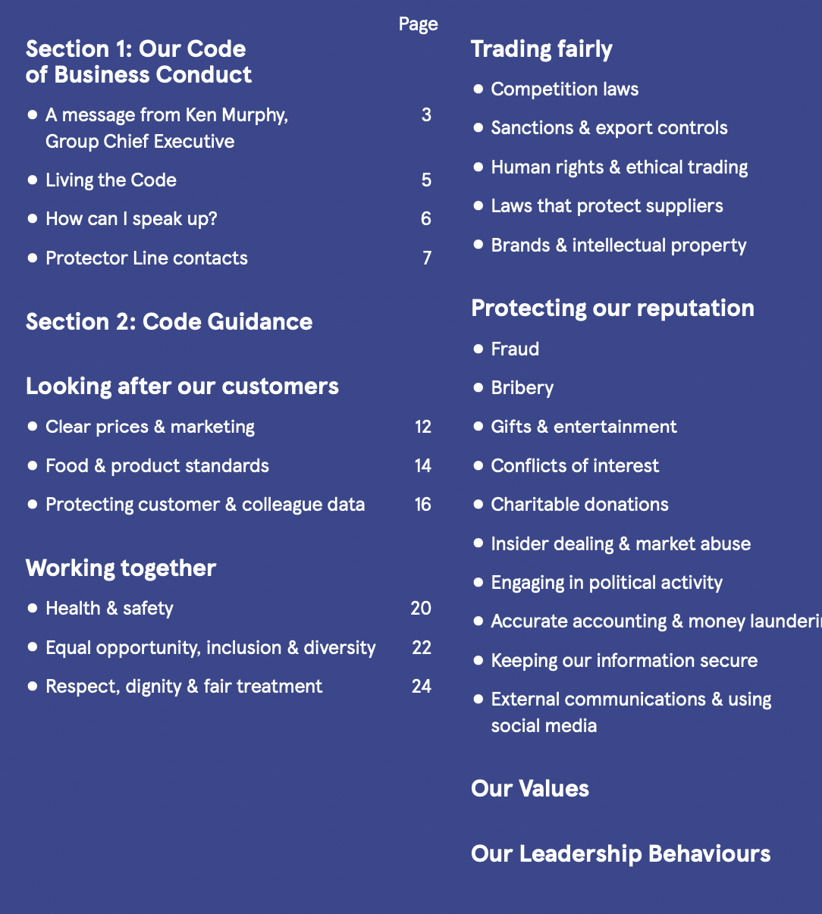

- The least ethical supermarkets in the UK
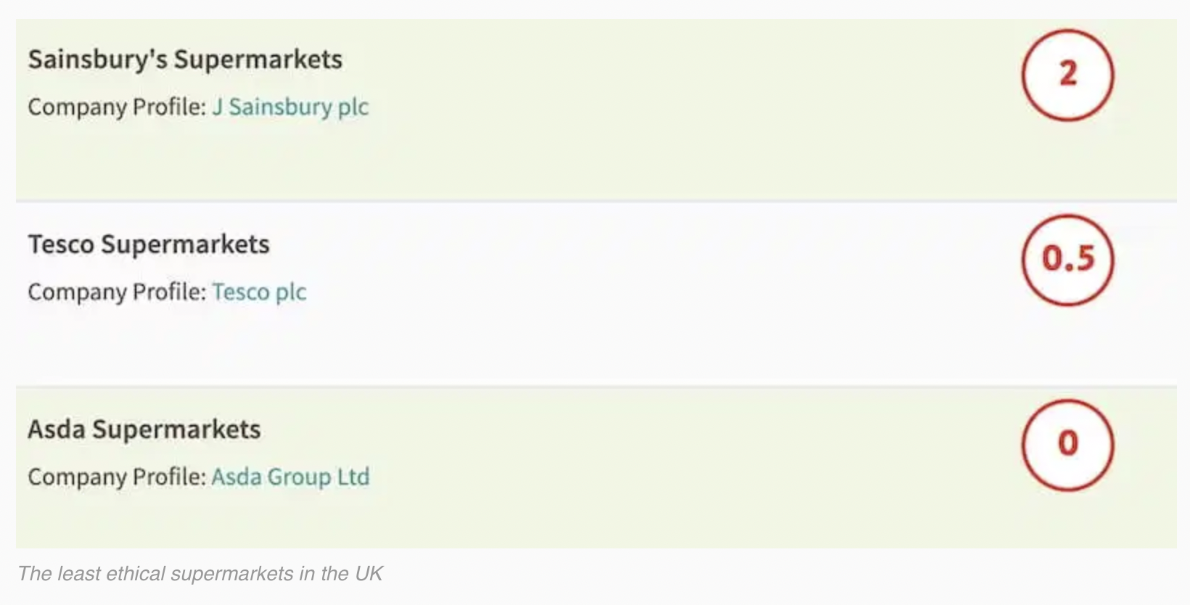

- Market share of grocery store
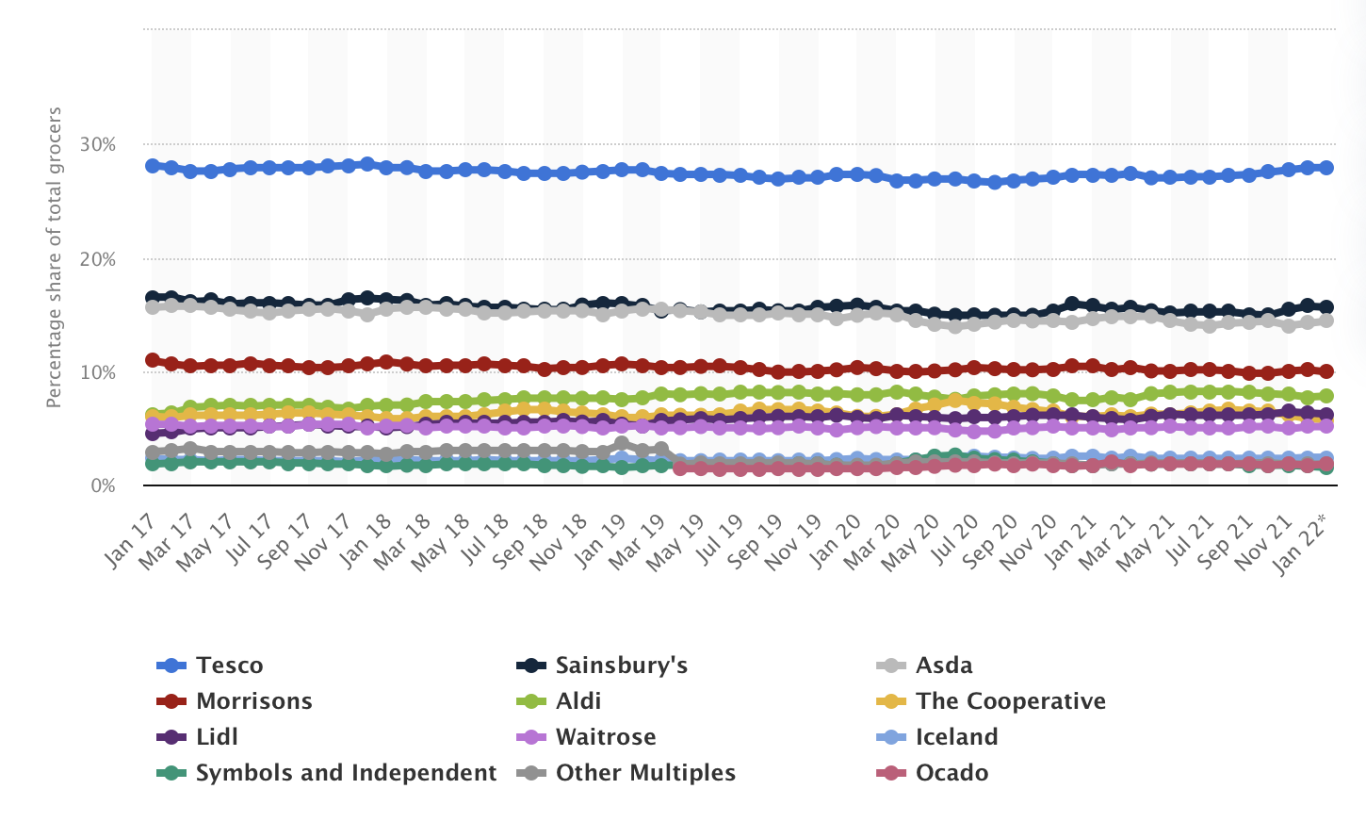

References
Butler, S. (2015) Tesco suppliers say retailer worst at following grocery code of practice. Available at: https://www.theguardian.com/business/2015/jun/22/tesco-suppliers-say-retailer-worst-at-following-grocery-code-of-practice (Accessed: 19th of February 2022).
Carter, A. (2021) Ethical and environmental record of 19 supermarkets. Available at: https://www.ethicalconsumer.org/retailers/shopping-guide/supermarkets (Accessed: 19th of February 2022).
Corporate Tesco (2022) Goals of Tesco and the UN. Available at: https://corporate.tesco.sk/en/sustainability/goals-of-tesco-and-the-un/ (Accessed: 20th of February 2022).
Cragg, W. (1997) Teaching Business Ethics: The Role of Ethics in Business and in Business Education. Journal of Business Ethics, Vol. 16.
Ethical Consumer (2022) Asda Group ltd. Available at: https://www.ethicalconsumer.org/company-profile/asda-group-ltd (Accessed: 20th of February 2022).
Freeman, R.E., Harrison, J.S., Zyglidopoulos, S. (2018) Stakeholder Theory. Concepts and Strategies. Cambridge university Press.
Green Eco-Friend (2021) Ethical Supermarkets UK. Available at: https://greenecofriend.co.uk/ethical-supermarkets-uk/ (Accessed: 19th of February 2022).
Mitchell, S. (2021) Perfectly Imperfect initiative saves 50m packs of fruit and veg at risk of going to waste. Available at: https://ethicalmarketingnews.com/perfectly-imperfect-initiative-saves-50m-packs-of-fruit-and-veg-at-risk-of-going-to-waste (Accessed: 20th of February 2022).
Mitchell, S. (2021) Tesco commits to net zero emissions from its supply chain and products by 2050. Available at: https://ethicalmarketingnews.com/tesco-commits-to-net-zero-emissions-from-its-supply-chain-and-products-by-2050 (Accessed: 20th of February 2022).
Mitchell, S. (2021) Tesco estimated new cleaning range can help save UK homes 60m pieces of plastic each year with new cleaning range. Available at: https://ethicalmarketingnews.com/tesco-estimates-new-cleaning-range-can-help-save-uk-homes-60m-pieces-of-plastic-each-year-with-new-cleaning-range (Accessed: 20th of February 2022).
Mitchell, S. (2021) Tesco receives royal approval for its approach to sustainability in Terra Carta Seal award win. Available at: https://ethicalmarketingnews.com/tesco-receives-royal-approval-for-its-approach-to-sustainability-in-terra-carta-seal-award-win (Accessed: 20th of February 2022).
Mitchell, S. (2022) Tesco becomes first major UK supermarket to sell range of braille Valentine’s cards. Available at: https://ethicalmarketingnews.com/tesco-becomes-first-major-uk-supermarket-to-sell-range-of-braille-valentines-cards (Accessed: 19th of February 2022).
Mitchell, S. (2022) Tesco brings £300k Blue Monday cheer for community groups nationwide. Available at: https://ethicalmarketingnews.com/tesco-brings-300k-blue-monday-cheer-for-community-groups-nationwide (Accessed: 19th of February 2022).
Mutyala, S. (2021) The Loyalty Ladder: a sideways look. Available at: https://www.eightleaves.com/2010/04/the-loyalty-ladder-a-sideways-look (Accessed: 20th of February 2022)
Nazir, S. (2019) Morrisons named UK’s most environmentally responsible retailer. Available at: https://www.retailgazette.co.uk/blog/2019/07/morrisons-named-uks-environmentally-responsible-retailer/ (Accessed: 20th of February 2022).
Poulter, S. (2011) No loyalty! Tesco sells details of your shopping habits for £53m. Available at: https://www.dailymail.co.uk/news/article-1365512/Tesco-sells-details-shopping-habits-53m.html (Accessed: 19th of February 2022).
Powell, S. (2004) The success of the Tesco Clubcard in winning customer loyalty. International Journal of Retail & Distribution Management, Volume 32, Issue 7.
Stark, A. (1993) What’s the matter with Business Ethics. Available at: https://hbr.org/1993/05/whats-the-matter-with-business-ethics (Accessed: 19th of February 2022).
Tesco Plc. (2021) Little Helps Plan, Sustainability update 2020/21.
Tesco Plc. (2022) Little Helps Plan. Available at: https://www.tescoplc.com/sustainability/ (Accessed: 20th of February 2022).
Tesco Plc. (2022) Our Code of Business Conduct.
Upadhyay, A., Kumar, A., Nur, S. (2012) An Analysis of UK Retailers towards Circular Economy Transition and Policy Driven Directions.
Wind, Y. and Bell, D. (2007) Market segmentation.

