DS 1 Template

My Screenshots/Photos
- Please add 4–6 screenshots or photos of your digital life.
- You can use your phone or laptop.
- For each screenshot, write one or two sentences explaining what it shows.

Screenshot/Photo 1
[Insert Photo/Screenshot below]
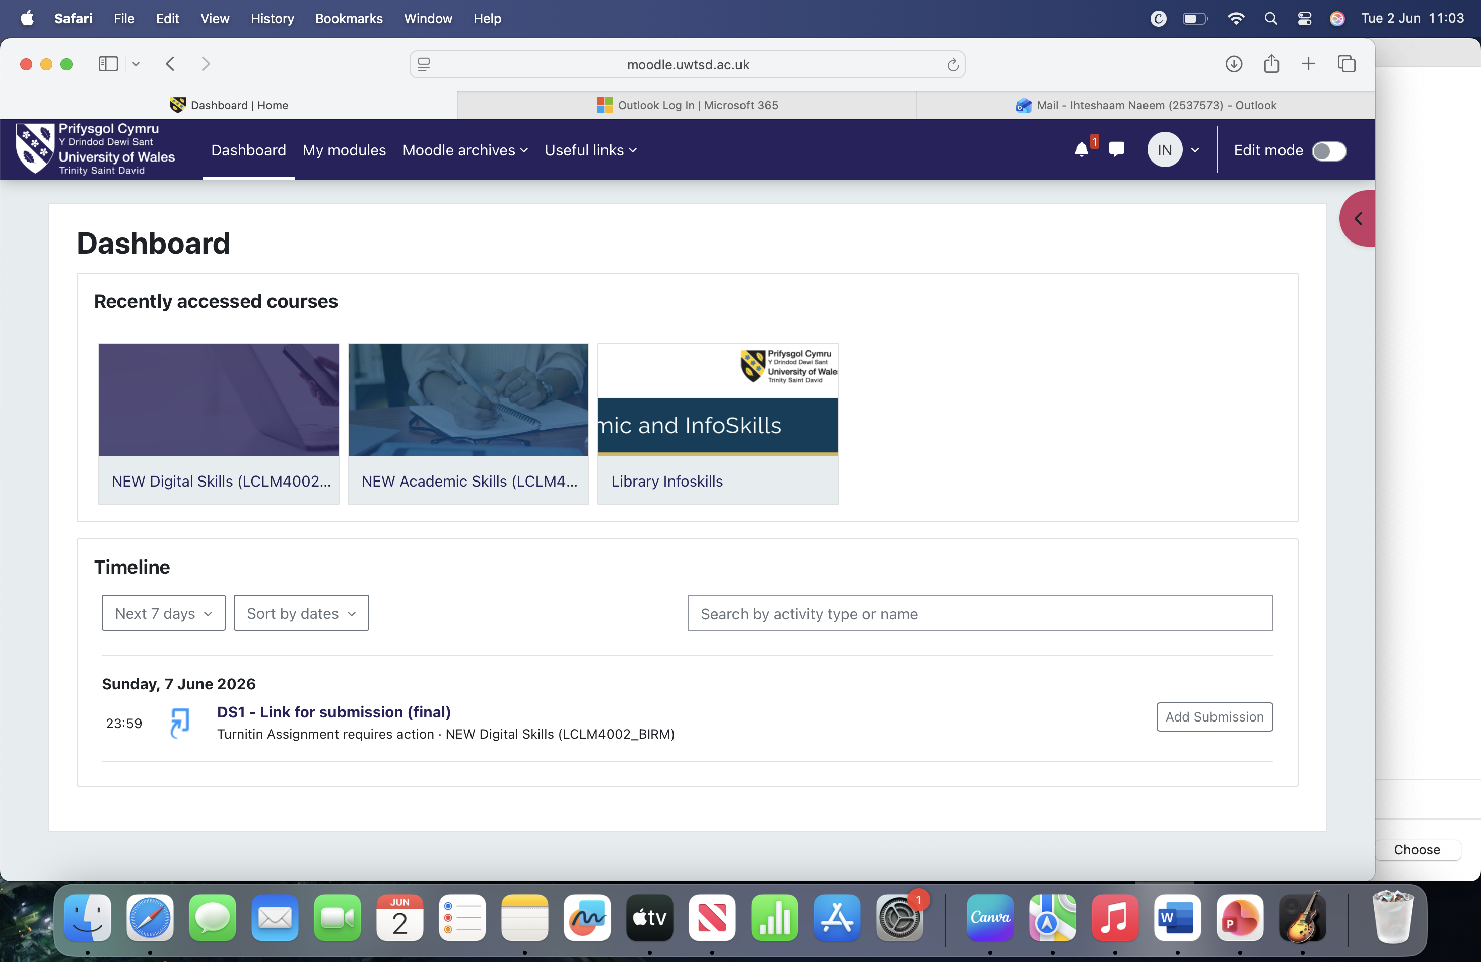
This is a screen shot of my Moodle dashboard which is the main hub for my assignments and also shows me what to do. I also use this to download templates and check my course information.

Screenshot/Photo 2
[Insert Photo/Screenshot below]
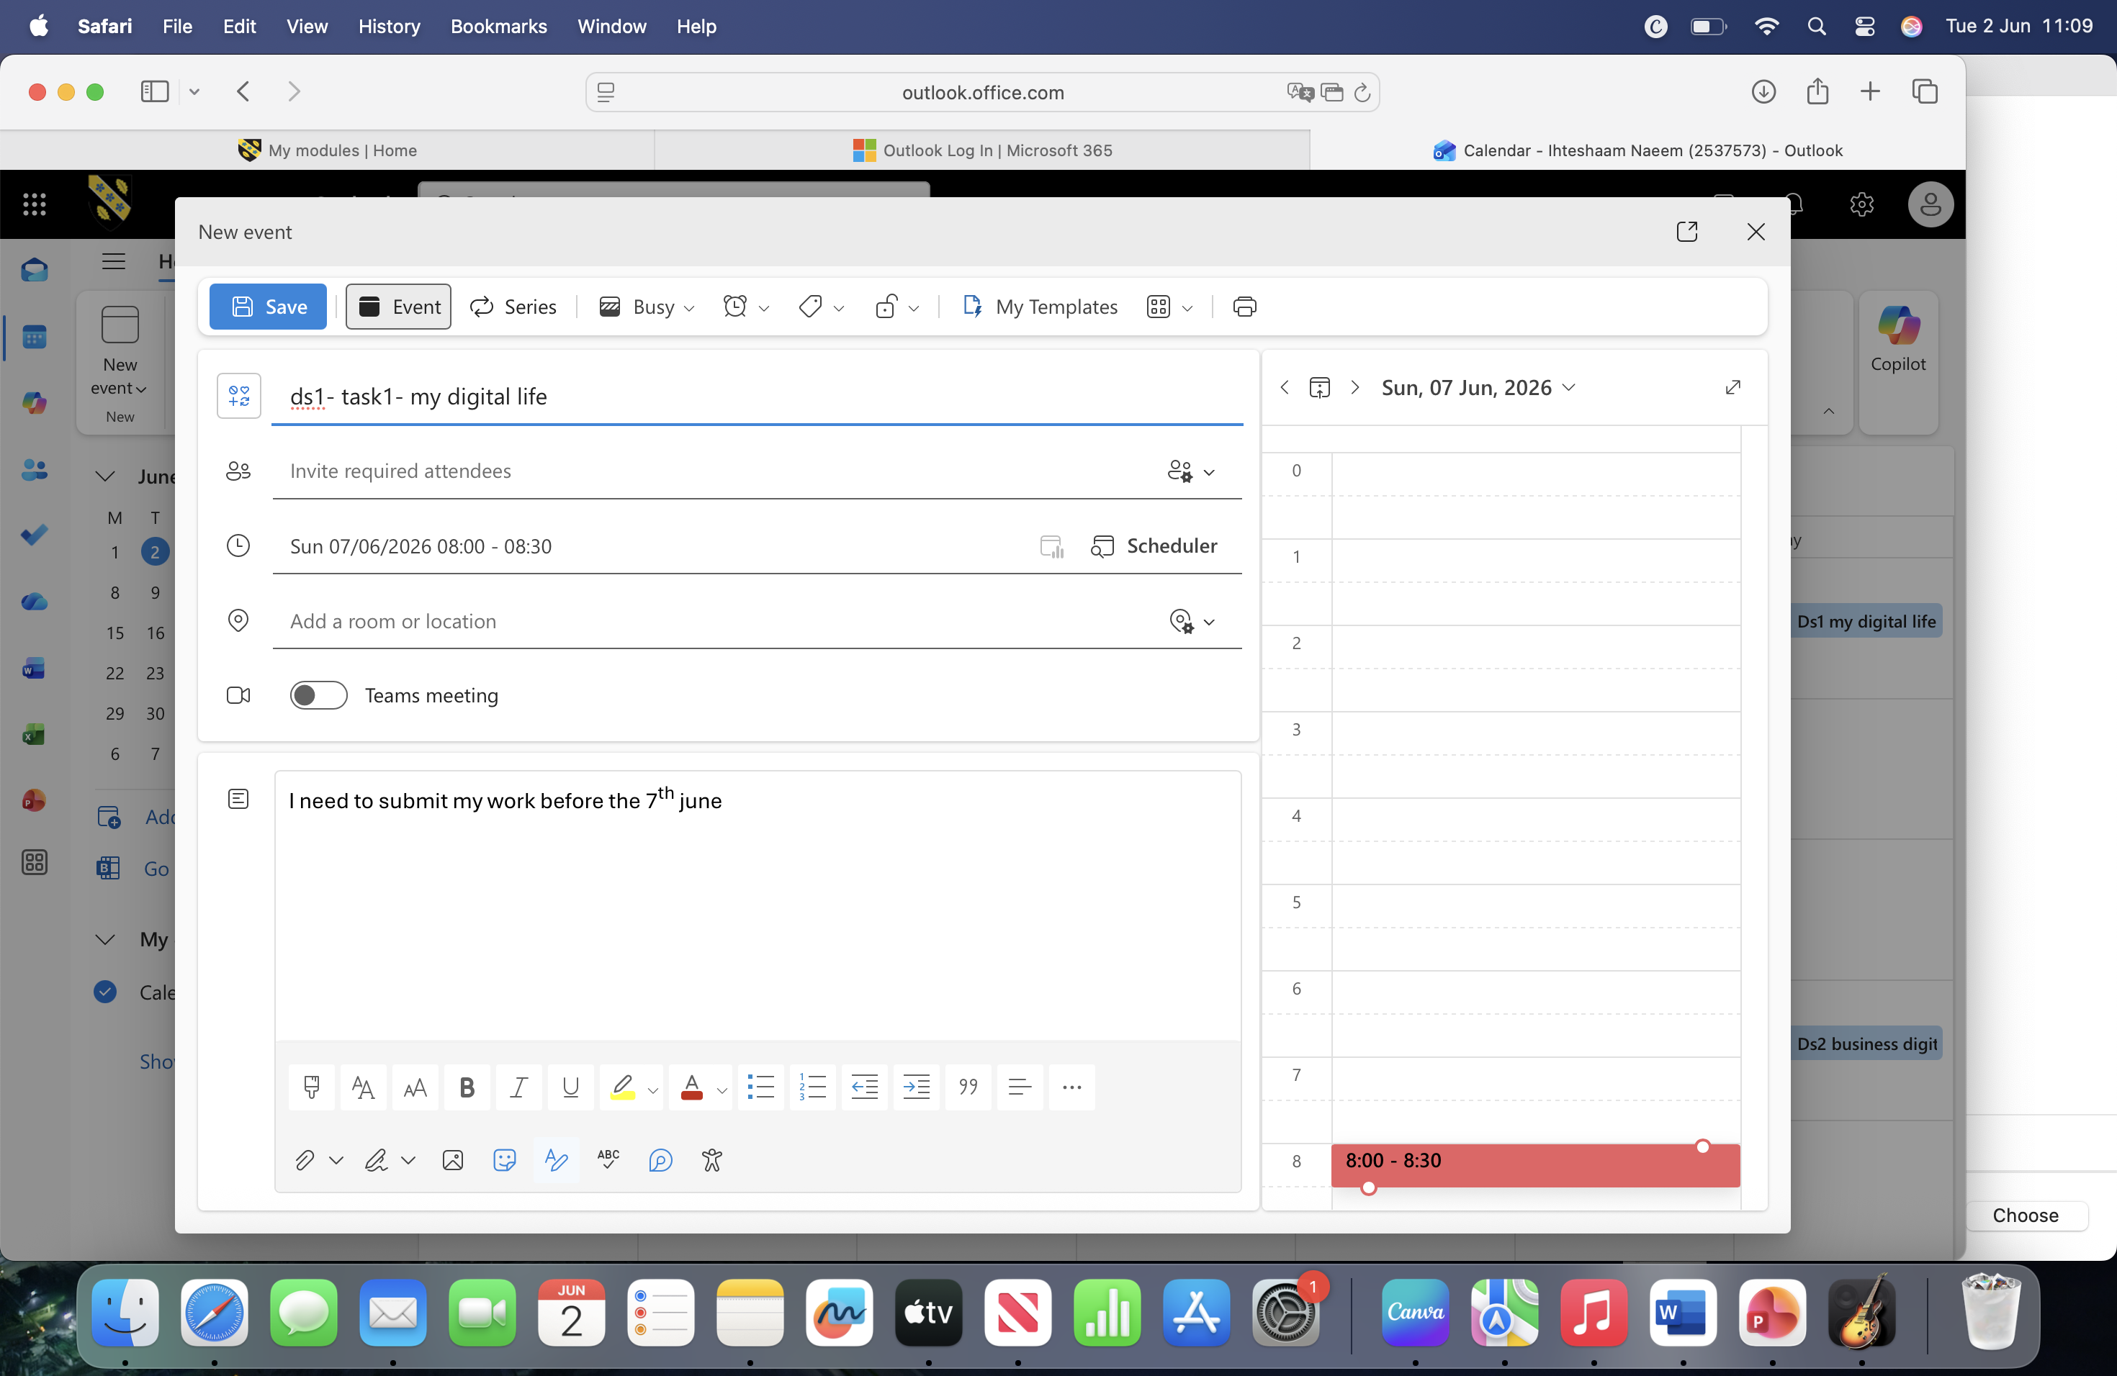
This isa screen shot of my calendar which helps me organise my schedule and deadlines

Screenshot/Photo 3
[Insert Photo/Screenshot below]
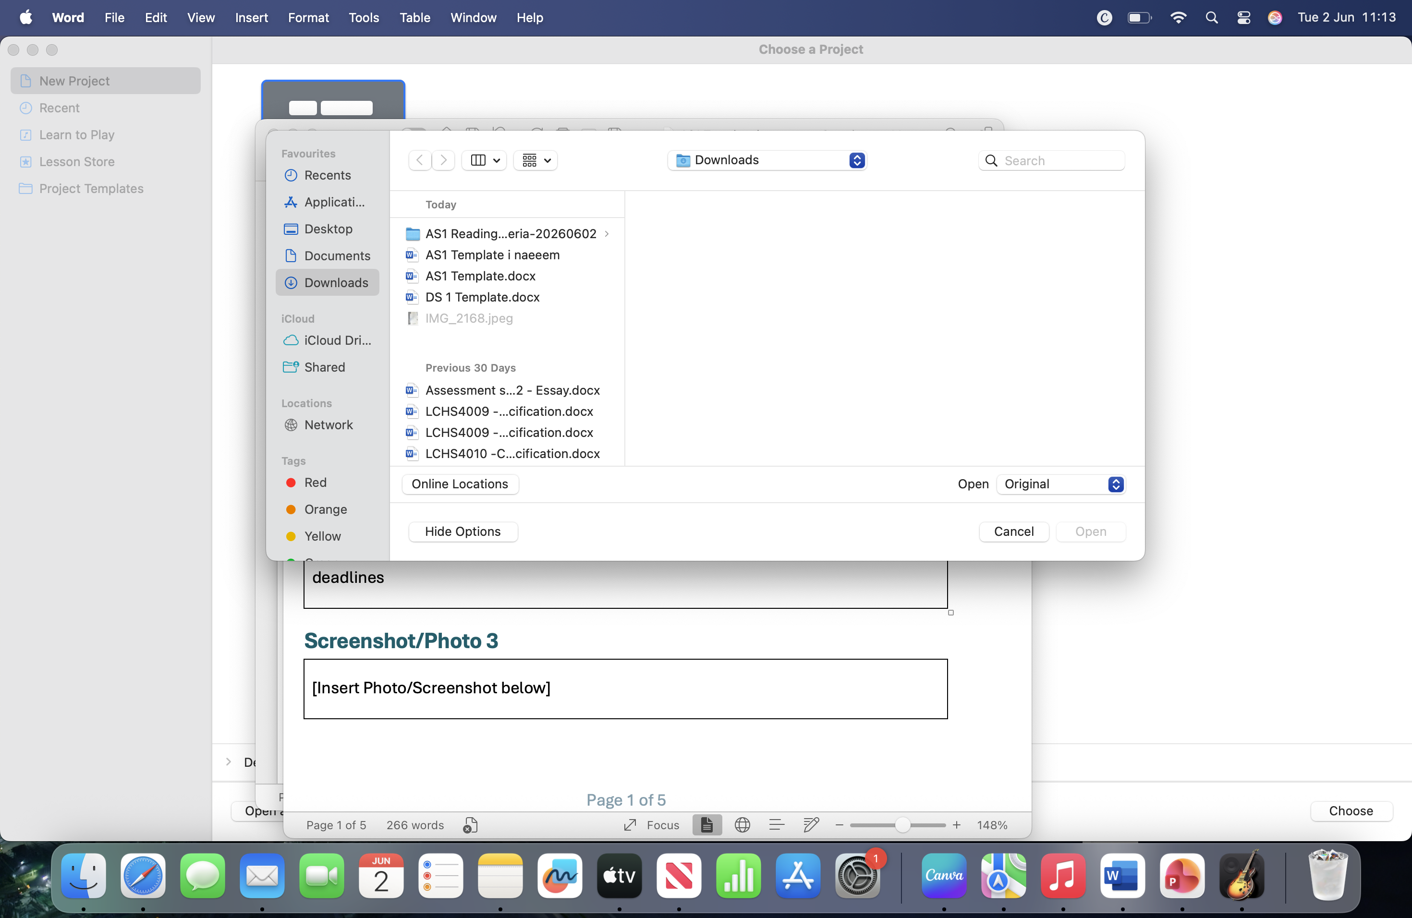
This screen shows a picture of my files for my assessments that I have organised correctly.

Screenshot/Photo 4
[Insert Photo/Screenshot below]
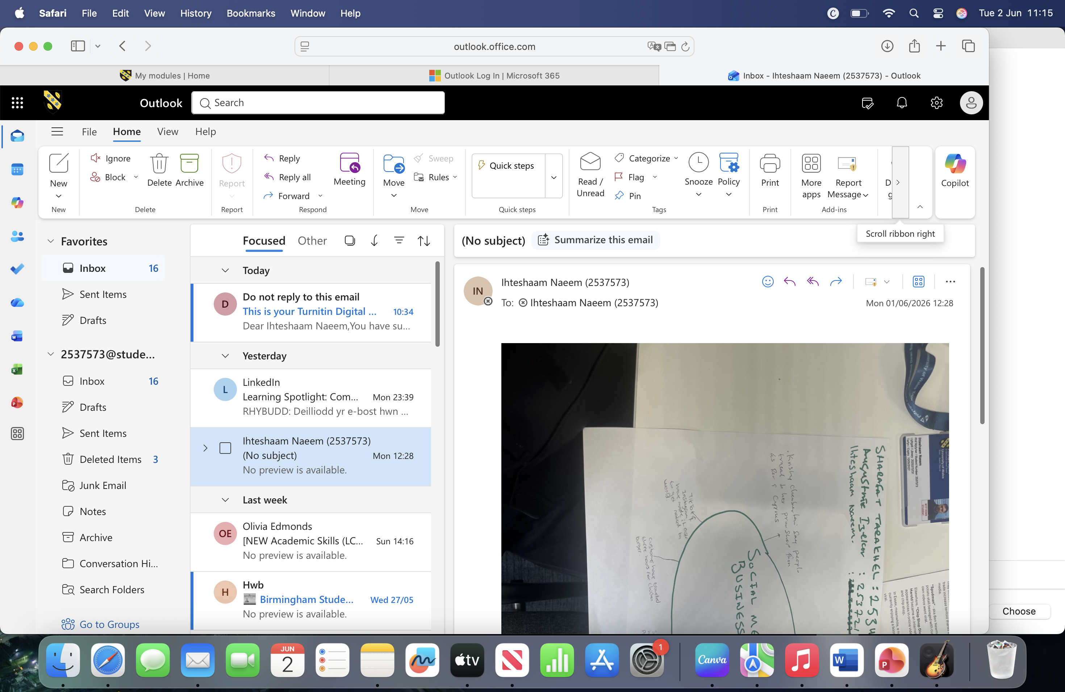
This is a screenshot of my emails which I use daily to send and receive emails for university.

Screenshot/Photo 5
[Insert Photo/Screenshot below]
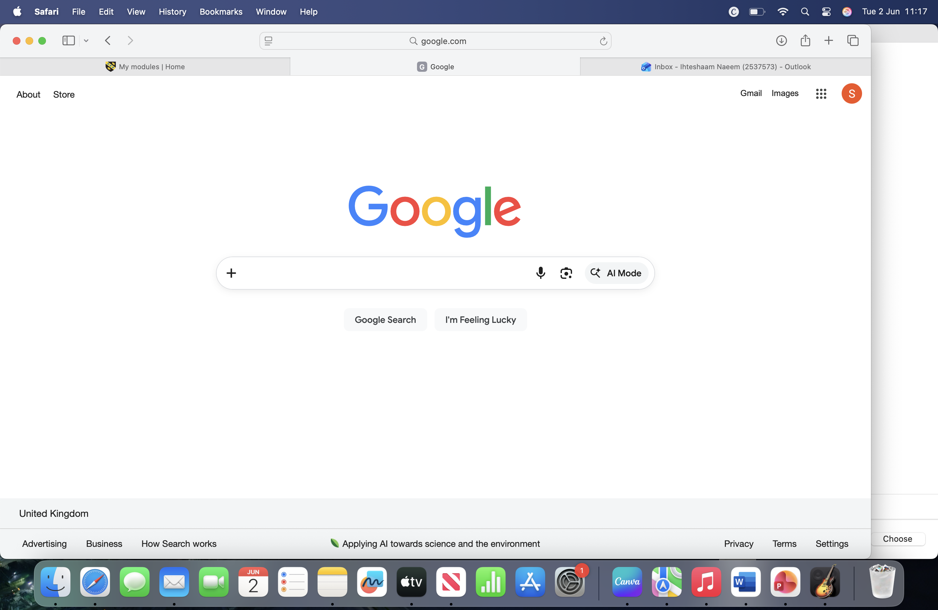
This is a screenshot of google search engine which I most commonly use for various information needed for university assignments for referencing. It is a basic skill but a important skill to use in your daily life.

Screenshot/Photo 6
[Insert Photo/Screenshot below]

[Write what this shows of your digital life]

My Short Reflection
- Write 5–8 simple sentences about your digital life.
- You can use the sentence starters below if helpful.
I use digital technology as a big part of my university studies and everyday life. I use online systems to check my coursework , view my moodles, and access learning materials. I also use email to contact my lecturers and keep up with my weekly schedule.

Sentence starters
- I use digital tools to …
- I feel confident when I …
- I want to improve …
- I often use these tools: …
- I sometimes feel nervous about …
- I hope this module will help me …
- Digital skills are important for me because …
You can write more if you want.

Submission Checklist
Before you submit, please check:
​​​ ☐ I added 4–6 screenshots
☐ I wrote short sentences for each screenshot
☐ I wrote my short reflection
☐ My work is my own
☐ My file opens correctly
​​☐ My file opens correctly

