
UNIVERSITY OF WALES TRINITY & SAINT DAVID
MODULE CODE: ACCA6020
Renuga jaykumar
Andrey Atanasov
2324732
2324732@student.uwtsd.ac.uk
2324732@student.uwtsd.ac.uk
BSC applied computing
Phishing detection and awareness using PYTHON (independent project proposal)

Contents
1. INTRODUCTION / BACKGROUND TO THE PROPOSED RESEARCH 1
1.1 Working Title 1
1.2 Background 1
1.3 Rationale 2
1.4 Industry/Organisational Context 2
1.5 Aim of the Study 2
1.6 Objectives 2
1.7 Expected Outcomes 3
2. PROJECT DESIGN 3
2.1 Design Outline 3
2.2 Data Collection Methods per Objective 3
2.3 Specialist Development Methods & Tools 4
2.4 Risks, Limitations, Ethics & Legal Issues 4
2.5 Generalisability, Reliability, Validity 4
2.6 Data Analysis / Evaluation Method 4
3. RESOURCES & PLANNING 5
3.1 Resources Required 5
3.2 Project Plan & Timeline 5
REFERENCES 6

1. INTRODUCTION / BACKGROUND TO THE PROPOSED RESEARCH

1.1 Working Title
Phishing Awareness and Detection Using Python: A Rule-Based Approach for Small Organisations

1.2 Background
Phishing remains one of the most persistent and disruptive forms of cybercrime. It first emerged in the mid-1990s, when a tool called AOHell automated the theft of passwords and credit card details from America Online users; the technique has since evolved from a niche prank into a global threat affecting organisations of every size [1].
Attackers now blend spoofed sender identities, urgency-driven language, and malicious links to bypass traditional perimeter defences, and the underlying philosophy of modern cybersecurity has shifted accordingly: rather than assuming a network is inherently safe, a Zero Trust approach verifies every request regardless of its origin [3].
This shift is reflected in current UK statistics, where phishing was identified as the most disruptive attack type for 85% of businesses that experienced a breach in the past year [6], and in global cost estimates that put cybercrime damages in the trillions of dollars annually [7].
Existing detection research falls broadly into four categories: stylometric analysis, rule-based (whitelist/blacklist) methods, machine-learning classification, and user education [4].
Rule-based approaches, including whitelisting of trusted senders and keyword/URL heuristics, remain attractive for smaller organisations because they are simple to implement, require no training data, and are easy to audit, even though they can be less adaptive than machine-learning classifiers to newly emerging phishing tactics [5].
This gap between what large enterprises can deploy and what a resource-constrained organisation can realistically maintain is the starting point for this project.

1.3 Rationale
Commercial anti-phishing platforms typically rely on proprietary threat intelligence, machine-learning models, or subscription-based services that are often out of reach for small businesses and charities, despite these organisations facing the same volume of phishing attempts as larger enterprises [2].
This project is worth undertaking because it addresses that accessibility gap directly: rather than proposing a novel detection algorithm, it investigates whether a lightweight, transparent, rule-based system, built entirely from freely available tools, can meaningfully reduce phishing risk for an organisation with limited technical resources. This applied focus is timely, since smaller organisations are frequently under-reported in breach statistics yet disproportionately affected when an attack succeeds [6].
There is no expectation that a rule-based scoring system will outperform commercial machine-learning solutions; instead, the project's contribution is to demonstrate a practical, explainable baseline and to critically evaluate its strengths and limitations against the wider literature.

1.4 Industry/Organisational Context
The project is framed around a simulated small organisation, reflecting the typical profile of businesses most exposed to phishing but least resourced to defend against it. Within such an organisation, three functions have a direct stake in the tool: IT security, which would deploy and maintain the trusted-sender list and scoring thresholds; risk management, which would use flagged-email data to assess exposure; and staff training/awareness programmes, which could use flagged examples to reinforce safe email behaviour.

1.5 Aim of the Study
The aim of this project is to design, develop, and evaluate a lightweight Python-based phishing detection prototype that uses trusted-sender verification, keyword analysis, and URL checking to flag suspicious emails for small organisations.

1.6 Objectives
- To investigate common phishing techniques and existing rule-based detection approaches through a review of academic and industry literature.
- To design and develop a Python-based phishing detection prototype that evaluates emails using a trusted-sender whitelist, keyword-based content analysis, and URL verification.
- To implement a cumulative scoring and threshold mechanism that classifies emails as suspicious without blocking their delivery.
- To evaluate the prototype's detection performance against a set of simulated phishing and legitimate emails, and to assess its limitations and scope for future development.

1.7 Expected Outcomes
By the end of the project, the following deliverables are expected:
- A working Python prototype implementing whitelist, keyword, and URL-based scoring; a small trusted-sender test database
- A documented test set of simulated phishing and legitimate emails used for evaluation
- A short evaluation report summarising detection performance, false positive/negative rates, and observed limitations
- A set of evidence-based recommendations for extending the prototype, such as adding a web interface or a report-phishing workflow, for future development.

2. PROJECT DESIGN

2.1 Design Outline
The project follows a Waterfall development approach, progressing through defined phases of research, system design, implementation, and evaluation [16].
This model was chosen because the project is undertaken independently, without iterative client feedback cycles, and because its fixed deliverables and timeframe are well suited to a linear structure that supports clear milestone tracking [17].
Although Agile methods offer more flexibility for evolving requirements, that flexibility is less valuable here than the structure and documentation discipline that Waterfall provides for an academic deliverable. The prototype itself follows a modular architecture, with separate components for sender verification, keyword scanning, URL checking, and score aggregation.

2.2 Data Collection Methods per Objective
Data collection differs by objective. For Objective 1 (literature review), data is secondary: peer-reviewed papers, government cybersecurity guidance, and industry reports identified through academic databases and organisational publications.
For Objective 2 (prototype development), a small, simulated dataset is created, comprising a trusted-sender list of sample email addresses and a set of constructed sample emails containing typical phishing indicators such as urgency phrases, spoofed domains, and suspicious links [11].
No real personal data or genuine phishing emails targeting real individuals are collected.
For Objective 3 (scoring/threshold implementation), the same simulated email set is used to test how sender, keyword, and URL signals combine into a cumulative score.
For Objective 4 (evaluation), the prototype is run against the simulated dataset, and its classifications are compared manually against the known status of each test email to calculate detection and false-positive rates.

2.3 Specialist Development Methods & Tools
The prototype is implemented in Python, using the re library for keyword pattern matching [19] and pandas for managing the trusted-sender database [20].
URL legitimacy checks are informed by the design of existing free tools such as Get Safe Online's Check a Website service [9].
Development takes place in Visual Studio Code with Git for version control. These tools were chosen specifically because they are free and widely documented, in keeping with the project's aim of demonstrating an accessible, low-cost detection approach.

2.4 Risks, Limitations, Ethics & Legal Issues
The main technical risk is inaccurate detection: overly strict thresholds risk false positives that disrupt legitimate email, while lenient thresholds risk missing genuine phishing attempts [13].
This is mitigated by testing and adjusting the scoring threshold against the simulated dataset before finalising it, and by flagging rather than blocking emails, consistent with layered-defence guidance from the National Cyber Security Centre [12].
Ethically and legally, the project avoids any real personal or organisational email data, which keeps it outside the scope of the UK GDPR and Data Protection Act 2018 [14].
No systems are accessed without authorisation, and no live phishing content is distributed, in line with the Computer Misuse Act 1990 [15].
The accompanying ethics form confirms this is a low-risk activity with no human participants.

2.5 Generalisability, Reliability, Validity
As a rule-based system, the prototype's reliability depends on how representative the simulated test set is of real-world phishing tactics; results may not generalise fully to sophisticated, AI-generated, or highly targeted spear-phishing attempts that lack the surface-level indicators the scoring system relies on [18].
Validity is supported by grounding the keyword and design choices in documented phishing indicators from industry sources [11] rather than arbitrary rules, but the small scale of the test dataset means performance figures should be treated as indicative rather than statistically generalisable.

2.6 Data Analysis / Evaluation Method
Evaluation is primarily quantitative: each test email's classification (flagged/not flagged) is compared against its known status to calculate a detection rate, false-positive rate, and false-negative rate. These are supplemented by a short qualitative review of borderline cases where the score sat close to the threshold, to assess whether the weighting given to sender, keyword, and URL signals is well balanced.

3. RESOURCES & PLANNING

3.1 Resources Required
The project requires no specialist hardware, only a standard laptop running Python 3 with the re, pandas, and validators libraries, Visual Studio Code, and Git/GitHub for version control [19][20].
A small MS Access or SQLite file will hold the trusted-sender test database. Free academic access via Google Scholar and the university's library databases (IEEE Xplore, ScienceDirect) supports the literature review, and regular contact with the subject specialist supervisor provides guidance on methodology and scope.

3.2 Project Plan & Timeline
The project is scheduled across approximately 4-5 months.
The work on the project, including proposal, begins at the start of the spring term and ends with submission deadline in last term:
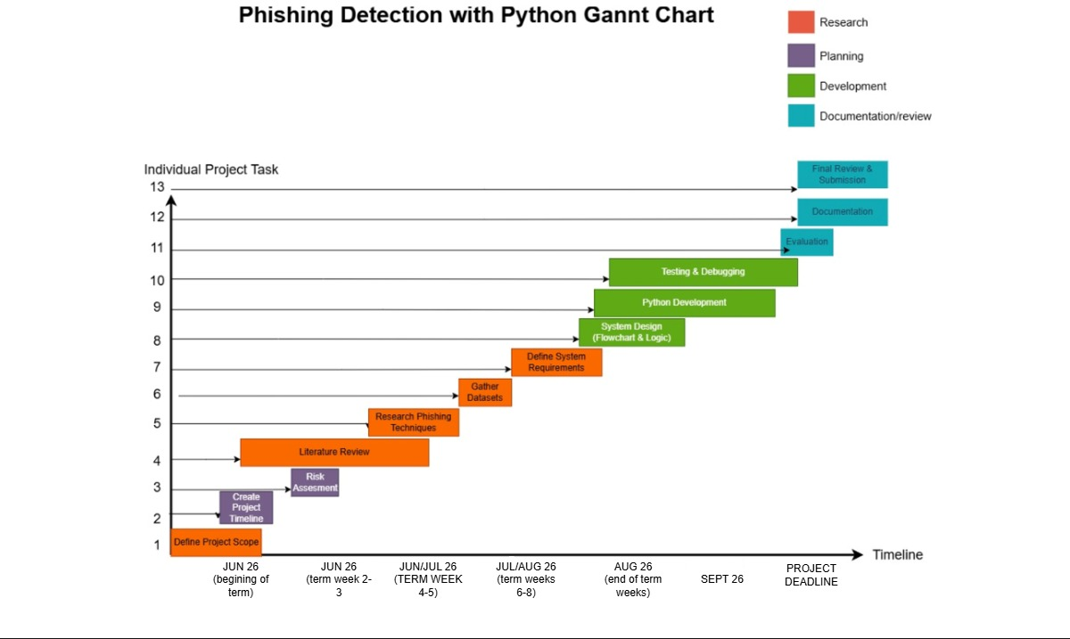
Figure 1: Gantt chart

The WBS breaks the project into six phases: planning, research, design, development/testing, evaluation, and submission. Each split into concrete sub-tasks. It underpins the Gantt chart directly (1.1.2 derives from it), so the two work as a pair: WBS shows what the work is, Gantt shows when it happens.
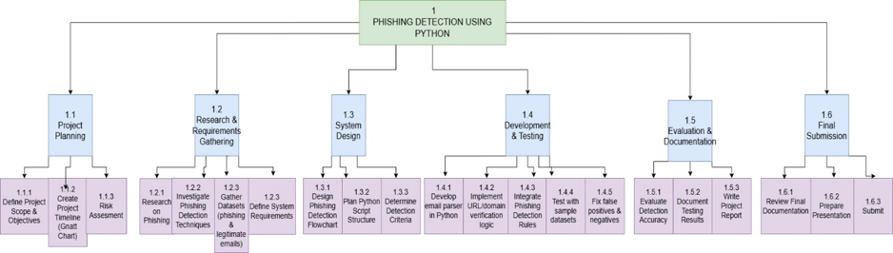
Figure 2: WBS model

REFERENCES
[1] “The History of Phishing,” Phishing.org. [Online]. Available: https://www.phishing.org/history-of-phishing
[2] Get Cyber Safe, “The history of phishing,” Communications Security Establishment Canada, 2021. [Online]. Available: https://www.getcybersafe.gc.ca/en/resources/history-phishing
[3] S. Rose, O. Borchert, S. Mitchell, and S. Connelly, “Zero Trust Architecture,” NIST Special Publication 800-207, National Institute of Standards and Technology, Aug. 2020. [Online]. Available: https://www.nist.gov/publications/zero-trust-architecture
[4] W. P. Nmachi and T. Win, “Phishing Mitigation Techniques: A Literature Survey,” International Journal of Network Security & Its Applications, vol. 13, no. 2, pp. 63-75, Mar. 2021. [Online]. Available: https://arxiv.org/pdf/2104.06989
[5] F. Salahdine, Z. El Mrabet, and N. Kaabouch, “Phishing Attacks Detection: A Machine Learning-Based Approach,” IEEE, 2021. [Online]. Available: https://arxiv.org/pdf/2201.10752
[6] Department for Science, Innovation and Technology, “Cyber Security Breaches Survey 2025,” GOV.UK, Apr. 2025. [Online]. Available: https://www.gov.uk/government/statistics/cyber-security-breaches-survey-2025/cyber-security-breaches-survey-2025
[7] Cybersecurity Ventures, “Cybercrime To Cost The World $10.5 Trillion Annually By 2025,” Cybercrime Magazine, 2020. [Online]. Available: https://cybersecurityventures.com/cybercrime-damages-6-trillion-by-2021/
[8] A. Daly, “What is Whitelisting and Blacklisting in Email Security?,” INKY Technology. [Online]. Available: https://www.inky.com/en/blog/what-is-whitelisting-and-blacklisting-in-email-security
[9] Get Safe Online, “Check a Website,” 2024. [Online]. Available: https://www.getsafeonline.org/checkawebsite/
[10] S. Dawkins and J. Jacobs, “NIST Phish Scale User Guide,” NIST Technical Note 2276, National Institute of Standards and Technology, Nov. 2023. [Online]. Available: https://nvlpubs.nist.gov/nistpubs/TechnicalNotes/NIST.TN.2276.pdf
[11] Neuways Ltd., “Phishing Awareness Training Booklet,” Sep. 2021. [Online]. Available: https://neuways.com/wp-content/uploads/2021/09/Phishing-Awareness-Training-Booklet.pdf
[12] National Cyber Security Centre, “Phishing attacks: defending your organisation,” Feb. 2018, reviewed Feb. 2024. [Online]. Available: https://www.ncsc.gov.uk/guidance/phishing
[13] Microsoft, “How to handle false positives in Microsoft Defender for Office 365,” Microsoft Learn, 2025. [Online]. Available: https://learn.microsoft.com/en-us/defender-office-365/step-by-step-guides/how-to-handle-false-positives-in-microsoft-defender-for-office-365
[14] Information Commissioner's Office, “Data Protection Act 2018.” [Online]. Available: https://ico.org.uk/about-the-ico/what-we-do/legislation-we-cover/data-protection-act-2018/
[15] “Computer Misuse Act 1990,” UK Public General Acts, legislation.gov.uk. [Online]. Available: https://www.legislation.gov.uk/ukpga/1990/18/contents
[16] Simplilearn, “What is the Waterfall Model in Project Management?,” 2025. [Online]. Available: https://www.simplilearn.com/tutorials/project-management-tutorial/waterfall-model-in-project-management
[17] Simplilearn, “Agile vs Waterfall: Which Will Lead Your Projects to Victory?” [Online]. Available: https://www.simplilearn.com/tutorials/agile-scrum-tutorial/agile-vs-waterfall
[18] “A Systematic Review of Deep Learning Techniques for Phishing Email Detection,” Electronics, MDPI, vol. 13, no. 19, 2024. [Online]. Available: https://www.mdpi.com/2079-9292/13/19/3823
[19] Python Software Foundation, “re — Regular expression operations,” Python Docs. [Online]. Available: https://docs.python.org/3/library/re.html
[20] pandas Community, “Ecosystem,” pandas.pydata.org. [Online]. Available: https://pandas.pydata.org/community/ecosystem.html

