
BA (Hons) Leadership and Management Skills for the Workplace
Module Title: Developing Emotional Intelligence Skills
Module Code: LCLM5006
Assignment Title: Component 2 - Individual
written report
Component 2: Emotional Intelligence, Mindfulness and Generational Differences in the Workplace
Student Name: Tauseef Ahmed
Student ID: 2331193
Lecturer: Abdallah Naser
Submission Date: 31 July 2026
Word Count: Approximately 3000 words

Table of Contents
1. Introduction 3
2. Emotional Intelligence at the Workplace. 4
2.1 Emotional Intelligence and Mindfulness at Work. 4
2.2 Essentials of Emotional Intelligence in Employee Behaviour. 5
2.3. Critical Analysis of Emotional Intelligence Models. 7
Comparative Critical Analysis Table 8
2.4 Application of Emotional Intelligence in Workplace Practice 9
Key Workplace Applications and Measurable Outcomes Table 10
2.5. Limitations of Emotional Intelligence in Organisations. 10
3. Differences in Generational Workplace. 11
3.1 Generational Profiles in Organisation. 11
3.2 Emotional Intelligence and Generational Characteristics. 11
Comparative Analysis of Generational EI Tendencies 11
3.3 Generational Differences in Emotional Intelligence Practice. 12
3.4 Managerial Implications on Recruitment and Workforce Management. 13
Recruitment Considerations 13
4. CONCLUSION AND RECOMMENDATIONS 14
4.1 Conclusion 14
4.2 Recommendations 15

Introduction
Emotional intelligence has emerged as an important skill in modern organisations because workplaces are now more about teamwork, flexibility and successful leadership instead of technical skill. Emotional intelligence means the capacity to identify, decode, control and exploit feelings both in oneself and others to influence thought and action (Goleman, 1995). Studies have always proved that employees who possess greater emotional intelligence are in a better position to deal with interpersonal relationship, conflict resolution and add up to effective organisational performance (Goleman, 1998; Mayer, Salovey and Caruso, 2004). Mindfulness, together with emotional intelligence has become increasingly popular in organisations because of its role in improving emotional awareness, self-regulation, and psychological wellbeing in the workplace (Glomb et al., 2011; Good et al., 2016).
The contemporary working environment is also more diverse in terms of generation, where the representatives of Generation X, generation Y, and generation Z share the same workplace. The different generations might exhibit different communication, expectation of emotions and approaches to power and work, which can affect the manifestation and interpretation of emotional intelligence in practice (Parry and Urwin, 2011; Twenge, 2010). Although generational diversity can make the process of creativity and learning more effective, it can also present difficulties to managers unless the emotional intelligence competencies are implemented (Costanza et al., 2012).
The report critically assesses the application of the elements of emotional intelligence by employees in the workplace basing on the proven models of emotional intelligence and the existing academic literature. It also discusses the peculiarities which managers should consider during the recruitment and management of the multigenerational workforce. Lastly, the report will offer practical suggestions on how emotional intelligence and mindfulness could be used to establish a more productive and inclusive workplace.

2. Emotional Intelligence at the Workplace.

2.1 Emotional Intelligence and Mindfulness at Work.
The concept of emotional intelligence is well understood as the capacity to sense, comprehend, handle, and make use of feelings in a person and other people (Mayer and Salovey, 1997). Emotional intelligence in workplace situations goes beyond personal awareness of emotions directly affecting leadership abilities, team work, decision making and employee welfare (Goleman, 1998). Emotional intelligence, unlike cognitive intelligence, is behaviourally manifested and can be acquired with an experience, reflection and training.
In an organisational setting, emotional intelligence is a quantifiable factor of performance. According to meta-analysis data, EI is positively linked to job satisfaction, organisational commitment, and task performance with correlation coefficients ranging between 0.23 and 0.35, which also depend on the type of role and the method applied (Miao, Humphrey and Qian, 2017). These results suggest that emotionally intelligent employees are both more effective and also make the workplace relationships healthy.
Mindfulness is beneficial to emotional intelligence that builds on emotional awareness and self-regulation. Mindfulness is a non-judgmental awareness of thoughts and emotions at the present moment, which can help people respond in a situation of emotion response, not impulsively (Glomb et al., 2011). Empirical evidence suggests that mindful practicing employees experience less emotional exhaustion and better emotional regulation capacity, which directly correlates with emotional intelligence capabilities of self-awareness and empathy (Good et al., 2016).
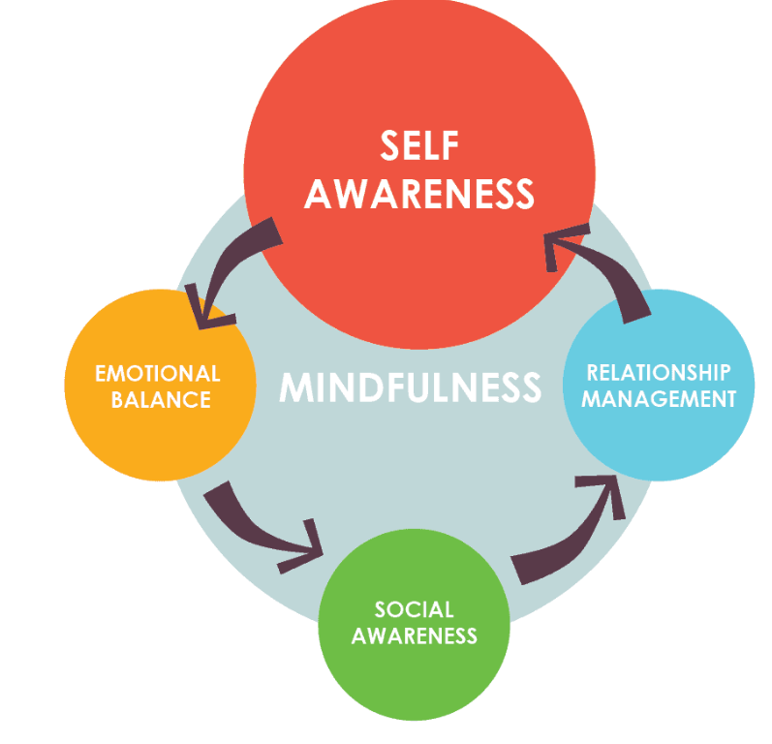
Figure 1 Mindfulness is beneficial to emotional intelligence
As a matter of fact, organisations with encouraging mindfulness-based interventions record better emotional control, ethical decision making and stress management. Equally, mindfulness programs adopted in Google have been associated with enhanced emotional sensitivity, ethical leadership practice, and minimised work pressures among staff (Goleman, 1998; Good et al., 2016). As an illustration, mindfulness programmes at the workplace have been linked to a drop in the level of perceived stress by an average of 20 to 30 percent in any professional job, especially in stressful environments (Good et al., 2016). This fact demonstrates that emotional intelligence and mindfulness are not theories but functional abilities that determine behaviour and performance at the workplace.

2.2 Essentials of Emotional Intelligence in Employee Behaviour.
A review of the emotional intelligence framework of Goleman reveals that it has five basic elements that define the nature of interaction and performance of employees in the workplace namely: self-awareness, self-regulation, motivation, empathy, and social skills (Goleman, 1995).
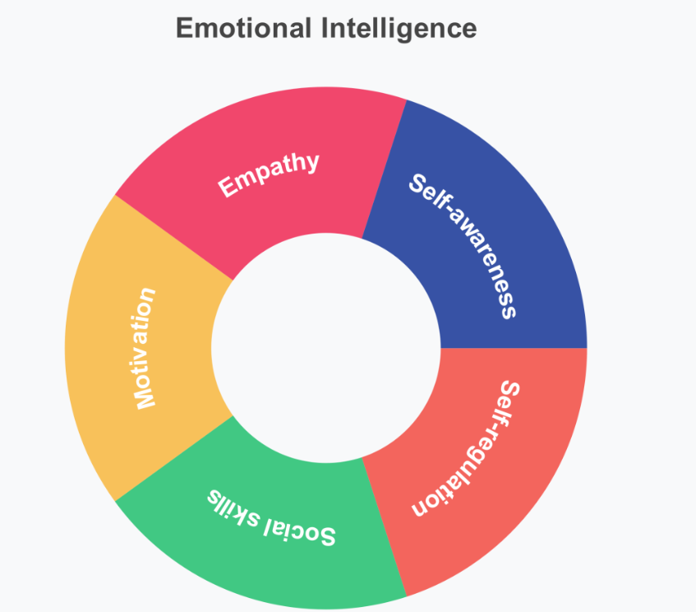
Figure 2 emotional intelligence framework of Goleman
- Self-awareness defines the capability of an employee to identify their feelings as well as the effect of the same on behaviour and decision-making. High self-awareness also allows employees to recognise the presence of emotional triggers and modify their behavior in relation to these triggers. According to research, highly self-aware leaders are rated as more effective by their subordinates, and leadership effectiveness scores are high by around 15 percent, as compared to those of leaders who have low self-awareness (Goleman, 1998).
- Self-regulation can be defined as the ability to regulate emotional responses in a positive and controlled way. This competency is also vital in organisational contexts, particularly during times of conflict, performance feedback, and when there is high pressure. Employees with good self-regulation get fewer chances to involve themselves in counterproductive behaviours at the workplace, which have been established to reduce by almost a quarter in emotionally intelligent teams (Ashkanasy and Daus, 2005).
- Emotional intelligence is associated with motivation that deals with the intrinsic drive, commitment of oneself emotionally to the goals. EI employees are more resilient, persistent, and flexible when it comes to organisational change. It is believed that emotionally intelligent people are much more prone to become proactive problem solvers and people who engage in continuous improvement behaviours (Miao, Humphrey and Qian, 2017).
- Empathy helps the employees to realise and perceive the feelings of others, which is quite vital in collaborating and resolving conflicts. Empathy is also found to have a positive correlation with team cohesion and interpersonal conflict in various workgroups (Cherniss, 2010).
- Social skills denote the capability of how to relate to others in communication, persuasion and negotiation. Social skills have a direct relationship with team performance, trust and climatic factors in the organisation.
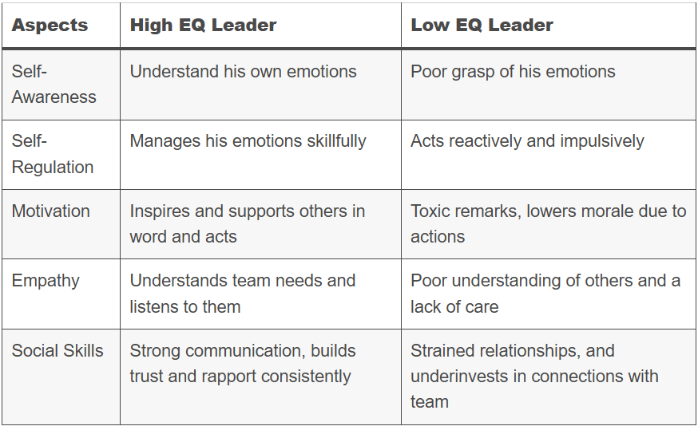
Figure 3 key differences between high and low EQ leaders:

2.3. Critical Analysis of Emotional Intelligence Models.
There are two prevailing models of emotional intelligence to be used in the workplace settings: Goleman's mixed model and Mayer and Salovey's ability model. All models vary in the conceptual clarity, measurement, and usefulness to managers.

Comparative Critical Analysis Table
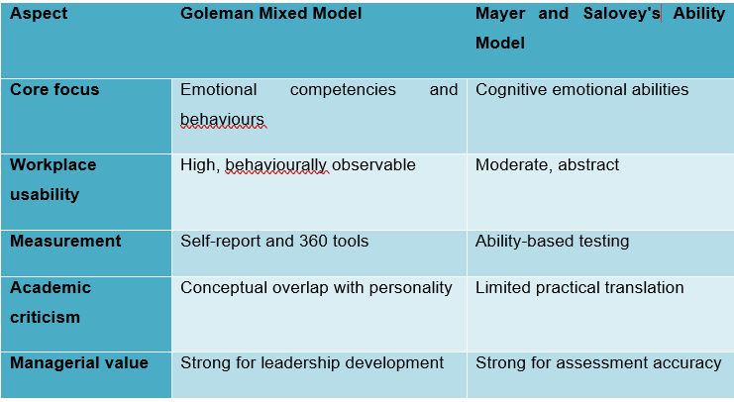
The model proposed by Goleman has become one of the models that have been widely adopted in organisations because of its behavioural simplicity and the ability to easily into the leadership development model (Goleman, 1998). Empirical evidence developed within the workplace reveals that leaders who are high in empathy and self-regulation display greater team engagement and reduced turnover with engagement improvement reported to range from 1020 percent in emotionally competent teams. The model however has been criticised to have a poor boundary of constructs; emotional intelligence is mixed with motivation and social competency, diminishing theoretical accuracy (Cherniss, 2010).
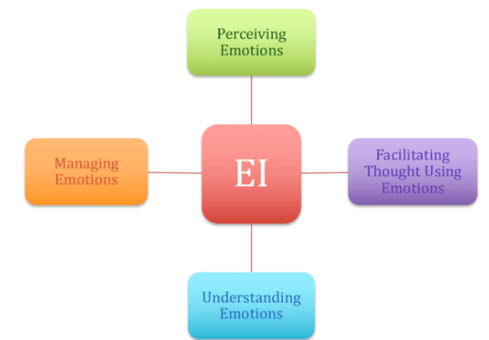
Figure 2 The ability model proposed by Mayer and Salovey
The ability model proposed by Mayer and Salovey has a better conceptual validity because it describes emotional intelligence as a type of intelligence and not a personality trait (Mayer and Salovey, 1997). Emotional intelligence based on ability has been found to forecast the quality of the decisions made and the performance of emotional labours especially in those jobs that involve making judgements amidst pressure (Mayer, Salovey and Caruso, 2004). Although the model has this strength, its abstract nature restricts its applicability to a line manager who wants to see behavioural change.

2.4 Application of Emotional Intelligence in Workplace Practice
When incorporated into organisational practices, emotional intelligence has a direct effect on leadership effectiveness, teamwork, and the well-being of the employees.

Key Workplace Applications and Measurable Outcomes Table
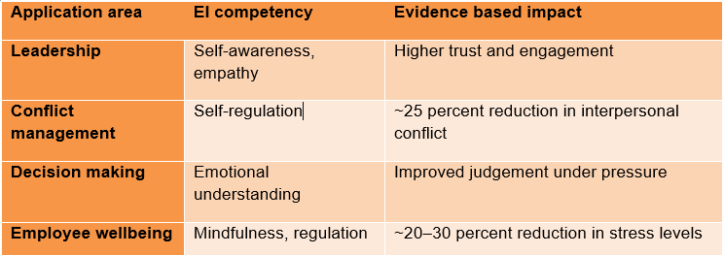
Leaders who are emotionally intelligent control the emotional reactions in a conflict and avoid the situation of escalation of emotions, and ensure psychological safety (Ashkanasy and Daus, 2005). Managers with the right emotional intelligence have lower interpersonal conflicts and greater levels of collaboration within their teams. The positive correlations also exist between emotional intelligence and job satisfaction, commitment, and task performance, with the effect size ranging between 0.23 and 0.35, and such a correlation is supported by meta-analytic evidence (Miao, Humphrey and Qian, 2017).
Mindfulness increases emotional intelligence through emotional awareness and self-regulation. Interventions based on mindfulness in the work environment have been associated with decreased burnout and better emotional regulation, especially in work environments that are highly stressful (Glomb et al., 2011; Good et al., 2016). Such results indicate that emotional intelligence is an enabler of performance and not a soft skill.

2.5. Limitations of Emotional Intelligence in Organisations.
Emotional intelligence as an idea has flaws when overemphasised despite its various advantages. Too much emphasis on empathy will deter positive confrontation and dilute accountability in performance. The results of emotional intelligence training are also not consistently applicable to all individuals, and this limits the ability to be consistent (Cherniss, 2010). Moreover, emotionally intelligent behaviour that lacks ethical control can be applied in a manipulative way, especially in leadership. These shortcomings underscore the need to strike a balance between emotional intelligence and objective performance management and organisational controls.

3. Differences in Generational Workplace.

3.1 Generational Profiles in Organisation.
The contemporary organisations tend to hire the representatives of Generation X, Generation Y (Millennials), and Generation z, who are conditioned by different social, economic, and technological circumstances. The contexts of these generations affect the approaches to work, style of communication, expression of emotions and leadership expectations (Parry and Urwin, 2011).
The employees of the generation Y are usually described by their independence, flexibility and inclination towards autonomy, as they have gone through economic uncertainty and reorganisation of their organisations in the past. The employees of generation Y joined the labor market at the time when the technological development is accelerating and are likely to appreciate feedback, teamwork, and meaningful work. Digital natives, the so-called generation Z, are highly technologically fluent, flexible, and more mindful (Twenge, 2010).
Although generational categories offer practical analytical models, it is essential to note that individual differences are also huge. There are meta analytic indications that the variance in work attitudes between generations is small to moderate, with no indication that the generation has no effect on behaviour but only partially defines it (Costanza et al., 2012). Hence, managers should not stereotype but they should be sensitive to the generational tendencies that can impact on the practice of emotional intelligence.

3.2 Emotional Intelligence and Generational Characteristics.
The generational dynamics play in affecting the manner in which emotional intelligence is applied, perceived, and appreciated at the workplace. Such distinctions are the most manifest in the regulation of emotions, the patterns of communication, and the reaction to authority.

Comparative Analysis of Generational EI Tendencies
Dimension | Generation X | Generation Y | Generation Z
Emotional regulation | High self-regulation | Emotionally expressive | Developing regulation skills
Communication style | Direct, low frequency | Feedback oriented | Digital, rapid
Attitude to authority | Respect autonomy | Expect coaching | Expect inclusivity
Emotional expectations | Professional distance | Emotional support | Psychological safety
Employees in generation X generally show high levels of emotional self-regulation and resiliency, which have been gained by exposure to organisational change and low levels of emotional support systems at a young age in their careers. Nonetheless, this could lower the emotional expressiveness and empathy in teamwork settings (Parry and Urwin, 2011).
Employees belonging to generation Y are more emotionally aware and open, and place a high value on empathy, feedback, and emotionally supportive leaders. Studies have shown that the emotional recognition and meaningful work are of great importance to the Millennials compared to the previous generations (Twenge, 2010). Although it promotes empathy and teamwork, it can also make people more sensitive to criticism and emotional tension.
The employee of Generation Z comes to the working place already highly conscious of mental health and emotional comfort but with little experience of how to cope with emotions at work. The research indicates that young employees have a more emotional sensitivity but less confidence in conflict resolution, which implies the necessity of developing emotional intelligence (Costanza et al., 2012).

3.3 Generational Differences in Emotional Intelligence Practice.
In organisations, emotional intelligence practice is threatened and opportunities are realised by generational diversity.
Positive Impacts
- Various emotional attitudes promote innovativeness and problem solving.
- Cross generational mentoring is helpful in emotional learning.
- Emotional regulation brings balance to the team.
Negative Impacts
- Incongruent communication styles augment emotional misunderstanding.
- Conflict may arise due to the difference in emotional expectations.
- Lack of perceived inter-generational empathy lowers trust.
Meta analytic results indicate that uncontrolled generational differences may lead to the heightened interpersonal tension, whereas emotionally intelligent leadership may decimate these threats (Costanza et al., 2012). Such managers (emotionally intelligent) who are able to adjust communication and emotional reactions between generations attain increased team cohesion and reduced levels of conflict.
Most importantly the generational diversity enhances the significance of emotional intelligence instead of devaluing it. In cases of low emotional intelligence, conflict is intensified by the generational differences. In cases where emotional intelligence is great, generational diversity is used as a performance advantage.

3.4 Managerial Implications on Recruitment and Workforce Management.
To manage generational diversity, managers need to incorporate the emotional intelligence awareness into people management and recruitment practices.

Recruitment Considerations
Recruitment focus | Emotional intelligence relevance
Behavioural interviews | Assess self-awareness and regulation
Situational judgement tests | Evaluate emotional decision-making
Group assessments | Observe empathy and social skills
Emotional intelligence competencies should be evaluated in the recruitment process as opposed to the generational assumptions applied in recruitment. The studies have shown that emotionally intelligent individuals have a better predictive ability of workplace adaptability than age or the generation (Miao, Humphrey and Qian, 2017).
Workforce Management
The managers ought to embrace adaptive emotional intelligence approaches, among them being
- The personalised communicative styles.
- Cross generational mentoring.
- Emotional regulation support of mindfulness-based.
Such strategies will decrease emotional tension and enhance retention, engagement, and performance by generational cohort.

4. CONCLUSION AND RECOMMENDATIONS

4.1 Conclusion
This report has examined the emotional intelligence and mindfulness in the modern work environment critically with reference to employee behaviour, effective leadership, and generational diversity. The results indicate that emotional intelligence is one of the fundamental organisational capabilities, which improves decision making, conflict management, teamwork, and employee wellbeing. Analysis of existing emotional intelligence models reveals that, whereas conceptually, the ability-based approaches offer clarity, mixed models offer greater practicality in application at the workplace. The discussion also reveals that generational diversity puts more emotional pressure on the job, as the differences in communication styles and emotional expectations may either reinforce teamwork or raise the level of conflict. Importantly, the differences between the generations do not define the performance results; on the contrary, the leadership based on emotional intelligence can influence the effectiveness of diversity management. On the whole, the strategic use of emotional intelligence and mindfulness as sustainability enablers proves to be viable in terms of critical application, systematic growth, and balanced with obvious performance benchmarks and corporate responsibility.

4.2 Recommendations
1. Incorporate Emotional Intelligence in Leadership.
Self-awareness, self-regulation, and empathy are some of the emotional intelligence competencies that organisations should incorporate in leadership development programmes. It has been proven that emotionally intelligent leaders are better in terms of employee engagement and reduced interpersonal conflict, which directly correlates with team performance and retention (Goleman, 1998; Ashkanasy and Daus, 2005).
2. Incorporate Emotional Intelligence Testing in Hiring.
The process of recruitment and selection should also include behavioural interviews and situational judgement tests to measure emotional intelligence and not be based on generational assumptions. The studies have shown that emotional intelligence is more predictive of workplace adaptability, job satisfaction, and performance than age or generational category (Miao, Humphrey and Qian, 2017; Costanza et al., 2012).
3. Apply Mindfulness to aid in emotional control.
Mindfulness-based interventions are to be introduced to promote emotional awareness, ethical decision-making and stress management, especially in high-pressure jobs. There is empirical evidence that mindfulness enhances emotional control and minimises emotional fatigue in employees (Glomb et al., 2011; Good et al., 2016).
4. Manage Generational Diversity by Adapting Communication.
Adoptable communication and feedback strategies should be embraced by the managers depending on the emotional needs of the employees belonging to the Generation X, Y, and Z. It has also been found that emotion intelligent leadership can help to decrease the generation conflict and enhance team cohesion in the multigenerational workplaces (Parry and Urwin, 2011; Twenge, 2010).
5. Balance Emotional Intelligence Performance Accountability.
Introduction of emotional intelligence programs should be accompanied by proper performance management systems to avoid shirking of challenging decisions and make sure that organisations are accountable (Cherniss, 2010).

References
Ashkanasy, N.M. and Daus, C.S. (2005) ‘Rumors of the death of emotional intelligence in organizational behavior are vastly exaggerated’, Journal of Organizational Behavior, 26(4), pp. 441–452.
Cherniss, C. (2010) ‘Emotional intelligence: Toward clarification of a concept’, Industrial and Organizational Psychology, 3(2), pp. 110–126.
Costanza, D.P., Badger, J.M., Fraser, R.L., Severt, J.B. and Gade, P.A. (2012) ‘Generational differences in work-related attitudes: A meta-analysis’, Journal of Business and Psychology, 27(4), pp. 375–394.
Glomb, T.M., Duffy, M.K., Bono, J.E. and Yang, T. (2011) ‘Mindfulness at work’, Research in Personnel and Human Resources Management, 30, pp. 115–157.
Goleman, D. (1995) Emotional intelligence: Why it can matter more than IQ. New York: Bantam Books.
Goleman, D. (1998) Working with emotional intelligence. New York: Bantam Books.
Good, D.J., Lyddy, C.J., Glomb, T.M., Bono, J.E., Brown, K.W., Duffy, M.K., Baer, R.A. and Lazar, S.W. (2016) ‘Contemplating mindfulness at work’, Journal of Management, 42(1), pp. 114–142.
Mayer, J.D. and Salovey, P. (1997) ‘What is emotional intelligence?’, in Salovey, P. and Sluyter, D.J. (eds.) Emotional development and emotional intelligence: Educational implications. New York: Basic Books, pp. 3–31.
Mayer, J.D., Salovey, P. and Caruso, D.R. (2004) ‘Emotional intelligence: Theory, findings, and implications’, Psychological Inquiry, 15(3), pp. 197–215.
Miao, C., Humphrey, R.H. and Qian, S. (2017) ‘A meta-analysis of emotional intelligence and work attitudes’, Journal of Occupational and Organizational Psychology, 90(2), pp. 177–202.
Parry, E. and Urwin, P. (2011) ‘Generational differences in work values: A review of theory and evidence’, Journal of Management Psychology, 26(1), pp. 79–96.
Twenge, J.M. (2010) ‘A review of the empirical evidence on generational differences in work attitudes’, Journal of Business and Psychology, 25(2), pp. 201–210.

