BLOG POST – “THANKS POST PROCEDURE”

STUDENT: HORHOCEA CRISTIANA-MARA (ID 1604608)
module: MARKETING FUNDAMENTALS
LECTURER: Tanja nathan


113 years ago, in 1906, Alfred Nehemias, a banker from Hamburg, and August Eberstein, an engineer from Berlin, two men with inspiration, ingenuity, imagination and well-set goals have decided to make a step further in the new, modern century by creating the concept of the fountain pen as a writing instrument. Later on, the business has been taken over by Wilhelm Dziambor, Christian Lausen and Claus Johannes, who made the internationally successful company MONTBLANC happen and since then it has been making the finest quality products. And with the aid of our customers, we succeeded to reach the number of 449 stores all around the world. MONTBLANC took the lead of Minerva's Villeret manufacture in 2006, collaborating with its pioneering designers and engineers to create a new line of truly impressive eminent watchmaking and launching the brand into the upper echelons of fine watchmaking. Trusted to preserving the inveterate art of Swiss watchmaking at an extreme level, MONTBLANC watches are projected with infinite aesthetics and accuracy movements.
Our high-quality products are appreciated by a lot of people who became our devoted customers and we are delighted to always please them and make them happy by creating a wide range of the best watches, writing instruments, jewelry, leather goods etc. And we are also thankful for all the appreciation.

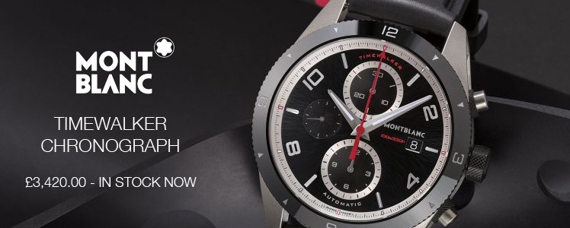


Therefore, in order to prove our gratitude for our customers love and appreciation, we are offering them a brand new VIP REWARDS PROGRAM, which is a Loyalty Program; that means that starting with the new 2019 year, we will be according them an annual discount on their anniversary. Our purpose is to give them the chance to get a 50% off discount on our limited edition TIMEWALKER CHRONOGRAPH, even if it is your own birthday or a friend’s, a relative’s or your partner’s birthday. You only have to prove it by sending us an email including the personal details and after that you will be given the voucher, but we can also send it via post mail; it is up to every customer’s choice.

Also, we will choose 10 lucky winners from those purchasing one of our Limited Edition watches to win a trip to the Mont Blanc (La Dame Blanche) mountains in France! Try your luck to be in the top 10 for the Mont Blanc challenge!

Furthermore, please do not hesitate to leave comments, reviews or ask questions! We are always here for you. Hopefully it will be in our customers’ minds that they are valued and appreciated!

Reflective Report

Student: Horhocea Cristiana-Mara

Module: Marketing Fundamentals

Lecturer: Tanja Nathan

The target group of my blog post was MONTBLANC, a well-known German brand of watches. My goal for this blog was to see things from the inside-out perspective, to see through customers’ eyes, to focus on their needs. The main idea of the Marketing Concept is to achieve organizational goals, determine the needs and wants to target markets and deliver the satisfiers more effectively and efficiently than the competitors, and also to listen to the customers, target, and be different or better. In order to achieve that, I have been very creative using visuals such as pictures and different fonts and colors, in order to attract the customers into my blog.
As the new marketing involves online, mobile and social media to engage customers, I have decided to use social media in order to obtain a creative blog which can attract customers easily, as a satisfied customer remains loyal and talks favorably about the company and its products. Keeping the customers interested is vital in a company, because a loyal customer spends more and stays around longer; it also makes good economic sense. Philip Kotler and Gary Armstrong said that its goal is to make the brand a meaningful part of consumers’ conversations and lives. (Kotler & Armstrong 2016)

References:
- Kotler, P., Armstrong, G. (2016). Principles of marketing. 16th edn.
- Montblanc (2019). History. Available at: https://www.montblanc.com/en-gb/home.html [Accessed on: 06th of January 2019]

