Cover page
UWTSD BIRMINGHAM CAMPUS
Leading and implementing workplace change
Module: BMSW6103
My name: SAJIDA BI
My id: 1810155
Lecturer name: Nauman Ali

Content page
Cover page: …………………………………………………………………….……..1
Content page: ………………………………………………………………………....2
Abstract:…………………………………………………...........................................5
Introduction:…………………………………………………………………………….5
Portfolio information:……………………………………...........................................6
Section 1………………………………………………………………………………...6
Situation analysis:……………………………………………………………………...6
Organisations current position:……………………………………………………….6
Environmental sustainability:………………………………………………………….6
Current actions taken by organisation in relation to scenario:………………….....7
Matalan business model canvas:……………………………………………………..7
SWOT analysis: ...………………………………………………………………………7
Pestle analysis: ..………………………………………………………………………..9
Porter’s 5 forces: ………………………………………………………………………..10
Section: 2: …………………………………………………………………………….....11
Stakeholders & Change: ……………………………………………………………....11
Stakeholder management: …………………………………………………………….11
Identify internal and external stakeholders: ………………………………………....11
P/I Matrix to place all identified stakeholders on matrix: …………………………...11
Importance of stakeholders in organisational change management: ……………12
Strategic change: ……………………………………………………………………….12
Identify the need for change: ………………………………………………………….13
Actions linked with strategic change conducted by the selected organisation:….13
Section 3: …………………………………………………………………………………13
Change management: ………………………………………………………………….13
What is change management: ………………………………………………………...13
Importance of change management approach in any organisation: ……………..13
Change curve model: …………………………………………………………………...14
Develop a change management plan including a model for change: …………….15
Identify the strategic fit option you want to consider: ………………………………..15
Consider using 8 step change plan: …………………………………………………..15
Issues related to strategic change in the organisation: ………………………..……17
Change administration: ………………………………………………………………….17
Importance of organisation design in change: ……………………………………….17
Leadership style: ……………………………………………………………………...….17
Identify different leadership styles: …………………………………………………….17
Section 4: ………………………………………………………………………………….18
Change management & organisation: ………………………………………………...18
Organisational Structure / Design……………………………………………………….18
Explain the organisational structure / design…………………………………………..19
McKinsey 7s model:..……………………………………………………………………..19
Consider applying it with your selected organisational context:……………………..19
Role of organisational development cube:……………………………………………..20
Organisational Culture:……………………………………………………………………20
Organisational learning:…………………………………………………………………...20
Role of culture in organisational learning:………………………………………………21
How the culture of selected organisations supporting to achieve the objectives:…21
Section 5:……………………………………………………………………………………22
Reflection:…………………………………………………………………………………...22
Insights based on the identified problem / scenario:………………………………......22
Organisational prospective:……………………………………………………………….22
What we have learnt:………………………………………………………………………22
What we can improve:……………………………………………………………………..22
Consultant prospective:……………………………………………………………………22
Current knowledge:………………………………………………………………………...22
New learning:……………………………………………………………………………….22
What can be improve:……………………………………………………………………..23
References:…………………………………………………………………………………23

Abstract:
To achieve success in a business it 1is 1highly 1vital 1for 1organisations 1to 1implement 1digital transformation by using the correct change management plan, considering covid19 which has increased the existing demand of this change, the companies are now focusing more on different ways and solutions which can help them improve their brand.
In regards to the company that I have chosen which is Matalan this company is successful and very well organised but still are unable to meet customers experience even in the presence of digital transformation, company needs to improve and implement some changes to their present digital transformation as to make their brand sustainable they really need to work hard to achieve their set target by using valid change management plan (Hayes, 2022), while considering relevant functional activities.
Introduction:
Matalan started its business in 1985 and it’s been over 30 years now and is still getting better, their mission 1has 1always 1remained 1the 1same 1to 1deliver 1outstanding 1quality 1and value 1for 1modern 1families. 1Matalan 1takes 1time 1to 1listen, 1understand 1and 1evolve 1to 1fit changing 1modern 1family 1needs, 112 1million 1UK 1families 1each 1year 1trust 1Matalan 1with 1their family 1budgets 1to 1provide 1the 1range, 1style, 1quality 1and 1value 1that 1enable 1them 1to 1run 1a happy 1family 1home, 1as 1a 1leading 1retailer 1ranging 1from 1womenswear 1and 1menswear 1to homeware 1and 1furniture 1they 1offer 1something 1for 1all, 1as 1of 1April 12019, 1Matalan 1has 1an impressive 230 1UK 1stores 1and 130 1International 1franchise 1stores 1within 1Europe 1and 1the Middle 1East, 1supported 1with 1a 1rapidly 1growing 1online 1channel, 1their 1locations, 1late 1night openings, 1convenient 1parking, 1'everything 1under 1one 1roof' 1offering 1and 1free 1click 1and collect 1service 1are 1just 1some 1of 1the 1reasons 1why 1their 1customers 1love 1shopping 1at Matalan
Although 1company 1has 1presence 1of 1digital 1transformation 1but 1they 1really 1need 1to 1improve their present digital transformation to make their brand sustainable as company doesn’t have good and organised delivery system, a lot of customers’ orders are getting late and sometime missing and when they receive their orders there are missing items which they have to report to either get refund or get delivered again, company need to implement some change management plan which will help them to improve their present digital transformation to meet customer experience (Paton, McCalman, 2008), also company have their website which is https://www.matalan.co.uk/ but still it’s not easy and friendly user so they also need to make it easy and simple to use for their customers, they also need to increase their return policy and method as I experienced some time if you return an item they issue a voucher to use next time instead of refunding using customers’ original payment method.
Portfolio information:
To fulfil customer experience it is highly vital for organisations to implement a useful change management 1plan 1which 1will 1help 1them 1to 1improve 1their 1brand 1by using digital transformation, considering the already existed need for this change and the pandemic situation which has made the need of this change even more demanding in organisations (Kalina, 2020), so due to this the companies need to be more alert when using a change management plan as by implementing the wrong plan they will not achieve their set targets which will not be beneficial for their organisation.
Section 1
Situation analysis:
- Organisations current position:
Matalan 1is 1a 1British 1homewares 1and 1fashion 1value 1retailer, 1founded 1in 11985 1by 1John Hargreaves, 1it 1mainly 1operates 1large 1stores 1in 1retail 1parks, 1with 1over 1200 1stores 1in 1the 1UK as 1well 1as 1a 1number 1of 1international 1franchises 1in 1the 1Middle 1East 1and 1Europe.
Matalan 1uses 1three 1price 1tiers 1for 1its 1products 1lowest, 1better 1and 1the 1best, 1meaning 1it competes with other large supermarkets, although company offer great services to meet customer experience, they also have digital transformation implemented but still they need to improve their services such as fast delivery method, website improvement and refund strategies and to keep their business sustainable they really need to 1improve 1their 1present digital 1transformation 1(Fletcher, 1Griffiths, 12020), 1as 1this 1will 1also 1help 1them 1to 1meet additional need for this created by present pandemic situation.
- Environmental sustainability:
At 1Matalan 1they 1recognise 1their 1responsibility 1to 1minimise 1the 1potential 1of 1causing 1harm 1to the 1environment 1and 1they 1strive 1to 1sustain 1and 1improve 1the 1environment 1through 1their careful 1consideration 1of 1design, 1selection 1of 1materials 1and 1operational 1procedures, 1they continually 1communicate 1with 1their 1customers 1encouraging 1them 1to 1recycle 1old 1items, 1from clothing 1to 1electrical 1items 1and 1batteries, 1company 1regularly 1review 1their 1policies 1and procedures 1to 1make 1sure 1that 1they 1maintain 1an 1appropriate 1level 1of 1environmental awareness 1and 1responsibility.
- Current actions taken by organisation in relation to scenario:
Regarding the situation in covid19 pandemic and considering the past and present demand for digital transformation improvement Matalan has made some changes the way they operate by implementing safety features for customers but considering all this the company still needs to improve their customer experience as their present situation is unsatisfactory to meet customer needs so they definitely need to implement some changes which can help their business to be achieve sustainability.
- Matalan business model canvas:
Key partners  Suppliers  Textile producers  Manufacturers from abroad  Logistics | Key activities  Design  Manufacturing  Logistics  Orders  Customer service  Marketing | Value proposition  Discounts  Value for money |  | Customer relationships  Convenience  Rewards  Loyalty card | Customer segments  Looking for best deals  Families  Massive customers
 | Key resources  Selling at low prices, 230 stores  Over 13000 employees |  |  | Channels  Matalan.com  Social networks  YouTube
Cost structure  Martials, Design, Manufacturing, Employee, IT |  |  | Revenue streams  Retail sale, Online sale

- SWOT analysis:
Due to the present demand and current situation the company has gone through a lot of problems so to improve this they need to use swot analysis which will give them an idea of the places that they further need to improve, this will also help them to see their position before implementing new changes in their organisation in their company (Leigh, 2009).

Strength:
- The 1company 1operates 1through 1over 1190 1stores, 1reducing 1the 1risk 1of 1not 1selling.
- The 1firm 1has 1an 1effective 1selling 1strategy 1which 1is 1detrimental 1in 1guiding 1the 1high rate 1of 1product 1turnover.
- Matalan 1has 1an 1attractive 1competitive 1pricing 1policy 1by 1using 1cost-effectiveness and flexibility 1in 1operations.
Weakness:
- Matalan’s delivery system is not good to meet customer experience.
- They need to change their refund policy.
- Website need to be improved as its not friendly user.
- The firm does not focus on innovation.
- Matalan 1has 1faulty 1warehousing 1facilities, 1which 1have 1led 1to 1a 1higher 1cost 1of production.
Opportunities:
- A 1newer 1wider 1consumer 1base 1is 1under 1the 1target 1audience 1of 1Matalan 1which 1can be 1used 1to 1boost 1the 1sales 1of 1the 1company.
- The 1effective 1BI 1has 1given 1Matalan 1a 1competitive 1advantage 1over 1its 1rivals 1which can 1be 1used 1to 1retain 1old 1consumers 1and 1even 1attract 1new 1ones.
- Strategies 1and 1marketing 1schemes 1developed 1by 1the 1company 1to 1improve 1its online 1medium 1are 1adequate 1and 1can 1improve 1the 1performance 1of 1Matalan.
Threats:
- Rivals 1like 1Zara, 1H&M, 1and 1Gap 1can 1give 1a 1high 1level 1of 1competition 1to 1Matalan.
- The 1pandemic 1and 1lockdowns 1have 1interrupted 1the 1selling 1and 1production 1process of 1Matalan.
- A 1hike 1in 1the 1cost 1of 1production 1due 1to 1the 1rising 1costs 1of 1labours 1and 1raw materials 1has 1lowered 1the 1profitability 1of 1Matalan.
- The 1inappropriate 1customer 1service 1provided 1by 1the 1brand 1has 1given 1a 1competitive advantage 1to 1its 1rivals.

- External environment analysis:
Considering a lot of competition Matalan is still running smoothly and making money as the company believes that to become successful you have to focus on your brand as this will make your business and product sustainable (Voiculet et al, 2010).
- Pestle analysis:
By using pestle analysis the organisation will know which direction they need to move on (Perera, 2017), and also through this analysis Matalan will be able to determine the brand position, targets and risks. To improve their weaknesses the company needs to focus more on social and technological factors instead of other factors involved.
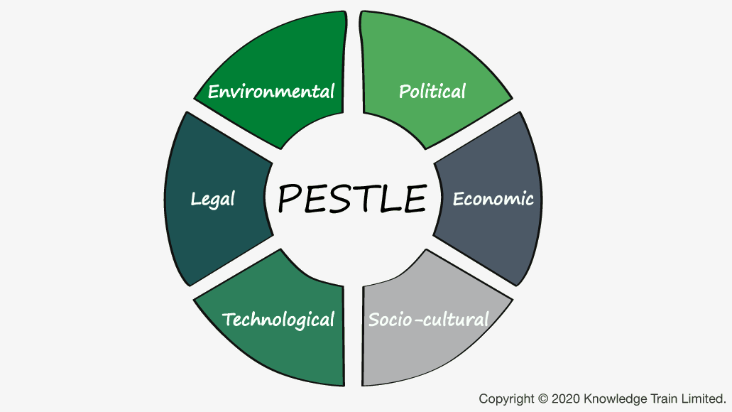
Social:
- Supporting 1communities 1and 1charities 1is 1important 1to 1Matalan.
- Matalan 1wants 1to 1make 1a 1difference 1to 1people’s 1lives 1and 1give 1something 1back.
- The 1Matalan 1retailing 1is 1highly 1affected 1by 1social 1trends 1like 1fast 1fashion 1and sustainability.
- Social 1media 1platforms 1and 1the 1actions 1of 1various 1influencers 1and 1celebrities 1also alter 1the 1sales 1and 1brand 1image 1of 1Matalan.
Organisation 1need 1to 1mix 1with 1society 1to 1make 1them 1feel 1as 1they 1are 1part 1of 1them 1by understand 1and 1observing 1customer 1needs 1through 1customer 1feedback 1as 1this 1will 1help them 1to 1make 1their 1business 1more 1presentable 1in 1society.
Technological:
- The 1introduction 1of 1business 1intelligence 1in 1the 1strategies 1and 1other 1technological advancements 1has 1Improved 1Matalan’s 1operations.
- Attention 1to 1media 1technology 1has 1also 1improved 1the 1brand’s 1overall 1performance.
- The 1digitalisation 1of 1transactions 1has 1helped 1vividly 1in 1data 1analytics.
- Introduction 1of 1advanced 1machinery 1in 1the 1warehousing 1and 1distribution 1of merchandise 1has 1improved 1the 1performance 1of 1the 1brand.
- Artificial 1intelligence 1in 1the 1retail 1industry 1of 1UK 1has 1been 1implemented 1well 1leading to 1an 1increase 1in 1efficiency 1of 1the 1operations.
Considering all above features organisation still need to improve digital transformation by improving website, delivery process and refund policy as this will increase their customer satisfaction.
- Porter’s 5 forces:
Most organisations use porters 5 forces to analyse the industries weaknesses and strengths, considering Matalan they need to 1use 1this 1model 1to 1analyse 1the 1market 1potential 1of all the other players in the market as this will give them the opportunity to know how to implement new changes in the organisation to make their business more sustainable. According to Michael porter there are 5 forces which can help organisations to understand their positions in the competitive market (Alrawashdeh, 2013), but 1I 1will 1be 1considering 12 1of 1them 1which are 1more 1relevant 1to Matalan.
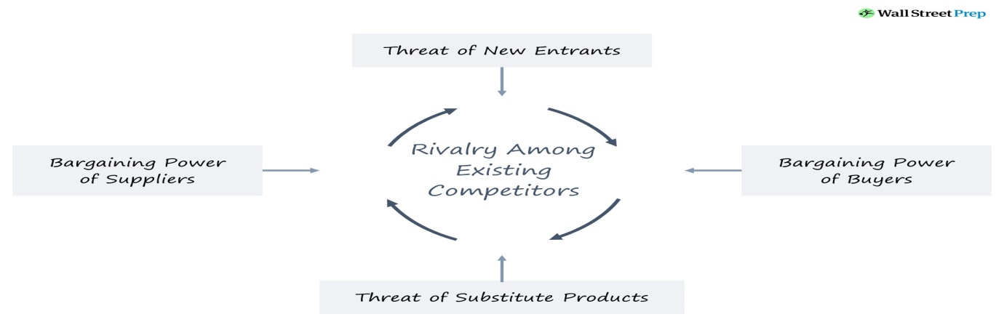
The threat of substitute:
Matalan experiences the moderate threat of substitution because of the 1low 1risks 1posed 1by existing 1retailers 1with 1low 1prices, 1the 1existing 1retailers 1are 1never 1called 1for 1a 1substitute (Arshed, and Pancholi, 2016), the Company, for example, may need to supply a product that is automatically important for a process, where the customers will substitute by outsourcing it, a cheap and easy substitution weakens the position of then company and threatens its profits so they need to make their product different and better from other retailers.
The threat of new entry:
The threat to Matalan Company is low, resulting from the high cost of establishing the company in the region, the risk 1of 1new 1entry 1is 1affected 1by 1people’s 1ability 1to 1enter 1into 1the company's 1market, 1strong 1barriers 1to 1the 1new 1entry 1prevent 1the 1rivals 1and 1maintain 1the position 1and 1power 1of 1the 1company so they need to implement and improve their present digital transformation as this will improve their customer experience and this will also decrease threats of new entrants.
Section 2
Stakeholders & Change:
- Stakeholder management:
By using stakeholder process you can monitor, organise and improve your relationship with your stakeholders, considering Matalan they need to mix with stakeholders so they can more clearly understand their needs and find a better way to implement new change and its effect on stakeholders.
- Identify internal and external stakeholders:
Stakeholders can be either internal or external of business or organisation, considering Matalan’s 1Internal stakeholders are people whose 1interest 1in 1the 1company 1comes 1through 1a direct relationship, such as employment, ownership, or investment 1and on the other hand external stakeholders don’t show direct interest or they don’t work direct with the organisation but and change within the company can put impact on them, these are suppliers, creditors, manufacturers, designers, other suppliers, logistics etc.
P/I Matrix to place all identified stakeholders on matrix:
To implement a new change and to make this successful Matalan need to use power interest matrix tool as by using this tool the organisation can find out how to handle different stake holders (Slabá, 2014), this is a very beneficial tool because this will give you knowledge and understanding to see who has high or low power and also who has high and low interest in the organisation.
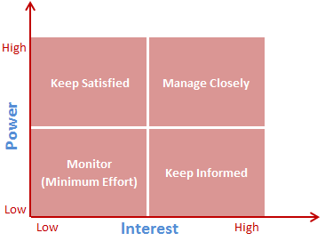
Considering Matalan there is different kind of stakeholders.
- High 1power 1high 1interest:
- High 1power 1low 1interest:
- Low 1power 1high 1interest:
- Low 1power 1low 1interest:

- Importance of stakeholders in organisational change management:
Stakeholders 1are 1important 1for 1a 1number 1of 1reasons, 1for 1internal 1stakeholders, 1they 1are important 1because 1the 1business’s 1operations 1rely 1on 1their 1ability 1to 1work 1together 1toward the 1business’s 1goals 1whereas 1external 1stakeholders 1on 1the 1other 1hand 1can 1affect 1the business 1indirectly, 1for 1instance, 1customers 1can 1change 1their 1buying 1habits, 1suppliers 1can change 1their 1manufacturing 1and 1distribution 1practices, 1and 1governments 1can 1modify 1laws and 1regulations, 1ultimately 1managing 1relationships 1with 1internal 1and 1external 1stakeholders are 1key 1to 1Matalan’s 1long 1term 1success.
- Strategic 1change:
Strategic 1change 1is 1the 1process 1of 1managing 1change 1in 1an 1organised 1way 1in 1order 1to meet 1organisational 1goals, 1objectives, 1and 1missions 1(Quiny, 12011), 1considering 1Matalan’s present 1situation 1changes 1are 1necessary 1to 1continue 1to 1thrive 1and 1meet 1and 1exceed 1the competition 1of 1industry 1competitors.
- Identify the need for change:
In my opinion Matalan need to implement change to meet customer needs, although the company does have digital presence but their delivery system is very poor and is lacking customer satisfaction, their website is very hard to understand and a lot of times the stock is not updated it shows in stock but when your come to checkout so many items show unavailable therefore the time is wasted and also this leads to customer dissatisfaction which is not good for the company’s reputation and also for their success (Vukmir, 2006), Matalan also need to improve their return policy because rather than giving refund vouchers they should give the original refund back to customers so they can use their money elsewhere and not just wait to find something in that store as they sometimes need money to use in other places to buy other products. This company needs a strong change management plan.
- Actions linked with strategic change conducted by the selected organisation:
To meet customer experience Matalan need to implement a valid change management plan which can support them in improving their present digital transformation, this management plan will help the organisation to improve their website, refund policy and delivery management, by doing all these things Matalan will build its way to success and be sustainable, by doing these things this will make them different from other organisation which will help attract more business.
Section 3
Change management:
- What is change management:
To improve Matalan’s digital transformation they need a good change management plan as this will make their business sustainable, as change 1management 1is 1a 1broad 1term 1used 1to define 1various 1ways 1in 1which 1an 1organisation 1prepares 1and 1implements 1change, 1most change 1management 1implementations 1focus 1on 1how 1stakeholders 1accept 1and 1adapt 1to 1a new 1way 1of 1doing 1things, 1whether 1the 1change 1is 1simple 1or 1complex, 1the 1primary 1aim 1is 1to ensure 1the 1implementation 1moves 1the 1organisation 1closer 1to 1its 1objectives.
- Importance 1of 1change 1management approach in any organisation:
Change management plays an important role in your organisation success, it is highly vital to consider and implement this correctly in both minor and major adjustments in the workplace (Lee, Lee, 2004), change 1management 1ensures 1that 1your 1employees 1understand 1their 1new responsibilities 1and 1can 1perform 1tasks 1efficiently, 1change 1management 1also 1helps 1your business 1as 1a 1whole 1remain 1viable 1due 1to 1its 1ability 1to 1grow 1and 1adapt 1to 1the 1current trends 1of 1the 1market.
- Change 1curve 1model:
The 1change 1curve 1helps 1to 1explain 1the 1impact 1of 1change, 1both 1on 1individuals 1and organisations 1as 1by 1predicting 1the 1likely 1responses 1to 1change 1Matalan 1can 1accelerate development 1and 1provide 1stakeholders 1with 1timely 1help 1and 1support 1so 1choosing 1the 1right change 1management 1model 1might 1seem 1overwhelming 1at 1first, 1but 1using 1a 1solid framework 1to 1deploy 1your 1changes 1is 1crucial 1to 1a 1business’s 1successful development (Wright, 2016), at Matalan this model will be helping the whole organisation to understand the impact of change on stakeholders.
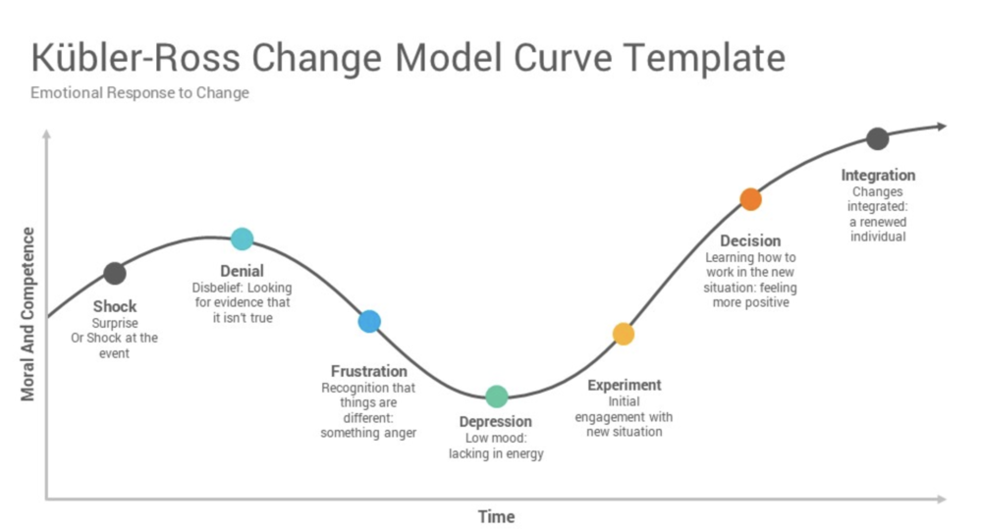
As 1defined 1by 1Elisabeth 1Kubler 1Ross, 1the 1change 1curve 1recognizes 1six 1stages 1in 1our reactions 1to 1change 1which 1are 1as 1below:
Shock 1& 1Denial:
People's 1first 1responses 1are 1often 1shock 1and 1denial, 1so 1it's 1vital 1to 1keep 1them 1fully informed 1about 1what's 1going 1on.
Anger:
Anger 1and 1fear 1often 1come 1next. 1At 1this 1stage, 1handle 1all 1the 1emotions 1involved 1with sensitivity 1and 1care.
Bargaining:
At work, this might mean that people adopt some parts of a new strategy but don’t really engage with the change as a whole.
Depression:
In this stage stakeholders feels under depression due to the implementation of change in their organisation.
Acceptance:
People 1gradually 1accept 1their 1new 1situation, 1but 1they'll 1still 1need 1time 1to 1get 1used 1to 1it.
Finally, 1when 1the 1people 1are 1fully 1committed 1to 1the 1changes, 1help 1them 1to 1celebrate 1their success.
- Develop 1a 1change 1management 1plan including a model for change:
It is highly vital for organisations to implement a correct change management plan because this will improve sustainability and the image of their brand so Matalan need to be sure to consider the right and best matching plan according to their needs, there are different plan options but I would suggest strategic fit option.
- Identify the strategic fit option you want to consider:
Considering varies options Matalan need to consider the strategic fit option because it is highly important for organisations to understand what impact the change will have on their organisation, as this strategy will not only affect an individual but impact on all of the stakeholders as well.
- Consider using 8 step change plan:
There are numerous models for managing a change process but I will be considering John Kotter's Change Model, this model help and advocates the organisations to lead employees to adapt the change through 1eight 1critical 1steps 1(Coutts, 12011), 1the 1eight 1steps 1include:
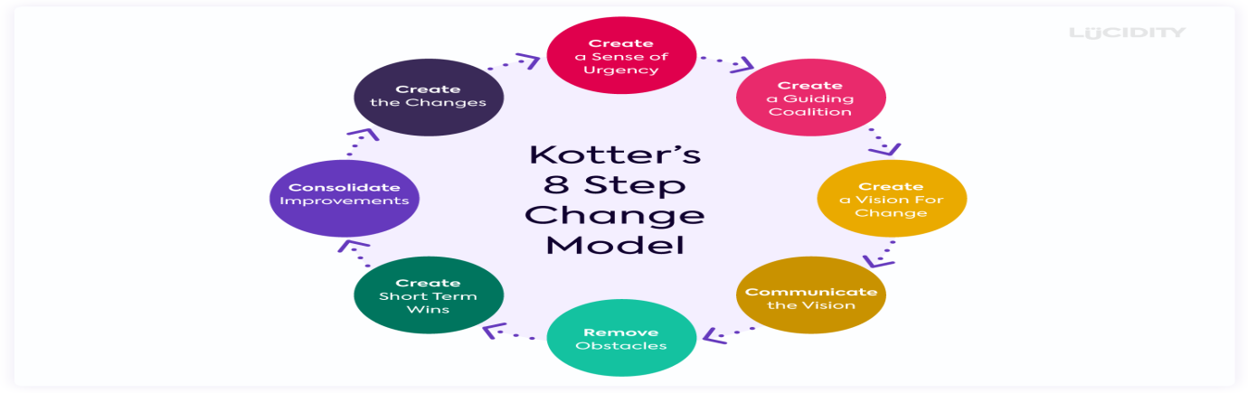
Create a sense of urgency:
In order for the change to happen, it should be approved by the whole company, management have to create 1a 1sense 1of 1urgency 1in 1order 1for 1them 1to 1promote 1the 1need 1for change to 1the 1company, so creating a sense of urgency can help Matalan move to make the plan into action.
Form a powerful coalition:
In this part Matalan need to evaluate or assess the stakeholders who understood the situation about the company status, in this phase management will be creating or forming a team of quality employees that can help them resolve the company issue.
Create a vision for change:
In this phase, Matalan will be making a clear vision for the team and they have to make them understand the main purpose of the change they're doing for the company, this might be difficult but they have to make them realize and understand the vision that they want for them and the company.
Communicate the vision:
In this step, the vision will be put into action, It is the step where management will take action for the completion or success of the vision and this will increase the chance to encourage and get support from the team.
Remove obstacles:
In this phase Matalan will be removing all barriers and conflicts to make their company successful, management will be evaluating or assess first all the barriers, the first step is to identify the barriers and know how it hinders the progress of the company and it has to be resolve right away so management will empower stakeholders by educating them about the situation, mentoring and training them.
Create short term wins:
In this stage Management giving their stakeholders the taste of success by giving them short rewards even if success in your company as a whole doesn't happen yet so by doing this they are motivating their employees to strive harder with their work and if they see that their job is attainable they don't feel pressured and this will result of them being motivated to do their jobs.
Build on the change:
It stated that change is a slow and continuous process for any company and in any aspects so in this phase management is setting the momentum, they are going to take advantage of the moment while their employees are motivated so management has to encourage them more by providing benefits and rewarding them for their hard work.
Anchor the changes in corporate culture:
In this phase Matalan will now make the change as part of the system in the company, It should be part of the culture that the company implements and to make the vision and the change lasts, it has to be incorporated to company's system.
• Issues related to strategic change in the organisation:
Implementing change in your organisation is very complicated process so Matalan’s management has to go through different aspects to make this change sustainable and successful, so when considering any change Matalan need to consider stakeholders culture, attitude, knowledge, motivation, sponsorship, support etc.
- Change administration:
To make their business successful Matalan need to use a perfect management plan which will help them to handle all the issues they will face after implementing any change, so its management responsibility that they create such atmosphere where all stakeholders feel comfortable and adjust the change easily.
- Importance of organisation design in change:
In implementing change organisational structure plays an important role as if your organisation doesn’t have proper design or structure then your company won’t reach success, so for It is highly vital for Matalan management to make sure when implementing any change in their organisation they also consider organisational design too as choosing wrong option can lead company to lose their business sustainability in the market.
- Leadership style
To become successful it is very important to have a proper leader who is leading the team of the company in a better and efficient way as leadership 1is 1the 1ability 1of 1an 1individual 1or 1a group 1of 1individuals 1to 1influence 1and 1guide 1followers 1or 1other 1members 1of 1an 1organisation.
- Identify 1different 1leadership 1styles:
Considering 1styles 1of 1leadership, 1there 1are 1many 1which 1are 1completely 1different 1from 1one another 1but 1keeping 1in 1mind 1that 1every 1style 1is 1beneficial 1in 1the 1company 1and 1organisation in 1its 1own 1way 1(Sethuraman, 1Suresh, 12014), 1these 1styles 1can 1vary 1but 1cannot 1be 1replaced with 1each 1other, 1according 1to 1lewin, 1lippit 1and 1white 1there 1are 13 1main 1leadership 1styles which 1most 1leaders 1tend 1to 1use 1while 1present 1in 1their 1work 1settings 1(Lewin 1et 1al.,1939) these 1styles 1are 1mentioned 1below.
Authoritarian 1leadership 1style:
In 1this 1above 1style 1the 1leaders 1make 1all 1the 1decisions 1by 1themselves 1and 1 1just 1give 1orders on 1how 1they 1want 1things 1to 1be 1done, 1 1these 1leaders 1are 1strong 1and 1adamant 1on 1what they 1want, 1they 1make 1sure 1things 1are 1done 1in 1their 1way 1and 1are 1done 1to 1the 1highest standard.
Democratic 1leadership 1style:
Democratic 1styled 1leader’s, 1are 1completely 1opposite 1to 1authoritarian 1styled 1leaders 1due 1to the 1fact 1that 1they 1are 1more 1like 1people 1orientated 1leaders 1as 1they 1care 1more 1about 1the people’s 1feelings 1emotions 1and 1problems 1rather 1than 1work 1or 1their 1way, 1these 1leaders 1put people 1first 1and 1themselves 1second 1and 1make 1sure 1that 1every 1person 1has 1a 1voice, 1they also 1like 1making 1a 1good 1and 1positive 1atmosphere 1for 1their 1employees 1and 1followers.
Laissez-faire 1style:
These 1leaders 1like 1to 1leave 1all 1the 1freedom 1to 1their 1employees 1and 1give 1them 1the 1freedom to 1do 1all 1their 1tasks 1and 1jobs 1the 1way 1they 1want 1to 1do 1it 1however 1they 1please, 1they 1also like 1to 1leave 1their 1employees 1to 1decide 1how 1and 1when 1they 1want 1to 1do 1their 1work 1and don’t 1give 1any 1pressure 1tor 1deadlines 1to 1their 1staff.
By comparing all above leadership styles democratic leadership style is meeting Matalan leadership style as Matalan higher management always look after their staff and make sure they meet all employee needs, so when it comes to implementing any change, Matalan top management make sure they discuss this change with whole organisation’s employees so this gives opportunity to this organisation to understand the outcome behaviour of employees or stakeholders.
Section 4
Change management & organisation:
Organisational Structure / Design:
- Explain the organisational structure / design:
Organisation design or structure is a fundamental part of what makes an organisation successful, it relates 1to 1work 1roles 1with 1in 1an 1organisation 1and 1how 1authorities 1relate 1to and 1work 1one 1another 1(Nelson 1& 1Quick, 12011). 1It 1shows 1the 1relationship 1pattern 1between various 1organisational 1roles 1and 1leadership 1structures, In terms of organisational design, here are mainly seven types of organisational designs which are used by different organisations but considering Matalan they use matrix structure which is very helpful to organise changes within an organisation so by using this structure they can meet stakeholders needs.
- Model / Mckinsey 7s:
McKinsey 17s 1model 1is 1a 1tool 1that 1analyses 1firm’s 1organisational 1design 1by 1looking 1at 17 key internal 1elements: 1strategy, 1structure, 1systems, 1shared 1values, 1style, 1staff 1and 1skills, 1in order 1to 1identify 1if 1they 1are 1effectively 1aligned 1and 1allow 1organisation 1to 1achieve 1its objectives (Channon, Caldart, 2015), considering Matalan this model can help them to reach their goal by aligning all 7 elopements of this model together 1to 1achieve 1effectiveness 1in their 1organisation, 1the 1key 1point 1of 1the 1model 1is 1that 1all 1the 1seven 1areas 1are interconnected 1and 1a 1change 1in 1one 1area 1requires 1change 1in 1the 1rest 1of 1a 1firm 1for 1it 1to function.
Elements to consider can be seen in below:
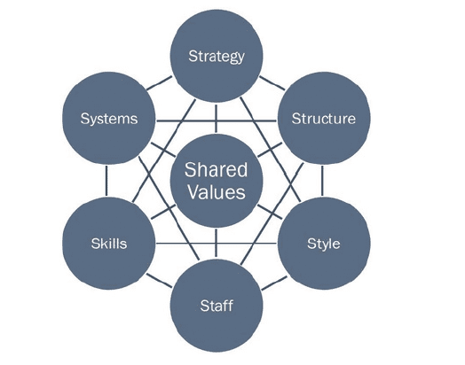
- Consider applying it with your selected organisational context:
The 1model 1can 1be 1applied 1to 1many 1situations 1and 1is 1a 1valuable 1tool 1when 1organisational design 1is 1at 1question, considering Matalan to implement new change or improve their present digital transformation this model can be very affective as most 1common 1uses 1of 1the framework 1are:
To 1facilitate 1organisational 1change:
To 1help 1implement 1new 1strategy:
To 1identify 1how 1each 1area 1may 1change 1in 1a 1future:
To 1facilitate 1the 1merger 1of 1organisations:
• Role 1of 1organisational development cube:
This model can also help Matalan to achieve their set target as to be successful and sustainable it is highly vital that organisation flow below steps correctly.
Entering:
Diagnose:
Data collection:
Feedback:
Confirmation:
Planning:
Change system:
Team building:
Evolution:
- Organisational Culture:
Organisation 1culture 1relates 1to 1the 1values 1of 1the 1organisation 1that 1are 1shared 1with 1the employees 1(Janicijevic, 12013), 1 1In 1other 1words 1culture 1is 1created 1by 1the 1founders 1of 1the organisations 1but 1stands 1for 1the 1thoughts 1and 1beliefs 1of 1every 1employee 1that 1makes 1up the 1organisation 1and 1incorporates 1values 1and 1actions 1that 1contribute 1to 1the 1overall 1social environment 1of 1an 1organisation,
• Use 1the 1organisational 1learning:
Matalan’s management can use organisation learning progress to learn new skills and knowledge as this can help their employees to understand the change in a clear way as by using this method they can reflect on their problems and find a new way to make their business sustainable. When in due course the organisation need to consider this process clearly because by following this process incorrectly it can lead to unsuccessful.
• Role of culture in organisational learning:
Organisational culture implies the integration of the various values, experiences, and concepts of an organisation that enables them to create a valid path to follow for the achievement of the organisation's set goals and objectives. In Matalan culture plays a significant role in guiding and directing all the employees within the organisation towards an excellent direction that will help develop and nature the required culture for the overall success of the organisation.
• How the culture of selected organisations supporting to achieve the objectives:
Organisational culture helps in different ways to the organisation 1to 1achieve 1their 1goal 1and to 1formulate 1strategies 1and 1propaganda 1so 1that 1proper 1and 1effective 1decision 1making process 1should 1work 1in 1favour 1of 1the 1organisation 1(Iljins 1et 1al, 12015), 1the 1organisation culture 1directly 1put 1effects 1on 1organisational 1policies 1like 1structure 1of 1the 1organisation 1, team 1behaviour, 1group 1psychology, 1working 1condition 1in 1the 1organisation 1, 1motivating 1the employees 1or 1stakeholders, 1job 1satisfaction 1, 1organisational 1values 1and 1effective 1control over 1management, 1so 1to 1make 1this 1change 1sustainable 1Matalan 1need 1to 1consider following points.
Communicate 1well:
Knowing 1how 1to 1communicate 1well 1is 1the 1best 1way 1to 1improve 1organisational 1culture 1and achieve 1objectives 1as 1miscommunication 1is 1the 1main 1reason 1people 1become 1unsatisfied with 1their 1jobs 1and 1start 1looking 1for 1other 1opportunities.
Listen 1to 1concerns 1and 1ideas:
Providing 1your 1employees 1with 1a 1public 1or 1anonymous 1platform 1that 1makes 1it 1easy 1for them 1to 1share 1their 1opinions, 1encourage 1one 1to 1one 1meetings 1with 1team 1members 1to allow them 1the 1chance 1to 1speak 1openly.
Provide 1feedback:
If 1you 1notice 1that 1a 1certain 1aspect 1of 1the 1company 1needs 1improvement, 1take 1time 1to provide 1feedback 1regarding 1the 1issue 1and 1encourage 1others 1to 1do 1the 1same.
Be 1consistent:
Being 1consistent 1helps 1people 1experience 1a 1sense 1of 1stability, once 1a 1company's organisational 1structure 1is 1in 1place, 1do 1your 1best 1to 1maintain 1processes 1and 1procedures, treat 1everyone 1in 1the 1same 1professional 1manner 1and 1avoid 1giving 1preferential 1treatment.
Section 15
Reflection 1/ 1Insights 1based 1on 1the 1identified 1problem:
Organisational 1prospective:
- What 1we 1have 1learnt:
In any organisation customers are the main key to success so to meet customer experience it is highly vital to meet customer demands and implement all the required changes to make your business sustainable (Bansal, DesJardine, 2014), Matalan will be extra careful when considering these changes because any un suitable change can put a negative impact on the organisation so they will make sure to use correct change management plan, tools, methods and theories to make this change successful.
- What we can improve:
To achieve their goals, meet customer experience and to make their business sustainable Matalan will be implementing and improving their present digital transformation in their organisation because their present digital transformation is not meeting customer expectations so organisation will be using a change management plan to improve their their stock management, delivery process, refund policy and website issues, and once all these will be sorted company can run towards the way of success.
Consultant prospective:
- Current knowledge:
As company is currently not 1meeting 1customer 1needs 1so 1they 1really 1need 1to 1implement new 1or 1improve 1their 1present 1digital 1transformation 1by 1using 1a 1suitable 1change management 1plan, and to meet this target they need to go through a lot of different processes by analysing the impact of these changes on organisation considering different tools and models.
- New learning:
To gain success it is highly important that you understand the needs of your customers as by doing this you can make your product image sustainable and this will give you opportunity to compete with other business and stay ahead (Bonfanti, 2016), Matalan always focus on customer experience and to fulfil this they really need to focus on the areas they need improvement and by meeting this criteria they will easily meet their goals and this will help them to make their business sustainable in the business market, so company need to follow this correctly to become successful.
- What can be improve:
As discussed above company is currently not meeting customer experience so they really need to focus on improving their website as by doing this they will have more traffic going through their website and this means more business for the organisation, they also need to consider and improve their delivery process and stock management as at present a lot of customers are complain about items missing from deliveries and deliveries not reaching on time, as this is causing a lot of customers moving to other retailers, company should also consider and improve their refund policy as at present they offer voucher refunds which is not better for some customers and they probably will not use their service again so customer satisfaction should be the number one priority as no business can achieve success without satisfied customers (Oh, 1999), therefore Matalan really need to work hard to improve their present digital transformation and implement this change in their organisation as this will make their business stand out and this will also help them to become sustainable.
References:
Arshed, N., & Pancholi, J. (2016). 9 Porter’s Five Forces. Enterprise and its Business
Environment.
Alrawashdeh, R., 2013. the competitiveness of Jordan phosphate mines company (jpmc) using porter five forces analysis. International Journal of Economics and Finance, 5(1), pp.191-200.
Bonfanti, A., 2016. Customers’ needs and expectations on servicescape surveillance management. The TQM Journal.
Bansal, P. and DesJardine, M.R., 2014. Business sustainability: It is about time. Strategic organisation, 12(1), pp.70-78.
Channon, D.F. and Caldart, A.A., 2015. McKinsey 7S model. Wiley encyclopedia of management, pp.1-1.
Coutts, P., 2011. Kotter’s 8 Steps to Successful Change. In Sirius Meetings.
Fletcher, G. and Griffiths, M., 2020. Digital transformation during a lockdown. International Journal of Information Management, 55, p.102185.
Hayes, J., 2022. The theory and practice of change management. Bloomsbury Publishing.
Iljins, J., Skvarciany, V. and Gaile-Sarkane, E., 2015. Impact of organisational culture on organisational climate during the process of change. Procedia-Social and Behavioral Sciences, 213, pp.944-950.
Kalina, P., 2020. Change Management: COVID-19 and Beyond. Journal of Human Resource Management, 23(1), pp.38-40.
Lee, S. and Lee, H., 2004. The importance of change management after ERP implementation: an information capability perspective.
Leigh, D., 2009. SWOT analysis. Handbook of Improving Performance in the Workplace: Volumes 1‐3, pp.115-140.
Oh, H., 1999. Service quality, customer satisfaction, and customer value: A holistic perspective. International journal of hospitality management, 18(1), pp.67-82.
Sethuraman, K. and Suresh, J., 2014. Effective leadership styles. International Business Research, 7(9), p.165.
Lewin, K., Lippit, R., White, R.K. (1939) ‘Patterns of aggressive behaviour in experimentally created social climates’. Journal of Social Psychology 10, 271-301.
Nelson, D., & Quick, C. J. (2011). Understanding organisational behaviour. South-Western
Cengage Learning.
Janicijevic, N. (2013). The mutual impact of organisational culture and structure. Ekonomski
anali, 58(198), 35-60. https://doi.org/10.2298/eka1398035j.
Perera, R., 2017. The PESTLE analysis. Nerdynaut.
Paton, R.A. and McCalman, J., 2008. Change management: A guide to effective implementation. Sage.
Quiny, J.B., 2011. Managing strategic change. Readings in strategic management, pp.19-42.
Slabá, M., 2014. Stakeholder power-interest matrix and stakeholder-responsibility matrix in corporate social responsibility. Proceeding of 8th International Days of Statistics and Economics, pp.1366-1374.
Vukmir, R.B., 2006. Customer satisfaction. International Journal of Health Care Quality Assurance.
Voiculet, A., Belu, N., Parpandel, D.E. and Rizea, I.C., 2010. The impact of external environment on organisational development strategy.
Wright, M., 2016. The change curve. In Gower handbook of internal communication (pp. 149-154). Routledge.

