


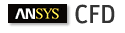
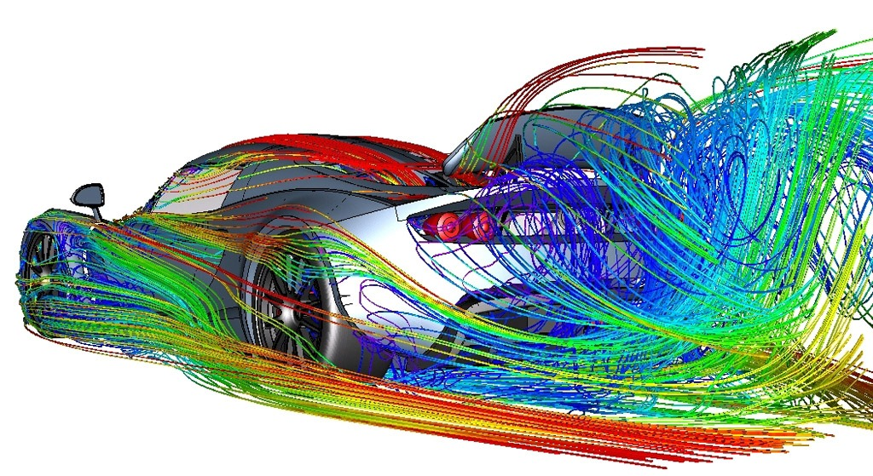
External CFD analysis AHMEd Body
Author: Sion Evans (P150600)
Advanced Computational Methods - M6X00408
Lecturer: Tim Tudor
School of Engineering
27/01/2020

Abstract
The purpose of this study was to create a simulation of an Ahmed body in a wind tunnel experiencing 40m/s winds flowing across it. The initial solve was created using literature around the subject, this initial solve was then used to investigate how specific parameters effect the solution. Through the collection and analysis of data, the best simulation set-up was found to be a polyhedral Delauney mesh using the controls meshing strategy.
List of Acronyms

$ρ$ = Density (Kg/$m^{3}$)
$ν$ = Velocity ($ms^{-1}$)
$d$ = Diameter ($m$)
$μ$ = Viscosity (Kg/$m^{-1}$)
$P$ = Pressure (Pa)
$g$ = Gravity ($ms^{-2}$ )
$Z$ = Elevation ($m$)
$∇$ = Nabla
FDM =Finite Difference Method
FEM = Finite Element Method
FVM = Finite Volume Method
$Re$ = Reynolds Number
CFD = Computer Fluid Dynamics
RMS = Root Mean Square
RNG = Re-Normalising Group
Figure 1. Geometrical details of the Ahmed body and expected flow structure in the wake region. 6
Figure 2. Diagram of the xy plane through the centre of the Ahmed body. 6
Figure 3. Grid set-up with local refinement areas. Upper refinement (H=0.5m, L=2.5m, z=0.5m,$ρ$= 0.05) Lower refinement (H=0.3m, L=3m, z=0.05m $ρ$= 0.02). 8
Figure 4. Graphs representing residual (b) Cl (a) and Cd (c) throughout the simulation. 9
Figure 5. Postprocessing images of the Ahmed body. A= velocity vectors superimposed onto turbulent kinetic energy contour B= Velocity vectors superimposed onto velocity contours at the centre. C=Pressure contours exerted on the Ahmed body D= vortex core region with swirling strength level of 0.5. 10
Figure 6. Vortex core region at varying swirling strengths coloured with a velocity contour. Strength level vary from E= 0.1 to F= 0.05. 10
Figure 7. Velocity vectors at varying from the centre xy plane. G= 0.7m, H= 0.14m and I= 0.19m. 10
Figure 8. Comparison of an Octree & Delauney mesh cross-section. 13
Figure 9. 0 prism layers Vortex core region with a swirling strength level of 0.1. 15
Figure 10. 8 prism layers, vortex core region with a swirling strength level of 0.1. 16
Figure 11. Comparison of Turbulence kinetic energy for K-e realizable (A), K-w SST (B), K-w standard (C) and K-e standard (D). 17
Figure 12. Comparison of streamline and swirling vortex in the wake region using K-e realizable (A), K-w SST (B), K-w standard (C) and K-e standard (D) models. 18
Figure 13. Comparison of residual graphs using K-e realizable (A), K-w SST (B), K-w standard (C), K-e standard (D), K-e RNG and RMS (F) models. 19
Figure 14. Velocity contour of the Ahmed 35 degree slant. 21
Figure 15. Expected velocity contour of the Ahmed 35 degree slant (W. Meile, 2011). 21

Table 1. Experimental Results. 5
Table 2. Global mesh controls. 7
Table 3. Boundary Conditions. 8
Table 4. Simulation convergence results. 9
Table 5. Results from domain volume investigations. 12
Table 6. Convergence results using Octree and Delauney methods. 14
Table 7. Results from solves with varying prism layers. 14
Table 8. Results using Tetrahedral and Polyhedral mesh types. 16
Table 9. Coefficient of life and drag with a varying scale factor. 16
Table 10. Convergence results at various Turbulence models. 17
Table 11. Final simulation set-up for most accurate solve. 20
Table 12. Convergence results for Ahmed 35 compared with expected. 21

$Continuity Equation (non conservation form)$ [Equation 1] 4
$Continuity Equation (Conservation form)$ [Equation 2] 4
$Momentum Equation, -x component$ [Equation 3] 4
$Momentum$ Equation - y-component [Equation 4] 4
$Momentum equation-z component$ [Equation 5] 4
$Energy Equation (conservation form)$ [Equation 6] 5
$Reynolds Number$ [Equation 7] 5
$Bernoulli'sPrinciple:$ [Equation 8] 5

Contents
1. Introduction 4
1.1 Governing Equations 4
1.2. Experimental Details 5
2. Computational Set-up 6
2.1. Domain Modelling 6
2.2. Meshing strategies Model 7
2.3 Volume Meshing 7
2.4 Boundary conditions 8
2.5 Turbulence Models 8
3. Preliminary results 9
3.1 Observations/Analysis 11
4. Simulation Parameter investigations 11
4.1 Domain independence Study 11
4.2 Mesh Method 13
4.2. i) Delauney Approach 13
4.2. ii) Octree Approach 13
4.3 Volume meshing study 14
4.3 i) Prism layers 14
4.3 ii) Mesh type 16
4.3 iii) Mesh Density 16
4.4 Turbulence models 17
4.4 i) Observations 20
5. Conclusion 20
6. Further Work 21
7. References 21

Introduction
Computational fluid dynamics (CFD) is a computational tool that is used to numerically solve Partial differential equations (PDEs) governing the transport of momentum, mass and energy in dynamic fluids. The first study using CFD based on the Naiver-Stokes equations (2.1) was by Los Alamos National lab as early as 1950-1960’shortly after the transition to computer-based calculations (Harlow, 2004).
Before the development of such tools, the design of engineering equipment such as gas turbine engines, heat exchanger and so forth, were reliant on empirical information generated at laboratory-scale. This data had to then be scaled up to industrial level using established scaling laws to ensure dynamic and kinematic similarities between the model and the full scale. This proved to be very difficult and expensive, designers required a tool that is scale neutral. It was known that the 200-year-old fundamental laws of mass, momentum and energy had potential for generating scale neutral information, however, the ability to solve these governing differential equations (2.1) was made possible by the emergence of computers along with improvements to mathematical models and numerical methods (Date, 2005). The equations under consideration must be discretized/transformed into a digitally solvable array of algebraic equations, through the use of numerical methods. Some numerical methods include finite difference, finite volume and finite element analysis. The progression in processing speed and availability of computers have solidified CFD as a reliable and cost-effective tool for designers across a range of engineering and scientific disciplines.
Using various packages within ANSYS Workbench, the aim of this report is to conduct analysis of external aerodynamic flow over a steady-state Ahmed body (2.2) and undertake investigations into specific parameters of the simulation to determine an accurate and time-effective solution.

1.1 Governing Equations
The governing differential equations in relation to aerodynamic analysis in CFD are known as the Navier-Stokes equations (Date, 2005). They are as follows:
Continuity equation – non-conservation form:
$\frac{Dρ}{Dt}+ ρ∇.V=0$ [Equation 1]
Conservation form:
$\frac{∂ρ}{∂t}$ + ∇.($ρV)=0$ [Equation 2]
Momentum equations - Conservation form:
$x-component : \frac{∂\left(ρu\right)}{∂t} + ∇·(ρuV ) = -\frac{∂p}{∂x} +ρfx$ [Equation 3]
$y-component : \frac{∂\left(ρv\right)}{∂t} + ∇ ·(ρvV ) = -\frac{∂p}{∂y} +ρfy$ [Equation 4]
z-component : $\frac{∂\left(ρw\right)}{∂t} + ∇ ·(ρwV ) = -\frac{∂p}{∂z} +ρfz$ [Equation 5]

Energy equation - Conservation form:
$\frac{∂}{∂t} \left[ ρ\left(e+\frac{V^{2}}{2}\right)\right]+∇·\left[ρ \left(e+\frac{V^{2}}{2}\right)v\right]V=ρq˙ -\frac{∂\left(up\right)}{∂x} -\frac{∂\left(vp\right)}{∂y} -\frac{∂\left(wp\right)}{∂z} +ρf.V$ [Equation 6]
Further explanation and the derivation of the Navier-stokes equations can be found in chapter 2 of Computational Fluid Dynamics, 3rd edition, J.F. Wendt (ed) (J.D. Anderson, 2009). Other equations of interest include:
$Reynolds Number: Re =\frac{ρνd}{μ}$ (Bill Rehm, 2009) [Equation 7]
$Bernoulli^{'}sPrinciple: \frac{1}{2} ρ V^{2}+P+ρgZ=constant$ (Ostadfar, 2016) [Equation 8]

1.2. Experimental Details
The Ahmed body was proposed in the 1980’s by Ahmed et al. It is used as a benchmark across the automotive industry for carrying out computations for the study of vehicle aerodynamic parameters (Saurabh Banga, 2015). Its geometry can be seen in (fig. 1). The body represents the basic aerodynamic principles of a vehicle due to the rear slant angle. which strongly effects the lift and drag. Changes in the angle has detrimental effect on the aerodynamic behaviour in the wake region. It is agreed between (W. Meile, 2011) and (Rehan Salahuddin Khan, 2014) a critical angle ≤ 30°, belongs to fastback vehicles, where an inward pair of strong longitudinal vortices with increasing strength can be observed extending far into the wake. The Ahmed body was placed in a wind tunnel where a wind with velocity of 40m/s was blown across it. The results can be seen in (table 1).

Slant Angle (φ) | Lift Coefficient | Drag Coefficient
25 | 0.345 | 0.299
35 | 0.004 | 0.279

Table 1. Experimental Results.

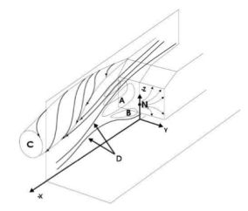
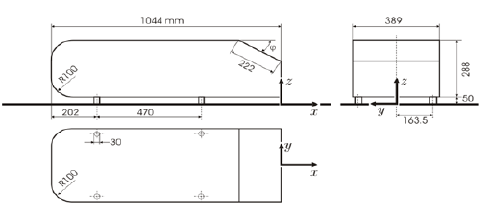

Figure 1. Geometrical details of the Ahmed body and expected flow structure in the wake region.

2. Computational Set-up

2.1. Domain Modelling
The domain is created to model the geometric al make-up of ta wind tunnel within ANSYS. To generate the domain for this study data from actual Ahmed body analysis is used. The horizontal dimensions are measured from the back of the Ahmed body and suggested 3xcar lengths in front and 5m behind as suggested in a research paper submitted by Marco Lanfrit (Lanfrit, 2005)agreed by (Saurabh Banga, 2015). (Eric Serre, 2013) also uses a total length of 8m along with Lanfrit ,therefore this will be my domain length. A domain with 5xbody height and 5xbody width is suggested, so a domain with 1.5m height and 1.5m width is created.
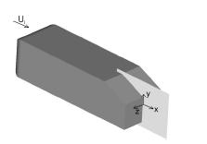

(Maryam Mirzaei, 2015)

Figure 2. Diagram of the xy plane through the centre of the Ahmed body.

2.2. Meshing strategies Model
The mesh is where the discretisation of the governing equations takes place using the numerical models such as FDM, FEM and FVM. They are generally categorised into structured and un-structured grids. The ICEM meshing software in ANSYS Workbench is used for this process. There are a number of meshing strategies for this discretisation, namely, Adaption, Boxes and Controls. As suggested by Fluent (Lanfrit, 2005), Controls strategy is used due to its accurate simulation capabilities with no requirements of additional surfaces in the early stages. Controls implements local refinement boxes in place of the internal boxes, where cells are refined and placed in areas of interest for analysis.

2.3 Volume Meshing
The volume mesh is the system of elements and mesh controls that fill up the domain geometry. Figure shows the meshing process in ANSYS. Details of the volume mesh controls can be found in (table. 2) and (table. 3).

Global Mesh Controls
Global Element Size | 0.15 m
Element Scale Factor | 1
Number of Elements | 218,000
Inflation; Prism Layer growth | Exponential
Number of layers | 4
Shell mesh Type | All Tri
Shell Mesh method | Patch Independent
Volume mesh Type | Tetra/mixed
Volume mesh Method | Robust (Octree)
Element size around body | 0.015m
Local refinement region | 2

Table 2. Global mesh controls.

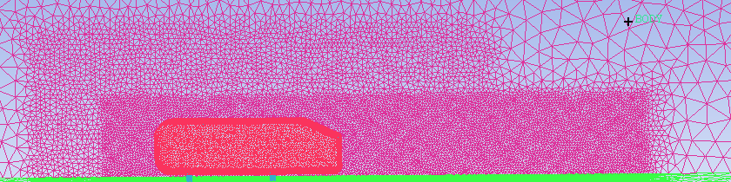
Figure 3. Grid set-up with local refinement areas. Upper refinement (H=0.5m, L=2.5m, z=0.5m,$ρ$= 0.05) Lower refinement (H=0.3m, L=3m, z=0.05m $ρ$= 0.02).

2.4 Boundary conditions
The boundary conditions are input into the FLUENT software package to represent the physical geometry of the experiment and the independent variables used. Details of these boundary conditions can be found in table 3.
Zone | Type | Value
Ahmed body | wall | N/A
inlet | Velocity inlet | 40 m/s
interior body | interior | N/A
outlet | Pressure outlet | 0 pascal
stilts | wall | N/A
symmetry | symmetry | N/A
topside | wall | N/A
Wall | Non-equilibrium | N/A

Table 3. Boundary Conditions.

2.5 Turbulence Models
Turbulence models are mathematical models containing simplified constitutive equations used to predict the evolution of turbulent flow that cannot be analytically predicted. The k-ϵ realizable turbulence model is used across (Lanfrit, 2005) (Saurabh Banga, 2015) and (Eric Serre, 2013) and is therefore used for the initial solve.

3. Preliminary results
The results for the initial solve and the aerodynamic analysis using the post-processing software can be found in this section.

Coefficient | values | Number of Iterations | % Error From Experimental
Lift | 0.31676 | 148 | 8.2
Drag | 0.32787 | 148 | 9.7
Table 4. Simulation convergence results.
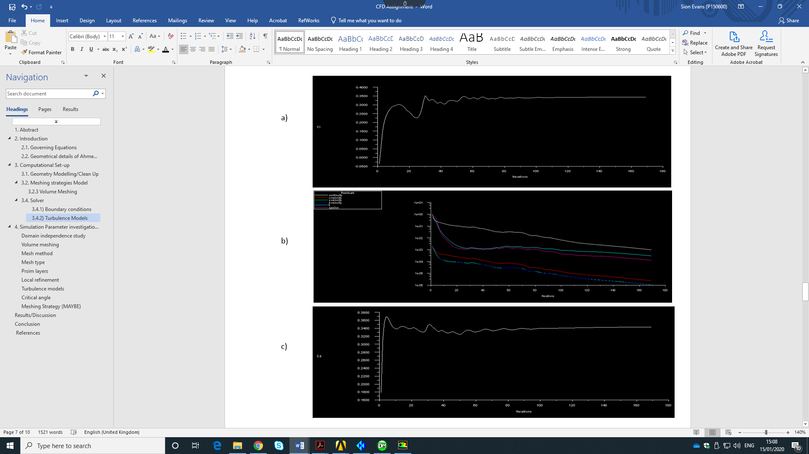
The values for the initial simulation can be seen clearly in table 4, with computational coefficients converging on values with ‘8.2%’ error from the lift and ‘9.7%’ from the drag values. This is an undesirable level of accuracy. Although the residuals in figure 2 are that of a good quality mesh with no skewness. Post-processing package is required to create a detailed analysis of the fluid flow around the body. This analysis will provide an insight into where simulation optimisation can take place.
Figure 4. Graphs representing residual (b) Cl (a) and Cd (c) throughout the simulation.
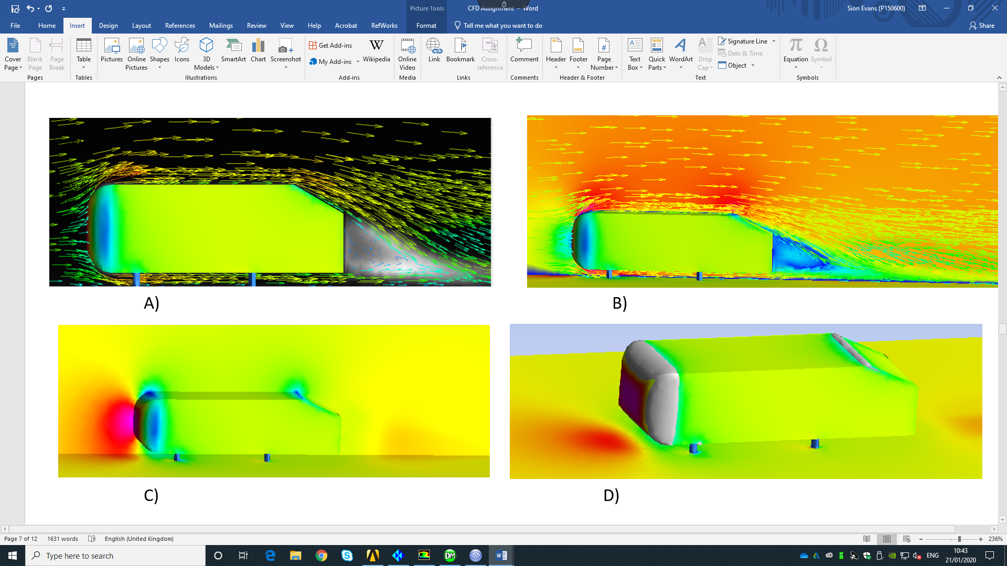
Figure 5. Postprocessing images of the Ahmed body. A= velocity vectors superimposed onto turbulent kinetic energy contour B= Velocity vectors superimposed onto velocity contours at the centre. C=Pressure contours exerted on the Ahmed body D= vortex core region with swirling strength level of 0.5.
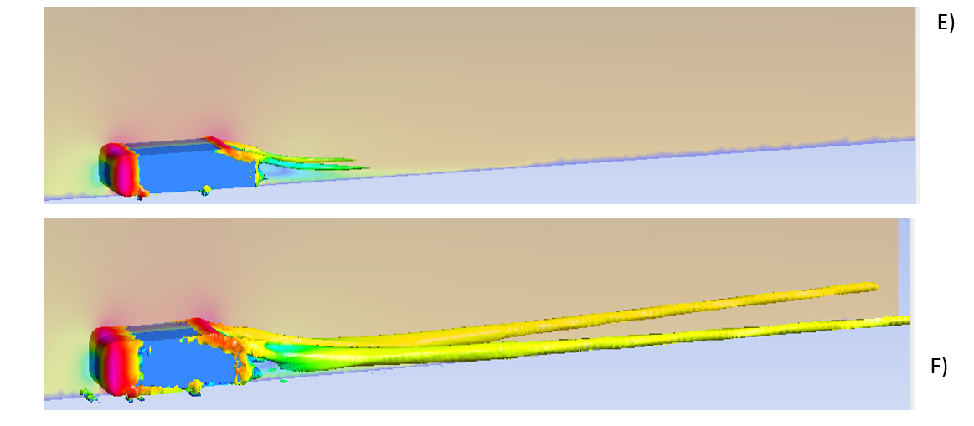

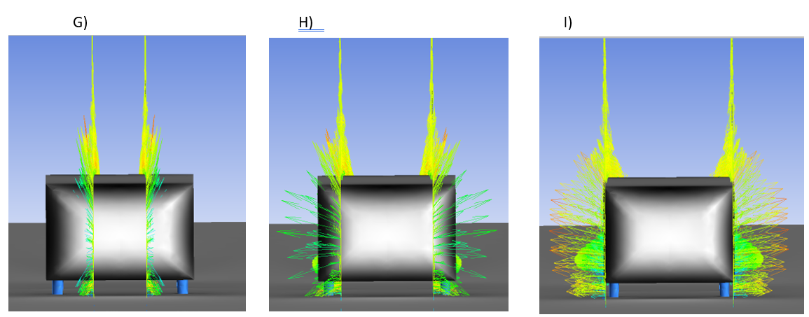
Figure 6. Vortex core region at varying swirling strengths coloured with a velocity contour. Strength level vary from E= 0.1 to F= 0.05.

Figure 7. Velocity vectors at varying from the centre xy plane. G= 0.7m, H= 0.14m and I= 0.19m.

3.1 Observations/Analysis
- In figure 3 C) the pink area represents a build-up of high pressure at the front of the Ahmed body, where the wind particles first collide with the body and nearly become stagnant. The air accelerates as it travels over the curve and experiences a drop in pressure represented by the blue regions. This increase in velocity as the pressure in this area drops is fundamental to maintain the conservation of momentum. A mathematical proof can be seen in Bernoulli’s principle [Eq. 8]. There is an area of low pressure behind the body which represents the wake region created by the separation of air particles as they collide with the curve at the front of the Ahmed. This phenomenon is agreed upon by (W. Meile, 2011) and (Eric Serre, 2013). There is also a relatively high-pressure zone behind where the particles flowing over the body meets the floor.

- Figure 4 displays the swirling strength of the wind particles at a level of ‘0.05’ and ‘0.1’. The two vortices match that observed on fastback vehicles (<30), where two longitudinal inward vortices can be observed (W. Meile, 2011). The origin of these vortices can be seen to be generated at the regions of low pressure, due to the increase of velocity and subsequent increase in Reynolds number. Reynolds number is defined as the ratio of inertial forced to viscous and describes whether flow in laminar or turbulent, the definition is shown in [Eq. 7]. At swirling strength level of ‘0.05’, the vortices can be seen stretching to the end of the domain where it is potentially cut short. Whereas at a level of ‘0.1’ they barely reach halfway to the across the domain. A study into domain size is necessary to determine at what point the swirling effect of the vortices effects the lift and drag coefficients.

- Figure 5 shows how the velocity of the wind particles vary depending on which part of the Ahmed body they collide with. Particles nearer the edge have a much higher velocity and are forced out and away from the centre xy plane creating high separation and turbulence discussed in observation 2. The particles colliding at the centre of the body can be seen to be reflected the way they came creating a region of stagnant air discussed in observation 1.

The fluid flow around the Ahmed body is in alignment with several literature papers submitted and the principles stated in section 1.2. However, further improvements to the mesh such as domain size, meshing strategy and turbulence model are required.

4. Simulation Parameter investigations
This section includes the investigation and analysis of certain features within the aerodynamic simulation.

4.1 Domain independence Study
This study was done by significantly reducing the size of the domain. A ratio of 2:1 was maintained between the length behind:infront of the body, and then increased in increments up to a total length of 15m. The initial solve conditions were kept the same to conduct a fair investigation.
 | volume ($m^{3}$) | Cl Error % | Coefficient of Lift Cl | Coefficient of Drag Cd | Cd Error % | No Iterations
 | [1] 1.5x1x3 | 13 | 0.38993 | 0.37043 | 23.8 | 172
 | [2] 2x1.25x4 | 5.2 | 0.36305 | 0.34895 | 16.7 | 155
 | [3] 2.5x1.5x5 | 8 | 0.31676 | 0.32787 | 9.7 | 148
 | [4] 3x1.75x6 | 2.3 | 0.33366 | 0.28612 | 3.8 | 236
 | [5] 3.5x2x7 | 7.3 | 0.32014 | 0.28266 | 3.5 | 260
 | [6] 4x2.25x8 | 7 | 0.32117 | 0.28943 | 3.3 | 796
 | [7] 4.5x2.5x9 | 5.6 | 0.32569 | 0.29084 | 2.8 | 799
 | [8] 5x2.75x10 | 3.3 | 0.33362 | 0.30839 | 3.1 | 912
Table 5. Results from domain volume investigations.
Graph 1. Coefficient of lift (Cl) and drag (Cd) plotted against the domain study number.
Graph 2. The % of error from the expected values plotted against the domain study number.
= Expected Cl = expected Cd
Table 6 shows how the coefficient of lift and drag change as the volume of the domain changes. At a small domain size, the coefficient values are much higher than actual experimental values. This is because the boundary’s acting as walls creates a smaller space for wind to travel, resulting in a drop of pressure and subsequent increase in velocity stated in Bernoulli’s principle (Hirch, 2007). The results show the % error exponentially decreasing as the domain size is increased. Between study [1] and study [4] the % error decreases from ‘13%’ to ‘2.3%’ shown in graph 2.
With a domain larger than ‘2.5x1.25x5’ the reduction in error from the expected values stopped changing as much. Any growth in size after ‘3x1.75x6’ shown to have minimal effect on the coefficient of drag, where the simulated value stayed within 4% of each other clearly shown in graph 1. A domain volume of ‘5x3x10’ does proceed to have the lowest combined error values at ‘3.7%’. However, the computational cost of this simulation was excessive when compared with a domain volume of ‘3.x1.75x6’ that boasts a combined error of ‘6.1%’ with ¼ of the iterations. Therefor domain [5] will be used moving forward with the model investigations.

4.2 Mesh Method
There are two main methods for generating a tetrahedral mesh, The Delaunay method and the Octree approach. A comparison can be seen below:

4.2. i) Delauney Approach
The Delaney approach (Fig. 6) uses a bottom-up meshing approach where a triangulation that matches a prescribed boundary, in this case the boundary of the Ahmed body, is created on the surface. The triangulation at the boundary then becomes the interior of the next layer that is grows bottom-up. The process continues until the domain is filled (NP, 1988).

4.2. ii) Octree Approach
The Octree method (Fig. 7) is similar to the Cartesian approach where the boundary discretisation is determined as a part of the domain meshing procedure. It uses the top-down meshing approach where the domain is divided into a system of rectangles, that are then further divided into tringles until a sufficient resolution is reached (Yerry MA, 1984).
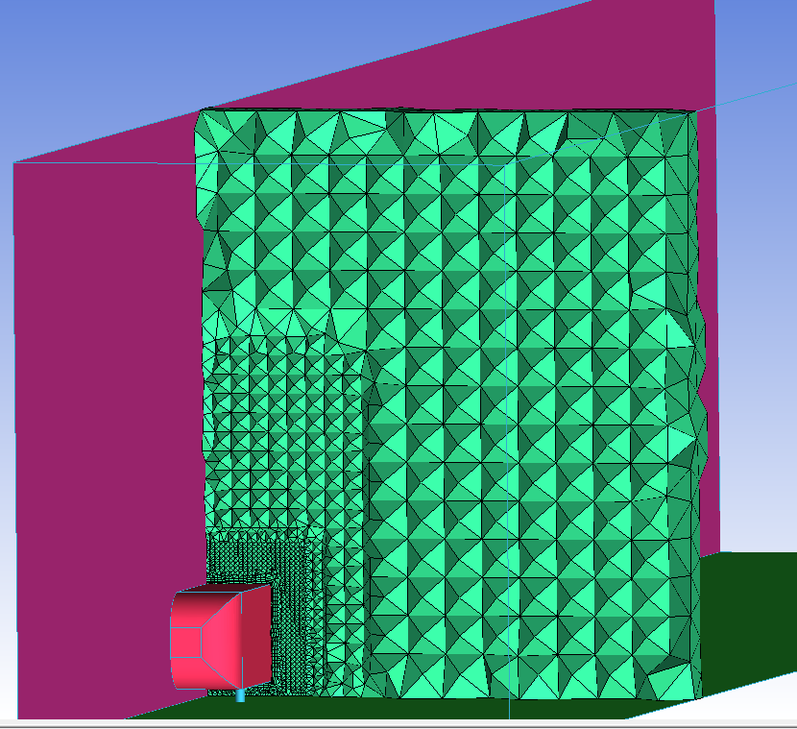
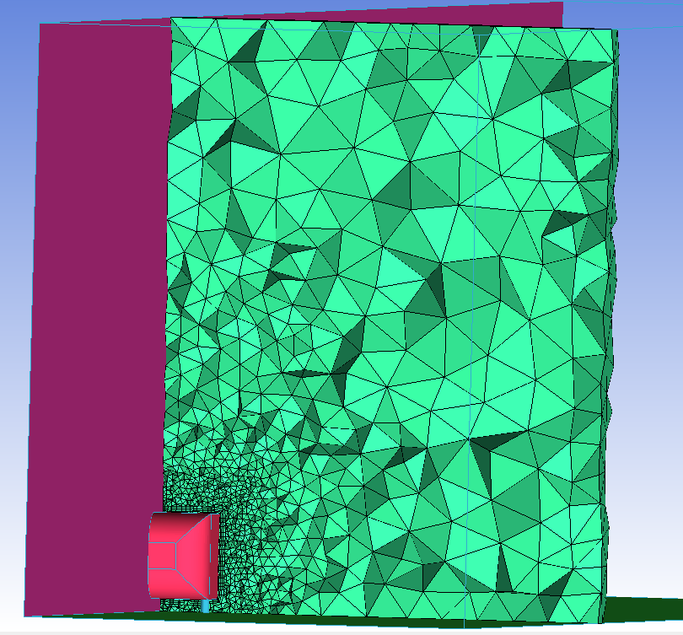

Figure 8. Comparison of an Octree & Delauney mesh cross-section.
The Octree method is a robust technique that does not require a well configured geometry to function. However, the quality of its triangulation can be very poor due to its organised structure and its inability to match prescribed triangulation since surface triangulation arises as a bi product of volume meshing. The bottom-up technique used in the Dulaney method is said to produce more reliable results (ref) and uses half the number of elements shown in table 6. The accuracy in the drag coefficient has increased. This is likely due to the fact turbulent airflow is better captures by the bottom-up technique. The accuracy of the lift has declined, however the reduction in iterations and number of elements allows for smaller elements to be used without as much computational cost. Therefore, Delauney is the method that will be used moving forward.

Mesh Type | Cl | % Error Cl | Cd | % Error Cd | Number of elements | Iterations
Delaney | 0.32268 | 6.5 | 0.28986 | 3.1 | 667,122 | 187
Octree | 0.33336 | 3.3 | 0.28612 | 4.4 | 1,890,368 | 236
Table 6. Convergence results using Octree and Delauney methods.

4.3 Volume meshing study

4.3 i) Prism layers
Prism Layers | Cl | % Error Cl | Cd | % Error Cd | Iterations
0 | 0.3379 | 2.1 | 0.2775 | 7.2 | 185
2 | 0.3117 | 9.7 | 0.2859 | 4.4 | 217
4 | 0.3219 | 6.7 | 0.2813 | 6.0 | 289
8 | 0.3194 | 7.5 | 0.2821 | 5.7 | 301

Table 7. Results from solves with varying prism layers.

Graph 3. Coefficient of lift (Cl) and drag (Cd) vs No of prism layers
= expected Cd = expected Cl
Graph 4. Error % from the expected values vs No. of prism layers.

A relationship between number of layers and accuracy cannot be clearly defined looking at graph 4. Graph 3 and 4 do however show a more accurate solve when no prism layers are used. This higher level of accuracy can also be seen in (fig. 9) compared with (fig. 10).

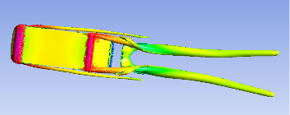
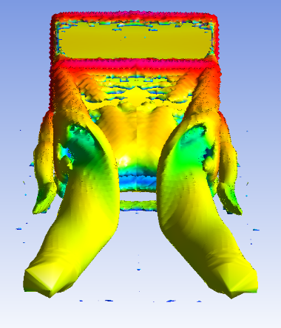

Figure 9. 0 prism layers Vortex core region with a swirling strength level of 0.1.
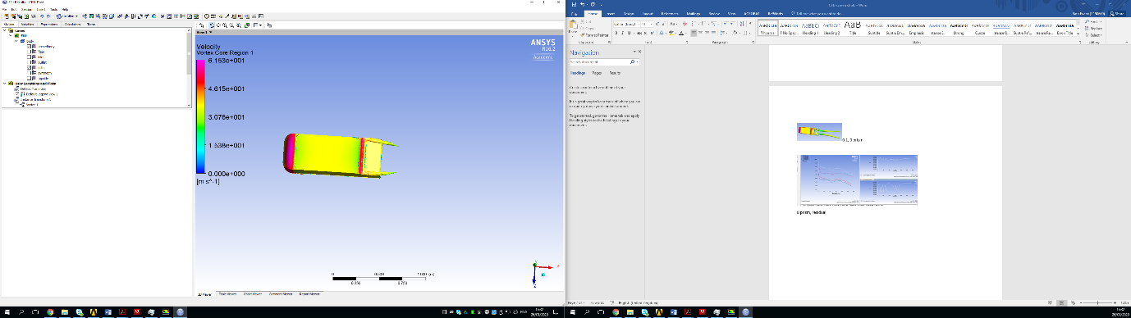
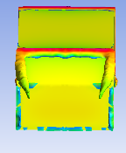

Figure 10. 8 prism layers, vortex core region with a swirling strength level of 0.1.

The results clearly show a more accurate solution with no prism layers and a faster solve time. This somewhat contradicts the suggestion 5 prismatic layers given by (Lanfrit, 2005). The difference is results is the different meshing methods used. Prism layers are highly recommended to be used alongside an Octree mesh (Yerry MA, 1984). However, due to the nature of the bottom-up methods prismatic layers show to be counter-intuitive in this case.

4.3 ii) Mesh type
Mesh Type | Cl | % Error Cl | Cd | % Error Cd | Iterations | Elements
Tetrahedral | 0.3379 | 2.1 | 0.2775 | 7.2 | 185 | 736,661
Polyhedral | 0.3206 | 7.0 | 0.29566 | 1.2 | 94 | 147,333

Table 8. Results using Tetrahedral and Polyhedral mesh types.
Polyhedral mesh type has a number of advantages over tetrahedral mesh types on top of the reduction of elements shown in (table. 9). A more accurate solution is created with a lower cell count because they have many neighbours (usually in the order of 10), so gradients can me approximated much better (Emre Sozer, 2014). They are said to be especially beneficial for capturing recirculating flows, which directly applies to this study. The mesh is transformed to polyhedral in the Fluent package, where 5 tetrahedral merge to form one polyhedral.

4.3 iii) Mesh Density
Local refinement described in section () was extended to account for the vortices stretching far into the wake region observed in 3.1. However the convergence results were unchanged. Instead, the density was changed using the global scale, and changing elements to 0.002m. Global scale variation can be seen in (table. 9).

Scale factor | Cl | % error Cl | Cd | % error Cd | Iterations | Elements
0.9 | 0.3543 | 2.6 | 0.3030 | 1.3 | 97 | 869,709
0.8 | 0.3490 | 1.1 | 0.2988 | 0.1 | 97 | 1,065,121
0.7 | 0.3492 | 1.2 | 0.2916 | 2.5 | 85 | 1,526,875
0.6 | 0.3722 | 7.8 | 0.2936 | 1.9 | 105 | 2,250,919
Table 9. Coefficient of life and drag with a varying scale factor.

4.4 Turbulence models

Turbulence Model | Cl | % Error Cl | Cd | % Error Cd | Iterations
Standard K-e | 0.3590 | 6.9 | 0.3027 | 0.4 | 65
Realizable K-e | 0.3490 | 1.1 | 0.2988 | 0.1 | 97
RNG K-e | Failure | Failure | Failure | Failure | 2000
Standard K-w󠄖 | 0.3527 | 2.2 | 0.30636 | 2.5 | 117
SST K-w | 0.3538 | 2.6 | 0.30092 | 0.6 | 55
RSM | Failed | Failed | Failed | Failed | 2000
Table 10. Convergence results at various Turbulence models.

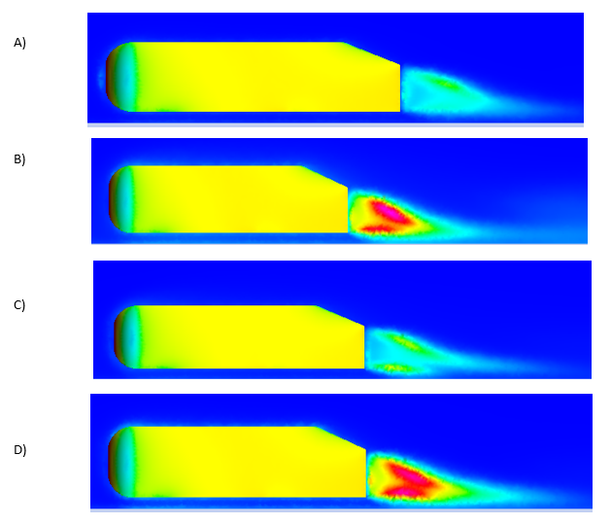
Figure 11. Comparison of Turbulence kinetic energy for K-e realizable (A), K-w SST (B), K-w standard (C) and K-e standard (D).

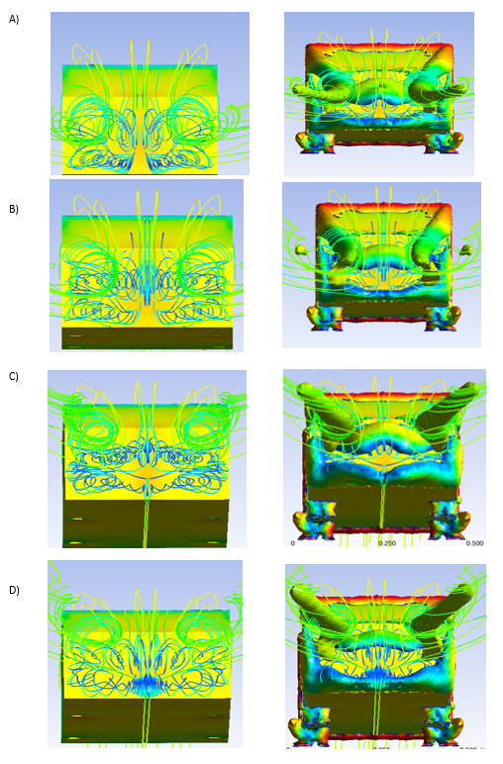
Figure 12. Comparison of streamline and swirling vortex in the wake region using K-e realizable (A), K-w SST (B), K-w standard (C) and K-e standard (D) models.

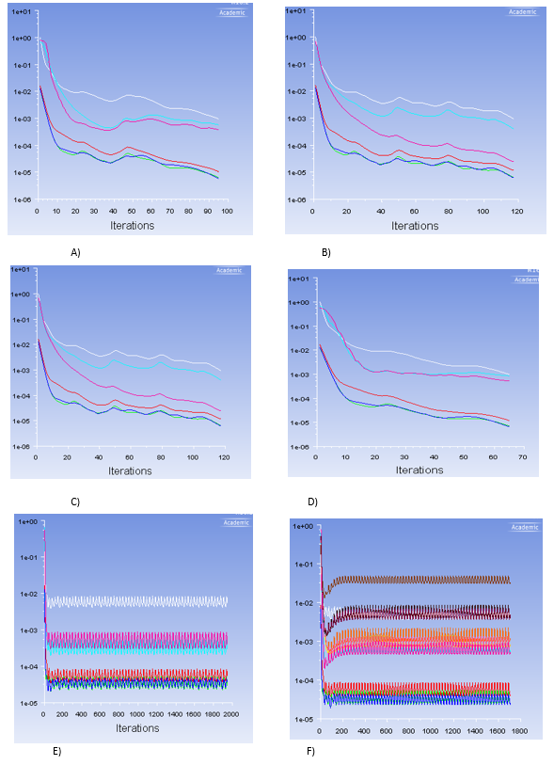

Figure 13. Comparison of residual graphs using K-e realizable (A), K-w SST (B), K-w standard (C), K-e standard (D), K-e RNG and RMS (F) models.

4.4 i) Observations
- Figure 10 shows the standard K-e turbulence has the most detailed illustration of the turbulent kinetic energy, where the K-omega models fail to capture much detail at all.
- Figure 11 it is difficult to differentiate between each turbulence model as they are all similar in detail, but no shape is the same. The vortex swirling strength does show to be clearer on the K-e models than on K-omega SST and standard.
- The residual graphs shown in figure 12 follow the same trend across the k-e and k-omega models. However, the residuals representing RNG and RMS experience extreme oscillations and both failed to converge on a solution.

5. Conclusion
Model | Mesh method | Mesh type | Elements | % Error Cl | % Error Cd | Iterations
K-e realisable | Delauney | Polyhedral | 1,526,875 | 1.1 | 0.1 | 97
Through a review of Literature and investigations into the parameters of the solve, successful convergence values have been validated. The Aerodynamic behaviour observed in section 3.1 agrees with the literature reviewed around this topic and supports the principles that govern aerodynamic flow. The best simulation set-up validated against the experimental data with an error of ‘0.1%’ from the drag and ‘1.1%’ from the lift. The Delauney mesh method and polyhedral mesh type were chosen to configure the grid for this simulation as both of these feature increase the accuracy and reduce the computational cost of the simulation. The K-e realisable model was used throughout this report and provided the most accurate solution. However, the K-e standard model provided a more detailed illustration of the aerodynamic behaviour as suggested by (Saurabh Banga, 2015). The details of the final set-up for accuracy and solve time, can be found in (table. 12).

Table 11. Final simulation set-up for most accurate solve.

6. Further Work
There are various Ahmed body designs with differing slant angles at the back. The change in the slant angle effects the drag and lift coefficients created by the body, this is due to the difference in the size of the wake area and intensity of the vortices formed. The wake behind the body is a low pressure region of recirculating air shown in section 3.1. It is known that the cause of this is the separation of flow as the air particles encounter a change in curvature and shape. To further test the optimised CFD simulation, it is used to create an aerodynamic analysis of an Ahmed body with a rear slant of 35.
There are similarities in the aerodynamic behaviour of (figure. 14 and 15) but it does lacks accuiracy as can be seen in (table. 12). This is because at a critical slant angle >30, there is more flow separation at the lower edge of the slant. This produces strong under pressures in that region resulting in barely any lift being generated. The simulation set-up found to be the best for 25 is inadequate for an angle of 35, therefore further investigation into set-up is required.

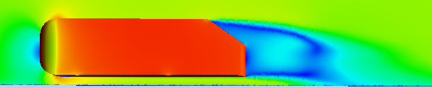
Figure 14. Velocity contour of the Ahmed 35 degree slant.
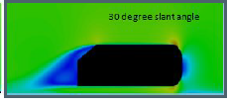
Figure 15. Expected velocity contour of the Ahmed 35 degree slant (W. Meile, 2011).

Ahmed | % Error Cl | % Error Cd | Iterations
35 | 632.5 | 27.4 | 194
Table 12. Convergence results for Ahmed 35 compared with expected.

7. References
ANSYS, 2011. Introduction To Ansys Meshing, s.l.: Ansys inc.
Bill Rehm, A. H. A. S. P. J. S., 2009. situational problems in MPD. In: A. H. A. S. P. J. S. Bill Rehm, ed. Managed Pressure Driling. s.l.:Gulf Publishing Company, pp. 39-80.
Date, A. W., 2005. Introduction to Computational Fluid Dynamics. New York: Cambridge University Press.
Emre Sozer, C. B. a. C. C. K., 2014. Gradient Calculation Methods on Arbitrary Polyhedral Unstructured Meshes for Cell-Centered CFD. American Institute of Aeronautics and Astronautics.
Eric Serre, M. M. R. P. ,. E. G. ,. G. B. D. ,., 2013. On simulating the turbulent flow around the Ahmed body. Computers & Fluids, Volume 78, pp. 10-23.
Harlow, F. H., 2004. Fluid dynamics in Group T-3 Los Alamos National Laboratory (LA-UR-03-3852). Journal of Computational Physics, Volume 195, pp. 414-433.
Hirch, C., 2007. Numerical Computation of Internal & External flows. 2nd ed. Oxford: John Wiley & sons Ltd.
J.D. Anderson, J. J. W., 2009. Computational Fluid Dynamics. 3rd ed. Washington, DC: Springer-Verlag Berlin Heidelberg.
Lanfrit, M., 2005. Best practice guidelines for handling Automtiv External Aerodynamics with Fluent, Darmstadt: s.n.
M. Corallo, J. M., 2015. Effect of aspec tratio on the near-wake flow structure of an Ahmed body. Journal of Wind Engineering & Industrial Aerodynamics, Volume 147, pp. 95-103.
Maryam Mirzaei, S. K. B. B., 2015. Partially-Averaged Navier–Stokes simulations of flows around two different Ahmed bodies. Computers & Fluids, Volume 117, pp. 273-286.
NP, W., 1988. A method for generating irregular computational grids in multiply connected planar domains. International Journal Number Meth Fluids, Issue 8, pp. 181-197.
Ostadfar, A., 2016. Dluid Mechanics and Biofluid Principles. Biolfuid Mechanics, pp. 1-60.
Rehan Salahuddin Khan, S. U., 2014. CFD Aerodynamic Analysis of Ahmed Body. International Journal of Engineering Trends and Technology (IJETT), Volume 18(7), pp. 301-308.
Saurabh Banga, M. Z. N. A. A. S. S. R. S. D., 2015. CFD Simulation of Flow around External Vehicle: Ahmed Body. IOSR Journal of Mechanical and Civil Engineering, 12(4), pp. 87-94.
W. Meile, G. B. A. R. B. L. A. F., 2011. Experiments and numerical simulations on the aerodynamics of the Ahmed body. ISSR journals, 3(1), pp. 35-39.
Yerry MA, S. M., 1984. Automatic three-dimensional mesh generation by the modified Octree technique. Int J Numer Meth Eng , Issue 20, pp. 1965-1990.

