Link for my Wordpress https://tyronehudson.wordpress.com/

Tyrone Hudson

Threats of Humankind
Health, Wealth and Happiness

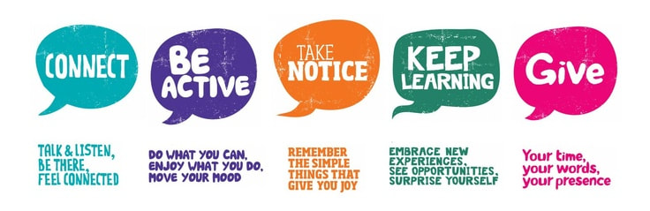

Are we the biggest threat to ourselves?
The answer is sadly yes, there have been plenty of instances where humankind has devolved and caused harm to our own species, this has not changed much, some people are out for themselves and will do ANYTHING to get there.

How does health, wealth and happiness affect the way we behave? Humans react very instinctively with very little rational thought involved most of the time.

Humans are very complex and to understand someone's thoughts you’d need to get out a calculator because it’s about to get complex, most people tend to go out of their way for an agenda, this causes a chain reaction within society, in both behaviour patterns and from a social economic standpoint, and at that point a lot of people are technically losing out because that one person had a bad day or can’t keep their emotions in check.

This can be seen in such documentaries of tyrant leaders using fear to emotionally manipulate a social standing, whether the recipient likes it or not, they accept it because they fear it.

This hysteria of excessive emotions causes an unintentional conflict of interest, without them knowing it, this is what makes humans sometimes the most irrational and dangerous beings on earth.

How can we be productive?
Humans feed off each other's mannerisms and productivity, this can be seen in the workplace and in any leisure activities, the way people perceive each other is purely based on a preconceived notion and judgement that is often wrong.

However this has escalated since the early to late 2000’s due to the access of the internet which has caused many youngsters to not engage with each other and find a common ground in options and interests.
This causes a lot of people to become lazy, anti-social and complacent towards people in general, this is more prevalent with the millennials and younger generations.

This has caused people like myself to suffer from anxiety and depression, it’s a lot easier to make mistakes, however you do learn from them, youngsters need to be more informed about the dangers of becoming anti-social and the real issues it can have on their physical and mental health.

This has a shared responsibility between both parents and teachers, to educate and inform the younger generations, this anti-social behaviour further causes more harm to other parts of their lives such as potential weight gain through depression, ignorance, un-informed opinion bias without taking proper action to inform themselves with facts and many many more.

Healthy body, healthy mind

How can people better themselves in terms of both mental and physical well-being? The answer is more complex than what it might appear to be, the way people approach life in general is through technology which is one of the causes so one way to solve it is to remove the catalyst.
One way of helping solve this issue is by simply meeting people at social gatherings or events, the main culprit to someone being in a rut is because they are so far removed from social normality.

In turn many people find that they lose a grasp of reality because they are so caught up in a life of unorganised internal conflict and struggles, a solution to this problem is mindfulness and self-awareness on how you act towards certain situations.

People who have a skewed view on their own personality or ideology of themselves are often created by insuracities either from bullying or a inferiority complex, this can be helped by doing something you are good at, this could be either a hobby or a career prospect to boost your confidence.

Is being wealthy a curse?

A lot of people are judged on wealth and income this has been prevalent since Roman empire and Celts, this preconceived value is a bias on your worth, it has been common practice for over a thousand years so the likelihood of it going anyway is very slim.

However this is not the case with non-judgemental people with an open-mind, everyone likes to see a good person be successful no matter the status, this is often the case when they come from a deprived or unfortunate background because they gain sympathy and empathy.

People who are generally happy most of the time are like that not because they have gained anything but are conditioned to be happy within their means, this can be said for a lot of people, however on the other hand there are people who want to be revolutionary in any industry.

Ultimately, this comes down to past experiences, upbringing, values, work ethics and personality traits, not everyone conforms to another person's reality but people often bend for their own means, whether it is to be successful or to simply have a new friend.

Joshua. S. Yamamoto, September 17th 2019, Psychology Today, viewed 14/04/2021 https://www.psychologytoday.com/gb/blog/silent-killer/201909/healthy-mind-needs-healthy-heart

Erin Peavey, May 3rd 2021, Psychology Today, viewed 14/04/2021 https://www.psychologytoday.com/gb/blog/designed-happiness/202105/is-your-environment-making-you-lonely

Arthur C. Brooks, April 9th 2020, viewed 16/04/2021
https://www.theatlantic.com/family/archive/2020/04/how-increase-happiness-according-research/609619/

Esther Cohen, July 5th 2017, Workamajig, viewed 17/04/2021
https://www.workamajig.com/blog/psychology-of-productivity

Sarah Gervais, 11th November 2015, Psychology.unl, viewed 17/04/2021
https://psychology.unl.edu/can-money-buy-happiness

Tyrone Hudson

Skills as an animator
A lot of the creative process in animation is analyzing and observing how people act and behave in certain situations, reading facial cues, body mannerisms and certain quirks.

This helps the animator with character development and provides a greater insight into the human mind and how we behave as a species.

Time management is a huge key, as many animated films take a long time to make, being able to bypass certain obstacles using certain techniques, even if there is a slight delay in the production pipeline it can cause a catastrophic effect as everyone else in the pipeline will be waiting.

Team management is a huge deal in a production pipeline as there can be up to 500 people working on the same project but in separate teams, the different responsibilities for each individual artist is crucial to being able to hold down a project and meet the deadline.

Organizational structure is also very important so each individual artist knows what the end goal of the project needs to be, this is to make sure no does anything different and steers completely off kilter, every individual goes through checks to make sure that the animation meets the precision and quality that is required from a studio or clients.

Another import aspect of any animator is budgeting as many different factors of 3D animation production cost a fair bit of money, also many studio’s will vary in budget, this means the animators need to be flexible with what they can make for the budget,

The key components to any CGI animation pipeline is pre-production, production and post-production; these stages of production have remained mostly intact for a long time but other studio’s creative processes may vary from others.

What pre-production is in an animation studio, this is where the artists research, design and plan what they are going to do for the whole animation, the pre-production phase is split up into two teams, allowing them to communicate more effectively and have their queries answered more efficiently.

Every animator should have a good basis to start from, including a solid design for the characters, great script writing and plan of attack when it comes to the animation.

Storyboarding is crucial for any animator, it provides a great way to get the narrative down on paper and have non-moving visuals shown in the narrative so the animator will have a good idea on whether it will work or not.

An animatic is a moving visual that is used in a 2D storyboard board, this is a final edit for the project as a whole.

Concept design is important for animation because it helps with letting your imagination go wild and coming up with really unusual character and creature designs, which helps create a unique personality and identity that people will recognize easily.
A 3D layout is roughly similar to a 2D animatic, instead they will have all the characters, props and layout implemented in a basic scene to give the artists a rough idea on what it would look like in its most simple format.
3D animation is where the animator will keyframe the character to do appropriate actions in the sequence, this part can be the longest time spent in the animation pipeline due to keyframing being the most time consuming and crucial part of any animation production.

In a 3D rendered animation each frame is rendered out individually and separated to the length of the shot, this is a very time consuming part of the production because it has to render out all of the shadows, lighting, textures and can be very intense on computers
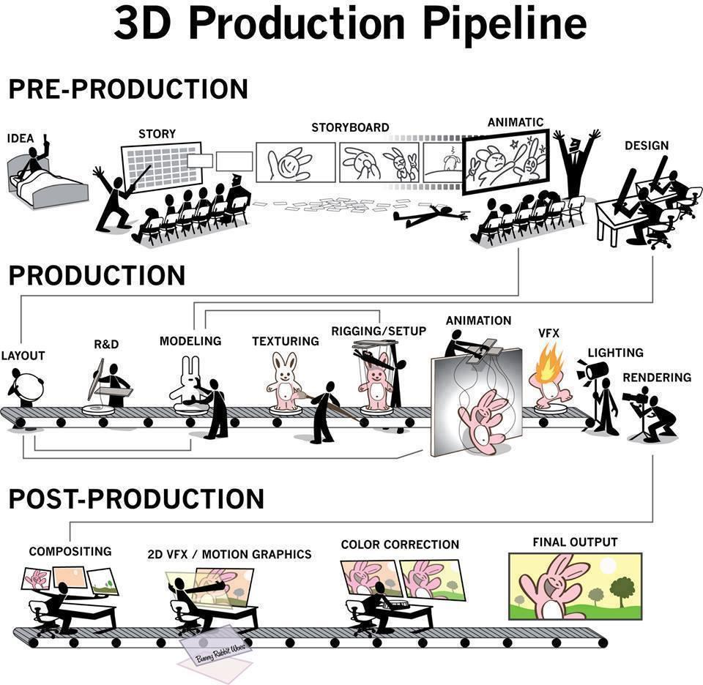
Thomas. J. McLean, November 22nd 2017, AnimationMentor, viewed 19/04/2021 https://www.animationmentor.com/blog/what-is-an-animation-pipeline/

James Cortes, April 19th 2020, University of Silicon Valley. , viewed 19/04/2021 https://usv.edu/blog/what-is-an-animation-production-pipeline/

Bryan W, March 11th, 2021, GameDesigning. viewed 20, 04/2021
https://www.gamedesigning.org/animation/pipeline/

Fabio Pellachi, 2009, Uniroma1, viewed 22/04/2021 https://pellacini.di.uniroma1.it/teaching/projects10/lectures/01_pipeline.pdf

Jiwon Paik, Cheeyong Kim, 11/2013, Research on DIsney’s 3D Animation, viewed 22/04/2021
http://www.koreascience.or.kr/article/JAKO201336447762321.pdf

Tyrone Hudson

Merits and Shortcomings
The life of an animator
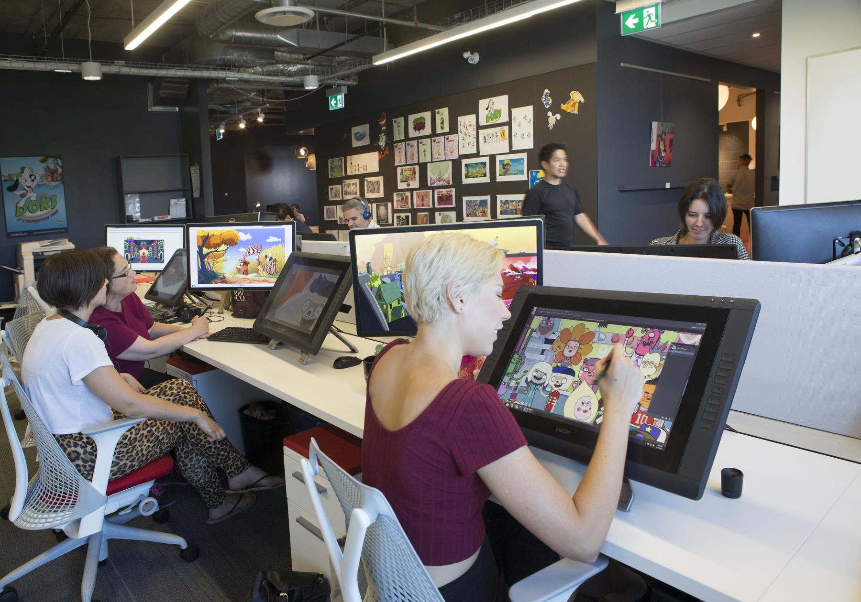

Merits
The Merits of design thinking as an animator helps you with understanding the human mind better and how people act in certain situations.

This is similar in performance and acting practices for animators to convey the personality of the character.
Animation also provides insight into the human mind and psyche by observing human interactions and analysing their mannerisms and behaviour patterns, this can also be applied to other occupations such as a counselor or social worker.

Learning how to design and making a character relatable to an audience is also a way to teach the person how to put themselves in other people's shoes and help them be more empathetic towards everyone else.

The time consuming job of an animator teaches a lot of patience and discipline, this in turn can help in dealing with unfavourable situations and help with defusing arguments.

The craft of animation is extremely intricate, the research goes into understanding human anatomy and skeleton, this lends it’s hand a little towards biology in a basic form.

Precise in animation is key to creating a cohesive character in both 2D and 3D, this precision is for acute and can be used in many other technical art practices, such as illustration or architecture.

The life of animators is very peaceful and relaxed for the most part (apart from deadlines), you can also do the job as an independent contractor for studio’s or even commercial advertising which allows for many opportunities for work.

Overall, I think that animation studies provide a lot of benefits that far reach the scope of just using it for animation, there are many implementations of other occupations that are involved in the whole process.

Shortcomings

I’d say one of the worst things as an animator is that it can get very lonely due to being hunched over a graphics tablet for 8-10 hours a day, unless you are working in a studio and have other colleagues around you to keep you company.

For me sometimes it can get very stressful and cause eyestrain the amount of concentration it takes to make sure every character and frame looks spot on, it can take up an insane amount of time from your social life too.

Another shortcoming of animation I have found is that I find it really difficult to get invested in creating a long animation from scratch because if you lose motivation halfway through or are suddenly not interested in the theme it can be very disheartening.

There are a few health issues that come with being an animator, one is having back pain for long periods of time from sitting down, it can cause muscle spasms in the back and sometimes even dizziness if you’ve been looking at the screen all day, breaks are key for anyone who is on the computer as much as an animator.

The hours for any animator can be excruciatingly painful because of the sheer amount of time it takes to do such a small piece of work, roughly it can take up to 4-6 months to do 3minutes of animation for a cinematic for example, it’s definitely more on the harder side of jobs out there.

Unless your working for a studio or in a College/University it can be very difficult to meet like-minded individuals because we all spent most of our time in the house doing the same thing day-in, day-out, so if you are going to be an animator make sure to go to events that are specifically catered towards the creative arts or animation/cgi work.

Maria Cesar, 27th November 2018, Mindstick, viewed 23/04/2021
https://www.mindstick.com/blog/12099/the-pros-and-cons-of-being-an-animator

Breann Kanobi, 7th August 2017, Classroom, viewed 23/04/2021
https://classroom.synonym.com/info-8389870-pros-cons-being-animator.html

Tim Ingersoll, March 8th 2021, AnimationMentor, viewed 24/04/2021
https://www.animationmentor.com/blog/the-pros-and-cons-of-large-vs-small-animation-studios/

Zeke, January 16th 2015, NYFA Student-resources, viewed 24/04/2021
https://www.nyfa.edu/student-resources/jobs-animation-average-salaries-career-paths/

Anja Peter, September 23rd 2019, LinkedIn, viewed 24/04/2021
https://www.linkedin.com/pulse/pros-cons-animation-anja-peter

