  Component One:  What are the key skills required when working in the housekeeping team? 750 words (+/- 10%)  Contribution to Overall Module Assessment: 25% | Student No: | 2212964 Lauren Garraghan Leonardo
 | Module Title: | Operating hotel facilities
 | Module Code: | BMIH4006
 | Lecturer: | Muhammad cassamo
When working in a housekeeping team, individuals need to develop various skills. Here various important skills need to develop to be part of the housekeeping team. The main motto of the housekeepers is focusing on cleanliness as well as safety hazards. The proper skill of the individual employees of the premier inn helps to develop a brand reputation in the right way. Here various skills need to be developed such as business management skills, customer service skills, flexibility skills, communications skills and team working skills (nationalcareers, 2023).
Week-1 Communications skills: Communication skill is an important skill of housekeeping work in the Premier Inn. I have developed good communication skills and it is very useful in this industry. Strong communication helps to create great guest experiences and it helps to portray all guest demand. My communication ability helps to create a good rapport with all guests. Through communications skill, I have developed the ability to give positive guest experiences and can solve conflicts in the right way. Right communications skill helps to boost the engagement, satisfaction, and productivity of the worker in the hotel (mooreandsmalley, 2022).
Week-2 Team working skills: Team working is another indicator of business success and I have developed this after joining Premier Inn Organisations. The corporations of workers can ensure better ability on the task and it helps to deliver flawless customer services. I can focus on the various areas of hygiene maintained and I create good impressions of the guests in the hotel. The team working ability helps to create common goals and develop trust among each other. Effective team working skill helps to manage various problems within less time and it focuses on creating efficiency for the team members. Using effective team working skills helps make the overall process easier as well as overcome various obstacles with the help of the team members (ranking, 2019). Lots of work is available in the hotel such as vacuuming, sweeping, dusting shelves, mopping floors, cleaning windows and many more. Therefore, our team manages the wash, laundry, ironing and emptying the trash cans and many more. We used to divide all work as per our shift timing and manage all tasks with the help of collaborations.
Week-3 Flexibility skills: Flexibility skill helps to create the persistence and determination of every worker in the organization. This ability creates acceptance of any changes as housekeepers develop the patience and ability to calm down based on stressful situations. I have developed flexibility after entering this hotel, I can focus on the needs as well as I can adapt to various new and unexpected areas or situations. It is expected that there are odd working hours during the festival season or any kind of event purpose. I have focused on ensuring extremely detail-oriented tasks and focusing on the cleaning professional to perform the duties successfully. Here I have developed my adjustable ability based on the schedules as well as focused on the meeting needs of the guest. The higher ability to adjust creates opportunities to grow in a career.
Week-4 Time management skill: Time management is a significant skill on the part of the housekeeping team. I have to complete all of the tasks with a successful schedule making and be able to juggle multiple tasks at the same time. I have focused on developing and organizing various tasks along with executing daily tasks in the right manner. The good ability in time management helps satisfy the supervisor as well as the guest. Good time management skills can help to maintain the consistency of business management along with maintaining the operations in the right way.
Weak-5 Customer service skills: The customer service ability helps to create positive experiences for the consumer and it helps to create positive interactions with premier brands. Strong customer service skill helps to ensure business loyalty and positive experiences to stay in the hotel. My good ability in customer survival skills helps to increase the number of repeat customers along with encouraging positive word-of-mouth marketing in the business. The premier focused more on the customer servicing skill for effectively maintaining business and I used to handle complaint polity. I apologize if I have done any mistake on the cleaning or housekeeping servicing. It created the ability to take unacceptable customer requests. I focused on turning complaints into the premier opportunities (bscaa, 2021).

References:
Janiking, (2019). The importance of teamwork - commercial cleaning, janitorial services Jani. Available at: https://www.janiking.com/jani-king-gulf-coast-commercial-cleaning/the-importance-of-teamwork/ (Accessed: 02 June 2023).
Mooreandsmalley, (2022).The importance of effective communication of a hotel manager Moore & Smalley. Available at: https://mooreandsmalley.co.uk/insights/knowledge-post/the-importance-of-effective-communication-of-a-hotel-manager/ (Accessed: 02 June 2023).
Nationalcareers, (2023) Housekeeper | Explore careers | National Careers Service. Available at: https://nationalcareers.service.gov.uk/job-profiles/housekeeper (Accessed: 02 June 2023).
Resumecat, (2023). 12 housekeeping supervisor skills: Definition and examples ResumeCat. Available at: https://resumecat.com/skills/housekeeping-supervisor (Accessed: 02 June 2023).
scaa, (2021). Customer service in the cleaning industry. Building Service Contractors Association of Australia Ltd. Available at: https://bscaa.com/training/online-courses/customer-service-in-the-cleaning-industry/#Accessed: 02 June 2023).

Word Count

Component Two:
Contribution to Overall Module Assessment: 25%
In this scenario – You have just been promoted to the team leader for a floor within the hotel. A guest complains that on their arrival, their room had not been properly cleaned. Create an action plan and answer the following questions.

Problem | Why did it happen? | What are you going to do? | How will you prevent this from happening in the future? | What measures would you introduce to improve team effectiveness?
Low-quality furnishing | The guest of the hotel faces the problem due to the lower quality of the furnishing. The furniture of the hotel creates clutter and untidiness in the hotel room ((Canry (2023). As a result, it creates unhealthy impacts among guests. | As a housekeeper, I check the quality of the furniture, and the other products such as the bed roll, bedsheet and pillow covers should be regularly replaced regularly. The hotel should choose the right furniture that enhances the well-being of the consumers. | I will focus on the streamlined process of the housekeeping operation in the hotel. I will take responsibility for the upkeep of the room and amenities that are associated with the perfect manner. | I will focus on the client satisfaction levels that help to measure the team's effectiveness.
Broken light | The guest faces problems with broken lights and electrical switches (Europe,2017). This process creates a frustrating situation among the guests. The deter guests return from the hotel rooms and it impacts profits. | I will work in a housekeeping team and should regularly check the electronic components in the proper working orders. This inspection will mitigate potential issues and the guest can experience inconvenience while staying in the hotel rooms. | I will introduce the SOP-managed team and that will help to improve the housekeeping operation and increase efficiency among the staff members. The team should clean the room within 20 minutes. | I will gather feedback from the customers through the surveys. I will ask some of the simple questions and identify the difficulties that are faced by the guest. That helps to measure team effectiveness.
Hygiene issues | The guest faces issues with cleanliness because they face the untidy condition of the bathroom and as well as the hotel could not deliver proper toiletries to hotel rooms (Hotelmogel, 2022) as a result it promotes unhealthy condition in the hotel rooms. | As a housekeeper, I should be prioritising stocking the hotel rooms with the necessary materials. They should be checkers to hard-to-reach areas. That process improves cleanliness on the hygiene issues | I will maintain the standardised quality of the cleanliness and hygiene issues. The housekeeping department maintains the highest standard by promoting room sanitisation after the check out of the guest as well as the changes of the room linen for the new guest. | I will focus on overall retention rates that process helps to measure and calculate periods. This process helps to measure the efficiency among the team members.
Dirty countertops and washroom | The guest faces water leakages from the countertops and washrooms (Ivan, 2023). As well that has the face's fingerprints and a dirty floor in the washroom that cheats an unhygienic situation for the guests. | As a housekeeper, I should prioritise the cleanliness of the surfaces that includes the washroom and mirror and other parts. Housekeeping diligent cleaning efforts and paying attention to the mashup and ensuring spotlessness to the room will be remnants from the previous guests that enhance the hygiene standard. | I will focus on inventory management which plays an important role in the hotel housekeeping operational process. This department is responsible for the distribution and requisition that short out the amenities among the guests and employees of the hotel. | I will understand the common plan that is faced by the staff and guests. Training should be handled effectively.
Dust | Guests after entering the hotel room face the cleanliness due to the dust on the large coverage area (Chloe, 2020). The dirty floor creates an empathetic situation for the guests of the hotel rooms. | As a housekeeper, I should be aware of the coverage areas and the housekeeper should clean the dust with the tool and mop up dust by cutting the corners with cleaning efforts. | I will apply the inventory technologies and that process will help to get the room updates. I will integrate with the housekeeping software that helps to deliver the room status in effective ways. | I will measure the improvement through the online feedback that helps to get the satisfaction of the housekeeping service.
References:
Canary (2023) 10 common hotel problems and solutions, RSS. Available at: https://www.canarytechnologies.com/post/common-hotel-problems-and-solutions (Accessed: 02 June 2023).
Chloe (2020) Spot signs of poor housekeeping, Signs of Poor Housekeeping and How to Avoid Them | Polo & Tweed. Available at: https://poloandtweed.com/blog/spot-signs-of-poor-housekeeping (Accessed: 02 June 2023).
Europe, C. (2017) 10 common housekeeping issues that damage hotel profits, Shoes for Crews GB. Available at: https://www.sfceurope.com/uk/blog/10-common-housekeeping-issues-that-damage-hotel-profits#j (Accessed: 02 June 2023).
Hotelmogel (2022) Hotelmogel.com. Available at: https://www.hotelmogel.com/5163-2/ (Accessed: 02 June 2023).
Ivan (2023) 10 hotel housekeeping issues that hurt hotel profitability, Impruve. Available at: https://www.impruvellc.com/hotel-housekeeping-issues/ (Accessed: 02 June 2023).

Component Three:
Contribution to Overall Module Assessment: 50%
Your task is to create and prepare a presentation following the detailed scenario provided below.

As the floor housekeeping manager and given the recent guest complaints you need to put together a basic training presentation for your colleagues within the housekeeping team to get the best out of them, ensure that brand standard is being achieved and that Health and Safety procedures are also being followed.

Introduction

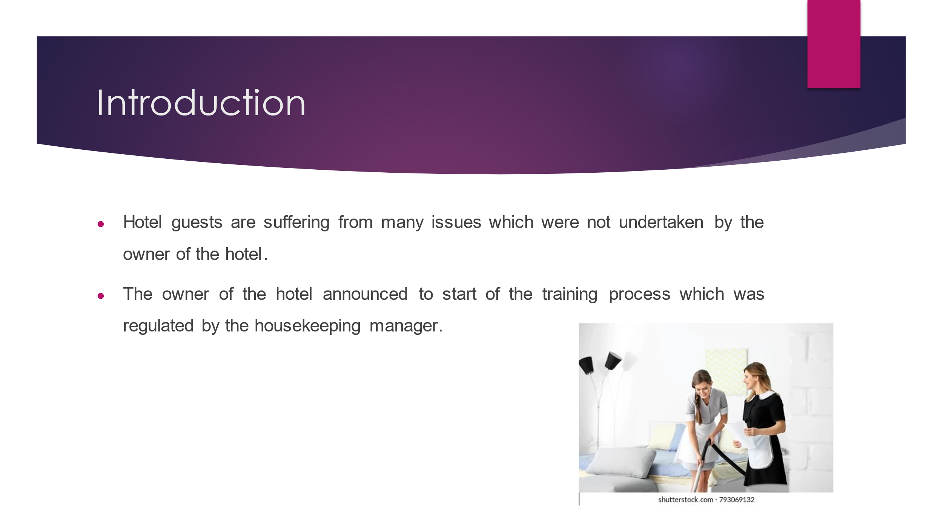
Training Notes: The purpose of this presentation is to demonstrate the training process according to the cleanliness of the hotel. This training process will help to develop better hygiene in the hotel. The presentation evaluated various issues which were complaints by the guests who visited the hotel (Shahane and Fernandes 2021). The presentation will describe various training processes to reduce the complaints which were proposed by the guests who are taking the service. Although the presentation analyses various problems such as poor quality furnishing, and light issues in the hotel room. Therefore, complaints were raised by the hotel's guests.
Training skills
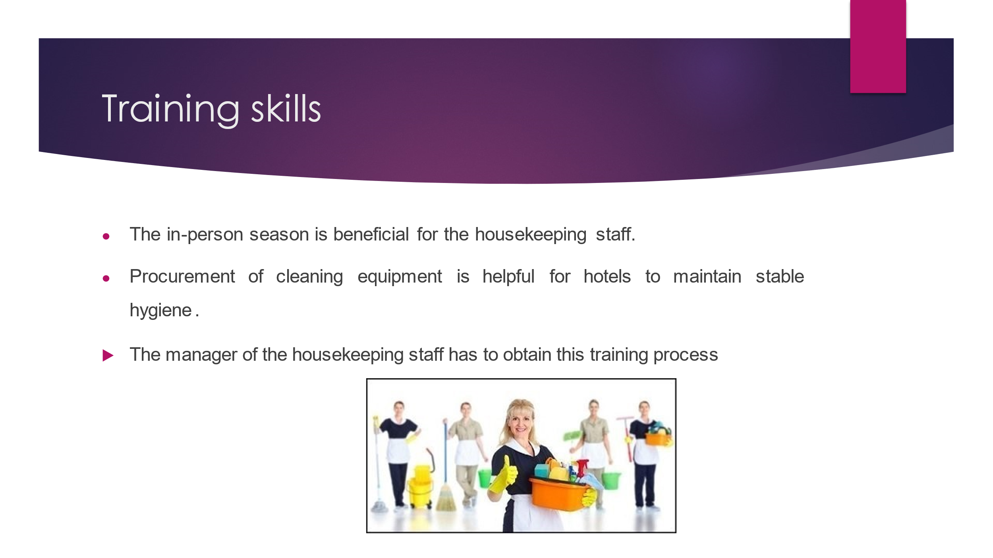
Training Notes: First of all, training for the housekeeping staff is very important for good behaviour within the hotel complex. many of the employers who do not focus to change the existing skills of the housekeeping staff. Thus, the owner of the hotel tries to build a strong team with good training skills which was adopted by the housekeeping staff (Batten et al., 2023). Let us elaborate on the training process which will benefit the housekeeping staff. The first training practice such as.
Personality training season: This training process is set up in-person professionally but yet friendly. Thus, this season clearly defines the expectations in terms of interaction, attitude, culture, behaviour, and as well as etiquette. This training process allows analysing values and principles through personal communication.
Training through video tutorial: After completing the first season, the housekeeping staff have to go through the training process (Flexkeeping 2022). This tutorial is based on the technology, techniques for cleaning, and uses of the latest types of equipment. The housekeeping manager of the hotel will showcase the presentation in the room of the hotel or near the dining area which contains the tutorial process.
Training skills
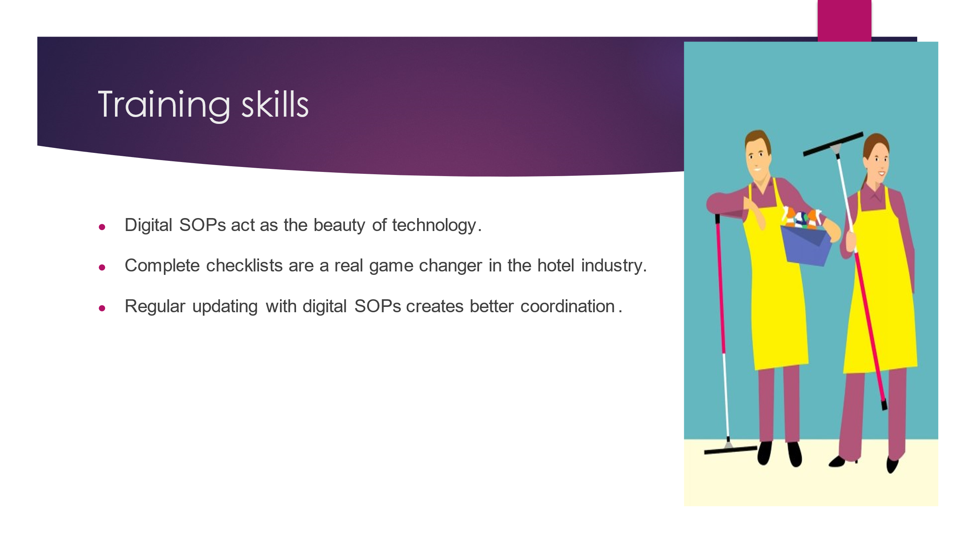

Training Notes: As earlier mentioned, the training process of housekeeping staff that should be working on a cyclical and as well as continuous process. Therefore, regular upgrading processes enhance the credibility of the hotel. in this regard, the next training process for the housekeeping staff such as.
Use of SOPs (standard operating procedures): Managers along with housekeepers' should always obtain this app on their mobile devices. Thus with the help of these digital SOPs, the training process can be held as a continuous process.
Complete checklists: While using a digital checklist, this procedure helps to ensure the tasks which have been completed or not and whether each of the tasks is running smoothly or not (Flexkeeping 2022). housekeepers should break the goals into smaller parts to remain motivated and which helps to reduce the stress level.

Cleaning skills
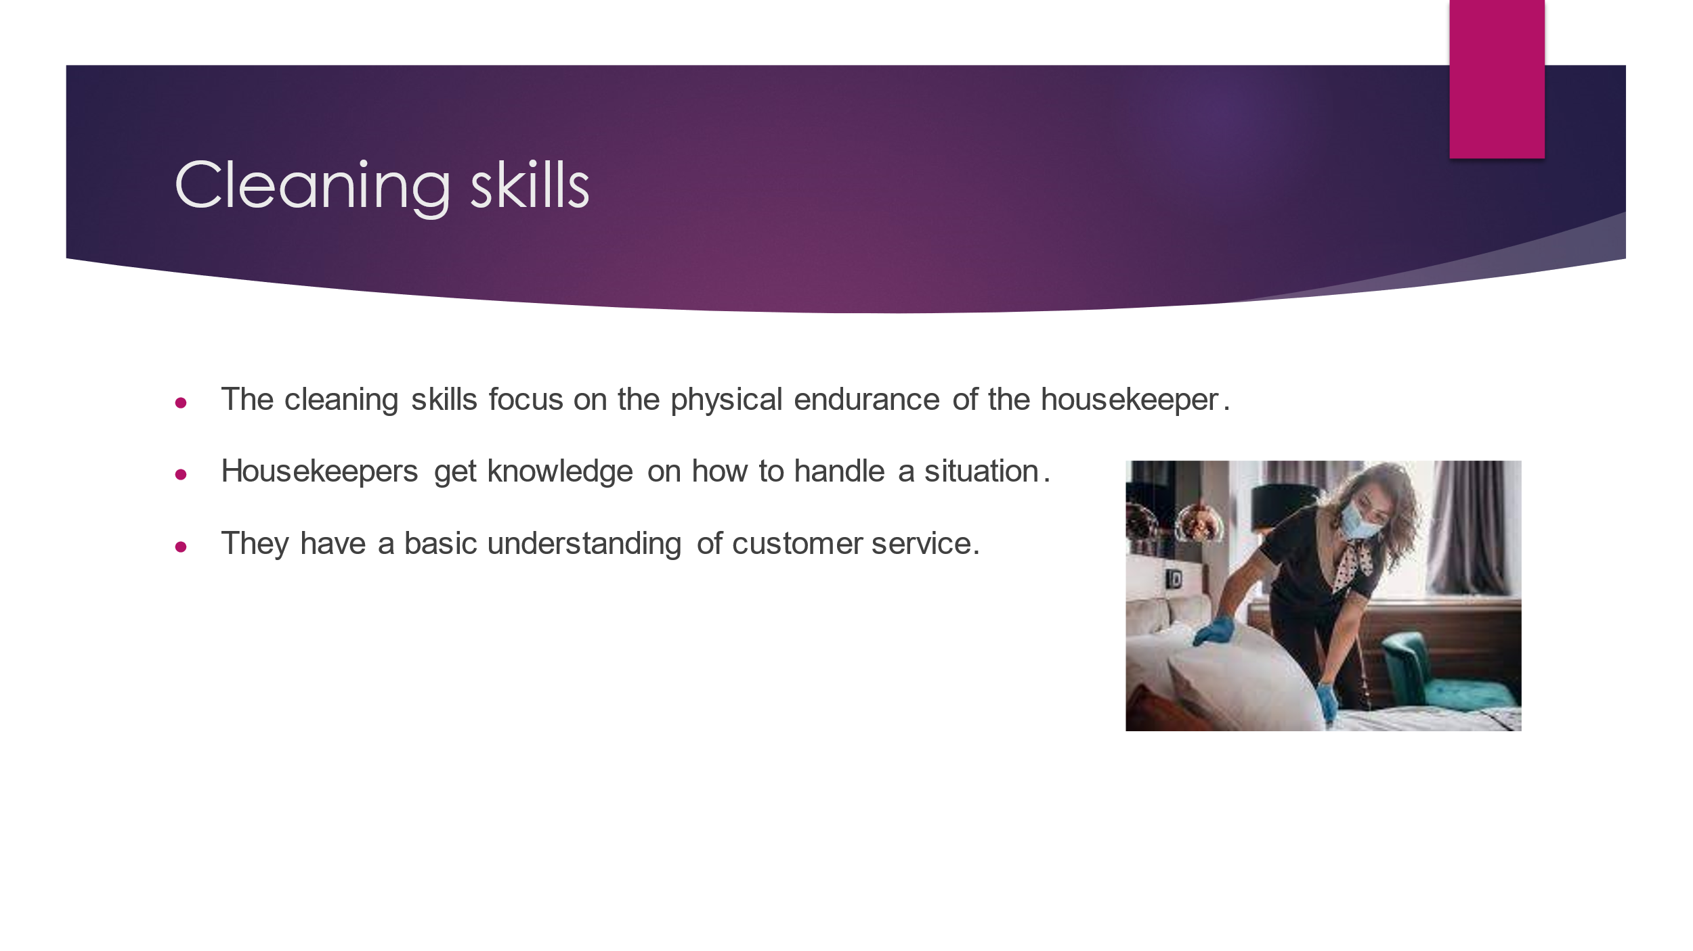

Training Notes: The guest of the hotel facing challenges due to the cleanliness issues. Therefore the Premier Inn promotes effective training on cleanliness they promote effective techniques to get the desired result. The housekeeping training establishes common ground for the housekeeping team (Vijaya et al. 2020). The training program increases the ability to increase efficacy on the specific skills as a result the team can hone skills during the cleaning skills section of the training.
Equipment and products
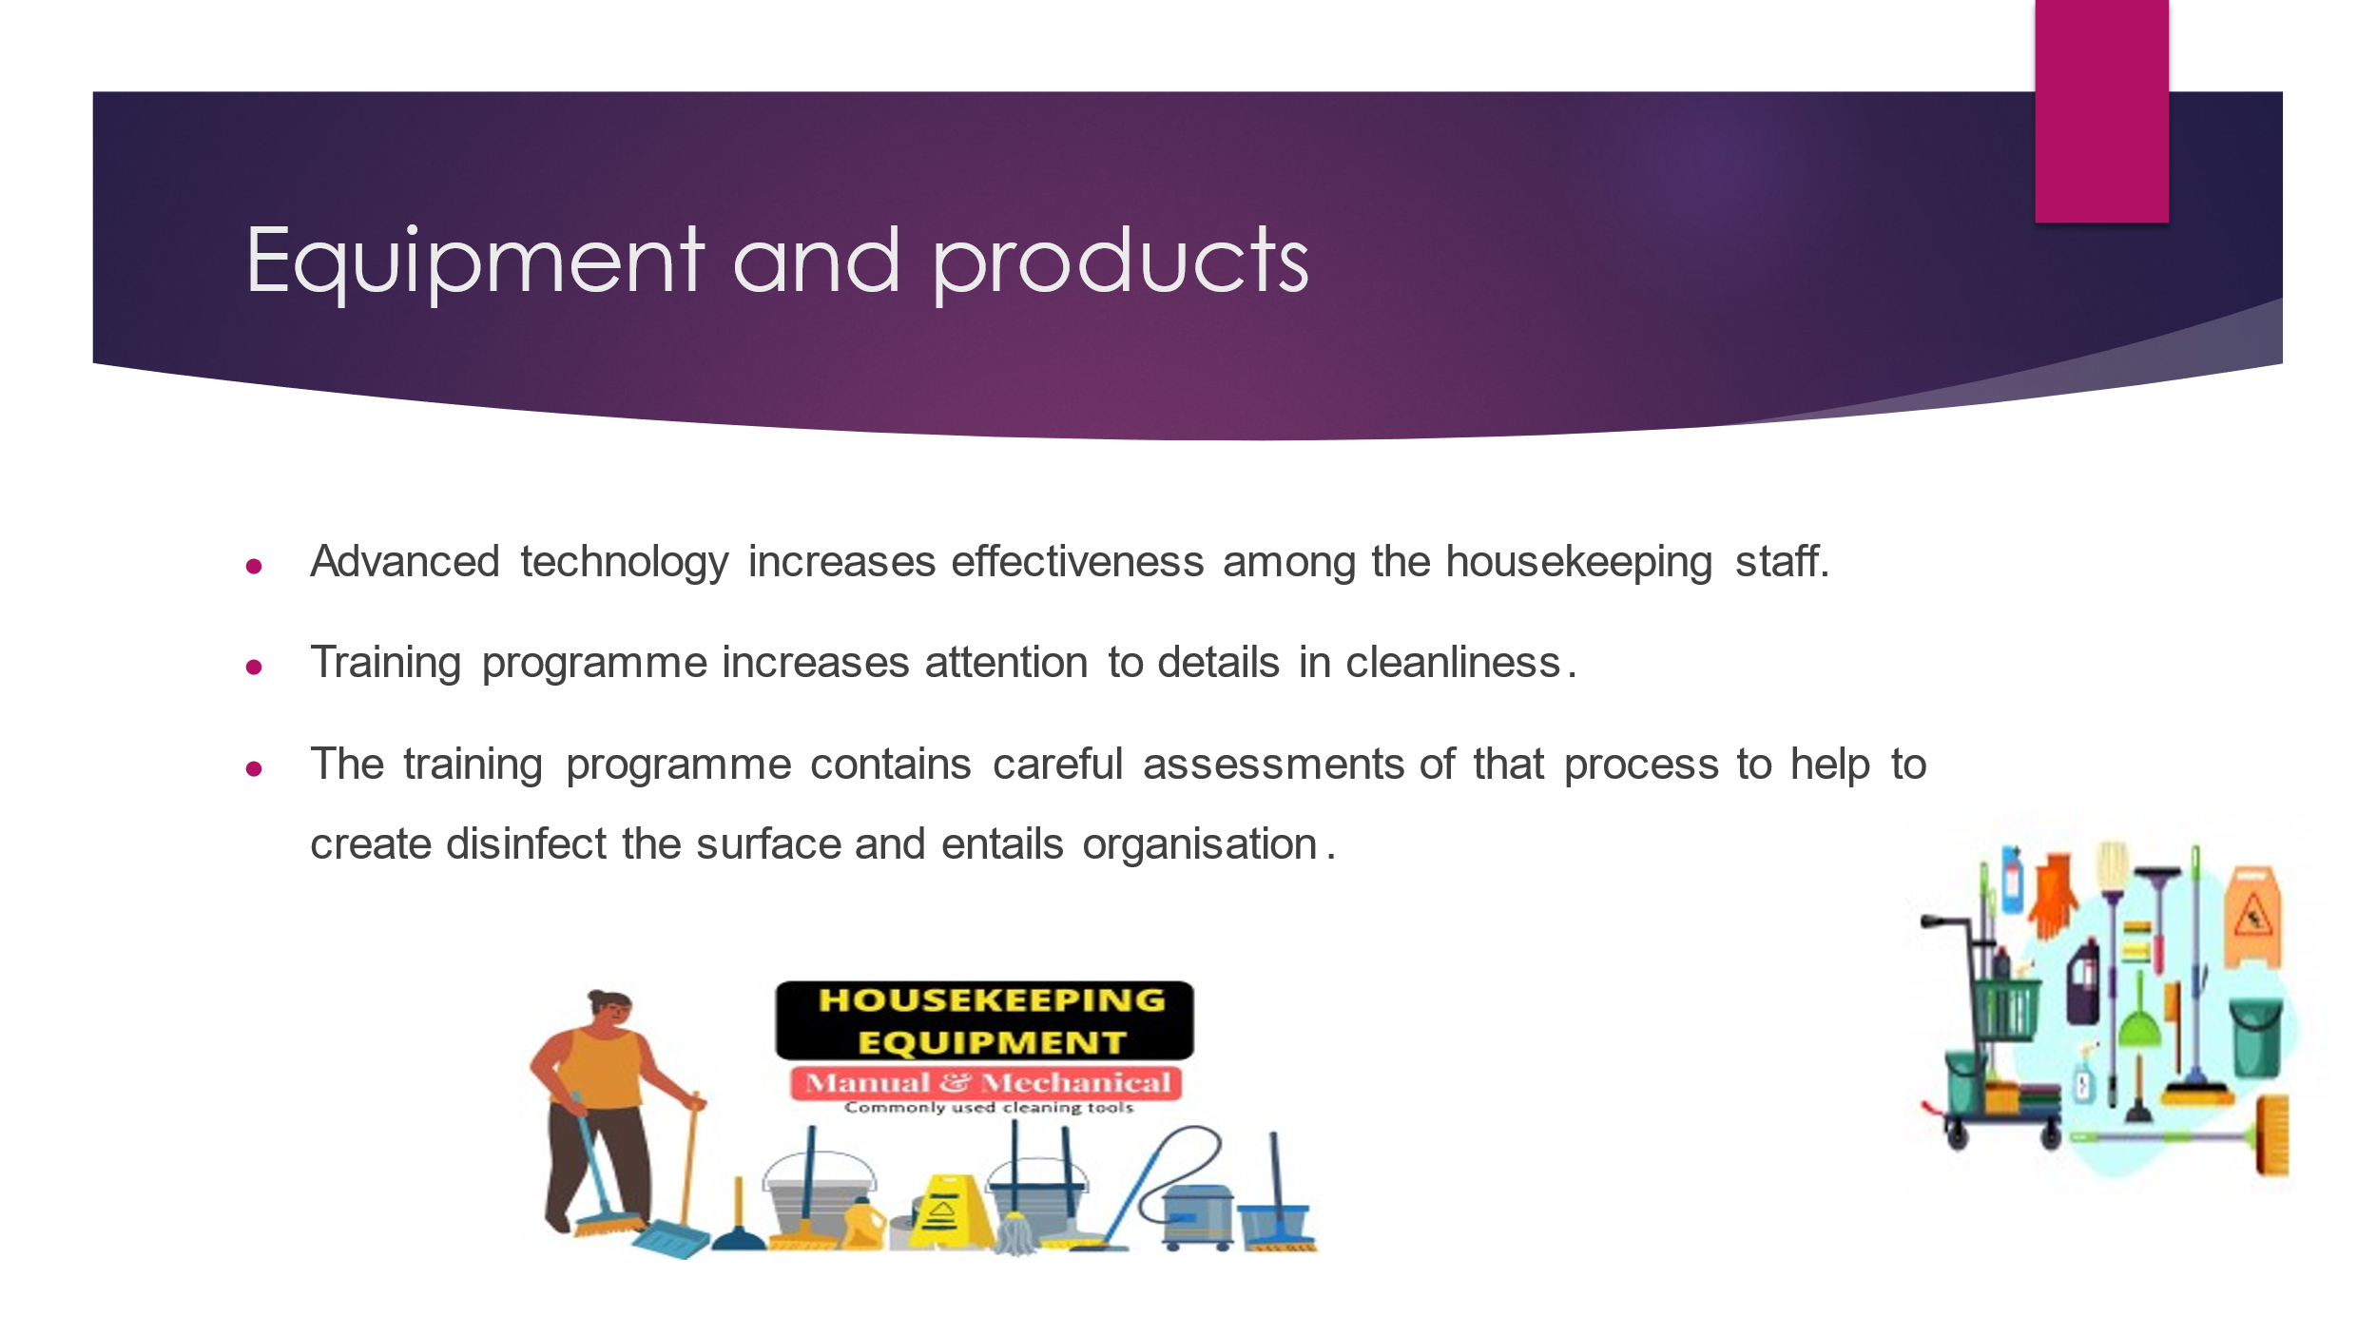

Training Notes: The training programme will use the equipment and products that analyse the actual skill and techniques. This actual equipment and products are familiar to the housekeeping staff (Tra, 2022). The training process should include advanced technologies that improve time management as well as the increased effect on the working process of the housekeeping staff of the Premier Inn.

Health and safety procedure
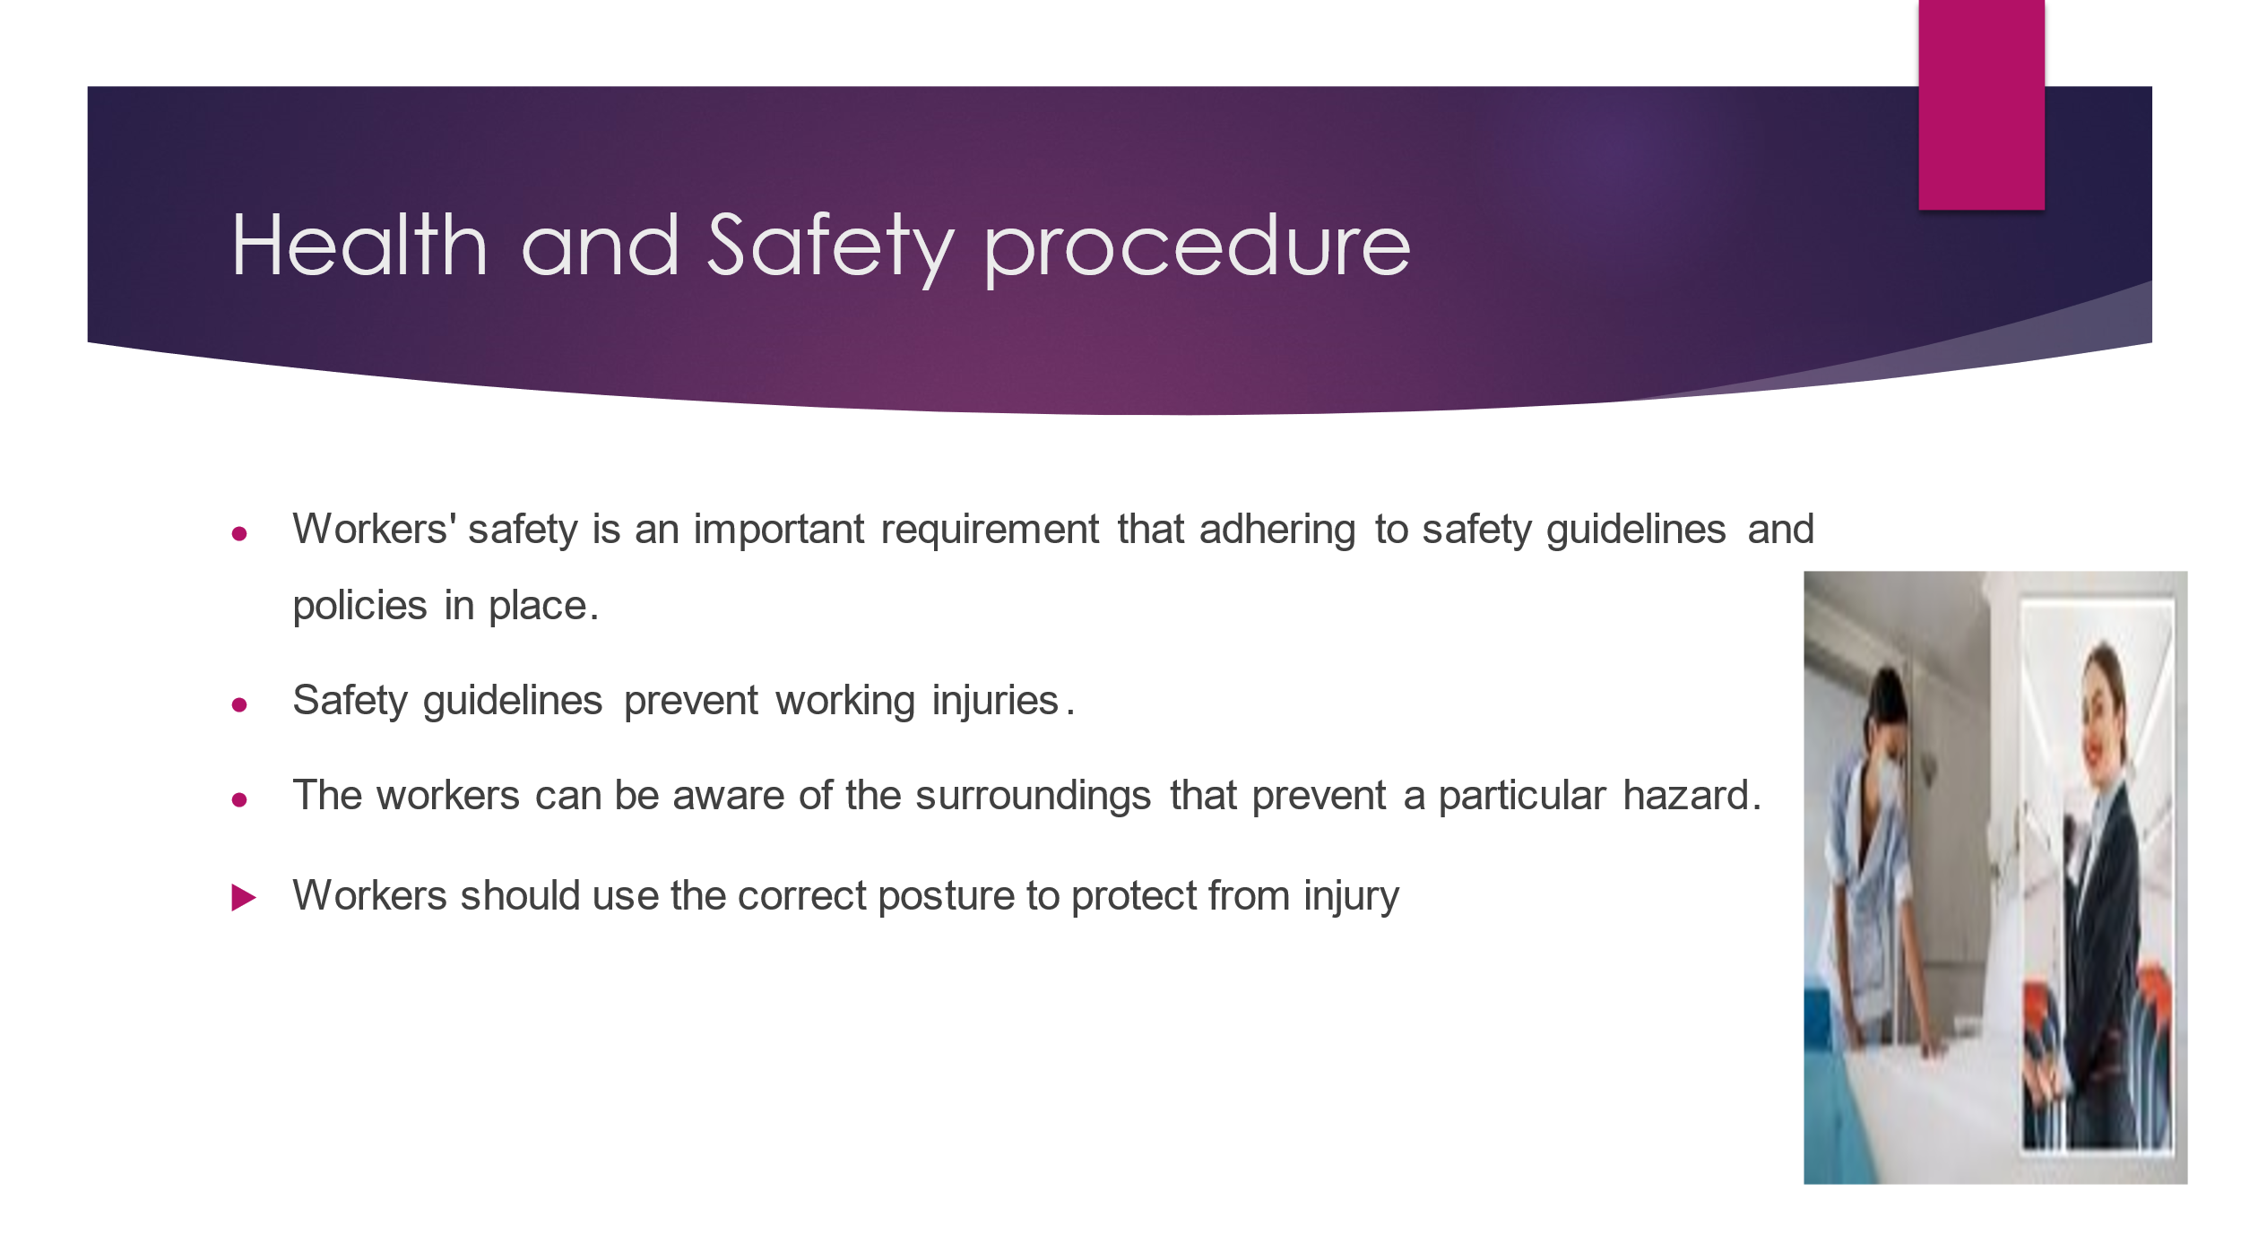

Training Notes: Housekeeping involves waste elimination programs throughout the organisation. The organisation follows the 5s process that refers to sustain, standardisation, clean, set in order and sort etc. Effective housekeeping programs eliminate the hazard in the working place (Rally, 2021). Housekeeping promotes management and organisation that effectively maintains waste management. The housekeeping plan manages order storage and includes the material flow plans. It ensures minimal handling.
Guest Etiquette

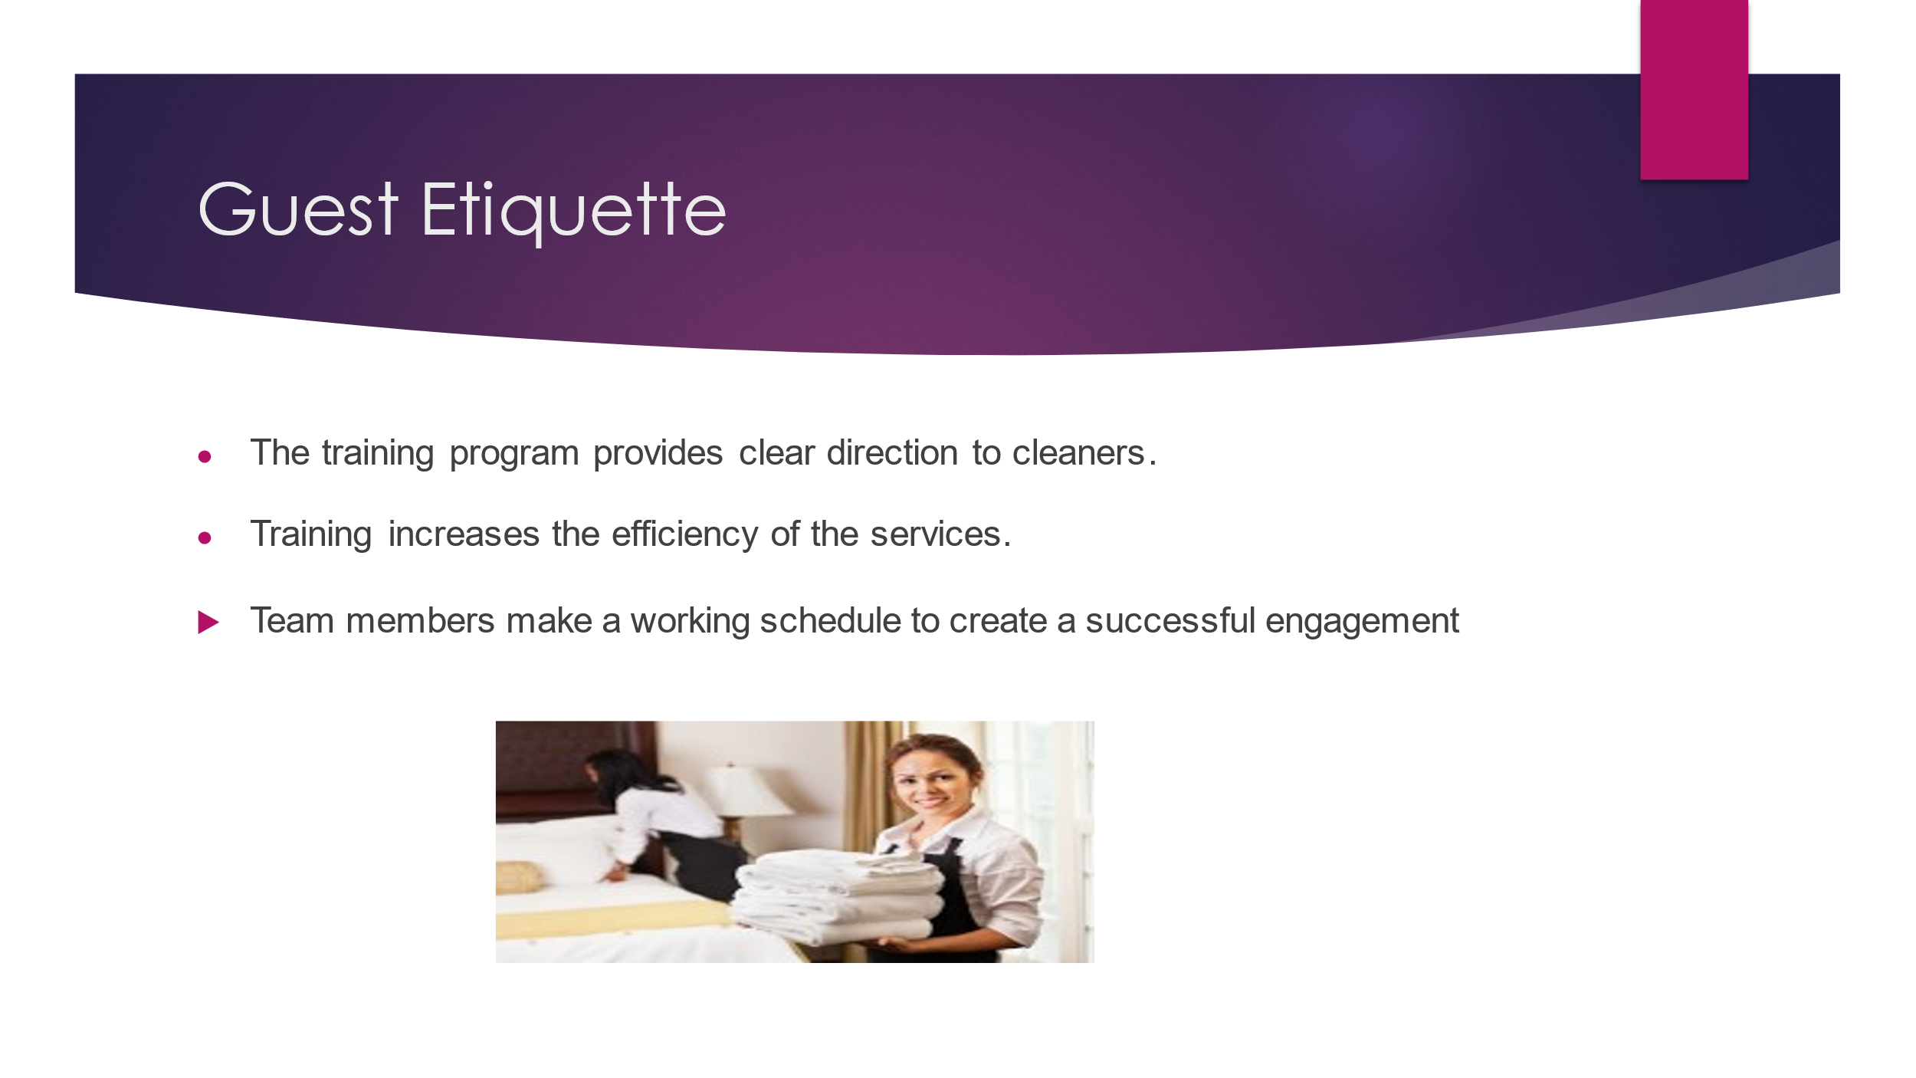

Training Notes: Guest interaction is a principle element for housekeeping works and the process has to be regulated for the working procedure. Interaction among the guest and housekeeper interacts indirectly. Housekeeping management works through the technological medium. Training programs evaluate the larger aspects of the training (Services, 2019). Guests share their experiences with the management team after that the housekeeping management encounters the situation of the guest. After that, they will provide effective services towards the customer experience.
Team framework
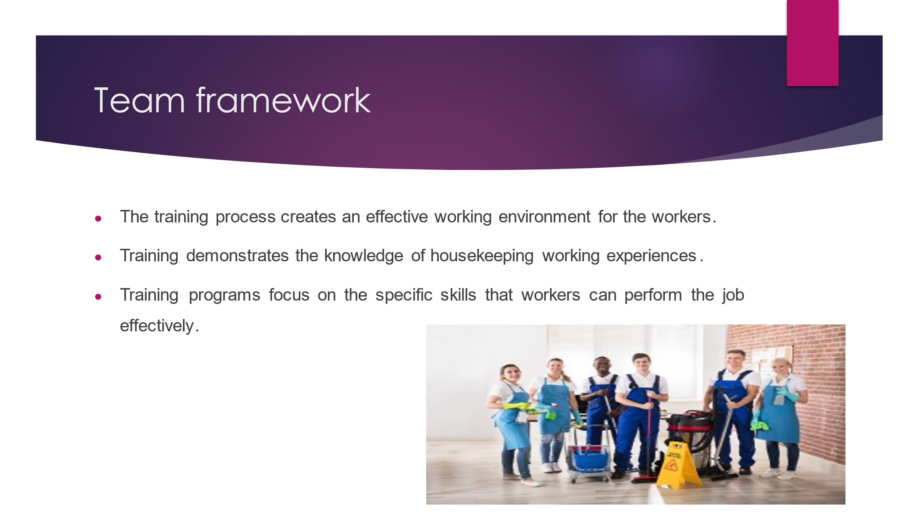

Training Notes: The Premier Inn organisation should implement a training programme for the new workers in the housekeeping department. The training programs should be designed through the three main stages and implemented schedules (Ccohs, 2023). Therefore the new workers get knowledge about the housekeeping function. Training protocol used for the accommodation business to the hotel operational process.
Employee engagement model
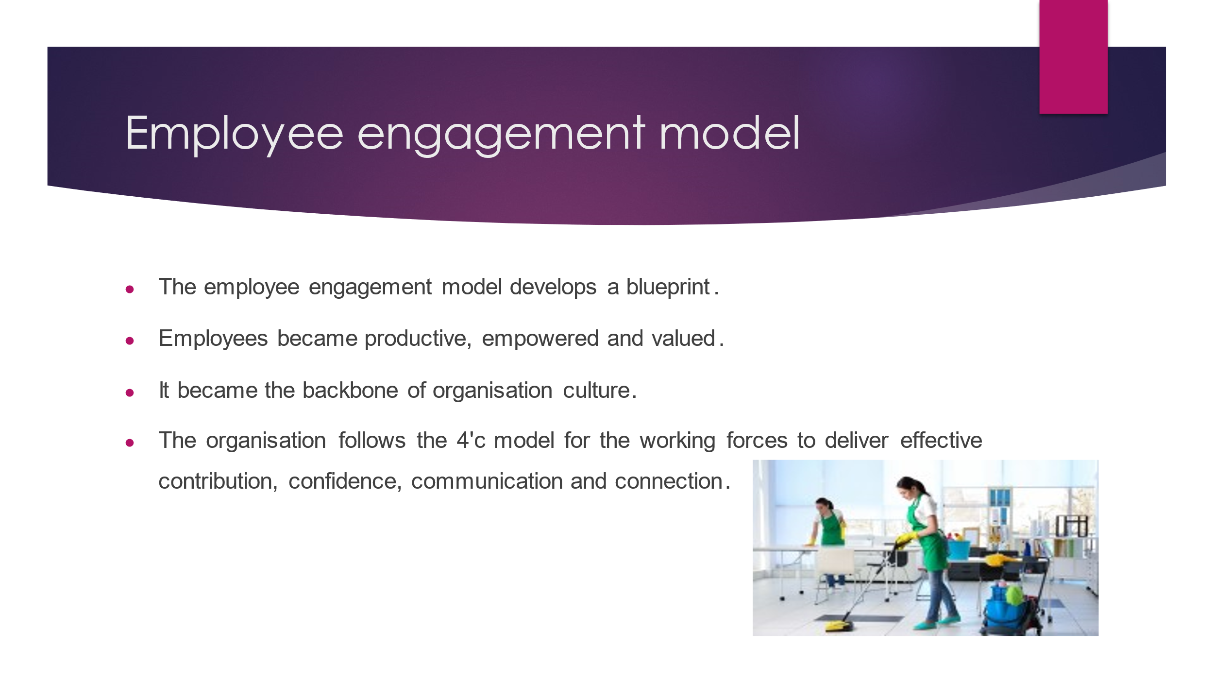

Training Notes: Engagement of the employees involves effective policies with the right managerial and provides effective guidance to the leaders of the housekeeping departments. Engagement consists of the working forces that promote success for the working forces. Employee engagement maximises satisfaction among the employees as well as increases contribution to the organisation (Casey, 2023). Therefore the workers can promote contribution to the organisation's operational process that leads to the success of the operational process.
Conclusion
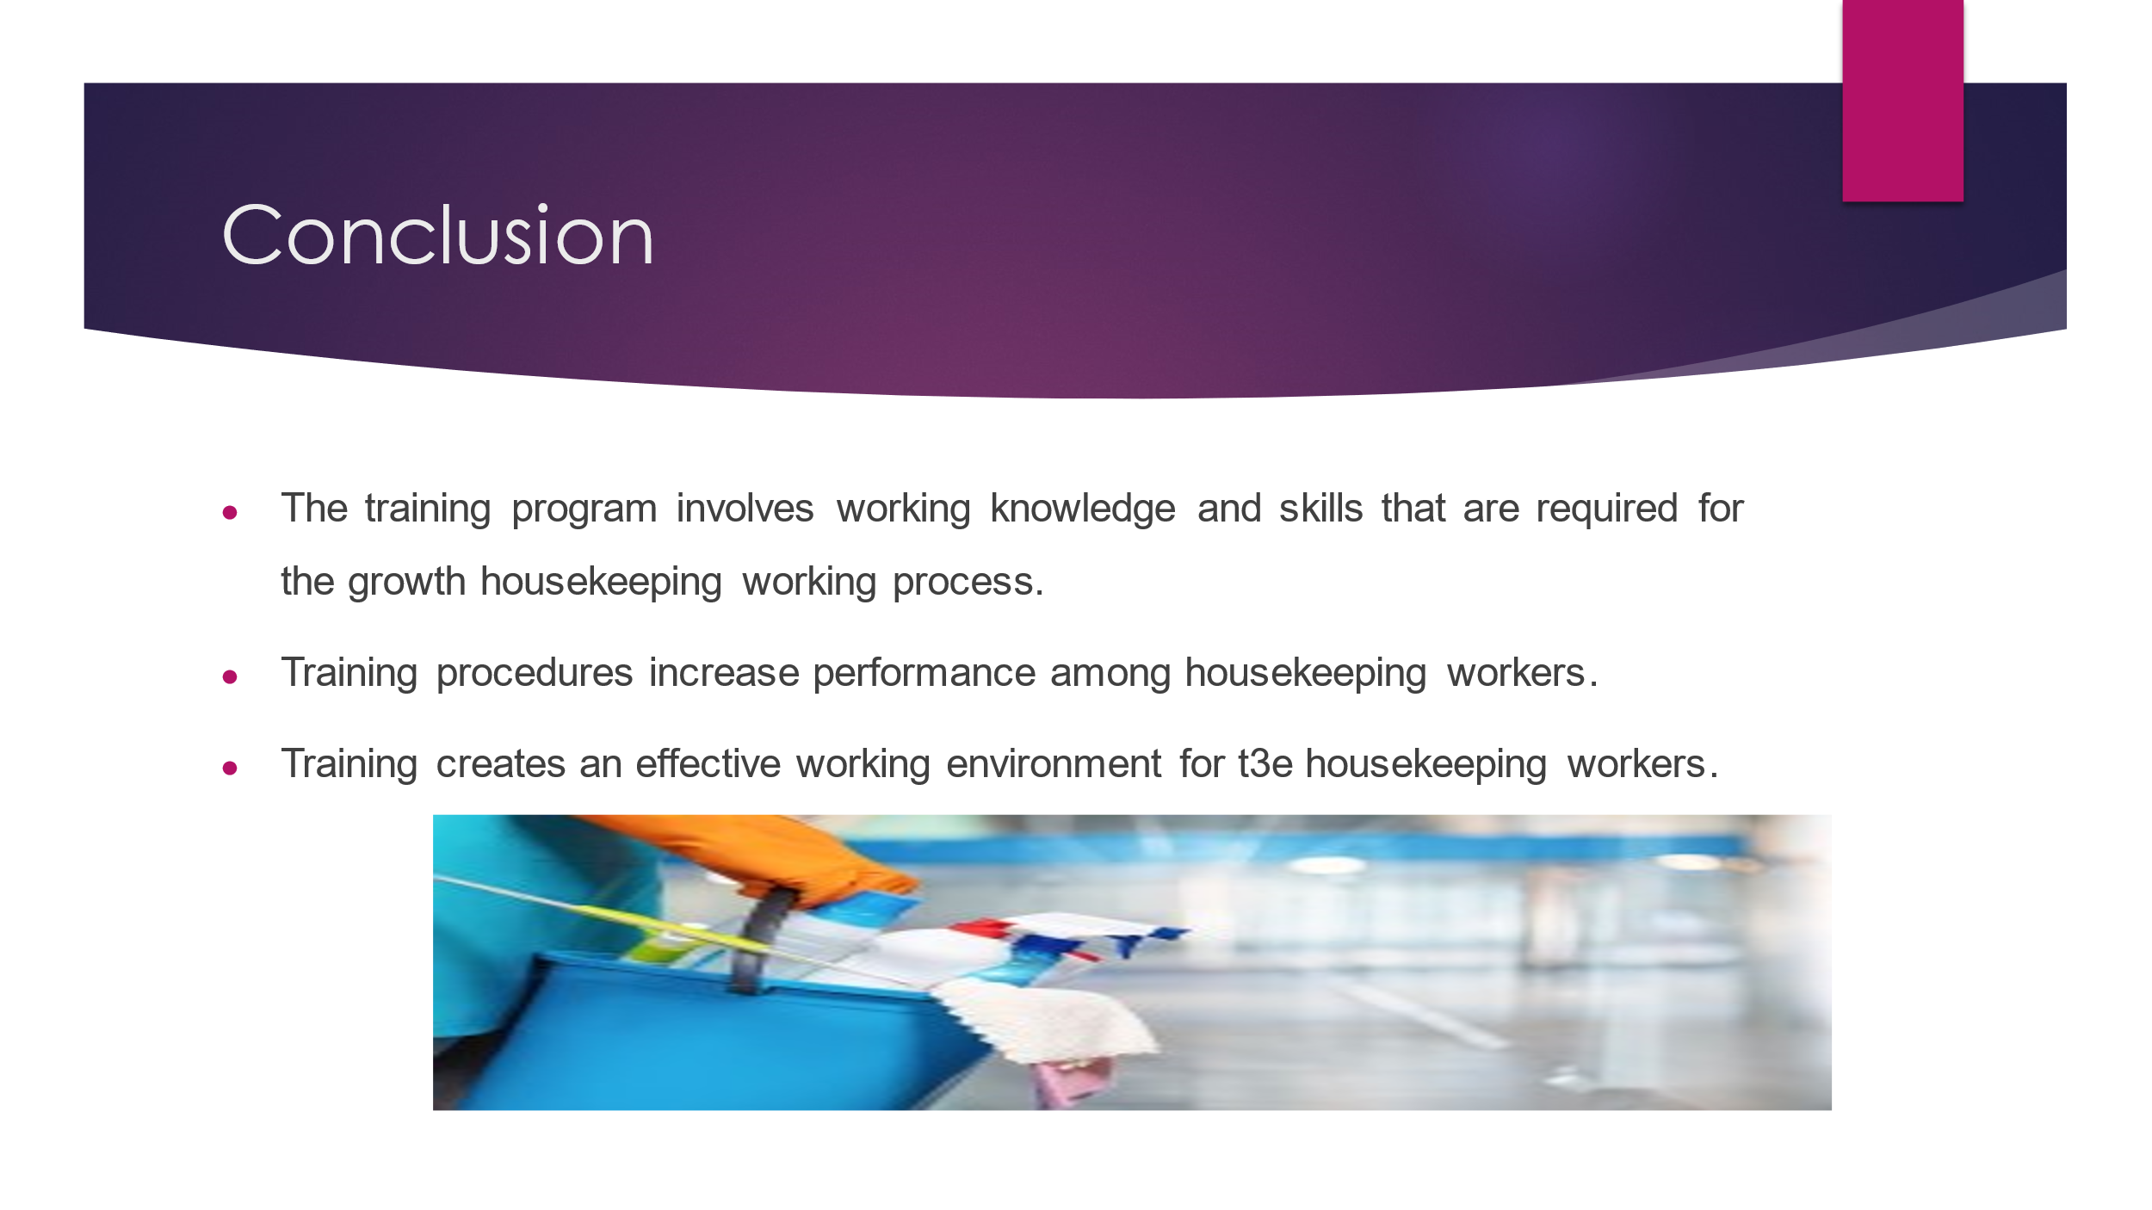
Training Notes: The training program focuses on the interpersonal skills among the team members which are listening skills and communication skills. The team collaboration process is vital for the housekeeping job. Training programs achieve the standard performances towards duties. The House skills training comprises different aspects of employee aptitude, technical skills, personal; and knowledge development for the property. Housekeepers follows the hotel's standard procedure and instruction and procedure maintain clean and neat condition.

References
Battan, R.M., Kattan, W.M., Saqr, R.R. and Alawi, M., (2023). The effectiveness of simulation-based training on KAU hospital housekeeping staff performance. Infection, Disease & Health.
Casey, C. (2023) Employee engagement in times of crisis, GP Strategies. Available at: https://www.gpstrategies.com/inspiring-your-workforce-in-times-of-crisis-the-4-cs-of-employee-engagement/ (Accessed: 02 June 2023).
Ccohs. (2023) Workplace Housekeeping - Basic Guide, Canadian Centre for Occupational Health and Safety. Available at: https://www.ccohs.ca/oshanswers/hsprograms/housekeeping/house.html (Accessed: 02 June 2023).
Flexkeeping (2022) 5 best practices for Hotel Housekeeping training Flexkeeping. Available at: https://www.flexkeeping.com/hotel-housekeeping-training-tips/ (Accessed: 02 June 2023).
Rally (2021) Occupational Safety Tips - Workplace Safety, SLMA. Available at: https://www.slma.cc/occupational-health-safety-tips/ (Accessed: 02 June 2023).
Services, L.B.C. (2019) 4 essential etiquette for house cleaning tips, McKinney House Cleaners | Plano Maids | Lemon Blossom Cleaning Services | Frisco, TX. Available at: https://lemonblossomcleaning.com/4-essential-house-cleaning-etiquette-tips-to-remember/ (Accessed: 02 June 2023).
Shahane, R. and Fernandes, M., (2021). To Study the Training Program Implemented by the Housekeeping Department for Onboarding Staff in a Post-Pandemic World and its Impact on Employee Motivation. Atithya: A Journal of Hospitality.
Tra, T. (2022) Action plan for training New Housekeeping employee - theseus. Available at: https://www.theseus.fi/bitstream/handle/ (Accessed: 02 June 2023).
Vijaya, R., Sharma, A., Daga, A. and Gopichandran, L., (2020). Effectiveness of structured training programme on infection control measures among housekeeping workers in selected intensive care units at tertiary hospitals. JoNSP, 10, pp.51-56.

