Community Engagement
Assessment 1

Student’s Name: Raul Trif
Student’s Id: 2030167

Table of Contents
Introduction 3
Literature Review 3
Community Engagement at WildWorks & Multistory 4
Events of project 4
Community engagement skills, knowledge and strategies 5
Community engagement through the social media platform 7
Training and development needs of employees 8
Recommendations 9
Conclusion 9
References 10

Introduction
Community engagement means bringing people together to make good relationships with them and to create a better community (Gilchrist, 2009). Community engagement makes the community a unit where people work together and share their ideas with their interested parties who are called stakeholders. Community engagement is very significant for the business organisation it led to improve outcomes for the organisation and promote the products and service of the organisation. Community engagement creates a positive workplace in the organisation and helps to build a relationship with the employees. In this module, we will discuss the concept of community engagement and the standards that enable people to engage in the community. We will also develop and evaluate several community engagements examples which are conducted by the selected organisations WildWorks & Multistory which are working for the development of community engagement.

Literature Review
The process of bringing people together is known as community engagement where people work collaboratively and share their ideas with the parties who are interested (Day, 2006). Community engagement helps to build a better community by engaging people together which includes education, healthcare, housing and urban development and transportation. Community engagement encourages people to work collaboratively and encourages collective decision making. The members of the community are involved in collective decision making and also involve in policy involvement (Bowen and others, 2010). Communication skills, interpersonal relation making skills and management skills developed through community engagement. Community engagement is very significant for the business organisation it promotes products and services which improve the outcome of the organisation. Community engagement increases community participation and collaboration and it also increases empowerment. Through community diversity, community engagement increases the sustainability of the organisation and it also fosters a strategic plan to accomplish border community visions. Community engagement help to identify the challenges and barriers of the community and help to understand the impact of community contribution (Barnes and Schmitz, 2016).

Community Engagement at WildWorks & Multistory
The process of working collaboratively is known as community engagement which brings people together and helps to create a relationship with the neighbourhood who are known as stakeholders. There various processes that can engage people to build community and make a relationship with them. Some of the projects which are taken to build community engagement are described below:
Community engagement is very significant to bring residents, businesses and local authorities together. To bring residents, businesses and local authorities together we decide to create a suitable project named honouring the past valuing the present and imaging the future. The project aims to create a receptive climate for discussions about the future and to facilitate the communities about their hopes and fears for the future. The project also creates a respective environment where other agencies can work with us and can share their past and future hopes.
Multistory is a community arts charity organisation that works with the people to make art that reflects their lives and their past experiences (Rochester and others, 2012). Imaginary Journey is a project of Multistory community organisation which is a participatory project that is conducted to bring residents, businesses and local authorities together. This project is initiated and funded by urban people and will be managed by an art organisation. This project aims to engage people in communities by using the creative arts where a diverse range of artists will participate. This project engages residents by using arts and creative activities which will give entertainment to the people. The project will take place across Cornwall to build a relationship and communicate with a new audience.

Events of project
This project will create various events to engage people and encourage them in community building. For example, the project will start with a project on memory through map-making where children will make a poetic map of St Dennis with their own important and secret places. In this project, children will be invited their elders to a tea party where they will be asked to bring photographs and art that contain their memories and experience. From this event, children can learn and they will be surprised when they see how much they had in common with their elders. At the same time, extraordinary photographs or art will be a poster in the project and children will encourage to store their present experiences so that they can share them with their future generations. At the same time, the project will also create an event where 15 community members will participate from the age of 10 to 84. In this event, they will be asked to travel to their favourite places in the city on foot and a team will capture their walking street where they love to walk and make a map of this. After that, all the 15 members' maps will be submitted to the project which will give an idea about the commonplace that they like. From this event, the member will be surprised when they noticed that most of the member's favourite place is the same it will help to create a bonding with them.

Community engagement skills, knowledge and strategies
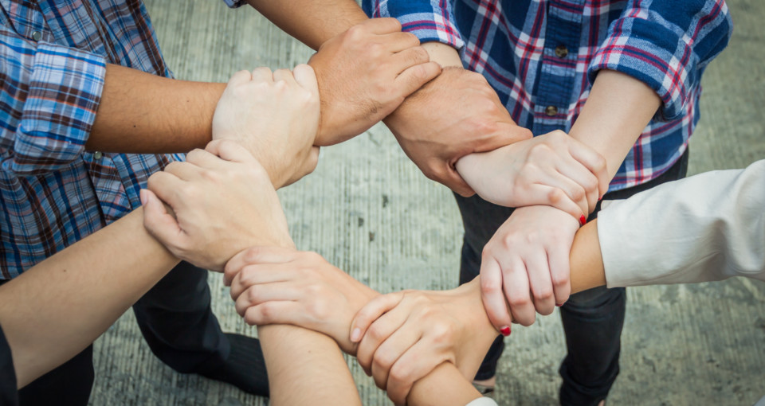
Figure: Community Engagement (Gilchrist, 2009).
Community engagement is very significant to increase community participation and collaboration. Increasing sustainability potentials through community diversity, require skills, knowledge and strategies. Some of the skills, knowledge and strategies are mentioned below:
Decision-making skills: Decision-making skill is very significant in the workplace and leadership process. In WildWorks & Multistory organisation they arrange the various voluntary event and various charity work for this reason members need to decide in the various situation so it is needed to have proper decision-making skills. The right decision can increase the efficiency of the work and increase the productivity of the organisation (Skinner, 2015).
Problem-solving skill: Problem-solving skill is very significant in community engagement. This skill helps to handle the critical situation in the organisation and an effective problem solver can easily find a suitable way to reduce the risk. A perfect problem solver does not afraid of the unknown and they can organize their time intelligently. For doing volunteer work it is very significant to have the ability to handle the problem and make a quick decision.
Communication Skills: Effective communication skill is very significant for professional and personal life. Communication skills help to understand better people and situations to avoid conflict in the organisation (Clifford and Petrescu, 2012). To engage people in the community and to build community engagement it is needed to develop communication skills. In the community, engagement collaboration is needed so it is needed to have good interpersonal skills so that one can manage and lead an organisation effectively.
Time management skill: Time management skills ensure that you have enough time to complete the task it increases the productivity of the work and it gives a bigger opportunity to achieve a bigger goal. WildWorks & Multistory organisation crate various events to engage people where need to proper time management because without schedule organisation cannot reach their target goal in time. So, the members of the organisation need to practise proper time management skills.
Fundraising skills: Fundraising skill means the ability to build funds. Though WildWorks & Multistory are charitable organisations they need to have funds to serve the people and to organise various events. Members of the organisations need to have the skill of arranging funds by convening people. So, they need to have good communication skills and interpersonal skills which will help to communicate with people effectively and interpersonal skills will help to manage people for funding.

Community engagement through the social media platform

Figure: Community engagement through social media (Skinner, 2015).
Social media become an integral part of our life about 3.6 billion people use social media worldwide and this social media plays a vital role in community engagement through their actions on social media with their audience. Most of the time people engage in social media and they share their experiences, likes, comments, and conversations through direct messaging, mentioning so it can be a good platform to engage people together. The organisation can promote their products and service through social media and can show support for a key player in the organisation (Habibi and others, 2014). Most business organisations use social media platforms to directly communicate with their customers and stakeholders. To engage people in the community WildWorks & Multistory organisation create various events. They can launch events on social media platforms so that they can engage a huge member at a time. They can arrange their art competitions and storytelling events on social media. People can post or share their experiences on this social media so that all the members can learn about them and children will inspire by their experiences (Lee and others, 2011). Students can also make a flow chart of their event and can poll an event on social media platforms. By creating a group WildWorks & Multistory organisation can engage people easily where members can message each other which will help to build a relationship with them. By using social media organisations can build their fund and can help people by analysing their needs which will help to create a better society. WildWorks & Multistory can also communicate with their stakeholders through social media and can involve them in workshops and seminars through the campaign on social media.

Training and development needs of employees
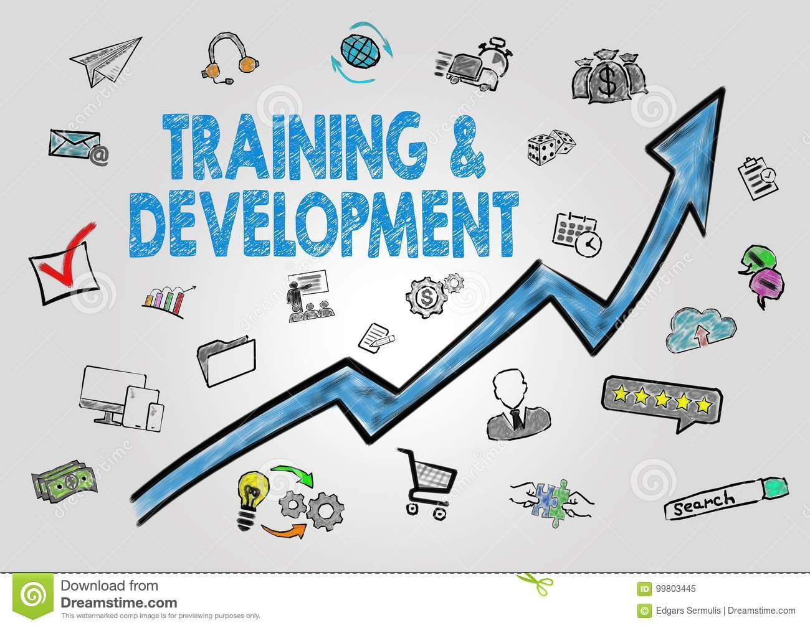
Figure: Training and development (Rochester and others, 2012).
The training and development process is very significant for building community engagement because it encourages collaboration between stakeholders and scheming the right explanations for the local context (Sal and Raja, 2016). Training and development process help to work effectively with the community groups and members. At the same time, it also gives a management strategy for setting up community engagement in the workplace of the organisation. Training and development help to increase the ability to work closely with the operations manager and logistics staff. As WildWorks & Multistory continuously participates in community engagement they need to have the proper training for the betterment of the organisation. They also need to increase the skills and experiences of the member by arranging training programs so that they can effectively engage in the community. All around the world, there are various cultural and sociocultural concerns so members need to learn about these and need to comprehend them to assist people in the community. To train members about multiculturalism organisations need to be proactive and need focus on forward-thinking strategies to effectively and efficiently deal with the people. By arranging training and development process organisations need to ensure that they gain communication, leadership, management creative thinking, problem solving and negotiation skills so that they can implement these skills where they need.

Recommendations
Community engagement is a very crucial part of the organisation and for society, it increases visibility and empowers the communities. Community engagement enables students to integrate community actions initiatives and promote sustainable decisions by recognizing and communicating their needs. Community engagement drives social transformation and promotes advocacy by raising awareness. WildWorks & Multistory organisation work for developing the community engagement so they need to focus on their strategy and need to develop their employees’ skills and knowledge by arranging training sessions. They also need to motivate their employees to get involved in community engagement and they also need to arrange more events to involve people in the community. Organisations also need to campaign more to engage people in the community and need to create an event for all ages people where they can make an interrelation among them (Falola and others, 2014). To understand the problems of the people organisations, need to contact the community and need continuously communicate with them.

Conclusion
A community means a group of people with common characteristics who live in a particular area and work collaboratively. Community engagement is very significant for the business organisation it helps to create a community where members share their ideas with interested parties who are known as stakeholders. Community engagement helps to build community skills, interpersonal skills and communication skills by involving the community engagement process. Community engagement increases empowerment and increases community participation and collaboration so various charity and voluntary organisations work for community engagement.

References
Barnes, M. and Schmitz, P., 2016. Community engagement matters (now more than ever). Stanford Social Innovation Review, 14(2), pp.32-39.
Bowen, F., Newenham-Kahindi, A. and Herremans, I., 2010. When suits meet roots: The antecedents and consequences of community engagement strategy. Journal of Business Ethics, 95(2), pp.297-318.
Clifford, D. and Petrescu, C., 2012. The keys to university–community engagement sustainability. Nonprofit Management and Leadership, 23(1), pp.77-91.
Day, G (2006) Community and Everyday Life. UK: Routledge.
Falola, H.O., Osibanjo, A.O. and Ojo, I.S., 2014. Effectiveness of training and development on employees' performance and organisation competitiveness in the nigerian banking industry. Bulletin of the Transilvania University of braşov, 7(1), p.161.
Gilchrist, A., (2009). The Well-Connected Community, a networking approach to Community Development. London: Policy Press
Habibi, M.R., Laroche, M. and Richard, M.O., 2014. The roles of brand community and community engagement in building brand trust on social media. Computers in human behavior, 37, pp.152-161.
Lee, D., Kim, H.S. and Kim, J.K., 2011. The impact of online brand community type on consumer's community engagement behaviors: Consumer-created vs. marketer-created online brand community in online social-networking web sites. Cyberpsychology, Behavior, and Social Networking, 14(1-2), pp.59-63.
Rochester, C., Ellis Paine, A., Howlett, S. (2012). Volunteering and Society in the 21st Century. Palgrave: Macmillan
Sal, A. and Raja, M., 2016. The impact of training and development on employees performance and productivity. International Journal of Management Sciences and Business Research, 5(7).
Skinner, A., 2015. ‘Voice of the Visitors’: An Exploration of the Work of the Charity Organisation Society in Oxford, 1878–1880. Midland History, 40(1), pp.74-94.

