

Financial business report
  - 2021
cal@majesic.co.uk

Contents
Summary- 4
Appendacies- 7
Promotional Items- 7
quote 1. 7
Quote 2. 7
Business Cards. quote 1. https://www.vistaprint.co.uk/business-cards/square?couponAutoload=1&expiredCouponCode=VP1512&GP=12%2f09%2f2020+13%3a15%3a30&GPS=5850017464&GNF=1 8
Quote 2. 8
Travel – 8
Ferry- Quote 1. 9
Quote 2. 9
London travel- quote 1. 10
Quote 2. 10
Travel from Swansea to London- 11
Quote 1. 11
Quote2. 11
Parking- Quote 1. 12
Quote 2. 12
Accommodation- Quote 1. Booking.com : Hotels in London . Book your hotel now! 13
Quote 2. 13
Design of stand- https://www.inspiredisplays.co.uk/portfolio/rcuk-exhibition-stand/ 14
Quote 1. 14
Quote 2. 14
Wines- 15
France- 15
Rose quote 1. 15
Quote 2. https://www.majestic.co.uk/wines/m-de-minuty-rose-8008?fbclid=IwAR2k6r6msn4ORj35FqDMWzqI_sO_fxmvbWNYjvCUAhASBX2gK6IwKFqyxEQ 15
White 16
Quote 1 16
Quote 2. https://www.majestic.co.uk/wines/macon-lugny-4303?fbclid=IwAR3TK8ThpV5KdsaH9znGAFnbtqVB1p2IPE5qdyOdFnrYchjZxFhxIGcq5HQ 16
Red quote 1 17
Quote 2. https://www.majestic.co.uk/wines/comte-de-baulieu-haut-medoc-61206?fbclid=IwAR1CfC4LX0UFZ9FhAM8beur1rhVBPMpxXtMaz9jN5vPEbfBDjgnNeDgsy_8 17
Italy- 18
Rose quote 1. 18
Quote 2. https://www.majestic.co.uk/wines/pasqua-11-minutes-rose-8268?fbclid=IwAR1vikbi7MPCUiuWlHQSE_OhxsLCqS7tX6B2ebqDgttFaLASULsPY2Juaqo 18
White quote 1. 19
Quote 2. https://www.majestic.co.uk/wines/la-raia-il-borgo-gavi-13499?fbclid=IwAR3ty_349U5RxrY_kDP0lf3G1uVGHezbzC1SJQ2OJ4zHXlmQ9la_t5zg38A 19
Red quote 1. 20
Quote 2. https://www.majestic.co.uk/wines/valpolicella-superiore-ripasso-13050?fbclid=IwAR3tYeKisMytqZ3VbEHWtGP5AkG1GIXzhKf3pqh29Qb0O6MM5-FmvWhJUQ4 20
Australia- 21
Rose quote 1. 21
Quote 2. https://www.majestic.co.uk/wines/yellow-tail-rose-8232?fbclid=IwAR1Wl-Z3Qxcfa0bahpaiMFqwuvu8Ta4oNsY1JbZcPtwUhnsv6S1rGuym6fQ 21
White quote 1. 22
Quote 2. https://www.majestic.co.uk/wines/the-lodge-hill-riesling-19110?fbclid=IwAR1-MFJYicii33xAJmHozdxZCUwajLORJtNJn6vkj1akTSIsA9zOhaFfhnc 22
Red quote 1. 23
Quote 2. https://www.majestic.co.uk/wines/penfolds-maxs-shiraz-cabernet-sauvignon-59110?fbclid=IwAR0v1yVy4qKunOKqbVYenx-UdgVLeor3tujCAPFcELG2r5pHpiubjpVm7wo 23
America 24
Rose quote 1. 24
Quote 2. https://www.majestic.co.uk/wines/bread-butter-rose-8254?fbclid=IwAR2ASMXblA4kfTJZD5gh1IZbxW9B22Xcj79w1F0zh27v2mmI9IgFFQmeK-I 24
White quote 1. 25
Quote 2. https://www.majestic.co.uk/wines/sebatiani-butterfield-chardonnay-18985?fbclid=IwAR1vikbi7MPCUiuWlHQSE_OhxsLCqS7tX6B2ebqDgttFaLASULsPY2Juaqo 25
Red quote 1. 26
Quote 2. https://www.majestic.co.uk/wines/edna-valley-pinot-noir-18110?fbclid=IwAR2Ja3DrJxr6jMLabzK6wV0Jt8K1GC1nVDMqHOmvf1I9Z87ts52Q_QtEQQw 26
Media quote 1. 27
Quote 2. 27
Tester cups quote 1. 28
Quote 2. 28
Training- 29
online trade stand training 29
quote 1. https://www.mandatorytraining.co.uk/products/trade-show-staff-training-e-learning-course-cpduk-accredited?variant=2557717315618 29
Quote 2. 29

Summary-

Promotional items: The reason I chose to go with justwood.com for the cork screws is because the price is better, quality and have the option to personalize.
buy 1,000 for £778
Need 4,500
total cost £3,161.92

Business cards: Choosing to go with vista print for the business cards saves the company more money as the price is £50.74 for 5,000 or £38 for 2,500 and has more personalized options.

Wages-
8 members of staff from London= £10 per hour, 8 hours a day, 3 days. =£240pp Total
2 members of staff from France = £300pp Total.
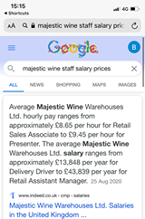
Total cost £2,520

Travel-

• oyster cards £306.90 (11)
• ferry return £211
• dover to London £7.28 each way
• Swansea to London £17.41 each way
• parking £152 per car (2 cars) 4 days nearest car park

Ferry: DFDS offer not only a cheaper option but they also have better travel times available.

London travel: The option of an oyster card is more cost efficient and also covers most range of transport within and around London for a more reasonable price than taxi’s.

Swansea – London: car- Not only does this option cost less, it’s more practical as crates of wine can be placed in the vehicle .

Parking: Although not many options available the car park chosen is the cheapest option by a couple of pounds and is the closest to the chosen hotel.

Accommodation: £1,186 -2 rooms, 4 nights Langham court hotel The hotel chosen is an hour away from the wtm event, but was the cheapest option for the location and also the time of year 31st October, as 3 members of staff will be arriving the day before the event. 2 members in twin room, 1 in single.

Food budget- Provide both members of staff from France with a daily budget of £15 each (5 days)
Total =£150

Stand design: Inspiredisplays offers an incredible range of set ups, or customizable choice for one of the lowest prices for the 45sqm stand. They Can create an advanced trade show stand at the space of 10.5m x 6m for under £10,000. Majestic wines stand is only 45sqm including VIP (smaller). Pitch £21,500 with shell scheme and £2000 promotion/ Please note that all exhibitors have compulsory indemnity and registration fees alongside the cost of stand packages.

Wine: Each wine chosen from each country is at a high enough standard to entice people but a low enough retail price for people to want to make pre orders on the day.
Wine-
Purchasing price for company £2 a bottle
4 countries, 3 flavours = 12 different wines
10 tasters in each bottle

Guests
1,500 people a day divided by 10 = 150
150 bottles x 12 different wines = 1,800 bottles a day for event (excluding vip)
Cost = £3,600 x 3 days = £10,800

V.I.P
150 people divided by 10= 15
15 x 12 different wines= 180 bottles
Cost £360

Total cost for samples = £11,160

Give away 1 bottle from each country (4) to vip
4 x 150 = 600 bottles to give away
Cost £1200

Total cost for wine samples and give away = £12,360

Media: £2,000 World travel market offered a low price for media coverage but is also attracting direct travel customers rather than a diverse market which other media offers.

Sample cups: 5,000= £24.95. The sample cups chosen are more suiting to size and helps with the measurement of where each taster should reach within the cup.

Trade stand training: £14.99 x 10 =£149.90
The train stand training chosen is a cheaper and more appropriate option as it’s online and all staff from both countries can attend.

Insurance-
merchant Liability for price of £75,000 https://www.wine-searcher.com/insurance
=£375 over the year
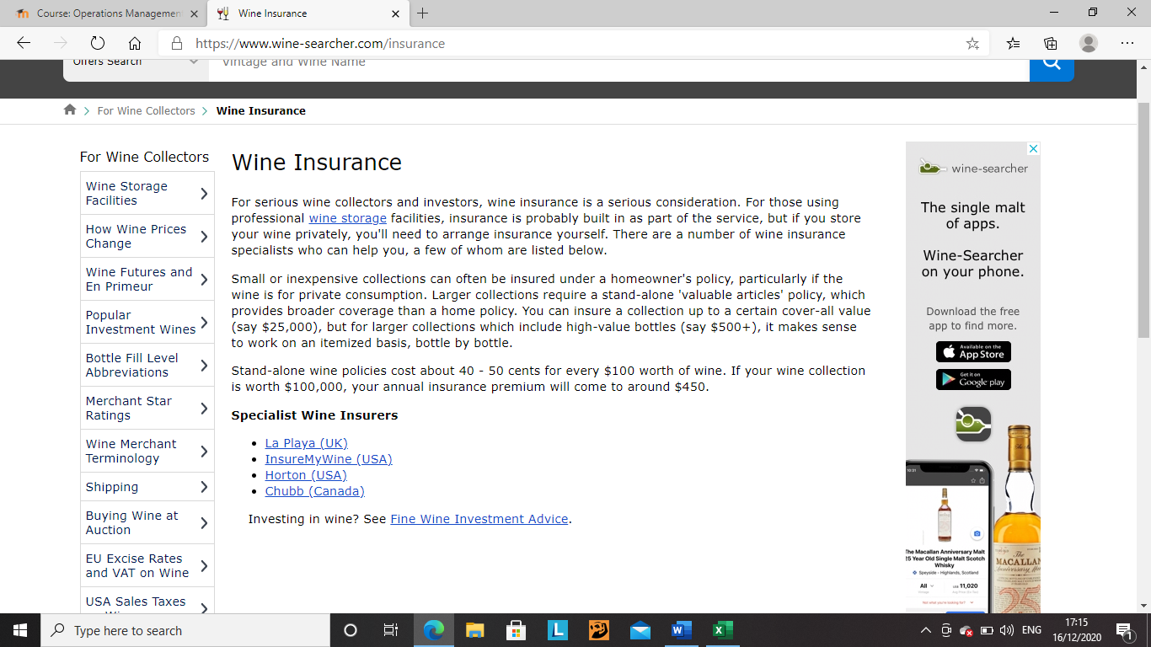

Total costs are £42,197.79

Leaving over a 10% contingency fund

Appendacies-

Promotional Items-
https://www.justwood.com/buy/personalised-wine-stopper-corks_129.htm

quote 1.
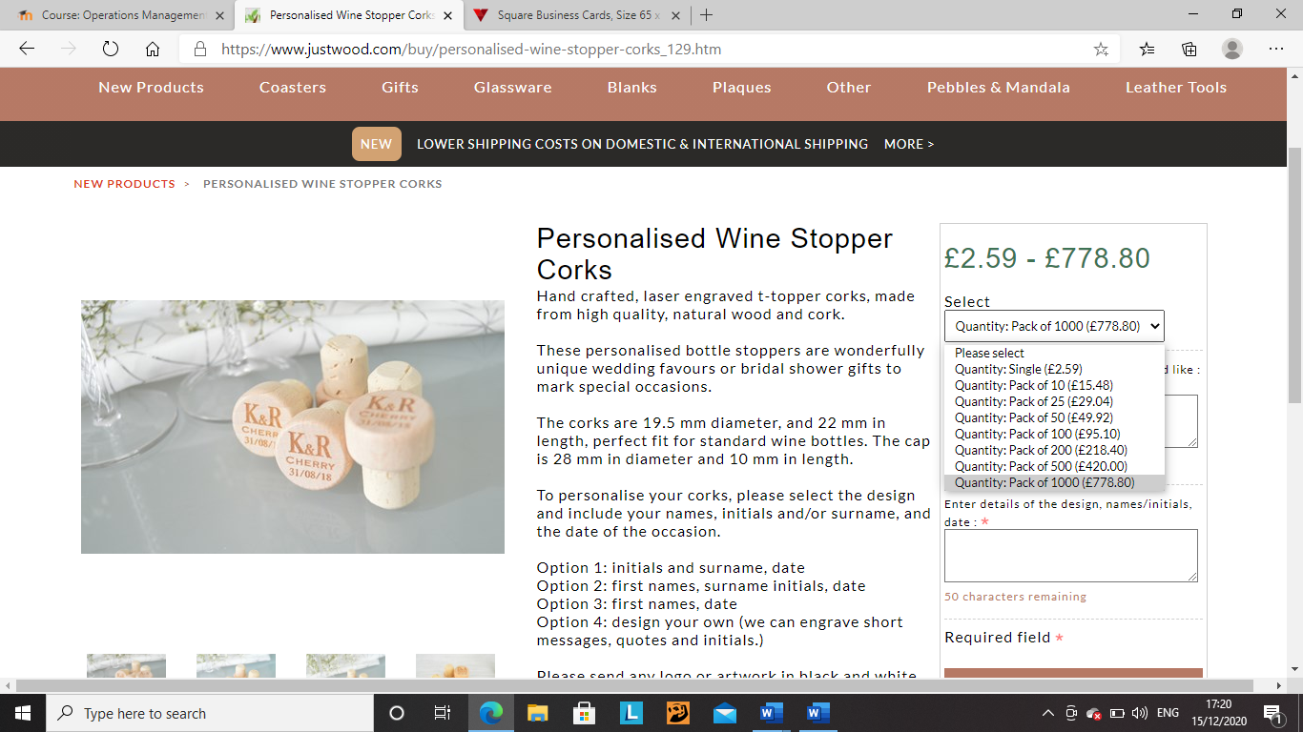

Quote 2.

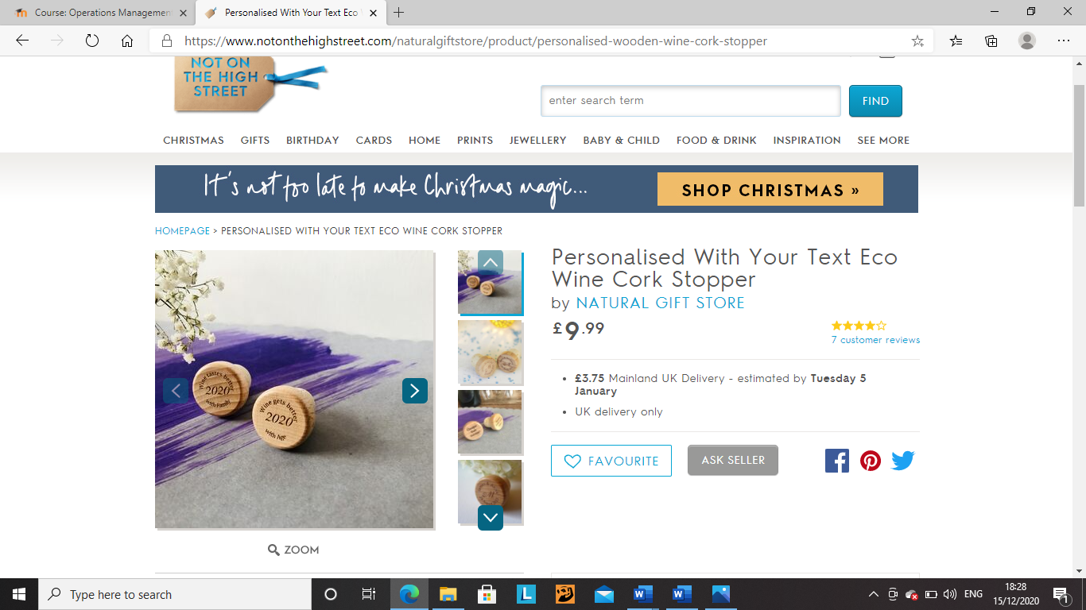

Business Cards. quote 1. https://www.vistaprint.co.uk/business-cards/square?couponAutoload=1&expiredCouponCode=VP1512&GP=12%2f09%2f2020+13%3a15%3a30&GPS=5850017464&GNF=1
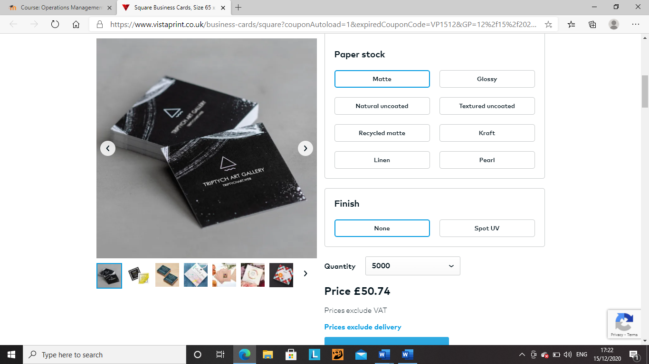

Quote 2.

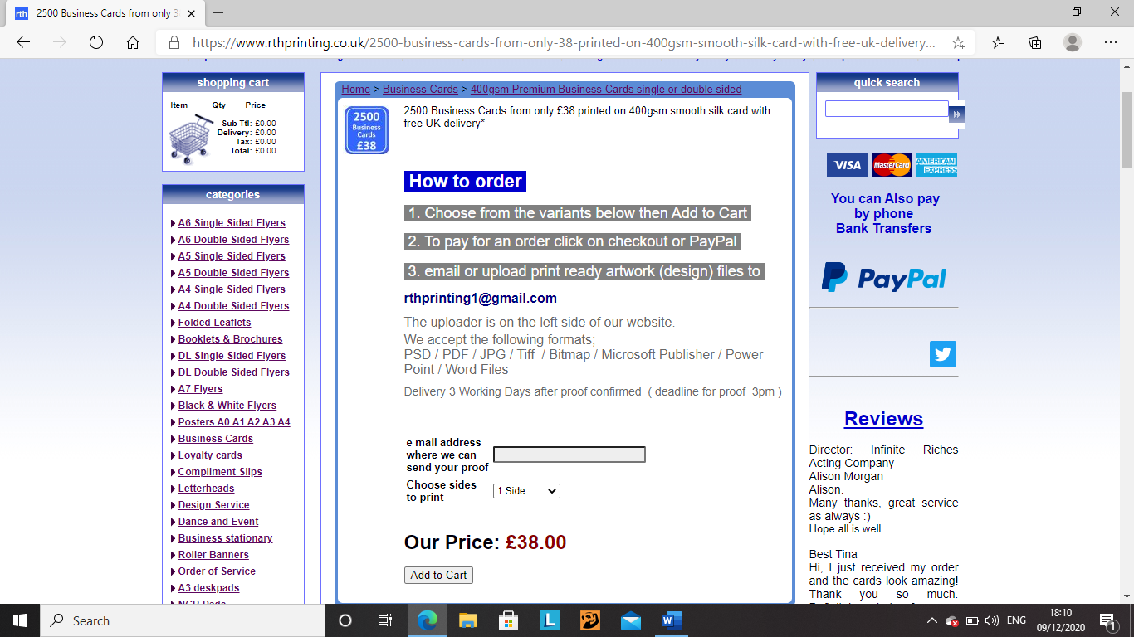

Travel –

Ferry- Quote 1.
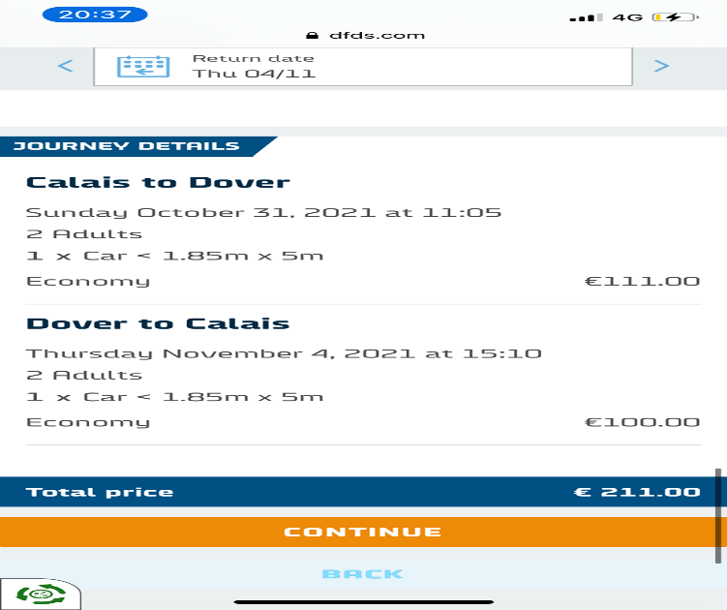

Quote 2.
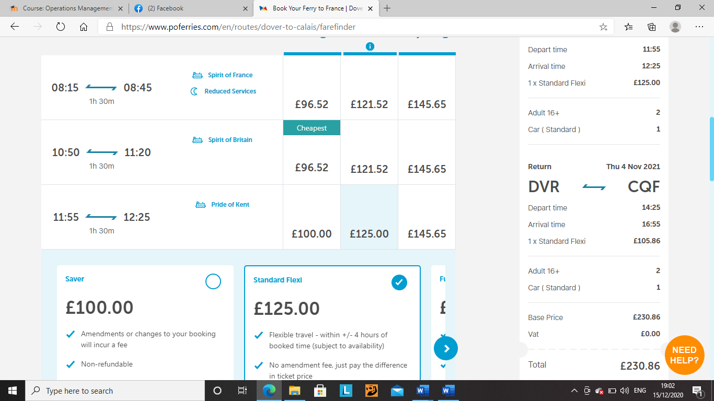

London travel- quote 1.

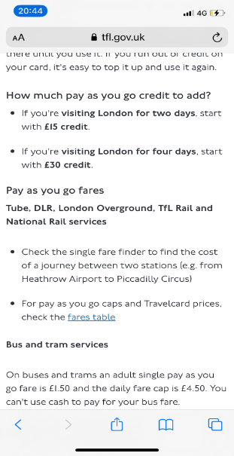
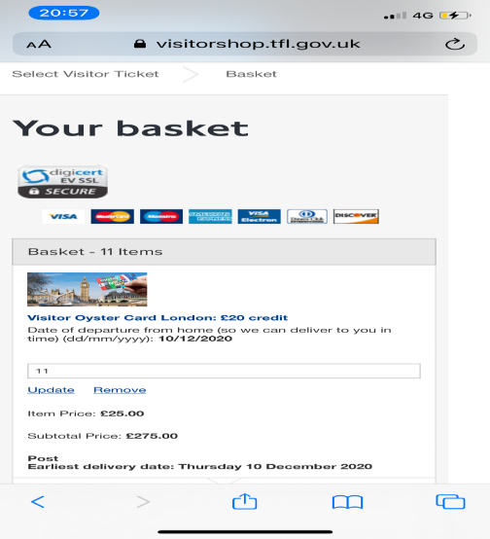

Quote 2. https://tfl.gov.uk/modes/taxis-and-minicabs/taxi-fares

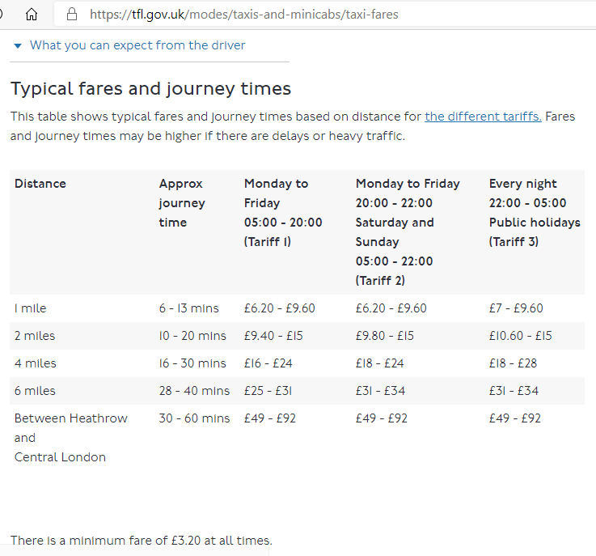

Travel from Swansea to London-

Quote 1. https://www.rac.co.uk/route-planner/mileage-calculator/

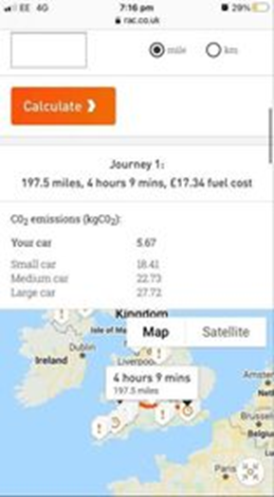
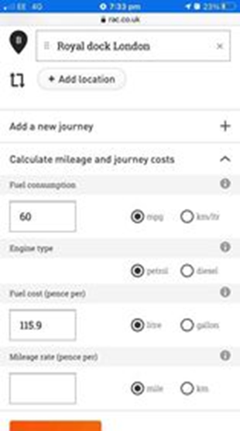

Quote2.https://www.thetrainline.com/book/results?origin=f0bdaecbf8bf0a80e964800b9d89fa0a&destination=2144c4ddc11461cf9b03af198933e8df&outwardDate=2020-12-16T15%3A00%3A00&outwardDateType=departAfter&journeySearchType=openReturn&passengers%5B%5D=1990-12-15&selectedOutward=BSC4p2%2FHTUM%3D%3A0GHFxAmiQR8%3D
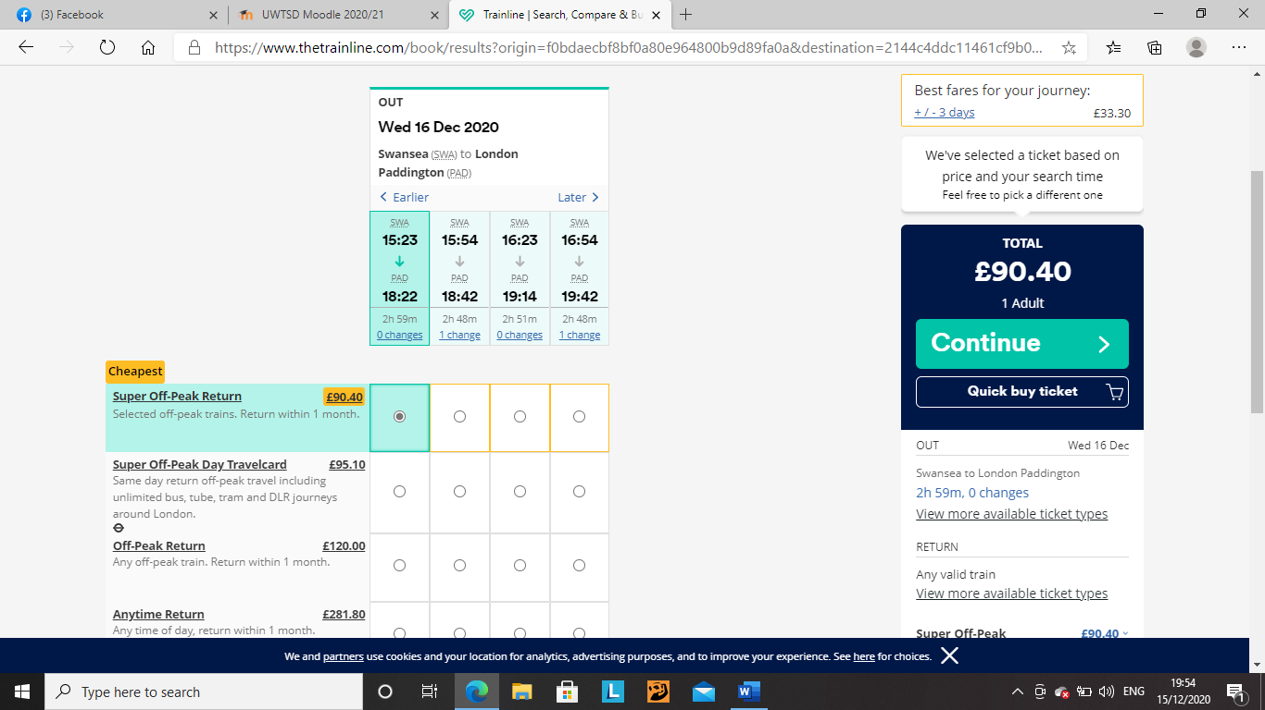

Parking- Quote 1.

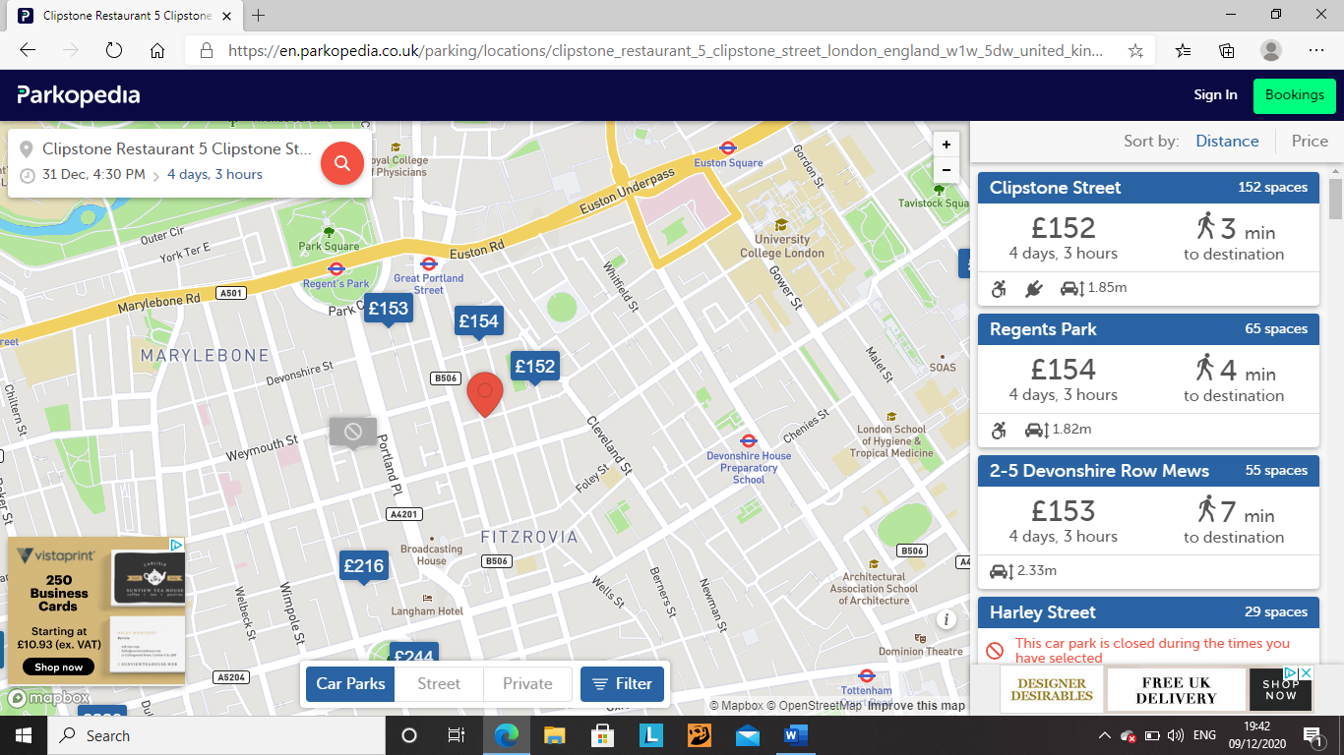

Quote 2.

Accommodation- Quote 1. Booking.com : Hotels in London . Book your hotel now!
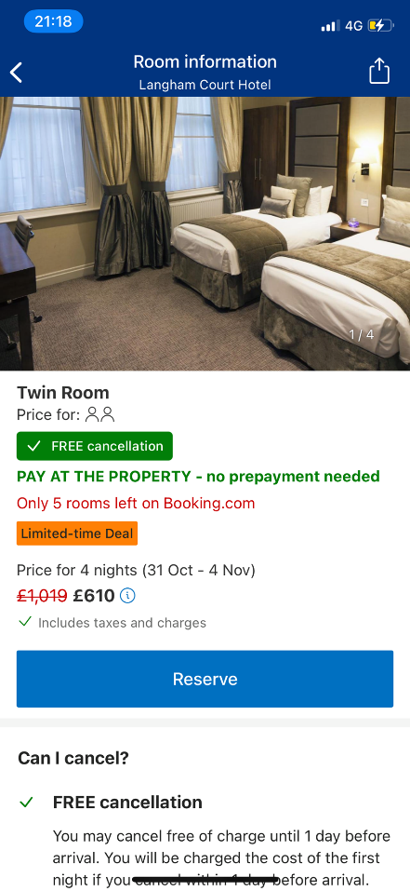
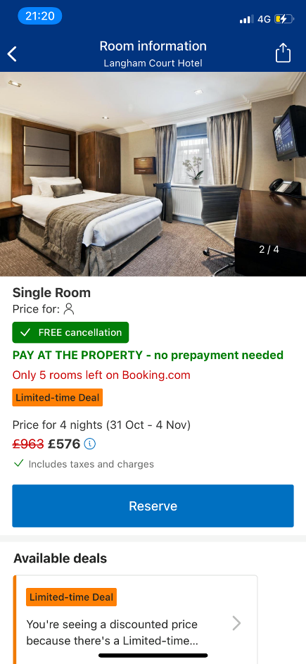

Quote 2. Crowne Plaza London - Docklands, London – Updated 2020 Prices (booking.com)
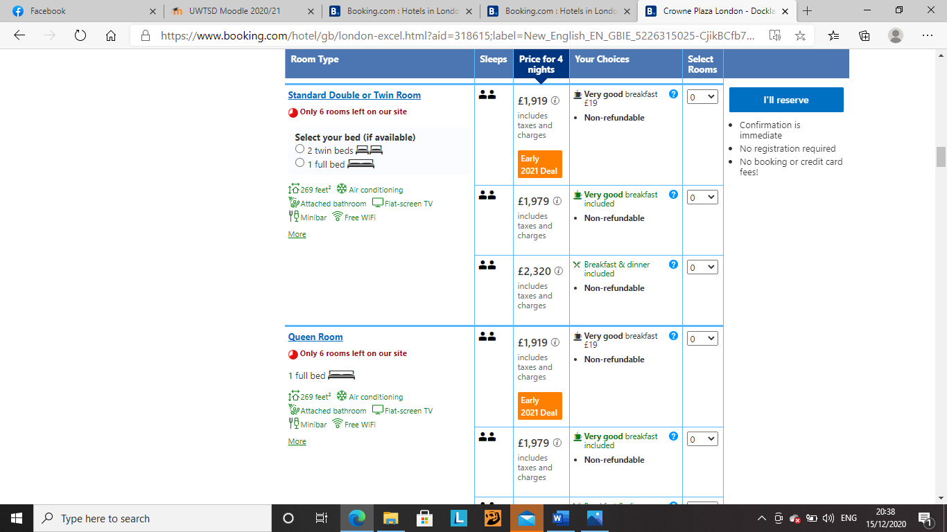

Design of stand- https://www.inspiredisplays.co.uk/portfolio/rcuk-exhibition-stand/

Quote 1.
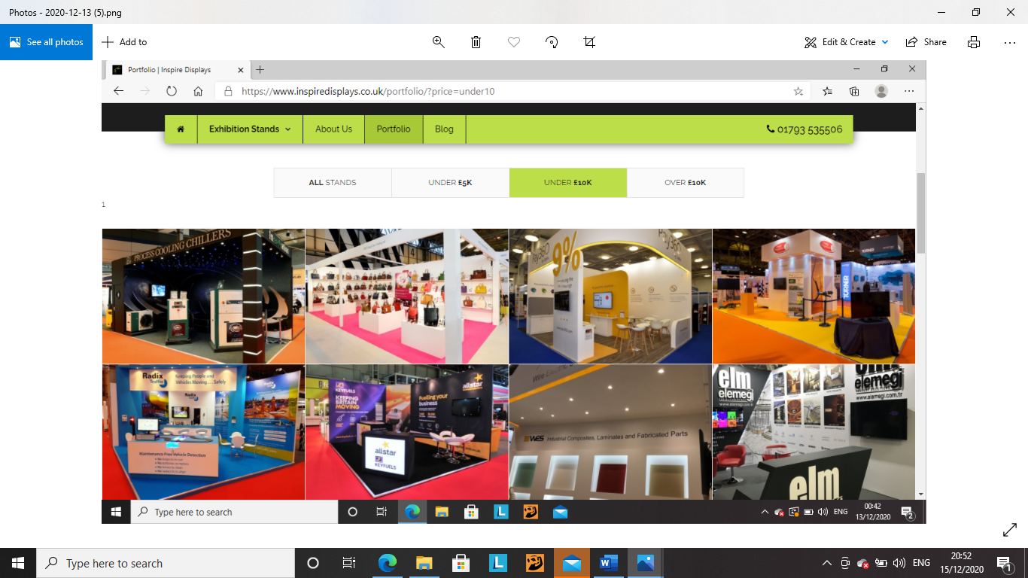
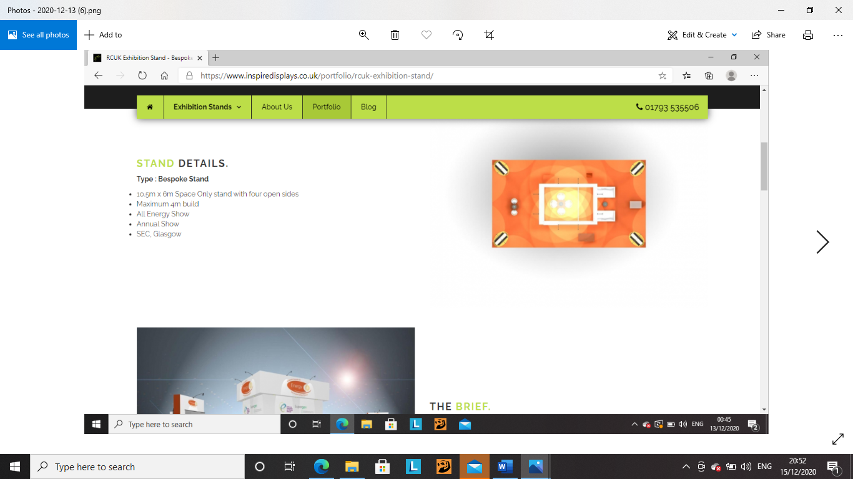
Quote 2. https://modexuk.com/

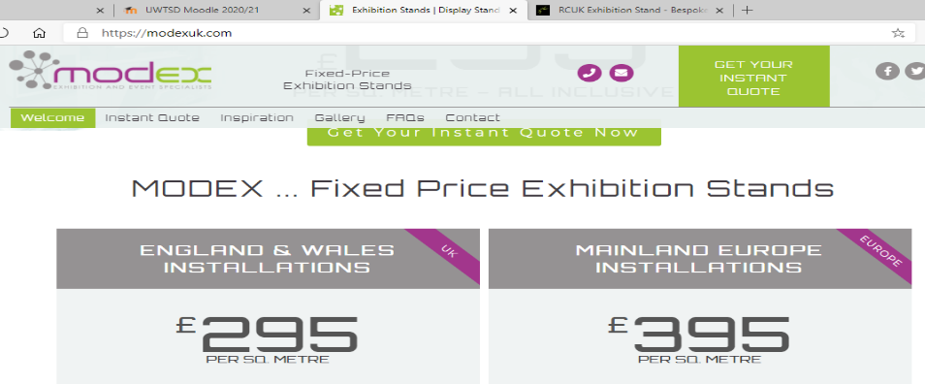

Wines-

France-

Rose quote 1. https://www.majestic.co.uk/wines/one-from-provence-rose-8310?fbclid=IwAR10QoR-KVmmC8H6BjDKXOuU79gXT10Zj7y5J0g-b370YE78ge_qpD26skQ

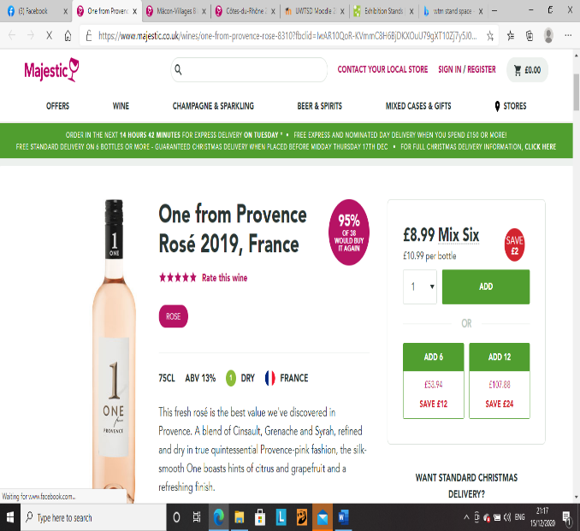

Quote 2. https://www.majestic.co.uk/wines/m-de-minuty-rose-8008?fbclid=IwAR2k6r6msn4ORj35FqDMWzqI_sO_fxmvbWNYjvCUAhASBX2gK6IwKFqyxEQ

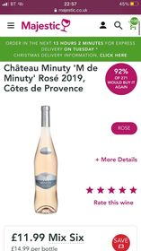

White https://www.majestic.co.uk/wines/macon-villages-blanc-les-pierres-blanches-4168?fbclid=IwAR2AGjvdM4o-n-NUUtOLdqu8nUqROUllVMhaXZA7b4K4d8JUM6wwJzBNEls
Quote 1.

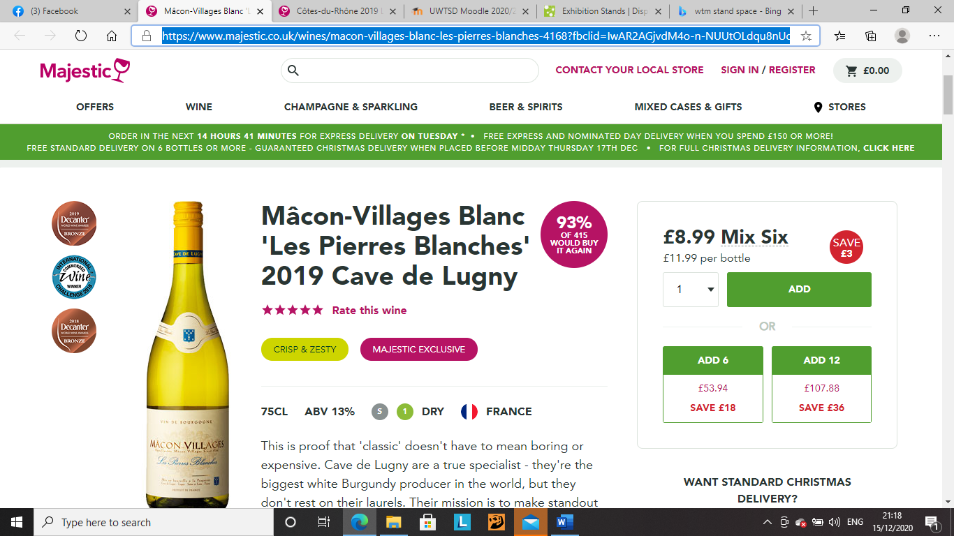

Quote 2. https://www.majestic.co.uk/wines/macon-lugny-4303?fbclid=IwAR3TK8ThpV5KdsaH9znGAFnbtqVB1p2IPE5qdyOdFnrYchjZxFhxIGcq5HQ

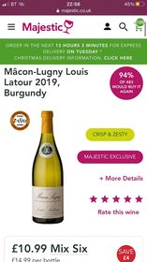

Red quote 1 https://www.majestic.co.uk/wines/cotes-du-rhone-6059?fbclid=IwAR11_seMI9N8nO65_4jJQHodKfzUGL7lRStj_IWi3gtgebcMI8kHT64Rj_A

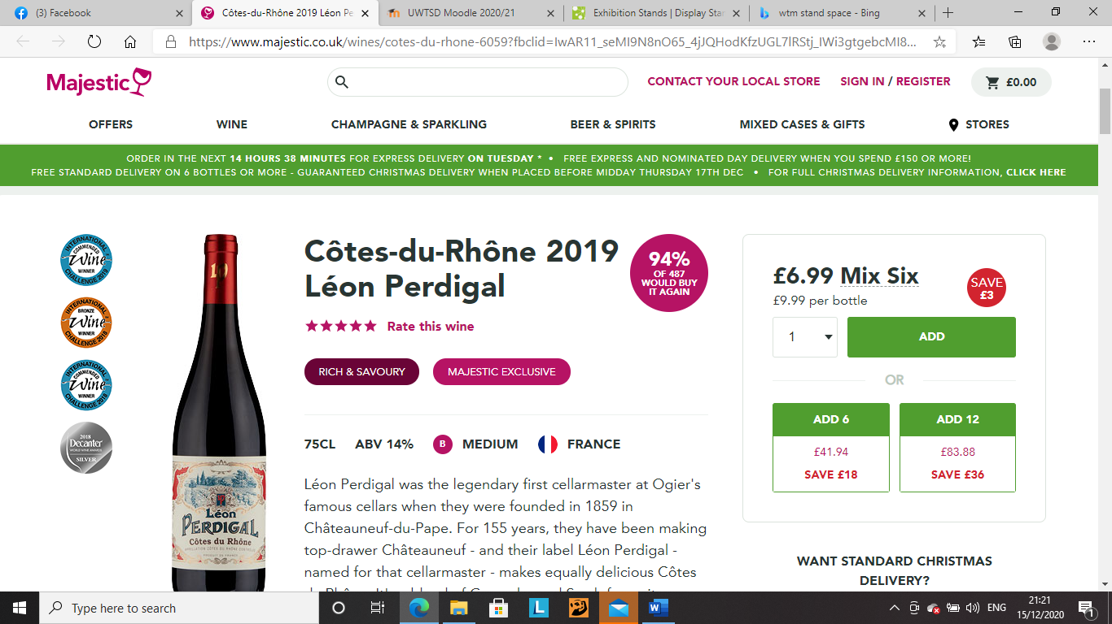

Quote 2. https://www.majestic.co.uk/wines/comte-de-baulieu-haut-medoc-61206?fbclid=IwAR1CfC4LX0UFZ9FhAM8beur1rhVBPMpxXtMaz9jN5vPEbfBDjgnNeDgsy_8

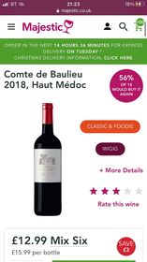

Italy-

Rose quote 1. https://www.majestic.co.uk/wines/pinot-grigio-rose-8139?fbclid=IwAR1GyDcAVgrnBHdBqoZV57JcppFHz1jZGXqlGiYUkiitJqt7vqCOc-OULtw

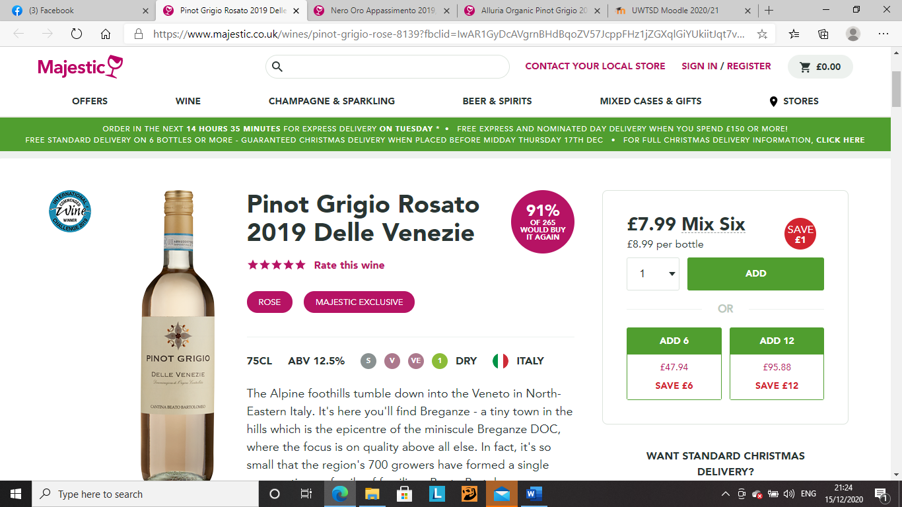

Quote 2. https://www.majestic.co.uk/wines/pasqua-11-minutes-rose-8268?fbclid=IwAR1vikbi7MPCUiuWlHQSE_OhxsLCqS7tX6B2ebqDgttFaLASULsPY2Juaqo
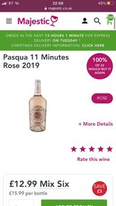

White quote 1. https://www.majestic.co.uk/wines/alluria-organic-pinot-grigio-13572?fbclid=IwAR2CHIew3y3K5HP0WNg9N8sSum_jLfLv0u0q6azaL_0FHFk6TsP8l_Br9sA

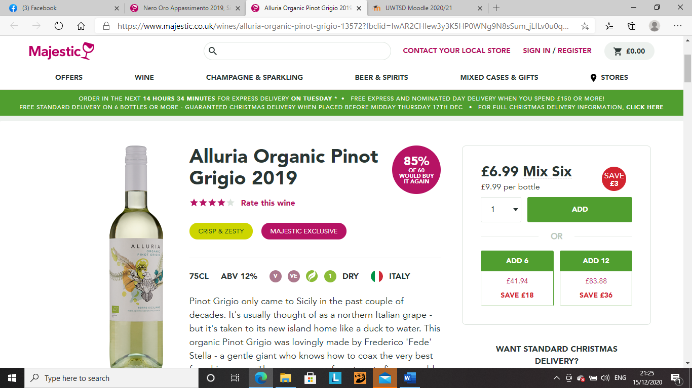

Quote 2. https://www.majestic.co.uk/wines/la-raia-il-borgo-gavi-13499?fbclid=IwAR3ty_349U5RxrY_kDP0lf3G1uVGHezbzC1SJQ2OJ4zHXlmQ9la_t5zg38A

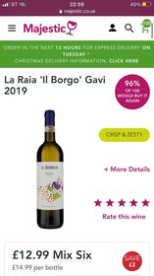

Red quote 1. https://www.majestic.co.uk/wines/nero-oro-appassimento-13476?fbclid=IwAR3PUK_1uYsDRK_6M5kubAsqJNv8HWTZjiiXWe-J2xDyOALeDqHuHOYqWpo

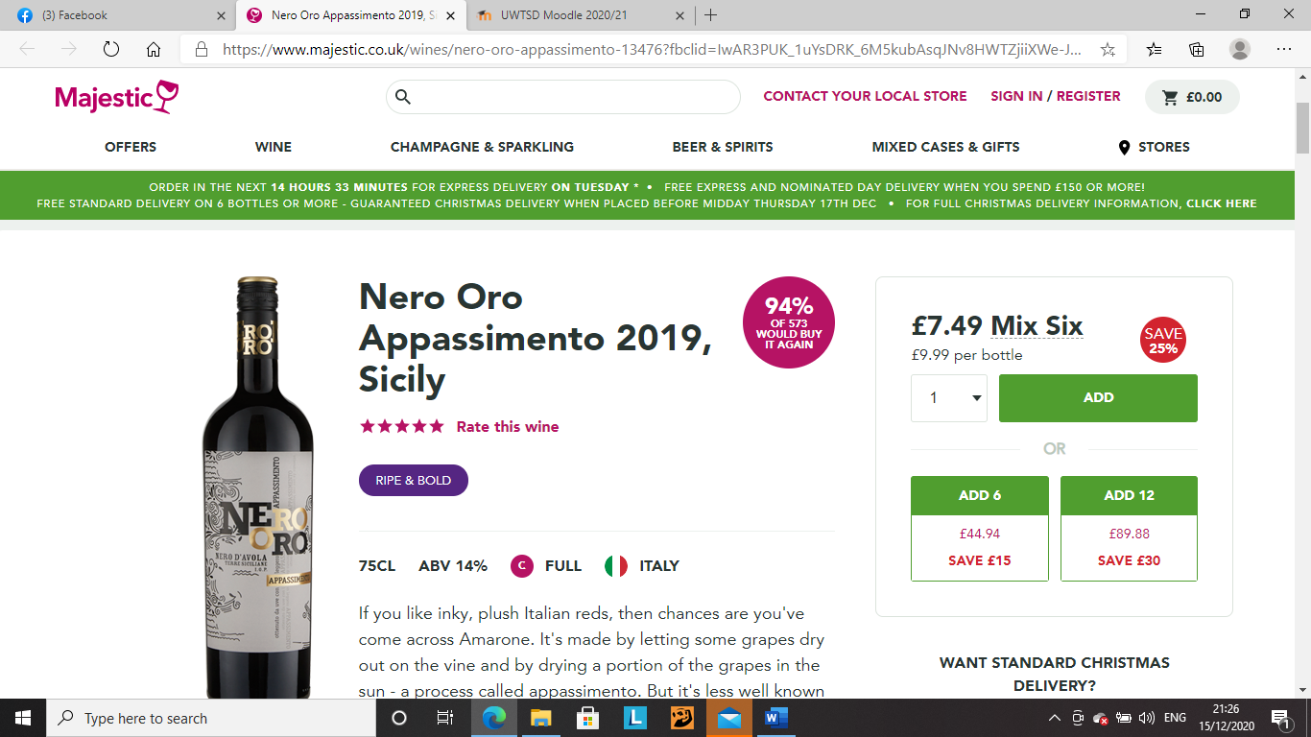

Quote 2. https://www.majestic.co.uk/wines/valpolicella-superiore-ripasso-13050?fbclid=IwAR3tYeKisMytqZ3VbEHWtGP5AkG1GIXzhKf3pqh29Qb0O6MM5-FmvWhJUQ4
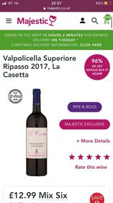

Australia-

Rose quote 1. https://www.majestic.co.uk/wines/cape-mentelle-rose-8308?fbclid=IwAR2cuDem6fD_KWvGhEhk9fmthHQZYs0VCCyrxrxfjO50YEk8mUgd_fJad84

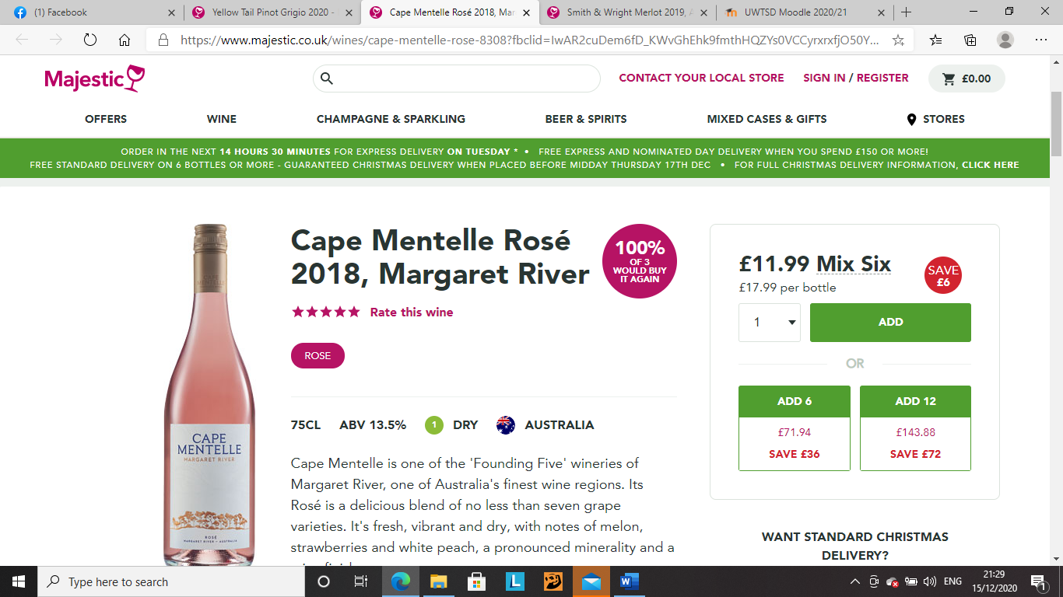

Quote 2. https://www.majestic.co.uk/wines/yellow-tail-rose-8232?fbclid=IwAR1Wl-Z3Qxcfa0bahpaiMFqwuvu8Ta4oNsY1JbZcPtwUhnsv6S1rGuym6fQ

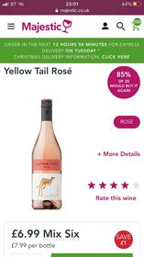

White quote 1. https://www.majestic.co.uk/wines/yellow-tail-pinot-grigio-59137?fbclid=IwAR33Gz4UokXX-wD8mb62BkodvNDhWlpXxVnvgNhfqzE1lxw-Qd9iZKpMZ98

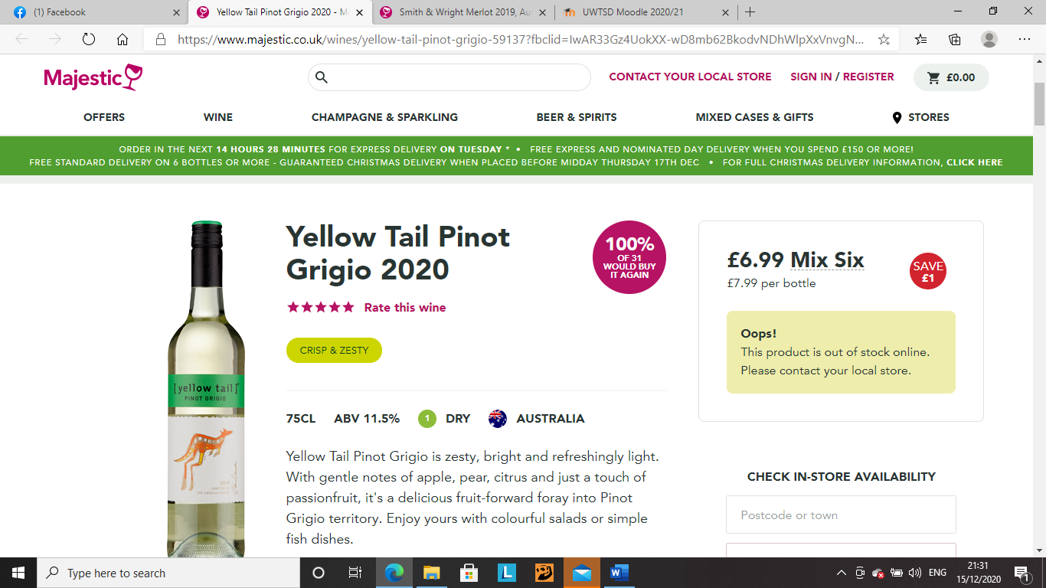

Quote 2. https://www.majestic.co.uk/wines/the-lodge-hill-riesling-19110?fbclid=IwAR1-MFJYicii33xAJmHozdxZCUwajLORJtNJn6vkj1akTSIsA9zOhaFfhnc
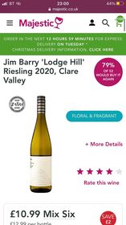

Red quote 1. https://www.majestic.co.uk/wines/smith-wright-merlot-59170?fbclid=IwAR3w1Gn-0NHTujxes0lh4mdfKqhMkx5l6VlovgGYqzUqZOvl1mSLFIOuzDY

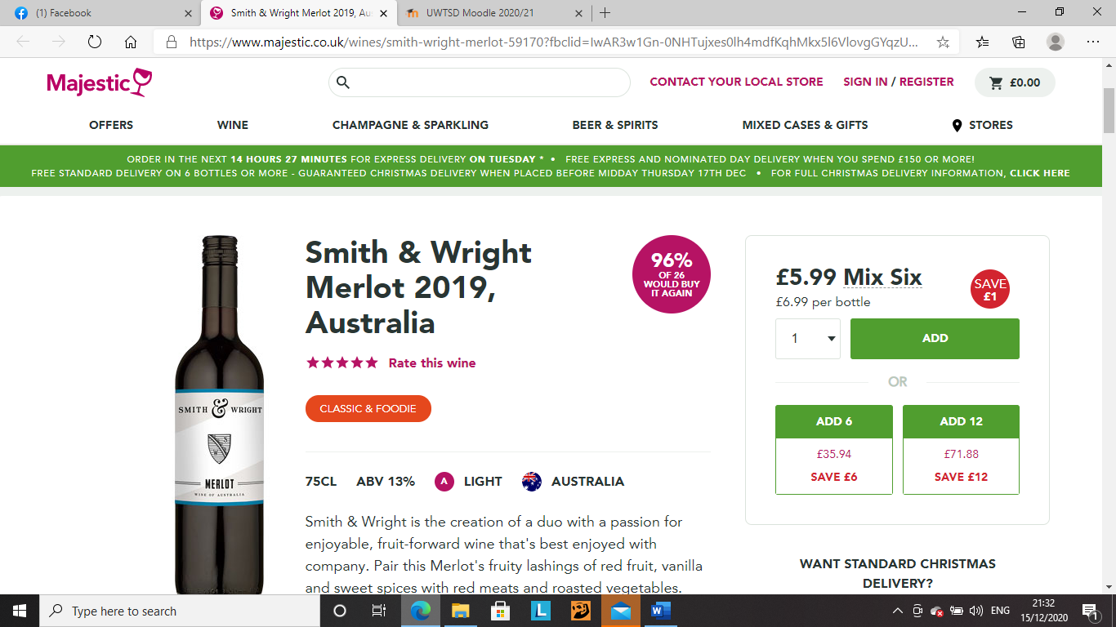

Quote 2. https://www.majestic.co.uk/wines/penfolds-maxs-shiraz-cabernet-sauvignon-59110?fbclid=IwAR0v1yVy4qKunOKqbVYenx-UdgVLeor3tujCAPFcELG2r5pHpiubjpVm7wo

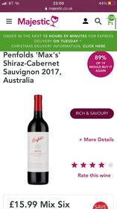

America-

Rose quote 1. https://www.majestic.co.uk/wines/barefoot-white-zinfandel-8320?fbclid=IwAR3w1Gn-0NHTujxes0lh4mdfKqhMkx5l6VlovgGYqzUqZOvl1mSLFIOuzDY

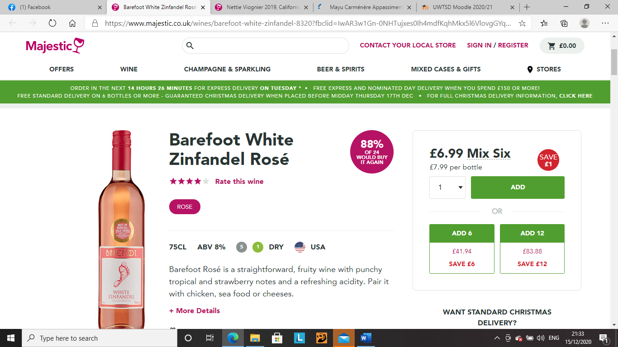

Quote 2. https://www.majestic.co.uk/wines/bread-butter-rose-8254?fbclid=IwAR2ASMXblA4kfTJZD5gh1IZbxW9B22Xcj79w1F0zh27v2mmI9IgFFQmeK-I
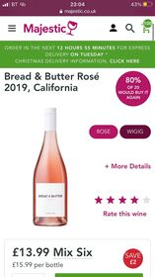

White quote 1. https://www.majestic.co.uk/wines/nettie-viognier-california-18058?fbclid=IwAR2nj1p-r7tXGDWvFPkuiBMlQRa6-MrUC-DvV1Nx5lYl9YbGW-QnkHQoTik

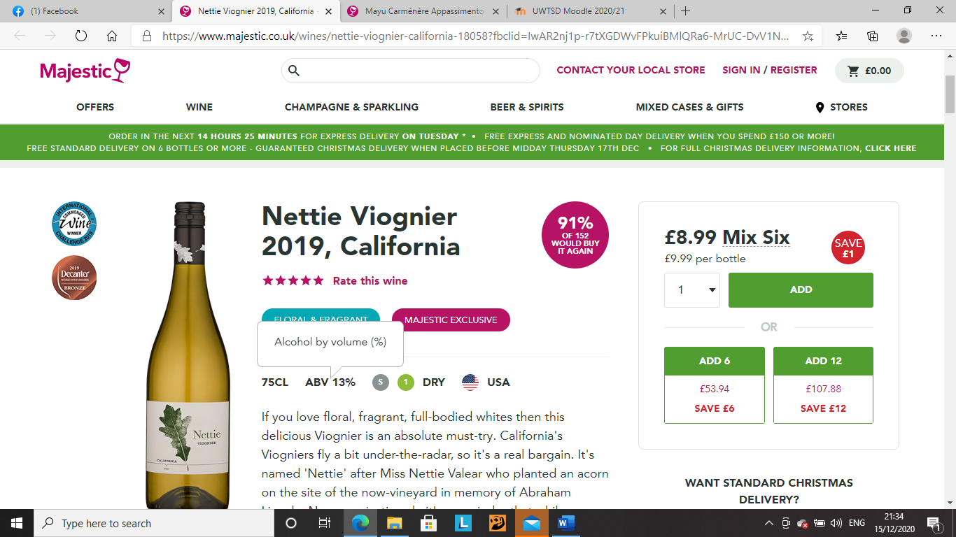

Quote 2. https://www.majestic.co.uk/wines/sebatiani-butterfield-chardonnay-18985?fbclid=IwAR1vikbi7MPCUiuWlHQSE_OhxsLCqS7tX6B2ebqDgttFaLASULsPY2Juaqo
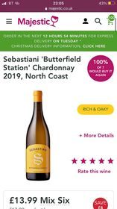

Red quote 1. https://www.majestic.co.uk/wines/mayu-carmenere-apassimento-39407?fbclid=IwAR2LRjElKAlKsD1VfLu8SSK_vts5bvmgf4Bkph-4dRxWizq8GBr3RT0RptA

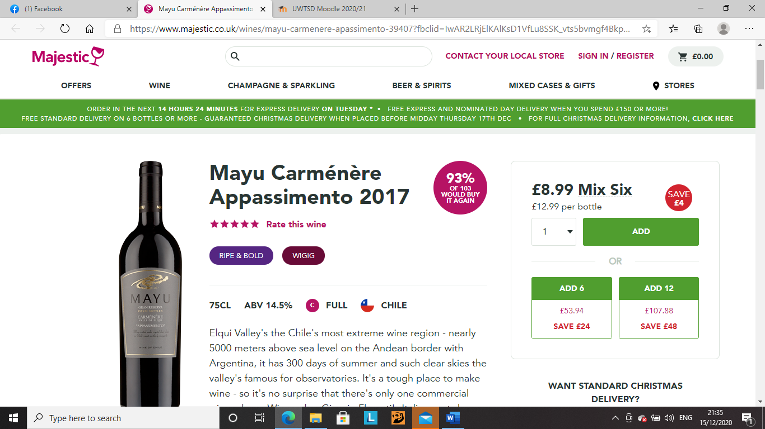

Quote 2. https://www.majestic.co.uk/wines/edna-valley-pinot-noir-18110?fbclid=IwAR2Ja3DrJxr6jMLabzK6wV0Jt8K1GC1nVDMqHOmvf1I9Z87ts52Q_QtEQQw

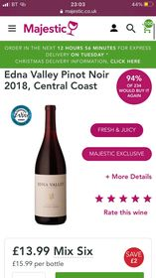

Media quote 1.
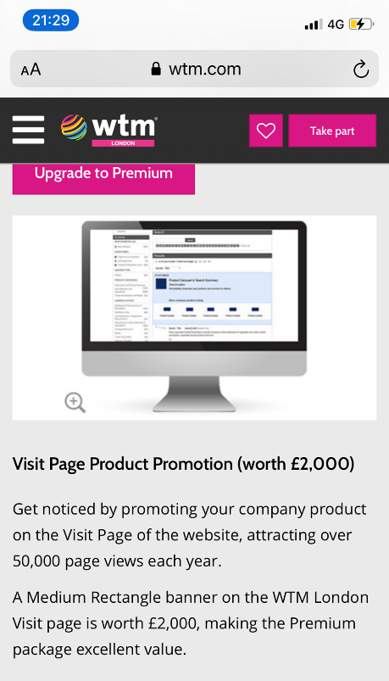

Quote 2. https://www.freelancer.co.uk/hire/travel-writing
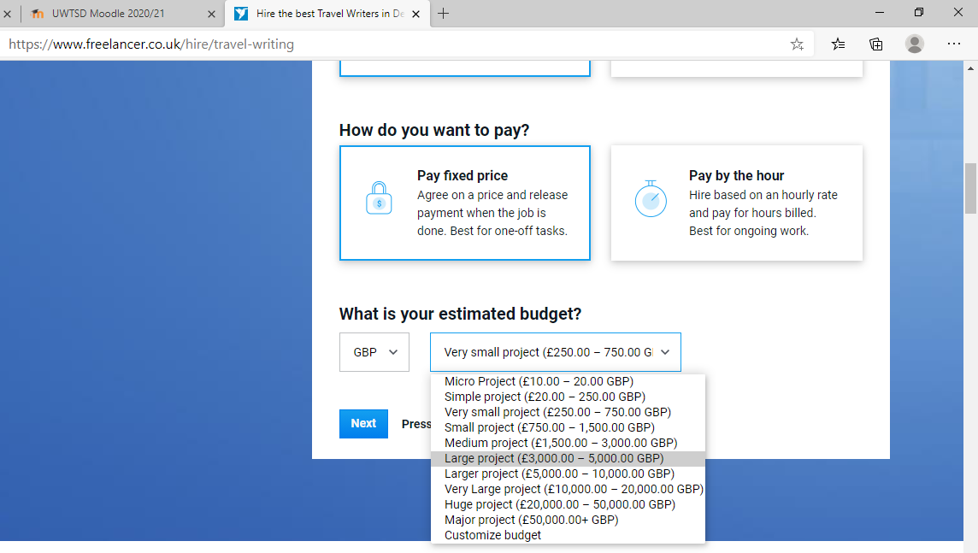

Tester cups quote 1. https://www.drinkstuff.com/products/product.asp?ID=7477&fbclid=IwAR2nj1p-r7tXGDWvFPkuiBMlQRa6-MrUC-DvV1Nx5lYl9YbGW-QnkHQoTik#.X9kwwnpxfIU

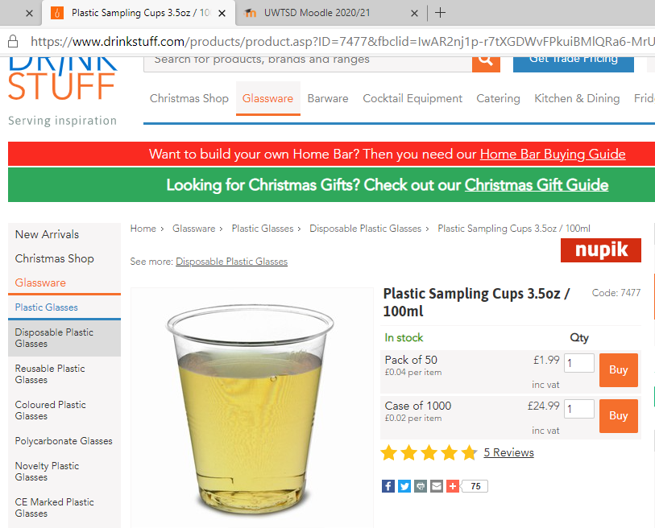

Quote 2. https://cupsdirect.co.uk/collections/food-and-drink-sampling/products/large-crystal-glass-sampling-cup

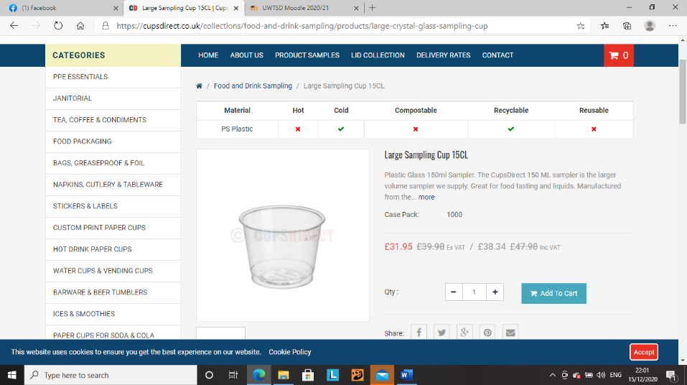

Training-

online trade stand training

quote 1. https://www.mandatorytraining.co.uk/products/trade-show-staff-training-e-learning-course-cpduk-accredited?variant=2557717315618

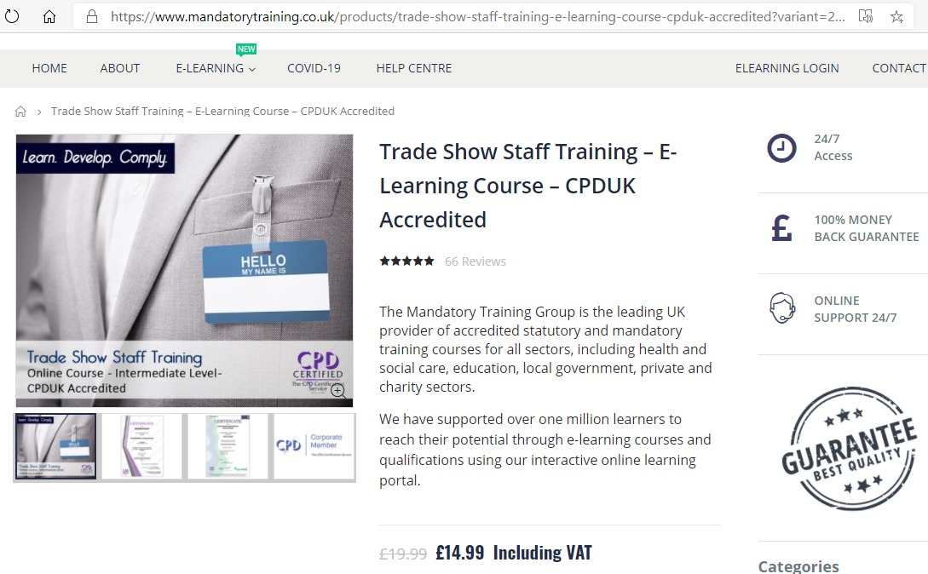

Quote 2. https://www.reed.co.uk/courses/trade-show-staff-training/229808



