Assignment 1
ZAID KHAN
2308983
University Of Wales Trinity Saint David
Learning In The Digital Era

Table of Contents
E-PORTFOLIO………………………………………………………….. 3
TASK 1 (a) 4-6
TASK 1(b) 7
TASK 2 (a) POSTER 8
TASK 2 (b) 9
TASK 3 (a) 10-11
TASK 3 (b) 12-35

HELLO.......


My name is Zaid Khan, and I am studying with the University of Wales, Trinity Saint David, in the program Computing in the Workplace. This e-portfolio has been developed to present the different tasks that were given to me for my course. It presents my completed work in an organized and professional manner, demonstrating learning, skills, and development throughout the assignments.

MY E-Portfolio Link:
https://25089838.wixsite.com/e-portfolio/task-1-a-1

TASK 1 (A)

Essential Skills For Study and Employment
Getting individuals especially the future workforce prepared for success within contemporary jobs is ever more important as traditional career tracks lose traction, jobs become increasingly competitive, and entry level positions shrink in pay. The changing labour market demands agility, continuous learning, and new education and employment preparedness measures [1].
After decades of oppression, a newly independent country is faced with rapid change, forcing citizens to adapt to new political, economic, and social realities. It is driven by the needs of individuals, emphasizing lifelong learning, learner autonomy, multiple opportunities, and equal respect for knowledge, preparing citizens to thrive in a changing, competitive world [2].

As we act, we tend to generate ideas and connect new information with the things we already know, making sense and the ability to respond to new situations. We test the viability of our knowledge with action, generating new meaning from consequences. While most of this is done automatically, entering new situations requires sensitivity regarding our learning process so that we can improve how we learn and adapt successfully [3].
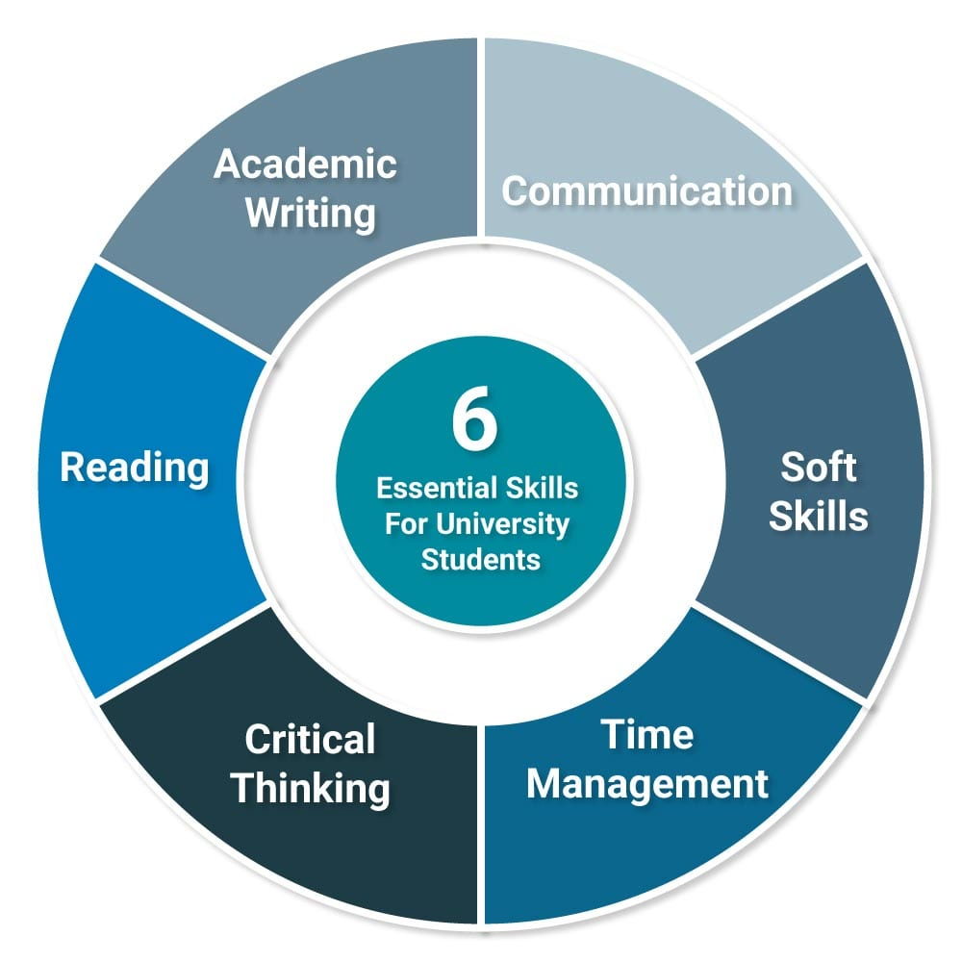

Figure 1: Six Essential Skills [4].

Social skills are essential to the ability to be employable, but work-specific social skills have been researched sparingly in recent decades. One piece of research replicated previous research by surveying secondary school teachers nationally regarding the use of social skills at work and the amount of teaching provided. Teachers’ most essential skills were thought to be explaining directions, punctuality, appropriate physical boundaries, completion of important tasks first, seeking assistance, receiving criticism, and handling clients. However, these critical competencies were all too often those most typically schooled, even while they recognized a mismatch between learning and work demands [5].

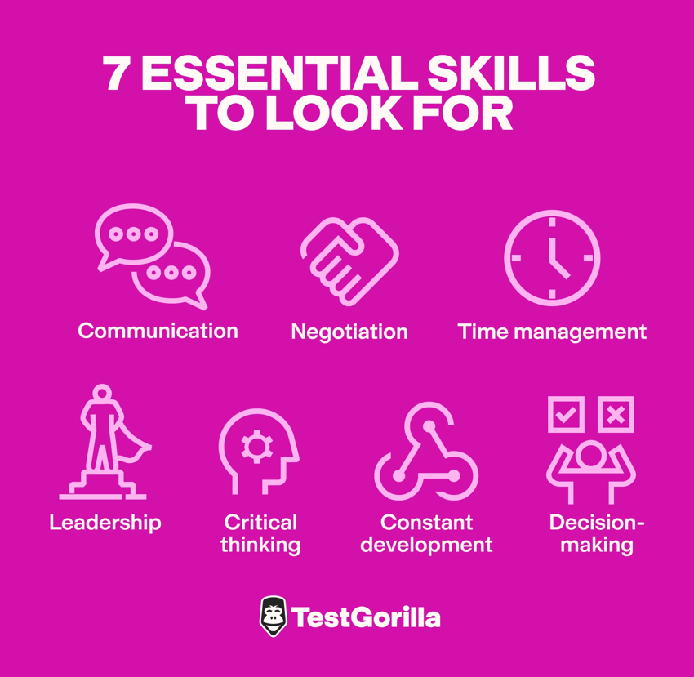

FIGURE 2: Seven Essential Skills Needed For Workspace Environment.

Task 1 References

[1] | J. F. Coates, "Skills required for twenty-first century employment," employment relations, no. Wiley Online LIbrary, fall 1995.
[2] | Z. Jelenc, The Learning Society, Routledge, 1999.
[3] | B. c. L. I. L. p. Kathy turner, Essential Academic skills, Oxford University Press, 2008.
[4] | R. Needlemen, "Uniadmissions,co,uk," [Online]. Available: https://www.uniadmissions.co.uk/application-guides/6-essential-skills-for-university-students/.
[5] | S. C. L. M. R. C. Agran M., "Expectancy effects in social validation methodology," Washington D.C, 1991.
[6] | "Testgorilla," [Online]. Available: https://www.testgorilla.com/blog/employee-skills/.

TASK 1 (B)

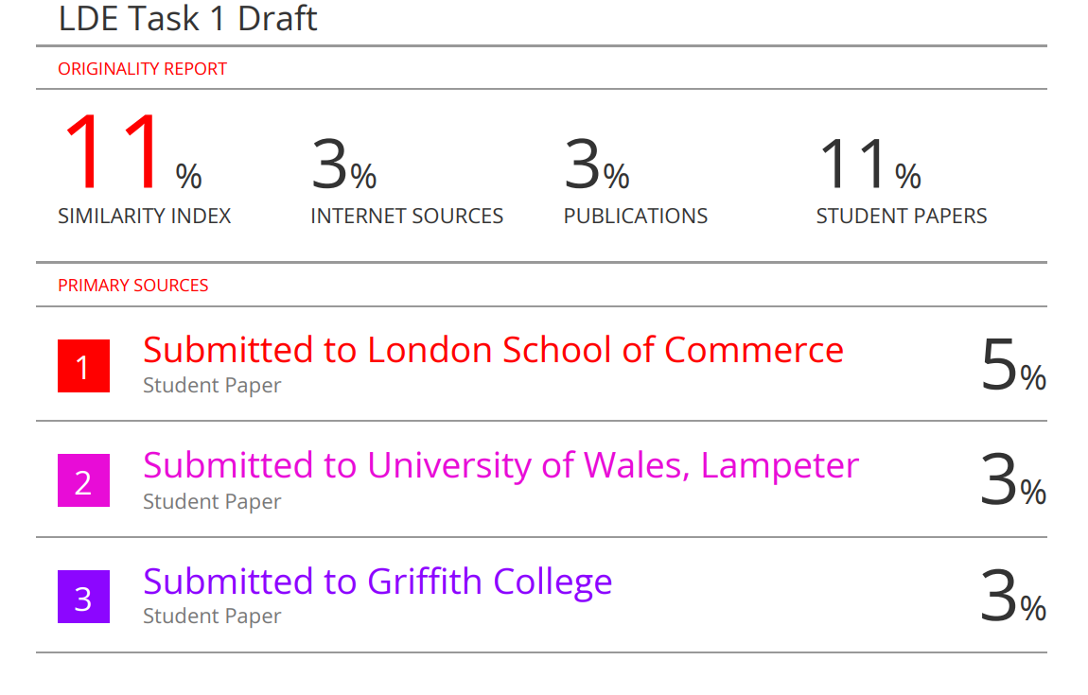

Next time, I can improve my assignment by creating smoother transitions between paragraphs and connecting the graphics more effectively to my discussion. I will use clearer academic language, ensure proper IEEE referencing, and focus more on analysis rather than simple description. I also plan to include recent research, real world examples and a concise conclusion to strengthen the overall quality and coherence.

would give myself around 65 out of 100 for this work. I believe I did well in presenting key ideas and using proper references, but there’s still room for improvement in linking visuals, enhancing flow, and providing deeper analysis and critical reflection.

TASK 2 (b)
Mind Map link
https://www.mindmeister.com/app/map/3844874658
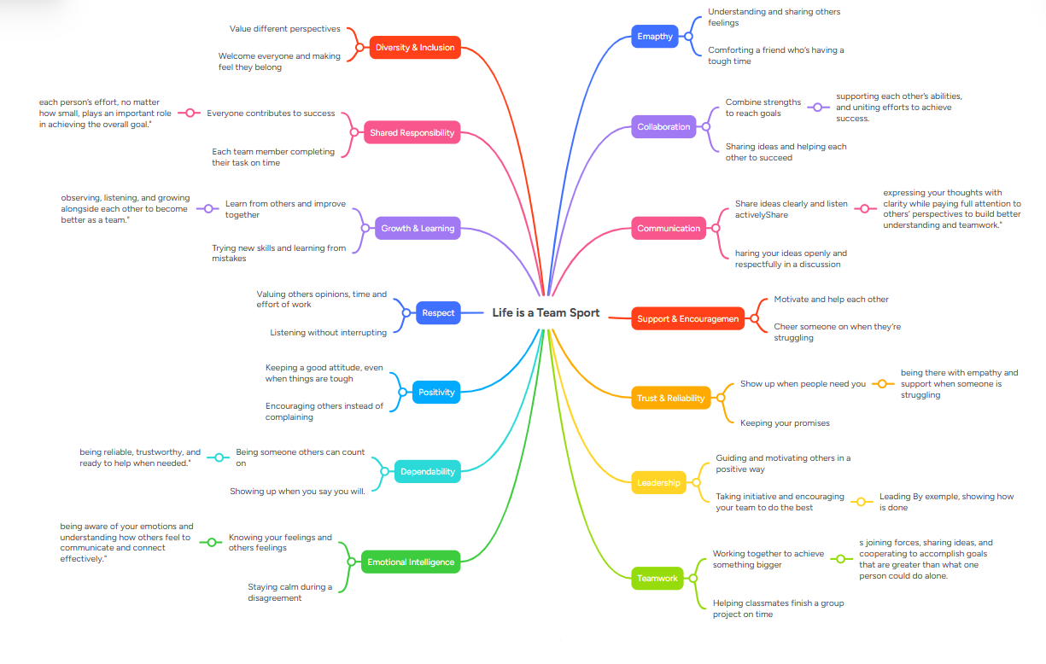

TASK 2 (a)
Poster link:
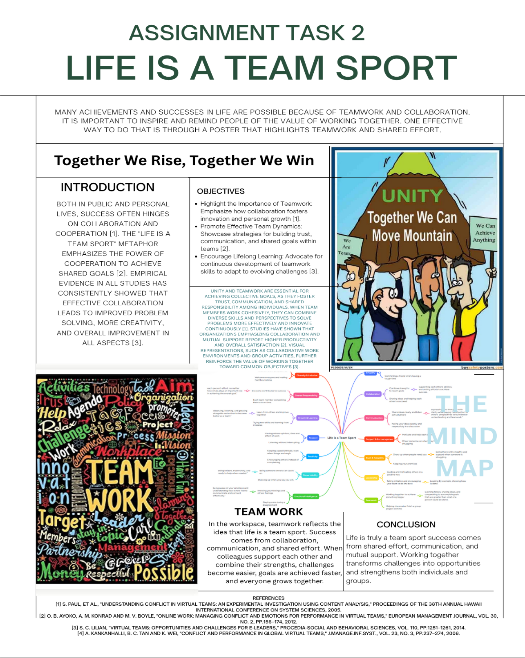
https://www.canva.com/design/DAG2-fuag9U/izs_wdz-fDOSbBU9TTlEiQ/edit?utm_content=DAG2-fuag9U&utm_campaign=designshare&utm_medium=link2&utm_source=sharebutton

TASK 3 (a)
RIDING THE STORM

Virtual collaboration can be defined as teams working together remotely due to the availability of digital tools and technologies. A team may be situated or distributed across different locations, time zones, and cultures. It allows for flexibility in communication and access to talent from all over the world, but it also gives birth to problems such as miscommunication, delays, reduced social connectedness, and a heightened likelihood of misunderstandings or conflict, which influence team efficiency and performances.
In this paper, the authors present a study on conflict in global virtual teams that have emerged through globalization and communication technology. It identifies cultural and functional diversity, electronic communication, and delays in feedback as sources of conflict. Such factors as task complexity, interdependence, and conflict resolution approaches would determine team performance. A model has been suggested to direct further research and management in GVT[1].
Diverse disagreement triggers and the development of negative emotions impact conflict and emotional dynamics in virtual teams. Tensions can rise as a result of things like asynchronous interactions, cultural differences, and poor communication. Affective conflict can be kept from getting worse by using techniques like structured communication, feedback-seeking, and emotional regulation. A thorough model is created to direct the management of emotional responses, improve collaboration, and boost overall performance in virtual team settings by combining affective events theory, emotional regulation theory, and workplace conflict frameworks. This model provides useful insights for both team leaders and team members[2].
Virtual teams are becoming increasingly common, relying on technology to support collaboration across large geographical distances. This literature review draws on 255 studies to identify challenges of collaboration and mitigation strategies by focusing on technology use. Challenges identified include geographical distance, temporal distance, perceived distance, team configuration, and workforce diversity, underpinning cognitive, social, and emotional impacts. The review also points out the gaps in current research that need to be tackled, such as the impact of tightly coupled work and temporal dispersion on coordination. The findings provide insight into opportunities for the design of groupware that better supports collaboration and improves virtual team performance[3].
Conflict and emotional dynamics are pivotal to understanding how virtual teams work as members collaborate across distance, cultures, and time. Factors such as miscommunication, cultural differences, misunderstandings, and lag time while collaborating asynchronously can escalate conflict and increased negative emotions that can [should] damage team performance. Techniques for exercising emotional regulation, engaging in active feedback seeking, and promoting a structured communication practice are necessary to curb affective conflict [the experience of negative feelings/conflict-based emotion] and maintain team cohesion [shared trust and confidence in the group]. Building from affective events theory
emotional regulation theory workplace conflict, and workplace conflict theoretical perspectives, a comprehensive model is developed that provides team members and leaders with insights to collude with team members to manage and intervene in emotional experience in virtual environments. Aspects of the model include proactive observations, the timing of interventions, and supportive team behavior to foster collaborative virtual team environments. Overall, team members, work teams, and leaders use the model to improve communication, reduce tension, use tacit knowledge, and foster synergies to improve performance, team resilience, and performance[4].

References
[1] S. Paul, et al., "Understanding conflict in virtual teams: An experimental investigation using content analysis," Proceedings of the 38th Annual Hawaii International Conference on System Sciences, 2005.
[2] O. B. Ayoko, A. M. Konrad and M. V. Boyle, "Online work: Managing conflict and emotions for performance in virtual teams," European Management Journal, vol. 30, no. 2, pp.156–174, 2012.
[3] S. C. Lilian, "Virtual teams: Opportunities and challenges for e-leaders," Procedia-Social and Behavioral Sciences, vol. 110, pp.1251–1261, 2014.
[4] A. Kankanhalli, B. C. Tan and K. Wei, "Conflict and performance in

TASK 3 (b)
REFWORKS AND THEIR SCREENSHOTS

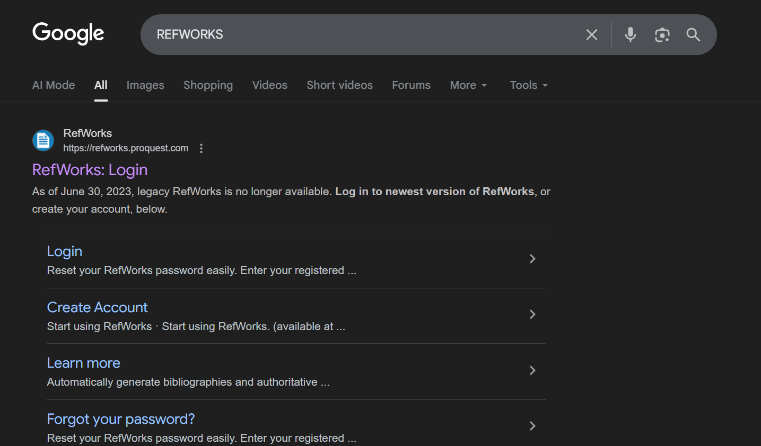

Search REFWORKD on chrome

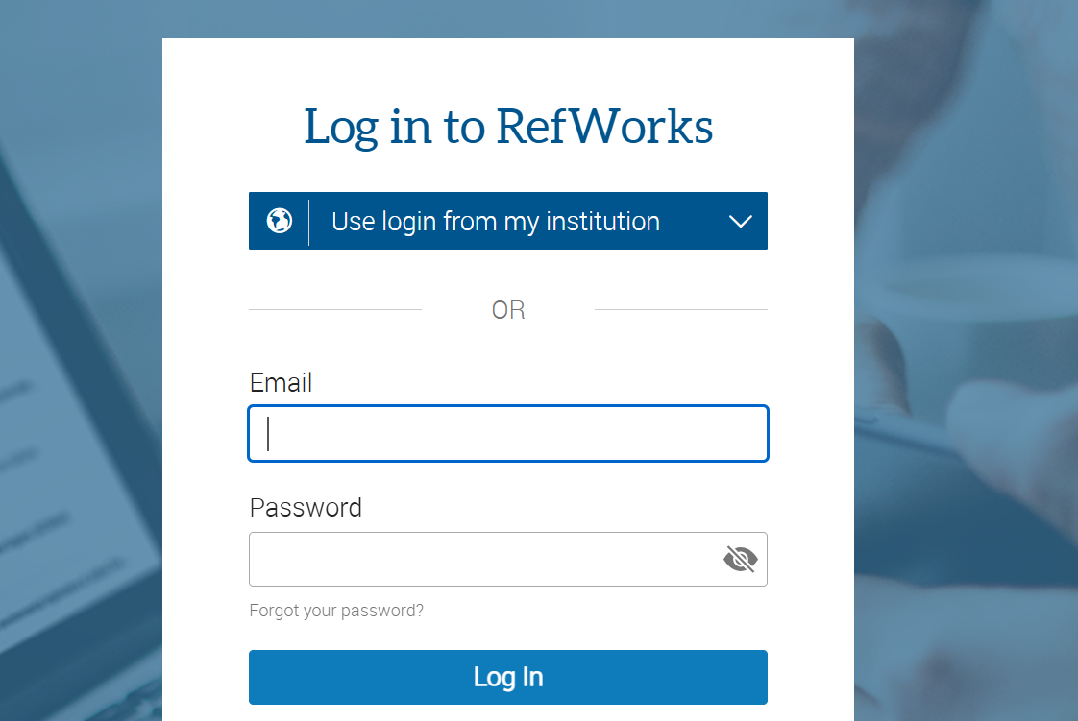
Log In to REFWORKS using your student email

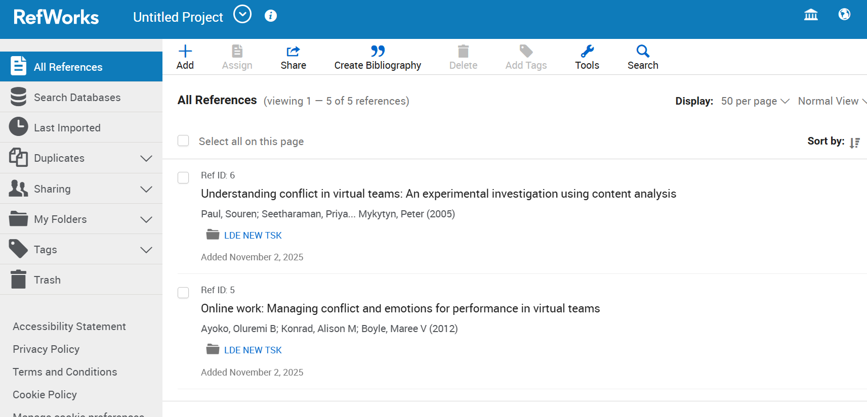

Open the site and click ADD




Search for google scholar on chrome


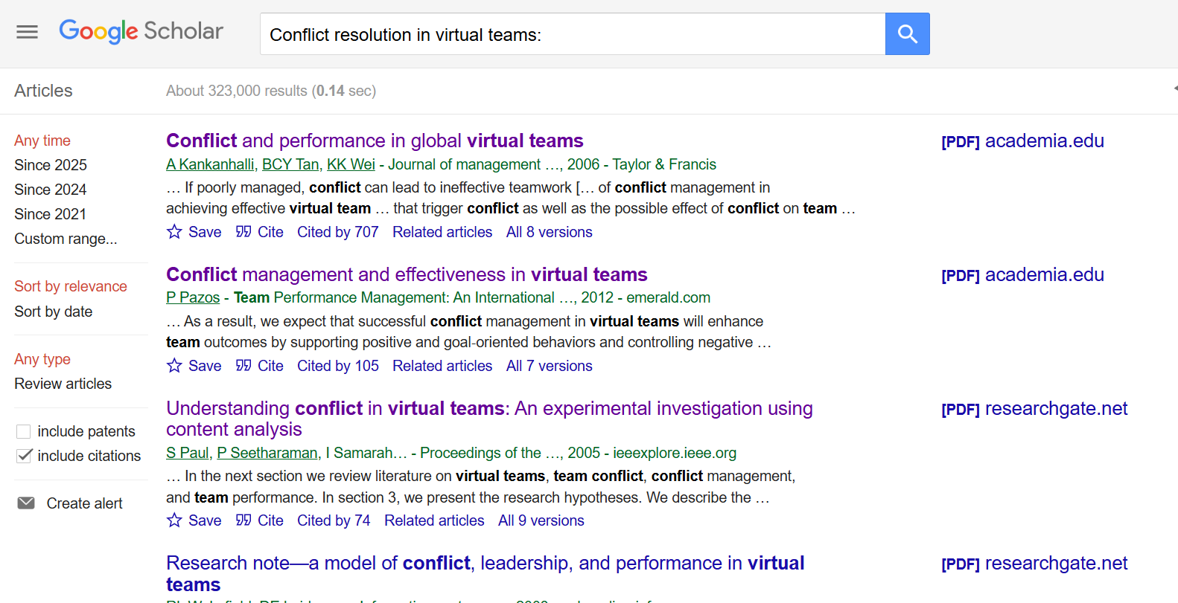

Search for the Topic like in my case its “Riding the Storm” Means i am explaining virtual collabs


Choose the Cite option for whatever link you are using


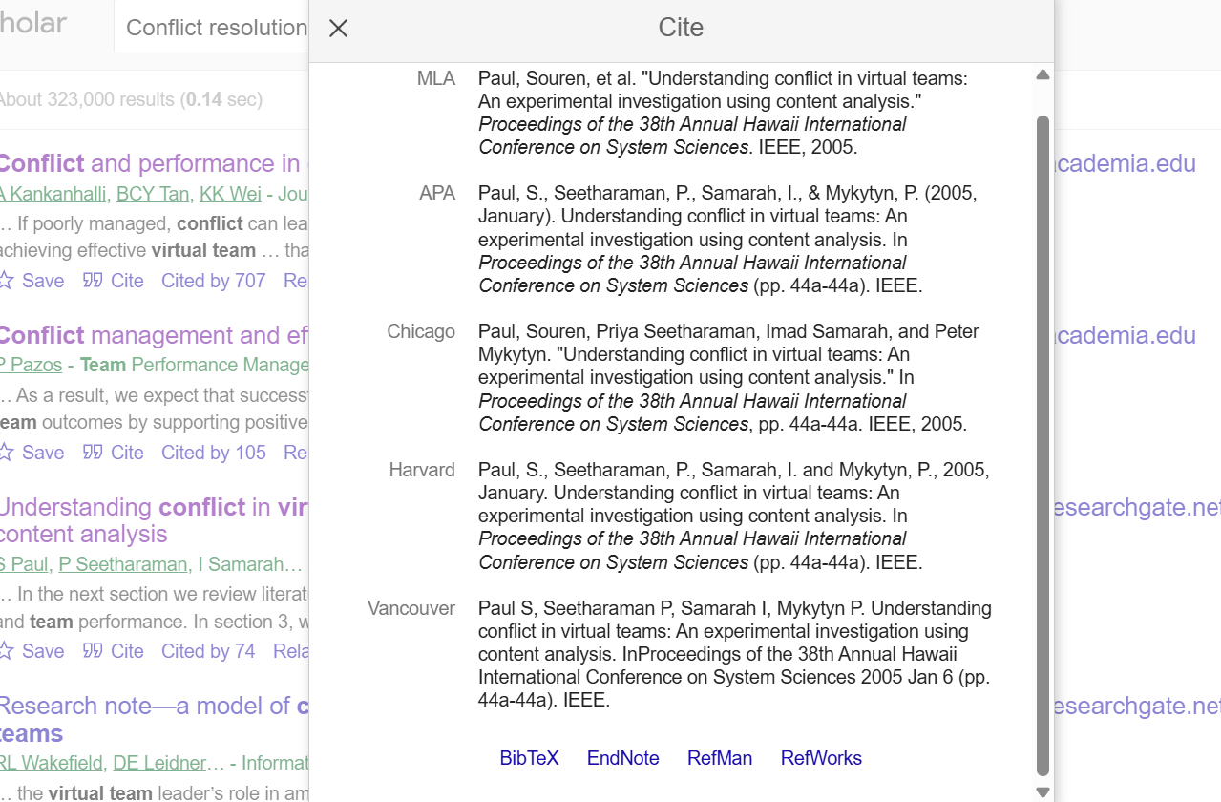

Choose the REFWORKS option from the “CITE”


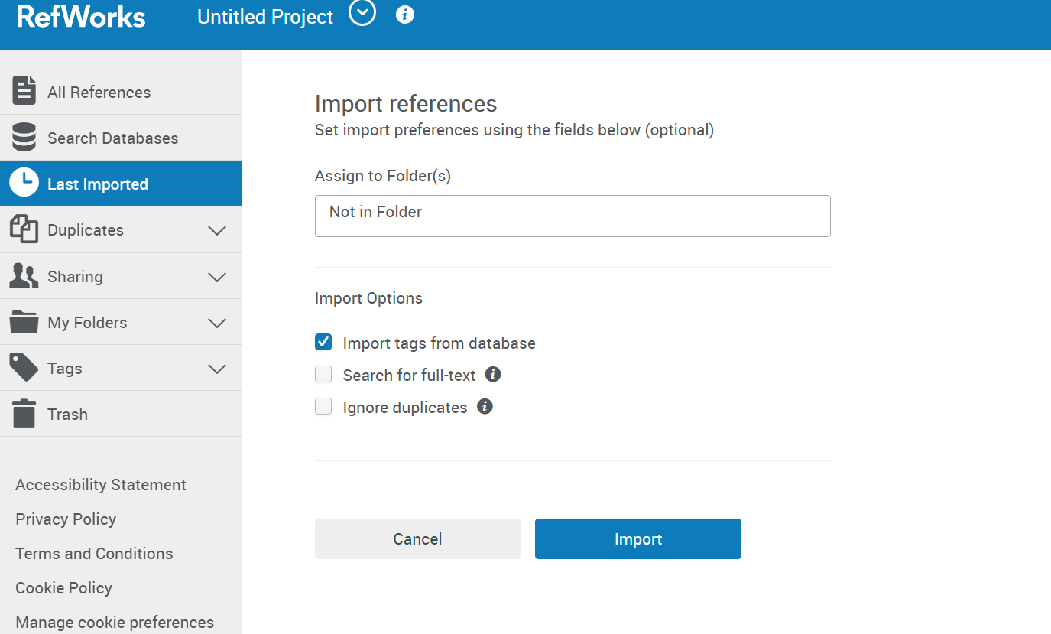

Create a Folder for your work


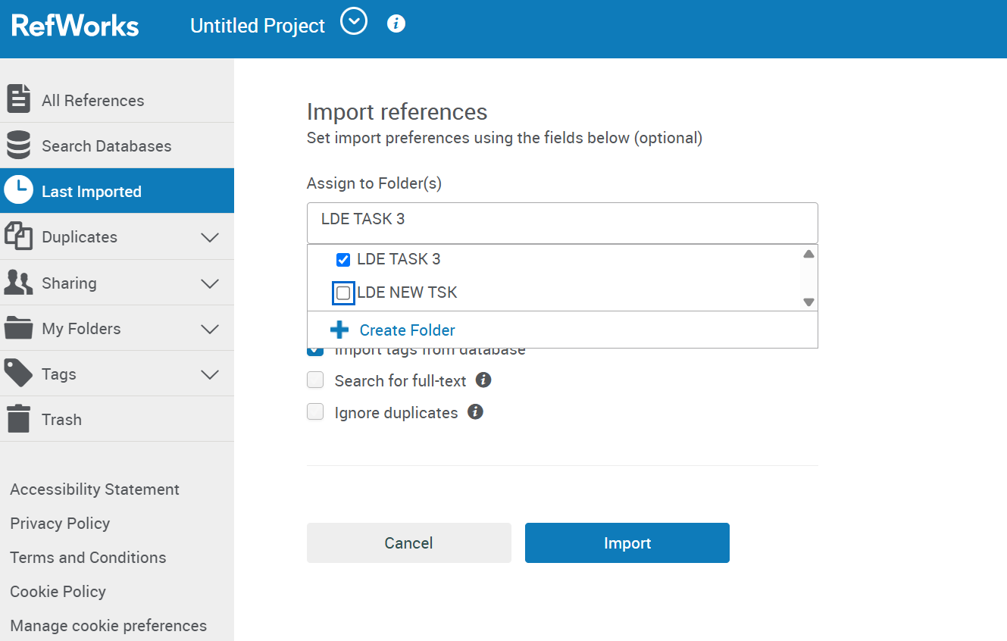

Add the Reference to your folder like in my case its LDE TASK 3

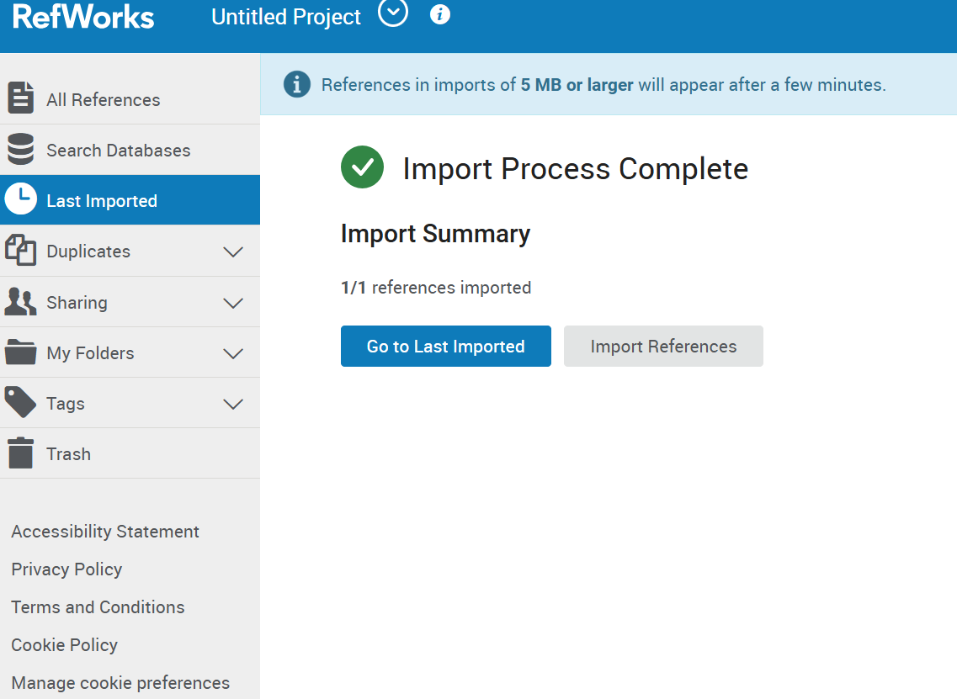

Successfully Added


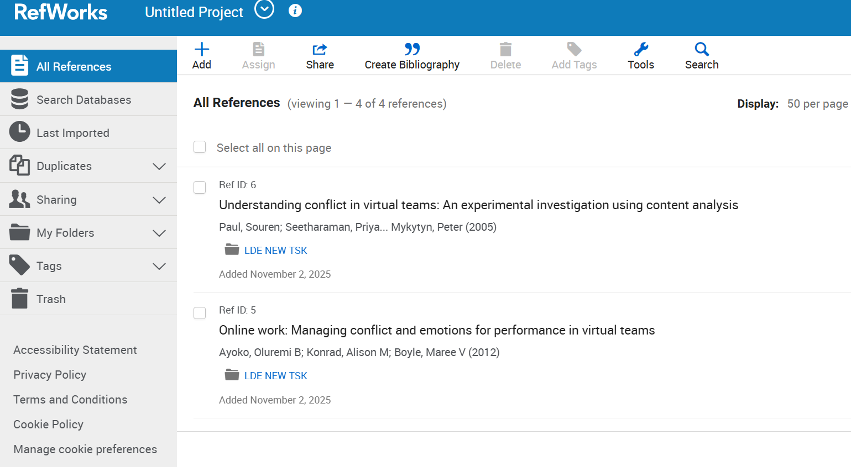
Now go back to All References

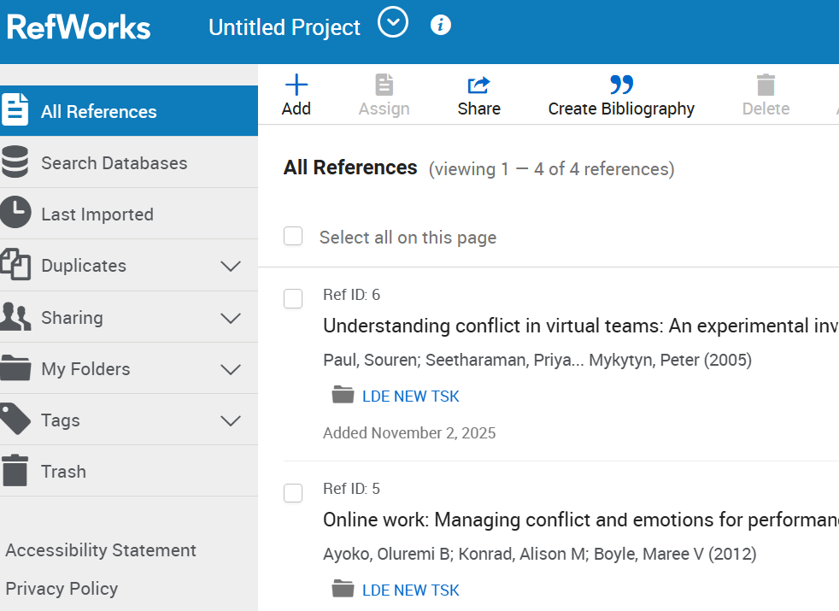


Click the Biblography


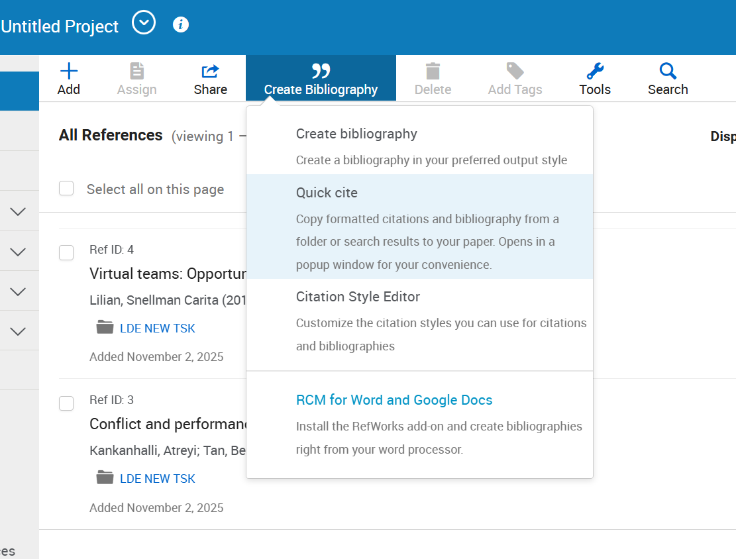

Choose create Bibliography


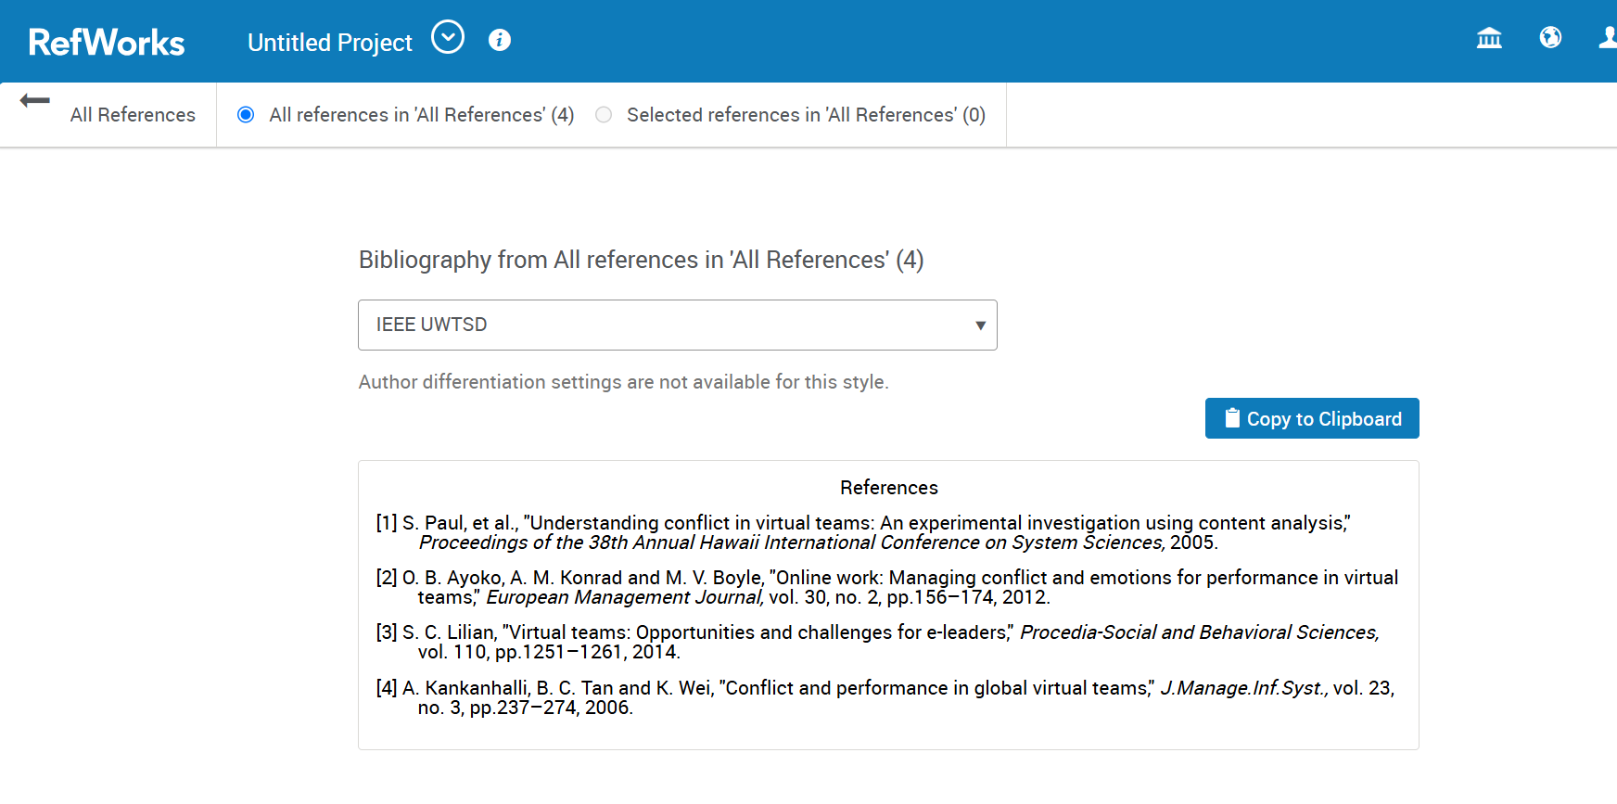

Our References are ready now choose copy to clipboard as shown in the picture


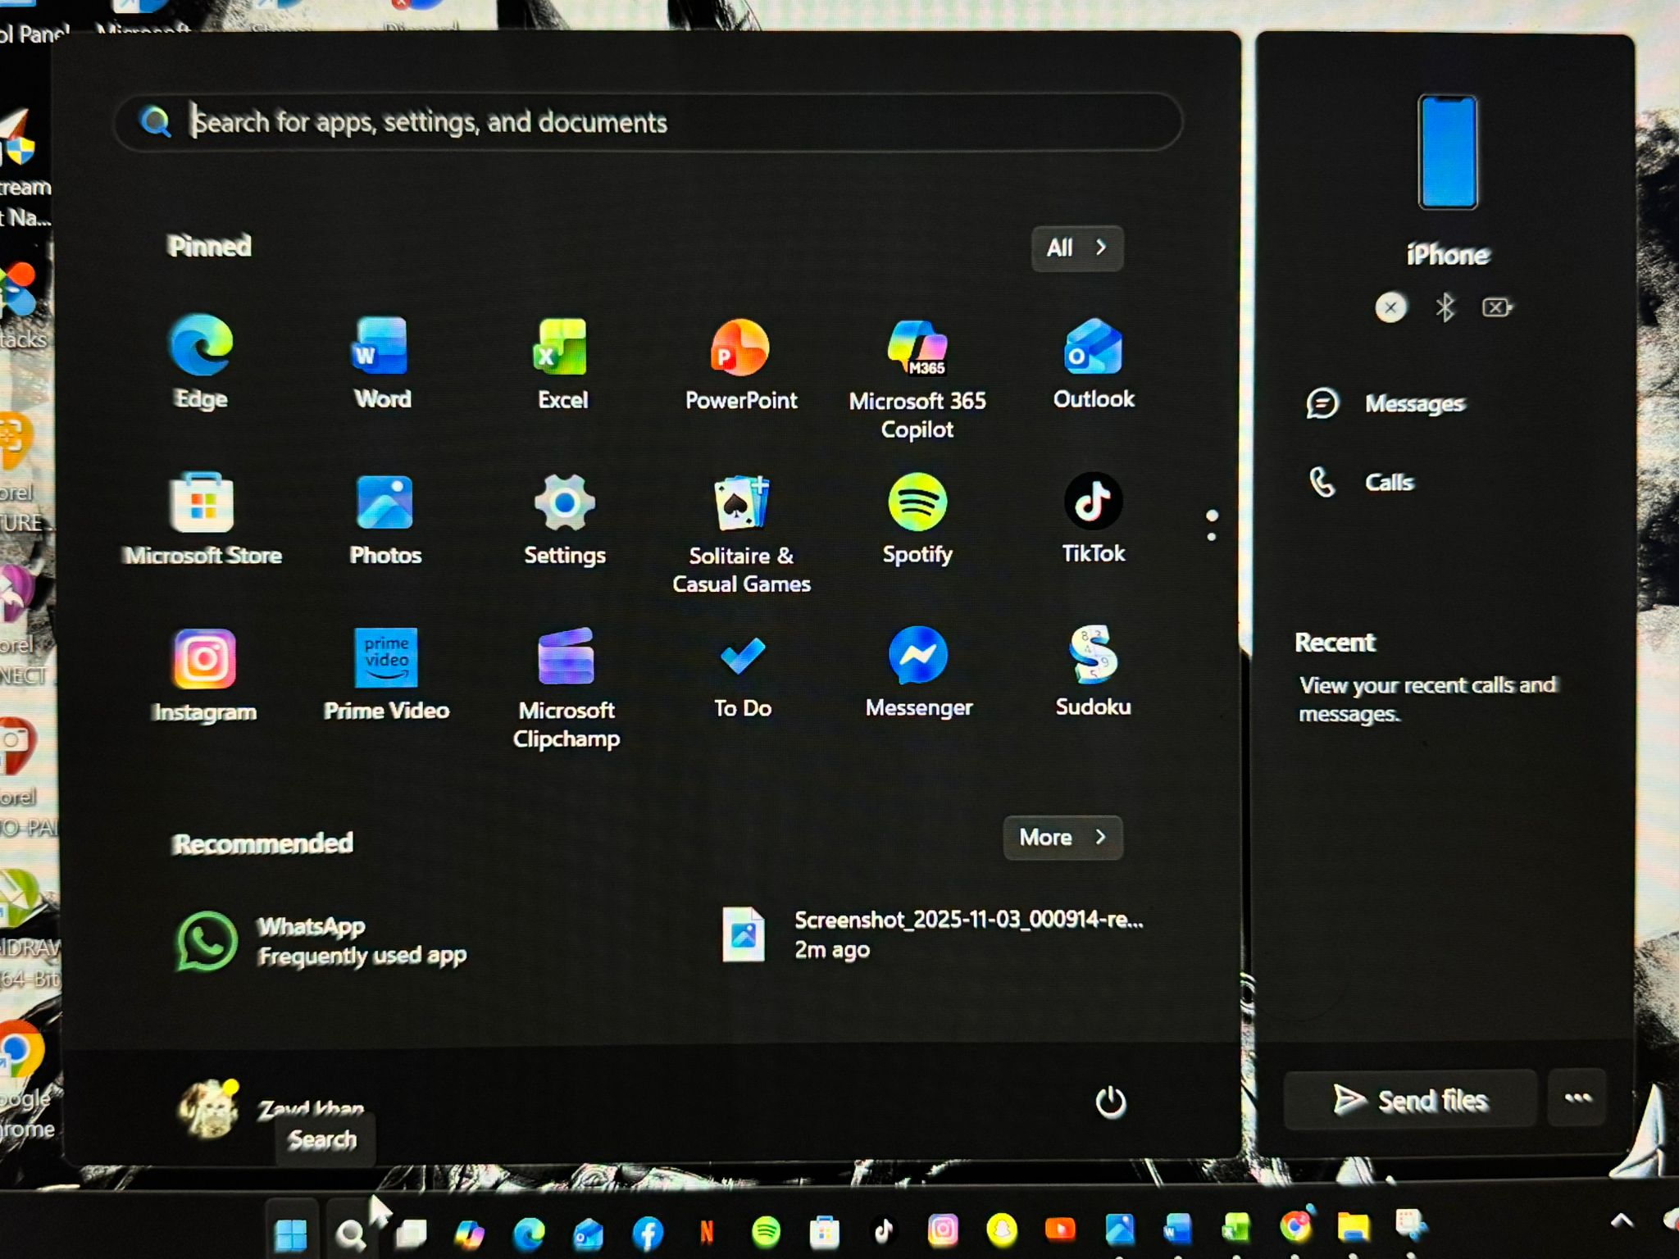
Open MS WORD on your computer

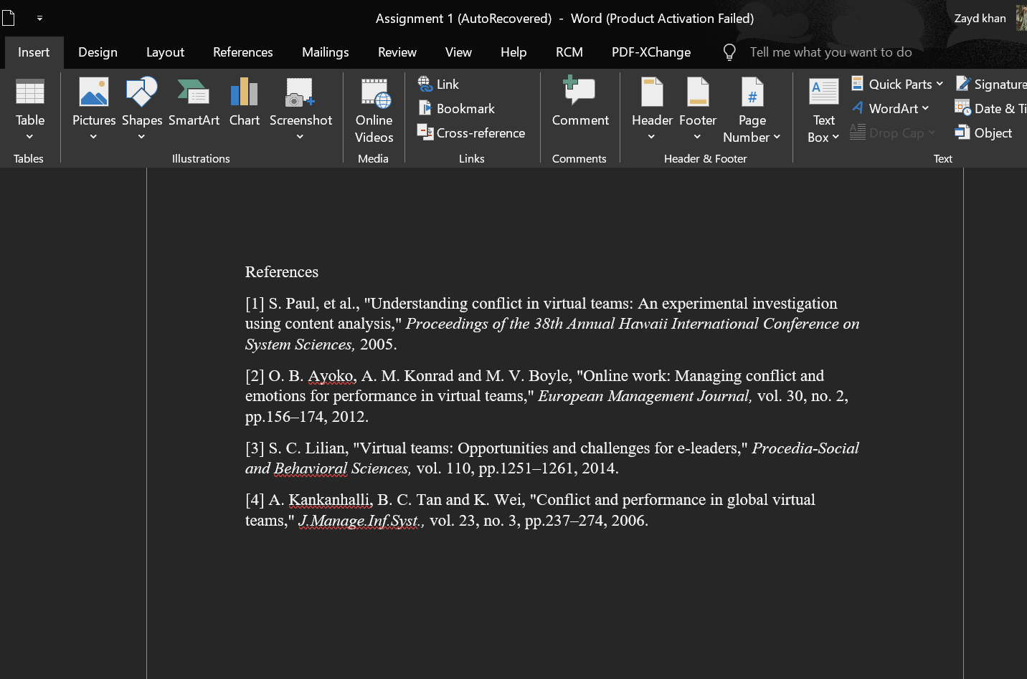
Paste the references here


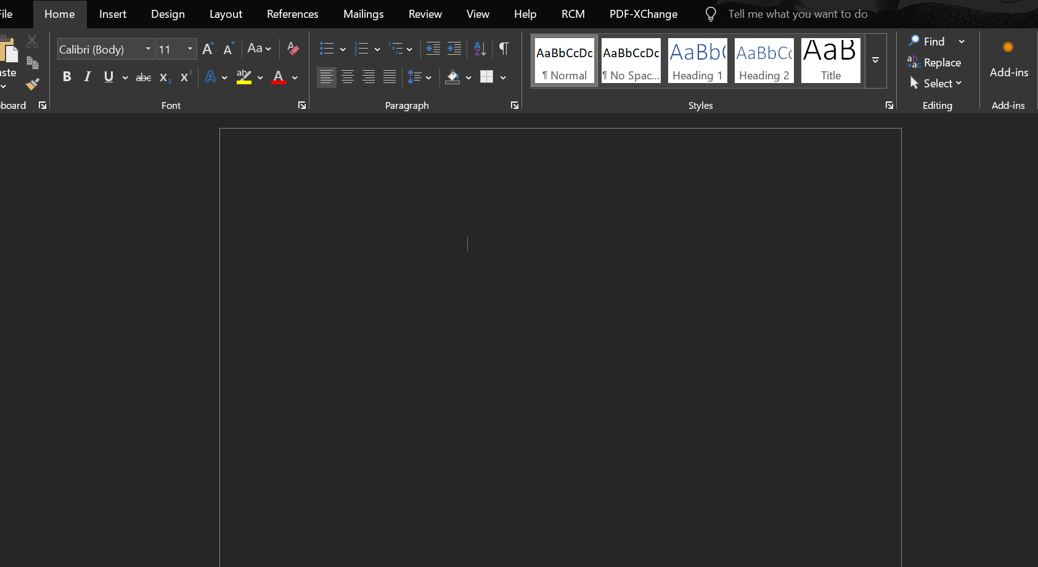

Click the LINK IN option in word


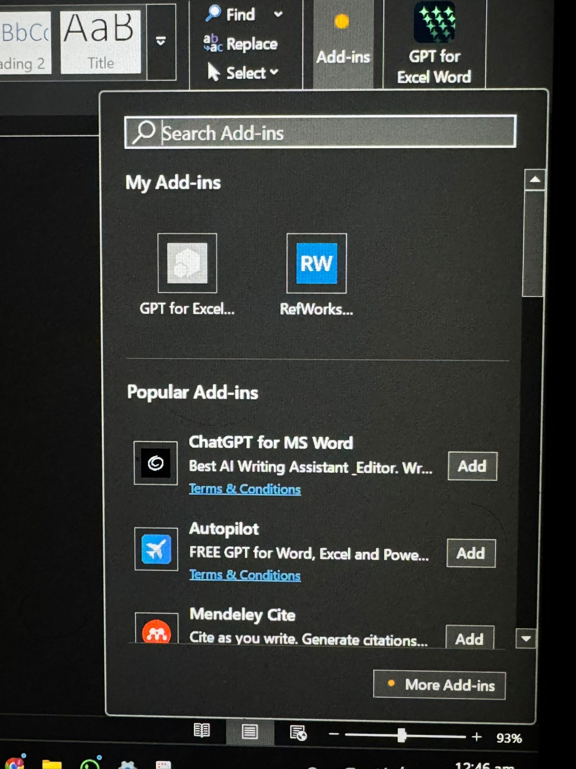
Select REFWORKS

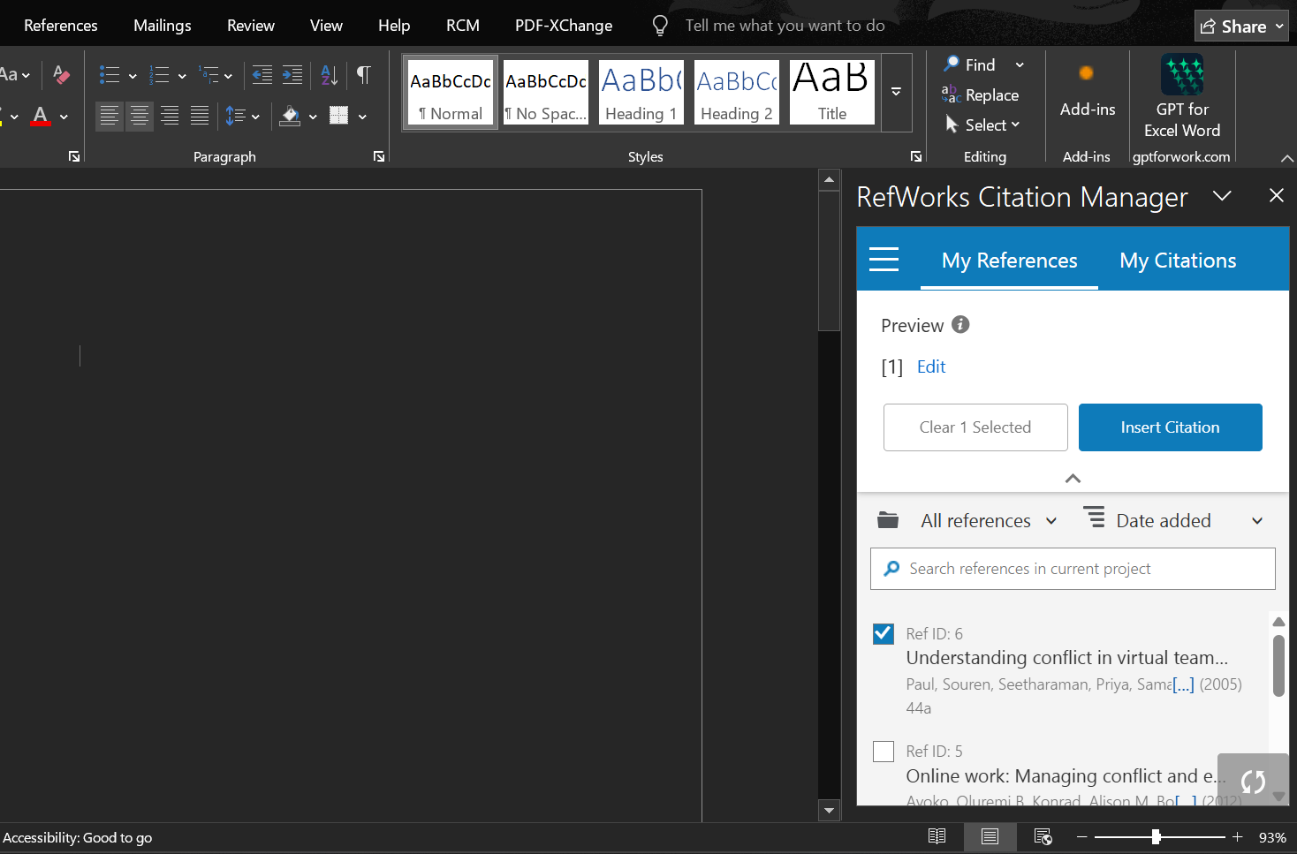
You will get this interface after

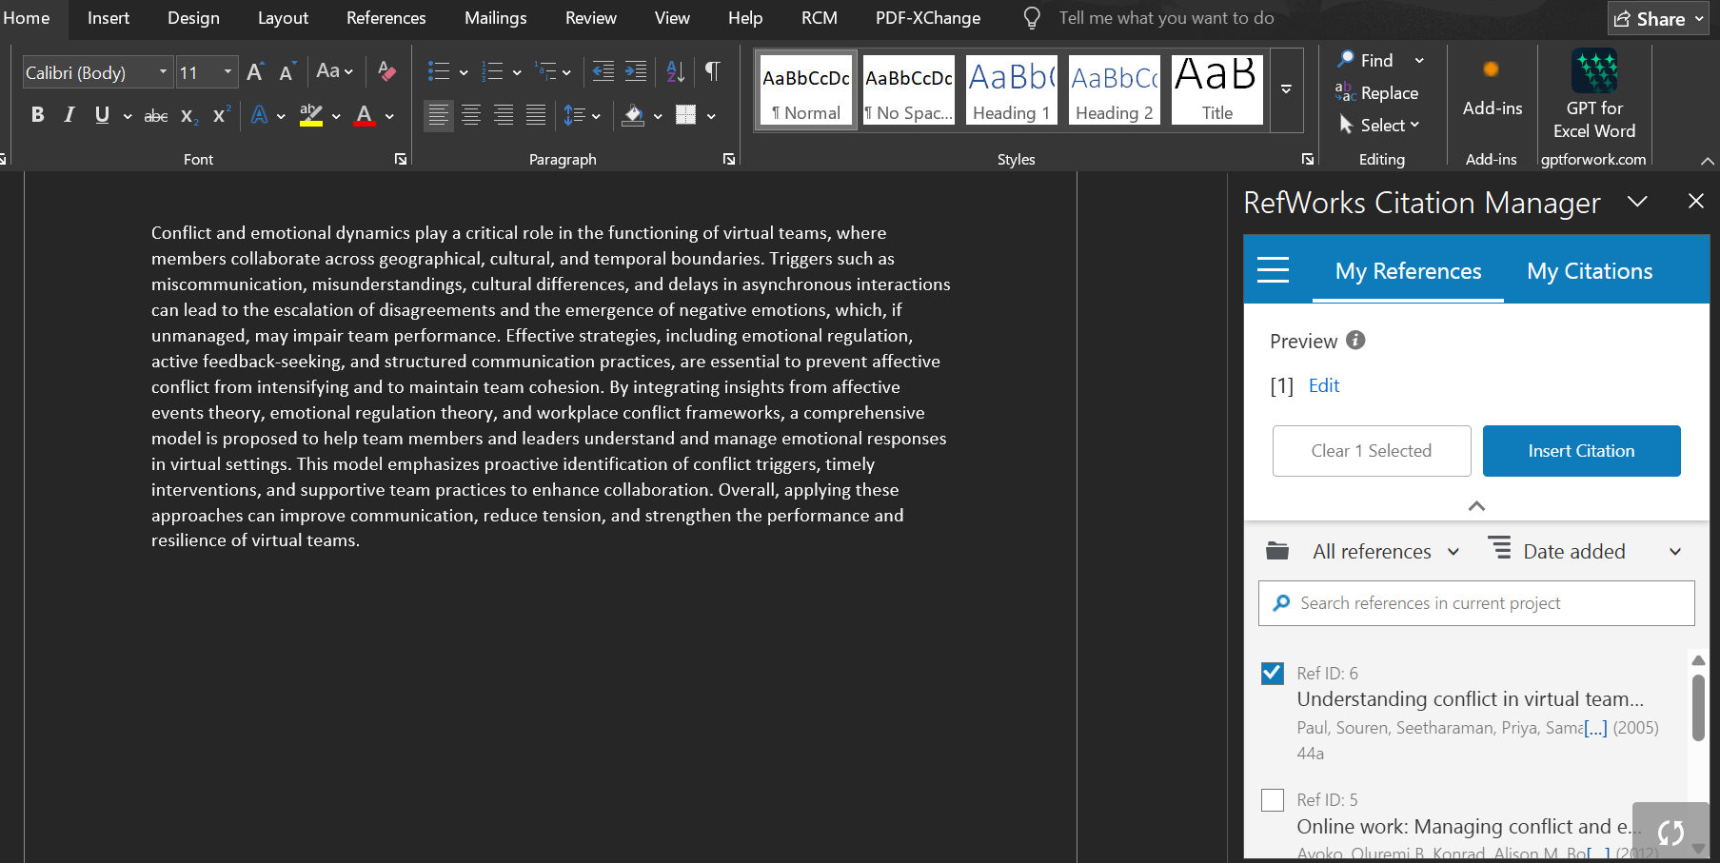

Write your paragraph


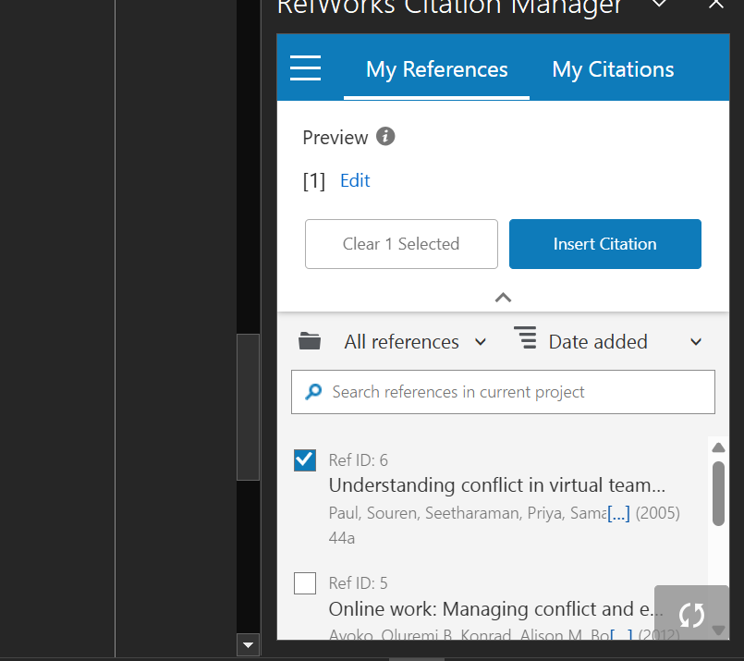
Add the citations and adjust them accordingly


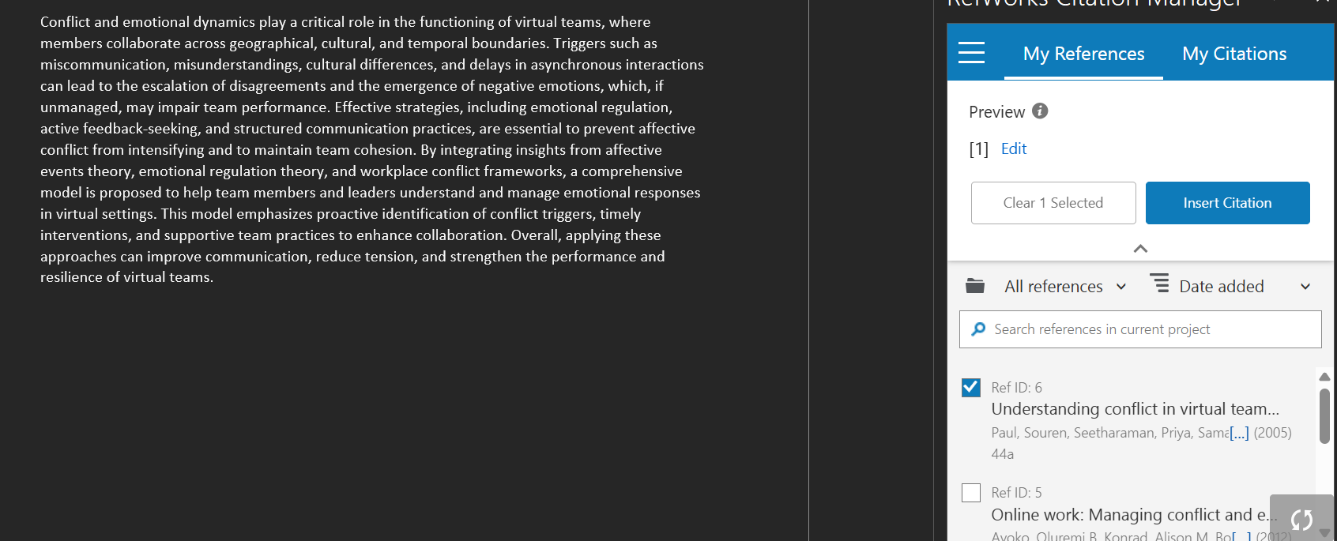

For example i am using the first reference for this paragraph


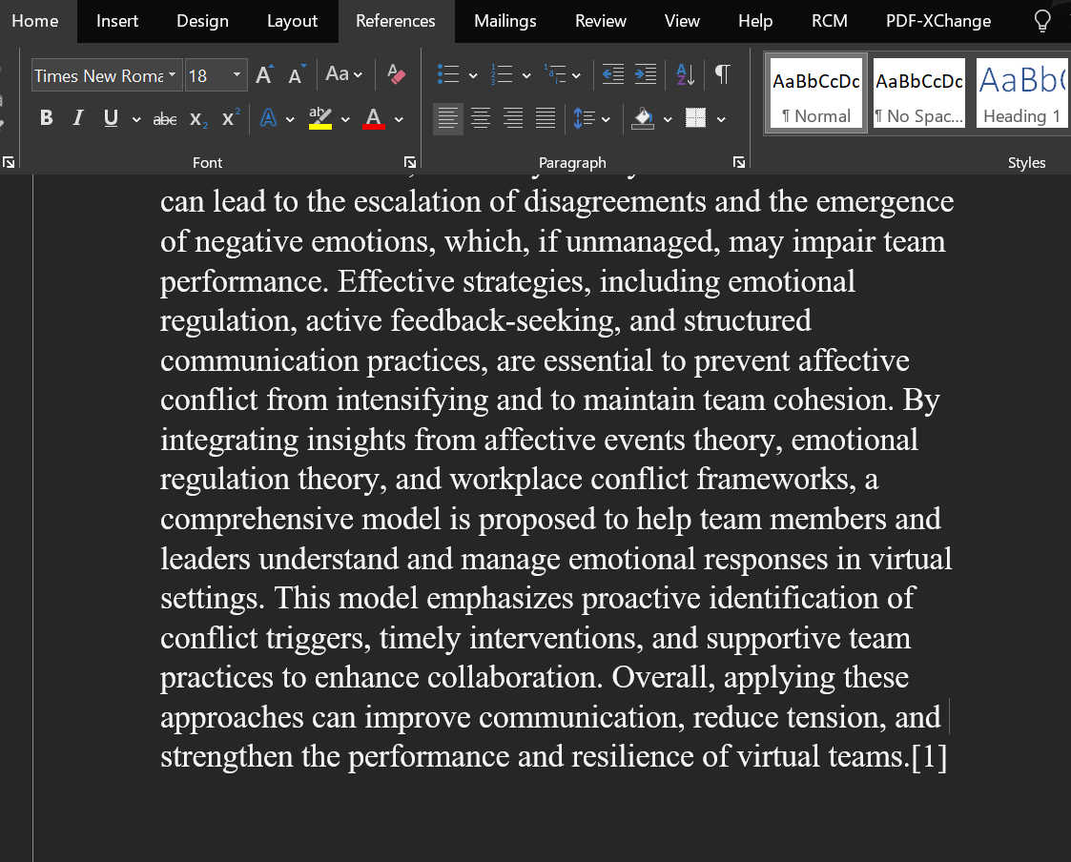
The reference is added to my paragraph

THANK YOU......

