Pitch, CV, and cover letter
E-PORTFOLIO

1. Umar Bilal Rahman
2. Student ID: 2018610
3. Module code: BMHP5015 Birm
4. Assignment: E-PORTFOLIO
5. Lectures Name: Tayo Korede

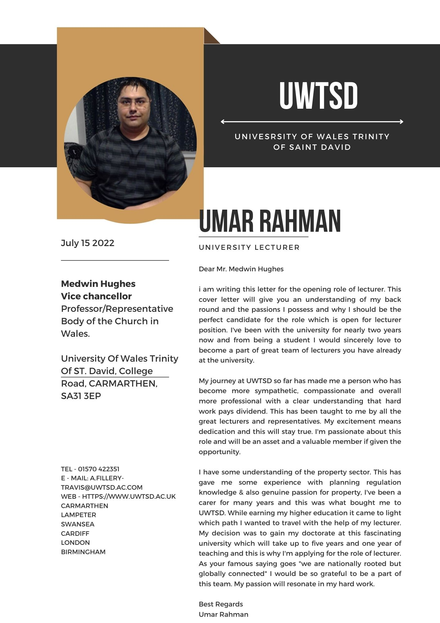

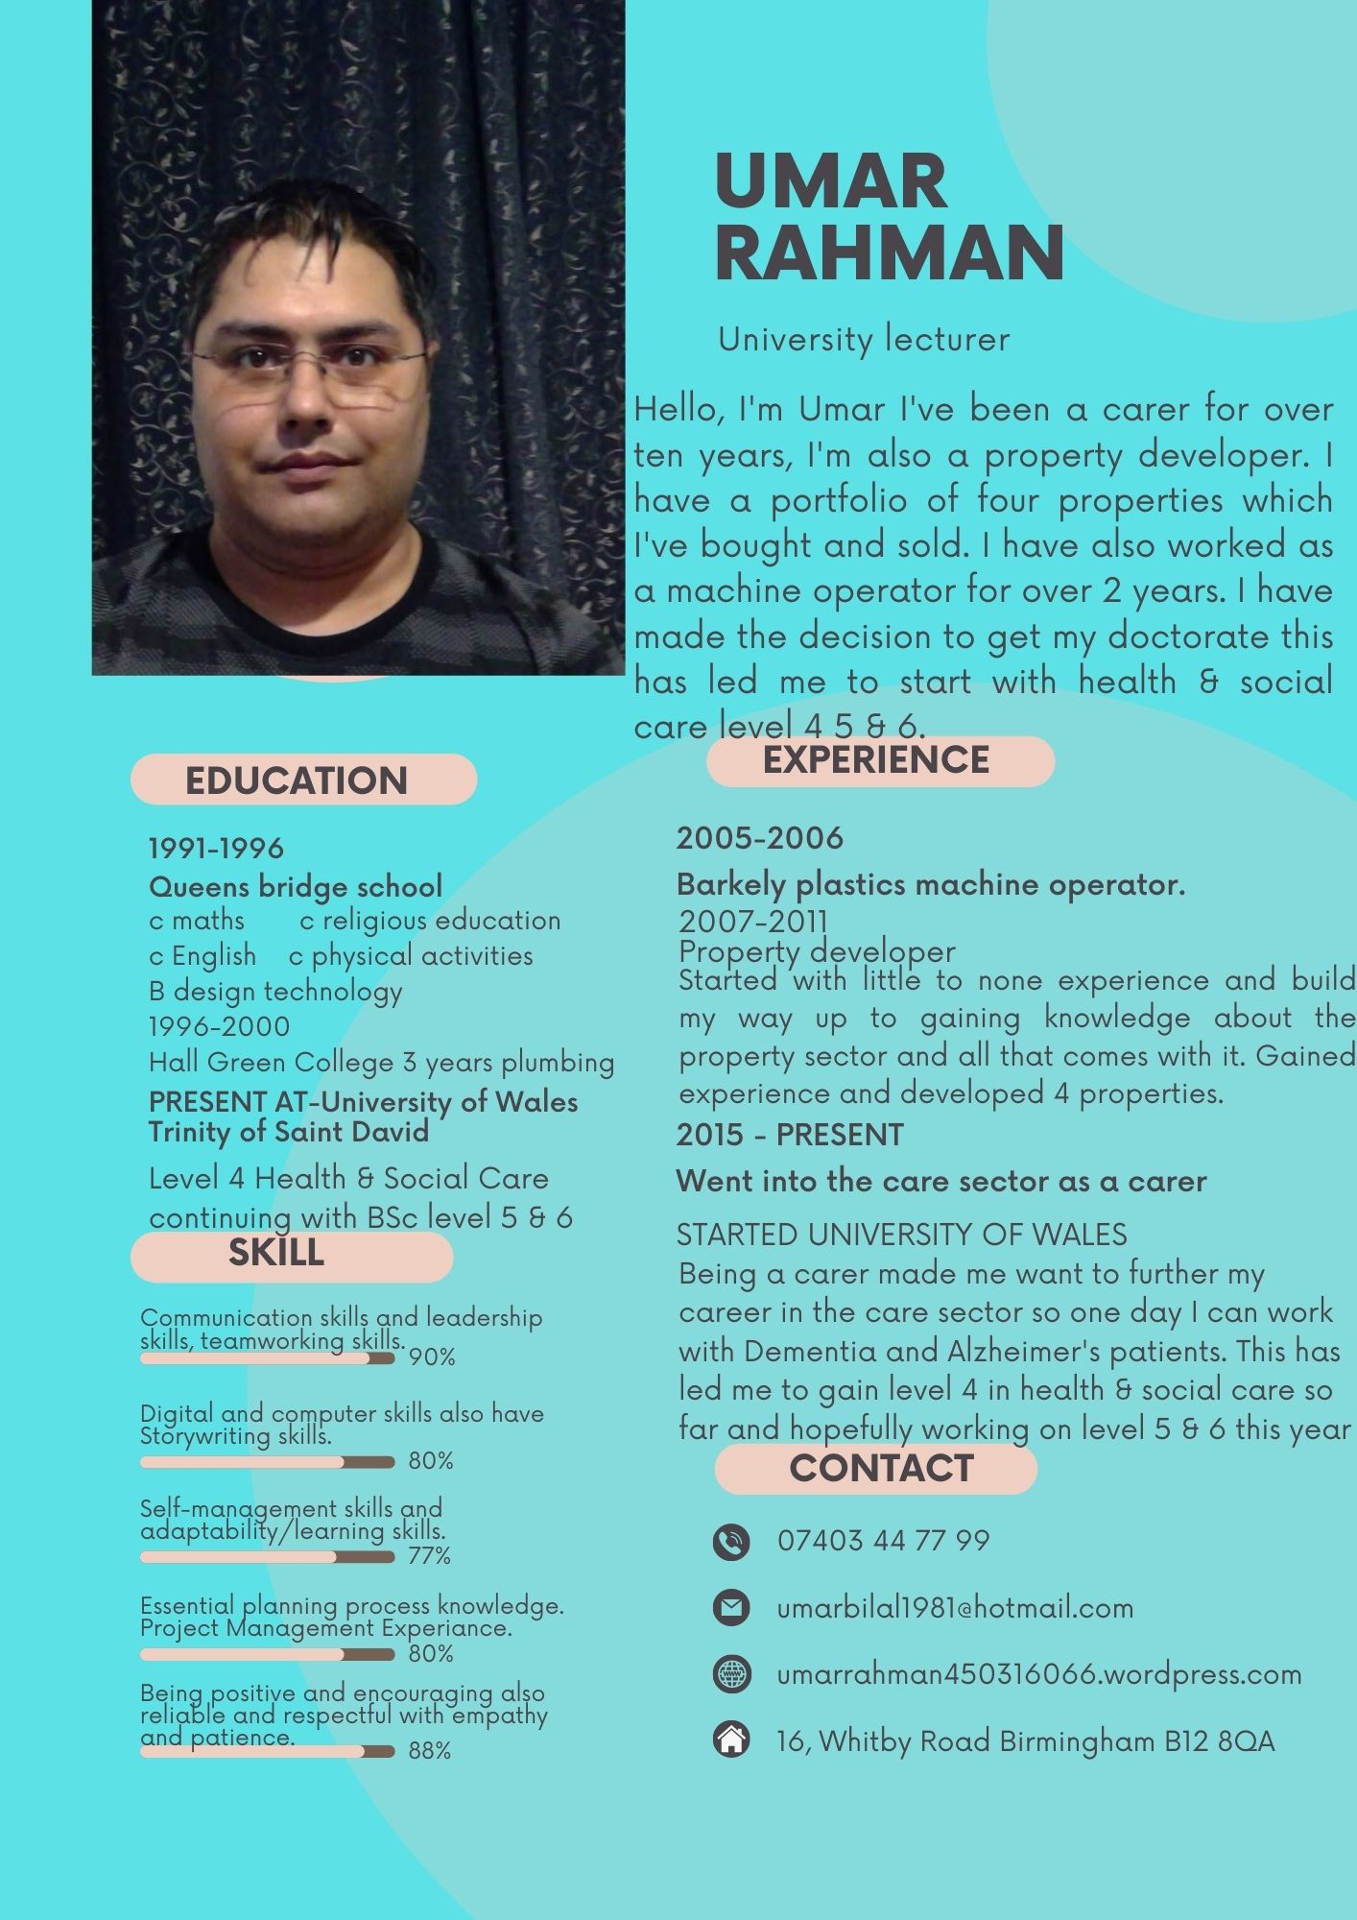


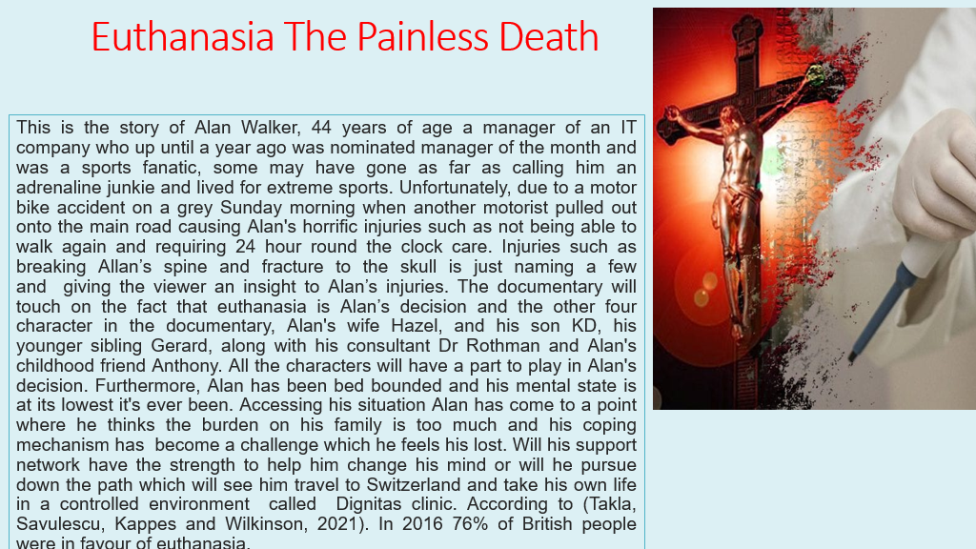

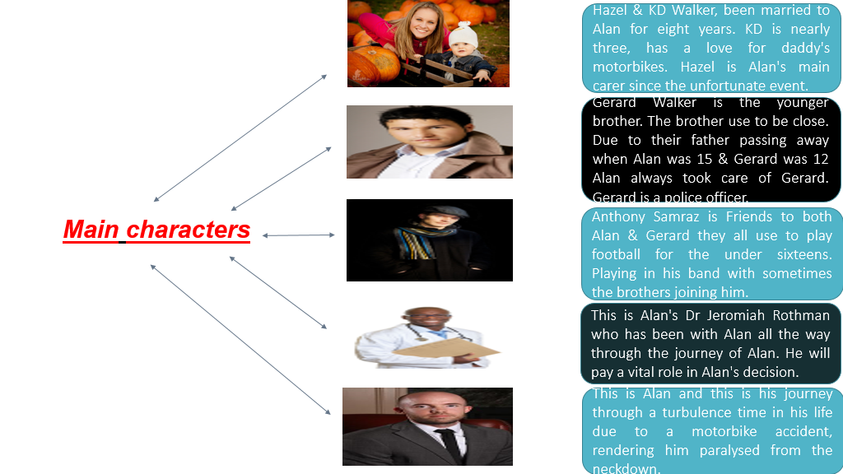

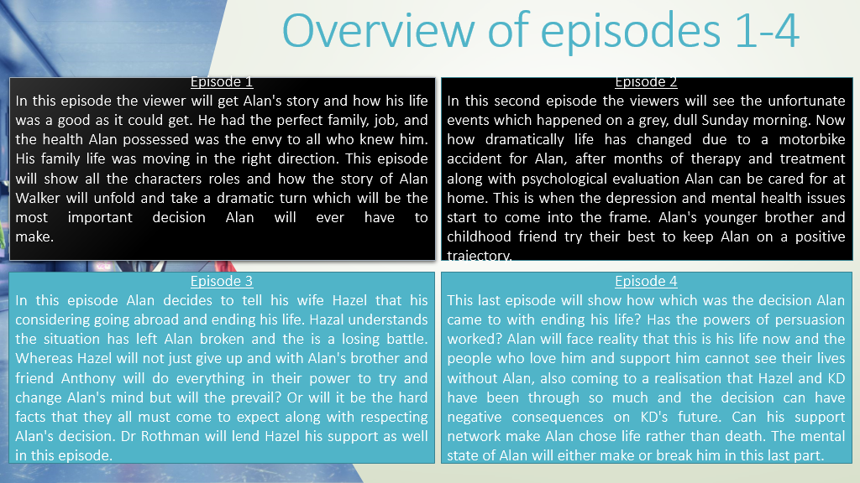

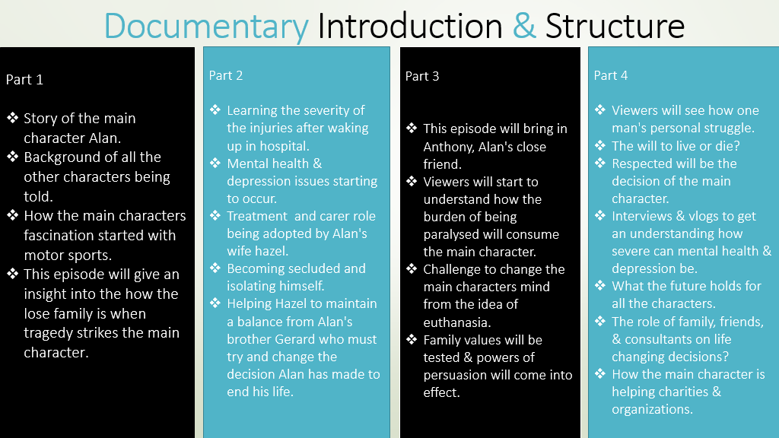
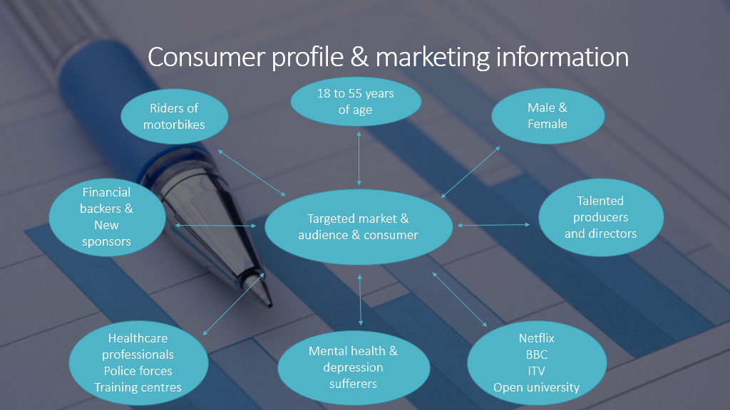

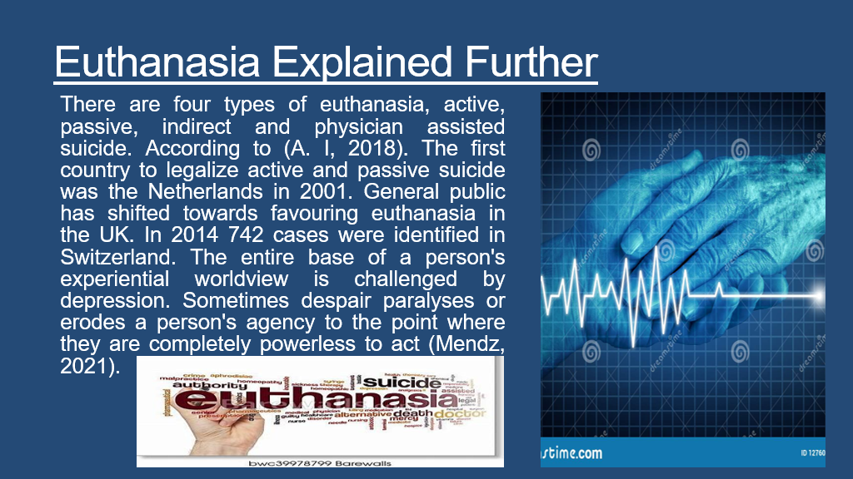

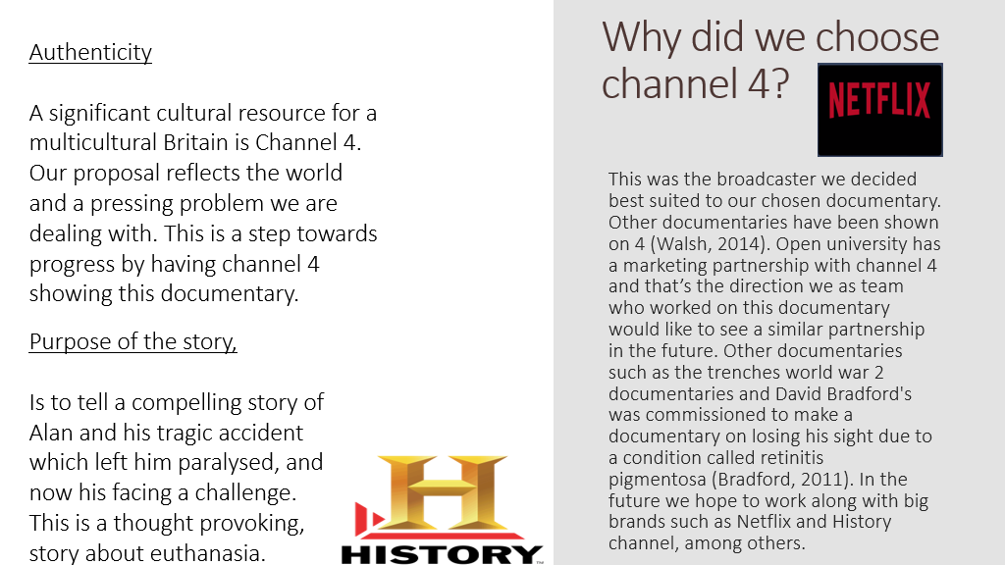

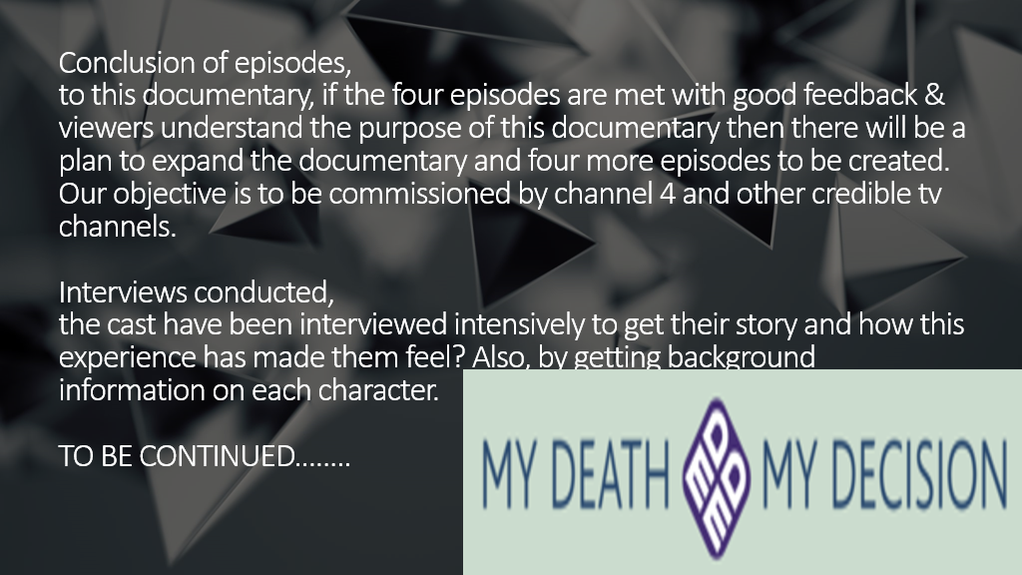

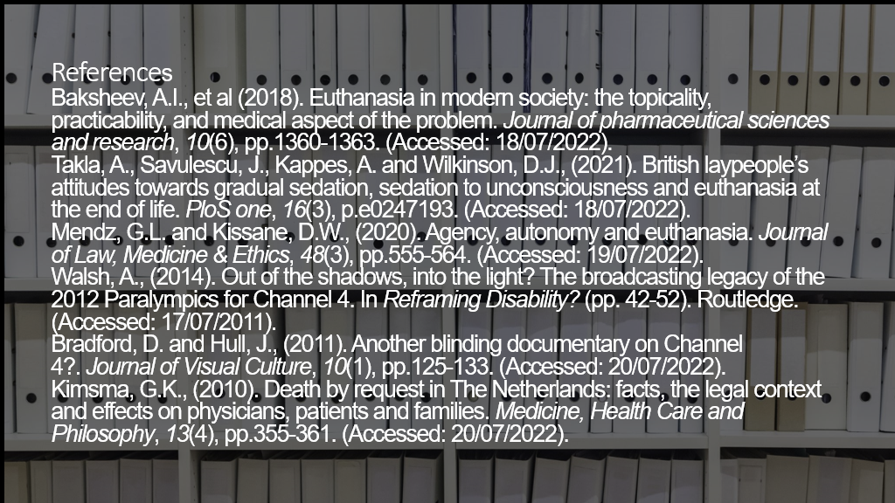
Appendix:

CV Umar Rahman
Location: Birmingham
Telephone:07403447799
Email: Umarbilal1981@hotmail.com

Professional profile
Accomplished and organised professional in the healthcare profession with experience and knowledge working in challenging environments with understanding the needs of the patients should always be prioritised before anything. I have worked in property developing with four properties bought and sold in my portfolio. Efficient running of service with strong work ethics is my motto.
core skills

- Face to face communication ↬ Striving for higher accomplishment
- Adapt to any working environment ↬ writing and editing skills
- Digital skills and research methods ↬ communication phone and email
- Support given to team leaders and management ↬ buying & selling experience
- Time management prioritise ↬ taken care of venerable adults
- Machine operating skills ↬ experience in business studies
- Advice on financial decisions ↬ professional affiliations

Career summary

January 2020-present University of Wales trinity of Saint David
- Academic employability skills ↬ Teamworking & effective communication
- Digital skills and research methods ↬ psychology in health & social care
- Problem & decision making ↬ Professional career development

The modules have been listed above which I have taken up at university. Some of my other roles have been helping fellow students with information. Helping the tutor with issues relating to students.

March 2010-2019 carer
- Medication supervision
- Feeding & clothing
- Cleaning & washing
I have been looking after an elderly family member who has multiple sclerosis for many years. It’s a very challenging role which I’ve adapted to very well. One must be on High alert when caring for someone who finds it difficult to do day to day tasks.

June 2008-2010 Skippers fast food outlet
- Cashier ↬ Opening & closing responsibilities
- Taking Phone orders ↬ excellent costumer service
- Keeping High standards of food hygiene ↬ understanding aspects of business
For two years I held a job in the fast-food outlet. Training was given in both internal and external with rules followed of health and safety. Working among a team helping and supporting each other when needed and strong communication skills with working under pressure was a norm.

January 2005-2008 Barkley plastics
- Machine operator ↬ sorting ↬ packing products
- Processing ↬ Quality control ↬ operating pallet jacks
Opportunity came to work in a factory which I believe opened me up to the world of work and taught me how to be responsible and maintain my work standards it also showed me the challenging environments where no mistakes can be made.

September 2000-2005 Property Developer
- Negotiating Buying & Selling ↬ local economic factors
- Financial decisions. ↬ time intensive
- Developing the property. ↬ Meeting building regulations
Before the recession maintaining mortgages was relatively a process which I was lucky enough to take part in and make it into a full-time job and the harder you worked the better the payoff was. This role involved collecting rent making mortgage payments. Bank meetings and paying visits to the auctions for research on upcoming properties. I’ve bought and sold four properties in my portfolio.

Achievements
January 1998-2000 Baptist church
- Voluntary work ↬ Maintenance of church ↬ cleaning glass panes
- Gardening. ↬ checking for infestation ↬clearing clog gutters
January 1998-2000 Rehman supermarket
- Shelve stacker ↬ cashier ↬ maintaining workspace

Qualification
1991-1998 Queensbridge secondary school & Hall green college ↬ Math c ↬ English c ↬ science d ↬ Design technology d ↬ PE c ↬Religious Education d ↬ language b ↬music b. 1 year in college I did business studies second year I did plumbing and third year was spent doing mechanics.

Dear Mr Medwin Hughes
I’m applying for the role of care assistant which you have advertised on your website. Having read the job advert and job description, I believe I hold and possess the exact qualities and skills necessary to carry out the duty of care needed to fill this position and carry out the role to a high standard
Even though the job description stated experience needed, I have experience in this field for over five years. I am self-motivated and enthusiastic with enhanced positivity with a clear understanding of the importancecy and nature of this role. My belief is that the life experience which I have gained has adapted me perfectly and moulded me to be the perfect candidate who can be suited to fit this type of role.
My qualities and attributes will also align in respect with your code of conduct required by your organization which include,
- A trustworthy, flexible, and reliable approach to any tasks handed to me.
- An understanding of the care being given to patients.
- Happy and positive demeanour being maintained whilst at work.
- Clear communication with colleagues and professionally handling situations.
- Assisting team members and carry on with duties.
If my application is successful, you will be impressed with my positive attitude to work and my ability to deliver excellent service. My ability to improve while learning will be a great motivator for the team.

Yours faithfully,
Umar Rahman
Telephone: 07403 44 77 99
Email: Umarbilal1981@hotmail.com

Cover letter
Dear Mr Medwin Hughes
I’m applying for the role of care assistant which you have advertised on your website. Having read the job advert and job description, I believe I hold and possess the exact qualities and skills necessary to carry out the duty of care needed to fill this position and carry out the role to a high standard
Even though the job description stated experience needed, I have experience in this field for over five years. I am self-motivated and enthusiastic with enhanced positivity with a clear understanding of the importancecy and nature of this role. My belief is that the life experience which I have gained has adapted me perfectly and moulded me to be the perfect candidate who can be suited to fit this type of role.
My qualities and attributes will also align in respect with your code of conduct required by your organization which include,
- A trustworthy, flexible, and reliable approach to any tasks handed to me.
- An understanding of the care being given to patients.
- Happy and positive demeanour being maintained whilst at work.
- Clear communication with colleagues and professionally handling situations.
- Assisting team members and carry on with duties.
If my application is successful, you will be impressed with my positive attitude to work and my ability to deliver excellent service. My ability to improve while learning will be a great motivator for the team.

Yours faithfully,
Umar Rahman
Telephone: 07403 44 77 99
Email: Umarbilal1981@hotmail.com

The above was an extra CV and cover letter I managed to do Mr Tayo. So it’s up to you to chose the best one that looks professional and you can mark that one please thank you sir it was an honour to be taught by you and also a pleasure to do this e-portfolio.

