University of Wale Trinity Saint David
Engineering Academic Discipline

Technical Report
Lily Yallop
2400645
Motorsport Engineering
12th January 2025
Analytical Methods ACHA4000

Contents
1. Question 1 1
2. Question 2 3
3. Question 3 4
4. Question 4 5
5. Question 5 8
6. Question 6 9
7. Question 7 10

1. Question 1

Solve the following equations, using the appropriate method, for 𝑥:

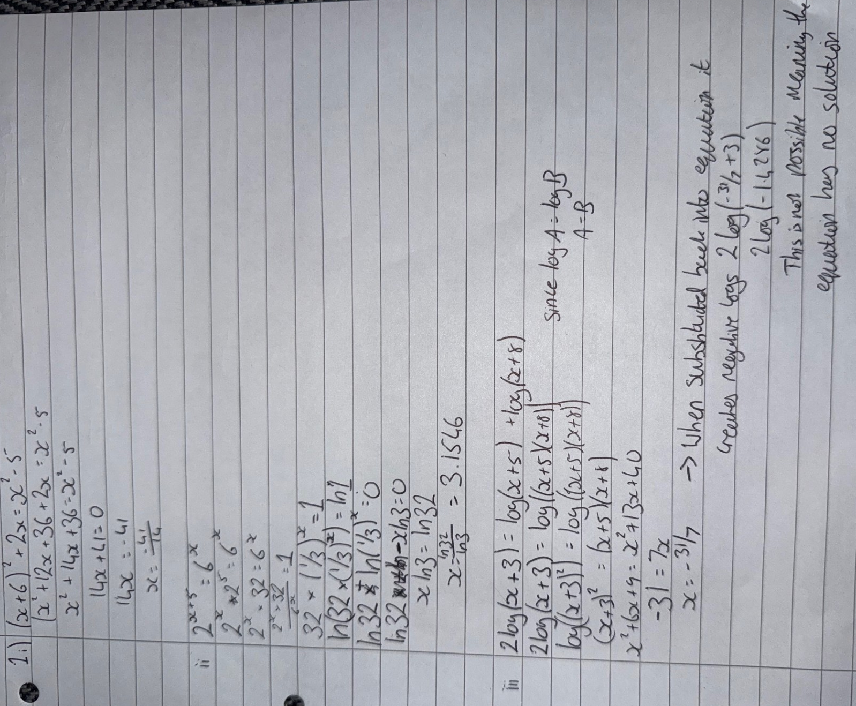

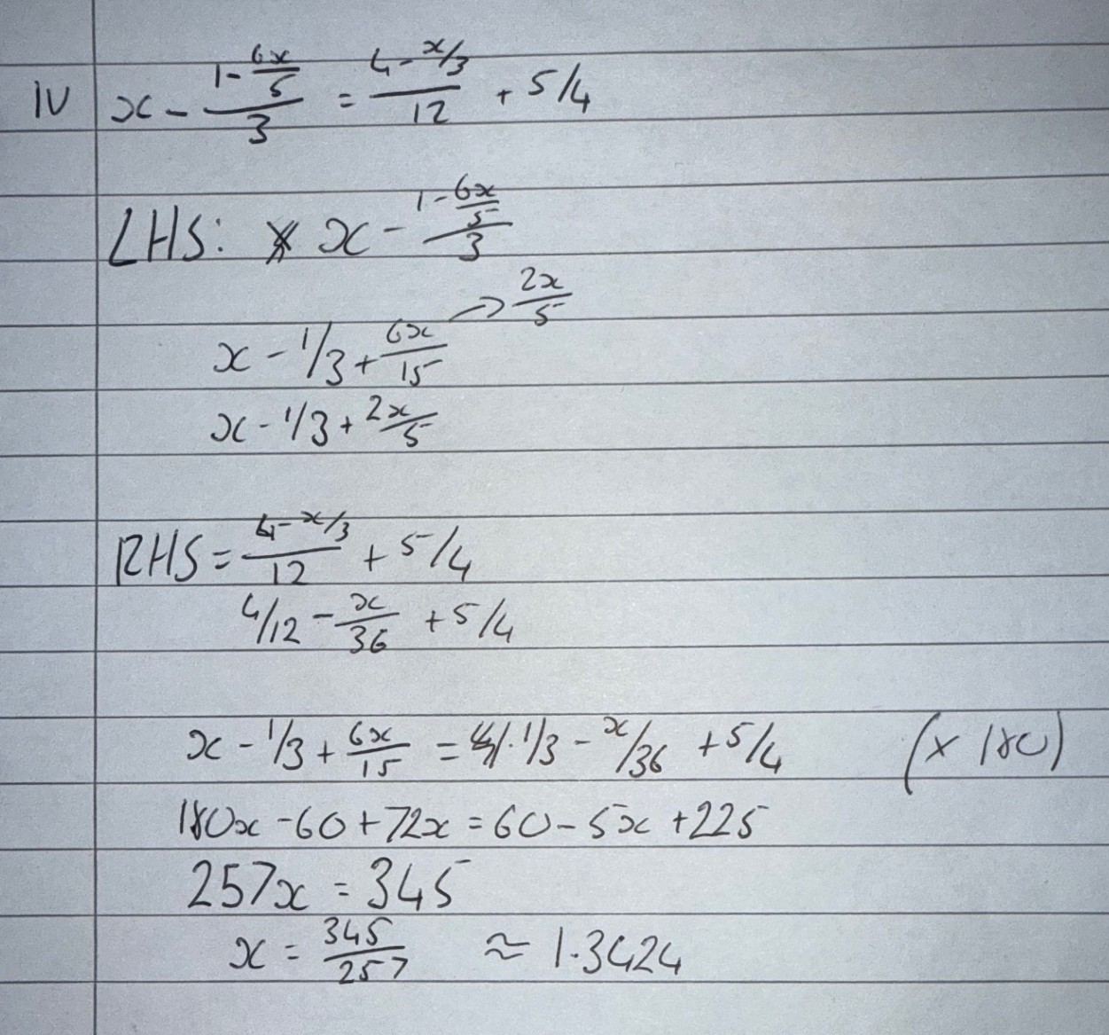

2. Question 2

Solve the following simultaneous equations, by using algebraic methods (i.e. substitution or elimination only).
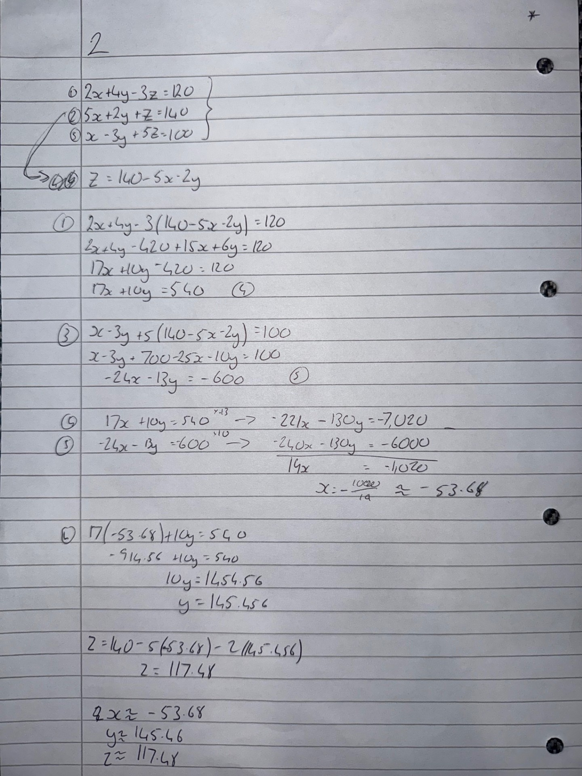

3. Question 3

Solve the following quadratic equation, using the appropriate method:

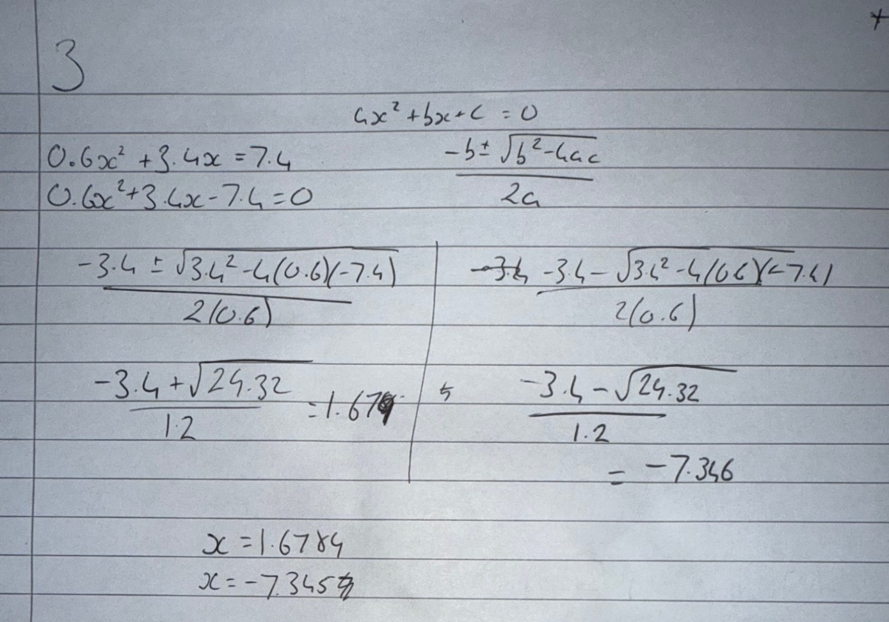

4. Question 4

Find the first derivative of the following functions, writing all steps of your calculations. Simplification of answers not required, but if you do simplify, write all workings down:
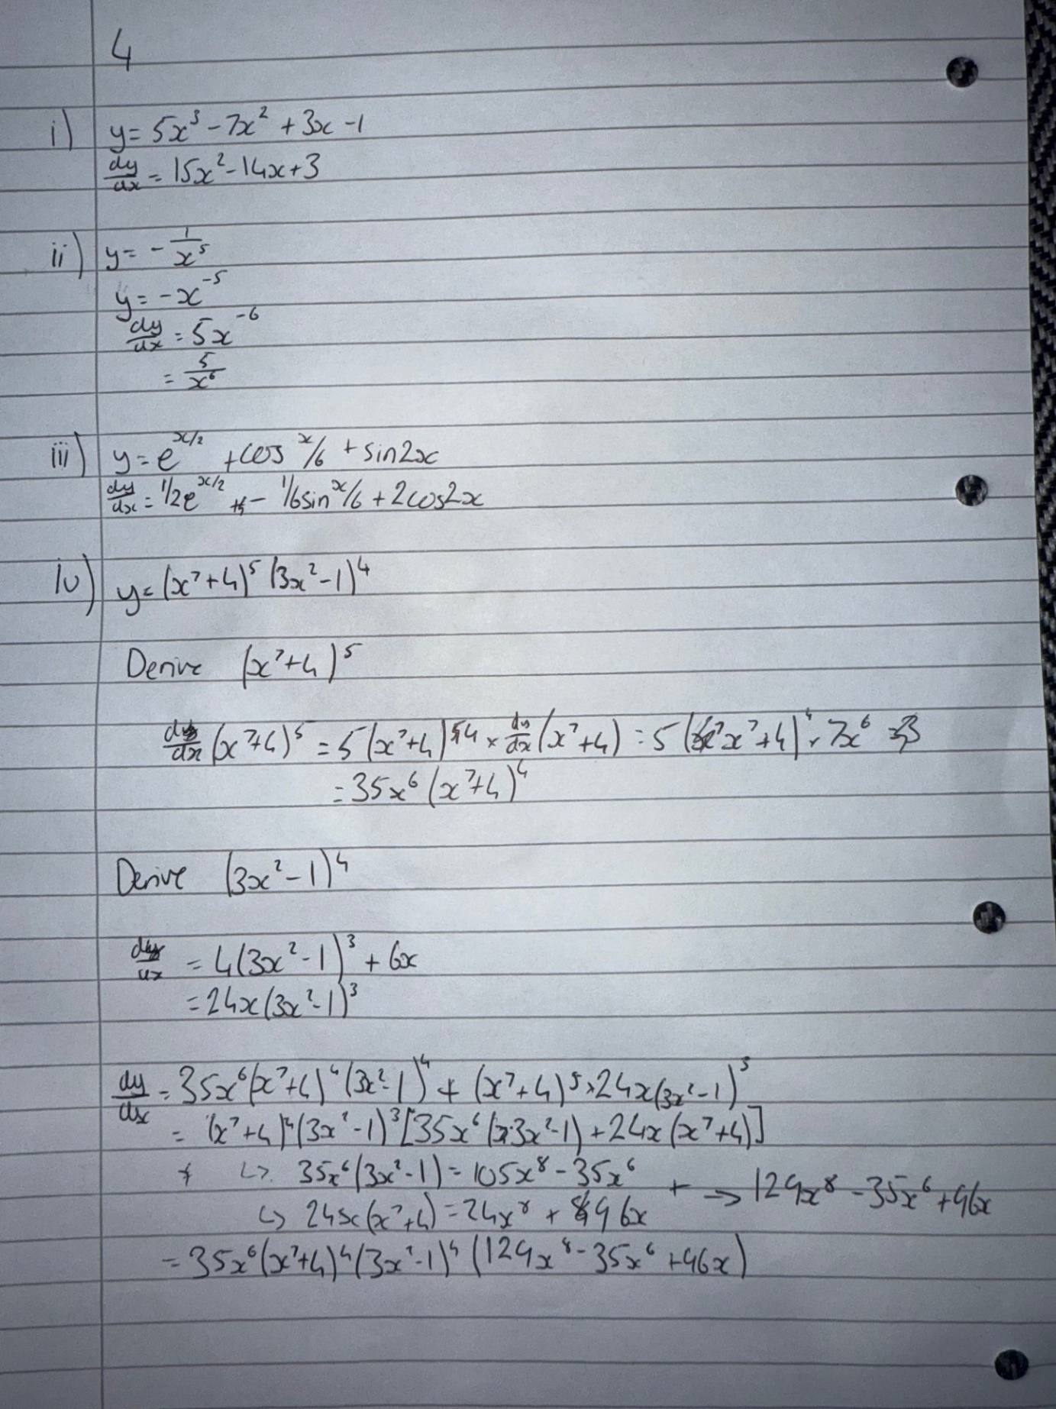
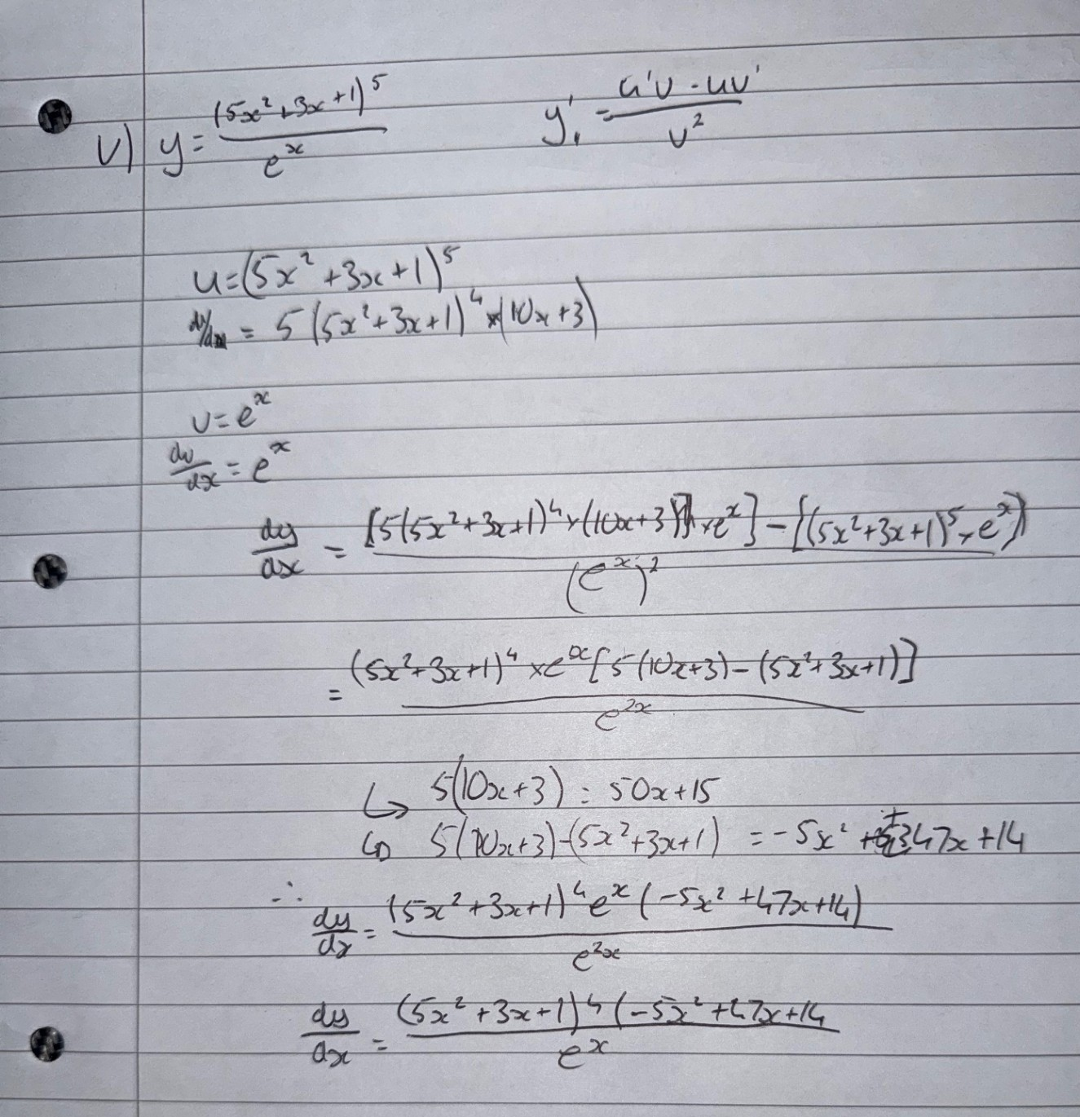

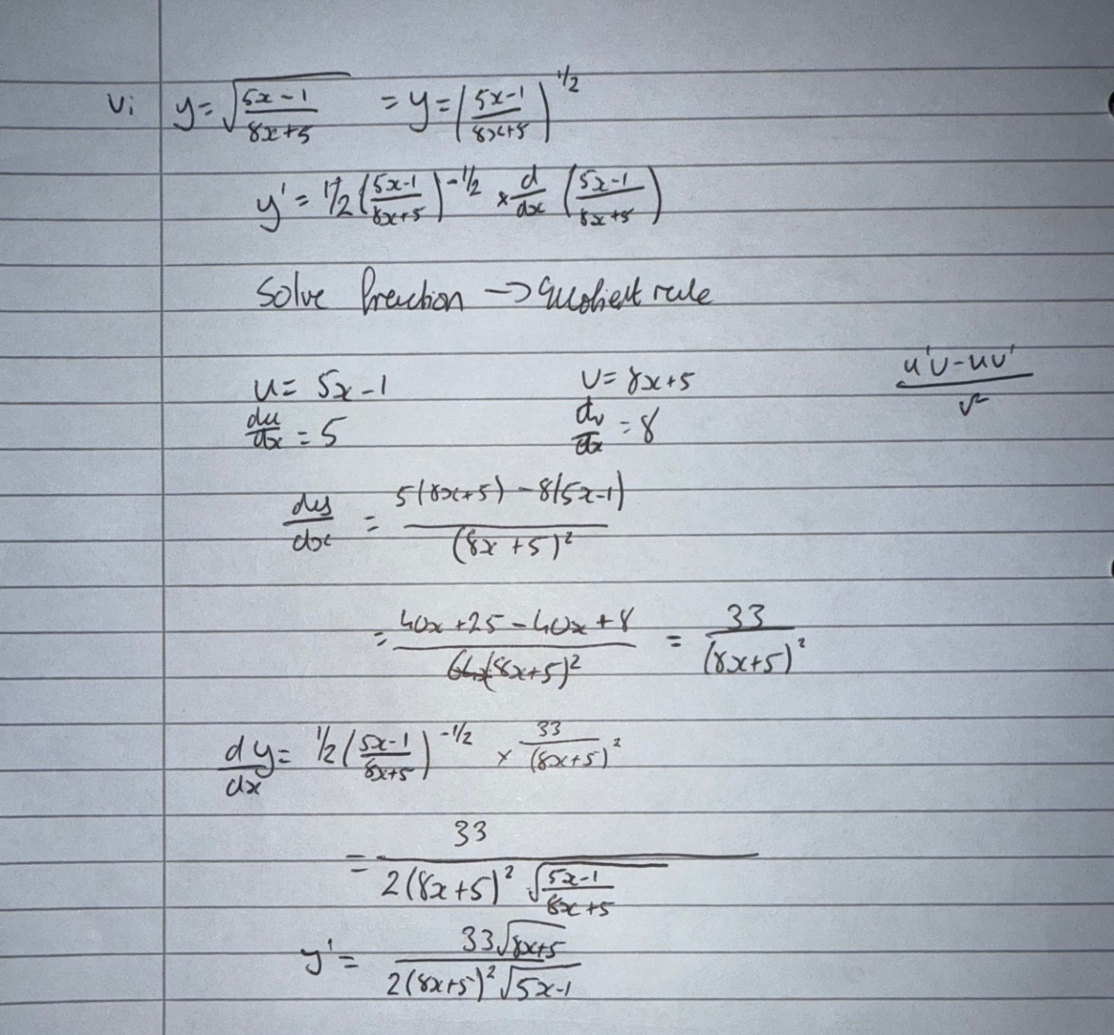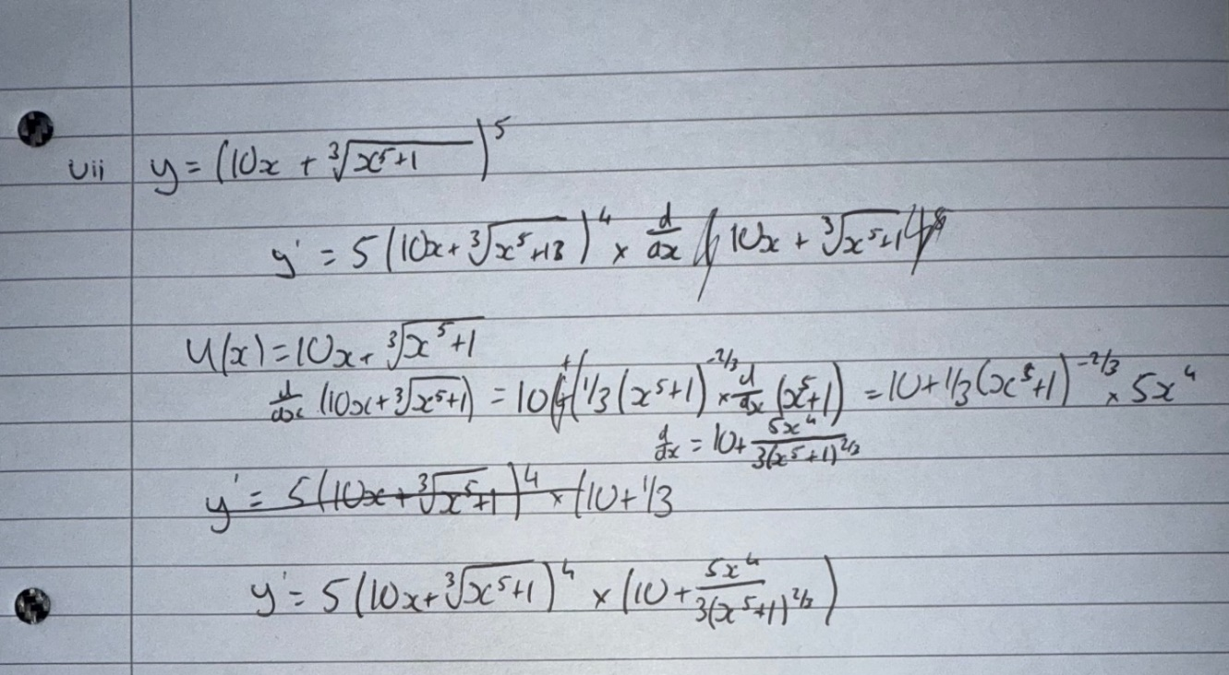

5. Question 5

The displacement of an object from a point is denoted by 𝑥. As this position changes with respect to time, we can write this, the velocity, as a derivative 𝑑𝑥/𝑑𝑡 .

If this first derivative represents the velocity of the object, state what the second, third, fourth, fifth and sixth derivatives (with respect to time) represent.



6. Question 6

Solve the following trigonometric equations for 0°≤𝑥≤360° :

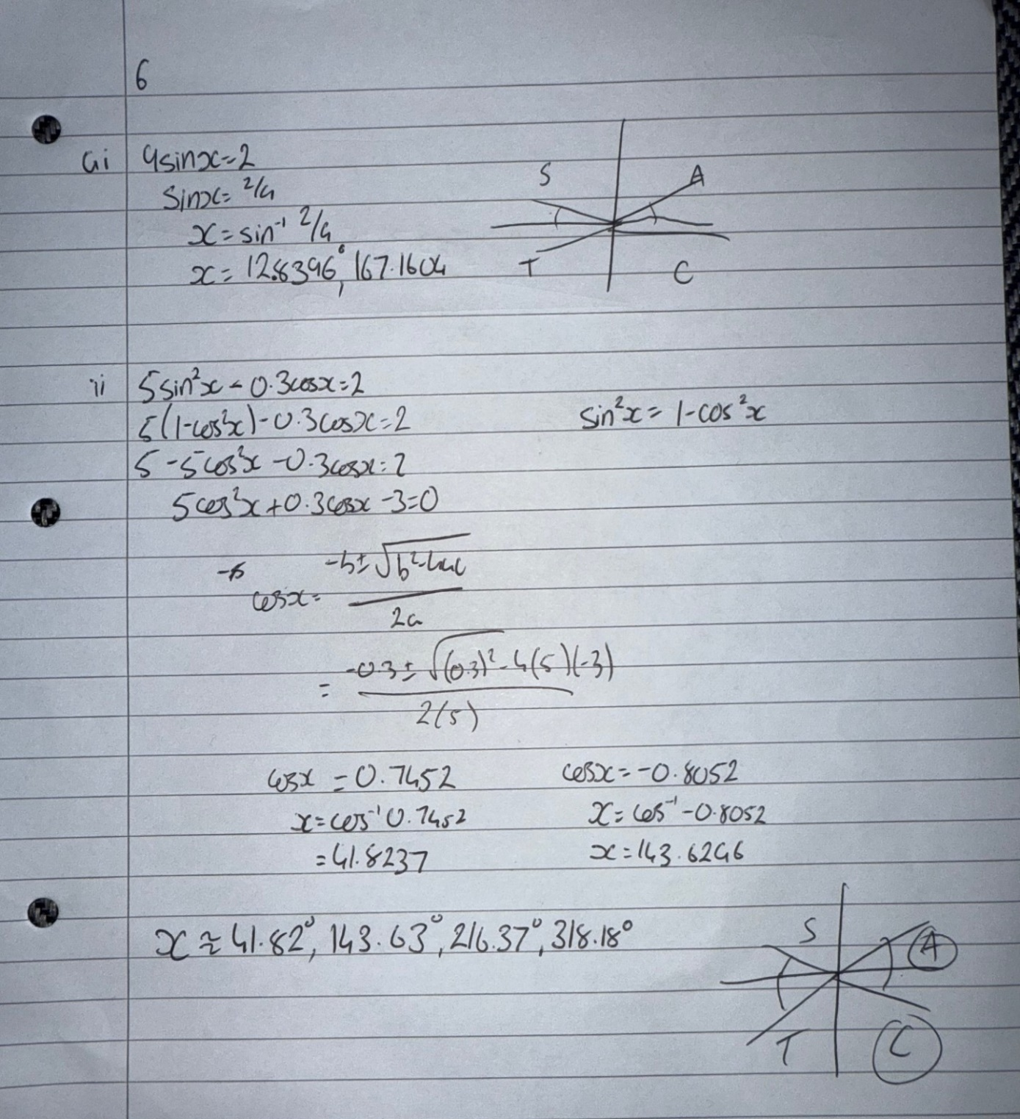

7. Question 7





