  Component One:Student Journal (learning log) 750 words +/- 10%  Contribution to Overall Module Assessment: 25% | Student No: | Denisa Elena Nisipeanu  2234127
 | Module Title: | Hotel Administration and Front Office Operation
 | Module Code: | BMIH4004
 | Lecturer: | Muhammad Cassamo

Introduction
The purpose of this section in this project is to evaluate the skills of myself to work in the hotel front office of the hospitality industry. The section enabled me to recognise my skills using relevant self-reflection models. Based on self-reflection, my skills have been established in this component and interlinked with the requirements of the hospitality sector.

KOLB’s Learning Cycle
I have used Kolb's reflective models, consisting of four distinct stages of learning that allowed me to underdo the self-reflection procedure stepwise for effective alignment of my skills with the working principles of hotel front office departments.
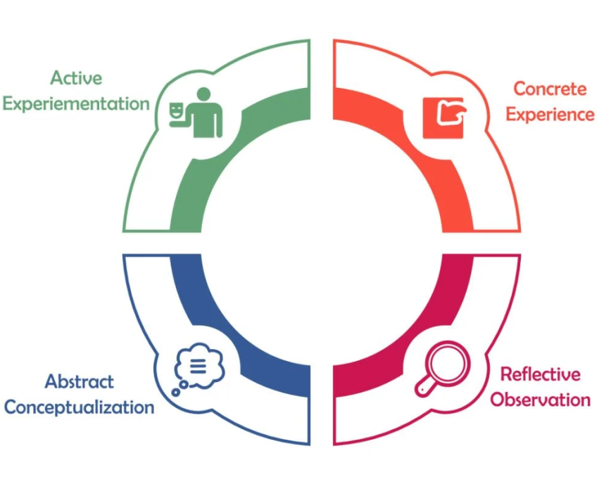
Figure 1: Learning cycle of Kolb’s
(Source: Watson et al. 2019)

Concrete Experience
The front office operations in the hospitality sector involve managing tasks based on guest's requirements and communicating with them to improve services (Sayin and Karaman, 2019). While working in the hotel front office positions, I experienced a diverse range of concerns and needs of guests. Hence, it can be depicted that I need to be dynamic while addressing the problems of guests. Moreover, this experience enabled me to enhance my efficiency in performing hotel front office activities concerning guest services and answering queries and calls. Hence, I need to improve my adaptability in managing different types of guests and enhance my pace while handling the issues. There are scenarios of multiple task management in the hospitality sector (Ivanov, 2019). Hence, I experienced the value of teamwork for effectively coordinating with the requests of guests and enabled me to develop a rational mindset to deliver a positive impression to the arriving guests through well-organised hotel front office service.
Reflective Observations
In this learning stage of Kolb's model, I have derived critical observations based on my experiences in performing hotel front office operations. The satisfaction as well impression of guests heavily relied on the services delivered by the hotel front office members (Christou, Simillidou and Stylianou, 2020). Hence, I observed major parameters that enabled me to deploy my skills effectively while undergoing hotel front office operations. Constructive communication with guests, concerned with their requirements, enabled the guests to gain a positive perception regarding the hospitality sector and ensured a friendly atmosphere (Latif, Pérez and Sahibzada, 2020). Therefore, I observed the worth of delivering effective communication in the hotel front office. Apart from that, I have further observed the necessity of prioritising tasks to minimise business delays and negative impact on guests. As per Nguyen and Nguyen (2020), collaboration is a key requirement in the hospitality sector. I observed that the collective working of different departments like reception staff, housekeeping staff and maintenance members improves efficiency in operation in the hotel front office.
Abstract Conceptualization
In this stage, I have generated key concepts and theories based on the required working principle in hotel front office posts. According to me, the Value-Percept theory is applicable in the working activities of the hotel front office to ensure the satisfaction of guests based on evaluating the qualities and performance of hotel front office services. Njagi, Mutinda and Mwangi (2023) argued that the application of this theory enabled the hotel front office authorities to assess the service quality through the parameters of Actual Value and Ideal Value, concerned with the perceived services and expectation of services by the guests respectively. Moreover, I have established that effective customer service facilities should be the primary role of hotel front office members to address the needs of guests in an agile manner. Apart from that, the mode of deploying services according to a generated routine optimises the performance of the hotel administration and enables the hotel front office members to work promptly (Liu, Chen and Teo, 2021). Hence, I understand the quality of scheduling routines to deliver guest services efficiently.
Active Experimentation
The final stage of the learning cycle involves the integration of all the gathered concepts, observations and experiences regarding hotel front office practice. Based on an effective analysis of the previous learning cycle stages, I can categorise the generic requirement of skill sets and attributes to perform efficiently in the hotel front office. Hence, by assessing the areas of improvement in my skill sets. I can enrol myself in various skill-learning programs to improve my professionalism while working as a hotel front office member. As per Alexopoulou, Batsou and Drigas (2019), skills-learning programs are important to obtain professional growth as well as improve my self-confidence and adaptability. Participating in training and mentorships, concerned with communication skills, allows me to interact with incoming guests proactively and enables me to resolve the issues of the guests. Moreover, enrolment in training programs and vocational institutes helps to improve my professional abilities, concerned with guest hospitality and time management.

Conclusion
The section summarises my self-reflection of myself, concerned with operations at the hotel front office. Deploying Kolb's self-reflection model helped me to evaluate myself by assessing four phases, concerned with my experiences, observations, derived theories and final experimentation.

Component Two
Contribution to Overall Module Assessment: 25%
Trip Advisor Review Response 150 words +/-10%
Hello Michael W, thank you for providing such delightful feedback for your recent stay at Premier Inn Doncaster. We are pleased to hear that you have enjoyed our services and created a memorable experience. Your positive comments are an extraordinary source of inspiration for us. Our team strives to deliver excellent in-room services for our guests to fulfil their expectations. We are committed to maintaining the quality standard of services and facilities that you have expressed during your recent stay. Your satisfaction and comfort is the ultimate priority of Premier Inn Doncaster. Additionally, our staff members take a tremendous amount of pride in delivering you a memorable living experience.
We are looking forward to escorting you again in the future by offering exceptional cuisines and drinks to ensure your satisfaction. We are grateful to make you a part of the Premier Inn Doncaster family and happy to address your future requests.

Screen shot of referenced Trip Advisor review used:
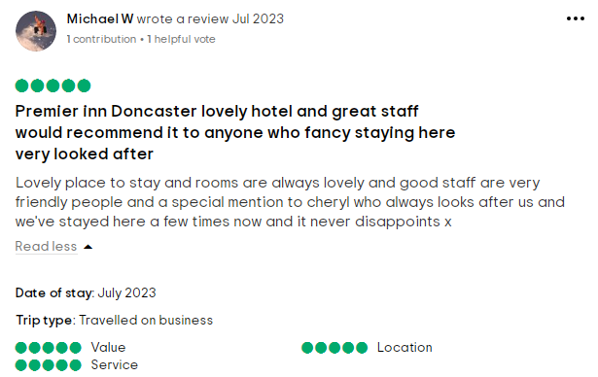
(Source: Tripadvisor, 2023)
Letter of complaint response500 words +/- 1-%
Subject: Complain Response
15 Penywern Rd
London SW5 9TY,United Kingdom
October 18th 2023
Dear Mr Ronald Federick,
I hope this letter ensures your satisfaction. I would like to express my sincere apologies for the unpleasant experience you had during your stay in our hotel. Your feedback is very valuable for us and we will look very seriously into the matter.
At our hotel, we strive to deliver the highest quality of services and hospitality to our guests. We consider our guests as deep assets of the company and always appreciate their honesty in bringing us issues and areas of improvement. Your concerns regarding food, services and cleanliness will be taken into deep consideration for comprehensive analysis for optimising our performance. As the management committee of the hotel, we are committed to addressing the issues raised by you regarding the hotel's ambience and meal quality. Your criticism enabled us to determine the flaws that need to be mitigated with immediate effect. We are entitled to make amendments to the administrative structure of our hotel so that such incidents do not arise shortly. Our employees are the significant pillars of providing services. Hence, we must address your concerns of by intensifying the mentorships and training practices to deliver you a better hospitable experience in future. We would like to host you again henceforward warmly and efficiently to deliver you an excellent living experience along with improvising cuisines. We hold primary ownership of the difficulties that arose during your accommodation in our hotel. We further optimise our communication medium by appointing a relationship manager to address the concerns of the guests and resolving their issues. Moreover, we are determined to establish a customised helpline facility to report the concerns raised by the guests and address them promptly.
We further ensure in providing consistent services by revising the quality standards of our hotel facilities and are determined to conduct inspections and quality measurements more strictly. The management committee of the hotel deeply respects the diversity of the guests with unique characteristics and requirements. Hence, we are focusing on delivering personalised services to the guests to meet their expectations and preferences. We deeply regret the inconvenience you faced during your accommodation tenure in our hotel. The hotel never intended to hinder the quality lifestyle of guests in terms of living, hygiene and cleanliness. Your feedback is the sole proprietorship of the organisation which enables the organisation to boost its performance. We show a deep sense of commitment to delivering quality living to our guests. We hope that you consider giving us a second chance to serve you more effectively with improved service quality, cleanliness and hygiene. We promise you to have a pleasant and quality experience during your upcoming visit.
Lastly, we again express our regrets for the disappointing experiences you had in our hotel. We are deeply thankful for your valuable concerns that highlighted the space for improvement within the organisation and we are determined to fill the space by improving our service.
Yours Sincerely,
Hotel Management Team

Component Three:
Contribution to Overall Module Assessment: 50%(1000 words +/- 10%)
Writing in essay format

Introduction
The purpose of this section is to study and evaluate the four stages of the hotel guest cycle and its impact on the guests and hotel management authorities. In this section, a detailed overview of these four stages has been projected.
Element 1 – Pre-Arrival

The pre-arrival stage of guest arrivals involves booking relevant hotels from websites or by call based on the requirement. In this stage, the guests initiated the booking process from online booking platforms. For instance, travel booking service providers like ClearTrip provide the feature of hassle-free hotel booking experience for the guests along with discount coupons(Cleartrip, 2023). Moreover, ClearTrip also has a mobile application, displayed in the Google Play store to improve booking flexibility. Apart from that, ClearTrip is renowned for enabling the criteria of hotel cancellation with zero service charge. Hence, in the pre-arrival stage, the guests compare the hotel rates and service flexibility before final booking.
After selecting the desired hotel from numerous options, the hotel performs a booking confirmation process and initiates confirmation mail to the guests. Furthermore, hotel authorities assessed the booking criteria, considering the date of reservation, document verification and type of rooms needed to be allotted for the guest (Sudana and Pratiwi, 2022). Moreover, based on the requests, the hotel authorities reach out to the guests to address the inquiries relating to booking preferences. Apart from that, the stage also involves making acute preparations by the hotel administration like transportation facilities, food habits and room choice before the arrival of guests. During pre-arrival, the hotel administration and front office members categorise the profiles of guests from the website and anticipate guest expectations. In addition to that, the hotel authorities send the billing details to the guests after booking confirmation and authorise the booking transactions based on the mode of payment.
Element 2 – Arrival

The arrival stage in a hotel involves executing the check-in process for the arrival of guests. It is the stage when the guest physically arrives inside the hotel premises to gather insights regarding hotel amenities through active observation. During check-in, the guests need to undergo various hotel formalities and regulatory practices by the hotel front office members (Puspita and Helmi, 2022). The practices involved verifying the room reservation with a generated invoice, and guest identification with valid identity proof. After completing the formalities, the assigned rooms are allocated to the guests along with keys or smart cards. For instance, the check-in policies in the Corinthia group of hotels in London are very strict guests from certain countries were recommended to fill out police registration cards and provide identification before final room allocation (Corinthia, 2023). Moreover, Corinthia Group also has a strict privacy policy to store the personal information of guests effectively.
During guest's arrival, the hotel staff provide welcome orientation to the guests and interacts with them by providing essential information regarding the hotel service facilities and information comprising check-out time, dining hours and Wi-Fi access codes. Moreover, the staff also assist the arriving guests by boarding luggage and transportation facilitates to the respective suites (Stringam and Gerdes, 2021). In addition to that, the hotel authorities also assessed the profiles of the guests to understand any specific preferences that the guests mentioned while booking. Hence, the arrival stage is significant for delivering a positive impact to the incoming guests by executing the check-in process smoothly.
Element 3 –Duration of stay

In this context, the duration of stay defines the period within which the guests will be accommodated in the hotel. As argued by Pratt and Tolkach (2022), this stage is essential for the hotel administration and management to determine the length of reservation of guests and accordingly streamline the hotel facilities for guest satisfaction. During the entire duration of the hotel reservation, the hotel front office members play a crucial role in delivering efficient services to the guest to improve the guest's perception during accommodation. Essential accommodation facilities have been provided to the guest, considering the cleanliness, addressing guest requests, dining facilities and other hotel amenities. Moreover, the facilities of laundry and personalised services have also been provided during the time of accommodation. The Hyatt Regency in London is known for its luxurious accommodation facilities, comprising the amenities of rooftop restaurants with magnificent views of the River Thames, Big Ben and Westminster Palace (Hyatt, 2023). Moreover, the Hyatt group also serves eminent facilities such as free internet access, minibars, fitness centres, swimming pools, 24/7 security and meeting facilities. Hence, during the course of the duration, the guest acquires the perception and overall experiences from the amenities delivered by the hotel. Such innovative amenities enabled the hotel authorities to develop a positive relationship with the guests during the accommodation period.
Element 4 –Departure

The departure is the last stage of the hotel guest cycle. In this stage, the guest develops the final impression of the hotel's facilities, room service and infrastructure. It also enabled the guest to make decisions in choosing the respective hotel in future. As per Wirya (2023), the departure stage involved initiating the check-out process by the hotel front office. During check-out, the guests have to leave the hotel within the strict regulatory deadline as per the checkout policy of the respective hotel. In London Town Hotel, the guests need to vacate the rooms by 11:00 a.m., failing which, the hotel is entitled to charge an additional night fee from the guests (Londontown Hotel, 2023). Moreover, the hotel staff at London Town Hotel also assessed any damage to property before the final departure of guests. Hence, the final stage deals with a detailed inspection of rooms by the hotel management staff to ensure the property conditions. Finally, the hotel front desk members express gratitude to the guests for their accommodation in the hotel and seek the feedback of guests regarding the hotel experience (Wu and Gao, 2019). Apart from that, the pending bills and payments have to be cleared by the guests during the final departures and detailed bills have been issued by the hotel front office regarding the expenses of the guests.

Conclusion
The section summarises the stages of the hotel guest cycle considering the pre-arrival where hotel bookings have to be done followed by the arrival of guests for check-in. After check-in, the guests have to be accommodated during the reservation tenure until final check-out.

References
References for Component 1
Alexopoulou, A., Batsou, A. and Drigas, A. (2019) ‘Resilience and Academic Underachievement in Gifted Students: Causes, Consequences and Strategic Methods of Prevention and Intervention’, International Journal of Online & Biomedical Engineering, 15(14). Available at: https://www.researchgate.net/profile/Athanasios-Drigas/publication/336833261_Resilience_and_Academic_Underachievement_in_Gifted_Students_Causes_Consequences_and_Strategic_Methods_of_Prevention_and_Intervention/links/5db86e54299bf1a47bfd4008/Resilience-and-Academic-Underachievement-in-Gifted-Students-Causes-Consequences-and-Strategic-Methods-of-Prevention-and-Intervention.pdf (Accessed: 18 October 2023).
Christou, P., Simillidou, A. and Stylianou, M.C. (2020) ‘Tourists perceptions regarding the use of anthropomorphic robots in tourism and hospitality’, International Journal of Contemporary Hospitality Management, 32(11), pp.3665-3683. Available at: https://clok.uclan.ac.uk/35303/1/35303%20FINAL%20Manuscript.pdf (Accessed: 18 October 2023).
Ivanov, S. (2019) ‘Ultimate transformation: how will automation technologies disrupt the travel, tourism and hospitality industries?’, Zeitschrift für Tourismuswissenschaft, 11(1), pp.25-43. Available at: https://www.researchgate.net/profile/Stanislav-Ivanov-7/publication/331152771_Ultimate_transformation_How_will_automation_technologies_disrupt_the_travel_tourism_and_hospitality_industries/links/5c6822d1299bf1e3a5ad2d99/Ultimate-transformation-How-will-automation-technologies-disrupt-the-travel-tourism-and-hospitality-industries.pdf (Accessed: 18 October 2023).
Latif, K.F., Pérez, A. and Sahibzada, U.F. (2020) ‘Corporate social responsibility (CSR) and customer loyalty in the hotel industry: A cross-country study’, International Journal of Hospitality Management, 89, p.102565. Available at: https://repositorio.unican.es/xmlui/bitstream/handle/10902/20705/CorporateSocialResponsibility_nv_articulo_9531.pdf?sequence=3 (Accessed: 18 October 2023).
Liu, P., Chen, Y. and Teo, C.P. (2021) ‘Limousine Service Management: Capacity Planning with Predictive Analytics and Optimization’, INFORMS Journal on Applied Analytics, 51(4), pp.280-296. Available at: https://arxiv.org/pdf/2009.05422 (Accessed: 18 October 2023).
Nguyen, T.Q. and Nguyen, H.T.T. (2020) ‘Factors affecting industry and university collaboration in education in the hospitality industry in Vietnam: A business perspective’, Journal of Asian Finance, Economics and Business, 7(2), pp.291-300. Available at: https://www.researchgate.net/profile/Nguyen-Thang-7/publication/339297572_Factors_Affecting_Industry_and_University_Collaboration_in_Education_in_the_Hospitality_Industry_in_Vietnam_A_Business_Perspective/links/5e49506192851c7f7f40e2e6/Factors-Affecting-Industry-and-University-Collaboration-in-Education-in-the-Hospitality-Industry-in-Vietnam-A-Business-Perspective.pdf (Accessed: 18 October 2023).
Njagi, C., Mutinda, M. and Mwangi, B. (2023) ‘Influence of Service Quality on Emotional Satisfaction in Game Lodges’, Journal of Hospitality and Tourism, 3(2), pp.20-35. Available at: https://www.ajpojournals.org/journals/index.php/JHT/article/download/1514/1636 (Accessed: 18 October 2023).
Sayin, O.G.K. and Karaman, A. (2019) 'Communication and productivity with guests at the front office; A qualitative study on hotels', Journal of International Management and Social Researches, 6(11), pp.186-196. Available at: https://www.researchgate.net/profile/Kursad-Sayin/publication/338765867_Journal_of_International_Management_and_Social_Researches_Uluslararasi_Yonetim_ve_Sosyal_Arastirmalar_Dergisi_Communication_and_Productivity_with_Guests_at_Front_Office_A_Qualitative_Study_on_Hotels/links/5e298776a6fdcc70a143b616/Journal-of-International-Management-and-Social-Researches-Uluslararasi-Yoenetim-ve-Sosyal-Arastirmalar-Dergisi-Communication-and-Productivity-with-Guests-at-Front-Office-A-Qualitative-Study-on-Hotels.pdf (Accessed: 18 October 2023).
Watson, M.K., Pelkey, J., Noyes, C. and Rodgers, M.O. (2019) ‘Using Kolb’s learning cycle to improve student sustainability knowledge’, Sustainability, 11(17), p.4602. Available at:https://www.mdpi.com/2071-1050/11/17/4602/pdf (Accessed: 18 October 2023).
References for Component 2
Tripadvisor (2023) Premier Inn Doncaster Central. Available at: https://www.tripadvisor.in/Hotel_Review-g187067-d1573398-Reviews-or10-Premier_Inn_Doncaster_Central-Doncaster_South_Yorkshire_England.html#REVIEWS (Accessed: 18 October 2023).

References for Component 3
Cleartrip (2023) Search hotels. Available at: https://www.cleartrip.com/hotels (Accessed: 18 October 2023).
Corinthia (2023) TERMS AND CONDITIONS. Available at: https://www.corinthia.com/terms-and-conditions/ (Accessed: 18 October 2023).
Hyatt (2023) World of Hyatt. Available at: https://www.hyatt.com/en-US/hotel/england-united-kingdom/hyatt-regency-london-albert-embankment/lonre (Accessed: 18 October 2023).
Londontown Hotel (2023) Terms and Conditions of Stay. Available at: https://www.londontownhotel.co.uk/termsc.htm#:~:text=Check%2Din%20%26%20Check%2Dout,charge%20for%20an%20additional%20night. (Accessed: 18 October 2023).
Pratt, S. and Tolkach, D. (2022) ‘Affective and coping responses to quarantine hotel stays’, Stress and Health, 38(4), pp.692-707. Available at: https://researchonline.jcu.edu.au/71262/7/JCU_71262_AAM.pdf (Accessed: 18 October 2023).
Puspita, W. and Helmi, S. (2022) ‘PROFESSIONALISM IN THE RECEPTION IN SUPPORTING THE FAIR OPERATIONS AT THE ZURI HOTEL’, Jurnal Ekonomi, 11(03), pp.81-88. Available at: http://ejournal.seaninstitute.or.id/index.php/Ekonomi/article/download/535/472 (Accessed: 18 October 2023).
Stringam, B.B. and Gerdes, J.H. (2021) ‘Hotel and guest room technology’, University of South Florida (USF) M3 Publishing, 17(9781732127593), p.6. Available at: https://digitalcommons.usf.edu/cgi/viewcontent.cgi?article=1179&context=m3publishing (Accessed: 18 October 2023).
Sudana, P.A.P. and Pratiwi, P.D. (2022 December) ‘A Task-Based Needs Analysis for English Correspondence Course’, In 2nd International Conference on Languages and Arts across Cultures (ICLAAC 2022)(pp. 29-39). Atlantis Press. Available at: https://www.atlantis-press.com/article/125978241.pdf (Accessed: 18 October 2023).
Wirya, I.M.S. (2023) ‘Analysis of the Implementation of Standard Operating Procedures (SOP) in the Housekeeping and Front Office Department of Frii Bali Echo Beach Hotel Canggu’, Jurnal Manajemen Pelayanan Hotel, 7(1), pp.192-223. Available at: https://mapindo.ejurnal.info/index.php/manajemen_pelayanan_hotel/article/download/208/135 (Accessed: 18 October 2023).
Wu, S.H. and Gao, Y. (2019) ‘Understanding emotional customer experience and co-creation behaviours in luxury hotels’, International Journal of Contemporary Hospitality Management, 31(11), pp.4247-4275. Available at: https://doras.dcu.ie/24240/7/Wu%26Gao_IJCHM_2019_DORAS.pdf (Accessed: 18 October 2023).

