Appendix 1
Transcribed Interview
Interviewer: How did you feel about not being able to put your hands up?
Child 1: I liked it. I was excited when you told us that we were going to be doing it again because we haven’t done it much, but I like it when we do.
Interviewer: Ok, so you liked it. What About you number 2?
Child 2: Well, it was ok. I think I got a bit scared because I didn’t know if I was going to be picked and I was I was scared in case it was to a question I didn’t know the answer to.
Interviewer: Why does that make you scared?
Child 2: Because if I get the question wrong it makes you look stupid because you don’t know the answer.
Interviewer: OK, thank you. How about you child 3?
Child 3: Well, it doesn’t really bother me.
Interviewer: Why doesn’t it bother you? Were you not interested in using the lollypop sticks?
Child 3: Well it’s fun, but people think I'm not paying attention in class, but I am so if my name is picked I can answer the questions.
Interviewer: If your name was picked through the lollypop sticks, how did it make you feel?

Child 2: My name was picked! I was a bit scared because it was a shock but because I knew the answer it wasn’t too bad.

Child 1: I didn’t get picked today but when I was picked before I knew the answer, so I just answered it. It is a bit scary when you say you're going to be using the lollypops though because normally we just put our hands up don’t we?

Interviewer: Yes, we do normally but today we used the lollypop sticks. Your name wasn’t picked today either was it child 3?

Child 3: No.

Interviewer: But it has before, how did that make you feel?

Child 3: It was alright, people just think I'm not listening because I'm quiet, but I am listening I wasn’t scared or anything.

Interviewer: When we were using the lollypop sticks were you still interested in the lesson?

Child 1: Yeah, I think it made me pay more attention because I was scared that you were going to ask me something I didn’t know.

Child 2: A bit, I was scared you’d ask me something, but I was interested anyway.
Child 3: I don’t think it made a difference to me.

Interviewer: By using the no hands up rule, did you feel you had to listen to the lesson more?

Child 3: I was listening, it doesn’t always look like I’m listening, but I was.

Child 1: Yeah I listened more to the lesson because I wanted to make sure I knew the answers if you asked me a question.

Child 2: I think so, I was listening more today, but I think that’s because we were doing something new as well as doing the lollypop sticks.

Appendix 2

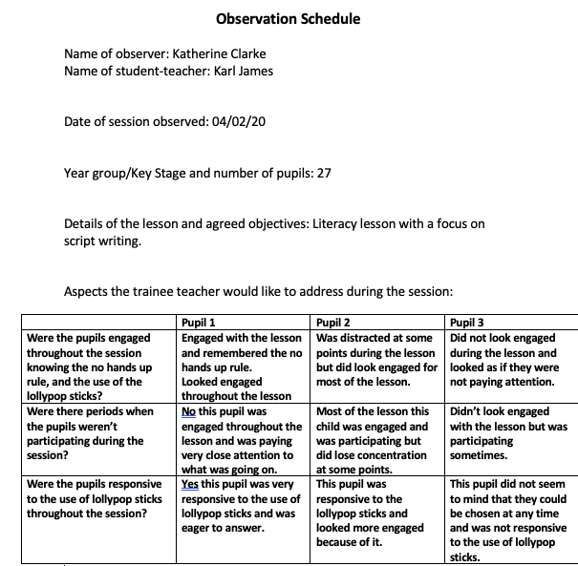
Appendix 3
Pupil Number: | 1
Date: | 6/2/20
Student-Teacher: | Katherine Clark
Appendix
How did you feel about not being able to put your hands up?
- Confident, because I knew the answers
- Didn’t like it when I knew the answer and couldn’t answer
If your name was picked through the lollypop sticks, how did it make you feel?
- I felt confident because I knew the answer
- If I don’t know the answer then I don’t mind
When we were using the lollypop sticks were you still interested in the lesson?
- Yes, I was listening in case my name was picked
By using the no hands up rule, did you feel you had to listen to the lesson more?
- Yes, just in case you get asked a question.

Pupil Number: | 2
Date: | 6/2/20
Student-Teacher: | Katherine Clark

How did you feel about not being able to put your hands up?
- I never usually put my hand up so it didn’t matter.
- If I knew the answer then I doesn’t matter if I get picked.
If your name was picked through the lollypop sticks, how did it make you feel?
- Nervous because if I didn’t know the answer then I wouldn’t be able to answer the question.
When we were using the lollypop sticks were you still interested in the lesson?
- Yes, I was listening in case my name was picked
- More worried about having to answer than learning.
By using the no hands up rule, did you feel you had to listen to the lesson more?
- Yes, in case my name was picked.

Pupil Number: | 3
Date: | 6/2/20
Student-Teacher: | Katherine Clark

How did you feel about not being able to put your hands up?
- Boring because I couldn’t answer when I wanted.
If your name was picked through the lollypop sticks, how did it make you feel?
- If I knew the answer it was fine, but if I didn’t I didn’t like it.
When we were using the lollypop sticks were you still interested in the lesson?
- No because I couldn’t answer.
By using the no hands up rule, did you feel you had to listen to the lesson more?
- Yes, just in case you get asked a question.

