

Lab: IPv4, Subnetting, VLSM and IPv6 Addressing

- Understanding IPv4 and IPv6 addressing (word count 1000)
This part of lab worksheet require you research and write a report on “Features of IPv6”. You may discuss but not limited to structure, address types, advanced functionalities and security.
- Subnetting and VLSM

NOTE: To complete this part you would need full understanding of Lab 10 to 14.



Using the Network address 172.16.2.0/24, VLSM the network to support the following requirements:
Subnet A: 16 hosts
Subnet B: 2000 hosts
Subnet C: 6 hosts
Subnet D: 500 hosts
Subnet E: 60 hosts
Subnet F: 180 hosts and Serial links between routers

Table 1
Subnet | Network Address | Subnet mask | First Address | Last Address | Broadcast Address
B | 172.16.2.0 | 255.255.248.0 | 172.16.2.1 | 172.16.2.254 | 172.16.2.255
D | 172.16.10.0 | 255.255.254.0 | 172.16.10.1 | 172.16.10.254 | 172.16.10.255
F | 172.16.12.0 | 255.255.255.0 | 172.16.12.1 | 172.16.12.254 | 172.16.12.255
E | 172.16.13.0 | 255.255.255.192 | 172.16.13.1 | 172.16.13.62 | 172.16.13.63
A | 172.16.13.64 | 255.255.255.224 | 172.16.13.65 | 172.16.13.94 | 172.16.13.95
C | 172.16.13.96 | 255.255.255.248 | 172.16.13.97 | 172.16.13.102 | 172.16.13.103
Serial1 | 172.16.13.104 | 255.255.255.252 | 172.16.13.105 | 172.16.13.106 | 172.16.13.107
Serial2 | 172.16.13.108 | 255.255.255.252 | 172.16.13.109 | 172.16.13.110 | 172.16.13.111

IPV6 Report
Alex Thomas 1352162
IPV6 (Internet protocol version6) is the protocol that will replace IPV4 (Internet protocol version4) and is the most recent standard RFC8200 (STD86) [1]. The lack of addresses under the current IPV4 due to the growth of the internet has been a driving factor behind IPV6 with the amount of addresses for IPV4 running out. There are other factors such as the ability of routers to support huge routing tables, finding a way of simplifying configuration, the need for improved security at an IP level plus an improvement of QOS (Quality of service) [2]. IPV4 can provide 4.2 billion addresses whereas IPV6 can provide 340 undecillion, figure 1 illustrates the improvement in scale compared to IPV4 [2].
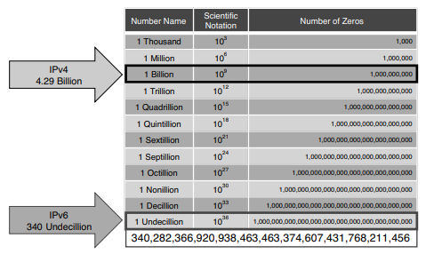
Figure 1 IPV6 and IPV4 address range comparison [4]
Structure
The structure of an IPV6 address is a 128 bit address with 8 segments of 4 hexadecimal digits making up the 128 bits, this offers considerable expansion of the 32 bit IPV4 address. The address is notated by colons, then logically split into a network prefix and an interface ID with leading zeros omitted [2]. The network prefix represents the network part of the address with the interface ID representing the hosts. The IPV6 network prefix is shown typically as /64 being the most common, this draws a parallel with IPV4 CIDR (Classless Inter-Domain Routing) representation /24 with the bits on the left representing the network, IPV6 does not include a broadcast address [4]. Any trailing zeros must be included and if zeros have been omitted this is highlighted with 2 colons, this is only permitted once per address if there are multiple continuous zeros these can be replaced by a single double colon as stated by RFC 5952 [4]. A combination of these 2 rules is permitted to simplify the address further, this is highlighted in figure 2.
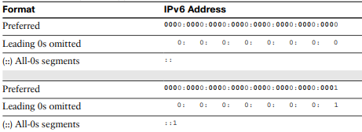
Figure 2 Simplifying the IPV6 address [4]
Address Types
The 3 address types for IPV6 are unicast, multicast and anycast. The unicast address has 6 types these are show in figure 3 below
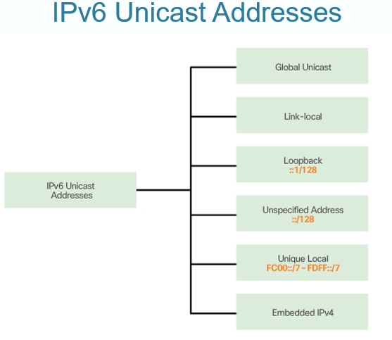
Figure 3 IPV6 Unicast address [5]
Global unicast address types are the most common and bear resemblance to the IPV4 public address type, the address is globally routable and broken down into 3 main components -
- Global Routing Prefix – Network component
- Subnet ID – Subnet component
- Interface ID – Host component generally 64 bit
This is highlighted in figure 4
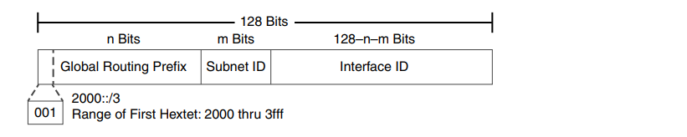
Figure 4 Global unicast address structure [4]
Configuration can be carried out statically e.g ipconfig for Windows or dynamically the later would be done using SLAAC (Stateless address auto configuration), DHCPV6 (Dynamic host configuration protocol version 6) or a combination of both where the router and DHCP server provide the information required [5]. Link local address types are unique only within their own network or subnet, the router will not forward the information and DAD (Device address detection) is used by the router to test if the packet is link local [4]. The loopback address for IPV6 performs a similar function to the IPV4 version, all portions of the address are set to zero excluding the last bit, which is set to 1, a packet will be dropped if the destination is set to loopback and the router will not send these packets on if they contain the loopback address [4]. The unspecified address is comprised of zeros and highlights the lack of an address, the router will not forward this information and this address cannot be used as a destination address or be assigned to a physical interface [4]. The unique local address is only correct within its own network or subnet, similar to the IPV4 private address type and these are not routable on the internet [2]. The embedded IPV4 address encapsulates an IPV4 address within an IPV6 address, this is possible with an IPV4 address being only 32 bit compared to the 128 offered by IPV6 [4]. IPV4 and IPV6 are not interoperable so a method of combining these protocols is essential if you are transitioning from one version to another, 3 methods are used tunnelling, dual-stack and NAT64 (Network address translation) [5]. Tunnelling encapsulates the IPV6 packet within an IPV4 packet, dual stack runs both versions simultaneously and NAT64 provides the NAT (Network address translation) technique used in IPV4 [5].
The multicast address type allows the sending of a packet to multiple destinations as a pose to the unicasts single packet to single destination, IPV6 will use 3 types in general for multicasting, well-known, transient and solicited node [4]. Well known refers to addresses that are reserved for groups of devices such as routers and hosts on the network. Solicited node performs a function that draws comparison to a broadcast in IPV4, it gives a way for packets in an IPV6 network to reach all devices without those devices having to process the data, the transient address type is not assigned on a permanent basis and are assigned via the application [4].
The anycast address can be duplicated on an interface within an IPV6 network, the packet that is sent with this address gets routed to the interface closest that contains the address [4].
IPSEC (Internet protocol security) gives IPV6 the ability to protect data across open networks. The device sending the packet can encrypt before transmission, ensuring a level of integrity before the packet leaves the network, the device receiving the data has the ability to check this packet to ensure it has not been corrupted in any way [6]. The implementation of IPSEC is handled by the AH (Authentication header) and the ESP (Encapsulating security payload), the AH uses an algorithm to confirm the source data then ESP provides confidentiality to the packet [6].
The improvement in address size and the ability of IPV6 to configure itself using SLAAC are the most obvious advantages of IPV6 coupled with the fact IPV4 has to be replaced in the near future due to the lack of address space must accelerate the position of IPV6 as the main protocol for network addressing.

References

[1] | B. S. K. Hinden, “IPv6 is an Internet Standard,” 18 October 2018. [Online]. Available: https://ietf.org/blog/ipv6-internet-standard/. [Accessed 1 December 2019].
[2] | Cisco, “Routing and Bridging Guide vA5(1.0), Cisco ACE Application Control Engine,” Cisco Press, [Online]. Available: https://www.cisco.com/c/en/us/td/docs/interfaces_modules/services_modules/ace/vA5_1_0/configuration/rtg_brdg/guide/rtbrgdgd/ipv6.html. [Accessed 2 December 2019].
[3] | “NEW ZEALAND IPV6 TASK FORCE FAQS,” NEW ZEALAND IPV6 TASK FORCE TRUST, [Online]. Available: https://ipv6.org.nz/index.html%3Fp=743.html. [Accessed 01 December 2019].
[4] | R. Graziani, IPv6 Fundamentals: A Straightforward Approach to Understanding IPv6, Indianapolis: Cisco Press, 2017.
[5] | D. K. Radhakrishnan, “L4 - Computer Architecture and Networks (Kapilan - Sem 1) (ACCD4001),” [Online]. Available: https://moodle.uwtsd.ac.uk/course/view.php?id=4025. [Accessed 02 December 2019].
[6] | “IPsec Data Plane Configuration Guide,” Cisco, 17 August 2017. [Online]. Available: https://www.cisco.com/c/en/us/td/docs/ios-xml/ios/sec_conn_dplane/configuration/xe-16/sec-ipsec-data-plane-xe-16-book/ip6-ipsec-vti.html. [Accessed 4 December 2019].

