Assessment Feedback Sheet

Student No./Name: 1701251, Robert Shaw

Module Code: SHSS5093
Module: Biomechanics of sport and Exercise

Personal Evaluation – to support your academic progress please complete the section below BEFORE submitting your work.
What do you consider to be the best aspects of this work? |  |  | The best aspect of the work is, finally getting to see the results of the work that we have thought about and constantly learn about the field that I wish to work in, in the future.
Which aspects do you consider could have been improved in this piece of work? |  |  | The layout, for some reason the final page it doesn’t seem to fit right.  Id also like to have had access to SPSS to do a more in-depth result section, which will be rectified for future studies.
What have you found most satisfying whilst undertaking this submission? |  |  | Undertaking the task of attempting my first CW in a article format and layout, its always good to have a new challenge and to constantly learn and improve on new or old skills.
ASSESSMENT CRITERIA | Learning  Outcomes |  | GRADE
ASSESSMENT CRITERIA |  |  | Poor  < 20% | Weak  20-29% | Unsatisfactory  30-39% |  | Satisfactory  40 – 49% | Good  50 – 59% | Very Good  60 – 69% | Excellent  70 – 84% |  | Exceptional  85– 100% | %
Abstract | 1,2 |  |  |  |  |  |  |  |  |  |  |  | 5
Introduction | 1,2 |  |  |  |  |  |  |  |  |  |  |  | 15
Method | 1,2 |  |  |  |  |  |  |  |  |  |  |  | 10
Results | 1,2 |  |  |  |  |  |  |  |  |  |  |  | 25
Discussion | 1,2 |  |  |  |  |  |  |  |  |  |  |  | 25
Conclusion | 1,2 |  |  |  |  |  |  |  |  |  |  |  | 5
References | 1,2 |  |  |  |  |  |  |  |  |  |  |  | 5
Article format | 1,2 |  |  |  |  |  |  |  |  |  |  |  | 10
It is expected that students will present work that is proof read, correctly referenced and adheres to the Assessment Checklist. Therefore a range of 0 – 10 marks will be deducted for non-completion of any of the points on the checklist below.
TUTOR COMMENTS:
Submission date:  via Turnitin |  | Return date:  (at least within 4 weeks) |  |  |  | Tutor: |  |  |  |  | Mark:

A biomechanical two-dimensional video analysis of a front squat and back squat of a single athlete at 75% of their 1RM.
Shaw, R, M, A.
School of Sport, Health and Outdoor Education, UWTSD, College Road, Carmarthen, Wales
Abstract
A biomechanical two-dimensional video analysis of a front squat and back squat of a single athlete at 75% of their 1RM. The squat is used in everyday life from training in a gym, competing in sports competitions to picking up a box at home or work. The squat has been developed over the years and from the basic back squat we now have over height, front, goblet squats ect. A better understanding of the joint angles for both squats can help athletes and coaches highlights strengths and weaknesses in their movement. It can highlight poor or incorrect form and weak or tight areas within the athlete’s body movement. Due to the video analysis been done from the side in two-dimensional, it was expected that the ankle, knee and hip would all have a positive relationship. However, due to the way the bar is help from the should to elbow there is no relationship expected between the front squat and back squat. The results showed that the lower limbs of the athlete flow in the same manor and in the front squat due to position the angle of the elbow to shoulder increases significantly more in a positive manor compared to that of the back squat.
Introduction
The squat is a fundamental functional movement that is used in everyday life from lifting a box to the movement in a gym-based exercise. From Kritz et al (2009) research they stated in their introduction that, ‘Humans throughout time have used variations of the squat pattern to accomplish various tasks associated with activities of daily living.’ The squat been such a fundamental movement to humans they are many varieties of the squat. Each has a similar movement pattern each other but engages the body in a slightly different way. The two main squats are front and back. Both used in high level competition, such as power lifting ad Olympic lifting.
The limitations of this study are that it was filmed and analysis in a 2D view. For a more accurate analysis the athlete could be videoed at multiple ankles to see the movement of the knee and how it tracks during the lift. As well as the research only been conducted on a singular athlete, having multiple to see if athletes A movement is the same or similar to athlete B.
The implications of this study can be used to provide the athlete with areas of improvement on both the front squat and the back squat. Given the angle of the joints under video analysis. The athlete will be able to see which area needs to be strengthened muscularly or for flexibility to improve range of movement in the eccentric and concentric phases of the movements. The athlete will be able to see the tracking of the bar through-out the movement to see if their technique needs improvement.
The aim of this study is to identify the similarity and the difference in the back squat and front squat of one athlete. The athlete completed a single reputation of body squats at 75% of their 1RM while been videoed. The video data collection shows the eccentric and concentric movement of the athlete and allows the angle of the ankle knee him and elbow to be calculated to see if there are any similarities.
Methods
One male athlete took part in a data collection from video analysis of the front and back squat at 75% of their 1RM. The athlete had already recorded their 1RM prior to the data collection and within the last 3 months and has experience performing these movements and is currently training 6+ hours per week. The front squat technique the athlete used was the same as that published by Waller and Townsend (2007) and the back-squat technique used by the athlete, was the same as Myer et al (2014) assessment.
Prior to completing any movement, the athlete warmed up and stretched his lower body to increase range of movement and to avoid injury during tests. The athlete warmed up with the bar complete reputations and then with a lighter weight (50kg) for reputations. After the warm up was completed the athlete loaded the bar to the appropriate weight for 1rm at 75% for back squat (101.25kg) and then the same for back squat (82.5kg). The athlete then completed one singular reputation of each movement under video analysis. The athlete used a maximuscle leather weight lifting belt for lumbar support during both lifts to ensure no variables. The athlete was recorded using an I-Pad with Technique video recording 2-dimensional analysis on while doing 75% of their 1RM for 1 reputation. The video captured the entire movement from a side 2-D view allowing the recording of the elbow, shoulder, hip, knee and ankle.
Results
The results from the video analysis show that the ankle, knee and hip all follow a similar movement pattern in the squat, with the back squat been a second slower in the eccentric phase shown in Figure 1, 2 and 3. However, the shoulder to elbow shows that there is no similarity in the movement as seen in figure 4. For the shoulder to elbow in the back squat the movement of the elbow is very slight and angle during the entire movement. For the front squat you see the angle from shoulder to elbow increase during the eccentric phase of the front squat.
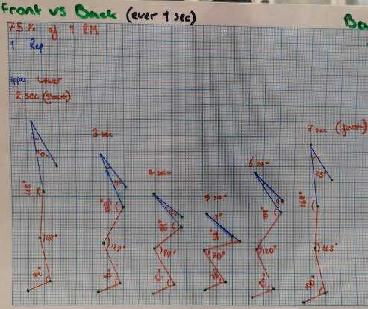
From the angles recorded during the video analysis of the athlete we can compare the mean and standard deviation from both front squat and back squat and see the similarity of the range of movement at each joint. The ankles Mean - 87.40, SDV - 5.90 for front squat and Mean - 88.50, SDV - 9.81 for back squat. We can see the angles movement during the entire movement have a positive relationship to each other. The Knee’s Mean - 125.40, SDV - 37.48 for front squat and Mean - 123.33, SDV - 35.93 for back squat. Again, shows that there is a positive relationship in the motion in the knee during both squats. The Hip’s Mean - 127.60, SDV - 48.83 for front squat and Mean -119.67, SDV - 45.55 for back squat. Like the other two joints the hip follows suit and has a positive relationship between the two squats with no major differences in the mean or standard deviation of the movement at the joint. The shoulder to elbow Mean - 73.00, SDV - 25.87 for front squat and Mean - 14.17, SDV -7.94 for back squat. Unlike the other joints this one has a negative correlation between front squat and back squat. Front squat shows a larger mean, that the range increases signification compared to back squat, causing the standard deviation to be larger as seen in table 2.

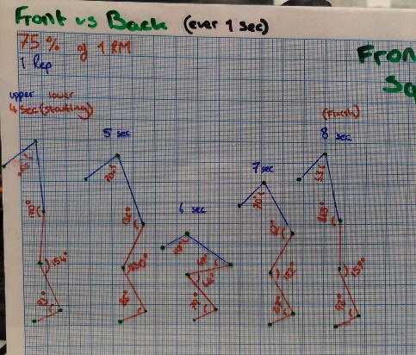
Figure 5, above. Angles of joint and degrees in back squat. Figure 6, below. Angles of joint and degrees in front squat. Eccentric and concentric phase in both squats.

Discussion
The purpose of this study was to find out the similarity and differences in the front and back squat at the joints during one reputation at 75% of the athletes one rep max. The findings where as thought and most of the joints under video analysis had a positive relationship between the two squatting styles. As Russell and Phillips (1989), findings show that both squats had similar comparisons for the knee and hip which was the same results in the findings. However, this was unlike Swinton et al, (2012) which shows in their research that there are significant biomechanical differences between the back squat the two varieties that their paper was on. Again, video analysis was used for this research, yet the findings show than their relationship in the squats is different during a competition. Multiple athletes where recorded which may be a factor to investigate for future research in this research paper.
The results of the ankle for both front squat and back squat relate to Schoenfeld (2010), findings that the ankle will adduct and abduct slightly during a squat motion. As seen in Table 2, the Mean for both squats is similar and the standard deviation (movement) during the whole action is only slight. However, the research done by Schoenfeld (2010), doesn’t show the same result for the hip. With the mean and standard deviation for front squat and back squat (which can be seen in table 2) been significantly higher than their reported 95+/- mean 27 degrees standard deviation.
As the paper by Gullet et al (2009) findings state that the front squat is less weight through the knees which could be the reason why the knee angle at the deepest eccentric phase was lower in the front squat than back squat as seen in figures 5 and 6. Further research would be needed to see if the finds done by Gullet et al (2009) had and major impact upon the findings in this research paper. Again, the research done by McKean et al (2010), their findings indicate that males in their study maximal depth of the hip was ‘Mean 73.6 SDV 3.5, with the athletes doing the squat at body weight + 50%’ with the result here been bodyweight + 75% the results showing in Table 1 that the Mean 53 degrees again showing the two research results share no relationship. However, this could be down to the 25% extra and again, further research is needed to be conducted to rule out a relationship between the two research projects.
There are limitations to this study that should be mentioned. Firstly, the study was only conducted up on a singular athlete, to get a better understanding and a wider range of results it should be conducted up on multiple athlete. Secondly, the study was conducted during a two-dimensional video analysis upon a side view. To get a better understand of the athletes joins the study could be conducted in a three-dimensional video to get a better understanding and view of the joint movement.

Conclusion
In conclusion, the results gathered from the researched conducted showed what was expected from the initial research into the analysis. The findings of the study show there is a positive correlation between the ankle, knee and hip in the front squat and back squat. However, there is no correlation between the shoulder to elbow in the front and back squat due to the eccentric movement of the squat. The results gather can provide coaches with an analysis of the athlete’s movement and bad position of the bar during the analysis. Moreover, it shows areas for the athlete to stretch and increase flexibility in areas that may seem tight or not have a range of moment as needed and It can highlight poor or incorrect form during the athlete’s body movement.
Acknowledgements
The author would like to thank the athlete who volunteered themselves and their spare time to take part in the study. University of Wales Trinity Saint David’s Leisure Centre that allowed the athlete to conduct the video analysis in their centre using their equipment in their gym. University of Wales Trinity Saint David, SHOE for providing the video analysis software and I-pads with the software installed to recorder the athlete.
Conflicts of Interest
The author has no conflicts of interest of interest with any parties involved with the research study.

Word count: 1887
References
Gullett, J.C, Tillman, M.D, Gutierrez, G.M. and Chow, J.W. (2009). A Biomechanical Comparison of Back and Front Squats in Healthy Trained Individuals. The Journal of Strength & Conditioning Research, 23(1), pp.284-292.
Kritz, M., Cronin, J. and Hume, P. (2009). The Bodyweight Squat: A Movement Screen for the Squat Pattern. Strength & Conditioning Journal, 31(1), pp.76-85
McKean, M.R, Dunn, P.K. and Burkett, B.J. (2010). Quantifying the Movement and the Influence of Load in the Back Squat Exercise. The Journal of Strength & Conditioning Research, 24(6), pp.1671-1679.
Myer, G.D, Kushner, A.M, Brent, J.L., Schoenfeld, B.J, Hugentobler, J, Lloyd, R.S, Vermeil, A, Chu, D.A, Harbin, J. and McGill, S.M. (2014). ‘The Back Squat: A Proposed Assessment of Functional Deficits and Technical Factors that Limit Performance’. Strength and conditioning journal, 36(6), p.4.
Russell, P.J. and Phillips, S.J. (1989). A Preliminary Comparison of Front and Back Squat Exercises. Research quarterly for exercise and sport, 60(3), pp.201-208.
Schoenfeld, B.J. (2010). Squatting Kinematics and Kinetics and Their Application to Exercise Performance. The Journal of Strength & Conditioning Research, 24(12), pp.3497-3506.
Swinton, P.A, Lloyd, R, Keogh, J.W, Agouris, I. and Stewart, A.D. (2012). A Biomechanical Comparison of the Traditional Squat, Powerlifting Squat, and Box Squat. The Journal of Strength & Conditioning Research, 26(7), pp.1805-1816.
Waller, M.A. and Townsend, M.S. (2007). ‘The front squat and its variations’. Strength and Conditioning Journal, 29(6), p.14.

Appendix
Table 1. The angles of front and back squat at the appropriate joints and duration in seconds.

Table 2. Mean and SDV of front squat and back squat.
Joint | Back squat Mean | Front squat  Mean | Back squat Standard Deviation | Front squat  Standard Deviation
Ankle | 88.50 | 87.40 | 9.81 | 5.90
Knee | 123.33 | 125.40 | 35.93 | 37.48
Hip | 119.67 | 127.60 | 45.55 | 48.83
Shoulder | 14.17 | 73.00 | 7.94 | 25.87

Figure 1. Duration and angle of joint in the ankle for front and back squat.

Figure 2. Duration and angle of joint in the knee for front and back squat.

Figure 3. Duration and angle of joint in the hip for front and back squat.

Figure 4. Duration and angle of joint in the shoulder for front and back squat.

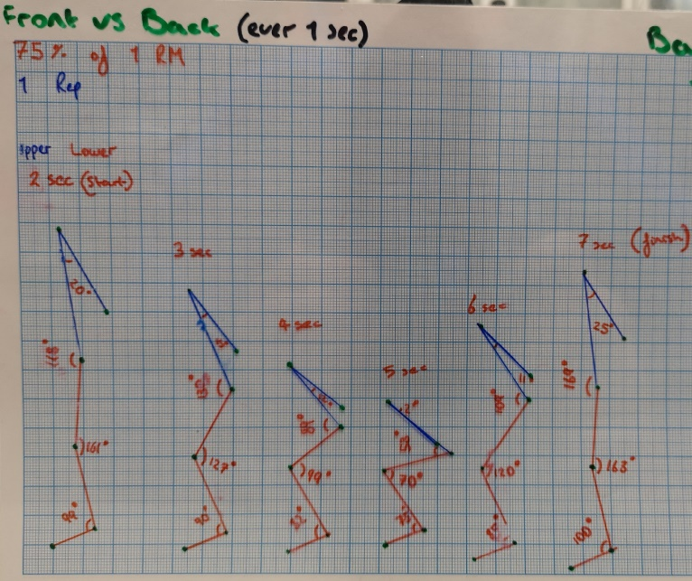
Figure 5. Joint angle and degree, eccentric and concentric phase of the back squat.

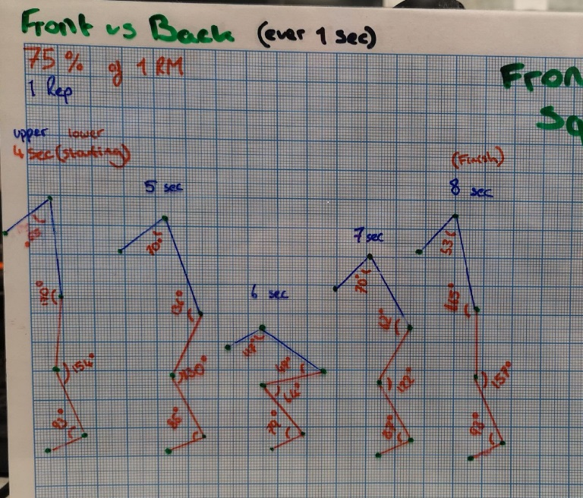
Figure 6. Joint angle and degree, eccentric and concentric phase of the front squat.

