University of Wales Trinity Saint David
Motorsport
Assignment 1
Alexandros Griffiths
2403677
Motorsport Engineering BEng
30/11/24
Workshop and Practice
1816 Words

Contents
Introduction 1
Health & Safety with Risk Assessments 1
Engineers Role in Society 2
Problem Solving (max. 300 words) 3
Team Structure (max 500 words) 4
Personal Development Plan 5
Conclusion 6
References 6

Introduction

In this report, it talks about a lot of the topics that are in completing a project, for example the health and safety, problem solving and team structures. It also includes personal aspects like a personal development plan and a engineer’s role in society. It will discuss the pros and cons within these subjects and real world examples of the ideas discussed.

Health & Safety with Risk Assessments

During the workshop and practice coursework, you are tasked with machining two parts using a mill, lathe and a drill within a specified tolerance. This includes following the correct health and safety procedures to keep yourself safe. During the assessment, you should be wearing a dust coat, goggles and steel toe capped boots to keep yourself safe. For example, using PPE and making sure your work equipment is in working order. In terms of legislation, this includes the Personal Protective Equipment at Work Regulations 1992 and the Provision and Use of Work Equipment Regulations (PUWER) 1998.

The Personal Protective Equipment at Work Regulations 1992:
This legislation outlines that the employer must provide and upkeep PPE in the workplace with the inclusion of training for the PPE. Its not just the employer’s responsibility, it’s also the employee’s responsibility to follow the training they have been given, to take reasonable care of the PPE and report any damage or defects with the PPE.

The Provision and Use of Work Equipment Regulations (PUWER) 1998:
This legislation is broader as it doesn’t just cover PPE, but work equipment safety. It includes that employees must be trained on the right equipment, and they must make sure they’re even using the right equipment for the job. As for the machines themselves, it states they must be labels with warning labels correctly and they must be kept to a high standard of maintenance, so they are safe to use.

This refers to the assessment you must carry out during workshop and practise as you use industrial machinery which must be kept to a high standard of maintenance, you must wear the correct PPE while operating this equipment and you must be trained on the equipment before their use.
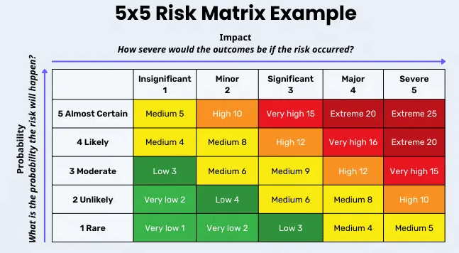
Using an appropriate risk assessment matrix, it is possible to quantify the risk and impact of certain actions or use of equipment. With the workshop and practice assessment you use a mill, lathe and a drill. Respectively the risk assessment would be 2, 4 and 1. The mill and drill are quite simple machines in the fact that not a lot is moving at once and when you operate these machines, you are not too close to the work piece. On the other and when the lathe is in use, there is a lot of mass spinning at once so there is much more of an impact if something goes wrong.

Engineers Role in Society

Being a chartered engineer means your are proficient in your area of study/work and that you abide by certain rules and regulations. This gives companies a way to know that their engineers are competent and are morally responsible. Two organizations that regulate this are the Institution of Mechanical Engineers (IMechE) and the Institution of Engineering and Technology (IET).

The Institution of Mechanical Engineers (IMechE):
This is a UK based organisation that specialises in automotive, aerospace, energy and manufacturing. They provide a framework for engineers so they have access to learning resources, professional development and guidance. Their code of conduct has a heavy lean towards sustainability and how it is important to the future of engineering. In relation to motorsport engineering, this could be the development of EV vehicles, the reduction of already established combustion engines (petrol and diesel) and the development of new combustion engines such as hydrogen engines and bio-fuel engines.

Institution of Engineering and Technology (IET):
This institution is worldwide and is one of the biggest in the world, I covers a wide range of engineering careers and it provides what IMechE can but on a bigger scale. It also has a big push towards sustainability for the future, such as using sustainable materials that can be recycled or biodegraded.

Problem Solving

A good way of problem solving a engineering problem is to use root cause analysis, especially on a issue found in development. It works by reverse engineering the problem to find the solution, you follow the effects to find the causes and you flow that trail until it leads you to the root cause of the issue. Then you will be able to find a appropriate solution to the problem and it can give you an outlook on what effects it will have as you already found out all the effects from the original issue.

An easy way to visualise root cause analysis is through a cause and effect fishbone diagram, it allows the engineer to visual a path of cause and effect to find the problem and it can help coming up with a solution as it shows what effects the solution will have.
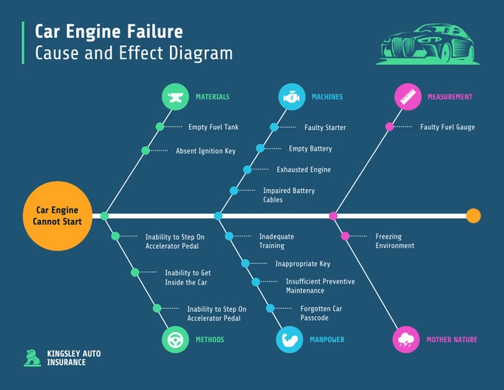

Root cause analysis is only one step in the process to coming up with a solution, after this step you will have to generate solutions, test the solutions and implement the solutions. A good way to show this and structure your solution is to use a flow chart, they are easy to read and easy to edit on the go.
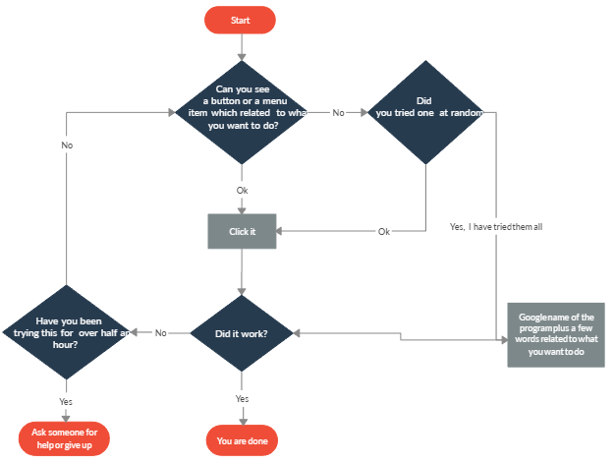

With using root cause analysis to find the problem, then structuring your solution with a flow chart so you can focus on finding a solution.

Team Structure

I was apart of a team-building exercise that needed us to transport everyone plus equipment over a certain distance with the given materials without touching the floor and come back within 2 hours. I was appointed IC for the exercise (In command) and in total there was about 30 other people apart of the team. I was the only person given the brief of the exercise and I had to relay that to the rest of the team. I started off by appointing a 2nd IC to help me keep everything organised, I appointed a time keeper to tell me the time every 10 minutes. I first split the group in two and asked them to come up with their own ideas on the best way to transport everything and everyone over and back. After 5 minutes I go the groups to come back, we talked about the two ideas they came up with and took the best parts of each and made a plan everyone was happy with.

I was using a hierarchical team structure as I was in charge, I has a second IC under me then the rest of the group. This is good as it gives a clear definition of who is in charge and that allows a defined final say in decisions, it gives a defined chain of command and increases accountability. The cons are there is slow decision making as it has to make its way up the chain of command, there is limited flexibility and innovation as the person in charge rarely changes and if the person in charge is incompetent and bad at their job the whole system breaks down. It’s a very good system only if the people in charge are good at their job and are willing to listen.
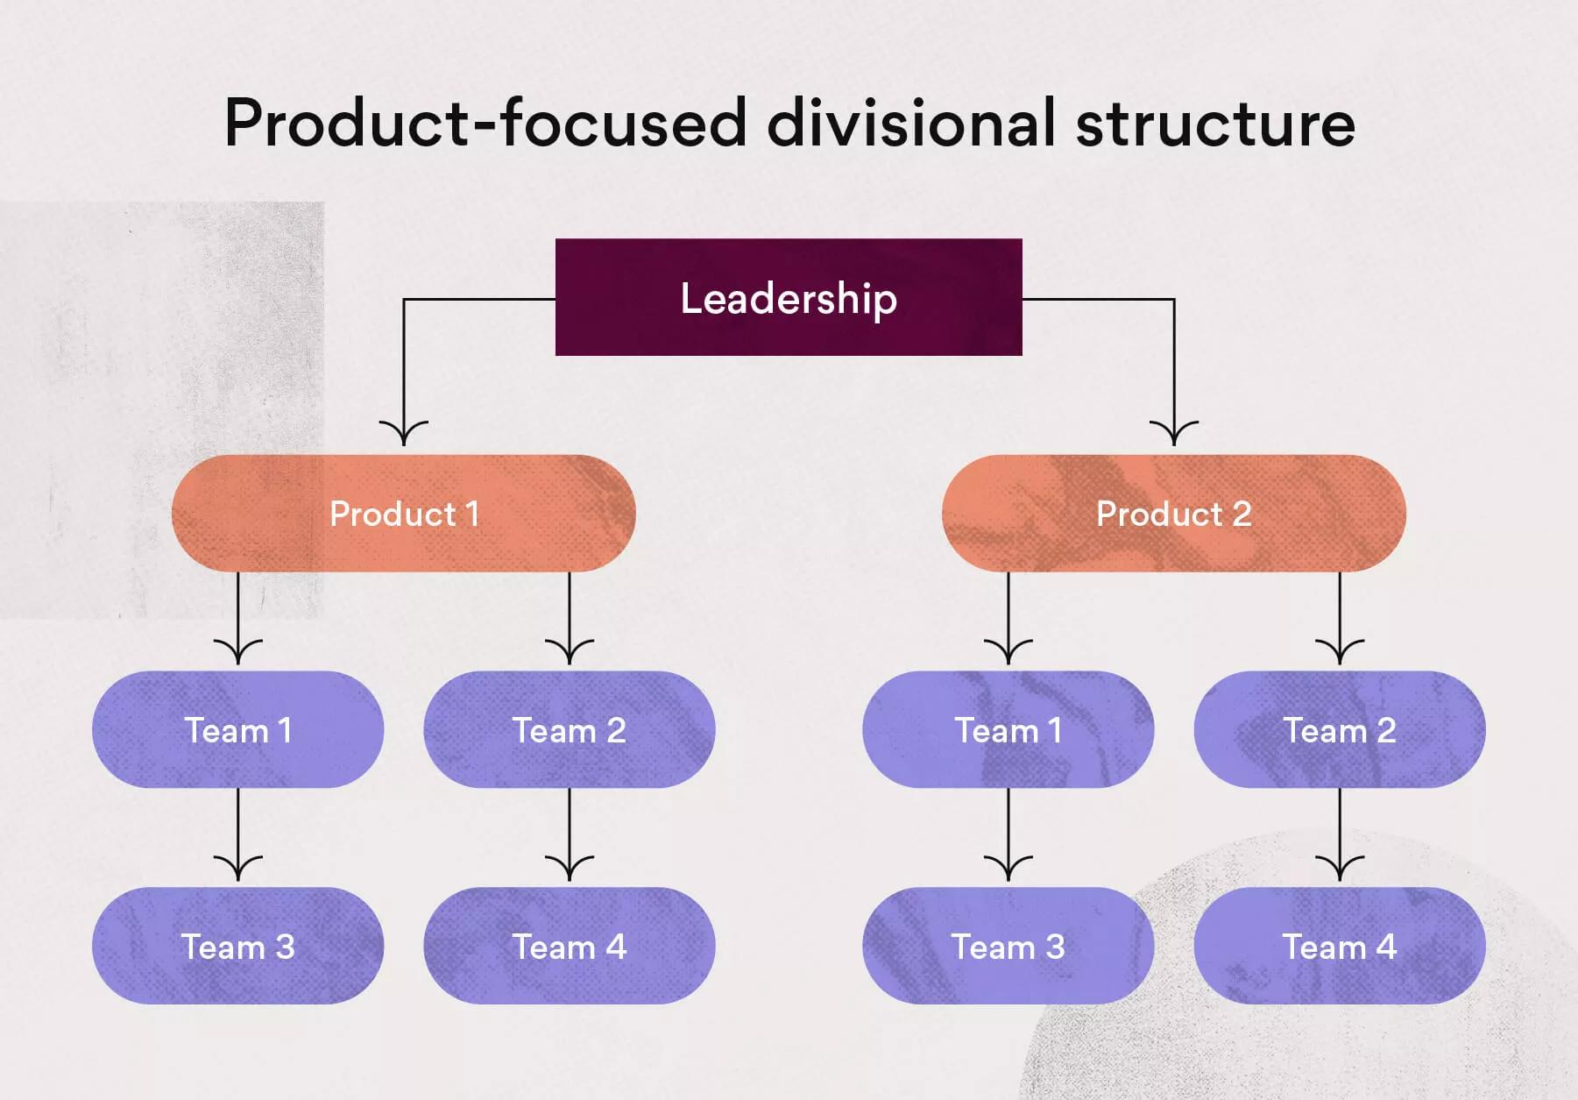
Another team structure that could work is the matrix structure. There would still be a team leader but their would also be a leader for different jobs in the team, in context it would be a leader for transporting equipment and transporting people. The pros are it quickens decision making as I don’t have to approve everything as they could go to their job leader, this also improves flexibility and adaptability. The cons are their could be a clash of interests as there are multiple people having the final say on decisions and you need to invest more time in communicating between leaders to make sure you are all on the same page.

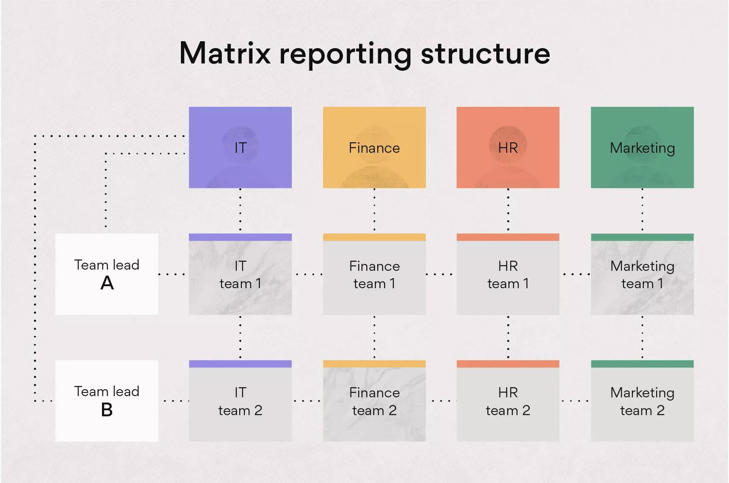

Personal Development Plan

Name – Alexandros Griffiths
Degree – Motorsport Engineering
Previous Qualifications – Level 3 Engineering BTEC Extended Diploma

Long Term Goals (5 to 10 years)
Work for a WEC team or start my own automotive company.
Short Term Goals (0 to 5 years)
Graduate University, move abroad for my job, job placement in a gap year.

Goal | Objective | Resources Required | Measurement | Target Date
Get my bachelor’s degree | Graduate university | Completing all my modules | When I get awarded my degree | In 3 years
Work placement | Get a work placement opportunity at a motorsport company | Careers officer and a lot of emails | When I get offered a job placement | In 1 – 2 years
Work for a WEC team | Get a job offer for a place at a WEC team | A good CV and networking | When I get a job offer for a job in the WEC | In 3 – 10 years
Have my own automotive company | Create a self-sustaining company. | Investors, knowledge, experience | When my company has been afloat for over a year | In 5 – 30 years

Conclusion
Throughout this report, I talked about the personal responsibilities of engineering, such as and engineer’s role and what organisations they can join, the health and safety risks that engineers can encounter and what legislations affect them and made a personal developmental plan of my future career. I also talked about how to work in teams as an engineer, what team structures are good for teams and how to problem solve. I expanded on these ideas and looked at the pros and cons of each method.

References
1. N/A
2. 2.1. Gov.uk (2023). The Personal Protective Equipment at Work Regulations 1992. [online] Legislation.gov.uk. Available at: https://www.legislation.gov.uk/uksi/1992/2966/contents.
2.2. Legislation.gov.uk. (2023). The Provision and Use of Work Equipment Regulations 1998. [online] Available at: https://www.legislation.gov.uk/uksi/1998/2306/contents.
2.3. Guevara, P. (2024). 5x5 Risk Matrix: Importance and Examples. [online] SafetyCulture. Available at: https://safetyculture.com/topics/risk-assessment/5x5-risk-matrix/.
3. 3.1. ImechE (2019). Institution of Mechanical Engineers - IMechE. [online] Imeche.org. Available at: https://www.imeche.org/.
3.2. IET (2019). IET - Home. [online] Theiet.org. Available at: https://www.theiet.org/.
‌4. 4.1. Tableau (2023). Root Cause Analysis Explained with Examples and Methods. [online] Tableau. Available at: https://www.tableau.com/en-gb/learn/articles/root-cause-analysis.
4.2. Ramuthi, D. (2023). 15+ Fishbone Diagram Examples for Brainstorming Problem Causes. [online] Venngage. Available at: https://venngage.com/blog/fishbone-diagram-examples/.
4.3. Creately.com. (2024). Problem-Solving flowchart | Creately. [online] Available at: https://creately.com/diagram/example/joh0bg5g1/problem-solving-flowchart [Accessed 29 Nov. 2024].
5. 5.1. Team Asana (2021). Team Structure: 10 Effective Ways to Organize Your Team • Asana. [online] Asana. Available at: https://asana.com/resources/team-structure.
5.2. Team Asana (2024). What Is a Matrix Organization and How Does It work? [online] Asana. Available at: https://asana.com/resources/matrix-organization.
6. N/A
7. N/A
‌

