PD05A1 WILLIAMSM-1708504

CILT LOGISTICS AND TRANSPORT LEVEL 5 PD05 A1 ASSIGNMENT
Report seeking authority to undertake planning and completing road move from Taunton to Albania during EXERCISE COUGAR 2014

LECTURER: GRAHAM ORR
STUDENT: MICHAEL WILLIAMS
STUDENT I.D: 1708504

Page 1 of 11
PD05A1 WILLIAMSM-1708504

CONTENTS

Page 1 Cover page
Page 2 Contents page
Page 3 Introduction
Page 4 Aims of the project
Page 5 Project characteristics
Page 6 Processes and issues
Page 7 The project organisational structure
Page 8 Major activities within project management
Page 9 Standards
Page 10 directing a project
Page 11 Programme management
Page 12 Reference page

Page 2 of 12
PD05A1 WILLIAMSM-1708504
1 Introduction, project background
In January 2014 exercise (EX COUGAR 2014) was confirmed and authorised from Commando logistics headquarters. This would take place from Taunton 40 Commando Royal Marines base. A project team would be assembled in the Taunton base. This project team would manage one project, planning and completing move from Taunton 40 Commando to (SF Tirana) a special forces base in Albania. The team will aim to provide an insight into the planning and execution of this project management evolution in detail throughout the project.
SMART objective principles will be used and specific details of tasks that are required. Measurable work output with good quality control. Achievable goals and deadlines for each task. Realistic expectations and allowance for any failings along with a plan B option. Timely completion of plans and tasks with continued evaluation.
2 Project board and project manager
The project board is made up from a project manager who is the motor transport officer (MTO) Royal Marines (RM). Then in order of importance vehicle mechanical warrant officer (WO), Sergeant RM, Leading hand Royal Navy (RN) and lastly vehicle mechanical corporal.

Page 3 of 12
PD05A1 WILLIAMSM-1708504
3 Project manager and board individual project requirements
The project manager MTO must have overall control and visibility of overall project including programme, time table and objectives that are required to be met. The WO will oversee middle management and make sure that MTO project tasks requirements are communicated throughout the project team. The sergeant will work as middle management in arguably the hardest job role, meeting the project
manager’s expectations. While keeping other project board members motivated and focused on the required tasks. Leading hand stores accountant will be tasked with all purchasing and acquiring essential equipment and commodities throughout the project timeline. Vehicle mechanic corporal will operate through the workshops and be responsible for vehicle maintenance and repair. This line up completes our project management team. Who will need to work together using good communication skills. External stakeholders will be employed throughout, and they will be managed by the project management team hierarchy according to there importance and management level.
4 Aims of project
Project management is employed in order to develop this plan.The aim is to foresee or predict any problems or issues. Aim to plan and control tasks with the project to achieve a lean top quality successful result. There is always an element of risk involved. Key objectives that are to be strived for are performance and quality which must fit the intended purpose or outcome of the project. Total quality management is crucial with responsibility for overall quality shared by the whole project management team. The project must be completed without exceeding the maximum authorised expenditure. Financial management is key and will be controlled by the MTO. Time scales have to be met with some allowance for certain tricky evolutions have extra time for any problems built into the overall time guidelines. Overall the timing tasking is given should be realistic and this is included within the planned finish date. The project will have a major project objective, with many minor objectives employed throughout the project.

Page 4 of 12
PD05A1 WILLIAMSM-1708504
5 Define a project’s characteristics and environment
The project management team will employ the Prince2 method for project managing. Prince2 incorporates resources, skills, technology and ideas to achieve my project objectives. It has a defined life cycle and a specific amount of resources available. It uses an organisational structure with separate defined responsibilities to manage the project as a whole.
Prince2 provides great control of resources and manages projects risk more effectively than other project management systems. It is beneficial to project managers, senior hierarchy including naval officers and all variety of organisations. Prince2 provides a consistent approach with an organised start, middle and end. Regularly reviews the project progress incorporating flexible decision points. The involvement of management and stakeholders at the right time and place for the duration of the project. Encouraging good communication channels throughout the whole team and a means of capturing lessons learned.
Heat would be a big factor in Albania. Investigation went into what could be done to properly prepare vehicles prior to deploying. Consult MTdepartment to see what their strategy would be for recovering vehicles from dunes and other potential hazards. Heavy rain and flooding could be a problem for vehicles and manpower in all the sites throughout Albania.
6 Define the processes and activities that comprise a project
I will create a giant to do list. Below is 7 tips for a successful project –
A. Ensure that the full project details are in place
B. Have realistic expectation
C. Have measurable criteria for success
D. Delegate Team members and assign tasks and responsibilities
E. Be a professional leader
F. Manage project risks and problems
G. Evaluate the project outcomes

Page 5 of 12
PD05A1 WILLIAMSM-1708504
Project management quotes -
“If you don’t know where you are going how can you expect to get there?” Basil s Walsh
“Those who plan do better than these who do not plan even though they rarely stick to their plan” Winston Churchill
“Expect the best, plan for the worst, prepare to be surprised” Denis Waitley
7 Processes and issues
Task 1. Prepare and maintain vehicles prior to road move.
Time allowed – 14 days
Task 2. Prepare navigation, recovery and conduct driver training including evaluation.
Time allowed – 12 days
Task 3. Recce area in advance, make assessments and prepare guide on planned route.
Time allowed – 96 hrs
Task 4. Road move takes place allowing for driver hours which is considered within the estimated time.
Time allowed – 5 days
An issues log will be used, this can be highlighted during meetings and used as a reference for future projects.

Page 6 of 12
PD05A1 WILLIAMSM-1708504
8 Select a typical project organisational structure
Fig 1

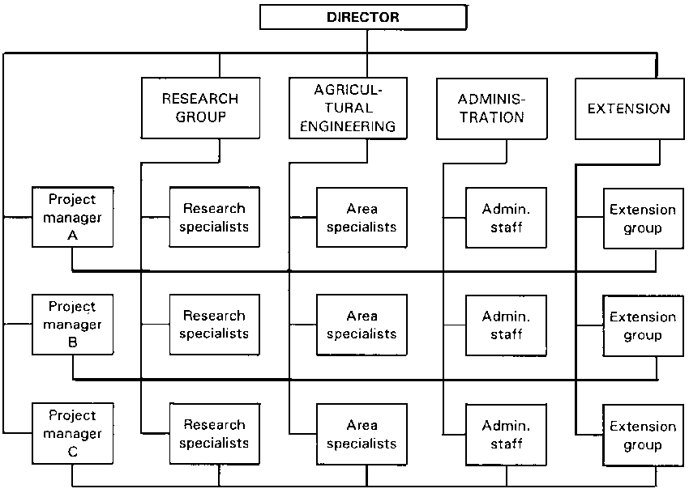

9 Above is an example of a typical project management hierarchy structure. However this will vary when working on different projects because of size and costing variables. A failure in any of the positions may result in impacting others and the organisation or company as a whole.
10 Factors comprising successful project organisation
Different Stakeholder bring different attributes, experience levels and motivations to the project. Some stakeholders may micro manage while others may concentrate on major evolutions and designate minor evolutions further down the management hierarchy.

Page 7 of 12
PD05A1 WILLIAMSM-1708504
11 Major Activities within project management
Project management originated from when the pyramids were built in Egypt. The job of building a final resting place for the pharaoh was commissioned to a project manager. In modern times five main phases are employed.
- Conception. The first phase is used by project managers to come up with ideas of how to achieve the finished project and fulfil the expectations of the customer. Top management will hold meetings to discuss ways to achieve the objective or objectives.
- Planning. Planning and designing will consist of task required and an order of which they need completing and who is responsible for each task. The budget is set out within this phase with parameters that can’t be exceeded. It will be determined if any external researchers are required for this phase and acted upon.
- Execution. This is the phase in which work starts, programme and project managers delegate tasks to managers. In turn these managers pass these tasks onto specialist workers and subordinates.
- Control. Managers will need to supervise and maintain quality control throughout all the project tasks. The schedule will need to be met and any possible problems need to be raised and reported on. Deadlines should be met but there should also be a contingency plan in place. Department managers are required to monitor and ensure costs are within the allowed budget.
- Closing. During this final phase, completion will be executed in the form of a finished project, product, service or building. The project manager will finish any reports, objectives and schedules ready to hand over to the customer.
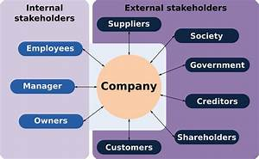
Page 8 of 12
PD05A1 WILLIAMSM-1708504
12 Some important factors will be Performance, quality, cost, budget and time scales. I will operate the (FAMTO) First Aid Mechanical Transport Organisation.
We will hold meetings with Commando Logs Squadron staff to set expectations of store demand placing while deployed. We will talk over potential problems with customs in Jordan and Albania. Plan B will be talked through as this will cut down on planning time once deployed.
13 Quote – What is a standard? – A standard is a document established by consensus and approved by a recognised body, which provides for common and repeated use, rules, guidelines or characteristics for activities or their results, aimed at the achievement of the optimum degree of order in a given context.
Standards need to be developed and approved with stakeholders involved.
14 Activity – An activity is a task that is completed by achieving the task of a process. An activity has a set start and finish time and date which contains a set of tasks requiring completion.
Fig 2
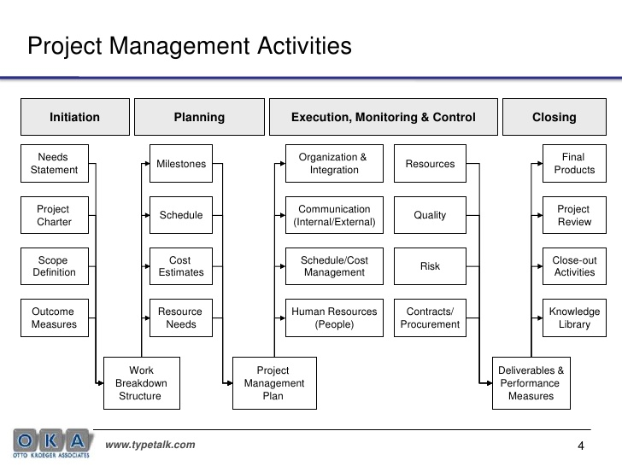

Page 9 of 12
PD05A1 WILLIAMSM-1708504
15 When directing a given project
Background quote – WWW2acdc.gov
Project issues must be identified, managed and resolved throughout the project in order for the project to be successful. Issue management plays an important role in maintaining project stability and efficiency throughout the project lifecycle. It addresses obstacles that can hinder project success and/or block the project team from achieving its goals. These obstacles can include such factors as differences of opinion, situations to be investigated, emerging or unanticipated responsibilities.
16 Accessing requirements, listings and prioritising jobs and setting timelines. We will research to achieve best possible correct information regarding this given project. Finding the right person or organisation will be vital to achieve accurate feedback and information to move the project forward. We must be aware of any rabbit holes and any incorrect information that we gather as this could represent a problem in the future project development. For example the wrong product being acquired which would create costing and supply time line issues.
By asking a wide range of people we will be able to weed out bad intelligence as a pose to reliable accurate information. Jobs will need prioritising, we will produce a correct sequence and order of tasks stage by stage. This will be helped along by holding a planning meeting to discuss any potential problems and task time frames regarding different processes.
17 Demanding stores, kit and arranging logistics in advance. When demanding stores I need to be fully aware of which kit will take longer to arrive than others. Whether this delay will impact certain jobs or tasks. I will take full control of progressing supply chain demands personally progressing them.
18 Workforce requirements, pre deployment training and any other courses. Leave and holidays for personnel including harmony time. At the earliest point I will consult staff into what their needs and requirements will be during the upcoming months. I will plan allowing for any absentees. Staff will need information on course completion requirements and check courses are booked in advance. A good example of this will be to sign up staff onto embarked forces sea survival course in Whale island, Portsmouth.
19 Factors and issues that can go wrong will include most commonly time extensions resulting from delays in deliveries and supply times.

Page 10 of 12
PD05A1 WILLIAMSM-1708504
20 Programme management
Managing several related projects with the aim of improving the Royal Navy performance as an organisation. It’s a umbrella structure used to manage a series of related projects. Project teams within the programme produce and develop the
project aims, objectives and delivers the finished project. The programme provides overall direction and guidance using good communication. The programme defines the way in which the project is focused and ensures the work gets completed successfully. A programme manager has authority to manage a programme. All project managers within the organisation report to the programme manager.
21 A key difference between a project and a programme is that a project usually spans a shorter duration. A couple of months for example, but this may vary. A programme tends to have a duration of years. When a organisation has different sets of programmes and projects it is controlling the term Portfolio is employed. Connected to this project are other projects within the exercise. The whole exercise would be managed by a programme manager with the entire programme due to last four months. A programme board may consist of programme manager, business case manager and programme assurance.
22 Business case
A business case should be undertaken to establish essential information ready to start the programme. These include benefits, costs, risks and any time lines. This will determine projected project costs, benefit realisation costs and all other costs.
23 Successful project managers must master four main elements, scope, resources, time and cost.
A. Scope - is the project size, goals and requirements of and within the project.
B. Resources - consist of people, employees, equipment and materials.
C. Time – task timings and any dependencies.
D. Cost – contingencies and profit verses any potential losses E.G Carilion company currently in financial difficulty, (liquidation).
24 Risk management and health and safety standards
A risk management strategy will be used to determine the necessary organisational requirements. A risk register is a good way to record and manage risks throughout the project. A issue resolution strategy will enable staff to resolve requests and issues in the correct fashion.

Page 11 of 12
PD05A1 WILLIAMSM-1708504
25 Effects on rest of organisation
The project may lead to several impacts on the organisation as the project could alter the way in which the organisation works. For example within the Royal Navy, projects internally and externally may effect working hours, employees morale and workload. It may mean the organisation employing extra staff, providing more training and understanding by both managerial and employees in the workplace.
Reference Page

WWW2acdc.gov
Brilliant project management by Rob Cole
Prince 2 Principles
Project management by Harold Kerzner
https://www.pmi.org/pmbok-guide-standards/about
The project managers desk reference 3rd edition by Lewis James
Managing successful projects with Prince 2
Project change management H. James Harrington
The definitive guide, to project management – The fast track to getting the job done on time and within budget

Page 12 of 12

