Marketing Management Assessment 1

Name: ANNA MARIA JOSE
Id: 2216778

Table of Contents
Introduction 3
Organizational Overview 3
Details of Communication 4
Details of Integrated Marketing Communications 6
Possible new promotional strategies for the company 7
Details of brand equity and branding 9
Brand Equity model 9
Customer Journey 11
Engagement Model 12
Conclusion 13
References 14
Appendix 17

Introduction
It may be claimed that a company's advertising strategy enables it to keep in touch with its clientele, create the ideal items for them, and choose the accurate way to pass on knowledge about the goods in question. Without a clearly defined strategy, a business would not be able to identify its target market, create the appropriate products, or effectively market them. Additionally, a marketing plan gives a company an advantage over its rivals and aids in the development of products and solutions with the highest potential for financial success (Talbot, 2021). Enhanced customer loyalty, greater market share, advantages in competition, more sales, and greater profitability for the company over the long term may all be attributed to marketing strategy.
Additionally, creating a working connection with clients is essential for a company to succeed in the long run. Customers feel safer and attached to brands when there is a strong relationship built on transparency and confidence. This connection may also increase the retention of clients and your percentage of repeat business. In light of this, the study's objectives include addressing the organizational overview, communication particulars, integrated marketing communications details, and potential new promotional techniques for the company. The presentation of branding and company reputation details will come after this, followed by the model for brand equity and the model for customer journey and engagement.

Organizational Overview
It might be stated in this section that Britten-Norman serves as a commercially held British aircraft constructor and provider of aviation-related services. The business is the only independent manufacturer of commercial planes in the UK. To date, Britten-Norman has produced and sold about 1,350 aircraft to clients in greater than 120 nations. Additionally, Britten-Norman provides adaptable solutions to accommodate the demands of various consumers. The customer and the internal design, production, unity, and validation teams collaborate closely to create custom solutions and offer concepts that satisfy particular needs. The company has been able to succeed and acquire growth because of the rise of people traveling on a global basis. This is due to the increase in passengers traveling by air each year between 2006 through 2022. Compared to the year 2019, the number of passengers flying internationally fell by more than 58% in 2021 as a result of the coronavirus epidemic (Mazareanu, 2019).
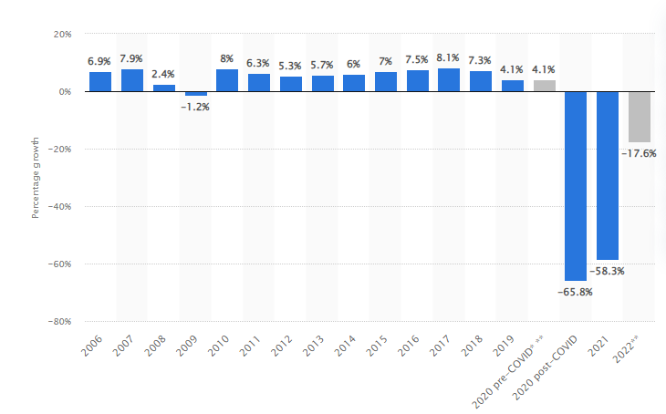
Figure 1: Demand for passengers in the air will increase annually between 2006 and the year 2022
(Source: Mazareanu, 2019)
On the other hand, the newest version of the automatic pilot, the S-TEC 3100, is being integrated into the Islander by Britten Norman as well as Genesys Aerosystems. Britten-Norman also partners with Garmin to provide "Engine Electronic Flight Instrumentation" for the turbine Islander series. Additionally, the corporation has guaranteed that while performing surveillance duty, these planes have performed a crucial controlling and commanding task (britten-norman.com, 2021). The aircraft, which constitutes the larger, more durable version of the propeller Islander, is scheduled to go through a significant refurbishing process before being placed back on the civilian airplane registry for future export sales.

Details of Communication
Information exchange between personnel and people outside the organization is referred to as communicating in an organizational setting. To achieve organizational goals, staff members and leadership connect with other people through efficient communication. It seeks to streamline organizational processes and lessen mistakes. It is also the method through which people communicate with one another by using a shared set of signals, behaviors, or gestures (Kalogiannidis, 2021). On the other hand, effective communication is crucial to every company's success. Consequently, the method of sharing information amongst individuals, whether inside or beyond a business. The elements and connections of the information of communication beneath the study may be identified and understood with the use of interaction models, which is why businesses require them. Models provide fresh perspectives on numerous facets of interpersonal interaction, which aids in the development of efficient communication systems. The organization's internal communication is facilitated by the adoption of the communicators model. It has been, therefore, an outline or a diagram that shows how a communication strategy is carried out for a certain project. It involves a set of stages to effectively convey the message for the success of a company.
Thus, the Aristotle paradigm for interaction is one of the most generally used and widely recognized models for interaction, in which the sender conveys knowledge to the recipients in an effort to persuade them and get them to react and behave in a certain way.
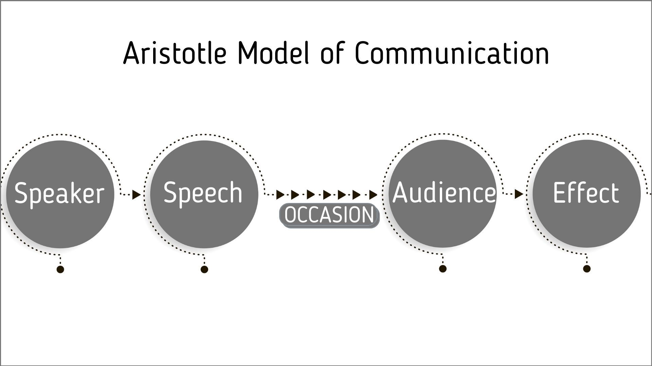
Figure 1: The Aristotle communication model
(Source: Bhasin, 2021)
It may also be claimed that it can be roughly broken down into five key components, which include "Speaker, Speech, Occasion, Audience, and Effect". Additionally, following this guideline will help one succeed in giving speeches, seminars, and presentations where the speaker delivers his point by creating compelling information that the audience just absorbs and responds to. One must also note that no comments, no bruit, and oral speaking centered are the three main objections of Aristotle's paradigm, despite all of these other factors. The fact that Aristotle's concept of interaction is continuous is also one of its most significant flaws. Additionally, it omitted feedback, which is crucial for the collaborative interaction process, and failed to explain it. However, one of the fundamental critiques of Aristotle's concept is the fact that communication is viewed as a one-way interaction process, with the main attention going from presenter to reception. It begins with the speaker delivering a speech and concludes with the listeners or recipient.

Details of Integrated Marketing Communications
The practice of harmonizing a brand's content so that it remains coherent across every channel that the company employs to communicate with its intended audience is known as integrated marketing strategies. It represents a tactical strategy that directs communication throughout all marketing platforms. Communication is hampered and functional operation is compromised when marketing and advertising teams are treated separately. A coordinated strategy, overall corporate goals, and firm principles are followed by all channels of communication with customers under a single umbrella (Elrod and Fortenberry, 2020). Implementing an IMC approach, for example, will increase efficiency by offering a simplified procedure. It makes a guarantee that the business's consistent message is broadcast across all available channels and prevents time from being lost on sending out the same message repeatedly or asking other people for information.
On the other hand, after that, integrated commercial communications seek to make sure that clients hear the exact same message no matter how they engage with the image of a business. Owing to this, it can be said that the usage of these models helps to increase the efficiency of a company and further enhance its effectiveness in operations. To help with comprehension, it may also be argued that the IMC's five major components are communications, promotions for sales, marketing through direct mail, individual selling, and advertisements. Additionally, the main responsibility of IMC has been to thoroughly assess the customer's communication requirements and preferences (Tompkins, 2021). Create a communication plan according to the data that will address the main concerns of the demographic being targeted, support the individual's capacity for good judgment, and boost productivity. Additionally, some of the "IMC" techniques utilized in a corporation include advertising, the revenue of sales, contact via direct mail, individual sales, communications, and social networking marketing. Following these factors, an entity would be successful in terms of making good use of integrated marketing communication for the benefit of a company and developing a healthy relationship with its customers.

Possible new promotional strategies for the company
In this section, it can be said that a promotion plan is essential for establishing a business image in the marketplace, educating consumers about the goods and services one provides, and emphasizing the advantages of working with the firm. However, with a lot of businesses providing comparable goods or services to yours, the way one advertises may be the deciding factor for a lot of prospective consumers (Strempel, 2021). Therefore, it may be claimed that an entirely novel advertising approach quickens the adoption of goods and services and supports the selling of products and services amid unfavorable market circumstances. Effective sales assistance is provided. Additionally, it aids in bridging the distance between producers and final customers.
Despite these, launching marketing campaigns concurrently across every platform requires an IMC, which is highly expensive. The costs of development, manufacturing, and distribution are involved. When executing ads of this magnitude, marketers risk running out of money. Additionally, even with hundreds of thousands of dollars invested, an integrated marketing message may fail due to a failure to standardize or accommodate them to regional cultures. Last but not least, small firms might not be able to implement an integrated marketing plan due to the absence of finances (Suay-Pérez et al., 2021). To successfully use it, users would need inspiration, creativity, expertise, and background, which tiny enterprises might not have. Neglecting these challenges, an individual is able to understand the benefits and essential factors further described below.
However, in order to select a suitable marketing strategy for the chosen company Britten Norman, it is essential to have an idea of the types of strategies relevant to the market. Traditional as well as internet campaigns, personal trading, direct advertising, media relations, sponsorships that end up and sales campaigns are examples of promotional strategy types (Forbes Communications Council, 2022). It may also be claimed that there are many various marketing strategies to pick from, ranging from tried-and-true promotional strategies like in-person sales to cutting-edge marketing strategies like internet advertising and customer loyalty schemes. Thus, based on the nature of the company, it can be said that sponsorship marketing is the most suitable one for Britten Norman in the given context.
This is because sponsorships provide companies with the opportunity to be seen as helping and advancing the community, which generates a lot of goodwill. Additionally, sponsorships assist the company in developing a reputation, trustworthiness, and improved public perception. In order to connect with the people you want to reach, it ought to be utilized strategically, just like any other method of marketing. Investigate the occasions and problems that the right customers are concerned about when the business develops its marketing strategy (Le Dang Lang et al., 2020). Additionally, corporations frequently utilize sponsorships simply as a form of communication tactic to build a positive reputation for their business. In addition to supporting markets, businesses may choose to support nearby children's athletic organizations, but they can additionally opt to support nearby marketplaces. Thus, it can be said that Britten Norman a large manufacturer of small-sized commercial aircraft and an aviation service delivery company, would be heavily benefited from this method.
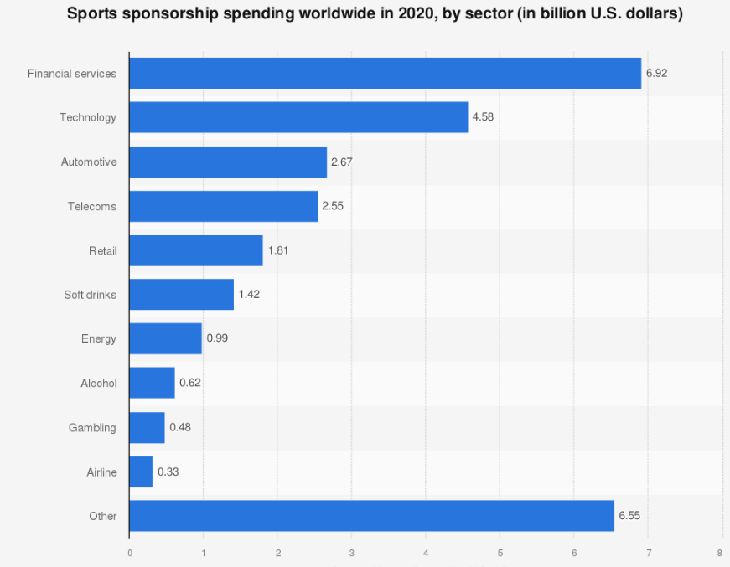
Figure 3: Spending on sponsorship for brand exposure by sector
(Source: Gough, 2022)
This is also suitable for the company because the amount spent on sports endorsements globally in the year 2020, is broken down by industry. After 2020, it is predicted that the aerospace and industrial industries would spend over 3 billion dollars on athletic sponsorship contracts (Gough, 2022). This way, it can be made sure that companies in the same segment have also started considering the use of sponsorship marketing as a part of the strategy to enhance the image of the brand and connect better with its customers.

Details of brand equity and branding
In this section, it can be said that the intrinsic worth of an organization is defined by the consumer's impression of its superiority and attractiveness, which is what is meant by the word brand equity in this section. It depends on elements like consumer loyalty, perception of the brand, and clients with customers. On the other hand, rebranding may be defined as the act of giving a company a unique character in the eyes of its target market and customers (Wood, 2020). The logo, graphic design, purpose, and manner of the language of a corporation make up its branding at its most fundamental level. Additionally, because customers favor items with solid reputations, confidence in the brand has an immediate impact on the number of sales.
It can also be said that in addition to being what leaves a lasting impression on buyers, branding helps consumers and prospects understand what to anticipate from a business. It serves as a means of differentiating a business from its rivals and outlining what a business offers that renders it a superior choice (Ramadhani and Mujayana, 2022). Additionally, the valuation of the brand represents the monetary value that a brand holds, whereas brand property is the value of a business in its perception of the client. The value of a company may be estimated using both the equity of the brand as well as brand's worth. Each provides a distinct method for boosting loyalty, but various measures are needed for each. The valuation of a company is the monetary relevance a brand holds, whereas reputation equity is the worth of a product in its perception of the client. Thus, it can be said that a brand's value may be estimated using both its reputation and its worth.

Brand Equity model
The functionality of something may be divided into five areas, including key qualities and amenities, reliability of the item, longevity, and usefulness, in accordance with Keller's model, which is discussed in this part. Along with style, design, and affordability, it also encompasses the efficacy, efficiency, and sympathy of the service. However, Keller's reasoning behind the approach is straightforward: in order to build a powerful brand, someone must design the optimum brand contacts or emotions (Kuhn et al., 2018). Furthermore, consumers or potential consumers should come away from every interaction with the business with good ideas, feelings, and convictions.
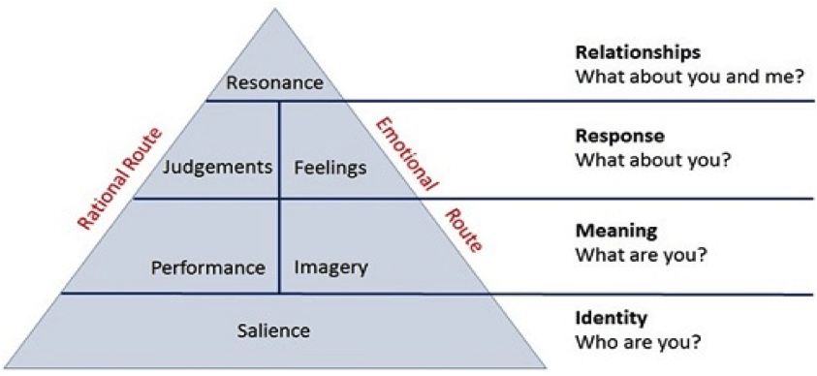
Figure 4: Brand Equity Model of Keller
(Source: Singh, 2019)
In the section, it may also be claimed that having a high brand equity results in consumers buying more from it as well, recommending the company to their friends and family, being more devoted to the company, and decreasing the likelihood that they will lose them to rivals. Furthermore, it has been found that the judgment this model aids in making frequently centers on the different categories. Clients evaluate the good or brand primarily on both its real and perceived excellence when it comes to cleanliness. When it concerns the good or the company, it is crucial to consider what an organization may do for enhancing both of these kinds of quality. Additionally, buyers assess credibility using criteria like competence, which encompasses innovation, dependability, and likeability. Owing to this, it can be said that the usage of this model is very helpful for companies that are willing to assure quality during maintaining customer relationships and quality in services.
Despite all the benefits and support, one must also note that in contrast with particular product brands, the financial value of manufacturer nameplates is not taken into account by Keller's approach. When questioned about one of the organization's slogans, the responses of those who responded provided an intriguing discovery. The significance of a company's aspect was minimized by respondents, who also indicated some perplexity (Kuhn and Alpert, 2016). Additionally, respondents indicated that corporate names are utilized to differentiate between items but expressed uncertainty regarding the distinction between the producer and brand of the product. The consequences of advertising seem to suggest that corporate purchasers are less concerned with trademarks or statements and more interested in the business itself and its line of goods, according to researchers. This way, it can be said that even with all the added advantages, the model at times creates confusion, and makes it challenging to communicate properly with all the stakeholders.

Customer Journey
In order to have a thorough grasp of this part, it may be noted that customer connections are all points of interaction between a brand and its customers. Customers could come across the company on the internet or in an advertisement, read ratings and evaluations; browse the website, visit the physical store, or get in touch with customer care. On the other hand, the total of all the interactions that consumers have with the enterprise and company is known as their client journey. The customer journey captures every phase that comes with being a client, as opposed to focusing on a single transaction or event (Miranda, 2021). As a result, businesses perceive the "customer journey map" as a tool for visualizing the customer's perspective on their interactions with the company. This map is important because it requires a company to consider the ways customers actually interact with the brand as opposed to how businesses believe they do.
Owing to this, the details of Britten Norman can then be summarised as follows:
Stage | Awareness | Consideration | Decision | Service | Loyalty
Action | Via ads and market news | Market Research | Making a deal | Products and service maintenance | Repeat Purchase
Touchpoint | Traditional Media | Word of Mouth | Website and news | Email and phone | Client Review
Experience | Hesitant | Curious | Excited | Satisfied | Satisfied
KPI | Increasing clients | New Orders | The increasing rate of conversion | Review of operations | The retention rate of stakeholders
Business Goals | Acquire more customers | Increase financial stability | Acquire mutual benefits | Benefit to the social and economic aspects | To generate good reviews
Table 1: Customer journey map of Britten Norman
(Source: Created by the learner)

Engagement Model
In this part, links between the four major components of the Total Engagement Model—the customer value statement, advertising for the company, civilization, and customer experience are brought all together. It is challenging to create significant levels of customer engagement given the manner in that firms typically conduct their operations. The fundamental issue is how the many suggestions for promoting customer loyalty and advertising to customers utilizing a comprehensive engagement strategy may be. This is another strategy used by companies to engage with their clients and create enduring connections. Thus, it can be said that the same can be considered while Britten Norman enhances its productivity and further engage with the customers in a better approach.
This is because, the complete engagement paradigm integrates things into a functional system, and Britten Norman can accomplish the same. Additionally, the secret is in concentrating on coordinating all business endeavors including promotion, service to customers, goods, and corporate culture around a common strategy for customer involvement. The cohesiveness created by the overall brand approach alignment all throughout the entire organization is a significant advantage of the total interaction approach (Roberts and Alpert, 2021). The suggested model unifies and simply clarifies, with a focus on actionability, ways to build and operationalize a growth strategy driven by rising consumer involvement. It is pretty extensive. Following the required criteria, Britten Norman would have an opportunity to make sure that a plan is developed to assuring proper actionability and operationalize a growth strategy driven by rising consumer involvement.
However, in the same process, the company also needs to be aware of the challenges associated with the usage of the model. For instance, this strategy necessitates ongoing client commitment. A corporation is going to have to put in energy and attention at every level of the project if it has an internal staff. Businesses must ensure that the in-house staff and the workforce they have delegated get along. In addition, it is typically difficult to determine the success of a project when there is no fixed deadline (Sweeney and Plewa, 2020). This makes an opportunity for inefficiencies as well. The procedure is typically slowed considerably by the creation team's intermittent availability. It is typically challenging to estimate expenditures in the absence of clear needs and deadlines. The final cost can be far more than the predetermined budget. Avoiding these factors, Britten Norman would have an opportunity to make sure that a plan is developed to assuring proper actionability and operationalize a growth strategy driven by rising consumer involvement.

Conclusion
It can be concluded that the organizational overview, communication specifics, integrated marketing communications information, and prospective new promotional strategies for the corporation were among the study's objectives. This was followed by the display of branding and corporate reputation information, the brand equity model, and the customer experience and participation model. Britten-Norman serves as a professionally owned British company that builds airplanes and offers aviation-related services. The expansion in international travel has allowed the business to prosper and experience growth. On the other hand, successful communication is essential to the success of every business. Therefore, the technique of information exchange between people, whether within or outside of a firm.
In this section, it may be argued that an advertising approach is crucial for building a company's reputation in the market and informing customers about its products and services. Knowing the many sorts of market-relevant strategies is crucial for choosing the best marketing approach for the specified firm, Britten Norman. Thus, it can be concluded that sponsorship promotion is the strategy that is most appropriate for Britten Norman in this particular situation depending on the nature of the firm. This approach would greatly benefit Britten Norman, a significant maker of light commercial planes and a provider of aviation services. Both a company's worth and notoriety may be used to determine its value.

References
Bhasin, H. 2021. Aristotle’s model of communication. [online] Marketing91. Available at: https://www.marketing91.com/aristotles-model-of-communication/ [Accessed 19 Apr. 2023].
britten-norman.com 2021. Britten-Norman eyes new export opportunities. [online] Britten-Norman. Available at: https://britten-norman.com/britten-norman-eyes-new-export-opportunities/ [Accessed 19 Apr. 2023].
Cambra-Fierro, J.J., Fuentes-Blasco, M., Huerta-Álvarez, R. and Olavarría, A. 2021. Customer-based brand equity and customer engagement in experiential services: insights from an emerging economy. Service Business, 15(3), pp.467–491. doi:https://doi.org/10.1007/s11628-021-00448-7.
Elrod, J.K. and Fortenberry, J.L. 2020. Integrated marketing communications: a strategic priority in health and medicine. BMC Health Services Research, 20(S1). doi:https://doi.org/10.1186/s12913-020-05606-7.
Forbes Communications Council 2022. 16 Effective Marketing Strategies To Boost Sales In 2023. [online] Forbes. Available at: https://www.forbes.com/sites/forbescommunicationscouncil/2022/12/19/16-effective-marketing-strategies-to-boost-sales-in-2023/?sh=7b1fd73a29d7 [Accessed 19 Apr. 2023].
Gough, C. 2022. Sports sponsorship spending worldwide by sector 2020. [online] Statista. Available at: https://www.statista.com/statistics/269785/sports-sponsorship-deals-worldwide-by-industry-sector-in-2009/ [Accessed 19 Apr. 2023].
Kalogiannidis, S. 2021. Business Trust and Communication as Predictors of Business Growth. WSEAS TRANSACTIONS ON BUSINESS AND ECONOMICS, 18, pp.1512–1522. doi:https://doi.org/10.37394/23207.2021.18.138.
Kuhn, K. and Alpert, F. 2016. Applying Keller’s Brand Equity Model in a B2B Context: Limitations and an Empirical Test. [online] Available at: https://research-repository.griffith.au/bitstream/handle/10072/2338/26187_1.pdf [Accessed 19 Apr. 2023].
Kuhn, K.L., Alpert, F. and Pope, N.K.Ll. 2018. An application of Keller’s brand equity model in a B2B context. Qualitative Market Research: An International Journal, [online] 11(1), pp.40–58. doi:https://doi.org/10.1108/13522750810845540.
Le Dang Lang, Le Tan Buu and Nguyen Van Hien 2020. The role of sponsorship and public relations in brand equity creation: an exploratory of vietnamese consumers perception of soft drinks. Journal of Food Products Marketing, [online] pp.385–400. doi:https://doi.org/10.1080/10454446.2020.1790459.
Mazareanu, E. 2019. Growth of global air traffic passenger demand 2019 | Statistic. [online] Statista. Available at: https://www.statista.com/statistics/193533/growth-of-global-air-traffic-passenger-demand/ [Accessed 19 Apr. 2023].
Miranda, D. 2021. Customer Journey Map: Everything You Need To Know. [online] Forbes Advisor. Available at: https://www.forbes.com/advisor/business/software/customer-journey-map/ [Accessed 19 Apr. 2023].
Ng, S.C., Sweeney, J.C. and Plewa, C. 2020. Customer engagement: A systematic review and future research priorities. Australasian Marketing Journal (AMJ), 28(4). doi:https://doi.org/10.1016/j.ausmj.2020.05.004.
Ramadhani, I. and Mujayana, M. 2022. BRAND EQUITY AND STRATEGIES TO WIN BUSINESS COMPETITION. Journal of Applied Management and Business (JAMB), 3(1). doi:https://doi.org/10.37802/jamb.v3i1.245.
Roberts, C. and Alpert, F. 2021. Total customer engagement: designing and aligning key strategic elements to achieve growth. Journal of Product & Brand Management, 19(3), pp.198–209. doi:https://doi.org/10.1108/10610421011046175.
Singh, V. 2019. Keller’s Brand Equity Model by International Brand Equity. [online] International Brand Equity. Available at: https://www.internationalbrandequity.com/kellers-brand-equity-model-by-international-brand-equity/ [Accessed 19 Apr. 2023].
Strempel, C. 2021. Council Post: Three Marketing Strategies To Help You Push Value Rather Than Sales. [online] Forbes. Available at: https://www.forbes.com/sites/forbesbusinesscouncil/2021/04/20/three-marketing-strategies-to-help-you-push-value-rather-than-sales/ [Accessed 19 Apr. 2023].
Suay-Pérez, F., Penagos-Londoño, G.I., Porcu, L. and Ruiz-Moreno, F. 2021. Customer perceived integrated marketing communications: A segmentation of the soda market. Journal of Marketing Communications, pp.1–17. doi:https://doi.org/10.1080/13527266.2021.1915853.
Talbot, P. 2021. Marketing Strategy 101. [online] Forbes. Available at: https://www.forbes.com/sites/paultalbot/2021/11/15/marketing-strategy-101/?sh=3d2e7f305dd6 [Accessed 19 Apr. 2023].
Tompkins, C. 2021. Council Post: Integrated Marketing: How To Get Started The Right Way. [online] Forbes. Available at: https://www.forbes.com/sites/forbesagencycouncil/2021/12/01/integrated-marketing-how-to-get-started-the-right-way/ [Accessed 19 Apr. 2023].
Wood, L. 2020. Brands and Brand equity: Definition and Management. Management Decision, 38(9), pp.662–669. doi:https://doi.org/10.1108/00251740010379100.

Appendix
Appendix 1: Infographic Poster


