Winter as a challenge in Delhi
by Khushi Aggarwal & Tara Lanba
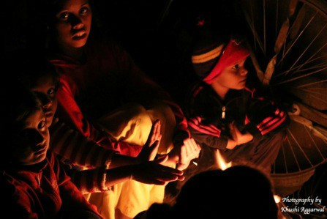


“Just trying to keep ourselves warm,” is what these kids had to say.
Cold, cozy nights, warm blankets and hot chocolate, that has always been our perception of winter. But for many of those who stay in Delhi, winters is that one season which they hate. They don't have cozy nights, warm blankets or hot chocolate like us. Winters have been hard for those who have had to sleep on the pedestrian, but most of us don't seem to care. They don't have heaters or radiators to keep themselves warm, just one thing-fire. It is cold but they still have a smile on their face, sitting around a fire just trying to keep themselves warm. Winter is so different for every person who stays in Delhi. Some have the privilege to keep themselves warm by being well clad whereas some have nothing to wear and all they do is shiver. Watching this man shiver was a bad site, he was so cold. Left us with tears in our eyes.

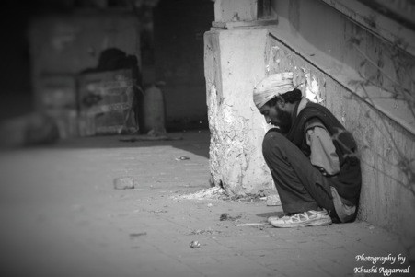

“I have no where to go, just sleep on the streets.”
We all would have never imagined how hard winter is for those who have nothing. Walking through the streets of Chandni Chowk and visiting various slums has actually put forward the real situation of many of those who have a hard time during winters. It was so cold, that the days we went to shoot we would also not get up, but we had one motivation-the people who would sleep
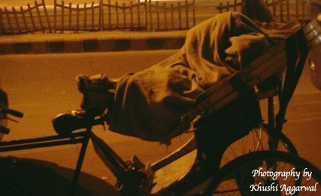


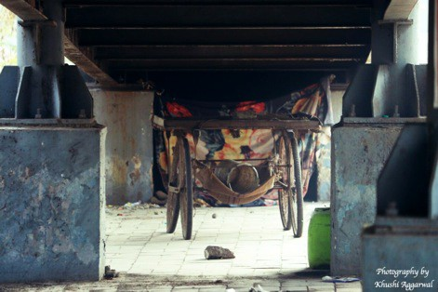

on the roads would be much much colder than us. Walking down those empty streets on cold winter mornings was a task. Capturing a perfect shot wasn't so easy. We didn’t have any idea about the shot that we wanted but somehow we got them. It seemed impossible in the beginning but we managed.
Early mornings, hot coffee in one hand but tears in our eyes when we would see people huddled up in nooks and crannies of the Delhi streets just to be warm.
One blanket is all this man had, he had no other way to be warm. None of us would ever imagine sleeping like this. We all have those comforts which a majority of the population outside on the Delhi streets don't have.

A small shelter under one of the Delhi’s metro walkway bridges. A small family of four staying in a small cluster. Parents trying to protect their little ones so that they don't catch a cold. What better could the parents do? No job, no home but just a blanket is what they have. Tying up the blanket from one corner to the other trying to make a room-so that the cold winter winds would not hit them. Sleeping on the streets which are freezing, with bare bodies and just a thin, dirty blanket to cover their bodies. It was heart-breaking to see the situation of these individuals who have nothing.

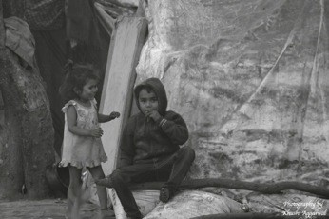

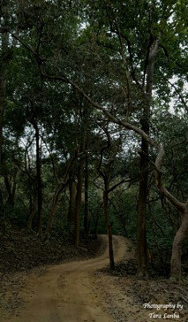


Cold winter morning and these kids sitting outside their little hut made out of old and scrap which has been thrown out by people like us. These kids hardly have any clothes on their bare
bodies to keep themselves warm. This picture only shows two kids but their were many more of them who had hardly any clothing on their body. These kids have nothing to keep themselves warm or to eat. What should these kids do? They sleep on the roads, beg and borrow just so
that they don't have to sleep hungry. Their parents have no work-they don't earn, they cant keep their kids warm. This site was freaky and gave us goose bumps. Watching these kids smile even when they were very cold.
A path that we would walk very often seemed never ending on that cold winter morning. Freezing in the cold weather, we realised what the situation would be for those who would up early every morning and do the odd jobs, cook food for their kids and live on the roadside. It isn't easy for the parents as they don't want their children to be in that state. Winters is one part of the year, where these individuals feel so helpless. They can do nothing to keep their kids and themselves warm. They suffer so much in winters. This years (2016-17) winters have been extreme and long. The temperatures

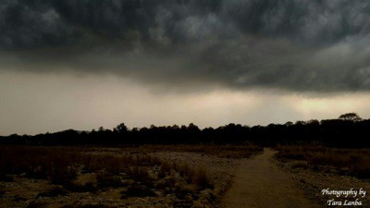

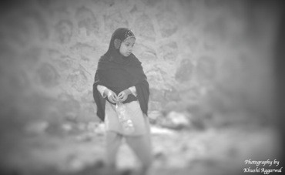
have fallen drastically leaving the poor in a bad state. The fog and mist just seemed to blur our vision and we could not see the end of this road. Walking down till the end of the path led us to this small slum where children were shivering and mothers were blowing at the fire so that they could cook food. The mothers could do nothing but keep the kids warm by just putting up a small fire. This little girl was just picking up the rags she was surrounded by things that we had thrown away and were of no use to us. The little girl would not have been over the age of 12 but had to do anything to get money to keep her brother warm. She had no support or family. When we spoke to her she told us that she did not know who her parents were but just had that one little brother who she had to take care off. Winter days are not easy ones for them, they have to deal with so much. They don't know what tomorrow would bring for them.

Another early morning shot. The sky just speaks about the that time of the year where a majority of the population suffers. They face thousands of problems; hunger, cold,

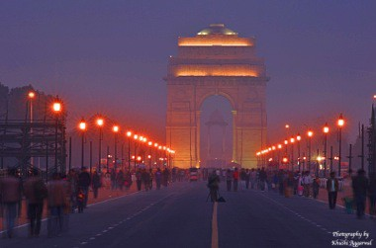

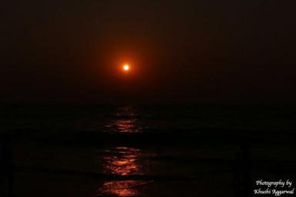

nothingness shelter and medical. We have all always thought that winter is the time where we get long breaks from school, sleep in till late and have bonfires. But it’s not the same for these little kids who sleep on the pedestrian.

Late evening winter shot at India Gate.
People gathered in large numbers roaming around.
Clicking selfies, and pictures of one another in the cold evening breeze. Fog and
mist making the street lights look even better. People sleeping and keeping themselves warm under trees in the parks near India Gate. The lights make it look even better. Making this monument look even better with the fog blurring everything else surrounding it and just the lights showing the beauty of the
monument. The winter morning makes the sunset look even better than the usual.With the perfect reflection in the water forming the beautiful shades of

orange. The sunset has never looked so beautiful in winter. Winter might be that one season which many hate but some of us specially photographers get to capture perfect shots like these.
The Delhi winter has been a real change for many of those who have nothing but just one blanket and fire to keep themselves warm. Leaving them with nothing but just hope that soon they would have something to keep themselves warm.

