The impact of Virtual Learning Environment (VLE) on students’ learning experience

Student name:Iulian Melinte
Student number: 2113144
Contents
Introduction 3
Background 3
Aims and objectives 5
Methodology 5
Results and Discussion 6
Conclusion 9
References 10
Appendix 1 11
Appendix 2 13

Introduction
With the advancement of modern telecommunication technologies, there have been changes in the form of education. Many schools and colleges adopted e-learning or virtual learning (Chou and Liu, 2019). Today, following the restrictions on physical schools due to COVID-19 pandemic, Virtual Learning Environments (VLE) have become a reality. It has brought revolutionary changes in the education system worldwide. Teachers now use online resources to teach students via online classes using virtual learning platforms. This new form of education requires no indoor physical classroom teaching. Students can regularly take their academic classes from home. Online learning enables teachers to deliver their lessons to students more efficiently. They use a number of tools in virtual learning environment such as PDFs, Power Point slides, Videos and podcasts. Using online tools beyond traditional textbooks, teachers have found more efficiency in teaching. At the University of Wales Trinity Saint David London Campus, students use Moodle to continue their learning during the covid-19 restrictions. This research study will carry out to identify the effects of Moodle on students’ learning experience.

Background
Virtual learning environments (VLE) have been consolidated in educational institutions. Moodle had been used in more than 212 countries with almost fifty thousand active sites in more than 75 languages by 2011. Many institutions use VLE as their repository for teaching contents and materials and use for assignment uploading. It enabled students to have small scale interactive functions (Wallace, 2013). Those colleges that use VLE believe with due confidence that technology contributes to teach students creatively with the access to relevant materials and giving flexibility in course design in terms of delivery time.
Today virtual learning has become a reality (Chyrun, 2019). Thanks to the advanced communication technology, there has been revolutionary changes in the field of education. In this post-pandemic situation – in new normal, online learning tools are still widely used to educate children. Though started before the pandemic, virtual learning has been fostered worldwide during Covid-19 pandemic. Almost every country has adopted online learning platforms to continue the academic and learning process to educate students. Now in this post-pandemic situation, many educational institutions want to keep this learning environment at the core of their education system.
A study conducted by Condie and Livingston (2007) supported the VLEs on student learning. Upper-grade elementary students communicated online to enhance their analytical and comprehending skills using a software collaboration tool. Surprisingly the students who used the software did better on standardized tests in vocabulary, language, reading, depth of comprehension and independent thought and realization than the students who did not use this online collaboration tool. Thus, the study concluded that VLEs enhanced students’ reflection and progressive thought and independent thinking. King and McInerney (2014) found in a study that non-traditional students found the use of technology-based instruction more useful, they showed more enthusiasm about the use of technology in their learning process. But it was reported that the usefulness of the technology and tools depends on the utility, access and exposure.
In summary, a range of studies have reported positive impacts of VLEs in various contexts. Use of these technologies in learning can promote reflection, accommodate the needs of students based on the changing circumstances such as the COVID-19 situation, increase confidence and enthusiasm, improve the effectiveness of learning and readiness to learn, and finally, improve the assessment process too. So, there is almost no space for questioning their appropriateness or acceptability today.

However, there is huge criticism that web-based learning doesn’t give the room for having social and emotional interaction among students as it happens in traditional classroom approach Ostrom, (2020) compared the VLEs classes with traditional classes and found no significant differences in their learning performance. Moreover, students participated in VLE group reported that they were less satisfied compared to the off-line classes. In online learning, participants lack the opportunity and benefits to develop the sense of community created in a traditional classroom-based learning environment. Learning using VLEs can cause social isolation and it will result in the lack of interactive communication skills among online participants. Though online learning methods are highly effective at improving students’ academic knowledge, developing communication skills is often neglected. Due to due to having no face-to-face communication among students, peers and teachers in an online setting, students will find them unable to work in a practical, social and team environment practically. They just learn in theory but not in practice.

Aims and objectives
The aim of the research is to study The impact of Virtual Learning Environment (VLE) on students’ learning experience at the University of Wales Trinity Saint David London Campus
Here are the objectives of the research report-
- To identify to what extent students agree or disagree that Virtual Learning Environment (VLE) carries a positive impact on effectiveness as a student.
- To identify how frequent a student use the VLE to learn their academic lessons
- To present how VLEs, i.e., Moodle encourages students to learn interactively.

Methodology
Due to the covid-19 pandemic, this research has been conducted using online tools. No face-to-face data collection method can be employed. Like some other studies on VLEs, this research has been conducted using both qualitative and quantitative techniques. The survey conducted was mainly focusing on the behaviors, views and experiences of the participants. Both open and closed questions have been used in the online questionnaire. The quantitative study has been done using an e-questionnaire and the data gathered were analyzed in excel. The questionnaire link was shared among targeted audience using WhatsApp which was the most convenient to reach and communicate whenever necessary. 20 undergraduates from University of Wales Trinity Saint David London Campus was provided with the questionnaire. They were given with clearly stated instructions and encouraged to fill their respective paper individually. All of them sincerely filled in the questionnaire and sent back in time.

To determine an appropriate base delegate test size, initially a size computation was carried out, just as an example. From this example test, a base delegate test size determined was 10 and 37% reaction pace was required to get effective agent results. Keeping the review results hidden, understudies were continued following the just finishing overview before the test under consideration. When the survey was completed, the derived was used as the informed consent for the study. Certain notifications were sent to the respondents as reminder before the final data collection. Responses were mostly in descriptive nature because a few questions were open questions. That’s why descriptive statistics have been used to analyze the issue questions.

Results and Discussion

This Moodle helps me learn more than I do without it
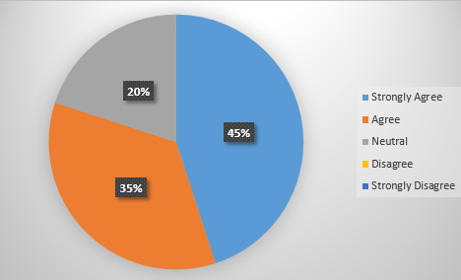
During this pandemic, students become highly engaging with VLEs. They have used to Moodle for their academic purposes. Students find that Moodle effectively help them to continue study during this pandemic when physical academic classes shutdown. This finding shows that almost half of the respondents strongly agree that this Moodle helps them to learn more effectively than they do themselves while one-third agree that they do learn more with the help of this learning tool than they would do otherwise. From qualitative information shared it has become evident that otherwise these students wouldn’t be able to continue their study in this pandemic situation.
This Moodle is an important educational aid to my study
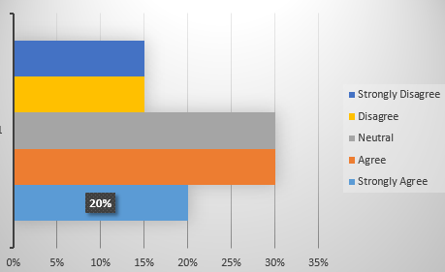
Students find that e-learning helps them to learn their lessons effectively. They feel that in their classroom they often lost their concentration and thus, sometimes missed important lectures. Even they believe that their memory is not everlasting one and thus, has no capacity every single gist of the classes. Thus, the suffer before the exam, failing to recover lectures. But this Moodle helps to have all classes recorded. Any student can watch those videos any time during the course exam not done. This is evident from this figure where we see that almost one-fifth students show strongly-agree that this is an important educational aid to their study and almost half of the participants are agree that with the help of this educational aid they can have quality education.
This Moodle positively affects my learning as a student
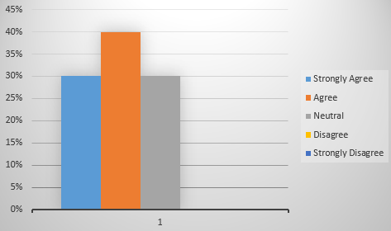
Using Moodle, students can submit their homework and teachers provide their feedback regularly. Students are monitored whether they are checking their updates, do their homework and perform in different tests as per schedule (Protheroe, 2005). When a student doesn’t do accordingly, respective teacher communicates with the student or his/her guarding to make aware of the hurdle needs to face for irregularities. This all arrangements make a student run more smoothly maintaining all requirements. That’s why almost no student disagree that this Moodle positively affects their learning. Rather 30% strongly agree and 40% agree while rest remain neutral in this point.
Using this Moodle, I feel motivated to study
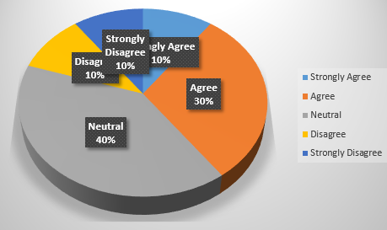
Often young students, teenagers feel interested to use electronic devices (Seifert and O'Keefe, 2001). Students who find traditional classroom learning quite boring they are getting highly motivated to study using tech-devices such as Moodle though the proportion is only ten but one-third students agree with it. On the other hand, 40% remain neutral with 10% disagree and rest are strongly disagreed.

Moodle helps me to be more interactive than traditional schools
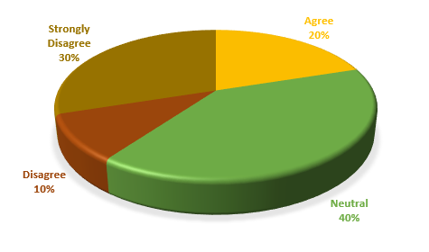
This is the key focus point of this study. We have mentioned that often this e-learning is criticized because students are becoming less socially interactive. Students feel that they lack some communication skills that make them less interactive and quite unfit to continue teamwork in the physically collaborative environment (Stricker, 2021). In this chart, only one-fifth students think that this Moodle helps them to be more interactive than traditional schools while remaining others disagree or remain neutral. To ensure that students are fit for the real world, most students agree that online classes are not fit to create interactive environment as traditional classroom provides.

Conclusion
From empirical studies, it has become evident that VLEs have positive impacts on learning in various contexts including promotion of reflection, accommodation of the needs of students based on the changing circumstances such as the COVID-19 situation, increased confidence and enthusiasm, improved the effectiveness of learning and readiness to learn and assessing students’ performance (Barker, 2013). Here the study reveals that this module helps students to learn more than traditional schools, they enjoy flexible timing of classes for recorded videos, feel motivated following teachers’ strict monitoring, assessment and feedback. But they feel that this Moodle makes them less interactive compared to the offline classes.

References
Barker, J. 2013. The learning impact of a virtual learning environment: students’ views. Teacher education advancement network journal (TEAN), 5(2), pp.19-38.
Chou, S.W. and Liu, C.H., 2019. Learning effectiveness in a Web‐based virtual learning environment: a learner control perspective. Journal of computer assisted learning, 21(1), pp.65-76.
Chyrun, L., 2016, August. Distance learning method for modern youth promotion and involvement in independent scientific researches. In 2016 IEEE First International Conference on Data Stream Mining & Processing (DSMP) (pp. 269-274). IEEE.
Condie, R. and Livingston, K., 2007. Blending online learning with traditional approaches: changing practices. British Journal of Educational Technology, 38(2), pp.337-348.
King, R.B. and McInerney, D.M., 2014. The work avoidance goal construct: Examining its structure, antecedents, and consequences. Contemporary Educational Psychology, 39(1), pp.42-58.
Ostrom, T.M., 2020. Mind and society: The development of higher mental processes.
Protheroe, N., 2018. Technology and Student Achievement. Principal, 85(2), pp.46-48.
Seifert, T.L. and O'Keefe, B.A., 2001. The relationship of work avoidance and learning goals to perceived competence, externality and meaning. British Journal of Educational Psychology, 71(1), pp.81-92.
Stricker, D., 2021. Efficient learning using a virtual learning environment in a university class. Computers & education, 56(2), pp.495-504.
Wallace, R.M., 2018. Online learning in higher education: A review of research on interactions among teachers and students. Education, Communication & Information, 3(2), pp.241-280.

Appendix 1
QUESTIONNAIRE 1
- I use Moodle outside the classroom activities-
❑ Yes ❑ NO
- Do you think Moodle helps you learning?
❑ Yes ❑ No
- Sex-
❑ Male ❑ Female ❑ Others
- Tick the appropriate cell in the following questions
SL  NO | Questions | Strongly Agree | Agree | Neutral | Disagree | Strongly Disagree
1 | This Moodle helps me learn more than I do without it
2 | This Moodle is an important educational aid to my study.
3 | This Moodle is easy to use, to find necessary materials
4 | This Moodle positively affects my learning as a student
5 | Using this Moodle, I feel motivated to study.
6 | It helps me to be more interactive than traditional schools
7 | This Moodle helps me to have quality learning
8 | I enjoy the flexibility of timing to have classes from recorded versions.

Appendix 2
Questionnaire Result
SL  NO | Questions | Strongly Agree | Agree | Neutral | Disagree | Strongly Disagree
1 | This Moodle helps me learn more than I do without it | 45% | 35% | 20%
2 | This Moodle is an important educational aid to my study. | 20% | 30% | 30% | 15% | 15%
3 | This Moodle is easy to use, to find necessary materials | 10% | 35% | 20% | 15% | 20%
4 | This Moodle positively affects my learning as a student | 30% | 40% | 30%
5 | Using this Moodle, I feel motivated to study. | 10% | 30% | 40% | 10% | 10%
6 | It helps me to be more interactive than traditional schools |  | 20% | 40% | 10% | 30%
7 | This Moodle helps me to have quality learning | 10% | 15% | 25% | 35% | 15%
8 | I enjoy the flexibility of timing to have classes from recorded versions. | 25% | 30% | 15% | 20% | 10%

