

Changemakers: Creativity and Value Creation
Professions (BMHP5014)

Component 1: Online portfolio of set exercises

Student name: Maria Blachut
Student number: 2337025
Lecturer’s name: Laila Surani

TABLE OF CONTENTS
Introduction 2
Task 1. Innovation, Creativity, Value Creation and Change in Health and Social Care 2
Task 2 - Mind Map 4
Task 3 - Self-Reflection of Group Activity 5
Kolb’s Reflective cycle! 5
Task 4 - Case Study Analysis of a UK Innovation 6
Task 5 - Research Task STAFF BURNTOUT 7
Task 6 - Exploring Digital Innovation in Health and Social Care 8
Wearables 8
EHRs 8
Digital Technology 9
Task 7 - Understanding the NHS Leadership Framework 10
Task 8 Self-reflection Journal Entry 11
Reference List 12

Introduction
Health and social care services dealing many challenges, including complex patient needs and rising needs. To respond effectively, practitioners must understand and apply key concepts such as innovation, value creation, creativity and change. This portfolio explores these ideas and demonstrates their importance in improving supporting service development and care quality. It also includes a mind map for problem-solving, a reflective account of group learning, a short research task, a case study of a UK innovation and an overview of digital technologies and leadership within the NHS.

Task 1. Innovation, Creativity, Value Creation and Change in Health and Social Care
An innovation is any new or remarkably improved service, product, process or an idea (Tidd & Bessant, 2018). Innovation means making something better or introducing something new in a way that creates new opportunities, improves efficiency or solves a problem. In health and social care, innovation refers to initiation of new or enhanced ways of delivering treatments, patient care, technologies or organisational practices that improve patients’ well-being, improve efficiency and support general outcomes. Furthermore, an innovation can involve a new digital tool (for instance telemedicine, electronic health records or remote monitoring), new models of teamwork or remodelled services, that could make patient care more effective, more accessible and more patient-centred (Greenhalgh et al., 2017). Moreover, process innovations, helps streamline care delivery and clearly improves work coordination among multidisciplinary teams (Zaggl et al, 2024). It also reduces delays in treatments and enhances collaboration (Amjad et al, 2023).
Creativity is the ability to bring on original solutions, expressions or ideas, by thinking in new, uncommon or imaginative ways (Runco & Jaeger, 2012).
Creativity is very important in health and social sector, because it enables practitioners to develop new ways of solving problems that are complex, respond to changing needs of patients and improve services. Staff members, who use creative thinking, can adapt care approaches, find an innovate solutions, when standard methods are not effective (Thakore et al, 2022). In this particular sector, where all type or resources can be limited and patient needs vary widely, this particular skill allows health professionals to enhance communication, create better person-centred care and think flexibly. By encouraging an alternative approaches and new, fresh ideas, creativity contributes to compassionate care across the health and social care service (Eaton et al, 2020).
Value creation is the process of generating improvements and benefits for individuals, communities or organisations. It involves actions that help to increase the quality, usefulness or positive impact of a product, service or outcome (Porter & Kramer, 2010).
Value creation in health and social care practice includes delivering services that can improve service users’ outcomes, use resources much more effectively and enhance wellbeing. Moreover, by staying focus on what matter most for patients, for instance, dignity, independence or safety, primary care providers create significant social value while busting up service quality. Collaborative approaches that involve main service users in shaping their own care also brace value by making sure all the support meets their real needs (Matscheck & Piuva, 2022). For an example, a telehealth services allow service users to access consultations remotely.
Change refers to a process of becoming different, that usually involves adjustment, alteration or transformation in the way something is structured, understood or simply done (Weick & Quinn, 1999). This can indicate to systems, environments, conditions or behaviours and can often happen in response to new challenges, opportunities or needs.
Change plays a significant role in health and social care practise. In this sector, especially, the introduction to electronic health records (EHRs), has changed patient care by reducing mistakes and improving record accuracy as well as empowering faster information sharing between the staff (Lovemore, 2024). 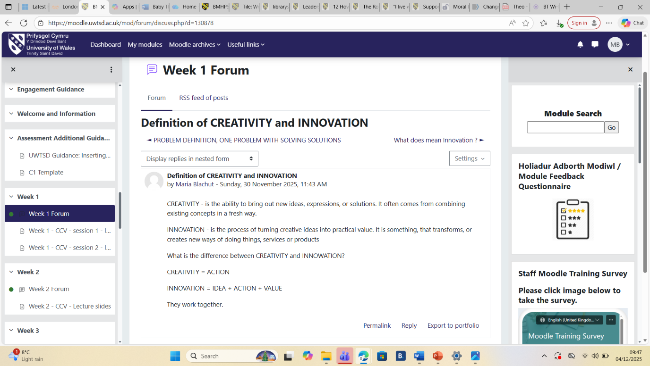

Task 2 - Mind Map
Staff shortages are a big issue in health and social care practice (Shemtob et al, 2023). Due to this problem, significant challenges are visible that include quality-of-service delivery, safety, and accessibility of care. Due to extremely high workloads and inadequate staffing, there is a longer waiting time for appointments, and the burnouts of professionals are more possible; this can reduce the whole system’s effectiveness. Poor work-life balance, emotional exhaustion, and lack of support also play a crucial role in it.
Poor life-work balance
Emotional exhaustion
Inadequate staffing
Lack of support support
High workload
Staff Burntout

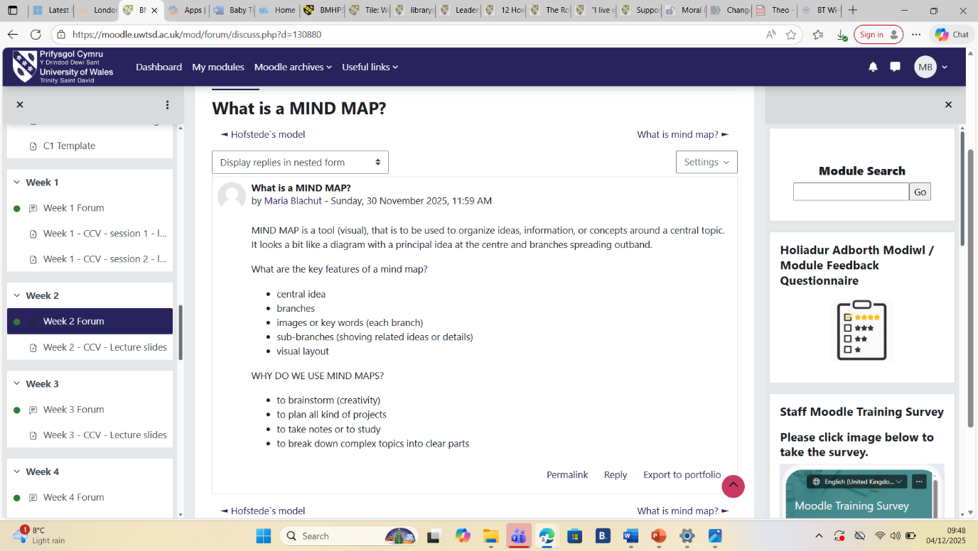

Task 3 - Self-Reflection of Group Activity
Convergent Thinking and Divergent Thinking are completely two different ways of approaching of problem solving (Rawlings et al, 2025).
Convergent thinking is a cognitive process in where an individual focuses on finding one, single solution to a problem by logically analysing all collected information and narrowing down alternatives.
Divergent thinking is a cognitive process in where an individual comes up with a multiply and creative ideas to a problem (Sun, Wang & Wegerif, 2019). It explores many possible approaches, rather being focus on one correct answer.
During the group activity we have used divergent thinking, where we have come up with a multiply ideas.

Kolb’s Reflective cycle!
- Experience
During this class activity, our aim was to work together to generate some ideas for improving communication. Each of us contributed ideas. We have used brainstorming for this.
- Reflection
I have noticed that all my group members were very confident and shared their ideas easily.
- Analysis
This show me how important teamwork is. Communication, collaboration and active listening are the key skills used commonly when working in a group. I have noticed that group works best when all participants have the chance to contribute and there are no judgements.
- Conclusion
From this experience I learned that a good group work needs a balance between organisation and creativity. Also, I have recognised the importance of inviting all members of the group, especially the quieter ones, to make sure, their voices are included. Overall, this experience helped me improve my confidence.
- Action Plan
In the future, while I will be taking part in a group exercises, I will plan to help structure discussion by using some visual tools like for instance mind maps. 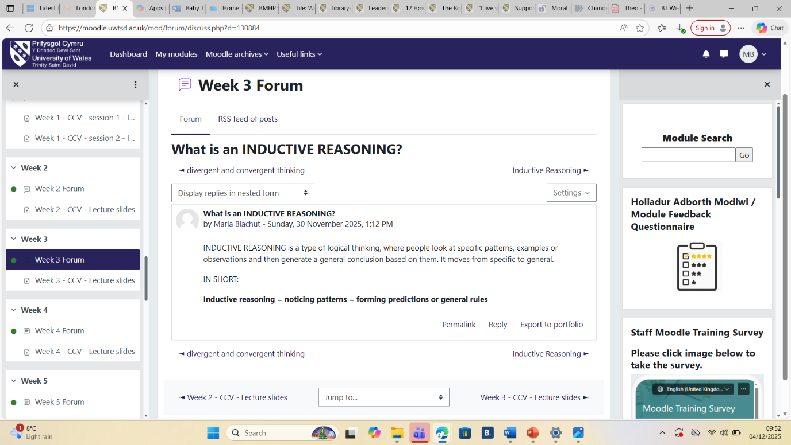

Task 4 - Case Study Analysis of a UK Innovation
The ‘’Shared Lives’’ Plus digital Expansion Project
Shared Lives is a UK project where adults (people with learning difficulties, those leaving hospitals or elderly people), regularly visit or move in with, an approved carer’s home (Brooks et al, 2024). This model has recently expanded through a digital innovation.
Creativity played a central role in delivering and developing The Shared Lives expansion by re-imaging relationship-based, face-to-face model, using modern human-centred technology. People, who created it, used tools such like digital matching or virtual visits to enhance choice and connection. It creatively translates face-to-face, trust-based processes into easy and very accessible online experience.
The Shared Lives digital enlargement addressed the need for more flexible, more personal and faster matching between adults in need of approved carers and general support, reducing any possible delays, that could be caused by traditional, paper process (Warburton-Wynn, 2024). By launching the virtual home visits and digital tools, this particular innovation created a great value for adults receiving support, offering bigger choice, quicker access to community-based care, and reduced anxiety, whilst helping staff to improve oversight, streamline all necessary assessments and use collected data to monitor general outcomes. Evidence found shows reduced waiting times, lower costs (compering to residential care), improved well-being, promote independence, general higher satisfaction and clear improvements in user experience and service efficiency (Brookes, Palmer & Callaghan, 2016).
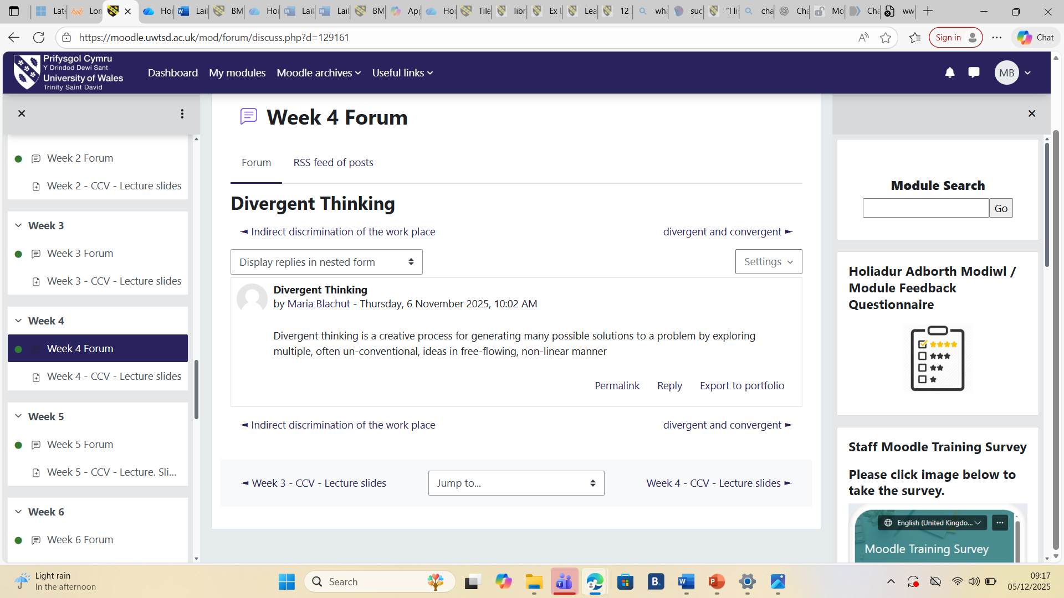

Task 5 - Research Task STAFF BURNTOUT
Staff burnout in health and social care sector emerges from a combination of value-based strain and organisational pressures as shown by the two studies. The regular review by Orgambídez and partners (Orgambídez et al, 2025) shows that moral distress—situations in which staff members cannot deliver the basic standard of care they believe is ethically correct because of limited staff or institutional constraints—creates ongoing emotional stress. With the time, this ethical conflict drains workers’ emotional resources and grows into emotional worn out, one of the main components of burnout. The second piece of research, written by Shanafelt and colleagues (Shanafelt et al, 2022), clearly shows that burnout is also fuelled by system-level factors, such like high workloads, long working hours, reduced autonomy and administrative burden. These pressures stand in the way of work–life balance, limit the ability to make significant decisions, and enlarge frustration as paperwork replaces contact with the patient. When organisational requirements rise while resources and support stay insufficient, staff experience chronic stress, and a sense of reduced professional perform. Together, the findings from both articles clearly show that burnout does not come from individual fragility but from organizational problems such as lack of control, ethical conflict or high job demands. These communication pressures make it difficult for health and social care professionals to maintain welfare, causing high burnout rates.
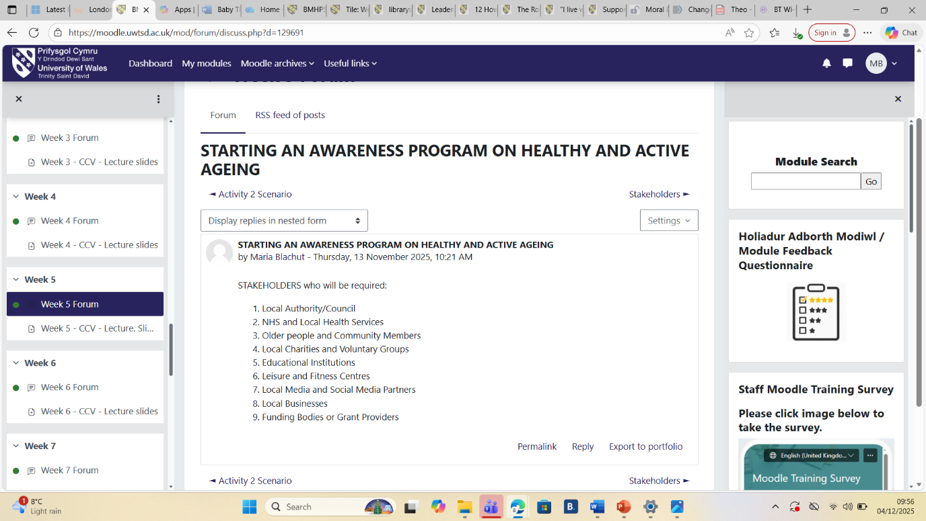

Task 6 - Exploring Digital Innovation in Health and Social Care

Wearables
One of the key benefits of wearable health technologies such as smartwatches, is the ability to give real-time monitoring of symptoms and health measurements which advocate better management of chronic illnesses. By monitoring data like activity levels, heart rate. sleep patterns, or blood glucose levels (depending on the wearable), devices give individuals continuous feedback that can help them detect early warning signs and modify their treatment quickly. This persistent flow of information also empowers more informed dialogue with healthcare professionals, who can use the data to customize care plans and intercede earlier when problems appear. Overall, wearables allow individuals to take a more active role in managing their condition, leading to better self-awareness, improved adherence, and potentially lower number of complications (Jakubczyk et al, 2025).

EHRs
Electronic health records (EHRs) improve collaboration and communication between healthcare professionals by giving all staff members of the health and social care team immediate access to the same current patient information that is up to date. This decreases delays, avoids information loss, and guarantee that everyone involved is working from an accurate record that is shared between of health professionals. Moreover, EHRs also make it easier for different health professionals, such as doctors, pharmacists, nurses, or social care workers—to integrate care, as they can, rise concerns, add necessary notes or review each other’s updates within the system. In general, EHRs builds up collaboration by creating a transparent flow of information that supports more coordinated and safer patient care.

Digital Technology
Digital technology plays a powerful role in supporting preventative care and health promotion by helping individuals monitor their health, identify risks in early stages, and make healthier choices. For example, imagine a digital prevention platform used by a community health service. Individuals can download an app connected to their phone and any wearable device, that collects data-based activity during the day, heart rate, sleep and stress levels. The app collects analyse all information to detect patterns such as persistently low physical activity or rising resting heart rate, that may show increased risk for conditions.
When the app recognises concerning tendency, it sends personalised recommendations, such as improving sleep routines, increasing daily steps or reducing desk-bound time. It may also suggest short educational videos if needed.
If the system detects a notable change, such as an unexpected drop activity or high stress indicators, it can automatically get in touch with a healthcare professional, who can reach out for an early check-up. In this way, digital technology helps catch possible problems earlier, motivates behaviour change promotes long-term wellbeing before serious illness develops. 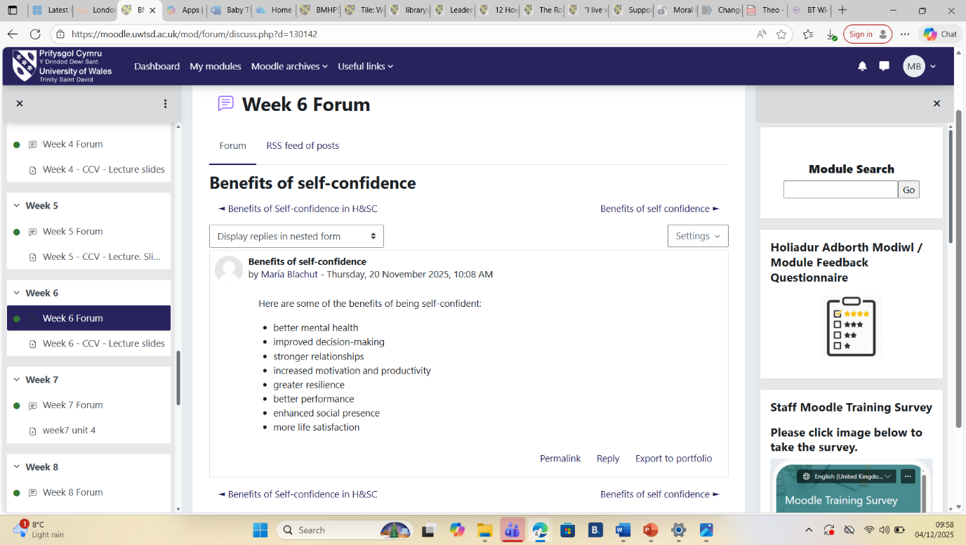

Task 7 - Understanding the NHS Leadership Framework

The NHS Leadership Framework defines the key qualities and behaviours, expected of leaders across all kind roles in health and social care sector (Balakumaran, 2024). It highlights that leadership is not limited to managers, everyone has a part to play in improving services delivery. The framework is built around key behaviours such as collaboration, setting a clear vision, supporting and developing others, driving continuous improvement and managing resources responsibly. It also shows the importance of ethical practice, focus on patient-centred care and self-awareness. By providing a shared understanding of what good leadership looks like, it helps teams make informed decisions, adapt to challenges and communicate better. Eventually, the NHS Leadership Framework uphold a culture where services work more efficient, patients receive high-quality care and staff feel empowered.

By creating a sense of shared responsibility and meaning, the leader motivates team members to think creatively about how to improve patients care (Andersen et al, 2018). They promote open discussion, new ideas, and value various viewpoints. This supportive environment allow staff to experiment with creative ideas, clarify their practices, and work collaboratively, ultimately leading to more receptive, effective and person-centred care. 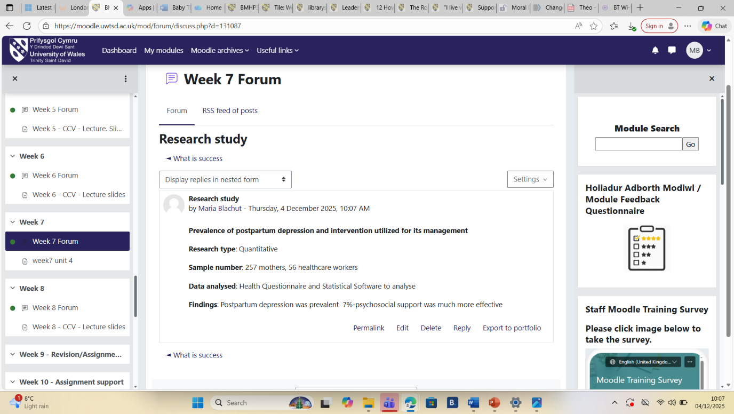

Task 8 Self-reflection Journal Entry
During this module, my understanding of value creation and creativity in health and social care sector has grown remarkably. I began with a small knowledge of creativity meaning, often comparing it with new technology or dramatic innovation. Over time, I have come to see creativity as everyday behaviour, that is practical, finding meaningful, small improvements that increase service user experiences. Activities such as group discussions, case studies and analysing real service challenges helped me understand how creative thinking can lead to greater outcomes, even within limited resources or strict guidelines. Concepts like user-focused design, and continuous improvement changed my view. I realised that value is crafted not just through efficiency, but by truly understanding what really matters to people. This learning will have a big impact my professional practice by inspiring me to question existing processes, involve service users in decision-making, and remain open to new ideas.
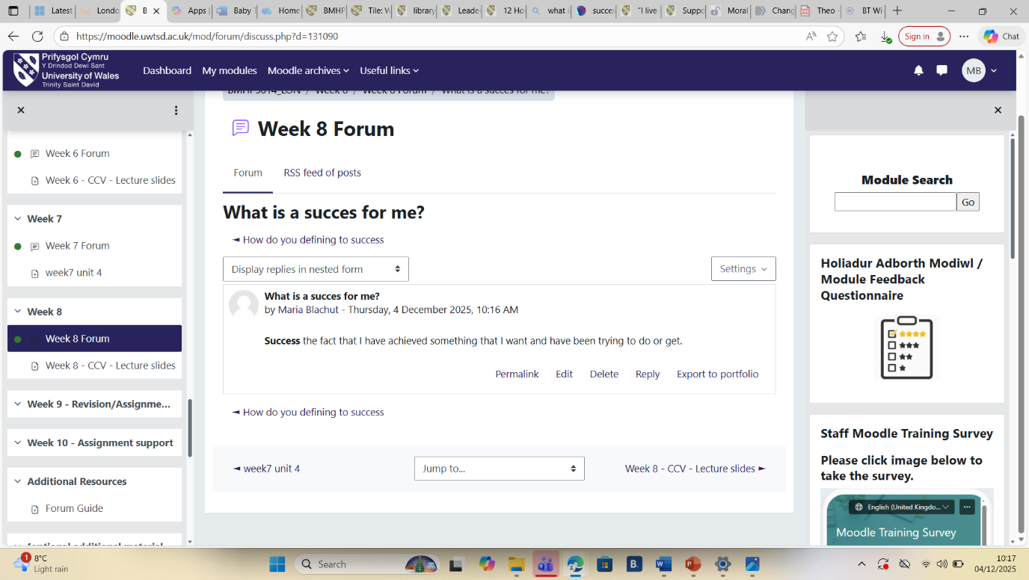

Reference List
Andersen, Lotte Bøgh ; Bjørnholt, Bente ; Bro, Louise Ladegaard ; Holm-Petersen, Christina (2018) ‘Leadership and motivation: a qualitative study of transformational leadership and public service motivation’, International review of administrative sciences, 84(4), pp. 675–691. Available at: https://doi.org/10.1177/0020852316654747.

Amjad, A., Kordel, P. and Fernandes, G. (2023) ‘A Review on Innovation in Healthcare Sector (Telehealth) through Artificial Intelligence’, Sustainability, 15(8), p. 6655. Available at: https://doi.org/10.3390/su15086655.

Balakumaran, S. (2024) ‘12 How can leadership in NHS hospitals be improved to ensure better quality of care for patients?’, BMJ leader, 8(Suppl 1), pp. A8–A9. Available at: https://doi.org/10.1136/leader-2024-FMLM.12.

Brookes, N., Palmer, S. and Callaghan, L. (2016) ‘“I live with other people and not alone”: a survey of the views and experiences of older people using Shared Lives (adult placement)’, Working with older people (Brighton, England), 20(3), pp. 179–186. Available at: https://doi.org/10.1108/WWOP-03-2016-0005.

Brookes, Nadia ; Palmer, Sinead ; Collins, Grace ; Callaghan, Lisa (2024) ‘Supporting people to live well: A multimethod study of Shared Lives (adult placement)’, British journal of learning disabilities, 52(1), pp. 131–139. Available at: https://doi.org/10.1111/bld.12556.

Eaton, Jacqueline ; Cloyes, Kristin ; Paulsen, Brooke ; Madden, Connie ; Ellington, Lee (2020) ‘Certified nursing assistants as agents of creative caregiving in long‐term care’, International journal of older people nursing, 15(1), pp. e12280-n/a. Available at: https://doi.org/10.1111/opn.12280.

Greenhalgh, T., Wherton, J., Papoutsi, C., Lynch, J., Hughes, G. (2017) ‘Beyond Adoption: A New Framework for Theorizing and Evaluating Nonadoption, Abandonment, and Challenges to the Scale-Up, Spread and Sustainability of Health and Care Technologies.’ Journal of Medical Internet Research, 19(11), pp.1-15.

Jakubczyk, Natalia ; Leszczyńska-Knaga, Elżbieta ; Kurowski, Marek ; Kuczapska, Karolina ; Gliwa, Anna ; Ryglewicz, Monika ; Fabian, Dariusz ; Kwaśniewska, Paula ; Moczydłowski, Paweł ; Michalczuk, Karolina (2025) ‘The Role of Wearable Devices in Tracking the Well-Being of Patients Suffering from Chronic Conditions - the review’, Journal of education, health and sport, 79, p. 58310. Available at: https://doi.org/10.12775/JEHS.2025.79.58310

Lovemore, M. (2024) ‘Electronic health records model to improve the quality of patients’ healthcare’, Health SA = SA Gesondheid, 29(2), pp. 2414–8. Available at: https://doi.org/10.4102/hsag.v29i0.2414.

Matscheck, D. and Piuva, K. (2022) ‘In the centre or caught in the middle? – Social workers’ and healthcare professionals’ views on user involvement in Coordinated Individual Plans in Sweden’, Health & social care in the community, 30(3), pp. 1077–1085. Available at: https://doi.org/10.1111/hsc.13311.

Orgambídez, A., Borrego, Y., Alcalde, F. J., & Durán, A. (2025). Moral Distress and Emotional Exhaustion in Healthcare Professionals: A Systematic Review and Meta-Analysis. Healthcare, 13(4), 393. https://doi.org/10.3390/healthcare13040393

Porter, M.E. & Kramer, M.R. (2011) ‘Creating Shared Value’, Harvard Business Review, 89 (1/2), pp. 62-77.

Runco, M.A. & Jeager, G.J. (2012) ‘The Standard definition of Creativity’, Creativity Research Journal, 24(1), pp. 92-96.

Rawlings, Bruce, S. ; Chetwynd-Talbot, Daisy ; Husband, Erin ; Nuttall, Aisling ; Quinn, Elissa ; Taggart, Rosie ; Roome, Hannah E. (2025) ‘Divergent thinking is linked with convergent thinking; implications for models of creativity’, Thinking & reasoning, 31(4), pp. 586–608. Available at: https://doi.org/10.1080/13546783.2025.2485059.

Shanafelt, T. D., West, C. P., Dyrbye, L. N., Trockel, M., Tutty, M., Wang, H., Carlasare, L. E., & Sinsky, C. (2022). Changes in Burnout and Satisfaction With Work-Life Integration in Physicians During the First 2 Years of the COVID-19 Pandemic. Mayo Clinic proceedings, 97(12), 2248–2258. https://doi.org/10.1016/j.mayocp.2022.09.002

Shemtob, Lara ; Asanati, Kaveh ; Pahl, Nick ; Majeed, Azeem (2023) ‘What needs to be done to address staffing shortages in health and social care?’, British journal of general practice, 73(728), pp. 102–103. Available at: https://doi.org/10.3399/bjgp23X732045.

Sun, M., Wang, M. and Wegerif, R. (2019) ‘Using computer‐based cognitive mapping to improve students’ divergent thinking for creativity development’, British journal of educational technology, 50(5), pp. 2217–2233. Available at: https://doi.org/10.1111/bjet.12825

Thakore, S., Baldie, D. and Teeling, S.P. (2022) ‘Enabling innovation and sustainable improvement in person-centred healthcare during the first wave of the Covid-19 pandemic – a reflective account’, International practice development journal, 12(1), pp. 1–8. Available at: https://doi.org/10.19043/ipdj.121.007.

Tidd, J. & Bessant, J. (2018) Managing Innovation: Intergrading Technological, Market and Organizational Change. 6th ed. Hoboken: Wiley

Warburton-Wynn, A. (2024) ‘The benefits of using a Shared Lives type community response to support survivors of domestic abuse with disabilities and older survivors’, The journal of adult protection, 26(3), pp. 104–112. Available at: https://doi.org/10.1108/JAP-12-2023-0037.

Weick, K.E. and Quinn, R.E. (1999) ‘ORGANIZATIONAL CHANGE AND DEVELOPMENT’, Annual review of psychology, 50(1), pp. 361–386. Available at: https://doi.org/10.1146/annurev.psych.50.1.361.

Zaggl, Michael A. ; Majchrzak, Ann ; Gibbs, Jennifer L. ; Birnbaum-More, Philip H. (2024) ‘Does Member Familiarity Help or Hinder Innovation? The Roles of Expertise and Dialogic Coordination’, IEEE transactions on engineering management, 71, pp. 4006–4021. Available at: https://doi.org/10.1109/TEM.2022.3224871.

