

MBA Dissertation 2017

Analysis of Third Sector Provision of the Statutory Function of Archaeological Planning Advice to Local Planning Authorities in Wales

P148719
Judith Bronwen Harris Doyle

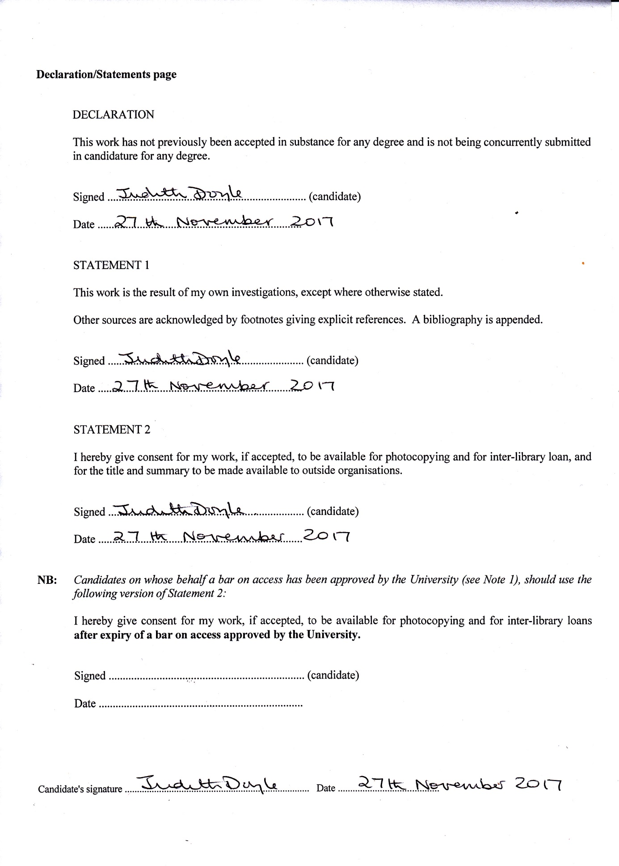

Contents

Declaration
Figures | iii
Glossary of Abbreviations | iv
Acknowledgements | v
Abstract | vi
Chapter One | 1
Introduction | 1
Policy | 1
Background and Context | 3
Rationale | 5
Aims and Objectives | 5
Structure | 6
Personal Note | 7
Conclusion | 7
Chapter Two | 8
Introduction | 8
Legislation and Policy | 8
Comparative Situation Outside Wales | 11
External Analysis | 11
Organisational Relationships | 13
Theoretical studies | 15
Policy | 15
Planning | 17
Stakeholder | 17
Governance and Structure | 19
Organisational Change | 21
Agency and Stewardship | 23
Collaboration and Partnership | 23
Finance | 24
Topical Literature | 26
Conclusions | 29
Chapter Three | 30
Introduction | 30
Aims and Objectives | 30
Limitations | 31
Methodology | 31
Research Design | 31
Philosophy | 33
Approach | 33
Strategy | 34
Choice | 34
Time Horizon | 35
Technique and Procedures | 35
Methods | 35
Population | 35
Pilot Study | 35
Sampling | 38
Selected Interviews | 38
Ethical Issues | 39
Conclusion | 41
Chapter Four | 42
Introduction | 42
Reliability and Validity | 42
Analysis of Online Quantitative Data | 44
Method | 44
Results | 44
Analysis of Qualitative Data | 64
Method | 64
Results | 64
Findings: Emergent Themes | 67
Investment | 68
Communication | 69
Governance | 70
Conclusion | 71
Chapter Five | 72
Introduction | 72
Achievement of Objectives | 72
Findings | 73
Recommendations | 73
Limitations | 75
Conclusion | 76
Self-reflection
Bibliography
Appendices
1: Hierarchy chart of legislation: historic environment in Wales
2: Raw data, converted from SPSS to Excel for clarity
3: Answers to Question 10 online survey
4: Responses to email interviews

List of Figures
Figure 1: Funding cycle for archaeological planning delivery | 3
Figure 2: Hierarchy for the Glamorgan Gwent Archaeological Trust (GGAT) | 4
Figure 3: Inter-organisational relationships | 14
Figure 4: Dimensions for analysing public policy | 16
Figure 5: Risk impact and management grid | 25
Figure 6: Research “Onion” for research design | 32
Figure 7: Questionnaire questions relating to the elements of the literature review | 37
Figure 8: Seedhouse’s Ethical Grid | 40
Figure 9: Respondents by role | 45
Figure 10: Respondents by employer type | 45
Figure 11: Respondents’ Satisfaction with CIfA Code of Conduct | 47
Figure 12: Respondents’ satisfaction with WATs Code of Conduct | 48
Figure 13: Respondents’ satisfaction with WATs value for money | 49
Figure 14: Respondents’ satisfaction with WATs efficacy of delivery | 50
Figure 15: Response to RTPI Membership as desirable | 51
Figure 16: Awareness of funding bodies WG | 52
Figure 17: Awareness of funding bodies UA | 53
Figure 18: Concern with loss of archaeological resource | 54
Figure 19: Concern with adverse impact on staffing | 55
Figure 20: Raising funds from developers | 56
Figure 21: Other potential service providers: national government | 57
Figure 22: Other potential service providers: universities | 58
Figure 23: Other potential service providers: consultancies | 59
Figure 24: Other potential service providers: Welsh local government | 60
Figure 25: Other potential service providers: merged WATs | 61
Figure 26: Other potential service providers: other partnerships in Wales | 62
Figure 27: Ethical issues with consultancies as a provider | 63
Figure 28: Thematic analysis of qualitative data | 65-6
Figure 29: Dimensions for analysing public policy | 70

Glossary of Abbreviations

ALGAO: Association of Local Government Archaeological Officers
APM: Archaeological Planning Management
CIfA: Chartered Institute for Archaeologists
CIPS: Chartered Institute of Procurement and Supply
DCMS: Department of Culture, Media and Sport
DCWW: Dŵr Cymru Welsh Water
GGAT: Glamorgan Gwent Archaeological Trust
HER: Historic Environment Record
KPI: Key Performance Indicators
NGO: Non-governmental Organisation
NRW: Natural Resources Wales
PPG: Planning Policy Guidance
PPW: Planning Policy Wales
RO: Registered Organisation (with CIfA)
SMR: Sites and Monuments Record
WATs: Welsh Archaeological Trusts
WCVA: Wales Council for Voluntary Action
WG: Welsh Government

Acknowledgements

I express my gratitude to my dissertation tutor, Dr Caroline Jawad, for her well informed guidance and professionalism throughout the dissertation process, and for accepting me part way through the process.

My thanks also to Huw Thomas, wishing him good health in the future.

My grateful thanks and appreciation to Dr Greig Parker, for his support and for reading the full draft of this dissertation.

To all my archaeological friends and colleagues across the world, thank you for your friendship, support and assistance in the surveys. Shoulders of giants.

Finally, thank you to my husband Nigel, for his support and patience in the midst of a million books and papers.

Abstract

This study analysed the archaeological planning service in Wales, delivered by the Welsh Archaeological Trusts, as third sector organisations, for the Welsh Government. There has been no academic study of the service, its setting or delivery, or its efficacy; no academic theory, framework or model fitted the service. Therefore, the aim of this study was to critically evaluate the archaeological planning function in Wales, achieved by the undertaking of the following four objectives: analysis of the current system in relation to efficiency during falling government grants using strategic analysis models and theories; evaluation of the efficacy of using Welsh Archaeological Trusts by means of gathering data by survey and interview; assessment of the current level of expertise in this field gathering data by survey and interview; and lastly, upon analysis, to potentially make recommendations relating to the system. A pragmatic mixed methods theoretical framework collected data, using an online survey to professional service users and three interviews, with a user from a strategic, combined strategic and operational, and operational view. The former was analysed using SPSS, creating statistics that showed the level of satisfaction, and also if the user groups were split in their opinion; the more detailed interviews were analysed using grounded theory which identified emergent themes. The results showed that over of the users were satisfied with the service, with no perceptible split in user groups. There was concern regarding the future funding of the service, and investment in staffing, training and capability. Recommendations were made regarding future investment, governance and communication.

CHAPTER 1: INTRODUCTION

Introduction
This study has been designed to analyse the provision, by the Welsh Archaeological Trusts (hereafter WATs), of archaeological planning advice in Wales. The effectiveness of the service will be evaluated, and the current level of expertise assessed by data gathering and analysis. Unusually for this type of service, it is provided by a third sector organisation as a statutory function for Welsh Government, and provides the means within the development process of managing the impact of development of the buried and upstanding archaeological resource, and its setting, to preserve this cultural inheritance for future generations.

This chapter provides the background and context to the study, and the key issues that are apparent, leading to the rationale as to why this study is necessary; the efficacy and provision of the service has not previously been evaluated

Policy
The archaeological planning service, its operation and strategy, is set within the hierarchy of The Well-being of Future Generations (Wales) Act, introduced in 2015 (Welsh Government, 2015b), and includes the Planning (Wales ) Act 2015 (Welsh Government, 2015a) and the Historic Environment (Wales) Act 2016. The hierarchy relationship chart can be viewed in Appendix One. As an overarching broad scale strategy, this aims to create a sustainable country, with seven goals of well-being, by making public bodies “think more about the long term, work better with people and communities and each other, look to prevent problems and take a more joined-up approach” (Welsh Government, 2015). This impacts on every aspect of life in Wales, and emphasises “A society that promotes and protects culture, heritage and the Welsh language, and which encourages people to participate in the arts, and sports and recreation.” The aim is for this to be achieved by partnership and collaboration between public bodies and the third sector, and involving people. Involvement will be measured by indicators and milestones (Welsh Government, 2015). The WATs archaeological planning service forms an important, statutory element of this. This can be viewed in the context of social policy, discussed and defined by Titmuss (1974) as the principles that govern action directed towards given ends (Chapter 5), for example, the government’s role in increasing and modulating life standards.

The Well-being of Future Generations (Wales) Act, promotes the importance of cultural heritage, and recognises in regard to heritage, that Wales is a nation blessed with thousands of archaeological sites. Some of those, such as the Roman fortress and amphitheatre at Caerleon (Cadw, 2017), the great Medieval castles at Cardiff and Caernarvon (Cadw, 2017) and modern tourist attractions such as Big Pit (National Museum of Wales, 2017), are familiar to most people; all are part of our cultural heritage, with a huge range in date and differing management needs. The aim of the Act and supporting Policy relating to heritage (Welsh Government, 2016) is to involve the public in Welsh heritage and culture, and a route to achieve this is via the delivery of archaeological planning in Wales. The public generally, however, do not see how these are managed, and nor do they see the mostly buried remains of associated settlements, burials, transport networks and industry; the everyday remains of how people lived, worked and died. Increasingly, via outreach as a result of the planning system, via websites and open days, is a growing means of education (Glamorgan Gwent Archaeological Trust, Ynysfach Ironworks micro-site, 2017).

The greater sites and buildings are all statutorily protected, but these only amount to less than around 2% of all archaeological sites and monuments (GGAT HER, 2017). The other 98% of archaeological sites are managed, in Wales, by the landowners, who are a variety of private, local authority, or corporate (Cadw, 2017). Changes to these sites and these settings can have sudden, severe, or minor and accumulative impacts, resulting in an impact on the wellbeing of cultural inheritance, and therefore these changes must be monitored and managed.

These sites vary in date from the early pre-historic period, tens of thousands of years old, to the twentieth century, and are a mix of types, including upstanding buildings, ruins, earthworks, deserted sites, habited buildings, scatters of flint tools, shipwrecks, religious sites, human remains and industrial landscapes (GGAT HER, 2017). All are vulnerable to pressures from a number of sources, climate, pollution, changing natural habitats, but mainly by proposed developments: some 30,000 applications are submitted in Wales each year on average and of these approximately 10% require archaeological planning input (GGAT, 2017). The archaeological planning service manages this on behalf of local government and Cadw.

Figure 1: Funding cycle for archaeological planning delivery

Background and Context
Provision of archaeological planning advice in Wales to the Local Planning Authorities is currently delivered by the WATs (Welsh Government, 2016; Planning Policy Wales, 2016). Required by legislation (Welsh Government, 2016) the Archaeological Planning advice to local Planning Authorities is provided by the four Welsh Archaeological Trusts; a statutory function provided by third sector. The Trusts, established during the mid-1970s, are not for profit organisations which are charitable trusts; they are: Glamorgan Gwent Archaeological Trust, Dyfed archaeological Trust, Clwyd Powys Archaeological Trust and Gwynedd Archaeological Trust. They cover Wales as geographical areas, covering a number of local authorities.

To assist in defining archaeological planning, the term heritage planning appears to be used in the wider academic analysis; van Assche and Duineveld (2013) state “Heritage planning is an integrated approach for dealing with traces of the past in spatial organisation.” The integrated approach analysed in this study is that provided by the WATs, as charities which are limited companies, on behalf of both local and national government, as a statutory function. Corry (in Taylor, 2010) notes that the third sector is unsuited in its nature to a single definition, and is open to confusion with voluntary action and social enterprises. He does state that the third sector definition is it’s “not being part of the state or the market sectors” (2010).

Figure 2: Hierarchy for the Glamorgan Gwent Archaeological Trust (GGAT).

Within the Trusts, there is also a separate administration section that includes administration and financial service (for example, HR, billing and invoicing). The Historic Environment Record (HER) is a separate charitable Trust that operates within the WATs system. Funding for this was originally from the Royal Commission on Ancient and Historic Monuments of Wales (RCAHMW), but the grant responsibility moved to Welsh Government via Cadw, and is now paid as part of the grants for archaeological advice to the WATs (Cadw, 2017). The Archaeological Planning area is ring fenced, as a statutory function, meaning that funds allocated for this purpose are not transferrable to any other function. This service is delivered also to other statutory bodies, Natural Resources Wales - a recent change - and Cadw. Indirectly, via archaeological consultants and contractors, it is delivered to developers and to other WATs, and by way of involvement in the planning system, to members of the public.

This system, whereby a statutory function as a service is delivered by a third sector organisation is more commonly seen in health, social and education related industries; this sector, which includes not for profit organisations and NGOs has become one of the main channels for employment services in Europe (Clark et al, 2009).

However, the context under discussion is different from many of the relationships stated above, as the WATs archaeological planners are currently the only means of achieving the service delivery Welsh Government, 2016). In contrast to the current business world, where there is competition and organisations seeking to win contracts usually tender for them, the WATs service is a monopoly. This is unusual and there is not immediately an apparent measure for analysing the system and the efficacy of its strategy and operation.

Rationale
The importance of the service essentially lies in two relationships, the organisational and social policy aspect where the heritage, archaeology and historic assets are protected; and the cultural relationship of Wales’ residents to the heritage in the current day. Studying the legislation and policy, the current means of service delivery and associated outreach, enables questions to be raised and answered, concerning how the partnerships, strategy and delivery can be understood, evaluated and assessed for efficacy.

Aims and objectives
The aim of this study is to critically evaluate the archaeological planning function in Wales, and in order to achieve this, this will undertake the following objectives.

- To analyse the current system in relation to efficiency during falling government grants using strategic analysis models and theories
- To evaluate the efficacy of using Welsh Archaeological Trusts by means of gathering data by survey and interview
- To assess the current level of expertise in this field gathering data by survey and interview
- Upon analysis, to potentially make recommendations relating to the system to create stronger relationships

Therefore, this study aims to research the current situation, evaluating its governance and structure, culture and organisational change.

Structure
In order to achieve these aims, and expand upon these points, Chapter Two will examine the available literature concerning the relationships between government and third sector, governance of organisations in this context, financing, the wider aspects of managing heritage and archaeological planning. Any topical literature that is directly relevant will be examined.

From the results of Chapter Two, points and issues raised lead to the content of Chapter Three, identifying the philosophy, the appropriate methodology and leading to the process of devising suitable questionnaires and interviews.

Chapter Four will provide the collation and analysis of both the online questionnaires, which provide the bigger picture, and the more detailed questions which have arisen from the results of the large scale questionnaire.

Chapter Five will be the discussion of the results of the analysis, and lead to recommendations for further research topics, and potential recommendations to allow a more effective operation for the service. The benefits of this will allow greater understanding of the current situation, shaping future strategic development and consistency, and also to undertake a re-survey at some point in the future.

Pressures which affect this sector, both internal and external, are financial and economic, and are likely to have impacts that are both strategic and long term. Planning issues often create public, often heated, campaigns and the process must be clear, auditable and transparent (Wales Audit Office, 2017). Policy has developed since the introduction of Planning Policy Wales (Welsh Government, 1991) and the creation of this, and subsequent Policy and suites of supporting documentation has been created via the process of consultation, both initially with heritage professionals and subsequently public consultation via the Welsh Government website.

Personal note
The researcher brings tacit knowledge of this subject, from thirty years of professional, practical experience.

Two specific business challenges were faced in undertaking this study. Firstly, that archaeological planning does not fit any specific business module, being rather a mix of different areas. Secondly, it is a specialist, esoteric sector, somewhat overlooked, where little research of any type has been undertaken.

Additionally, there was the challenge of a change of dissertation tutor part way through the process, with associated changes in direction.

Conclusion
This chapter has detailed the aims and objectives of the study, and how the research process will be delineated and followed. It has provided a background to the organisational structures and funding of the system, and also the hierarchy of the delivery set within the legislative process.

Chapter Two, as stated, will seek out relevant literature on a legislative, academic and topical basis, from a range of published sources in order to identify and assess relevant key issues and themes.

CHAPTER 2: LITERATURE REVIEW

Introduction
In this chapter, the existing literature will be reviewed, and as noted previously, this includes the Welsh Government Legislation, Policy, Technical Advice Notes and Best Practice Guidance, which provides the framework of the archaeological planning service, as well as peer reviewed journal articles relating to the management of heritage, and academic theories which are identified as relevant to this study.

The current literature is primarily legislative, and at the outset there is a paucity of academic theory, frameworks and models which relate directly to the topic, showing there is a gap in the academic understanding of the arena. The business discipline of the organisational sphere of archaeological planning difficult to establish and does not fall into any particular arena of operation.

As stated within the introduction, the aim of this dissertation is:

To analyse the current system in relation to efficiency during falling government grants using strategic analysis, models and theories

The first aim is analysed in this chapter, and there are three categories of literature that are applicable to the study; these are:
- policy, which in this study has a high relevance relating to the current issues;
- theoretical, referring to the concepts and frameworks around the wider strategy of the topic; and
- topical, which in this study is the relationship of heritage to both legislation and as the delivery of a service in Wales.

Legislation and Policy
With the introduction of The Historic Environment Act (Wales) 2016 (Welsh Government, 2016), the supporting changes in Planning Policy Wales (Welsh Government, 2016) and the supporting TAN 24 and best practice guidance (Welsh Government, 2017), much has changed in Wales over the last two years regarding statutory regulation and how protection of the archaeological resource and cultural heritage is implemented. The Act is the first piece of legislation passed following the extended legislative powers of the Welsh Government, and also the first legislation on the historic environment ever drafted specifically for Wales (Cadw, 2016) and clearly shows the importance to Wales of the historic environment.

Supported by a suite of policy, advice and guidance that the Cadw website details will “keep the management of the Welsh historic environment in step with current conservation philosophy and practice” (Cadw, 2017) the documents are the result of extensive consultation with heritage professionals from various specialisms, as well as public consultation. The four levels of legislation (the Act, Planning Policy Wales, Technical Advice Notes and Best Practice Guides) whilst the result of consultation, are extremely detailed and subject to re-consultation, alteration, reading by legal teams, ministers, professionals and so on. Therefore the high end of legislation and policy is structured and sets a strong basis for the WATs to functions upon.

They are the result of hierarchical government and civil service, organisations not noted for speed in process or determination (Lynch, 2003). Essentially, they leave little room for interpretation of delivery, but with providing a framework can be seen to be a progression in management, having started with protection of individual monuments, moving towards identification of the landscapes in which they are located, then the wider aspects of enhancement and understanding as well as preservation (Cadw, 2011). These Principles are based on the then English Heritage Conservation Principles (English Heritage, 2008); there had been calls for such measures in Wales, but these had not been developed in tandem, or solely for Wales from an archaeological or cultural aspect, but appeared to some heritage professionals at the time to have been simply reactive to pressure. It can be argued that the framework of delivery and reasoning behind it, clearly defined, can be seen to be the systems relationships defined by Luhmann in his systems theory (1997), Senge (2006) and expanded upon by van Assche and Duineveld (2013) in relation to heritage planning, with shared values and meanings. Senge (2006) also notes the shared vision can provide courage, quoting Maslow (1965) that “task is no longer separate from self”, but also noting the crucial contribution of investment in capacity building to achieve this (Senge, 2006).

Whilst this suite of legislation is live and worked to, there are following this, further consultations which will affect the working of the archaeological planning service. The White Paper on Regional Working is currently out for consultation (Welsh Government, 2017c); this appears to be looking towards a strategy for Wales’ local government, of partnerships and regional working, and indicates that the government would look favourably on organisations which are aligned in strategic direction, both in local government and third sector organisations which provide statutory services (Welsh Government, 2017, WCVA, 2013, and Kramer and Pfitzer, 2016). Particularly, the Wales Council for Voluntary Action (WCVA) document draws attention to this in that the fulfilment of provision of statutory services by the third sector organisations (TSOs) reflects the need to achieve maximum financial value via the procurement system (WCVA, 2013), and that this can be accomplished by combining services.

The Heritage Services Review, a current Welsh Government consultation (Welsh Government 2017b), is a framework for future working which will “create a stronger unified identity”, and leads on from previous attempts to merge services, which were rejected in March 2017. The potential for strengthening the system has therefore been proposed. This, although it has not succeeded previously, is clearly the way forward; it follows the Randerson Review of 2016 and the resulting PWC report (2016) and is again promoted and relates to four aspects. These are: joint working of heritage organisations; a new charity; a new executive agency; and merger of existing national heritage organisations. These have been examined as a framework by Hudson (2011), in which Arsenault’s Typology of Mergers (1998) is quoted. Looking at these, the four types of Horizontal, Vertical, Conglomerate and Concentric are assessed on aims, with Horizontal representing organisations in the same field, with aims of economies of scale appears to fit, although is used with takeovers, and Vertical uses the continuity of relationships with users and implemented as a group structure; Arsenault in her work (1998) also notes the move towards shared regional organisational conferences, with shared problems and approaches, experiences can move towards adding value to such organisations. It can be argued that these aspects, which encompass finance, economy of scale, staffing and organisational and strategic alignment can be seen in current government guidance.

The latter two Reviews have been put out for consultation since the title of this dissertation was submitted, and within the political realm the relationships between third sector and statutory government are high profile and contemporary. The Welsh heritage legislation is purposeful, ground breaking and provides a strong foundation on which the WATs can build.

Comparative situation outside Wales
The emphasis appears globally to be on collaborative working between government and universities; and generally developers are required to employ and involve archaeologists at early stages of planning (Davies and Parker, 2016). Ireland (National Monuments Service, 2017) and Italy (Pompeii, 2017) both have government funding and directed guidance service. Australia varies between States, with some legislation being stronger for indigenous sites, and government funded for mining (Victoria, 2017, and Queensland, 2013). Davies and Parker (2016) describe the evolution of archaeology relating to urban development, and the differing styles of delivery which are mainly the result of issues of finance. As far as can be ascertained, the Wales situation where a not-for profit, third sector organisation provides a statutory function is not replicated elsewhere. There is a growth of partnerships such as Planning and Heritage, an EU funded research network which examines the governance and regulation of heritage and urban planning (Planning and Heritage, 2017). It can be argued that the arrangement and delivery of heritage planning is growing in importance, especially on a European basis. The exit of the UK from the EU should be considered as part of this study, however, the details and forward strategies relating to heritage and its management are unknown at this time (May 2017).

External analysis
Essentially, this study is a topical timeshot of the provision of this service. A PESTEL analysis (political, environmental, socio-cultural, technological, economic and legislative/legal) provides the background to the situation and gives reasoning for the influences and causes of the strategic direction and operational style. Lynch (2003, and 2015) describes this as a step in the environmental analysis which allows analysis of both the wider environmental and general sector trends; and will forecast all factors that are likely to have an impact on the organisation, whether positive or negative. Lynch (2015) notes the complexity of the process when applied to government, particularly economic and legislative, where macro decisions and policies have a micro effect, and where the PESTEL system is usually based on past events, can be used to forecast future events (Lynch, 2015, Chapter 3).

A study of these six factors (described in Lynch, 2003; Johnson et al, 2013; amongst others) shows that two are of particular relevance in the archaeological planning situation, legislation and political. These two influences are the basis, as the Welsh Government legislation in the form of the Historic Environment (Wales) Act, which states the delivery of the service must be provided (Welsh Government, 2016); although the Policy statements in PPW from 1991 onwards also state this, there had been no legislative basis, and rightly or wrongly, the WATs system was the only facility available. In fact, whilst strengthening the position of the current system with the Act, the supporting policy also weakens it by stating that the service could be provided by “for example” the WATs but does not give any indication that such expertise that has been developed is in fact available elsewhere. The political drive behind this is also a consideration in that the less funding there is for the service, there appears to be an increased link between third sector organisations undertaking what was formerly provided by local government, particularly relating to health and social care (Hudson, 2011).It could be argued that this is due to financial considerations or necessity, or political ideology.

The current system has been in place since the WATs started to operate in the mid-1970s as a response to the destruction of Medieval town centres as the pressure of motor traffic became intense, although the pressure to halt or record the buildings and archaeological deposits came from local volunteer groups at that time (Field, 2001). The official legislative power was introduced only in 1991 with the introduction of PPG 16, followed by the Welsh equivalent with Planning Policy Wales 1991 (UK Government, 1991). This therefore shows that whilst the introduction of the system was cutting edge, it is also static and requires change as the development of computerisation, changes to HR and employment law, and more complex planning regulations have all taken place without movement.

There have been many reviews following this introduction. Pickering (2002) is typical in that it shows an analysis of legislation that is England focused and particularly on urban London. Having reviews is positive, although an analysis of the Wales situation and delivery could not be found. Whilst this may show a need that has arisen, it leaves out the differing elements of rural, small urban archaeological management in England, and also Wales, Scotland and Northern Ireland. Reliance on the expertise of staff with a Wales based knowledge has been achieved but not necessarily by design. Each review, whether academic (Manley, 1987, Pickering, 2002) or political (Randerson, 2016) is valid as they have been examined and founded from the perspective of the commissioning requirements, and Manley particularly explained the then process in a Welsh context. Elements of the various works can be useful, as some of the main actors remain, but their analyses and conclusions were based on what are now outdated assumptions and scenarios.

With the introduction of PPW Wales (Welsh Government, 1991), the WATs archaeological planning teams had a firmer base from which to operate, and this formed the basis of the service, its system and delivery. Details of funding were not included in any Policy or supporting documents, so whilst a string framework is positive, there is no certainty of future funding.

Relationships
Later recognition of the changes in relationships between government and third sector providers, again in the health sector is given in WCVA (2013) explaining changes in phraseology from a legal point of view. Grant funding, as the grant was received by the WATs from Cadw and local government (Cadw, 2017), is now not referred to as a grant but as a contract, thereby identifying the recognition from Government of the role of the third sector in delivering public services (WCVA, 2013).

A better understanding of this can be gained by compiling an Inter-organisational Relationships infographic, following the model given by Narasimhan in Daft (2001), see Figure 1 below. This does produce a complex and network of relationships, and illustrates the direction the system has grown.

Whilst it is applicable to many business and organisational relationships, and has been so here, the naming of elements could be considered to be constrictive. For instance, all networks collaborate in the Wales system, and Cadw, using a hierarchical system of governance, could be considered as “Institutionalism” rather than Collaborative Network. It is helpful to separate the types of organisation or section responsibilities, but also limiting in the sense that the “real world” cannot necessarily be boxed. Senge (2006) examines this complexity and the need for an organisation to have a metanoia, a mind shift to allow sustainable change and growth in complex relationships. This, it could be argued, would be a positive element to promote within the WATs, potentially as strength for future organisational change.

Dis-similar Similar
Independent Organisations,  Registered Organisations (ROs)  Consultancies  Independent Utilities  Resource Dependent | Welsh Archaeological Trusts’ Contracting Sections  Population Ecology
Welsh and Local Government  Cadw  NRW  DCWW  Collaborative Networks | Welsh Archaeological Trusts Curatorial Sections: HER; APM; HER Wales  Institutionalism
Figure 3: Inter-organisational Relationships: After Narasimhan, in Daft, 2001. Organisation Types: Resource Dependence and Population Ecology are Competitive in nature; Collaborative networks and Institutionalism are Co-operative in nature

Theoretical Studies

The theoretical studies examined for this chapter referred to aspects of the delivery, and strategic and operational aspects of modern business practice. Many did not necessarily address the issues included in this study to any great depth, or could not be adapted with any degree of success, and were therefore not included in the chapter. The elements of theories which follow were chosen for their adaptability and relevance to the major aspects of business, policy and organisational relationships.

Policy
Differing from legal policy, in this case the wider examination of an agreed course of action, the delivery of WATs archaeological planning is essentially governed by Planning Policy Wales (introduced 1991, current edition 9, 2016). As noted above, the relationship between the WATs and Welsh Government is unusual and frameworks for analysis of the overarching policy could not be found in the Welsh Government or archaeological sector. The model proposed by Shouwstra and Ellman (2006) whilst addressing the “how to” aspect of policy analysis, appears focussed on more project specific frameworks. However, the National Collaborating Centre for Healthy Public Policy (NCCHPP) in Quebec has a framework for the analysis of policy (Morestin, 2012) and this appears to be applicable to the WATs situation, in that whilst WATs archaeological planning is a project, it is cyclical and continuous, and requires analysis of the various stages within the cycle.

Effects | Effectiveness | What effects does the policy have?
 | Unintended Effects | What are the unintended effects of this policy?
 | Equity | What are the effects of this policy on different groups?
Implementation | Cost | What is the financial cost of this policy?
 | Feasibility | Is this policy technically feasible?
 | Acceptability | Do the relevant stakeholders view the policy as acceptable?
Figure 4: Dimensions for analysing public policy

As can be seen above, the two main areas of the framework, effects and implementation, lead to subsections with spurs for analysis. The framework is intended for use in monitoring policy during preparation of and implementation policy; however, it could be applied to an ongoing policy by means of the audits from Welsh Government.

It could be argued that effectiveness can be measured by the fact that the policy and system are still workable, and have regular updates, the expected effects being that the policy guides and allows WATs planning to function, amongst other planning guidance, although this does not allow for knowledge that there may be room for improvement. Regular audits are undertaken for and by Cadw, although these primarily measure achievement with figures. Unintended effects are perhaps more difficult to assess, and given that the model was intended for a health service, effects were more predictable. It can be argued that pressures of limited time with limited staff within WATs to deal with upwards of 20,000 applications a year is unintended, if applications increase with no subsequent major increase in funding or staffing. This impacts on the organisations themselves and therefore also becomes part of the equity and the effect on differing groups. Developers, planning authorities and archaeological contractors all are also under pressure and time limited by the planning regulations. The implementation aspect appears to be intended for test prior to rolling out, although the checks could be applied to an ongoing policy, by checking financial cost on a regular basis. The feasibility and acceptability are obviously acceptable, although gathering the views of relevant stakeholders for this study would ensure effective feedback.

Planning
There are many theories and academic works that have analysed, examined and described the nature of urban planning, planning as an element of government control, or of independence from it, post-modernism, and modernism. Allmendinger in his works of 1998, and 2009, has evaluated theory relating to planning although it is purely dealing with its philosophical nature. His examination of the post-modern (1998) does suggest that this aspect of interpretation and delivery could equate to neoliberalism. Lord (2014) questions whether or not moving into the 21st century is matched by an increase in uncertainty over the purpose of planning theory, and what the extent of planning theory should be.

In relation to this, Lord (2014) also asks how and if such theories should relate to making sense of the system, or to establish a methodological system to forecast the outcomes of planning and policy. If the setting of planning, not necessarily archaeological planning alone, does have such a wide scope, then the control of regulation could be argued to be an increase in neoliberalism. Lord (2014) also states Friedman (2008) arguing the long history of relevance and impact of planning outside the academic sphere. This, whilst not referring directly to archaeological planning, could be used to create a model to reflect its delivery and process, leading to opportunities for further study in the future.

Stakeholder
It is useful to identify the type of stakeholder involved and how they sit together, as there are a large number of stakeholders in the Wales archaeological world, with differing standpoints and differing responsibilities. Primarily, Welsh Government Ministers, Cadw and Local Government are the financiers and the policy guiders, and data is collected for the Government in order to trigger further grants. The WATs as planners, HER data, all archaeological contractors who benefit from undertaking work, and the consultancies who represent developers, all have a part in knowing, being kept informed, expecting an adherence to codes of practice and conduct. It can be argued that all of the stakeholders are involved in the governance of archaeological planning, being related organisations where relationships influence systems by increasing diversity and strength (Senge, 2006).

Carroll (2009) questions whether having such codes goes far enough, but at the same time acknowledges that these codes give confidence to customers and other professionals, who expect responses that are timely, accurate and beneficial to the client and, in this case, the archaeological resource. Carroll (2009) also expects services that are “truthful and honest” and here, if the service is maintained as independent from client pressure, then the stakeholders can have confidence in it. As the WATs adhere to the Chartered Institute for Archaeologists (CIfA) Code of Practice and the Welsh Curators’ Code of Conduct (WATs websites, 2017), and are auditable as Registered Organisations (RO) with CIfA, and as receivers of government monies, this ensures transparency. From the ethics management view, this has both self-regulatory and external regulatory elements, and both ensure that the service should be delivered professionally. If there is any perceived shortcoming in standards, then there is a pathway that a complainant could follow (CIfA, 2017). In reality, regular audits are more likely to pick up any divergence from the standard, and as the WATs are subject to audit by both Welsh Government and CIfA, the criteria ensure that checks and balances are in place.

The Association of Local Government Archaeological Officers (ALGAO), 2017) states its aim is to represent the local authority archaeologists although the web details are more than two years out of date and given the speed of change appears not to be part of guidance or voice. The Earl of Clancarty, speaking in the House of Lords in March (Hansard, 2017), raises the importance of archaeology as culture and states clearly that government should support local government in its management, stating “90% of known archaeological sites are undesignated and rely on local planning” and that “local archaeology cannot be divorced from the work of local authorities”.

Governance and Structure
With the governance of these organisations (Raffel et al, 2009 and Hudson, 2011) there are a number of factors that influence a service - archaeological planning - and its delivery (Mallin, 2013). Hudson (2011) reviews the nature, roles and structure of governance in a third sector organisation and in defining the meaning of the term “third sector” concludes that the definition has “fuzzy” boundaries as a sector. This can be true, but with the WATs the boundaries must be clear and align with ethical codes, HR laws, Government regulations, financial audits and metrics. Examining charitable status, there appears to be a dichotomy between the general understanding of what a charity is and the WATs. Whilst they are charities, not for profit organisations, they employ professional staff members who undertake a statutory function on behalf of government; they maintain a hierarchical structure, and are regulated by the Charities Commission (Charities Commission, 2017) which is a non-ministerial government department.

There is potentially a conflict in the theories of power and resources, leadership and management, as in an autonomous organisation there should be. This is discussed by Foucault (1982), and whilst it is a deeply philosophical examination, it does bear examination in that the WATs are acting perhaps as civil servants, as agents of the government in this instance. In his power relations theory (ibid) defining the totality of the state in governing the individual at all levels could be interpreted as existing within the relationship between the government and a third sector organisation delivering policy. The power and resource strategies are also examined by Daft (2001) in his resource dependency theory, where he considers the dependency of service or product users on an external monopoly, when the organisation minimises its dependence on other organisations, influencing its environment. In the WATs, this can be seen as the archaeological planning service being ring fenced, giving some independence, but being dependent of external bodies for continuance.
Usually, the relationship between government and the third sector is seen as the delivery of a service, especially in the health and social care sector (Eastern Cheshire NHS, 2012). However, theories and frameworks can be employed to improve service delivery, metrics and auditing. Standfield (2005) designed “intangible finance” to measure performance and value in time, rather than solely production costs, and applied it to services, which could be said to be of interest in government and third sector. Measuring and tracking processes appropriately should ensure the identification of key areas that would need development, and allow prioritisation and thereby progressing sustainability and longevity (Eastern Cheshire NHS, 2012).

Although this referred to health and local government, the application of a framework such as McKinsey 7S Model with success can be shown to balance different hard and soft elements of strategy, and recognises wider issues that are also interlinked (Peters and Waterman, 2004). The development of such a model and its application to many areas of business show that it is applicable to a system such as the WATs, where there is a mix of hierarchical, set elements from government and legislation in authority relationships, and more creative, less hierarchical relationships in the WATs and between clients and partners. Style (culture) and skills (Bryan, 2008) are noted within this re-examination as of importance if change is necessary, enabling moving forward in an informed and aligned way; this meets the WATs service delivery in the current changing economic and cultural climate.

Partnership, collaboration and joint working are necessary to allow the WATs planning to be funded and function. Daft (2001) has examined joint working, and appears have a similar outlook to the McKinsey 7-S in that his sociotechnical systems model (2001) identifies two broad groups based largely on technical or social which must be considered in joint working. The collaborative aims are the shared goals, values and skills and abilities that enable achievement, the interaction that is at all levels. The organisational ecosystem (Daft, 2001) allows identification of the spectrum of relationships of stakeholders, primarily a product, not service organisational base. It can be readily understood from viewing the relationships that they are complex, multi-stranded and often appear to be replicating sections, which again could form the basis for further academic study with a view to practical application, where recognition and pooling of strengths produces a stronger organisation and system. The results of this could form a strategy for further investment, or to generate financial resourcing from other areas.

The WATs are not a competition based system, although they have a contracts section that undertakes fieldwork (WATs websites, 2017) they tend to remain mainly in regions of Wales reflecting organisational expertise. The archaeological planning service within the WATs is not competitive, and this could raise the question, examining the literature, if it does somehow need to be. Whilst the ecosystems relationships are based on shared visions, the elements of hierarchy, collaboration and partnership relate to manufacturing and supply, there are transferrable skills and strategies relating to lean systems that may be applicable. If the services areas or Trusts were to be merged then the ecosystem would be simplified. The ecosystem is good in that it illustrates the complexity and extent of the everyday relationships; however, it also appears complex and somewhat unclear to trace, but this also shows the complexity of the relationships themselves. Billis (2010) has considered the structure and governance of third sector organisations against the delivery of their aims, and in his model, the WATs are certainly hybrid organisations, having differing core elements from public, private and straightforward third sector organisations.

Organisational Change
In a relationship such as the WATs, Welsh Government and Local Government, there will be an element of hierarchical management and culture as governmental organisations tend to be more rigid, with compliance with the more traditional management (Carroll, 2009, and Daft, 2001). From a strategic direction viewpoint, any change that occurs could be argued to be imposed rather than generated from teams at the active front (Lynch, 2015); where experience may drive change that could be more strongly embedded. Lynch (2015) also notes that in implementing public sector change, identifications of added value and budget constraints led to a more smooth implementation, and quotes Reich (1988) noting “ the core responsibility of those who deal in public policy” is to stimulate deliberation of what is desirable and possible, with the value here of cultural protection by the best means.
WATs may be vulnerable to current and further financial cutbacks and these may have significant impacts on staffing and operation, as well as governance. The life cycle of the organisation must also be considered; WATs were established in the mid-1970s in response to a specific threat, their relationships internally and externally reflect the situation then (Welsh Trusts websites, and Archaeology in Trust, 2015), and forward strategies have been produced (for examples, GGAT website, 2017). Daft (2001) notes periods of crises and change in leadership and systems occur to meet needs, whilst an increase in bureaucracy details a need for further examination. Culture in older organisations is often rigid in hierarchy, whilst needing a strong framework for implementation of change, and implementing mergers or partnerships can lead to a single imposed culture. The impact of change, and change itself could be argued to have both a positive and negative impact on WATs.

As with any organisation, there are day to day changes as well as large scale changes in policy, direction or governance that require successful implementation in order to ensure the continuance of service or product delivery. Lewin’s change model (1947) is broad and not detailed as to how changes are implemented, but necessarily describes the process of “unfreeze – change – refreeze” that ensures the ongoing circular embedding that must take place.

Change is more likely to come from the top down, although if the WATs are dependent on government policy there can only be a certain amount of autonomy in changing aspects of hierarchy, methodology of delivery and auditing the delivery. However, as Pascale (2016) and others have found, a measure of positive deviance using the expertise of staff at the cutting edge can ensure change is more effective, as it is based on experience of delivery.

Being agile, either in responding to change, or being proactive and instigating change, whether large or small, will ensure organisational survival and growth, and sits with the Theory X and Y (McGregor, 2006) examined below.

Agency and Stewardship
Daft (2001) also examines the agency theory where there is a need for a strong, adaptive culture which is healthier. This is more likely to inspire input and allow a flowing change, which aids the decision making processes in team meetings within a flat organisation. In relation to the WATs archaeological planning, it sits within a set framework which generally would not allow a swift flowing change to its structure. Theories X and Y (McGregor, 2006) are clearly described and seen as the Government element of the partnership and by the WATs, where the civil service naturally has a Theory X style, traditionally bureaucratically shaped and which is a clash against Theory Y, which allows higher motivation, and a realisation of the organisations and individuals goals. McGregor (2006) describes the Y theory in the 21st century as more agile for encouraging and inspiring collaboration. This line should ensure achievable goals and aligned working between government and third sector, especially in Wales, although again the set structural framework and hierarchy would have to be significantly altered to achieve it.

Van Slyke (2006) and Macmillan (2013) have examined agency and stewardship theories in a government – not for profit relationship, as have Donaldson and Davis (1991), proposing that where agency theory invests a modicum of self-interest in the actions of managers, stewardship is a more responsible governance of these assets. The neoliberalism of deregulation could apply in this situation, although if the parameters are controlled by government, such as legislation sitting with the Well-being of Future Generations (Wales) Act (Welsh Government, 2015) then it could be argued that there is no great autonomy for the WATs planning service in which to operate. Stewardship does involve responsible governance and could be argued to apply to the WATs position, in order to comply with codes of practice and remain as a RO with CIfA. However, it is not clear that one theory would apply overall as both agency and stewardship have aspects which could apply to the WATs, whereby the responsibility of the WATs as stewards could be argued to be appropriate, the agency of the multi organisational operation could cause unaligned interests.

Collaboration and Partnership
Hughes and Weiss (2007) emphasise the importance of collaborative working, and given that collaborative working in partnership with a range of organisations. How far partnership could fully be achieved in the third sector relationship with government is limited by legislation and political hierarchy. Usually, partnerships are viewed with the intention of shareholder benefit and profit maximisation (Levin and Tadelis, 2002); although the aspect of sector prominence may be relevant here. Levin and Tadelis (2002) also show that whilst their theory is based around products, the trend was even then towards collaborative, regional working and partnerships, identifying partnership equilibrium as a major factor in ensuring the balance of interests is maintained for the greater good.

If the WATs were to be merged, for instance, there may be a loss in local expertise which is vital in maintaining knowledge of the archaeological resource, and thereby confidence in giving advice. Wider research and guidance relating to mergers and shared services is mooted by Welsh Government (Welsh Government, 2017c) in the Local Government Reform White Paper, and further explained by WCVA (2013) where services which benefit two or more parties are promoted. Regional expertise would need to be considered in techniques relating to identifying periodical settlement in varying geological areas. One Trust rather than four could also lead to a reduction in independent negotiating power as well as skills. It is known (Billis, 2010) that grants are more likely to be awarded even if they cover part of a regular service, if there have been considerations and moves towards effective partnerships and collaborative working, a fact also noted by the Welsh Government (Audit Office, 2016).

Finance
Although non-statutory (Keep, 2016) finance for the devolved Wales government is regulated by the mechanisms within the Barnett Formula, for block funding public spending (HM Government, Welsh Government, 2016). Alterations to this have left less spending per head than other home nations (Bristow, 2001) whilst allowing access to European Objective 1 Funding, although between 2007 and 2013, Wales benefitted from £1.8bn of EU funds (Welsh Government, 2017a).

In respect of understanding this in relation to the WATs services, the efficacy of the archaeological planning provision is dependent on appropriate funding from national and local government, and cuts (or a reduction in real terms) in grants from all areas of government (National, local and via Cadw) will have a significant effect on the service. A model for monitoring this is developed by the Chartered Institute of Procurement and Supply (CIPS, 2017) as a Risk Impact Grid, against which factors can be plotted with a probability of occurrence against severity of impact, with red, amber and green indicators (see below, figure 2).

CIPS’ recommendations, not only assessing where on the grid the risk may lie, but managing risk through a process chain of collaboration, communication, prioritisation, show a transferrable framework. Both strategic and operational areas are considered, and these are also in relation to people skills and capabilities to enhance resilience. A continuing follow on process of monitoring identifies strengths and weaknesses; this can be applied logically to any business in any situation.

Potentially less grant funding in real terms
Less investment in staff and resources
Figure 5: Risk impact and management grid: adapted from CIPS Brexit Health Check

Funding is necessary for the provision of the service, although its origins within government face severe cuts and are likely to have to change (Wales Audit Office, 2016). The Audit Office found that local authority financial management must be resilient in order to face the “seismic” changes that must be addressed in order to deliver their budget commitments; the finance received from the Welsh Government budget is decreased overall but aspects of the grant to local authorities remains the same (Welsh Government Budget, 2016).

Raffel et al (2009) have recognised and examined the theory of shortfall, and balance it with a rise in the shift from government responsibility for certain areas of work to a more dispersed responsibility in the third sector, in not for profit organisations. Any strategy for long term aims requires robustness in all aspects, yet the third sector when it undertakes statutory work, cannot raise funds by leverage due to its very nature. Financial shortfall would adversely impact on the quality of staff, as described by Dobbs et al (2016); the importance of expertise is recognised by Carnwell and Carson (in Carnwell and Buchanan, 2009), and by Macmillan (2013) in their assessments of partnership processes and collaboration between the third sector and government. Macmillan also quotes Salamon (1987) emphasising the importance of the growth of this relationship although it is generally overlooked in research analyses. A robust optimisation theory would be required to be developed and implemented to take the organisations forward sustainably, taking into account the growth of interdependence between third sector and state (Salomon, 1987).

Topical Literature
Academic articles analysing any aspect of this unusual provision by a third sector not for profit organisation are rare, and therefore a true strategic analysis of the situation is limited in this area: this study is the first to address this provision in the current Welsh context. Mainly dealing with an English perspective, which has a different system in implementing archaeological planning, there are only three journal articles that have some direct relevance (Wainwright, 1983, and Manley, 1987 and 1987). In evaluating the planning function in Wales, therefore, there are no current academic articles, theories or frameworks to consider.

Firstly, Wainwright (1983) in response to the pan-European Charter looked towards a hopeful heritage, managed not only by site, by country or by volunteers, but by a partnership that covers a thoughtful, focused long term management with clear goals that are achievable (strategy). It is useful to note that whilst Wainwright does refer to Wales, this in the context of the legislatively conjoined “England and Wales” prior to the establishment of the Welsh Assembly and with more power the Welsh government. Wainwright (1983) does not refer to the differences of the Welsh system, and it can be argued that Manley (1987) although also pre-Welsh Government, does more to acknowledge the speciality of the Welsh arrangement. However, where Manley misses an opportunity is to look for analysis of the provision in the local government structure plans to protect archaeological remains. He is dismissive of the system in which he worked and quotes Hedges (1985) as supporting his belief that the WATs is “too expensive”. This is not supported in the current system, as there is no in-house local government expertise in archaeological planning, and it can be argued that this surmise was a false premise as it is based on an English system viewpoint. Given the current situation in England with severe financial cutbacks (CIfA, 2017, and Hansard, 2017) the Welsh system still is delivering what it was established to do.
Of more modern date is Forrest (2010) which whilst being more concerned with the impact of damage, theft and war on tangible heritage, considers the variety of the meanings of heritage and looks at how it can be protected within the scope of international law and conventions. This is viewed from an international point of view, and it is also weighted towards physical site and artefact management and does not look at how protection is delivered. However, the reasoning behind this is topical to current affairs, and relevant in this study as the WATs have powers within the scope of the Treasure Act Code of Practice (DCMS, 2008) as local government archaeological officers. Forrest does however ask a pertinent question when considering how to provide a regime to protect culture, which is essentially what archaeological planning in Wales is, when he queries what are we trying to protect, how and why are we attempt to do so?. The definitions are helpful in a legal sense, but against a prescription for a methodology for a sound delivery of protection for archaeology in the planning system, it is a reactive rather than proactive analysis and approach.

The same issues are dealt with by other authors, especially Paterson and Karjala (2003) who have examined intangible areas and how they can be protected. Neither they nor Forrest (2010) propose how this can be achieved, although they agree it must have balance. This can be difficult to achieve and is recognised in Conservation Principles (Welsh Government, 2011). How this can be monitored and understood is partly explained in the Wales Audit Office document of 2016, where there is expansion of key strategies especially in aligned provision. The use of Key Performance Indicators (KPIs) is part of government audit metrics; however if the number of applications varies (approximately 15,000 for SE Wales), and there is up to five years to reapply, then unless individual applications is tracked, there cannot be a true audit figure for archaeological planning services.

Van Assche and Duineveld (2013) make an analysis of heritage planning looking at Luhmann’s systems theory. A great deal of what is examined is relevant in some way to the WATs archaeological planning, although the terms van Assche and Duineveld use are much broader. It is helpful to define heritage planning, although their scope includes other specialisms such as art history, geography, anthropology and sociology. The reasoning for the inclusions can be understood as an input to broader planning and development; however, these other areas are not relevant to the Wales situation. The relationship of archaeology and planning is defined in the planning policies (Welsh Government, 2016); a seemingly unique relationship that does not exist elsewhere.

In summary, having examined the available literature, what is relevant to the delivery in Wales by the WATs appears to be legislation and supporting guidance, and two articles, both of which pre-date the establishment of the Welsh Assembly and local government re-organisation in 1999 and 1996 respectively. The content of the latter in the current situation is not relevant to the relationships of the WATs and the Welsh Government, or to the WATs and local government, given that there is more alignment and collaborative working towards a pan-Wales system. Much literature is primarily international, and artefactually or site based. Academic theories whilst not targeted at archaeological planning allow understanding of relationships with stakeholders, patterns of management in third sector, and emphasise a basis for moving forward in aligned and collaborative strategic directions.

There is an inherent dichotomy between the hierarchical system that has provided the legislative basis for the undertaking of the service, and the delivery of the service which increasingly requires agile, aligned and collaborative systems. There appears to be a lack of research in understanding Welsh archaeological planning and its delivery, post The Heritage (Wales) Act and post Planning Policy Wales. This gap also appears in the metrics for feedback from the local planning authorities to Cadw, and from the WATs to the local planning authorities.

The legislation and policy show what must be delivered, and taken into consideration, the legal framework, which highlights an absence of methodology for delivery, and absence of funding and governance direction. The Heritage Act and supporting documents are cutting edge, and this analysis of Welsh archaeological planning is timely with the regional working and heritage review.

Conclusions
This chapter has reviewed all the appropriate and, as far as possible, up to date material; many theories and models are available for the individual areas of planning, policy analysis, governance, organisational change and other business sectors, although there is no specific area for archaeological planning in Wales. It has highlighted a gap in our knowledge which this study will address.

The next chapter explains the methods that will be used to address this by means of undertaking a mixed methods survey, by quantitative online questionnaire and qualitative targeted email interviews.

CHAPTER THREE: METHODS AND METHODOLOGY

Introduction
The previous chapter demonstrated the gap in our understanding of the Welsh archaeological planning service. To progress this study, the aim is therefore to provide a further understanding and in order to do this, a method and methodology is stated in this chapter.

This chapter will detail the reasoning and justification behind the research process and the methods that were undertaken to address the gap. Saunders et al, (2015) created the “research onion”, which provides clearly defined layers to guide the researcher through the research process, the journey through philosophy, approaches, methodology, strategy, time horizon and how the techniques of collection is achieved.

As well as the research question, the influences on the methodology are political development (direction by legislation and policy being the overarching influence), and commercial development (as there would be no archaeological planning without this).

Aims and Objectives

This chapter has also been undertaken to achieve the second of the aims of the dissertation:

2: To evaluate the effectiveness of using the Welsh Archaeological Trusts [to deliver the archaeological planning system in Wales] by means of gathering data by survey and interview.

Saunders et al (2015) discuss the importance of research in understanding cause, effect and relationships, leading to logical reasoning and the understanding of the application of theory. As the importance of the WATs planning service depends on appropriate funding to engage with the wider audience, this element will be looked at. The research methodology will follow the principles outlined in Saunders et al (2009); using the “research onion” as a guide. The technique for the data collection and analysis will follow the cross sectional time horizon as there will be no long term study, but the method will allow replication of the study at a future date if necessary. The choice of using the mixed methods will take account of the broader experience of those heritage professionals in differing sectors (the numerically greater curatorial, contractual, consultancies, and planning authorities) who use the service on a regular but intermittent basis, and the examination in more detail of the experience of representatives of the delivery and strategic sector actors. The strategy will therefore be by survey, an online questionnaire for the numerically greater sector, and email interviews with the representatives.

The external environment, such as impacts of economic and legislative factors, such as declining grant funding, and internal forces, such as staffing and training, and relationships will both contribute to the study, guiding the survey and its analysis. The as yet unknown impact of “Brexit” what this will be and how the service is provided in the future are important factors, but cannot be addressed in this study.

Limitations
It is a statutory function, under pressure from a number of external and internal factors. Nearly all of the archaeological scholarly and academic articles and journals relate to analysis and discussion of archaeological sites, remains of features, artefacts and sampling methodologies. The process of how the structure and provision of the archaeological planning advice service is decided, to allow the decisions on how the impact of development on archaeology to be made, has rarely been considered since its implementation forty years ago. Opinions gathered, in addition to a strategic analysis, should provide unique data on how the system is performing and lead to recommendations for any improvements to performance. Chapters Four and Five will contain the results of the data gathering, and leading from the conclusions, will make recommendations to create the achievement of a leading service delivery.

Methodology
Research Design
Saunders et al (2009) note Shapiro et al (2007) as saying that managers and academics on the whole perceive a gap between pure research and applied research; their Table (1.2) shows the gap of orientation of management researcher and practitioner, useful in producing research that has a practical end use. The research onion, Figure 6, is a useful tool, although not totally inclusive of all the routes for research. Factors such as epistemology, axiology and deontology are not included, although examined by Saunders et al (2009) in their chapter four. There is a need for these in that they also define the knowledge background and directional base for the survey element (Horn, 2012).

This study is an attempt to narrow that gap, in that understanding the WATs delivery of archaeological planning in a unique relationship should provide the basis for both replicating this research by undertaking a similar study at a later date, and also to provide a springboard for better delivery.

The technique and process for collecting data and analysing it are detailed in Saunders et al (2009) where the “Research Onion” provides six clearly defined layers of research management, which enable progress to be charted and directed.

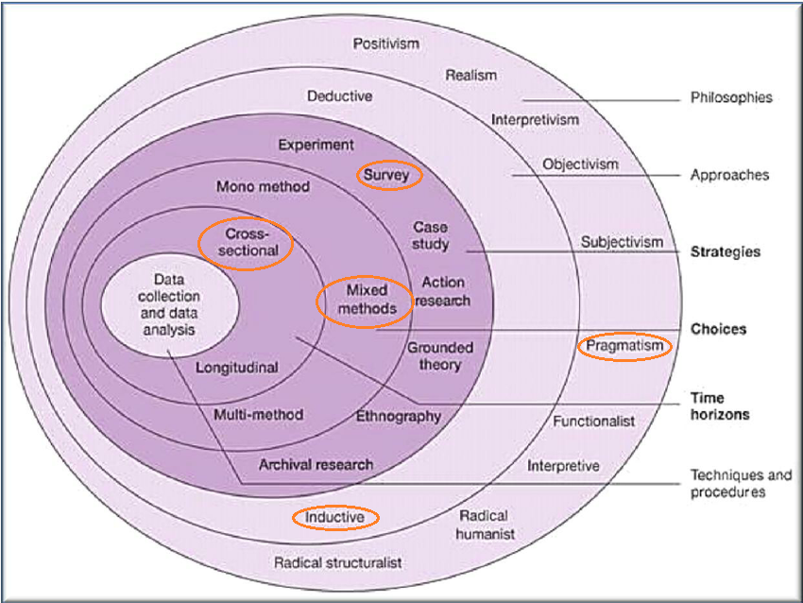
Figure 6: Research “Onion” for research design, following Saunders et al (2009)

Philosophy
The Pragmatism view of philosophy was chosen as it incorporates a more flexible view for the research outcome, reconciling what may be considered as opposites in other philosophies (Saunders, 2015). As defined in Jawad (2017, p169), “Pragmatic mixed methods approach uses any reasoning from qualitative or quantitative research suitable for producing research findings which are both defensible and usable (Burke Johnson et al, 2007). Pragmatic mixed methods are the third major research paradigm and can supply superior research findings and outcomes (ibid)”.

As Kelemen and Rumens (2008, in Saunders et al, 2015) demonstrate, the pragmatism philosophy allows resulting actions to be carries out, contributing a practical outcome and solution to a research problem. Knudsen (2003, in Saunders et al, 2015) further gives a strength to joint ideas in pluralism and unification, where business and management are either fragmented (in unification) or where this diversity provides a more helpful understanding (in pluralism). Rather than focusing on data results that are rigid, this approach takes into account the human element and therefore the mechanics of accountability.

Jawad (2017, p167) quotes Rubels (2006) in expanding on epistemology, that its usefulness comes from problem solving, which is appropriate for this study as there has been no analysis undertaken from an academic point of view, and the results will inform future strategy. Morrow (1994) notes that within a subjective view, the response cannot be based solely on data; the responses in this study are shaped by professional experience.

Saunders (2015, p124), outside the research onion, notes that realities encountered (ontological assumptions), human knowledge (epistemological assumptions) and values influencing the research process (axiological assumptions) shape methods, questions and interpretation, whether or not the researcher is aware of these influences.

Approach
In this study, the Inductive approach is assumed to be the most relevant, as there is no relevant hypothesis relating to this, which has been identified, and which could be tested. Horn (2012) describes the inductive approach as being more open in stance, from the “bottom up”, to allow ideas and approaches to be more widely explored and identify trends and themes (Cresswell, 2014). As it is the intention to gather information from surveys, the data collected will be used to identify themes which can ascertain general trends, both in the operative and strategic direction of the archaeological planning system and in the relationships between the major organisations.

Strategy
Survey was used as the strategy; as described in Horn (2012), it provides a reasonable representation of a population. As noted in Robson (2007) it is a widely used approach with a fixed design that can be replicated, and is not expensive to generate. Whilst disadvantages noted include lack of response, affecting confidence in the findings, using networking to distribute and informing participants beforehand creates a higher response. Robson’s (2007) concerns regarding ethics and validity can be overcome by ensuring academically correct questioning is easily achieved with support from ethical guidelines in universities, and professional presentation of the survey by using online design. Drilling down, using purposeful sampling, the population is related to the area and purpose of the study (Horn, 2012) and the data is gathered from a group displaying expertise.

Choice
Mixed methods were decided as most appropriate (Saunders et al, 2009) with the on-line questionnaire providing the “bigger picture”, a broad spectrum response from a large number of professional service users. Saunders (2009) also discusses the difference between qualitative and quantitative data, with the former giving more richness and depth, including opinion and attitudes which can be gathered and themes identified, resulting in a deeper insight; quantitative generates data from a wider audience and uses the results in numerical form to generate usable statistics. The email interviews provide a deeper and more detailed response from the operational and strategic elements of the archaeological planning system. Questions for interviews can be based on the results of a wider survey, which has highlighted themes and issues (Horn, 2012).
Time Horizon
The time horizon is cross sectional (Saunders et al, 2009), as this is not part of a longer study or observation process, and no survey such as this has been undertaken in Wales. As the means of undertaking the survey is recorded and analysed in this study, it is arguable that should circumstances allow, the replication of the survey can be achieved at a later stage if necessary. The views collected will therefore be representative of differing professional service users and deliverers at a set point in time. The results of any replication at a later date would hopefully record a more accurate analysis of any changes in every aspect examined.

Technique and Procedures
As discussed in Morrow and Brown (1994), the differing methods will provide a more even basis for responses, particularly as these come from individuals with a range of employers or self-employed, the culture and ethics of which may influence their personal opinion and potentially therefore their answers. This approach was considered appropriate for the mixed cultures of the organisations which form the relationship around professional archaeology in the UK. Handy (1988) considers the four groups of cultures in voluntary organisations, and whilst the WATs are third sector, they are not voluntary, but the culture can be seen as task based for WATs archaeological planners, but with role culture in the government relationships. Structure is needed to allow certain respondents to be able frame their answers. However, the credibility of the respondents is high, as it comes from their experiences in their sectors, and that they are Members of their professional Institutes or Chartered Organisations.

Methods
Population
The population for this study was deemed by the researcher to encompass the variety of professional users of the archaeological planning service.

Pilot Study
The appropriateness of undertaking a pilot study in any form of questionnaire is discussed by Perry (1998). It is encouraged in order that not only to ensure appropriateness, but also to ensure understanding, reliability, validity and may also suggest additional questions. Following academic approval of the questions, a paper pilot study was undertaken, with a copy given to a professional service user, each a representative of differing aspects, i.e., WATs planner, WATs heritage management, archaeological consultant, archaeological contractor. These were undertaken face to face, and allowed users to question phrasing, content, abbreviations and how understandable the questions were. Silverman (2011) in the introduction to his work states that the audience of that research includes the policy makers, practitioners and clients, and in a sense it can be argued that the object of this study is to reach that very audience in the archaeological and planning sector.

The quantitative questionnaire was so the basis of a large section of professional service users could respond, and to encourage attention to the archaeological planning service and its pressures and futures. Laing and Todd (2015) examine the aspects of how a situation can be examined, in their model and the assessment of the starting situation, and the progression to the strands for action is essentially where this study lies. Cresswell (2012) explains the nature of the mixed methods and the nature of closed and open questions, for the questionnaire, by the nature the questions were closed, with the exception of the final question. The Likert scale was used for most of the questions, Vanstone (2017) states Beal and Dawson (2007) supporting the usefulness of this in questionnaires.

Question in Questionnaire | Relating Theory in Chapter Two
Q1 Roles: Are you a Planning Archaeologist in: Wales; England; Elsewhere. Archaeological Consultant. Archaeological contractor. Academic Archaeologist. Planning Officer. Other Please specify | External analysis: PESTEL; sector analysis. Lynch (2015); Historic Environment Act Wales (2016);Planning Policy Wales (2016)
Q2 Employment: Are you employed by: Local government; National government; Welsh Archaeological Trust; University; Private Company: Other Please specify | External analysis: PESTEL; sector analysis. Lynch (2015); Planning Policy Wales (2016)
Q3: How satisfied are you that: the archaeological planning service is Wales is currently an effectively delivered service; that WATs archaeological planning staff adhere to the CIfA Code of Conduct; that WATs archaeological planning staff adhere to the WATs Curators Code of Practice; that the level of expertise provided by WATs archaeological planning gives value for money | Public Policy Analysis, inter-organisational relationships; collaborative working and partnerships. Carroll (2009); CIfA (2017); WATs Code of Practice (2017); Morestin (2012)
Q4: How far do you agree that WATs archaeological planning staff should have Royal Town Planning Institute training or membership? | Professional standards. WCVA (2013); Kramer & Pfitzer (2016);
Q5: Are you aware that archaeological planning in Wales receives some funding from: Welsh Government via Cadw; from Local Planning Authorities | Finance and funding, forward strategy. Wales Audit Office (2016); Lynch (2015)
Q6: Regarding current funding, to what extent are you concerned that any shortfall in government funding may: ultimately lead to the loss of archaeological resource; will adversely impact staffing of the archaeological planning service | Finance and funding; collaboration. Wainwright (1983); DCMS (2008); Forrest (2010); Hansard (2017); CIfA (2017)
Q7: How strongly do you agree that further funding should be raised from developers? | Finance and funding. Wales Audit Office (2016);CIPS (2017); WCVA (2013)
Q8: How far would you agree that the current level of expertise provided by Welsh Archaeological Trusts could be provided by: National government; Universities; Consultancies; Welsh Local government; Merged WATs; Other partnership working in Wales | Systems theories; legislation.  Hughes and Weiss (2007); Daft (2001); Arsenault (1998); Welsh Government 2016 and 2017
Q9: How far do you consider there may be ethical issues in an organisation such as a consultancy giving archaeological planning advice and undertaking any subsequent work? | Ethical Issues, funding and finance issues. Carroll (2009); Davies and Parker (2016)
Q10: Please comment on any other further issues you feel are important, e.g. finance, collaborations | Public Policy analysis, inter-organisational relationships; finance and funding; economy; Senge (2006); WCVA (2013), Morestin (2012)
Figure 7: Questionnaire questions relating to the elements of Chapter Two, Literature Review

Sampling
The recipients of the online survey were chosen to be a mix of representatives from all sectors that encounter the Welsh Archaeological Planning system in a professional capacity, namely, WATs archaeological planners, local planning authority planners, archaeological consultants and archaeological contractors. They encompassed both the public and private sectors. The sampling system was purposive (Palys, 2008); in that the reasoning behind their choice ensures the sampling strategy will accomplish the answering of the questions. All recipients of the questionnaire and the more detailed interview questions are stakeholders, and cover a spectrum of positions in relations to the study (Palys, 2008). A range of questions covered positions titles, employer type, and will lead to a “state of the nation” opinion of the service delivery. Answers should help understand not only internal organisational governance and culture, but also inter-organisational relationships (Daft, 2001). From the axiological view, the research is worthwhile and adds to knowledge

Actual numbers of recipients are not balanced, in the sense that the number of WATs archaeological planners does not exceed six full time equivalents, and the numbers of individual contractors who work in Wales and liaise with the WATs planners can exceed 100, although yearly recording of archaeological contracting firms shows that 15 organisations undertook fieldwork in some years. Multi-disciplinary consultancy firms (for example, AECOM, Atkins, WSP Parsons Brinkerhoff) have heritage sections and their consultants liaise with archaeological planners across the UK, therefore they will interact with many, and have experience of how effective differing archaeological planning systems are. The WATs planners also have wide experience in liaising with consultancies and contractors, as they cover larger geographical areas than do their counterpart English county archaeologists.

Selected Interviews
For the three selected interviews, the qualitative aspect was important. Thody (2007) notes the purposes of qualitative research as, amongst others, conveying the reader to the research site, and transmitting the direct experience of the responders and communicating the atmosphere. Cresswell (2012) notes that a major element of this tasking is to place the reader in the environment of the respondents. This is vital, in that the experience of the reader, especially with archaeological planning, may be minimal.

Each interview respondent was chosen to represent an aspect of the archaeological planning delivery and relationships; one from the archaeological planning delivery, one from Welsh government and one from the local planning authority as primary user. The strengths and weaknesses of the system could be gauged without too general or limited a view. Looking at the opportunities and threats for future strategic directions, these will also be considered from the same three differing aspects.

The more detailed interviews were chosen to be undertaken by email, due to the disparate geographical locations of the interviewees, and the fact that in the archaeological world, the period of early summer through to autumn is one of extreme busyness and if the respondents are given the time to consider their answers and respond in their own time then a less pressured, more detailed set of answers is more likely.

The analysis of data gained from the both survey methods will enable an understanding of the current situation, and hopefully to be able to engage with, understand and pursue Senge’s (2006) shared vision. This details that understanding the position of the organisation strengthens the core competences, discussed also by Hamel and Prahalad (1988) and emphasised in their resource leverage.

Ethical Issues
An ethics form submitted to UWTSD received approval from the ethics committee; it was anticipated that adherence to the university’s ethical guidelines ensured consideration of the ethical dimensions of, and human participant protection in, this study.

The author of this study has had over thirty years’ experience as a professional archaeologist, mainly in the field of archaeological planning in Wales; and has also worked for a variety of archaeological organisations including WATs, archaeological consultancy, archaeological contracting as a field archaeologist, archaeological illustrator, and a researcher for development projects.

Clearly, the reasoning behind the aims of this study, and the questions for the surveys, result in some part from personal experience. All attempts have been made to lessen any personal bias, and the undertaking of a pilot study also ensured that different views were gained both from UWTSD and from a variety of professional archaeologists.

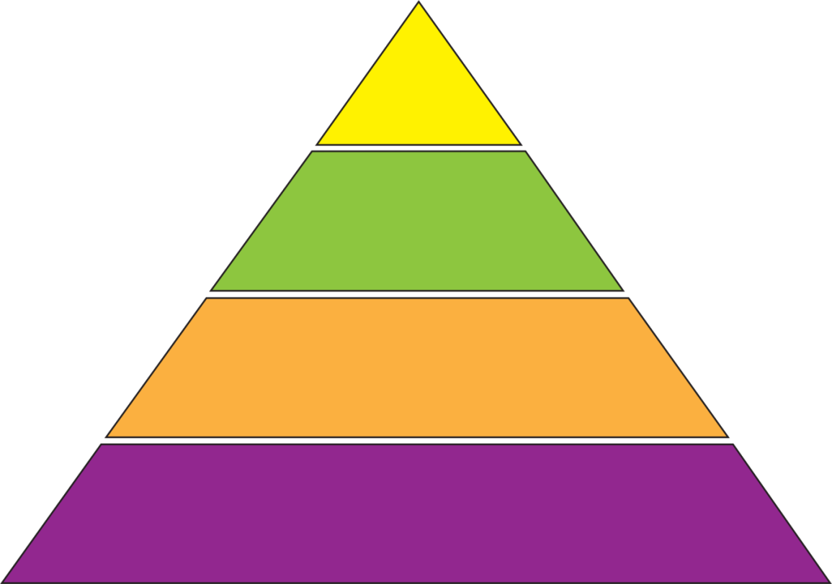
Deontological layer

External considerations

Consequential layer

Core rationale

Figure 8: Seedhouse’s Ethical Grid (after Jawad, 2017): Considering the levels of ethical responsibility.

Seedhouse’s grid (2009) was originally created for the healthcare system, as with many other government and third sector relationship models, and appears to be the nearest applicable. Seedhouse (2009) applied philosophical principles to medical ethics; this allowed examination of patient interaction. The core rationale uses a concern for the individual in that their anonymity and the confidentiality of their responses is confirmed. Following the ethical guidelines of UWTSD, looking at the deontological layer, preserving anonymity should prevent harm occurring to the researcher or the individuals (Horn, 2012). Consequences to this study are both positive, as an MBA qualification, and allowing the voices of those service users and provider, both at operational and strategic level, to be heard with confidence. External consideration allows the ethics, and similar considerations, to be monitored both by the researcher and UWTSD within the supervisory process.

Conclusion
This chapter has clarified the research methodology, and justified the pragmatic mixed methods used in this study. The next chapter will gather, analyse and present findings from the data collection, gathered by methods explained in this chapter.

CHAPTER FOUR: DATA COLLECTION AND ANALYSIS

Introduction
As set out in chapter three, in this chapter, the data collected from two surveys is analysed and presented.

The two surveys were sequentially collected, with the online Survey Monkey questionnaire first and the more detailed email interviews second, with those questions derived from the responses to the first. The analyses will therefore be sequential, with the online survey presented before the email interviews.

The online questionnaire is primarily quantitative, and has been analysed using SPSS. The email interviews are qualitative and have been analysed thematically using grounded theory (Creswell, 2011, and Glaser and Strauss, 1967).

Saunders et al (2015) in Chapter 13 likens the process of data analysis to completing a jigsaw puzzle, so that out of many disparate pieces of data, one final, full picture can be completed, which ensures the bigger picture is seen. The mode of data collection and analysis is explanatory sequential mixed methods (Creswell, 2011) where the quantitative leads to qualitative.

Reliability and validity
Reliability has a number of differing interpretations across academic authors; Robson (2007) considers the reliability of data as relating to repeat studies under similar conditions; if the methodology is standardised then it could be argued there is a higher reliability. Horn (2012) argues that the results could also inspire further research on a similar yet differing path. Thody (2006) adds that the research should demonstrate accuracy, and Creswell (2014) considers that consistency of approach is important. Enough information will be sought from a balance of service users which includes the regulatory and funding bodies, as well as the operational and delivery organisations.

In discussing the reliability of analysis of such data, Silverman (1993, p145) notes Kirk and Miller (1986) discussing “synchronic reliability”: the similarity of observations within the same time period; where a standard way of assessment is through triangulation of gathering methods. Silverman (1993, p10) notes that the aim is to gather “an authentic understanding”. Glaser (2010) discusses seeing a pattern in the data which falls into core categories, with believability of data vested with the interviewer. Reliability is high as the processes have been approved and followed.

Validity appears to inspire that same variety of definitions, and all of them again, it can be argued, have equal weighting. Words used by Creswell (2014) such as accuracy, credibility, authenticity all essentially have the same meaning although differ in nuance. Horn (2012) discusses whether validity is more subjective, and Thody (2006, p99) stays with the simple “truth”. Using the survey with questionnaire and fewer more in detail interviews should provide the best range of information from enough respondents.

Validity as mooted by Peräkylä (in Silverman, 1993) here is how credible the data is, if the correct instruments are used in its gathering. In this study, all of the responses to the open question were anonymous, the validity should be high, and whilst the interview respondents are also anonymous, the author felt (given personal conversations, and personal knowledge of the archaeological planning system and its setting) that some element of restraint was noted, and an emphasis on responses being the personal views. The reasoning for this may be rooted in a reluctance to discuss finance, whether personal or relating to the employer or funding bodies, uncertainty of future funding or employment if a confidence may have been felt to have been breached.

In complying with university ethics and by following previously used, agreed methods and pathways the validity and reliability of this study this should be ensured. There are no adverse ethical issues relating to this study and the UWTSD Ethics Form has been completed. Questions did not relate to gender or age, as there was no methodological requirement for this.

In this study, as the data gathered by the online survey included a range of options, including an open question for further information, the open ended questioning used in both the online survey and the deeper questions of the three email interviews to bring out themes and issues provided a range, which given the number of responses, is considered acceptable by the author.

Analysis of online quantitative data
Method
Initially, eighty three surveys were sent to users of the archaeological planning service in Wales, this was also shared by recipients to other professional groups; the full number of recipients is not known although there was some cross posting. Seventy responses were received. Raw data is given in Appendix Two, responses to the open question in Appendix Three.

Coding was assigned for quantitative responses as nominal for question 1 (relating to employment type), question 2 (to employer type), ordinal for question 3 (a four part question, with Likert scale regarding satisfaction of delivery of the archaeological planning service in relation to effectiveness; value for money; adherence to CIfA Code of Conduct, and WATS Code of Conduct), questions 5 and 6 (four parts relating to government and local government funding), questions 7 (relating to raising funding from developers), question 8 (provision of the service from six other sources), and scale for questions 4 (relating to RTPI membership) and 9 (relating to ethical issues). Likert scale response were graded 1 = negative through to 5 = positive. The data was tested with SPSS, using ANOVA tests, as this method allows a variable with a group of more than two values to be compared to ascertain any statistical significance. Results are presented to give as much detail as necessary, as both bar graphs with the curve, and as statistical information.

Results
Some questions were skipped, but out of the 19 x 70 = 1330 pieces of data, 45 were skipped, 3.38%. The final open question was the higher skip number, with 26 of the 45. The job type or employer of the respondents was not a factor in this as the skip was spread over all categories.

The data was analysed to compare the views of different groups of service users. The responses received illustrated the variation in numbers of post holders, for example, the number of responses from Archaeological Planners in Wales is numerically small, 10, but responses represent 100% of the total posts employed in the sector than archaeological consultants responses in relation their number FTE. Questions one and two therefore related to the role and employer type of the respondent.

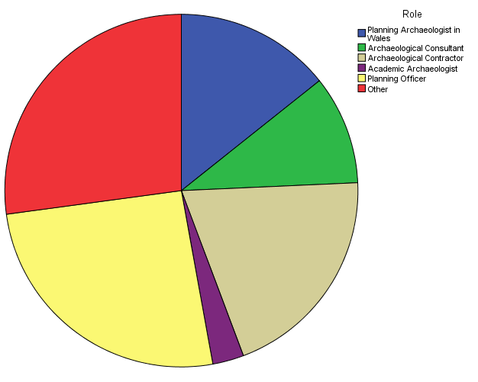

Figure 9: Q1: Respondents by role

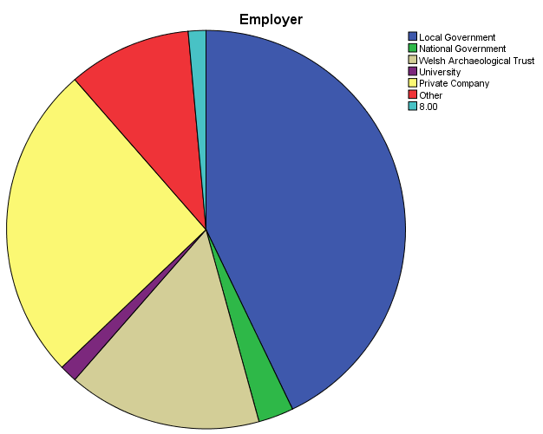
Figure 10: Q2: Respondents by employer type

Question 3 asked for the perceived level of satisfaction with the service, in relation to adherence to the WATs Code of Conduct and the CIfA Code of Conduct, the level of expertise is value for money, and how effective the service is currently.

Overall, by grouping 1 and 2, 3, 4 and 5 on the scale the satisfaction percentage for all roles was 75%, 75%, 73.5% and 68.5 respectively. As noted in the test results, the p value (sig) with μ as 3, the mean on the Likert scale. For all four options, the p value was greater than 0.05, apart from the archaeological planners in Wales responses for the Codes of Conduct where values of 0.016 (WATs) and 0.56 (CIfA) showed a strong difference to other groups (between 0.201 to 0.947).

With the expertise as value for money, the p value for WATs planners was 0.46, again showing a significantly different to other groups (0.17 to 0.49); the values in efficacy of delivery showed no such difference. It had been expected by the author that there would be a significant difference relating to the disparate professional users expectations and experiences of the archaeological planning service.

Effectively Delivered CIfA Code of Conduct
 |  | Frequency | Percent | Valid Percent | Cumulative Percent
Valid | Very dis-satisfied | 3 | 4.3 | 4.4 | 4.4
Valid | Dis-satisfied | 1 | 1.4 | 1.5 | 5.9
Valid | Neither dis-satisfied nor satisfied | 15 | 21.4 | 22.1 | 27.9
Valid | Satisfied | 28 | 40.0 | 41.2 | 69.1
Valid | Very satisfied | 21 | 30.0 | 30.9 | 100.0
Valid | Total | 68 | 97.1 | 100.0
Missing | 99.00 | 2 | 2.9
Total |  | 70 | 100.0

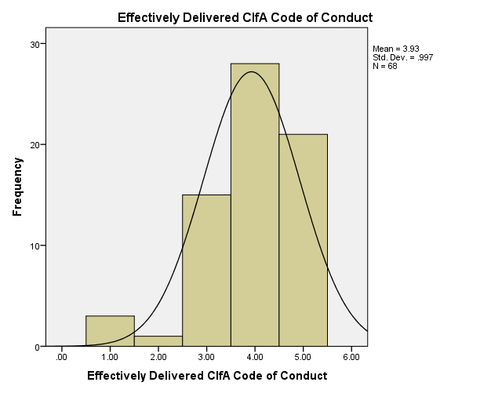

Figure 11: Q3: Respondents’ Satisfaction with CIfA Code of Conduct

Effectively Delivered WATs Code of Conduct
 |  | Frequency | Percent | Valid Percent | Cumulative Percent
Valid | Very Dis-satisfied | 3 | 4.3 | 4.4 | 4.4
Valid | Dis-satisfied | 1 | 1.4 | 1.5 | 5.9
Valid | Neither dis-satisfied nor satisfied | 15 | 21.4 | 22.1 | 27.9
Valid | Satisfied | 29 | 41.4 | 42.6 | 70.6
Valid | Very satisfied | 20 | 28.6 | 29.4 | 100.0
Valid | Total | 68 | 97.1 | 100.0
Missing | 99.00 | 2 | 2.9
Total |  | 70 | 100.0

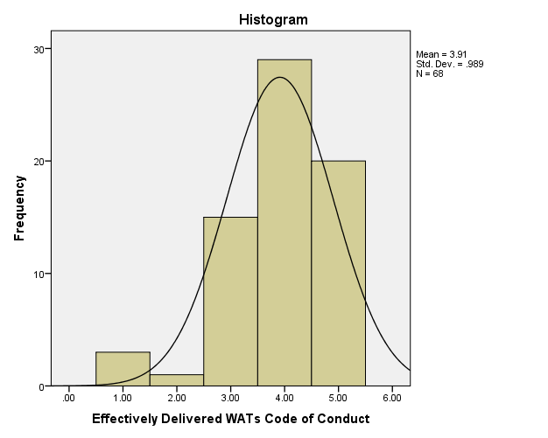
Figure 12: Q3: Respondents’ satisfaction with WATs Code of Conduct

Effective value for money
 |  | Frequency | Percent | Valid Percent | Cumulative Percent
Valid | Very dis-satisfied | 2 | 2.9 | 2.9 | 2.9
Valid | Dis-satisfied | 3 | 4.3 | 4.4 | 7.4
Valid | Neither dis-satisfied nor satisfied | 13 | 18.6 | 19.1 | 26.5
Valid | Satisfied | 28 | 40.0 | 41.2 | 67.6
Valid | Very satisfied | 22 | 31.4 | 32.4 | 100.0
Valid | Total | 68 | 97.1 | 100.0
Missing | 99.00 | 2 | 2.9
Total |  | 70 | 100.0

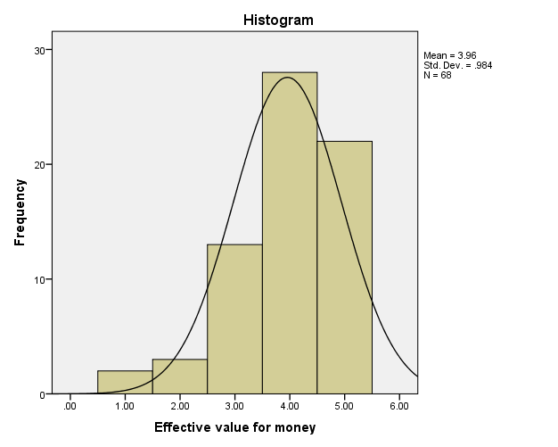
Figure 13: Q3: Respondents’ satisfaction with WATs value for money

Effective Delivery
 |  | Frequency | Percent | Valid Percent | Cumulative Percent
Valid | Very Dis-satisfied | 3 | 4.3 | 4.3 | 4.3
Valid | Dis-satisfied | 6 | 8.6 | 8.6 | 12.9
Valid | Neither Dis-satisfied nor Satisfied | 14 | 20.0 | 20.0 | 32.9
Valid | Satisfied | 43 | 61.4 | 61.4 | 94.3
Valid | Very Satisfied | 4 | 5.7 | 5.7 | 100.0
Valid | Total | 70 | 100.0 | 100.0

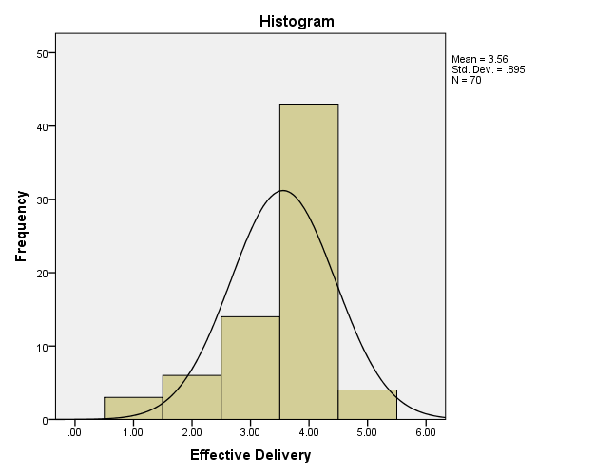

Figure 14: Q3: Respondents’ satisfaction with WATs efficacy of delivery

For Question 4, whether Membership of the RTPI was desirable, there was no significant difference between groups, although there were two spikes in responses indicating a more negative response overall.

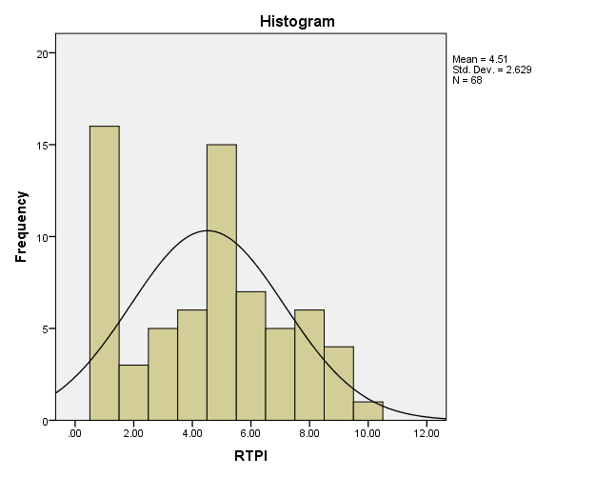
Figure 15: Q4: response to RTPI Membership as desirable

Question 5 related to the awareness of Cadw and Local Government, as funding bodies into the WATs planning, and there was a strong awareness response of 73.5% and 83.8% respectively, and a p value of around 0.8 for all groups in both responses, no significant difference.

WG Funding
 |  | Frequency | Percent | Valid Percent | Cumulative Percent
Valid | No | 9 | 12.9 | 13.2 | 13.2
Valid | Some idea | 11 | 15.7 | 16.2 | 29.4
Valid | Yes | 48 | 68.6 | 70.6 | 100.0
Valid | Total | 68 | 97.1 | 100.0
Missing | 99.00 | 2 | 2.9
Total |  | 70 | 100.0

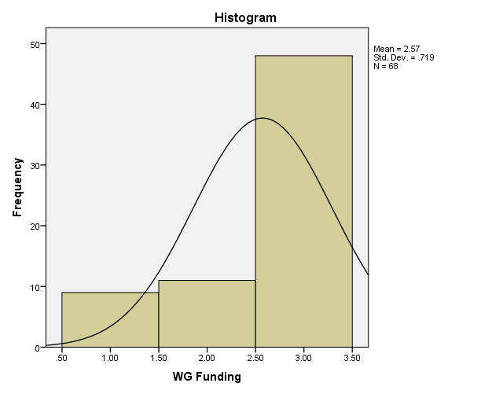

Figure 16: Q5: Awareness of funding bodies WG

UA Funding
 |  | Frequency | Percent | Valid Percent | Cumulative Percent
Valid | No | 5 | 7.1 | 7.4 | 7.4
Valid | Some idea | 6 | 8.6 | 8.8 | 16.2
Valid | Yes | 57 | 81.4 | 83.8 | 100.0
Valid | Total | 68 | 97.1 | 100.0
Missing | 99.00 | 2 | 2.9
Total |  | 70 | 100.0

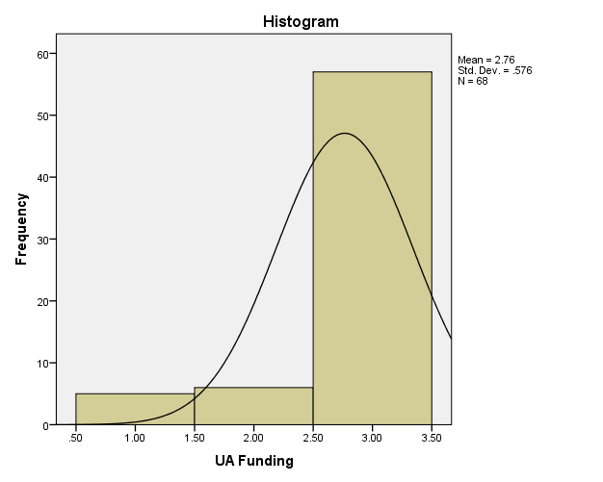

Figure 17: Q5: Awareness of funding bodies UA

Question 6 related to the concerns regarding the potential adverse impact of any future shortfall in funding on the archaeological resource, and the staffing of the WATs planning teams. Again, there was no significant difference with values of over 0.05, and the grouping 1 and 2, 3, 4 and 5, both responses showed 94.2% having strong concerns.

Loss of Archaeological Resource
 |  | Frequency | Percent | Valid Percent | Cumulative Percent
Valid | Very Concerned | 32 | 45.7 | 46.4 | 46.4
Valid | Concerned | 33 | 47.1 | 47.8 | 94.2
Valid | Neither concerned nor unconcerned | 3 | 4.3 | 4.3 | 98.6
Valid | Unconcerned | 1 | 1.4 | 1.4 | 100.0
Valid | Total | 69 | 98.6 | 100.0
Missing | 99.00 | 1 | 1.4
Total |  | 70 | 100.0

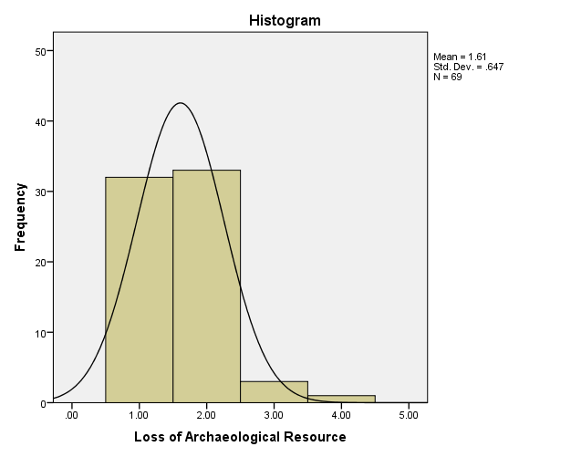
Figure 18: Q6: Concern with loss of archaeological resource

Adverse impact on staffing
 |  | Frequency | Percent | Valid Percent | Cumulative Percent
Valid | Very Concerned | 37 | 52.9 | 53.6 | 53.6
Valid | Concerned | 28 | 40.0 | 40.6 | 94.2
Valid | Neither concerned nor unconcerned | 2 | 2.9 | 2.9 | 97.1
Valid | Unconcerned | 2 | 2.9 | 2.9 | 100.0
Valid | Total | 69 | 98.6 | 100.0
Missing | 99.00 | 1 | 1.4
Total |  | 70 | 100.0

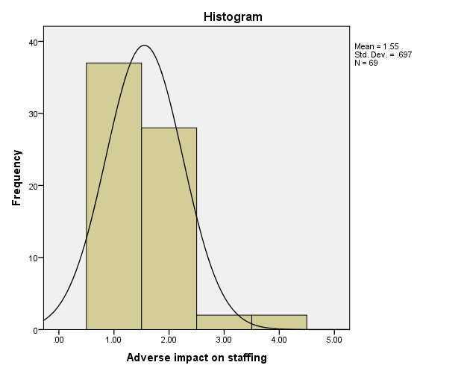
Figure 19: Q6: Concern with adverse impact on staffing

Question 7 asked how strongly respondents felt about the raising of funds from developers, which may secure further funding for the service but raised ethical questions. There was no value difference and the standard deviation of 1.79 led towards a stronger view in favour of this option.

Developer Funding
 |  | Frequency | Percent | Valid Percent | Cumulative Percent
Valid | Strongly disagree | 3 | 4.3 | 4.5 | 4.5
Valid | Disagree | 12 | 17.1 | 17.9 | 22.4
Valid | Neither disagree nor agree | 9 | 12.9 | 13.4 | 35.8
Valid | Agree | 26 | 37.1 | 38.8 | 74.6
Valid | Strongly agree | 17 | 24.3 | 25.4 | 100.0
Valid | Total | 67 | 95.7 | 100.0
Missing | 99.00 | 3 | 4.3
Total |  | 70 | 100.0

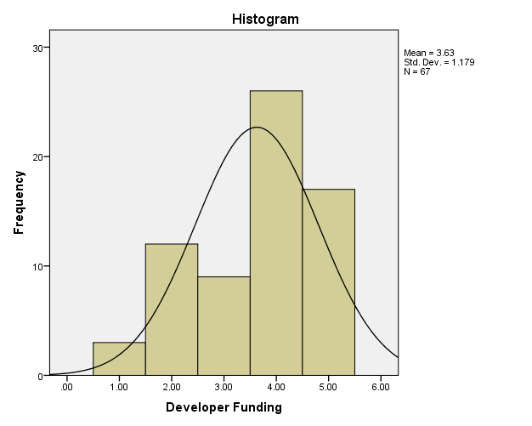

Figure 20: Q7: Raising funds from developers

Question 8, in posing a number of alternative providers for the planning service, gave six options. The only significant difference was the response of the WATs planners with a value of 0.12 for a consultancy option. No other significant differences were recorded. The balance of responses over the options showed that most responders believed Welsh government or local government should provide the service, or merged WATs, but the standard deviation with other options showed a more negative view.

National Gov to Provide
 |  | Frequency | Percent | Valid Percent | Cumulative Percent
Valid | Strongly disagree | 11 | 15.7 | 15.9 | 15.9
Valid | Disagree | 20 | 28.6 | 29.0 | 44.9
Valid | Neither disagree nor agree | 16 | 22.9 | 23.2 | 68.1
Valid | Agree | 20 | 28.6 | 29.0 | 97.1
Valid | Strongly Agree | 2 | 2.9 | 2.9 | 100.0
Valid | Total | 69 | 98.6 | 100.0
Missing | 99.00 | 1 | 1.4
Total |  | 70 | 100.0

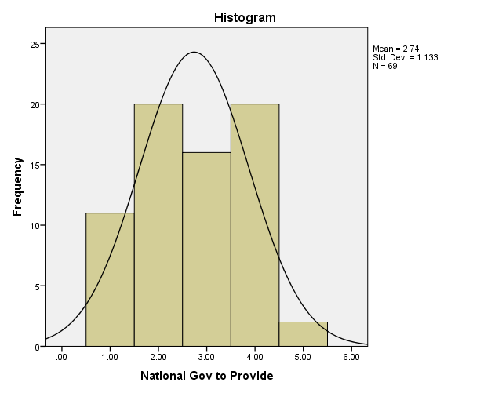

Figure 21: Q8: Other potential service providers: national government

University to Provide
 |  | Frequency | Percent | Valid Percent | Cumulative Percent
Valid | Strongly disagree | 28 | 40.0 | 40.6 | 40.6
Valid | Disagree | 25 | 35.7 | 36.2 | 76.8
Valid | Neither disagree nor agree | 9 | 12.9 | 13.0 | 89.9
Valid | Agree | 5 | 7.1 | 7.2 | 97.1
Valid | Strongly agree | 2 | 2.9 | 2.9 | 100.0
Valid | Total | 69 | 98.6 | 100.0
Missing | 99.00 | 1 | 1.4
Total |  | 70 | 100.0

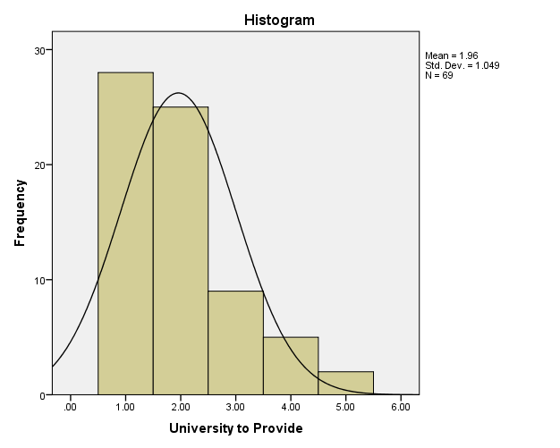

Figure 22: Q8: Other potential service providers: universities

Consultancy to Provide
 |  | Frequency | Percent | Valid Percent | Cumulative Percent
Valid | Strongly disagree | 18 | 25.7 | 26.5 | 26.5
Valid | Disagree | 24 | 34.3 | 35.3 | 61.8
Valid | Neither disagree nor agree | 11 | 15.7 | 16.2 | 77.9
Valid | Agree | 13 | 18.6 | 19.1 | 97.1
Valid | Strongly agree | 2 | 2.9 | 2.9 | 100.0
Valid | Total | 68 | 97.1 | 100.0
Missing | 99.00 | 2 | 2.9
Total |  | 70 | 100.0

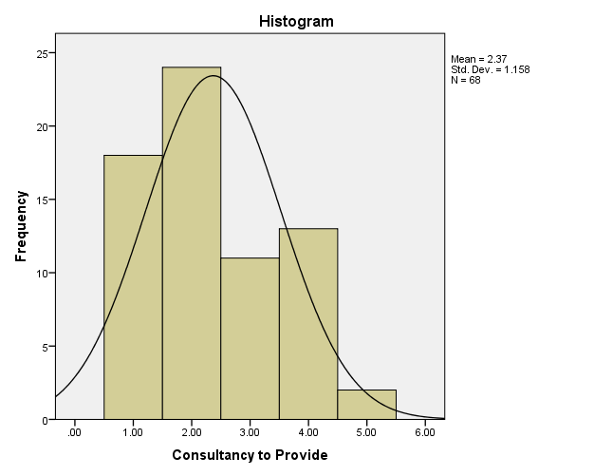

Figure 23: Q8: Other potential service providers: consultancies

Welsh Local Gov to Provide
 |  | Frequency | Percent | Valid Percent | Cumulative Percent
Valid | Strongly disagree | 11 | 15.7 | 16.2 | 16.2
Valid | Disagree | 15 | 21.4 | 22.1 | 38.2
Valid | Neither disagree nor agree | 17 | 24.3 | 25.0 | 63.2
Valid | Agree | 22 | 31.4 | 32.4 | 95.6
Valid | Strongly agree | 3 | 4.3 | 4.4 | 100.0
Valid | Total | 68 | 97.1 | 100.0
Missing | 99.00 | 2 | 2.9
Total |  | 70 | 100.0

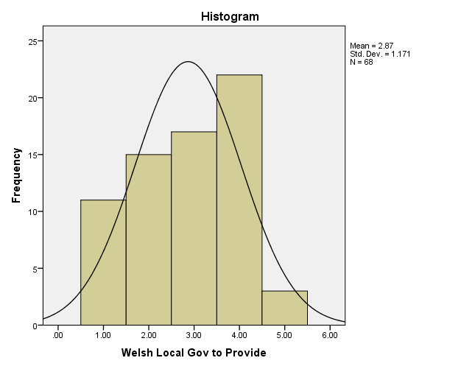

Figure 24: Q8: Other potential service providers: Welsh local government

Merged WATs to Provide
 |  | Frequency | Percent | Valid Percent | Cumulative Percent
Valid | Strongly disagree | 1 | 1.4 | 1.4 | 1.4
Valid | Disagree | 12 | 17.1 | 17.4 | 18.8
Valid | Neither disagree nor agree | 16 | 22.9 | 23.2 | 42.0
Valid | Agree | 30 | 42.9 | 43.5 | 85.5
Valid | Strongly agree | 10 | 14.3 | 14.5 | 100.0
Valid | Total | 69 | 98.6 | 100.0
Missing | 99.00 | 1 | 1.4
Total |  | 70 | 100.0

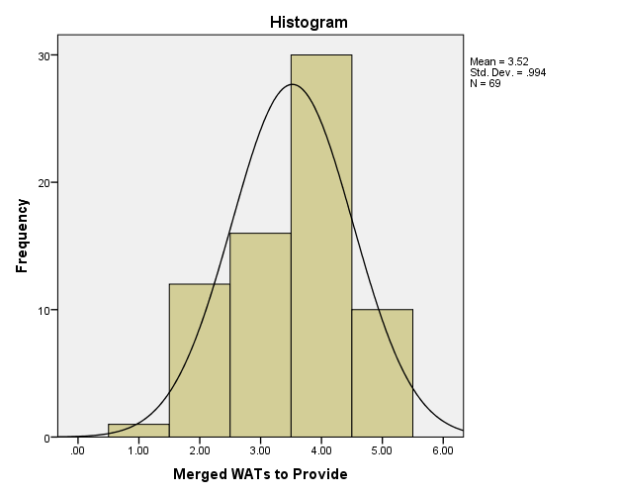
Figure 25: Q8: Other potential service providers: merged WATs

Other Partnerships in Wales to Provide
 |  | Frequency | Percent | Valid Percent | Cumulative Percent
Valid | Strongly disagree | 7 | 10.0 | 10.1 | 10.1
Valid | Disagree | 14 | 20.0 | 20.3 | 30.4
Valid | Neither disagree nor agree | 30 | 42.9 | 43.5 | 73.9
Valid | Agree | 16 | 22.9 | 23.2 | 97.1
Valid | Strongly agree | 2 | 2.9 | 2.9 | 100.0
Valid | Total | 69 | 98.6 | 100.0
Missing | 99.00 | 1 | 1.4
Total |  | 70 | 100.0

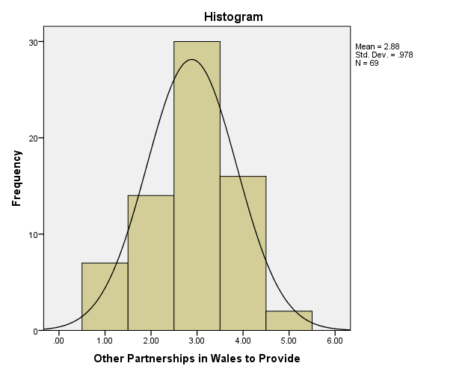
Figure 26: Q8: Other potential service providers: other partnerships in Wales

The final question, 9, requested the view as to how far there may be ethical considerations with independent consultancy firms, which also employ commercial sections and offer “whole package” response to developers, giving planning advice and undertaking subsequent work. There was no significant difference between groups, but with a standard deviation of 2.15, and 81% having ethical concerns it is a strong view.

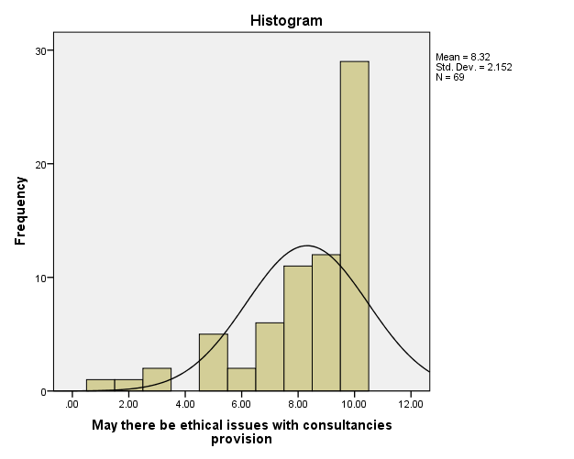
Figure 27: Q9: Ethical Issues with consultancies as a provider

The final, open ended, question of the online survey received forty four responses, 63% of all responses. This data varied between one sentence and nineteen lines, and was initially highlighted to identify themes such as funding, finance, ownership, expertise, ethics, partnership, feedback and independence. These were then grouped into three, investment, governance and communication.

The proportion of responses that raised concerns regarding short term and long term funding was 52%, by far the largest issue to be raised and illustrates the awareness and concern regarding the long term survival of the planning system. Ethical issues regarding the sharing of information between organisations on a commercial basis formed 22% and were also linked with expertise (20%); as likely reflecting concerns around payments for advice if the system were altered. Whilst five answers gave a positive response for the WATs and unitary authority relationship and advice, the fact that more concerns were raised in Q10 against the number of “satisfied /highly satisfied” at Q3 is noteworthy.

Analysis of qualitative data
Method
The responses have been sorted (by theme and by respondent) and linked back to the elements identified in Chapter Two Initial sorting of the in depth interviews was by Matrix Analysis using table to identify themes and recurrent issues, set out by theme and then by interviewee. Mason (2006) notes that such methods are based on an appreciation of complexity and detail. In this, the common themes and various issues which are identified in the interviews can be recorded and those which are common to all interviewees can be identified. Responses are given in Appendix Four.

Interviews have been conducted via email, due to distance and work pressures. It can also be argued that this method allows the interviewee more time to give a more considered response without time pressure of a face to face situation. They are semi-structured: the interviewee has been given questions to provoke thought in certain areas, to allow further information to be gained, i.e. the SWOT analysis ensures the strengths and weaknesses ascertained are from the interviewee’s perspective. Areas such as finance and collaboration will equally gain independent viewpoints. Three interviewees were chosen, one from each field within the archaeological planning system: the operational delivery of that system at the “front line”; a mix of operational and strategic from the main professional user; and the strategic and forward element.

Results
All of the respondents emphasised that their views are not the official views of the organisations represented, and are their own personal views.

Themes | Issues | Interviewee 1 | Interviewee 2 | Interviewee 3
Investment | Funding responsible organisations, long term |  | “WG funds the archaeological planning services. The sum is ring fenced and increased with inflation.”
 | Finance: lack of and potential future cuts | “If WG legislates it should make appropriate resources available to implement the legislation in full”. | “In the last three years the funding for Cadw has been reduced by some 20% but the budget for the WATs archaeological planning service has been maintained at the same level and increased by inflation”.
 | Recruitment and retention of staff with expertise |  |  | “We are sleepwalking into a mess if we don’t start adding to the pool of skilled people working in Wales”.
 | Training and CPD |  | “individual officers should all be corporate members of CIfA and at least the lead officer of each WAT archaeological planning service should be a full Member”.
Communication | Feedback between partners, in time and nature | “Through planning applications the communication is controlled”. |  | “Greater emphasis needs to be placed on feedback between the WATs & LPA”.  “Being essentially more business-like and slick”.
 | Ownership: management of decision making processes |  | “There may also be a need for meetings between the four WATs planning teams to ensure consistency of advice across Wales”.
 | Perceptions of independence, in processes of information | “Establish a vision of what the WAT could be and seek investment to achieve it”.
Governance | Organisational relationships | “Limited extent”. | “The biggest weaknesses are due to the archaeologists not being part of the LPA”. | “The biggest weakness as I see it is the lack of close working relationship with local authorities. The face to face/personal service element of our work needs to be developed”.
 | Ethics: control of information, perceived power | “WATs to instigate ‘peer reviews’.” | “…there [is] a clear Code of Conduct approved by Welsh Government ensuring that the officers providing advice to the LPAs are independent of the commercial work of the WATs and no evidence being produced that such collusion is happening after the system has been in place over 30 years”.
 | Training and recruiting of staff |  |  | “Most importantly though we need to develop a career path for planning archaeologists, and put in place clear progression steps & provide necessary training”.
 | Legal and statutory |  | “The Welsh Government has recently issued TAN24 which clarifies how the historic environment should be considered in the planning system. It has also produced a series of guidance documents”.

Figure 28: Thematic analysis of qualitative data

Data was initially sorted to reduce non-significant “chaff” (Chenail, 1995), and remove personal names linked with roles, and personal remarks. Responses were grouped together related to the questions and then similar phrasing and words were highlighted.

As indicated in the above table, whilst the questions evolved from the online survey results, they were tailored to bring out more detail and knowledge, and allow a comparison (Chavez, 2012). The themes were identified by highlighting words and phrases which fell into the categories of finance, funding, wages, feedback between WATs, Local Authorities and Cadw, partnership, ownership, independence, ethics, training, and expertise. This led to a common emergent themes, and each of these was then clustered into similar but larger groupings, funding, finance and wages come together as investment; themes of communication such as feedback, partnership, independence and ownership; and governance encompasses legal and statutory issues, as well as ethics, and responsibility. The governance and relationship of third sector with government (Allmendinger, 1998; Van Slyke, 2006 and Macmillan, 2013) links with neoliberalism and falls within the wider arena of linkage with the Well-being of Future Generations (Wales) Act (Welsh Government, 2015).

Respondents did not answer some questions fully, due to their perceived non-understanding of the question. To the author, this was important as it illustrated to some extent that the organisation of the archaeological planning system and the relationships and responsibilities within the partnership organisations were not well understood by those working within the system. However, it may also be that the questions were not as clear to the respondents as expected, or may have been misunderstood (Presser et al, 2014). A repeat study may choose to utilise a stronger pilot study.

Findings: Emergent themes
Silverman (2011) notes that validity is the interpretation of observations, and the groupings chosen for collating themes reflect the interpretation of the author of this study. Some individual topics could be considered to fall within more than one wider topic, such as training coming within the scope of finance and partnership; responsibility within finance, communication and governance.

Investment
Two themes emerged, financial investment, and investment in people, although investment in people requires financial input, as well as time, which in turn requires funding. Finance was mentioned in both aspects of strength and weakness of the system; relating to the main investment that allows the service to function (Welsh Government, 2016). The long-term strategy of planning rests with Welsh Government, and then via the local government to the WATs. It was felt by two respondents that the funding should be increased from Welsh Government, as the legislation that has created the archaeological planning system should ensure its survival.

Degradation of the value of grants and funding was a concern to all, with grant funding being increased by inflation, but resulting in a loss of value in real terms.

The current financial climate was noted, with cuts to public spending passed down from central Westminster and Welsh Government through local government. All of the respondents were aware of pressures, but one also noted the particular relationship between the governments as the cuts were passed to the end use, but the archaeological planning system still functioned. This was also noted by another respondent, but in the sense that whilst the service continues, it does not work at its best due to financial constraints. The nature of future finance via a grant programme was noted in Chapter Two, as one of the elements of future proofing (Dobbs et al, 2015).

Two respondents believed that if the government legislation required something to be undertaken, then appropriate funding should be provided by the government, in order that the system is fully supported to ensure a strong identity (Welsh Government, 2017a). This is reinforced by the wording of the WCVA (WCVA, 2013) and Cadw (Cadw, 2017) documents referred to in chapter two where the strength and investment in the system is vested in legislation, policy and guidance.

As part of training, investing in staff with expertise or providing training for that expertise was considered to be of vital importance. Within the last two years, two of the four WATs have lost experienced planning staff; this has resulted in some concern. Whilst the system does continue, the expertise is elsewhere and the replacement and retention of experienced staff is a matter of concern. This again relates to future proofing (Dobbs et al, 2015), as an organisation which must continue to function effectively must have appropriate staff.

Investment in continuous professional development (CPD) was considered a necessary aspect, as pressures on time to do not always allow sufficient support to achieve this, with a knock on effect of potential problems with compliance with professional membership and ethical Codes of Conduct (Carroll, 2009).

Communication
Communication was a major theme, with interviewees having clear opinions concerning feedback from the WATS to both local and national government, and the communication of satisfaction and requirements in the other direction. The regular feedback of figures and quarterly meetings between WATs and Cadw is accepted, although the lack of fewer figures based, more operational, involvement is noted as a weakness. The need for this links with Arsenault’s (1998) regional organisation, with the growth of shared values leading to strength. This was noted particularly by respondent 3, noting the importance of quickly sharing important information.

Stakeholder theory is important here, in identifying those organisations where the sharing of information is needed, as opposed to wanted or expected, and relates to the adverse effect of staff feeling “kept in the dark” if the information is not forthcoming. If so, it can be argued that Foucault’s (1980) power and relations theory comes into the picture here, where power is exercised through institutions (in this study, for example, Welsh Government), as does Daft’s resource dependence theory (2001), particularly if an organisation is subject to external control if it is dependent on such an external source for a critical resource such as funding (Daft, 2001). If there is an imbalance between stakeholders, especially where there is an organisational difference between hard and soft management in the partnership, the human element of the stakeholders is part of the wider picture identified by McKinsey in the 7-S process. If there is an imbalance, then Daft’s sociotechnical systems model (2001) does show shared goals and values and that the differences if identified can be overcome by collaboration.

Governance
The third major theme related to governance. The issues within this related to managerial responsibility, with the crossover to communications, and finance linking to McKinsey 7-S and Daft’s theories. With the dichotomy of the more hierarchical governmental organisation providing the legislative and funding structure, the delivery organisations include the softer elements relating to strategy and governance (Peters and Waterman, 2004).

This links to the model for analysing social policy (Morestin, 2012), repeated below as a framework for analysis.

Effects | Effectiveness | What effects does the policy have?
 | Unintended Effects | What are the unintended effects of this policy?
 | Equity | What are the effects of this policy on different groups?
Implementation | Cost | What is the financial cost of this policy?
 | Feasibility | Is this policy technically feasible?
 | Acceptability | Do the relevant stakeholders view the policy as acceptable?
Figure 29: Dimensions for analysing public policy

Under the above groupings, if it is taken that the policy is both legislation and policy from national government, taking into account the various operational and strategic responses of both the quantitative and qualitative surveys, it can be seen that the effects of this reach into every aspect of the system. The unintended effects are perhaps the pressure of performing a service with resourcing that appears to be under pressure, whilst being a legislative requirement. The equity, the effects on different groups, also appears pressured, whilst maintaining a service with differing aspects of input including operational and strategic.

Looking at implementation, the financial costs will rise, and whilst the policy is feasible because it is being undertaken through legislation, and stakeholders view the policy as acceptable.
Wider aspects of the literature review which especially were raised in the responses relate to legislation and policy, and the grouping of finance, social policy, responsibility and governance which all lie within management theory. Arguably, the two most important aspects are the former, and from the others, finance. Results of this analysis are intended as academic research and also to reach the service providers, investors and stakeholders.

Conclusion
The main findings of this chapter, revealed by the data collection and analysis, are that issues raised fell into the broad categories of governance, communication and investment. Investment, whilst concerning direct funding and investment in staff, ultimately leads to financial investment. The wider sphere around all of these is how the archaeological planning system can survive and meet the challenges in the future. There is a concerning trend of a lack of appropriate increase in funding to achieve a future proofed organisation with core competences (Hamel and Prahalad, 1994).

Relating the responses to the wider setting within the Well-being of Future Generations Act (Welsh Government, 2015), the cultural aspect of this is in part managed and facilitated by the WATs archaeological planning service. It can also be noted that satisfaction as a measure is a perception; the answers to the questions are relative.

The implications of these findings will be discussed more fully in the final chapter, Chapter Five.

CHAPTER FIVE: CONCLUSIONS AND RECOMMENDATIONS

Introduction
Having analysed, in Chapter Four, the data acquired by both quantitative and qualitative methods, the findings fell into the categories of investment, communication and governance. This chapter states the conclusions and limitations of this study, and offers recommendations, to strengthen the system and its organisational setting, as well as suggesting directions for future academic study.

These recommendations are based not only on the rigorous research that was undertaken as part of this study, but also on the knowledge and experience the author has accumulated over the past thirty years in professional archaeology.

Achievement of Objectives:
To analyse the current system in relation to efficiency during falling government grants using strategic analysis models and frameworks:
The analysis was undertaken to the research methodology and methods approved.

To evaluate the efficacy of using Welsh Archaeological Trusts by means of gathering data by survey and interview:
Data was gathered and analysed within the scope of the agreed methods and methodology.

To assess the current level of expertise in this field by gathering data by survey and interview:
This assessment was made, although the wider impact of investment proved to be a stronger response.

Upon analysis, to potentially make recommendations relating to the system:
Analysis of the data gathered allowed six recommendations to be made as follows.

Main findings
The WATs archaeological planning service is at risk from current and increasing future financial cuts and changes in policy. Figures 6 and 27 record the themes which the literature study brought out, and upon which the questions were based, and the results of these. Highlighting the main themes of the results showed that whilst there is a high level of satisfaction recorded by the users their concerns illustrate that the service is weak and potentially vulnerable to changes which may be caused by different governments.

The implications of this are that legislation, policy, economic and financial changes may have an adverse impact, whilst currently governments ensure legislation and policy protects the heritage. In view of this, WATs must be in strong and agile organisational position to be able to respond to these likely changes.

Recommendations
The analysis of the data collected showed that there was a good level of satisfaction with the service provided, the expertise of the WATs archaeological planning officers and with the level of engagement between the major partners. Concerns were raised about the potential impact of any further reduction in real term funding, and the further strategic impact that this would be likely to have on the posts themselves, given that posts had been cut in England, and also on recruiting and retaining experienced staff.

The importance of the provision of the service in the wider arena relates to the Well-being of Future Generations (Wales) Act 2015, and the value that heritage, and cultural heritage brings to people in order to relate to their ancestry and ancestors cannot be too highly emphasised. Public interest in modern archaeology, where visitors can relate to the immediate work of their families and communities, is promoted in education and the enthusiasm for this can be seen in the media where programmes such as Time Team, Digging for Britain, and Meet the Ancestors allow people to connect with the more distant past.

The following recommendations are made within the scope of investment, governance and communication to link with the structure of the analysis of the research. These should ensure that this important service is maintained in the face of mounting pressures.

1: To provide a strong future for the service, the potential for the merging of the archaeological planning services, if not the wider curatorial services of the WATs also, should be explored. This potential restructuring would need investment in time and staffing to audit the current system. The involvement of Welsh Government and Local Government as well as the WATs would be necessary; there may be potential also for the involvement of the Welsh Audit Office as the exploration of the success of policy and legislation would come within their remit. Long term benefits of greater investment may also include support of staff and lead to a greater consistency of response, and greater organisational strength and resilience in governance.

2: To explore the potential for developer funding, particularly of large pre-application enquiries such as major infrastructure projects. This may be in line with the incoming payments for the local authority planning, and allow staff to devote more time to complex issues which appear not to be currently adequately funded. Clearly there may be ethical issues around this with developer expectancy of timescales and outcomes. There may also be an impact on extant grant funding from both local and national government which would need to be explored.

3: Encouragement for all staff to achieve and maintain appropriate professional memberships of the Chartered Institute for Archaeologists, including local authority staff.

4: The acquiring of a business qualification for WATs staff would promote and enhance team, and organisational capability.

5: In order to promote a greater understanding of the WATS and the archaeological planning service, the establishment of regular meetings to ensure that local authority operational staff understand the raison d’être of the WATs and the reasoning behind the planning advice given. Frequent changes in staff mean knowledge is often lost and this would give ensure continuity, and consistent improvement in communication.

6: Clearly there needs to be a forward strategy, and robust optimisation plan to not only protect the current system and it’s delivery, but also to ensure the enhancement of the future system. This must be in relation to funding, training, communication between partners and promotion of collaborative working

7: It is suggested that as the Heritage Act Wales has been implemented, and the supporting policy updated; TAN 24 in place with supporting guidance and best practice, that the Wales Audit Office undertake a systems analysis of the WATs and in particular the archaeological planning system in relation to this. Results of this should provide detailed results to ensure a stronger system, especially if the audit is undertaken on a regular basis.

If implemented, in relation to social policy, a stronger and more efficient system should then be in place; this would benefit all the stakeholder groups by providing what may be a physically leaner service but with suitable investment. Any transfer of responsibility within these would lead to greater confidence and benefit the organisation. Any unintended effects could only be quantified if the system were to be analysed at a later stage. The implementation would certainly be feasible as a change to an existing system, and would not require the financial input of establishing a scheme from scratch, and would be an Invest to Save measure, where investment would upskill teams and ultimately provide a more streamlined team and organisation. The potential for improvement may prove a positive attraction for the stakeholder groups.

Potential for further academic research lies in the ability to repeat both the online survey and the interviews at the strategic and operational levels, and to identify if satisfaction levels with the delivery, efficiency, capability and funding of the service have changed from this study.

Limitations
The population for both the survey and email follow up was chosen to be professional service users, comprising the strategic planning and funding bodies, the local government planners, the WATs service deliverers and other professional who engage such as archaeological consultants, contractors, academic archaeologists and heritage professionals. This was to produce a response from the population and a sample that was informed yet broad, and specialist in knowledge. If the survey were to be repeated at a later date, the posts, employer types and post holders may still remain but not be the same in nature or person.

A different sample group, perhaps chosen at random, may have produced different information regarding opinions on the awareness of and funding for the archaeological planning service. Samples chosen from professional groups such as architects or construction companies which may have a related interest may have produced wider and differing opinions, perhaps relating to funding, independence or collaborative partnerships. Formal partnerships between archaeological companies have been established for large construction projects, enabling group expertise for a single project, including archaeological planning, consultancy and fieldwork, for example HS2 (HS2, 2017) and Framework Archaeology (Framework Archaeology, 2017).

Although demographic data was not used for this study, as it was the opinion of the service users was important, asking a question related to the length of experience in either archaeology generally or the type of job role held, more specifically, may have added more weight to the answers.

Conclusion
This study is the first academic study of the current archaeological planning situation in Wales, and which includes the attitudes of those involved in the service provision. It has identified the issues which are of most concern and the areas that need to be addressed in future policy making decisions. It has also identified the need for such studies to be done in future and possibly expanded to include other stakeholders.

It has achieved its aims and objectives, set out in Chapter One.
Chapter Two examined the literature available, under the three headings of legislation, theoretical and topical. This led to the knowledge gap that no academic study had been undertaken of the archaeological planning situation in Wales, and that there was no theory that directly related to the provision of a service that formed part of a collaborative partnership between government and third sector in statutory function. Chapter Three outlined the most appropriate methodology, by using the “research onion” leading to pragmatic mixed methods, which collected data both qualitative and quantitative, with questions related to the literature review. The respondents for both the online survey and the ensuing numerically limited questionnaire were chosen for their professional interaction with the archaeological planning system in Wales.

The analysis in chapter four concluded that over 75% of respondents were satisfied or very satisfied with the archaeological planning service; it identified that the service provision and the input of grant funding, currently ensures continuance but viewed against the uncertain political future where more cuts are likely this will place an unacceptable strain on the system.

Self-Reflection

Undertaking both the primary and secondary research for this study has increased my understanding of how the different elements of research operate and how they function, and I have enjoyed building my understanding of the philosophical elements of both research and planning. Whilst in my professional career I have had experience of secondary research to write reports, I have not undertaken primary research and this has been a learning curve I have found both interesting and useful. The topic is an area in which I have worked for twenty years and this study has given a new dimension to both my understanding of the structure of the archaeological planning service, and how it is viewed by users.

I am used to managing my time in my work to produce reports to deadlines, prioritising demands and responding to complex queries, this, however, was a deeper understanding, which required more significant long term management.
My existing research skills were useful, and I balanced the needs of this study with those of an archaeological desk based assessment, where research is needed to look at a development site and the existing archaeological resource, assess existing information from a range of sources, and assess the impact of the development and future archaeological works needed to mitigate the impact.

The importance of communication throughout, with tutors and interviewees, is paramount. I was very interested that the amount of data collected could not totally be analysed within the timescale, and that it could be revisited at a later stage.
The knowledge I have gained in the process of producing this study has considerably extended my knowledge of academic research processes; I believe my self-confidence has been raised as a result of completing the study and adding to the wider body of knowledge.

BIBLIOGRAPHY

ARSENAULT, J. (1998) Forging Nonprofit Alliances: A Comprehensive Guide to Enhancing Your Mission Through Joint Ventures & Partnerships, Management Service Organizations, Parent Corporations, and Mergers Washington: Jossey-Bass
ALLMENDINGER, P. (1998) Planning practice and the post-modern debate, in International Planning Studies, Vol 3(2), pp 227-248

ALLMENDINGER, P. (2009) Planning Theory 2nd edn Basingstoke: Palgrave Macmillan

BILLIS, D. (Ed) (2010) Hybrid Organisations and the Third Sector: Challenges for Practice, Theory and Policy Basingstoke: Palgrave Macmillan

BRISTOW, G. (2001) Bypassing Barnett: The Comprehensive Spending Review and Public Expenditure in Wales in Economic Review Vol 21, Issue 3, pp 44-47

BRYAN, L. (2008) Enduring Ideas: The 7-S Framework, McKinsey Podcast http://www.mckinsey.com/business-functions/strategy-and-corporate-finance/our-insights/enduring-ideas-the-7-s-framework Accessed 01 May 2017

BUSINESS WALES (2017) Micro Business Grants https://businesswales.gov.wales/sites/business-wales/files/tourism/MSBF%20-%20Guidance%20Document%20E%20130617.pdf [online] Accessed 25 July 2017

CIfA, (2017) Research into the impact of cuts to local authority services in the south west (Online survey March 2017, closed April 2017)

CIPS, (2017) Brexit Health Check Brief [online] https://www.cips.org/Documents/Brexit-Health-Check-Brief.pdf?utm_source=website&utm_medium=pdf&utm_campaign=Brexit+Health+Check Accessed 03 April 2017

CIPS (2017) Late Payments in Supply Management, July/August 2017, Volume 22, Issue 6, pp 56-57

CADW (2017) Welsh Archaeological Trusts [online] http://cadw.gov.wales/about/partnershipsandprojects/aboutpartners/welsharchtrust/?lang=en Accessed 01 August 2017

CARNWELL, R. and BUCHANAN, J. (2009) Effective Practice in Health, Social Care and Criminal Justice: A Partnership Approach 2nd edn Maidenhead: McGraw Hill

CARROLL, A. (2009) Business Ethics: Brief Readings on Vital Topics New York: Routledge

CHARITIES COMMISSION (2017) Website [online] https://www.gov.uk/government/organisations/charity-commission/about Accessed 10 April 2017

CHAVEZ, K. (2012) Constructing Grounded Theory Sage: Thousand Oaks

CHENAIL, RJ. (1995) Presenting Qualitative Data, in The Qualitative Report, Volume 2, Number 3, Article 5

CLARK, J., DOBBS, J., KANE, D. AND WILDING, K. (2009) The State and the Voluntary Sector Recent Trends in Government Funding and Public Service Delivery London: NCVO

CRESWELL, JW. (2014) Research Design 4th edn Thousand Oaks: Sage

DAFT, RL. (2001) Organization Theory and Design 7th edn Cincinnati: Thomson Learning

DAVIES, P. and PARKER, G. (2016) Cities in the Modern World, in Post-Medieval Archaeology 50:1; pp 53-72

DEPARTMENT OF CULTURE, MEDIA AND SPORT (2008) Treasure Act (1996) Code of Practice (2nd Revision) England and Wales [online] https://www.gov.uk/government/publications/treasure-act-1996-code-of-practice-2nd-revision-england-and-wales Accessed 03 May 2017

DOBBS, R., LUND, S. and RAMASWAMY, S. (2016) New talent tensions in an era of lower investment returns in McKinsey Quarterly July 2016 [online] http://www.mckinsey.com/business-functions/organization/our-insights/new-talent-tensions-in-an-era-of-lower-investment-returns Accessed 04 May 2017

DONALDSON, L. and DAVIS, JH. (1991) Stewardship Theory or Agency Theory: CEO Governance and Shareholder Returns, in Australian Journal of Management, Vol 16, pp 49-64.

EASTERN CHESHIRE NHS (2012) One Team, Working Together: Organisational Development Plan 2012-2015 [online] https://www.easterncheshireccg.nhs.uk/Downloads/Publications/Strategies/NHS_ECCCG_OD_Plan_2012-2015_Final.pdf Accessed 07 March 2017

FIELD, N. (2001) An Archaeological Resource Assessment of Post Medieval Period Lincolnshire (c. 1500-1800). East Midlands Archaeological Research Framework (Revised 8th September 2001)

FORREST, C. (2010) International Law and the Protection of Cultural Heritage Abingdon: Routledge

FOUCAULT, M. (1982) The Subject and Power, in Critical Inquiry Volume 8, No. 4, Summer 1982, pp 777-795.

FRAMEWORK ARCHAEOLOGY (2017) website http://www.framearch.co.uk/ [online] Accessed 15 September 2017)

FRIEDMAN J (2008) The uses of planning theory: A bibliographic essay, in Journal of Planning Education and Research Issue 28: 247–257

GHAURI, P. and GRØNHAUG, K. (2010) Research Methods in Business Studies 4th edn Harlow: Pearson Education

GLAMORGAN GWENT ARCHAEOLOGICAL TRUST, (2017) Governance Documents [online] http://www.ggat.org.uk/trust/governance.html Accessed 03 May 2017

GLAMORGAN GWENT ARCHAEOLOGICAL TRUST (2017) Historic Environment Record [online] http://www.ggat.org.uk/her/her.html Accessed 06 August 2017

GLASER, B. (2010a) High Impact Dependent Variables [online] https://www.youtube.com/watch?v=WwR9K17kul0&list=PLNCas4ucmlWPDDcKr6QJPOL_FI0jvzFmp&index=3 Accessed 22 September 2017

GLASER, B. (2010b) Grounded theory is the study of a concept! [online] https://www.youtube.com/watch?v=OcpxaLQDnLk&index=4&list=PLNCas4ucmlWPDDcKr6QJPOL_FI0jvzFmp Accessed 22 September 2017

HAMEL, G. and PRAHALAD, CK. (1994) Competing for the Future Boston: Harvard Business School

HANDY, C. (1988) Understanding Voluntary Organisations London: Penguin

HANSARD, HL Deb. (2016-2017), Vol. 782, Col. 749 and 750

HORN, R (2012) Researching and Writing Dissertations: A Complete Guide for Business and Management Students 2nd edn London: CIPD

HM GOVERNMENT, WELSH GOVERNMENT (2016) The agreement between the Welsh Government and the United Kingdom Government on the Welsh Government’s fiscal framework [online] https://www.gov.uk/government/uploads/system/uploads/attachment_data/file/578836/Wales_Fiscal_Framework_Agreement_Dec_2016_2.pdf Accessed 11 September 2017

HS2 (2017) website https://www.gov.uk/government/organisations/high-speed-two-limited [online] Accessed 15 September 2017

HUDSON, M. (2011) Managing Without Profit: Leadership, management and governance of third sector organisations London: DSC

JAWAD, C. (2017) A Pragmatic Mixed Methods Analysis Of Experiences, Behaviours And Perceptions Of Gamblers Towards The Efficacy Of Responsible Gambling In Minimising ‘Problem Gambling’ PhD Thesis, University of Wales, Trinity St. David.

JOHNSON, G., WHITTINGTON, R., SCHOLES, K. (2013) Exploring Corporate Strategy: Text and Cases, 10th edn Harlow: FT Prentice Hall

KEEP, M. (2016) The Barnett Formula House of Commons Library [online] http://researchbriefings.parliament.uk/ResearchBriefing/Summary/CBP-7386 Accessed 06 September 2017

KRAMER, MR. and PFITZER, MW. (2016) The Ecosystem of Shared Value in Harvard Business Review, October 2016 pp81-89

LAING, K. and TODD, L. (Eds) (2015) Theory-based Methodology: Using theories of change in educational development, research and evaluation Newcastle University: Research Centre for Learning and Teaching

LEVIN, J and TADELIS, S. (2002) A Theory of Partnerships SIEPR Discussion Paper 01-28 Stanford University Institute for Economic Policy Research

LORD, A. (2014) Towards a non-theoretical understanding of planning, in Planning Theory, 2014, Volume 13 (1) pp 26-43

LUHMANN, N. (in German, 1997, English Translation 2012) Theory of Society Stanford, California: Stanford University Press

LYNCH, R. (2003) Corporate Strategy 3rd edn England: Prentice Hall

LYNCH, R (2015) Strategic Management 7th edn Harlow: Pearson Education

MACMILLAN, R. (2013) Decoupling the state and the third sector? The ‘Big Society’ as a spontaneous order [online] http://epapers.bham.ac.uk/1798/1/WP101_Decoupling_the_state_and_the_third_sector_-_Macmillan,_July_2013.pdf Third Sector Research Centre Working Paper 101 Accessed 10 April 2017

MALLIN, C. (2013) Corporate Governance 3rd edn Oxford: Oxford University Press

MANLEY, J. (1987) Archaeology and Planning: A Welsh Perspective, in Journal of Planning and Environmental Laws Occasional Papers July 1987 pp 466-484

MANLEY, J. (1987) Archaeology and Planning: A Welsh Perspective, in Journal of Planning and Environmental Laws Occasional Papers August 1987 pp 552-563

MASON, J. (2006) Six strategies for mixing methods and linking data in social science research ESRC Nation Centre for Research Methods: NCRM Working Paper Series 4/06 [online] http://eprints.ncrm.ac.uk/482/1/0406_six%2520strategies%2520for%2520mixing%2520methods.pdf Accessed 18 July 2017

MCGREGOR, D. (2006) The Human Side of Enterprise Annotated Edition, Maidenhead: McGraw Hill

MORESTIN, F. (2012) A Framework for Analysing Public Policies: Practical Guide NATIONAL COLLABORATING CENTRE FOR HEALTHY PUBLIC POLICY

MORROW, RA., with BROWN, DD. (1994) Critical Theory and Methodology Thousand Oaks: Sage

NATIONAL MONUMENTS SERVICE (2017) Archaeology and the Planning Process [online] https://www.archaeology.ie/planning Accessed 12 May 2017

NATIONAL MUSEUM OF WALES (2017) Big Pit [online] https://museum.wales/bigpit/ Accessed 07 August 2017

OXFORD ENGLISH DICTIONARY (2017) https://en.oxforddictionaries.com/definition/archaeology [online] Accessed 10 May 2017

PALYS, T. (2008) Purposive Sampling, in GIVEN, LM. (Ed) The Sage Encyclopaedia of Qualitative Research Methods Sage: Los Angeles Vol.2 pp 697-8

PATERSON, RK. and KARJALA, DS. (2003) Looking Beyond Intellectual Property in Resolving Protection of the Intangible Cultural Heritage of Indigenous Peoples, in Cardozo Journal of International and Comparative Law Volume 11, 2003, pp 633-670

PERRY, M. (1998) A Structured Approach for Presenting Theses, in Australasian Marketing Journal Volume 6, Issue 1, pp 63-85

PETERS TJ. and WATERMAN, RH. (2003) In Search of Excellence 2nd Edn London: Profile Books

PICKERING, P. (2002) Learning from Ten Years of PPG16, in London Archaeologist Winter 2002 pp64-68

POMPEII ARCHAEOLOGICAL PARK (2017) Superintendency for Pompeii and Naples [online] http://www.pompeiisites.org/Sezione.jsp?idSezione=979 Accessed 16 May 2017

PRESSER, S., COUPER, MP., LESSLER, JT., MARTIN, E., MARTIN, J., ROTHGEB, JM. and SINGER, E. (2004) Methods for Testing and Evaluating Survey Questions, in Public Opinion Quarterly Vol.68, No.1, pp 109-130 [online] https://oup.silverchair-cdn.com/oup/backfile/Content_public/Journal/poq/68/1/10.1093/poq/nfh008/2/nfh008.pdf?Expires=1509468400&Signature=a3U3mLXJ0CwwtgNNaUNwsWZY116PyPLY9mzOWMQw~Zl7Cd99N0X5bWQzlYSZ1fode34C72vJibma42nAP-9Rli9Zq7OmN4OW0m0EshddxjQxv1GtoGK7Vx8tZry6O417bvYssyYm1bfET4qLjaELvcdKAZbpIg1Xgp~-0urI3vzM1mgdOB6j3Wv232RBjmIDPwToe0QHZb4FJKKqaWRRi-N5lIVDeP-Yjr~6GmL4EGUJYszRYEJ1tWlTMk~VTB40LUIQmkbe5~-WDOKrcKFiFAUq-rQdO1gwiJ2LNG4S8R8liARofi8926O2DQ4ZeWvex--eGxcLz73UjfnQ4qz7oA__&Key-Pair-Id=APKAIUCZBIA4LVPAVW3Q Accessed 30 October 2017

PWC (2016) Investing in the Future to Protect the Past [online] http://gov.wales/docs/drah/publications/160928-investing-in-the-future-to-protect-the-past.pdf Accessed 05 April 2017

RAFFEL, JA. LEISINK, P. and MIDDLEBROOKS, AE. (2009) Public Sector Leadership: International Challenges and Perspectives Cheltenham: Edwards Elgar Publishing

REICH, R. (1988) (Ed) The Power of Public Ideas Cambridge: Harvard University Press

ROBSON, C. (2007) How to do a Research Project Oxford: Blackwell

SALAMON, LM. (1987) Of Market Failure, Voluntary Failure, and Third-Party Government: Toward a Theory of Government-Nonprofit Relations in the Modern Welfare State, in Nonprofit and Voluntary Sector Quarterly Volume 16, Issue 1-2, pp29-49

SAUNDERS, M., LEWIS, P. and THORNHILL, A. (2015) Research Methods for Business Students 7th edn Harlow: Pearson Education and e-book 2015 https://www-dawsonera-com.ezproxy.uwtsd.ac.uk/readonline/9781292016641

SCHOUWSTRA, M. and ELLMAN, M. (2006) A New Explanatory Model for Policy
Analysis and Evaluation Tinbergen Institute Discussion Paper TI 2006-063/2 [online] https://papers.tinbergen.nl/06063.pdf Accessed 21 June 2017

SEEDHOUSE, D. (2009) Ethics: The Heart of Healthcare 3rd edn Chichester: Wiley-Blackwell

SENGE, PM. (2006) The Fifth Discipline: The Art and Practice of the Learning Organisation 2nd edn London: Random House

SILVERMAN, D. (1993) Interpreting Qualitative Data London: Sage

SILVERMAN, D. (Ed) (2011) Qualitative Research London: Sage

SOCIETY FOR AMERICAN ARCHAEOLOGY (2017) http://www.saa.org/ForthePublic/FunforAllAges/ArchaeologyQuotations/tabid/1058/Default.aspx [online] Accessed 10 May 2017

STANDFIELD, K. (2005) Intangible Financial Standards Burlington: Elsevier Academic Press

QUEENSLAND GOVERNMENT (2013) Guideline: Archaeological Investigation Queensland: Heritage Branch, Department of Environment and Heritage Protection

TAYLOR, R. (Ed.) (2010) Third Sector Research New York: Springer

THODY, A. (2006) Writing and Presenting Research London: Sage

TITMUSS, R. (1974) What is Social Policy? New York: Pantheon Press

UNCLES, M. (1998) A Structured Approach to the Presentation of Research Theses, in Australasian Marketing Journal Volume 6, Issue 1, pp 87-98

van ASSCHE, K. and DUINEVELD, M. (2013) The good, the bad and the self-reverential: heritage planning and the productivity of difference, in International Journal of Heritage Studies Volume 19, Number 1, pp1-15

VAN SLYKE, DM., (2007) Agents or Stewards: Using Theory to Understand the Government – Nonprofit Social Service Contracting Relationship, in Journal of Public Administration Research and Theory Volume 17, Issue 2, pp157-187

VANSTONE, S. (2017) A Critical Evaluation of the Affiliation Between Trade Unions and Young Workers MBA Dissertation University of Wales, Trinity St. David

VICTORIA GOVERNMENT (2017) Legislation and Other Protections for Cultural Heritage [online] http://www.dtpli.vic.gov.au/heritage/about-heritage-in-victoria/legislation-and-other-protections-for-cultural-heritage Accessed 16 May 2017

WAINWRIGHT, GJ. (1983) The management of change: archaeology and planning, in Antiquity, Volume 67, 1993, pp 416-421.

WALES AUDIT OFFICE, (2016) Financial resilience of local authorities in Wales 2015-2016 [online] https://www.wao.gov.uk/system/files/publications/445A2016-Financial-resilience-eng.pdf Accessed 03 April 2017

WALES AUDIT OFFICE, (2017) [online] https://www.wao.gov.uk/system/files/publications/circuit-of-wales-eng-2017_0.pdf Accessed 21 June 2017

WELSH GOVERNMENT, (2009) Code of Practice for Funding the Third Sector

WELSH GOVERNMENT, (2011) Conservation Principles: for the sustainable management of the historic environment in Wales Cardiff: Cadw

WELSH GOVERNMENT, (2015a) Planning (Wales) Act 2015 [online] http://gov.wales/topics/planning/legislation/planning-wales-act-2015/?lang=en Accessed 07 August 2017

WELSH GOVERNMENT, (2015b) Well-being of Future Generations (Wales) Act 2015 [online] http://gov.wales/topics/people-and-communities/people/future-generations-act/?lang=en Accessed 07 August 2017

WELSH GOVERENMENT, (2016) The Historic Environment (Wales) Act 2016 [online] http://gov.wales/topics/culture-tourism-sport/historic-environment/the-historic-env-wales-bill/?lang=en Accessed 21 June 2017

WELSH GOVERNMENT, (2017a) European Structural Funds Programmes [online] http://gov.wales/funding/eu-funds/previous/?lang=en Accessed 11 September 2017

WELSH GOVERNMENT, (2017b) Heritage Services Review [online] http://gov.wales/topics/culture-tourism-sport/historic-environment/heritage-services-review/?lang=en Accessed 03 April 2017

WELSH GOVERNMENT, (2017c) Local Government Reform White Paper [online] http://gov.wales/newsroom/localgovernment/2017/170131-local-government-reform/?lang=en Accessed 03 April 2017

WELSH COUNCIL FOR VOLUNTARY ACTION, (2013) Grants and Contracts: guidance for third sector organisations and public authorities Geldards LLP [online] https://www.wcva.org.uk/media/666585/wcva_grants___contracts_e.pdf Accessed 21 June 2017

YNYSFACH IRONWORKS [online] http://www.ggat.org.uk/ynys_fach_excav/index.htmlAccessed 07 August 2017

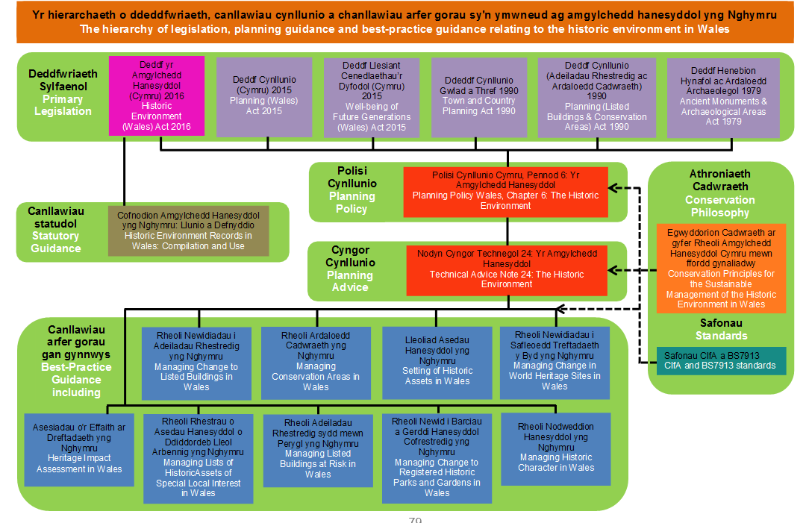

Appendix One: Hierarchy chart of legislation, policy and best practice guidance relating to the historic environment in Wales
Appendix Two: Raw data, converted from SPSS to Excel for clarity

Resp No | Role | Employer | Effective  cifacoc | Effective  watscoc | Effective  value | Effective  delivery
1 | 1 | 1 | 4 | 3 | 4 | 4
2 | 1 | 3 | 5 | 4 | 5 | 4
3 | 1 | 3 | 5 | 5 | 5 | 4
4 | 1 | 3 | 4 | 4 | 4 | 2
5 | 1 | 3 | 5 | 5 | 5 | 5
6 | 1 | 3 | 5 | 5 | 5 | 5
7 | 1 | 3 | 5 | 5 | 5 | 4
8 | 1 | 3 | 4 | 4 | 5 | 2
9 | 1 | 2 | 4 | 4 | 5 | 4
10 | 1 | 1 | 3 | 3 | 4 | 4
11 | 4 | 5 | 4 | 4 | 5 | 4
12 | 4 | 5 | 5 | 5 | 5 | 4
13 | 4 | 6 | 5 | 5 | 5 | 4
14 | 4 | 5 | 5 | 5 | 4 | 4
15 | 4 | 5 | 4 | 4 | 4 | 3
16 | 4 | 5 | 4 | 4 | 4 | 4
17 | 4 | 5 | 5 | 4 | 5 | 4
18 | 5 | 5 | 3 | 3 | 3 | 3
19 | 5 | 6 | 4 | 3 | 3 | 2
20 | 5 | 5 | 4 | 4 | 3 | 4
21 | 5 | 5 | 4 | 4 | 5 | 3
22 | 5 | 5 | 5 | 5 | 4 | 4
23 | 5 | 5 | 5 | 5 | 5 | 4
24 | 5 | 6 | 4 | 4 | 4 | 4
25 | 5 | 3 | 4 | 5 | 3 | 4
26 | 5 | 5 | 3 | 3 | 3 | 3
27 | 5 | 5 | 5 | 5 | 4 | 3
28 | 5 | 5 | 3 | 3 | 4 | 3
29 | 5 | 6 | 3 | 2 | 2 | 1
30 | 5 | 6 | 4 | 4 | 3 | 3
31 | 5 | 5 | 3 | 4 | 4 | 4
32 | 6 | 6 | 3 | 3 | 3 | 3
33 | 6 | 4 | 2 | 3 | 3 | 2
34 | 7 | 1 | 4 | 4 | 4 | 4
35 | 7 | 1 | 3 | 3 | 3 | 3

Resp No | RTPI | Fund  WG | Fund  UA | Loss  Arch res | Adverse  impstaff | Devfund | ProvNatgov
1 | 1 | 3 | 3 | 2 | 2 | 3 | 2
2 | 1 | 3 | 3 | 1 | 1 | 4 | 2
3 | 1 | 3 | 3 | 1 | 1 | 5 | 3
4 | 1 | 3 | 3 | 1 | 1 | 2 | 2
5 | 1 | 3 | 3 | 2 | 2 | 2 | 1
6 | 3 | 3 | 3 | 2 | 2 | 4 | 1
7 | 4 | 3 | 3 | 2 | 1 | 4 | 4
8 | 5 | 3 | 3 | 2 | 1 | 5 | 2
9 | 6 | 3 | 3 | 1 | 1 | 5 | 5
10 | 9 | 3 | 3 | 1 | 1 | 5 | 1
11 | 1 | 3 | 3 | 3 | 2 | 2 | 3
12 | 1 | 2 | 3 | 3 | 3 | 4 | 2
13 | 1 | 3 | 3 | 1 | 1 | 4 | 3
14 | 5 | 3 | 3 | 1 | 1 | 99 | 4
15 | 5 | 3 | 3 | 1 | 1 | 5 | 4
16 | 5 | 3 | 3 | 2 | 1 | 5 | 2
17 | 9 | 1 | 3 | 2 | 1 | 5 | 1
18 | 1 | 3 | 3 | 1 | 1 | 3 | 2
19 | 1 | 3 | 3 | 1 | 2 | 2 | 4
20 | 2 | 1 | 3 | 1 | 2 | 4 | 4
21 | 4 | 2 | 2 | 1 | 1 | 2 | 3
22 | 5 | 1 | 1 | 1 | 1 | 5 | 1
23 | 5 | 3 | 3 | 2 | 2 | 1 | 4
24 | 5 | 3 | 1 | 2 | 2 | 2 | 3
25 | 6 | 3 | 3 | 2 | 2 | 2 | 4
26 | 6 | 3 | 3 | 1 | 1 | 1 | 2
27 | 6 | 3 | 3 | 1 | 1 | 5 | 1
28 | 7 | 2 | 2 | 1 | 1 | 4 | 2
29 | 7 | 3 | 3 | 1 | 2 | 3 | 4
30 | 8 | 3 | 3 | 1 | 1 | 2 | 4
31 | 9 | 2 | 2 | 2 | 1 | 5 | 2
32 | 1 | 3 | 3 | 2 | 2 | 5 | 2
33 | 6 | 3 | 3 | 1 | 1 | 5 | 1
34 | 1 | 2 | 3 | 1 | 1 | 4 | 2
35 | 1 | 1 | 2 | 2 | 4 | 2 | 5

Resp No | Prov  Uni | Prov  Consultancy | Prov WLGov | Prov  Merged  WATs | Prov  PartnerWales | ConsEthics
1 | 1 | 2 | 3 | 3 | 2 | 10
2 | 1 | 1 | 5 | 4 | 3 | 10
3 | 2 | 1 | 3 | 5 | 2 | 10
4 | 2 | 2 | 2 | 2 | 2 | 7
5 | 1 | 1 | 1 | 2 | 1 | 10
6 | 1 | 1 | 1 | 3 | 1 | 10
7 | 2 | 1 | 4 | 4 | 3 | 9
8 | 1 | 1 | 2 | 5 | 3 | 10
9 | 1 | 3 | 1 | 5 | 3 | 8
10 | 1 | 4 | 2 | 4 | 3 | 10
11 | 1 | 3 | 2 | 3 | 3 | 7
12 | 1 | 1 | 2 | 3 | 3 | 10
13 | 1 | 99 | 4 | 2 | 3 | 8
14 | 2 | 2 | 4 | 4 | 3 | 10
15 | 1 | 3 | 3 | 4 | 2 | 8
16 | 2 | 2 | 4 | 2 | 3 | 6
17 | 1 | 4 | 4 | 2 | 3 | 2
18 | 1 | 2 | 1 | 3 | 2 | 10
19 | 1 | 3 | 4 | 2 | 5 | 10
20 | 4 | 2 | 3 | 4 | 4 | 9
21 | 1 | 1 | 5 | 5 | 4 | 10
22 | 1 | 1 | 4 | 4 | 1 | 10
23 | 2 | 4 | 2 | 5 | 4 | 5
24 | 2 | 2 | 3 | 2 | 2 | 9
25 | 1 | 2 | 3 | 4 | 3 | 8
26 | 1 | 1 | 1 | 1 | 1 | 10
27 | 1 | 2 | 3 | 4 | 3 | 10
28 | 1 | 1 | 2 | 2 | 2 | 7
29 | 2 | 5 | 4 | 5 | 4 | 9
30 | 1 | 2 | 4 | 3 | 1 | 9
31 | 2 | 2 | 4 | 4 | 4 | 7
32 | 1 | 3 | 2 | 4 | 3 | 10
33 | 3 | 1 | 99 | 4 | 2 | 10
34 | 3 | 2 | 3 | 2 | 3 | 8
35 | 5 | 5 | 1 | 5 | 5 | 99

Resp No | Role | Employer | Effective  cifacoc | Effective  watscoc | Effective  value | Effective  delivery
36 | 7 | 1 | 5 | 5 | 2 | 4
37 | 7 | 1 | 5 | 4 | 99 | 4
38 | 7 | 1 | 5 | 5 | 5 | 3
39 | 7 | 1 | 3 | 3 | 4 | 4
40 | 7 | 1 | 99 | 99 | 5 | 4
41 | 7 | 1 | 5 | 5 | 5 | 4
42 | 7 | 1 | 3 | 3 | 4 | 4
43 | 7 | 1 | 5 | 5 | 5 | 4
44 | 7 | 1 | 4 | 4 | 4 | 4
45 | 7 | 1 | 4 | 4 | 4 | 4
46 | 7 | 1 | 1 | 1 | 1 | 1
47 | 7 | 1 | 3 | 3 | 4 | 4
48 | 7 | 1 | 4 | 4 | 4 | 4
49 | 7 | 1 | 1 | 1 | 1 | 1
50 | 7 | 1 | 4 | 4 | 4 | 4
51 | 7 | 1 | 4 | 4 | 4 | 4
52 | 8 | 1 | 4 | 3 | 3 | 4
53 | 8 | 2 | 4 | 4 | 4 | 4
54 | 8 | 3 | 5 | 5 | 5 | 4
55 | 8 | 1 | 3 | 3 | 3 | 4
56 | 8 | 1 | 4 | 4 | 4 | 3
57 | 8 | 1 | 4 | 5 | 5 | 4
58 | 8 | 5 | 4 | 4 | 4 | 4
59 | 8 | 8 | 3 | 4 | 4 | 4
60 | 8 | 3 | 4 | 4 | 4 | 3
61 | 8 | 1 | 5 | 5 | 5 | 5
62 | 8 | 3 | 4 | 4 | 5 | 4
63 | 8 | 5 | 3 | 4 | 3 | 2
64 | 8 | 1 | 4 | 4 | 99 | 4
65 | 8 | 5 | 5 | 5 | 4 | 4
66 | 8 | 1 | 3 | 3 | 4 | 4
67 | 8 | 6 | 5 | 5 | 5 | 5
68 | 8 | 1 | 1 | 1 | 3 | 3
69 | 8 | 1 | 99 | 99 | 2 | 2
70 | 8 | 1 | 4 | 4 | 4 | 3

Resp No | RTPI | Fund  WG | Fund  UA | Loss  Arch res | Adverse  impstaff | Devfund | ProvNatgov
36 | 2 | 2 | 3 | 2 | 1 | 2 | 4
37 | 4 | 3 | 3 | 1 | 1 | 5 | 4
38 | 4 | 1 | 3 | 1 | 1 | 4 | 99
39 | 4 | 2 | 3 | 2 | 2 | 4 | 2
40 | 5 | 1 | 1 | 1 | 1 | 5 | 2
41 | 5 | 3 | 3 | 2 | 2 | 4 | 2
42 | 5 | 3 | 3 | 2 | 2 | 4 | 4
43 | 5 | 3 | 3 | 2 | 2 | 3 | 3
44 | 5 | 3 | 3 | 3 | 3 | 4 | 4
45 | 6 | 2 | 3 | 2 | 2 | 99 | 4
46 | 7 | 1 | 3 | 1 | 1 | 5 | 4
47 | 7 | 3 | 3 | 2 | 2 | 4 | 3
48 | 8 | 2 | 3 | 2 | 1 | 3 | 3
49 | 8 | 1 | 1 | 2 | 2 | 2 | 2
50 | 8 | 3 | 3 | 2 | 2 | 4 | 3
51 | 10 | 2 | 2 | 2 | 2 | 4 | 2
52 | 1 | 99 | 99 | 99 | 99 | 99 | 1
53 | 1 | 3 | 3 | 2 | 2 | 4 | 3
54 | 1 | 3 | 3 | 2 | 1 | 1 | 1
55 | 2 | 3 | 3 | 2 | 2 | 3 | 3
56 | 3 | 3 | 3 | 1 | 2 | 4 | 2
57 | 3 | 3 | 3 | 2 | 2 | 4 | 2
58 | 3 | 3 | 3 | 1 | 1 | 2 | 3
59 | 3 | 3 | 3 | 2 | 2 | 4 | 1
60 | 4 | 3 | 3 | 1 | 1 | 3 | 3
61 | 5 | 3 | 3 | 2 | 2 | 4 | 1
62 | 5 | 3 | 3 | 1 | 1 | 4 | 2
63 | 5 | 3 | 3 | 1 | 1 | 5 | 4
64 | 6 | 2 | 2 | 2 | 2 | 4 | 4
65 | 7 | 3 | 3 | 1 | 1 | 4 | 3
66 | 8 | 1 | 1 | 4 | 4 | 4 | 4
67 | 8 | 3 | 3 | 1 | 1 | 5 | 3
68 | 9 | 3 | 3 | 2 | 1 | 3 | 3
69 | 99 | 3 | 3 | 1 | 1 | 3 | 4
70 | 99 | 99 | 99 | 2 | 2 | 4 | 4

Resp No | Prov  Uni | Prov  Consultancy | Prov WLGov | Prov  Merged  WATs | Prov  PartnerWales | ConsEthics
36 | 5 | 4 | 4 | 4 | 4 | 1
37 | 3 | 3 | 4 | 4 | 2 | 7
38 | 99 | 99 | 99 | 4 | 99 | 9
39 | 2 | 3 | 3 | 3 | 3 | 5
40 | 2 | 2 | 1 | 3 | 3 | 9
41 | 3 | 3 | 2 | 2 | 3 | 7
42 | 2 | 4 | 4 | 4 | 4 | 10
43 | 3 | 2 | 3 | 4 | 3 | 9
44 | 2 | 4 | 2 | 3 | 3 | 8
45 | 3 | 3 | 4 | 99 | 3 | 10
46 | 2 | 4 | 2 | 4 | 2 | 10
47 | 4 | 2 | 2 | 4 | 4 | 9
48 | 3 | 2 | 3 | 4 | 3 | 9
49 | 2 | 2 | 3 | 3 | 2 | 10
50 | 2 | 2 | 4 | 4 | 4 | 10
51 | 4 | 3 | 4 | 4 | 4 | 5
52 | 3 | 3 | 1 | 3 | 3 | 8
53 | 1 | 1 | 1 | 4 | 1 | 10
54 | 1 | 2 | 3 | 5 | 3 | 9
55 | 2 | 2 | 3 | 2 | 2 | 10
56 | 4 | 4 | 2 | 4 | 3 | 3
57 | 2 | 2 | 2 | 4 | 4 | 5
58 | 1 | 1 | 5 | 3 | 3 | 8
59 | 1 | 4 | 4 | 4 | 4 | 5
60 | 2 | 4 | 3 | 4 | 4 | 8
61 | 2 | 1 | 1 | 3 | 2 | 8
62 | 1 | 1 | 4 | 3 | 1 | 10
63 | 2 | 2 | 4 | 4 | 3 | 10
64 | 2 | 4 | 4 | 5 | 3 | 8
65 | 2 | 1 | 3 | 2 | 2 | 9
66 | 4 | 4 | 4 | 4 | 4 | 10
67 | 2 | 1 | 3 | 5 | 4 | 10
68 | 3 | 2 | 1 | 3 | 3 | 6
69 | 1 | 4 | 2 | 3 | 3 | 10
70 | 2 | 2 | 4 | 4 | 4 | 3

Appendix Three: Answers to Question 10 online survey
Each paragraph is a single response

The service is currently underfunded. With the recent changes in the planning law in Wales there is an increase in enquiries for archaeological planning advice directly to WAT planning departments. There is no mechanism for this advice to be paid for. The quantity of the enquiries now presents a significant percentage of staff time and it is not clear how this is funded.

There are many feasible service delivery models, some of which present potential ethical issues which would need managing (as they currently are through the Code of Practice. I would think the main principles are: maintaining the provision of expert advice, maintaining a regional services (strongly linked to expertise) and adherence to the CIfA Standard and guidance for the provision of archaeological advice by historic environment services. With regards the latter, and my answer to Q.3, I'm sure all planning archaeologists in Wales are acting in accordance with the CIfA Code of conduct but as so few of them are accredited; it's hard to answer more positively.

Local Government / Welsh Government are not safe hosts given political nature of organisations, voluntary / private sector more appropriate, with any ethical issues dealt with by the relevant professional body.

Field experience of the Planning Archaeologist to monitor commercial site work is often far too little.

While planning archaeologists in Welsh Archaeological Trusts are protected from LPA funding cuts, they are vulnerable to cuts passed on by Welsh Government and national pressure that change of any sort is both necessary and positive. The planning landscape and market have changed since the Welsh Archaeological Trusts were formed and the fact that the Trusts also have a commercial function now means that the Trust decision makers are inevitably in a position of conflict of interest. Recent experience shows that planning/ curatorial staff are disadvantaged in this situation because of the disconnect between funding and workstream, and control over either.

The ethical issues in 9 are already present in the current arrangement. Despite the Code of Conduct there are numerous informal breaches of the Chinese wall, joint marketing and promotion through website, telephone answering and emails, and differential treatment of internal and external contractors. The WATs currently claim that their advice is based on deep regional expertise, however it is unclear whether those involved in screening and responding to development proposals have engaged sufficiently with the area's heritage to benefit from the WATs involvement in the majority of fieldwork in the area. In particular there is an over-reliance on viewing GIS data from the HER to indicate constraints without recognising that the HER data is incomplete (due to backlogs of data awaiting input) and inaccurate (due to defects in the records and sourcing). Generally archaeological planning in Wales is opaque and inconsistent in its decision-making process, over-concerned with the minutiae of specifications rather than the key principle of the need for the work, over bureaucratic in dealing with the application process, and dilatory in following up and signing off on conditions following completion. If the WAT system was providing a high quality responsive and informed regional service then it would be worthy of protection and enhancement; as it is, the benefits of a more independent, business like and focused service through a joint or centralised service outweigh the potential loss of local expertise.

I think a lot of the answers I've given above are more nuanced than the tick boxes allow. For example, Q3: the quality of advice given by the DC across the welsh trusts is dependent on individuals and is certainly variable both in terms of opinions/interpretations (e.g. about 'setting') and absolute quality. I would note this variability is worse in England, where EH and some county council-based staff are real mediocrities, while others truly expert. Q4. The 50% score indicates I don't really have the knowledge of RTPI to have a valid opinion. Q8. Again, so much depends on the quality of the staff we're taking about. An absolute 'no' to academics, and I'd worry about too much delegation down to a local level, thus fragmenting the planning process (and potentially unworkable for schemes which span multiple authorities). Equally, combining the 4 Welsh Trusts or centring advice in a national WG department risks losing regional expertise - though I would like to see the DC in the four trusts delivering more uniform advice/interpretation of policy. A consultancy is fine to a point, if staff are good and have the detailed local knowledge. But as my Q9 response shows, there are potential conflicts of interest - actual or perceived - where a consultancy seems to profit subsequently from an earlier advice-giving phase. Though of course the Chinese walls of the Welsh Trusts are just as suspect!

Charging developers for advice is a good way forward. But there needs to be a measured standard of response- eg supplying Briefs, approving WSIs etc. within a set timescale

The current system appears to work well however funding is poor. Advice coming from a non-governmental organization enables a much greater level of objective advice without getting too caught up in political agendas. However clear divisions need to be ensured within the Trusts between the contracting and curatorial advice arms (this includes clarity over how the overarching role of a director/chief executive works) to ensure this objectivity. Funding is poor and could be much enhanced. There needs to be a much greater recognition of the expertise involved and value of the advice in ensuring the conservation of the finite resource that is the Historic Environment. For accelerated or large (notably infrastructure) applications developer funding for advice should be mandatory to ensure adequate resources can be made available to meet time pressures.

It is a service which needs to be well supported through funding, for both wages and for suitable IT resources. A deep knowledge and understanding of both the archaeological and planning systems at a local level are fundamental to a successful service and therefore appropriate staffing is essential.

The funding of regulatory functions such as archaeological planning must be maintained (either through national or local government, ideally both) and expertise should be provided at a local level by impartial curators. Other potential funding streams such as developer-funding of certain functions should be explored.
Slightly confused by question 8 [other providers] as all of the services could be provided by these organisations if they employed qualified staff! Currently however apart from WATs and Cadw no other organisations apart from 2 NPs and 1 LPA have any qualified archaeologists.

Greater staffing needed and a standardisation of requirements

With regard to Question 9 [ethics], this already happens as the WATs provide planning advice, and undertake consulting and commercial work, competing with other professional archaeologists. The general public do not understand the difference between the WATs planning archaeologists and the contracting teams.

I think there are current ethical issues with the Trusts having commercial arms and a close relationship with planning services. Paper walls cannot hide the fact that both sides have joint staff meetings, are in the same buildings, and are paid from the same payroll. I do not think that there is evidence of bias at the moment but the system is open to abuse and external scrutiny.

The planning needs to be moved outside the Trust system to remove all conflict of interests/perceived conflict of interest with their commercial arms

The level of planning advice depends very much on the particular Trust in Wales. Some are over-zealous, others are particularly relaxed. For archaeological contractors the most confusion arises from having to deal with arch planners from the National Parks at the same time as the Trusts. Too many cooks!

The above scores are averaged, there is a high degree of variability, particularly between the Trust lead planning and that offered in the National Parks

Funding delivery through increased planning fees and PPAs [pre-planning applications] could be a useful future model or delivery through a regionally based Welsh Government department like the NRW model.

Provision of appropriate levels of funding to support archaeological planning in Wales is core to ensure that Wales' archaeological heritage is protected

I think the current system works well - compared to the increasing chaos in England, for example. And recent Welsh legislation has underpinned the HER function of the Trusts, so enabling more secure forward planning for resourcing the planning archaeologists. The idea of the pooling of environmental planning advice in to regional hubs seems to have gone away, but may be a solution if funding continues to be cut. All in all, I think archaeological planning in Wales is in a relatively good place.

Underfunded service. Good legislation, supportive policy. Under pressure from developers archaeologists. Financing could be linked through planning authorities more strongly. Welsh Trusts merging may provide more stable and strong protection of archaeological resource and more effectively delivered.

Expert local knowledge is essential, experience suggests that a consultancy (especially if based outside Wales) often does not have sufficient local knowledge, especially of the Welsh social, language and ecclesiastical issues needed to provide the level of detailed advice required

My main concern is that archaeological planners in Wales do not have enough power / clout to be able to raise issues with poor archaeological practice from contractors (any contractor, whether within the Trust system or externally). They sometimes let poor practice go as they do not have the backing of the Welsh planning system, local govt or Cadw to raise concerns.

Central/Welsh Government should provide additional funding. I have no concerns regarding the use of consultants provided they are appropriately accredited members of a professional body, and therefore must abide by a code of conduct. Limited resources should be focussed on sites that matter the most: the service sometimes feels like developers are paying to fund someone's hobby. The impact of archaeological costs on development viability should not be underestimated - this work can cost us an affordable house or two, so we are literally studying things to re-bury them at the expense of housing someone in significant need.

Provided that the level of expertise is high, as it is now, it makes little difference what organisation provides the planning service provided that there are no conflicts of interest and that critically there continues to be a planning service. Funding should be provided by WG and Local Authority at a level commiserate with the volume of planning case work, for example those areas with higher planning applications and development should receive more funding than an area with significantly lower numbers of applications.

It needs to speed up and be consistent across the country

Very satisfied with service provision despite very tight budget constraints faced by GAPS and CPAT. Always very helpful, knowledgeable etc.

It's important to keep the service neutral and ensure the expertise is retained with sufficient funding. Bringing it into local government would do the opposite to this

WAT planning officers need to meet more regularly with LPA planners to explain the levels of service and value for money. And I mean planning officers not the usual BS from trust directors!!

The current system of advice from Trusts appears to be working well generally with useful advice received at pre-app and application stages.

Planning costs should be the responsibility of applicants, to overcome cuts in funding to LPAs from central government. The Welsh Trusts provide a high quality service which applicants benefit from, and which therefore should be chargeable to applicants if not funded centrally, to ensure planning legislation, policy and guidance is applied consistently, and that the historic environment is protected for future generations.

I think there are very few people in the profession will the skills and experience to do this work. I also think that the planning services do not maximise their potential in demonstrating how valuable a service they provide, how skilled they are in providing that service and how much value for money they provide. I think it would be easy for local authorities to be taken in by the good advertising consultants do to allow them to be swayed that they could provide something bigger and better than currently. Staff should market themselves and their services better and train others and raise awareness of the work they do and have a more client centred approach rather than just hoping that the status quo will prevail.

A lack of understanding between what can be conditioned or controlled as part of the planning process versus archaeological standards often results in inappropriately consultations and conditions being requested. There appears to be a significant amount of good work being carried out by the archaeological trusts, however, this is not necessarily related to what the planning departments require.

The LPA has a good working relationship with the local archaeological planning service in Gwynedd by providing advice on planning applications.

Re Q9 [ethics]. There is always a potential for conflict of interest in a "whoever pays the piper calls the tune sense" but a well thought out code of business ethics should resolve it

Care needs to be paid in the costs benefits of a larger organisation (eg Welsh Govt/Merged Trusts) against the loss of local knowledge. Whilst there are, in my opinion, clear ethical issues arising from a consultancy providing advice and undertaking subsequent work this can (and should) be managed.

Hi, your questionnaire doesn't have box for don't know! I have fundamental concerns with the Trusts and how they are organised, funded etc. - the ethos of why they were set up and how seems to have been forgotten and their funding stream (like all) is under pressure - similar issues to the Biodiversity Centres - a similar situation/mess

The issue is that consultants paid for by developers may conveniently not find things of archaeological interest. That would be impossible to enforce against from a planning point of view unless we were to then consult our own archaeological planners, at which point it costs the LPA money anyway.

Archaeological Trust provides an efficient service as our advisor. Welsh Government need to ensure that adequate resources are made available to ensure that this function and service is maintained.

I believe the current system works well with ease of contact with our provider for day-to-day queries as well as formal consultation on applications. Archaeology is an important resource that can sometimes get overlooked even now in appeal decisions etc., and the concern is that a Welsh Government set up would not be so amenable to offer local government advice (e.g. Cadw). Similarly if transferred into local government, then it is more likely that differing authorities would seek to reduce expertise in cost cutting, and the service would become patchy.

Many consultants are not abiding by CIfA guidelines and are not unbiased; there are a few we would like to blacklist. Advice should be impartial.

I feel that the four trust system currently in operation works effectively; it enables regional specialism to be developed whilst also being largest enough to avoid parochialism. Having the service provided by a private contractor opens the system to a host of issues and could ultimately end in a situation where certain areas of Wales have no cover, as they are deemed unprofitable.

I agree that there could be ethical issues with a consultancy delivering the service, but also acknowledge that there is the same level of possibility for ethical issues in the current system. It's more luck that most curators have strong moral values and do their best to adhere to policy and guidance. It depends on the individual.

Appendix Four: Responses to email interviews

What are the strengths and weaknesses of the current system, from your point of view at the delivery of them?

Respondent 1
Strengths: Expertise retained, WAT not restricted by LA governance.
Weaknesses: Sat outside the LPA departments, WAT are essentially seen as another consultee. Archaeology not ‘owned’ by LA.

Respondent 2
The strength of the current system is that all LPAs in Wales have access to independent advice on archaeological issues from professionally qualified archaeologists through the Welsh Archaeological Trusts’ (WATs) archaeological planning system. The information required to assess the impact of a proposed development on the historic environment is available from Historic Environment Records which are sponsored by the Welsh Government and are statutory instruments which the LPA must use.

The biggest weaknesses is due to the archaeologists not being part of the LPA they are often not consulted internally by the Council when developing regeneration projects and improvements to the landscape even when the historic features are the focus of the project. They are also sometimes not included in a non-statutory consultations between LPAs and developers as the meetings are often held in council offices a long way from the WATs offices. There is also a perceived issue that the advice given by WATS is not independent as they also have commercial archaeological units. This is despite there being a clear Code of Conduct approved by Welsh Government ensuring that the officers providing advice to the LPAs are independent of the commercial work of the WATs and no evidence being produced that such collusion is happening after the system has been in place over 30 years.

Respondent 3
Strengths – the most obvious strength to highlight at the outset is cost effective delivery for clients at LPA. The service being held centrally within the WATs (excepting national parks) and serving a region with numerous clients has I feel been important to staving off any reduction/cuts to archaeological planning advice in Wales. This is in stark contrast to England where in the majority of cases this service has been provided within local authorities at a higher cost where the number of local authority planning archaeologists has nosedived since 2008.

Other strengths – the regional nature of the current service means there is greater ability to assess the impact of development across a wider area & put results of work into a bigger picture context. This is also the case when you scale up to pan-Wales level, and think about the cross trust and national park working in terms of communication (ALGAO Cymru), it is quick and easy to communicate as a group and share important information. This is actually quite interesting I think my suspicion would be that in Wales the way the service is provided we have a better idea of the impact of development on archaeology & what is changing in terms of understanding.

The biggest weakness as I see it is the lack of close working relationship with local authorities. The face to face/personal service element of our work needs to be developed, so that planners know who to call and when. This is something that could be achieved with the service remaining centralised but with increased staffing and funding for time spent out in local authorities…perhaps as a regular day a month with each LPA and annual feed events (like the old heritage forum meetings, but more focussed).

Other weaknesses relate to consistency in advice across Wales….CIfA guidance is overarching, but need more specific guide for work in some cases. GGAT are working on a document to guide work and advice (akin to the SW Heritage Trust guide). This is also a reflection of the lack of a clear training/qualification process or criteria for “being” an archaeological planner.

To what extent do you feel that there is adequate and accurate feedback and liaison between the WATs and Local Authority Planners?

Respondent 1
Limited extent: Through planning applications the communication is controlled

Respondent 2
I am not certain what feedback you are referring to here. Can you please give further information.

Respondent 3
This is extremely poor & the weakest part of the service. I feel this is reflects a lack of funding to deliver this, no funding is really set aside for this type of work and this is no real clarity as to how clients at the LPA expect this to be delivered as a part of the service. Greater emphasis needs to be placed on feedback between the WATs & LPA.

If not, how can this be achieved?

To what extent do you consider there to be a shortfall in financing services such as WATs archaeological planning?

Respondent 1
Uncertain of the finances involved.

Respondent 2
What evidence is there that the WATs archaeological planning services are underfunded? Are services not being carried out? Are planning applications not being responded to?

Welsh Government currently funds the archaeological planning services of the WATS over £280,000 per annum to undertake the identification of development that are likely to have an impact on the archaeological resource and to provide initial advice on these application. This sum is “ring-fenced” and has increased with inflation over the last three years. This money allows each trust to fully employ one officer, with the Glamorgan-Gwent Archaeological Trust receiving additional moneys to employ a second full time officer due to the number of application in their area. It should also be noted that the Welsh Government also funds the input of new information deriving from planning work into the Historic Environment Records.

Across Wales LPAs provide circa £85,000 to the WATs archaeological planning service an average of c.3,850 per LP; however it should be noted that the 12 LPAs in the GGAT area contribute c.£55,000 between them, an average of c £4600 each.

The LPAs need archaeological planning advice to fulfil their service, but currently only contribute circa 23% of the costs of receiving this advice.

Respondent 3
Yes there is. In the most basic sense this has impacted on our ability to recruit experienced and suitably qualified archaeological planners to our team at GGAT. This has been problematic following the departure of long term experienced staff from the department.

The lack of suitable finance makes it difficult to allocate resource to follow up on results of advice given. This is an issue as we are not measuring the impact of our advice in a consistently or if our advice is even taken & if not why not. This is so important to understand to help provide a good service to clients and archaeology and we are not even close to this.

In your opinion, should Welsh government provide more?

Respondent 1
If Welsh Government legislates; it should make appropriate resources available to implement the legislation in full.

Respondent 2
In my opinion the level of funding from Welsh Government for the initial archaeological planning service is adequate. In the last three years the funding for Cadw has been reduced by some 20% but the budget for the WATs archaeological planning service has been maintained at the same level and increased by inflation

Respondent 3

If LPAs are too stretched to provide more, even if there is a statutory requirement to have this service, how could this shortfall be met?

Respondent 1
WAT to instigate ‘peer reviews’. Establish the ‘statutory’ minimum as a baseline. Establish a vision of what the WAT could be and seek investment to achieve it (not from government sources).

Respondent 2
An increase in planning fees would be obvious. These fees are controlled by the UK Government however it should be noted that the UK Government has offered to raise planning fees by up to 20% from July 2017 in exchange for the Councils undertaking to spend the additional income on improving planning departments' service and performance. Presumably such improvements in performance could also cover the WATs archaeological planning service.

The LPAs could also add fees to discharging conditions and this could include monitoring of archaeological works

Respondent 3
More money…from LPA clients?? Improved professional relationship with LPA clients…actually treating them like clients and sending expert team to provide specialised advice in cases where extra provision is needed. Being essentially more business-like and slick…this can potentially allow us to increase charge for service.

Realistic Cadw grant…they keep asking for more, but no real terms increase in provision has been forthcoming.

How can improvements be made to the current system in order to meet the complexity and number of planning applications?

Respondent 1

Respondent 2

The Welsh Government has recently issued TAN24 which clarifies how the historic environment should be considered in the planning system. It has also produced a series of guidance documents which should assist in applications being appropriately documented and so speed up decision making,

CIfA, IHBC and IEMA are jointly authoring new guidance on impact assessment for cultural heritage which it is hoped will improve the standard of information on archaeology and other historic environment issues presented with planning application, which again should assist in making decisions easier see link below for more information.

Article: http://www.archaeologists.net/news/collaboration-breaks-new-ground-industry%E2%80%99s-first-guidelines-impact-assessment-cultural-heritage

Respondent 3

Considering the WATs planning staff and their experience, if you feel there is a need for more experience in planning or training, how can this be achieved?

Respondent 1
Unsure of WATs planning staff and their experience.

Respondent 2
Although all of the WATs are Chartered Institute for Archaeologists Registered Organisations, individual officers should all be corporate members of CIfA and at least the lead officer of each WAT archaeological planning service should be a full Member. This would show a commitment by the individuals to working at professional standards and also add weight to the advice given to LPAs especially if an application becomes the subject of an appeal.

Whilst formal training is difficult, meetings with LPA planning officers would allow both sides to discuss the level of information that is required to be produced and submitted in response to planning applications.

There may also be a need for meetings between the four WATs planning teams to ensure consistency of advice across Wales.

Respondent 3
The situation is dire, staff in current planning teams work hard but skill and experience is less than one would hope…as succession planning has not been addressed, nor have jobs been advertised at appropriate level when they have become available. We are sleepwalking into a mess if we don’t start adding to the pool of skilled people working in Wales.

Reasonable wages are important, but so is working environment. People need to want to work in Wales and for WATs. At the moment I think the reputation of the WATs as a place to work isn’t great (even though there are some amazing benefits).
We need to create an environment that is enticing to come to and one where people feel they are contributing to positive work. There also needs to be a chance for people to develop and innovate, as well as have clear opportunities for career progression.

Some minor restructuring & review of recruitment policy. Most importantly though we need to develop a career path for planning archaeologists, and put in place clear progression steps & provide necessary training. A bit like an NVQ…possibly in partnership with town planners and universities??

Wales Council for Voluntary Action: the national membership organisation for the third sector in Wales.
Chartered Institute for Archaeologists: the leading professional body representing archaeologists working in the UK and overseas.
Registered Organisation: CIfA's Registered Organisation scheme is a unique quality assurance scheme. There is no equivalent in the historic environment. It is a ‘kite mark’ of commitment to professional standards and competence (http://www.archaeologists.net/regulation/organisations).
Association of Local Government Archaeological Officers: provides a forum representing archaeologists working for local authorities and national parks throughout the UK. http://www.algao.org.uk/
Many major cities in England and Wales had their Medieval and early post-Medieval narrow streets, buildings, bridges and layouts demolished and removed due to the pressure of access for modern traffic and the need for updated safety and services in buildings.

