Name : Ravi Sukhrani
Student ID: 1916534

Problem Solving and Decision Making

Contents
Introduction 2
Analysis of problem with scope and its impact 3
Analysing of this complex problem 3
Decision-making tools and techniques to identify solutions for Associated British Foods Plc to resolve their existing problems. 4
Suggestions whether proposed solutions better or not based on Fishbone analysis 7
Implementation of plan B as it is considered appropriate enough 8
Communication of plan with expected stakeholders 9
Monitoring and review of technique 9
Conclusion 11
Reference 12

Introduction
Associated British Foods Plc is a known company in the food processing industry of UK and they have a reputation in serving quality food to the customers but recently the company is facing the problem of losing the quality of products. In this report, two solutions will be presented along with the feasibility analysis of these selected solutions through PESTEL, SWOT & FISHBONE analysis. And in addition to that, the implementation approach and monitoring approach after proposed solution implementation will also be disclosed here.

Analysis of problem with scope and its impact
Associated British Foods Plc. is a very known and reputable company and by maintaining the quality of foods they are serving people for about 85+ yeast. But recently Associated British Foods Plc. Company is facing a problem that the quality of their foods in Allison, Agro, Capullo and Billington’s brands have been drastically fallen due to the inefficiency of their existing employees. The scope of the problem will mention why this problem is occurring within the organisation and the prime reason is undeveloped training process which is used for the employees of the organisation and in addition to that the organisation doesn't arrange several seminars for enriching the knowledge, efficiency, and capability of employees about updated foods item which wanted by the customers of theirs. And this problem will cause the organisation to face a deduction rate of profitability condition and in addition to that, this phenomenon has a debacle impact also (Shapira, 2016).
Now the impact of this problem on Associated British Foods Plc will be exposed.
- This problem may resist the Associated British Foods Plc from obtaining a competitive advantage by competing with the rivals of there and this is a very negative impact arising from this problem.
- This problem may cause for losing the loyal customers of the organisation which may exist with the organisation if quality foods are supplied to them by Associated British Foods Plc.
- This problem may reduce the profitability of the organisation at a high rate.
- This problem may cause Associated British Foods Plc to face the loss of market share.
These are some negative impact which arises from the existing problem of Associated British Foods Plc.

Analysing this complex problem
The problem which is faced by Associated British Foods Plc. is the reduction of quality of products which are supplied by the organisation to the consumers which problem has arisen from the reduction of performance of employees in term quality of performance. This problem is very complex because this problem can create some other problems also for Associated British Foods Plc and this complexity will become very giant as Associated British Foods Plc is a well-based company. The problem can create some other problems for Associated British Foods Plc rather than solving this problem easily. And those further created problems can be forming belief of customers will be very challenging for Associated British Foods Plc as their current problem breaks the belief of customers. Here the problem of Associated British Foods Plc is considered a complex problem because it isn't easy for them to manage the problem within a short time after recognising the problem. Here the problem which causes for experiencing a bad situation for the organisation by considering the current market situation. Associated British Foods Plc needs to introduce some changes in the brand of food items like in Allison, Agro, Capullo and Billington’s from which the problems have been generated as reduction of quality.

Decision-making tools and techniques to identify solutions for Associated British Foods Plc. to resolve their existing problems.
Here decision-making tools will be used to identify the viability of solutions for Associated British Foods Plc. and those tools are SWOT analysis, PESTEL analysis, and Fishbone analysis. Here selected two solutions are:
Solution A: Ensure financial motivation for the employees by extending their salary so that they work hard and maintain product quality.
Solution B: Ensure training opportunities for the employees so that they work hard and maintain the quality of the product.
PESTEL ANALYSIS:
PESTEL ANALYSIS | EXPLANATION
Political factor | Solution A: Like providing financial motivation can be impacted by the government's law when the government imposes any standard regarding employee’s scale.  Solution B: The labour law of political factors may support the second solution for the improvement of employees.
Economical factor | This bad economic condition due to covid-19 may not support the organisation to follow solution one which is about providing financial motivation to the employees by extending their salary scale.  In addition to that time, this bad economic condition due to covid-19 may not support the organisation to invest more in the employee's development segment (Proctor, 2014).
Social factor | The belief of employees as a social being that increased salary rate and ensures financial safety and their honourable position too. And this social thinking supports the first solution which may instigate employees to work more.  Employees' training program arrangement frequently by the organisation is thought by social people as the way of developing the quality of products.
Technological factor | The technological variable like R&D segment analysis considers that these two solutions are very feasible to eliminate their existing problems.
Environmental factor | These two solutions are formed to ensure the quality of products so these will be an eco-friendly strategy where the benefits of consumers will be thought of (Shapira, 2016).
Legal factor | The extension of salary as a solution may be impacted numeration law where a lower salary from the standard will be considered as humiliation and a higher salary will be considered as a bribe.  Training opportunity as the second solution should be formulated based on health and safety law as a deviation from this law will be considered as a crime.

SWOT ANALYSIS
Strength of solution A & B  Solution A:  - Financial motivation works more effectively for improving the employee's intention to work with feasibility to ensure the quality of the product (Fitzgerald, 2012).  Solution B:  - Proper training opportunities will increase compressor efficiency and skill which will support providing quality products to the customers. | The weakness of solution A & B  Solution A:  - The bad economic condition of this organisation won’t support them to extend salary according to the expected rate of employees.  Solution B:  - The poor financial condition of the organisation won’t support them a lot to invest more in the employee development segment.
Opportunity for solution A & B  Solution A:  - This solution will motivate the employees a lot and as a result, the employees will be attracted enough to work in a feasible way which may help the organisation to ensure availability of several standard and quality foods before the customers and can make a long-run relationship with the customer.  Solution B:  - This solution will ensure the efficiency level of employees which will help the organisation a lot to grasp market profitability. | The threat of solution A & B  Solution A:  - Associated British Foods Plc may face scarcity of money in the time of implementing the strategy (Proctor, 2014).  Solution B:  - Improper management can never ensure success and if the training seminar is not managed effectively then the main motive may go in vain.

Fishbone understanding and its application
Fishbone is generally known as a cause-and-effect diagram through which organisations can track some information regarding the logic of variation, defects, imperfections, and failures (Proctor, 2014). Here through Fishbone analysis, the problem will be generalized for deriving a solution.
- Fishbone Analysis to derive solution A
Through Fishbone's analysis, it is understood that the existing employee’s motivation level has fallen and they are not attracted to work with devotion. In addition to data organisational environment is not supporting, the method of working is also poor as a result the quality of the performance of theirs has fallen result in low-quality products in this situation this step for providing financial motivational to the employees will be a genuine solution to solve the problem. Fishbone Diagram for solution “A” showing cause and effect
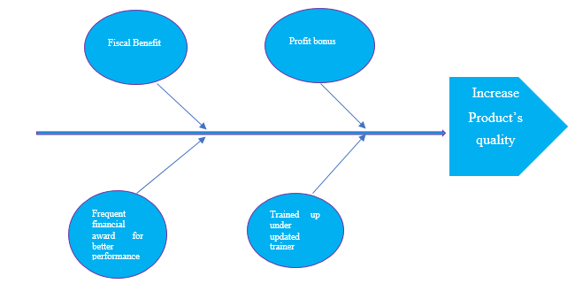
Figure 01: Fishbone Diagram (Self-created)
- Fishbone Analysis to derive solution B
Employees of the organisation facing severe problem including the lack of training opportunities, the pressure to work more without motivation, lack of knowledge to launch machine for producing foods with standard, lack understanding in processing, etc. And this problem is resulting in poor product’s quality. And the solution of providing training opportunities to the employees will be a capable solution to deal with the problem.

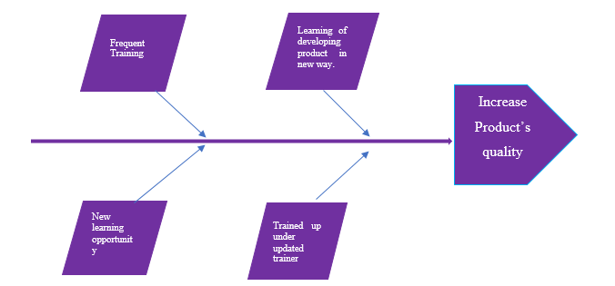
Figure 02: Fishbone Diagram (Self-created)

Suggestions whether proposed solutions better or not based on Fishbone analysis
Solution B would be the best solution to deal with the identified problem of the organisation and after applying the Fishbone analysis and knowing about the problem of the organisation that solution is thought to be viable enough.
Solution A: Solution A may not ensure the quality of products because the inefficiency of the employees cannot be eliminated based on the proposed solution and this may not ensure product's quality to a high extent. Though motivation enriches employee's performance intension but doesn't increase the quality level of performance.
Solution B: Solution B is considered to be appropriate enough because this solution like providing training opportunity to the employees will improve the quality of performance where the employees will become enable to learn about machine launching for producing the products effectively and in addition to that they will become capable of to launch effective processing. In this way, solution B will be more appropriate to deal with the problem.

Implementation of plan B as it is considered appropriate enough
The ADKAR model can be used to implement the solution B for resolving the identified problem and this ADKAR model indicates how change management can be introduced as a solution to make the business successful (Shapira, 2016).
A = Awareness | Awareness is needed to introduce the new training process so that employees learn more from the training opportunity
D = Desire | Associated British Foods Plc and the employees of theirs should have effective intension or desire to support the new change or model of training (Proctor, 2014).
K = Knowledge | Knowledge should be ensured about how this new training facility will be introduced. Here Associated British Foods Plc should introduce online and offline training opportunities to the employees as employees spend most of the time in the online zone also.
A = Ability | Here Associated British Foods Plc can arrange the training facility before the employees as a solution of solving the problem as the organisation has financial property.
R = Reinforcement | This solution will be introduced in a way so that this sticks with the organisation for the long run to ensure organisational success (Fitzgerald, 2012).

Communication of plan with expected stakeholders
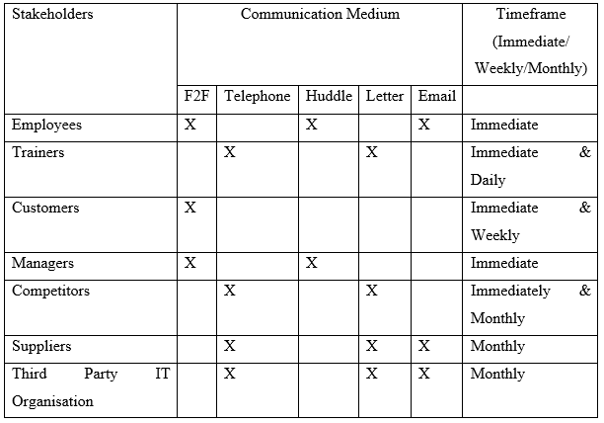

Monitoring and review of technique
Some techniques will be used here for monitoring the proposed solution for ensuring whether this solution working effectively or not.
- Product quality: If the quality of products increased then the proposed solution will be considered fecund and if not then the organisation can take some necessary steps (Shapira, 2016).
- Customer’s feedback: The customer’s review justification will be another technique that may support the organisation to measure whether the proposed solution is working or not. And if not working then the organisation can apply some steps to resolve the problems.
- Productivity: Justification of increment of production technique which can be used by the organisation to justify the fecundity of their existing solution.
- Trainer feedback: If the trainer said that the employee's performances have been developed after training then this phenomenon will be considered fecund otherwise some required steps should be taken (Proctor, 2014).
In this way, the monitoring of the proposed solution's viability can occur.

Conclusion
The problem occurs within the organisation for many reasons where some of the problems are avoidable and some problems are unavoidable. In this report, the selected organisation like Associated British Foods Plc is facing the problem of losing the quality of products and this problem can be avoidable in many ways. Here two solutions have been presented along with the feasibility analysis of these selected solutions through PESTEL, SWOT & FISHBONE analysis. And in addition to that, the implementation approach and monitoring approach after proposed solution implementation has been disclosed here.

Reference
Berry, J., and Bartholomew. 2017. Every Kid's Guide To Decision Making And Problem Solving. Chicago: Children's Press.
Brest, P., and Krieger, L., 2010. Problem Solving, Decision Making, And Professional Judgment. Oxford: Oxford University Press.
Dittmer, R., and McFarland, S., 2018. 151 Quick Ideas For Delegating And Decision Making. Franklin Lakes, NJ: Career Press.
Fitzgerald, S., 2012. Decision Making. Oxford: Wiley.
Leonard, B., 2016. Multidimensional Decision Making. [Bradford, England]: Emerald.
Linstone, H., 2019. Decision Making For Technology Executives. Boston: Artech House.
Proctor, T., 2014. Creative Problem Solving For Managers.
Richardson, L., 2018. Creative Problem Solving. Delhi: Global Media.
Shapira, Z., 2016. Organizational Decision Making. Cambridge: Cambridge University Press.

