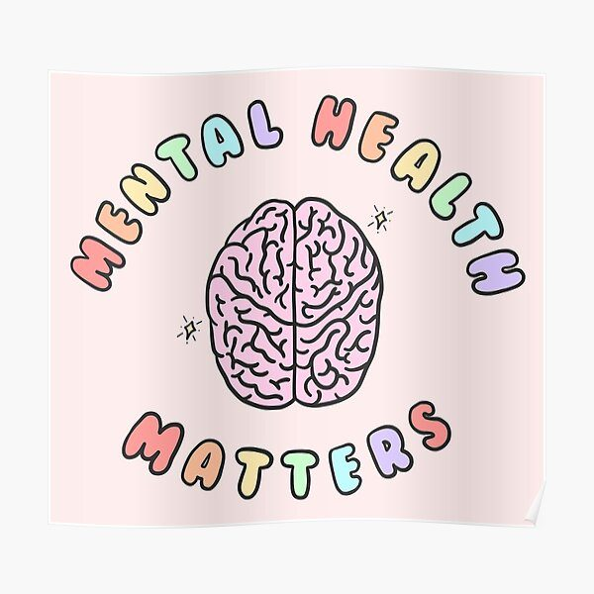  E-Portfolio evidence of learning comprising of 2 separate artefact items | Name: Mohammad ilyas  Student number: 2029045  Module: Changemakers: Creativity and Value Creation (part 1 0f 2)  Module code: BMHP5014_BIRM  Lecturer name: Robert Nartowski

A BLOG:
My project idea is a new plan which I have identified a gap in a service. I am going to use two artefacts to explain my plan, one is a blog and second is a poster.
I want to open up a care home where I can provide support to the people physically as well as mentally. And give one to one sessions to young youth as well with mental health illnesses. Such as, depression, anxiety etc. the ones who started to taking drugs because of the disturbance of their mind. Such as, ex-prisoners.
How I come up with my project idea. Once there was a friend of mine and he was going to visit his grandmother in a care home, so he took me with him. There I have seen so many faces just laying down in the bed. Some was sitting there waiting and hopping for their children and family members to visit them. As we entered to the care home there was a women walking in a lounge and suddenly asked my friend, ‘oh are you my son’. After this I have seen a patient who was going through depression and sitting by the window crying. I have noticed there was a staff who just came up to him cleaned his room, gave him medication and food and left. This just broke my heart. That day I have decided that in future I am going to open a care home where they have been provided with help with their mental state.
I feel as though providing a mental support to the people is really important specially in a care homes. Most of the people don’t take mental health a serious illness. Even teenagers are going through a depression. I just don’t want to help older people but I want to help any age of individual who is going through this phase. I want to make sure in my care home that everyone is getting checked from doctors or specialists every other day. I want to provide the quality care and an environment where they don’t feel alone and share whatever is in their heart and mind. I want to make sure in my care home there’s been given a one-to-one session on their mental and physical health. As I have explained in a poster, we will take care of a people’s mental health in our care home. You can access to this website for more information. https://www.carehomeprofessional.com/government-must-address-social-care-mental-health-crisis-says-gmb/

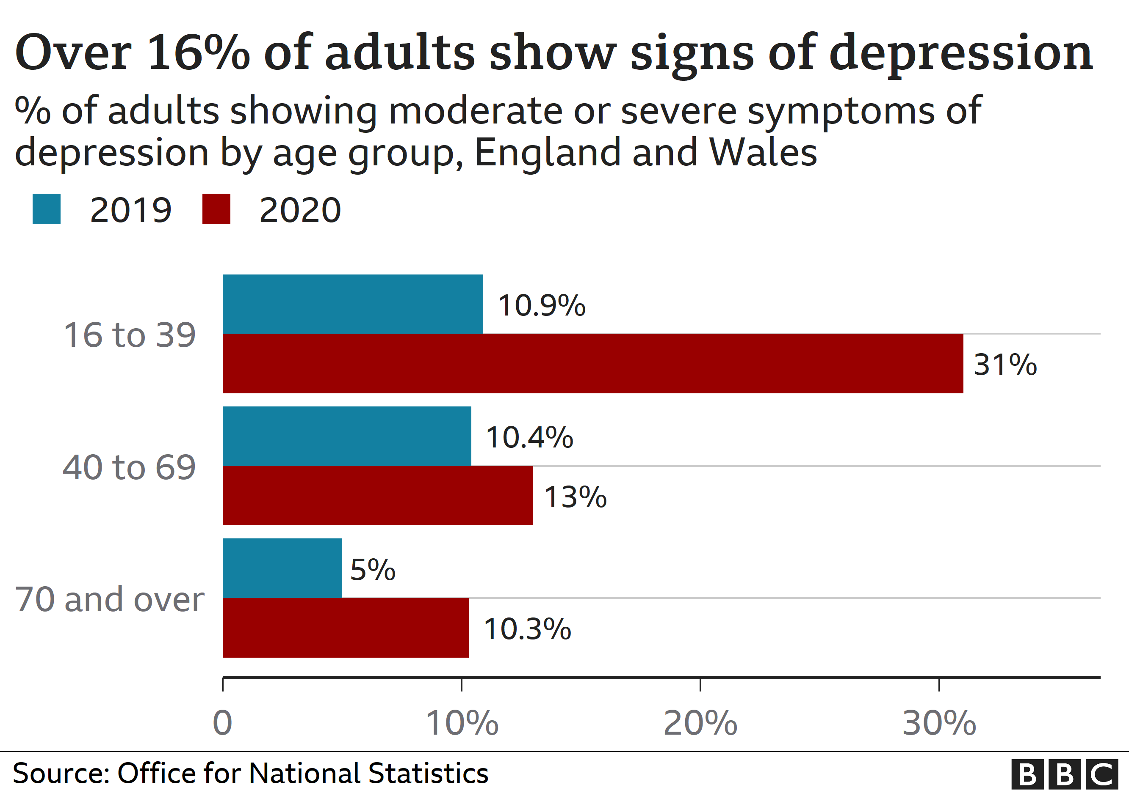

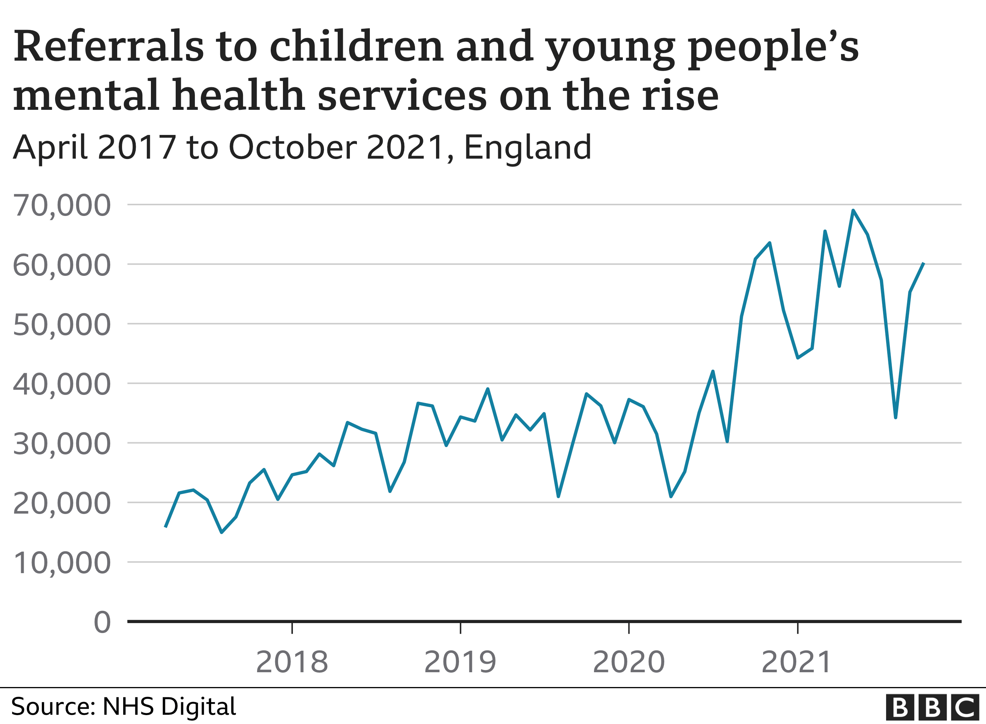

This graphs shows the worsening of mental health of people since past few years different age groups. Depression can manifest in a variety of ways, many of which are so subtly hidden that they go completely unnoticed. In order to recognize personality changes that might be an indication of depression or other mental health concerns, caregivers must truly get to know and understand the unique needs of individuals they serve. This means adopting a person-cantered approach to care.
After the UK separates from Europe and a lot of nurses and caregivers had to leave their jobs and move back. This left NHS and care homes specially in a staff shortage. This is the second most important reason of not providing quality care to the patients. Long waiting lists in NHS. Most people can’t get an appointment on time. A lot of elderly people waiting for their medications. In care homes they are not taken care how they should be. Care homes are in staff crisis as well. I am studying this course to pursue my career in this and give my best of services to the people with mental health issues and provide them shelters.
Would any of us want someone else to take care of us, to see and clean our private parts of our bodies? Our goal is to make sure that we try to reduce the discomfort as much as we can and to relieve them of any guilt they might force to feel through sensitive approaches and communication. Citizens are to both embarrassed and guilty that this needs to be done for them. As this will increase their level of independence encourage and help lessen any feelings of shame or guilt, we should of course always help residents in doing as much as they are able to.

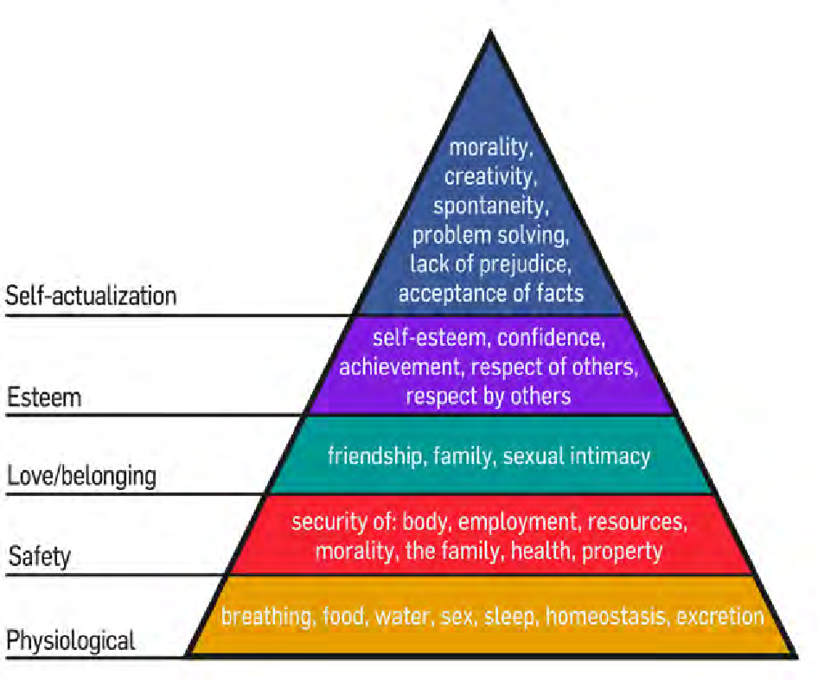
We only have to consider ourselves when figuring out what a resident in our care might need if they aren't fully able to communicate their needs or manage their care independently, just like with food and drink. Staff members will conduct a skin assessment within the care facilities to determine whether a resident is particularly at risk for skin deterioration, which allows us to apply extra preventative measures like air mattresses, air cushions, or repositioning routines.

A poster:
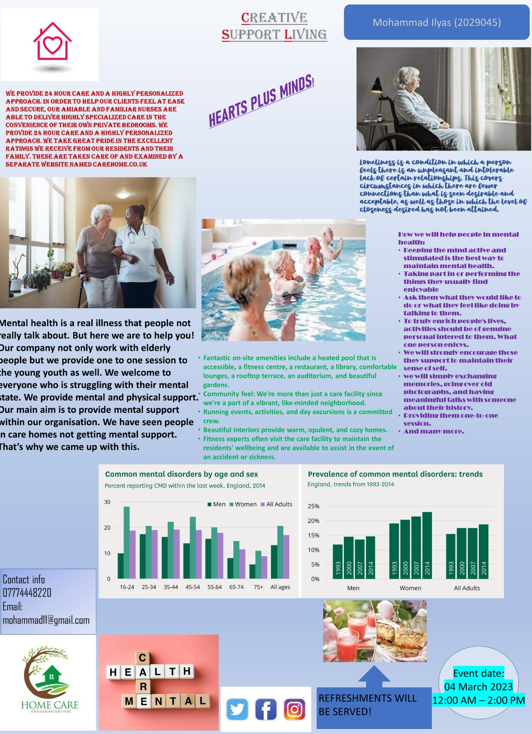

This poster explains how we will help people differently in the creative care support living care home. Our main aim is mental health, and we want to help age group patients. A care home is not suppose to be a hospital where people should be treated with medications. Care home is many people’s homes where they wanted to be taken care mentally and physically. This poster explains what facilities will be provided there, such as heated pool, restaurant, library, an auditorium, beautiful gardens, therapists who will always make sure of your mental health and many more.
Also, this poster contains groans which showing common mental health disorder my age and sex in England in 2014, dark green in men, light green women and purple all adults. Overall this shows that women’s mental health was worst at the beginning but it came to almost same level for all adults. Here is how we will help people with mental health:
- Making interesting and captivating activities:
We will talk to them individually and ask what they would want to do or are in the feeling for. In order to truly improve people's lives, activities should truly be of interest to them personally, what one person enjoys, another may not. It's crucial to come up with a variety of various activities that can be enjoyed by everyone since, for instance, some of the activities offered might not be appropriate for some persons with physical or learning disabilities.
- Adopting development and personal identity:
Their identity is most important for us It's crucial for caregivers to firmly urge individuals they support to continue embracing their unique identity. Just because someone moves into a social care environment doesn't imply, they immediately lose their own originality and identity. Elderly individuals in care should be encouraged to take charge of as many aspects of their lives as they can, including choosing their own clothes and determining what they want to do or eat that day. Dignity is crucial to identity.
- support in tracking and logging mood:
Everybody's mood changes, and there are several fairly common reasons why this could happen. Although it's possible that they just don't like the mornings or get angry when they're hungry, it's necessary to acknowledge when mood swings might be a sign of something more severe. It is important to monitor and record the varying emotions of the individuals you help in order to promote mental health and well-being in senior care facilities. By doing this, you can learn more about trends (poor mood connected to medicine, for instance), or determine whether another issue needs to be resolved.
- Physical pain recognition and recording:
Pain experienced physically frequently has an impact on the psyche as well. When checking in with the people you assist, it's crucial to be exceedingly thorough because suffering may not always be obvious to the naked eye. we will always talk to them and urge them to open up about any discomfort they may be feeling because many individuals might be ashamed about an problem or not want to speak out and make a scene.
These are some of ways we will help and serve the community in our care home. And lastly, my contact has been given also, we are on socials too. Event details have been given as well.

REFERENCE LIST:
- Healey, J. (2020) Loneliness and social isolation. Thirroul, N.S.W.: The Spinney Press.
- Silverstein, M., &amp; Chen, X. (1996). Too much of a good thing? Intergenerational social support and the psychological well-being of older persons. Jountal of Maniage and Family, 58, g7o982.
- Van Tilburg, T., De Jong Gierveld, J., Lecchini, L., & Marsiglia, D. (1998). Social integration and loneliness: A comparative study among older adults in the Netherlands and Tuscany, Italy. Journal of Social and Personal Relationships, t5, 7 40-7 5+.
- Aartsen, M. (2003). On the interrelationships between cognitive and social functioning in older age. Unpublished doctoral dissertation, Vrije University, Amsterdam.
- Hale, B. (1976) Mental health. London: Sweet and Maxwell
- Line, W. et al. (2019) Mental Health in Public Affairs : A Report of the Fifth International Congress on Mental Health 1954 Under the Auspices of the World Federation for Mental Health. Toronto: University of Toronto Press,. Available at: https://doi.org/10.3138/9781487582791
- Coverdale, G. (2017), “The importance of well-being in children and young people”, Journal of Public Mental Health, Vol. 16 No. 3, pp. 93-95
- Caroline Baker (2015) Developing Excellent Care for People Living with Dementia in Care Homes. London: Jessica Kingsley Publishers (Bradford Dementia Group Good Practice Guides). Available at: https://search-ebscohost-com.ezproxy.uwtsd.ac.uk/login.aspx?direct=true&db=nlebk&AN=924070&site=ehost-live (Accessed: 7 February 2023

