Report – Research report
Module Name: Digital Skills and Research Methods
Module Code: BMSW 4003_BIRM
Student Name: Paul Enache
Student ID: 2129433

Table of Contents

Introduction 3
Research Design 4
Research Questions 4
Research Method 4
Participants 5
Ethical Considerations 5
Results 6
Discussion 8
Conclusion 11
References 12
Appendix 13

Introduction
Collaboration is an essential factor for humans in order to work effectively and for that matter, collaboration is a key skill that is required while engaging in teamwork activities. Collaboration in a team enhances the capacity of team tasks and also is helpful in solving problems and coming up with positive outcomes (Djiwandono, 2018). Learners are often required to create content such as projects and assignments in their curriculum. Most often these assignments and projects are team tasks and require teamwork and collaboration (Loes et al., 2018). In addition to this, digital literacy is a must among students in today society. Digital tools help students to be more deeply engaged providing a better understanding of information. Digital tools also help in efficiently navigating challenges as it provides more effective means for communicating knowledge (Tusting et al., 2019). Hence, in order to accomplish good outcomes of teamwork, it is important to be collaborative as well as have digital knowledge. The report will provide insight regarding the research that had been conducted in relation to the topic of digital skills and how it is helpful in collaborating. The report will outline the research questions that were outlined and the method that was used. The results of the report along with discussions will also be provided.

Research Design
Research design which is sometimes referred to as the research approach is a framework of techniques and methods that a researcher chooses to conduct research (Dannels, 2018). Research design can be seen as a researcher’s choice between quantitative and qualitative methods or even as the researcher’s choice of a particular method of collecting and analysing data (Bloomfield and Fisher, 2019). The most appropriate explanation of research design however would be a master plan in order to conduct a study or research project. Hence, the questions related to the research that was designed and the method used for conducting the study has been provided below.

Research Questions
The chosen topic basically highlights the key points of teamwork, collaboration and digital knowledge and their relevance and importance for students. Based on the key points, a discussion was done and certain questions were designed. The questions have been given below.
- How important is the skill of collaboration for the students?
- Why do the students need to possess digital literacy?
- How do students at UWTSD use technology to collaborate?
- Which digital tools do the students at UWTSD use the most while collaborating with each other?

Research Method
Research methods can be defined as the processes that researchers use for the collection of data. The data that is collected can be used for analysing current procedures and for finding additional information on the research topic (Lê and Schmid, 2022). Generally, the research methods can be distinguished into qualitative and quantitative. A qualitative research method is an approach which involves investigating information through various means such as personal interviews in focus groups, experiments and case studies. A quantitative method, on the other hand, entails the use of numbers and figures in order to measure data (Liamputtong, 2020). Quantitative methods include a collection of data through surveys and questionnaires. Researchers use these methods accordingly as per the relevance and philosophy that is adopted for a research project (Bloomfield and Fisher, 2019). The questions were analysed and based on the objectives, a quantitative method of research was adopted. A test questionnaire was designed using MS Forms and a total of five questions were included. Two close-end questions, two Likert Scale questions and one rank order question were included in the test questionnaire. The questions that were included in the test questionnaire aimed at answering the core question which led to gaining information about the other secondary questions as well. The primary focus question was what digital tools the UWTSD students used for collaborating with peers. The questions asked were as follows:
- Do you use MS Teams more than other digital tools to work with your peers?
- Do you use WhatsApp more than other digital tools to collaborate with your peers?
- Rank these applications in order according to how frequently you use them to collaborate with others. (Most frequent at the top)
Rank Options
1. WhatsApp
2. MS Teams
3. Moodle
4. MS Word
5. OneDrive
- I use MS Teams more frequently to collaborate with others
- Strongly agree
- Agree
- Disagree
- Strongly disagree
- Neither agrees nor disagrees
- I do not use any digital tools to collaborate with peers.
- Strongly agree
- Agree
- Disagree
- Strongly disagree
- Neither agree nor disagree

Participants
The students from various streams of the UWTSD were handed out the questionnaire as well as an online link was sent to them. They were asked to take the test questionnaire along with them and fill it out or click the link and take the online test during their free time. The work of handing out the questionnaire and collecting them as well as storing the online information was equally divided among our team members. It took fourteen days for us to engage in the activity and collect the data. Most of the students provided us with useful data while there were a few students who were not interested in participating in the activity.

Ethical Considerations
It is important to take certain ethics into consideration while conducting research studies. Some of the ethical principles were taken into account while conducting the research (Fiesler, 2019). As researchers, we made sure that confidentiality was maintained, and that the information received through the questionnaire was anonymous. The safety and storage of data that had been accumulated were also taken into consideration. The participation of the candidates was also done on a voluntary basis. As a team of researchers, we tried and maintained honesty and aimed at presenting genuine information as an end result in our research project without any personal biases.

Results
The test questionnaire after being collected gave an insight into the information that we expected to receive. The results of the questions as per the questionnaire have been presented below.
- Do you use MS Teams more than other digital tools to work with your peers?
The data as per the first question has been given below.

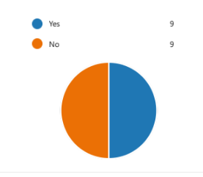
Figure1: Use of MS Teams versus other digital tools

- Do you use WhatsApp more than other digital tools to collaborate with your peers?

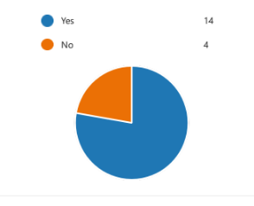
Figure2: Use of MS Teams versus other digital tools among participants while collaborating with peers

- Rank these applications in order according to how frequently you use them to collaborate with others. (Most frequent at the top)

Rank Options
1 WhatsApp
2 MS Teams
3 Moodle
4 MS Word
5 OneDrive

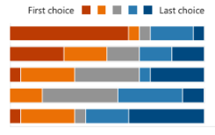
Figure3: Ranking of the digital apps in order of the frequency of their usage in collaboration

- I use MS Teams most frequently to collaborate with others.

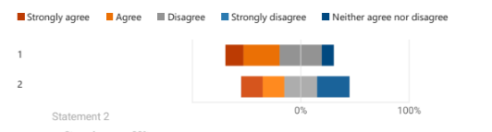
Figure 4: Participants that use MS Teams for collaboration with peers

- I do not use any digital tools to collaborate with peers.

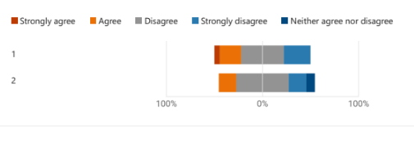

Figure 5: Participants that do not use any digital tools to collaborate with peers

Discussion
The results of the questionnaire were able to outline data that was necessary for drawing conclusions. The results that we received regarding the first question on how many participants used MS Teams over other digital apps were on a 50-50 basis. The data was collected and based on the findings, it could be concluded that an average of 9 out of 18 students had answered the option of yes and the other 9 had ticked the option of no.
The results of the second question that highlighted the use of WhatsApp over other digital apps for collaborating with peers were interesting and it was able to outline the popularity of WhatsApp among the students at UWTSD. Among the 18 participants, a maximum number of 14 students ticked the option of yes and the remaining 4 ticked the option of no. As per the third question, a ranking order was given where the students were supposed to rank the five apps WhatsApp, MS Teams, Moodle, MS Word and OneDrive accordingly. The ranking was based on how frequently participants used these apps while collaborating with others. The results as per the questions were in the favour of WhatsApp which again the first choice among the students with the second favourite was being MS Teams. The result was also able to highlight the fact that MS Word was the least used app among the students. The fourth question was a question about how often the participants individually used MS Team for collaborative activities. The results of the question were more emphasised through the second statement which provided the information that 30% of the participants strongly agreed with the motion, 20% agreed, 30% disagreed and the remaining 30% strongly disagreed with the given sentence. The final question was based on the fact of how many of the participants did not use any digital platforms for collaborating with their peers. The results of the fifth question provided information regarding the statement that was provided and the majority of the participants disagreed with the given statement. There was a tie between the participants that agreed and strongly disagreed with the statement. There were a few percentages of participants that strongly agreed. Finally, there were also a small number of candidates that neither agreed nor disagreed. Through the analysis of the given data, it was clear that the majority of the participants were using some digital means while engaging in collaborative activities with their peers. The results have provided insight as to how important and convenient digital intellect and its usage has become in academic practices. The results have been able to highlight the importance of digital knowledge and collaboration together in academic practices in order to become more efficient. This has been felt by the students as the results have proved that the majority of the participants are using some form or the other of digital apps in their collaborative activities. This has also been helpful in proving the hypothesis of the importance of collaboration and how digital platforms and technology help in the enhancement of these factors. The research has also been helpful in highlighting the fact about the digital tool frequently applied by the students of UWTSD. WhatsApp seems to be the first preference among students when they have to collaborate with their peers regarding assignments and projects. While WhatsApp seems to be the most convenient app for collaboration with peers, the next in line is MS Teams. The research also helps in outlining the value and importance of technology in today’s learning. To become efficient and competitive students must be up to date with the use of modern technology as it provides opportunities for both academic as well as career development. Thus the result has been helpful as it coincides with the literature that has been provided in the introductory phase of this study.

Conclusion
The report has outlined a detailed analysis of the importance of collaboration in academic learning. To boost the process of collaboration in order to meet the standards of the modern era, the need for students to have technological knowledge has also been emphasised. The report has focused on the research design that was adopted while conducting the study. The key question for research on what technological means do the students at UWTSD use while engaging in collaborative activities has also led to collecting quantitative data on the basis of a questionnaire. This has been helpful in collecting data through which a conclusion can be drawn. Hence, in conclusion to the report, it can be stated that the students at UWTSD use the digital tool WhatsApp frequently while collaborating with their fellow students. Apart from WhatsApp, the student’s second favourite tool is MS Teams which we have been able to state through the analysis of the collected data.

References
Bloomfield, J. and Fisher, M.J., 2019. Quantitative research design. Journal of the Australasian Rehabilitation Nurses Association, 22(2), pp.27-30.
Dannels, S.A., 2018. Research design. In The reviewer’s guide to quantitative methods in the social sciences (pp. 402-416). Routledge.
Djiwandono, P.I., 2018. The effect of blended learning on reading abilities, vocabulary mastery, and collaboration among university students. The New English Teacher, 12(1), pp.23-23.
Fiesler, C., 2019. Ethical considerations for research involving (speculative) public data. Proceedings of the ACM on Human-Computer Interaction, 3(GROUP), pp.1-13.
Lê, J.K. and Schmid, T., 2022. The practice of innovating research methods. Organizational Research Methods, 25(2), pp.308-336.
Liamputtong, P., 2020. Qualitative research methods.
Loes, C.N., Culver, K.C. and Trolian, T.L., 2018. How collaborative learning enhances students’ openness to diversity. The Journal of Higher Education, 89(6), pp.935-960.
Tusting, K., McCulloch, S., Bhatt, I., Hamilton, M. and Barton, D., 2019. Academics writing: The dynamics of knowledge creation. Routledge.

Appendix


