

Module Title: Foreign Languages and Cultural Awareness
Module code: BMIH5003
Assignment: Student Self-Reflection
Student name: Florin Vasilica Mecic
Student Number:2215417
Word Count: 500
Lecturer: Giulia Chifari

Table of Contents
1 Student Self-Reflection 3
1.1 Introduction 3
1.2 Kolb’s Model 3
1.2.1 Concerete learning 3
1.2.2 Reflective Observation 3
1.2.3 Abstract Conceptulization 3
1.2.4 Active Experimentations 4
2 Conclusion 4
3 References 5

Student Self-Reflection

Introduction
The presentation on cultural diversity, multilingualism, and language awareness in the context of organizational efficiency in the hotel sector was a valuable learning experience that enabled me to participate in Kolb's experiential learning cycle. Reflecting on the presentation, I can see the steps of tangible experience, reflective observation, abstract conceptualization, and active experimentation, each contributing to a more excellent grasp of the subject. This self-reflection delves into my experiences, insights, and progress as I developed these competencies using Kolb’s model (Adeani et al., 2020).

Kolb’s Model
Kolb's Experiential Learning Model is a four-stage cycle that describes how people learn by doing. Concrete Experience (CE), Reflective Observation (RO), Abstract Conceptualization (AC), and Active Experimentation (AE) are the four phases (Vince, 2022). Learners go through these levels to develop knowledge and skills, emphasizing hands-on learning and reflection.
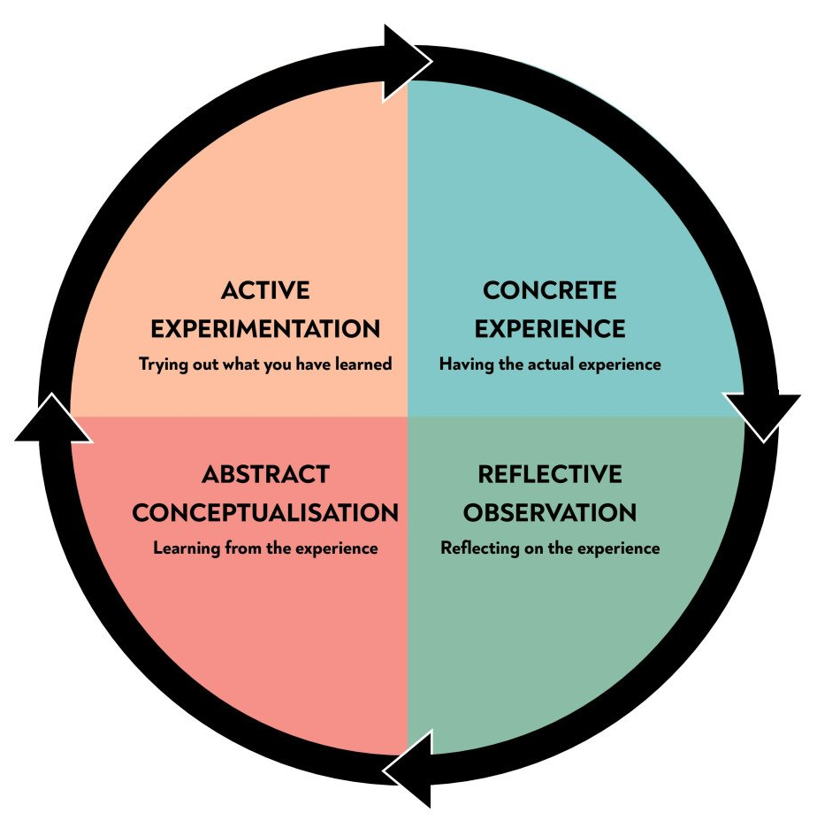
Figure 1: Kolb's learning style and experiential learning cycle
Source: Mcleod, S. (2023)

Concrete learning
During the practical experience part, I paid close attention to the presentation, which offered a thorough overview of the importance of cultural sensitivity in the hotel sector. The speaker gave real-life instances of how cultural misunderstandings may contribute to visitor displeasure and organizational inefficiency. This direct exposure aroused my attention and set the groundwork for future investigation (Ly, 2022.).

Reflective Observation
Moving on to the reflective observation stage, I reflected on the examples presented in the lecture. I discovered that the success of the hotel sector is inextricably related to its capacity to serve a broad range of customers, many of whom speak other languages and have distinct cultural expectations (Sinha, 2023). This observation highlighted the significance of multilingualism and language awareness in guaranteeing visitor happiness and efficient communication within the enterprise.

Abstract Conceptulization
I connected the presentation material and more comprehensive theoretical frameworks during the abstract conceptualization phase. I read the writings of scholars such as Hofstede and Trompenaars, who have extensively examined cultural elements and their consequences for company operations. This conceptualization reinforced the idea that cultural awareness is about more than simply being aware of differences; it is also about using them to obtain a competitive advantage. In addition, I noticed that multilingualism is a benefit for hotels. The abilConnectingsitors in their original language generate a sense of welcome and belonging, ultimately improving the guest experience. This realization prompted me to investigate the practical consequences of encouraging language diversity among hotel employees and the possible advantages to organizational productivity.

Active Experimentations
During the active experimental phase, I imagined methods for hotels to introduce language awareness programs and encourage personnel to become multilingual. I evaluated the viability of language training activities and the possible return on investment in terms of increased visitor satisfaction and repeat business. In addition, I considered how hotels may effectively adjust their marketing techniques to attract varied ethnic groupings. Advertising campaigns, culinary options, and guest services might all be tailored to various ethnic tastes (Yu et al., 2023). The prospect of actively incorporating language and cultural awareness into hotel operations piqued my interest since it appeared to be a realistic step toward organizational performance.

Conclusion
Finally, this lecture on cultural diversity, multilingualism, and language awareness was an invaluable learning experience that enabled me to participate in Kolb's experiential learning cycle. I developed a better knowledge of the relevance of cultural sensitivity, multilingualism, and language awareness in the hospitality business via experience, introspective observation, abstract conceptualization, and active experimentation. I will keep these lessons with me in my education and profession, realizing their importance in a worldwide and culturally varied society.

References
Adeani, I.S., Febriani, R.B. and Syafryadin, S., 2020. Using GIBBS's GIBBS'reflective cycle in making reflections of literary analysis. Indonesian EFL Journal, 6(2), pp.139-148.
Arjmandi, M., Woo, M.W., Mankelow, C., Loho, T., Shahbaz, K., Auckaili, A. and Thambyah, A., 2023. Embedding computer programming into a chemical engineering course: The impact on experiential learning. Education for Chemical Engineers, 43, pp.50-57.
Cortellazzo, L., Bonesso, S., Gerli, F. and Pizzi, C., 2021. Experiences that matter: Unraveling the link between extracurricular activities and emotional and social competencies. Frontiers in Psychology, 12, p.659526.
Hardie, P., O'Donovan, R., Jarvis, S. and Redmond, C., 2022. Critical tips to providing a psychologically safe learning environment in the clinical setting. BMC Medical Education, 22(1), pp.1-11.
Ly, A., 2022. Developing Future Global Leaders' Competencies in a Business School Course: A Case Study of a Course Design Inspired by Team-based Learning. In Advances in global leadership (Vol. 14, pp. 227-245). Emerald Publishing Limited.
Mcleod, S. (2023). Kolb’s Learning Styles and Experiential Learning Cycle. [online] Simply Psychology. Available at: https://www.simplypsychology.org/learning-kolb.html.
Sinha, E., 2023. ' Co-creating 'Experiential learning in the metaverse-extending Kolb's learning cycle and identifying potential challenges. The International Journal of Management Education, 21(3), p.100875.
Vince, R., 2022. Reflections on “behind and beyond Kolb’s learning cycle”. Journal of Management Education, 46(6), pp.983-989.
Yu, Z., Guo, K., Huang, S.S., Li, Z., Du, Y. and Yu, M., 2023. Tourist emotion-learning nexus: A case of Sertar, China. Annals of Tourism Research, 102, p.103618.

