

Assignment 1: Blogs

Feiyu Ren 2014120 | Identity and Approaches to Applied Business Research | 19th July 2021

Word count:3616
Contents

Blog 1: Investigate ideas for a viable research proposal 2
Blog 2: The evaluation of the two-factor theory and its application in several possible lines of investigation 10
Blog 3: The exploration of the research topic about the relations between the workers’ job satisfaction and the organizational outcomes in Beijing University of Chemical Technology 16

List of Figures
Figure 1: The HR (Source: Baidu, 2021) 2
Figure 2: Ideas (Source: Baidu, 2021) 14
Figure 3: Comparison of traditional and the Two-factor theory 15
Figure 4: The concept mapping diagram for the initial research 25
Figure 5: The formal structure of the network map of my organization(Administration department of the school) 27

Unless otherwise stated images were created by the author using the Canva online design tool.

Blog 1: Investigate ideas for a viable research proposal
(Word count 1548)


Figure 1: The HR (Source: Baidu, 2021)
The topic of my research proposal is about the exploration of the research topic about the relations between the worker’s job satisfaction and the organizational outcomes in Beijing University of Chemical Technology(BUCT). There are five main reasons which makes me select this topic as the research direction of my future DBA thesis. Firstly, I did a personal evaluation of my past educational studies and training experiences in a critical way before the start of this research. I got a Bachelor’s degree in Economics and two Master’s degree in finance and international business and people, management and organizations. So it is good for me to start a research topic which is highly relevant with my past educational studies. Secondly, I am currently working in a public university as a research assistant who is undertake the teaching tasks of the module of a series of courses about human resource management at present. I am also working as a low-level manager who is in charge of the management of academic affairs and foreign affairs of the school of economic and management in Beijing University of Chemical Technology for three years since I start my career in this organization. Moreover, I also worked as a program supervisor for the management of the Sino-Canadian Joint Master program in Renmin University of China between the year of 2015 and 2016. Therefore, I am consistently accumulating a great deal of working experiences in last three years and Moreover, I was never stop my personal pre-work for the research about the improvement of efficiency in human resource management of organizations in China since I graduated from the University of Sydney and Cardiff Metropolitan University. I attended the e-commerce training in Alibaba Beijing which is the one of the top e-commercial company in the world in 2019. Such training was sponsored by Beijing University of Chemical Technology where I was employed in. I was treated by a series of theoretic teaching and practices about e-commerce and human resource management which guided by professionals of e-commerce in Alibaba. Indeed, I was benefited a lot from this training because it could contribute me to understand the essence of e-commerce and how it is work globally. Later, I was invited to attend a short-term training program which was held by the Xian Jiaotong-Liverpool University in Suzhou where is a traditional typical ancient city in China. It is a one week course and I learned a lot about the aspects of the importance of international communication and human resource management for the success of international business. It is good at establish a more completed framework for my further research about the improvement of efficiency in human resource management of my organization by attending these short-term training because it is critically improve my thinking and knowledge about human resource management and international business which are the research background of my further research about the improvement of efficiency in human resource management of my organization in Beijing University of Chemical Technology by the application of combining quantitative and qualitative methodologies.

I searched many kinds of sources about this topic as a good start of my research. First of all, I need to pick up the compatible philosophies as the research base for my research. There are three main philosophies for research which comprise Epistemology, Ontology and Axiology. My research philosophy is various and may change in my further steps of my research due to the factors which may influence the process of my research. All of these philosophies have their pros and cons. For example, there will some obvious advantages for my research if I choose the positivism as the philosophy of my research. I can collect large amounts of data in an economical way and these data are easily comparable when my research is based on the philosophy of positivism which originated from the viewpoint of epistemology. However, it should not be ignored that it is hard to change the direction of my research once data collection started by the use of the philosophy of positivism. The similar circumstances could also be anticipated to happen to my research by the use of interpretivism, pragmatism and philosophies of ontology and axiology. Therefore, it is important to keep my critical thinking on my research with all steps.

Secondly, the approaches for the source of data collection may cover interview, questionnaires and secondary data because of the nature and characteristics of my research topic. I will adopt multi-strategy for my research by the use of combing quantitative and qualitative methods so that the relevant assumptions could be analysis from two different perspectives to make the analysis to be more practical and critical. It can be confirmed that the conclusions of my research and how is the data represented may different and various by the application of approaches for the source of data collection which based on the perspectives of quantitative and qualitative methods respectively. For example, I have find some academic articles which based on different perspectives which relates to my research and collected some secondary data from this kind of data collection. These articles come from the journals which is ranking 3 or 4 stars by the Academic Journal Guide 2018. Among, I selected some articles from European Economic Review, Journal of Economic Geography, etc. These articles could be reckoned as relevant valid and reliable for the foundation of my research. However, there are still some problems on the aspect of validity and reliability among these articles for my research. Firstly, some articles may imply me its relations with my research topic. For example, I read the article about ethnic diversity and firms export behavior.(Parrotta, Pozzoli and Sala, 2016) This articles argues that the diversity of one company’s workforce may improve its internationalization by increasing its relational capital and ability to market its products in global market.(Parrotta, Pozzoli and Sala, 2016) It adopts several empirical strategies to test its hypotheses and then confirm its hypotheses in its conclusions from the perspective of the human resource management.(Parrotta, Pozzoli and Sala, 2016) The article is emanated from the journal which is ranking 3 stars by the Academic Journal Guide 2018. Such ranking standard is highly regarded by many important organizations throughout the world such as the University of Liverpool Management School, University of Aberdeen Business School, Warwick Business school, etc. However, there are still some limitations for this article. First of all, the limitations of the data source of this research and its topic will restrict the adoptions of its conclusions in other circumstances because its conclusion may different from its conclusions in this article due to the change of these factors. Moreover, the limitations may be emanated from its empirical strategies. For example, this research only focused on the Danish firms and their employees. Its data source is only come from Danish official statistical institute which is not enough for an objective research because the data source is too single even if these data is emanated from Denmark Statistics which may influence the objectivity of the conclusion of my research.(Parrotta, Pozzoli and Sala, 2016)
Another article about minority ethnic inventors and diversity and innovation in the UK shows another viewpoint for me from the perspective of relations between ethnic inventors and diversity and innovation which is also helpful for my research.(Nathan, 2014) It compares the circumstances about the contributions of minority ethnic inventors and ethnic entrepreneurs to the development of innovation in UK and US. The author analysis the similarities and differences between these two kinds of circumstances in these two countries and concluded that European countries could benefit from the ethnic group diversity which could bring potential ethnicity-innovations for the progress of the society.(Nathan, 2014) It also demonstrates that the circumstances in UK is highly likely to the situation of Continental Europe because the minority ethnic inventors are come from wider minority populations compare to the situation in UK. Such minority ethnic inventors also could be seen as valuable human resources for the development of the organization from the perspective of human resource management. However, the author also admits that there are two limitations which influence the results and trend of the research. Firstly, it concluded that there are some factors which are highly relevant to the inventors’ productivity. Secondly, its poor data could not completely show the identification of ethnic inventors and diasporic groups. The relevant sample size is too small for further research about this topic. Overall, all these two factors may influence the reliability and validity of this article which as academic source for my research.(Nathan, 2014)
I have concluded some concepts and themes by investigating and evaluating some research sources about my research topic. These concepts and themes are relevant with human resource management of the minority ethnic groups for the development of the organizations and countries or industries. Such research resources were not only focus on the research of the industry of foreign trade but also other industries because almost the development of each organization or the country of the industry could be easily influenced by the development of foreign trade directly or indirectly. The result of the evaluation is that the discussion and application of some concepts and theories such as the theory of two-factor theory, Maslow’s hierarchy of needs, the expectation theory, the theory of Hofstede’s culture dimensions, the theories of ethics, the research philosophies, the test of reliability and validity and the details of my research design will be embraced in my research.

Blog 2: The evaluation of the two-factor theory and its application in several possible lines of investigation
(Word count 1124)

Figure 2: Ideas(Source: Baidu, 2021)
The two-factor theory is a classical theory about human resource management which was created by Frederick Herzberg in 1959 when he was trying to find the answers about workers’ real needs from their job. The essence of this research is about the research of job satisfaction. So all of the relevant research revolves around the workers’ job satisfaction throughout the research. Herzberg was influenced by Marslow’s theory of the hierarchy of needs seriously before he began his research. However, Herzberg’s research is focus on the topic of workplace tests and measurements for job satisfaction which is different with Marslow. The approach of his research is worth for us to study as it is a practical and industrial-focused method which makes the results of the relevant research to be more critical and objective. Finally, Herzberg and his colleagues conclude the results of his research by explaining his two-factor theory model in their work. The so-called two-factor model actually means the two-dimensional model of factors influencing workers’ attitudes towards work. Such model analysis the relevant circumstances which includes dissatisfaction, no satisfaction and satisfaction which is also different with the traditional model. Traditional model just considers two circumstances which embrace dissatisfaction and satisfaction compare with the two-factor theory. Among, as the figure 3 shows that the two-dimensional factors are make up of the motivator factors and hygiene factors which constitute the model together. Herzberg find that there are six motivator factors which include responsibility, achievement, personal growth, recognition, advancement, and the work according to his research of the motivation to work. These motivator factors reflect the special characteristics of the people’s needs. The hygiene factors include working conditions, supervisor relationships, salary, quality of interpersonal relations among colleagues, security, company policies and quality of technical supervision. All of these hygiene factors may result in no dissatisfaction if the company did well in these aspects. It is notable that Herzberg improve the traditional model by the application of the motivator factors and hygiene factors and he find the circumstance of no dissatisfaction which is his contribution to the development of the human resource management.(Sanjeev and Surya, 2016)

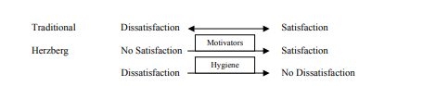
Figure 3: Comparison of traditional and the Two-Factor Theory
Although the invention of this theory is originated from the research for the job satisfaction. It could still be extensively used in my research because the research about the job satisfaction of the organization is also important for the improvement of the efficiency of the organization. That is also the reason why Herzberg and other management experts are endeavor to do the research of the influential factors of workers’ job satisfaction of the organization. Firstly, I will evaluate the relations between the workers’ job satisfaction and the efficiency of the organizations. Then I will collect the data from many ways and compare, analysis and test the data by the use of the Herzberg’s two-factor theory. Thirdly, I will summarize the relevant results and get the conclusion for my further research about the improvement of efficiency in human resource management of organizations in China. Therefore, the conclusions of two-factor theory can contribute to my research about the improvement of efficiency in human resource management of organizations in China because its conclusions are meaningful for the research of the factor of job satisfaction of the organizations.(Alrawahi et al., 2020)
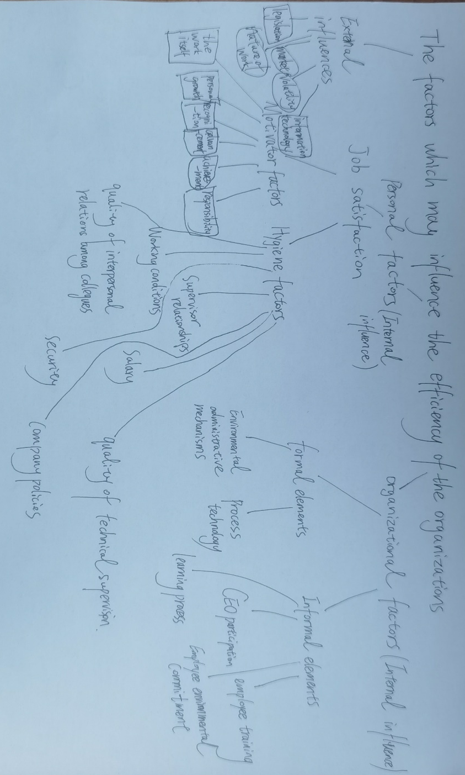Figure 4: The concept mapping diagram for the initial research
The figure 4 shows a series of concepts mapping diagram for my initial research about the improvement of efficiency in human resource management of organizations in China. The influential factors are categorized as external influential factors and internal influential factors. The internal influential factors include personal factors and organizational factors. The external influential factors include legislation, nature of work, information technology, market and volatility respectively. The characteristic of job satisfaction could be categorized as the internal factors in this framework.
There are three strengths that the two-factor theory may contribute to the research of the improvement of efficiency in human resource management of organizations in China. First of all, Hertzberg’s conclusions about the job satisfaction for workers’ efficiency in the organization prove the relations between the factors which may positively or negatively influence the workers’ efficiency within the organization. It could effectively improve the efficiency of my research because they had already proved such conclusions in the past. Therefore, such conclusion is still critical important for my research topic. The second strength is about the diversification of the relevant concepts so that makes my further research to be more clear by harnessing the two-factor theory. Moreover, the third notable strength is that it is enlighten me the way to research by studying his framework of research.(Aquino Jr, 2020)
However, there are still exist some limitations for the use of two-factor theory. Firstly, the Hertzberg’s conclusions of two-factor theory could only be used for the research of workers’ job satisfaction and it still need me to take time to explore the use of this theory for my other aspects of my further research. Secondly, the inherent flaw of Hertzberg’s research influences the conclusions of his research. Such as he did not mention the difference of the gender and just select male workers as representative of the whole working group for his research may result in inaccurate of the results of the experiment. Moreover, the two-factor theory oversimplifies the factors which influence the job satisfaction of workers. Such result may not critical enough.(Ozsoy, 2019)
Despite these potential inherent flaws of the two-factor theory, it is still a well-known classical theory that influence the development of the human resource management in the last 60 years. It could be extensively used for testing the workers’ job satisfaction in non-profit organization, public organization and private business. Then its result could contribute me to the influence of personal factors for the efficiency of different organizations by analyzing and comparing the results of job satisfaction of these organizations. Moreover, its conclusions could also help me to research the relations between the job satisfaction and other factors, such as cultural factors, regional national factors.(Gardner, 1977)
It could be used for collecting some data in details by the use of two-factor theory. However, there are still some factors that I need to take care such as ethical problem, availability of data. For example, I will admit that I will follow the code of conduct to design the questionnaire and do not leak the privacy of my participants by signing and supplementing the relevant terms in the questionnaire to avoid the ethical problems arising.(Code of ethics and draft code of conduct for review, 2021)

In addition to this, there are still some bias for the use of two-factor theory in my research. Such as the accuracy of the relevant conclusions and the bias for the process of the research. I need to improve the process of my further research and offers a critical analysis of the relevant conclusions to improve its accuracy.

Blog 3: The exploration of the research topic about the relations between the workers’ job satisfaction and the organizational outcomes in Beijing University of Chemical Technology
(Word count 944)
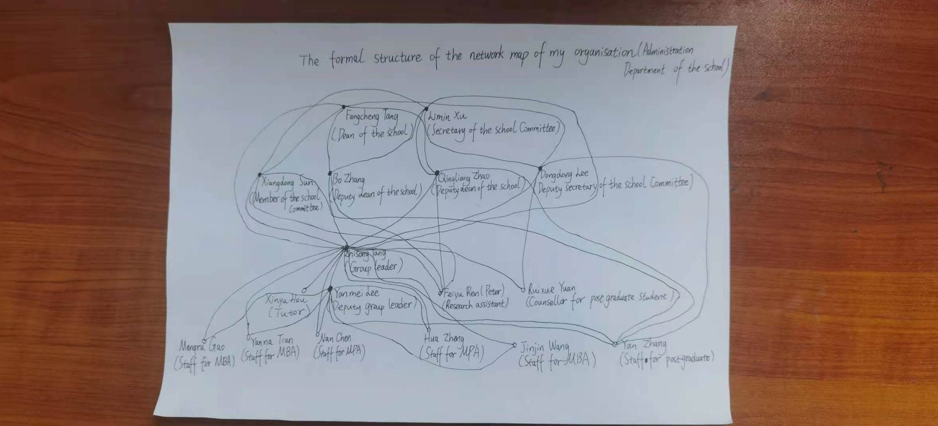
Figure 5: The formal structure of the network map of my organization(Administration Department of the school)
I will choose the research topic about the relations between the workers’ job satisfaction and the organizational performance in Beijing University of Chemical Technology. Such topic is highly relevant with the area of human resource management. The mixed qualitative and quantitative method approach will be used for my study of this topic. The essence of the word of qualitative is different from the word of quantitative. The qualitative information is unstructured and unquantifiable. Conversely, the quantitative information is structured and can be explained by numbers and generalized. The qualitative methods which includes interviews, case studies, action research, focus groups, diary studies, observation, ethnographic research that will be used in my study. The quantitative methods include the process of collecting, analyzing, interpreting, etc. It will not be critical enough if only the qualitative or quantitative approach used in the research. So that is the reason why I choose the mixed methods research. It could help me to integrating two forms of data and makes the research design framework to be more complete.(Creswell and Creswell, 2014)
There are some advantages and disadvantages of these different approaches. It could not only contribute to the potentiality and creativity inspiration but also easy to use for individuals by conducting qualitative approach. Such characteristics of qualitative approach are extremely suitable for researchers whose does not know the variables to test so that increase the efficiency of the research. However, its disadvantages are also conspicuous. Firstly, its conclusions may not critical enough by the application of qualitative approach because it lacks support from the relevant conclusions of previous research. Secondly, such new conclusions may lack of accuracy and easy to be understand in a biased way by the application of qualitative approach.(Bryman, 2007)
Whatever, quantitative approach also has its advantages and disadvantages. It could make the explanations to be more logical so that enables the readers to understand the theory base better by separating the theory into components in the process of research. The disadvantage of the quantitative approach is also obvious. It is difficult for readers to isolate and connect the components of the research process by the application of quantitative approach. For example, it is difficult for the readers to understand and isolate the calculation of job satisfaction rate from the organizational performance in Beijing University of Chemical Technology.(Creswell and Creswell, 2014)
The validity and reliability of the research are also important and necessary for the production of critical conclusions. Qualitative validity can be viewed as a standard for checking the accuracy of the findings from the process of research. Qualitative reliability can be seen as a connotation about the level of consistency of different projects and researchers. There will be some challenges for the data collection by the application of qualitative approach in my research. Firstly, observations are easily to be influenced by my subjective states of consciousness so as to influence the validity of the results. Secondly, participants may betray or conceal their true feelings when discussed sensitive topics for them so that influence the validity of the data collection. For example, many interviewees are my colleagues so that some of them don’t want me to know their true feelings because they worry that leaders may punish them if they know the truth even if I promise I will guarantee the secret of the contents of the interview between us.(Bashir and Marudhar, 2018)
On the other hand, there are also existing challenges by the application of quantitative approach in my research. Quantitative approach has three typical forms of validity which includes content validity, concurrent validity and construct validity. Quantitative reliability is focus on the internal consistency of the items and correlations between results of test-retest. The challenges about the application of quantitative approach in my research is also conspicuous. The first challenge is the sampling design for the survey which easily influence the validity of the results. For example, the sampling range within the city of Beijing is far different than within the China for my research. Moreover, the choice for the types of data collection by the application of quantitative approach will be another challenge for the validity of my research. For example, there are a lot of quantitative methods for data collection which includes the Internet, personal interviews, mail, etc. It will not only take me a lot of precious time to do it but also can’t guarantee the validity of the results if I choose personal interviews for my colleagues for my research because of the same reasons in the part of qualitative validity.(SALMAN, 2021)
Currently I will use the mixed approaches to conduct my research. In details, it will be transformative mixed methods to construct a framework which includes the research problems, the questions, the methods for data collection and analysis, interpretations, and the plan for actions.(Brannen, 1995)
Moreover, I will use the source which includes my interpersonal relations such as my friends, colleagues, leaders, etc. as my first data source for my research. It is still precious for my research even if it is hard to guarantee the truth of these first data source. These sources belongs to the type of non-refereed source. Refereed source has more validity guaranteed by the academicians and authors compare with these non-refereed source.(Creswell and Creswell, 2014)
Moreover, there are also some potential risks for my research such as potential ethical risks. The ethical issues may happen throughout the whole stages of my research. For example, I should acquire the permission from my organization and participants before I start my research for my organization. I also should not pressure participants to sign the consent forms of my research or otherwise it also unethical. It is an effective method for me to strictly follow the codes of conduct to avoid the happen of unethical things throughout all stages of my research.(Creswell and Creswell, 2014)

Reference list:
Aquino Jr, P., 2020. Accounting for Job Satisfaction and Job Performance via Herzberg’s Two-Factor Theory: The Case of Overseas Filipino Workers (OFWs) in Vietnam. Journal of Advanced Research in Dynamical and Control Systems, 12(SP3), pp.1173-1183.
GARDNER, G., 1977. Is there a valid test of Herzberg's two-factor theory?. Journal of Occupational Psychology, 50(3), pp.197-204.
Parrotta, P., Pozzoli, D. and Sala, D., 2016. Ethnic diversity and firms' export behavior. European Economic Review, 89, pp.248-263.
Nathan, M., 2014. Same difference? Minority ethnic inventors, diversity and innovation in the UK. Journal of Economic Geography, 15(1), pp.129-168.
Louisi Francis, M., Pinheiro de Lima, E., Fernando, D., Aken Eileen M, V., E Gouvea Da Costa, S., 2020. Factors for performance measurement systems design in nonprofit organizations and public administration. Measuring business excellence, [online] 24(3), pp.377-399. Available at: <https://www-proquest-com.ezproxy.uwtsd.ac.uk/docview/2414725604?pq-origsite=primo&accountid=130472> [Accessed 2 July 2021].
Pombo, G. and Gomes, J., 2019. Employees’ perceptions and the relationship between human resource management and organizational performance: a conceptual view. Knowledge and Performance Management, 3(1), pp.46-63.
Erk P, P., Alina M, B., and Torsten Oliver, S., 2021. The Relationship Between Employees' Perceptions of Human Resource Systems and Organizational Performance: Examining Mediating Mechanisms and Temporal Dynamics. Journal of Applied Psychology, 98(6), pp.926-947.
Kuvaas,B., 2007. An Exploration of How the Employee–Organization Relationship Affects the Linkage Between Perception of Developmental Human Resource Practices and Employee Outcomes. Journal of Management Studies, 45(1), pp.1-25
Park, S. and Ryoo, S., 2013. An empirical investigation of end-users’ switching toward cloud computing: A two factor theory perspective. Computers in Human Behavior, 29(1), pp.160-170.
Tekeş, B., Üzümcüoğlu, Y., Hoe, C. and Özkan, T., 2018. The Relationship Between Hofstede’s Cultural Dimensions, Schwartz’s Cultural Values, and Obesity. Psychological Reports, 122(3), pp.968-987.
Creswell, J. and Creswell, J., 2014. Research design. 4th ed. California: SAGE, pp.1-300.
Bryman, A., 2007. Qualitative Research. Los Angeles: SAGE, pp.1-200.
Brannen, J., 1995. Mixing Methods: Qualitative and Quantitative Research. 1st ed. Aldershot:Avebury, pp.1-189.
Bashir, J. and Marudhar, M., 2018. Reliability & Validity of the Research. Scientific Journal of India, 3(1), pp.66-69.
Ozsoy, E., 2019. An Empirical Test of Herzberg's Two-Factor Motivation Theory. Marketing and Management of Innovations, pp.11-20.
SALMAN, M., 2021. The Evolution Usefulness Scale: Development, Reliability, and Validity. Kastamonu Eğitim Dergisi,.
Sanjeev, M. and Surya, A., 2016. Two Factor Theory of Motivation and Satisfaction: An Empirical Verification. Annals of Data Science, 3(2), pp.155-173.
Alrawahi, S., Sellgren, S., Altouby, S., Alwahaibi, N. and Brommels, M., 2020. The application of Herzberg's two-factor theory of motivation to job satisfaction in clinical laboratories in Omani hospitals. Heliyon, 6(9), p.e04829.
Preview, 2021. Code of ethics and draft code of conduct for review. 2021(212), pp.6-8.

