Student name: Layla White
Student number: 2016838
Module: Physiology
Module number:
Lecturer: Muhammed

Introduction
A health assessment is taken to assess an individual’s needs and plans for care. In this paper, a health assessment form has been filled out by an individual that has recently been diagnosed with Chronis Obstructive Pulmonary Disease (COPD). This disease affects the respiratory system. COPD is caused by the lungs becoming inflamed, damaged, and narrowed. Most cases are caused by long-term smoking, although some cases are caused by long-term exposure to harmful fumes or dust. Others can be the result of a rare genetic condition that makes the lungs more susceptible to damage (NHS, 2019).
A person's health assessment form must be completed to create a personalised care plan for each patient, by gathering information on the person’s health background and current diet and lifestyle. Once the information on an individual is obtained and assessed then recommendations for an improved quality of life can be given.

Case study
The individual that has undertaken the health assessment form is a woman aged 52 years old. This lady has been diagnosed with mild COPD earlier on in the year and has currently been a smoker for 33 years. She has been suffering from a cough which is producing mucus and says that she experiences shortness of breath when walking to the shops, which she did not feel walking the same distance this time last year.

LIFESTYLE QUESTIONNAIRE

Introduction:

In order to help us focus our Health Promotion activities in the practice, we would be grateful if you could fill in this short questionnaire. If you have already completed one on a previous visit, please return this questionnaire to the receptionist.

Name: Amanda Malley Date of Birth 04/05/1970

Do you smoke? |  | Yes | [ | x] No [ ]
If Yes, do you –
smoke less than 1 | cigarette/day |  | [ | ]
1 – 9 | cigarettes/day |  | [ | ]
10-19 | cigarettes/day |  | [ | ]
20-39 | cigarettes/day |  | [ | x]
more than 40 | cigarettes/day |  | [ | ]
smoke a pipe |  |  | [ | ]
smoke cigars |  |  | [ | ]

If No, have you –

never ever smoked  given up smoking in the last year not smoked for more than 1 year |  | [  [  [ | ]  ]  ]
Do you have high blood pressure? | Yes | [ | ] | No | [ | x]
Have you ever had a heart attack or suffered from angina? | Yes | [ | ] | No | [ | x]

Have you ever had a stroke, “shock”
or any weakness down one side? Yes [ ] No [x ] Have any of the following – mother, father,
brothers or sisters had –
a heart attack below the age of 60 | Yes | [ | x] | No | [ | ]
a heart attack above the age of 60 | Yes | [ | ] | No | [ | x]
a stroke | Yes | [ | ] | No | [ | x]
trouble with very high cholesterol | Yes | [ | ] | No | [ | ]

(hyperlipidaemia)

………………………………………………………………………………………

Practice Use Only
Health Education Smoking ………….

BP 120/80 mm Hg

Height 162.56 cm

Weight 64.410

EXERCISE
Healthy exercise usually involves activity that lasts for at least 20 minutes, raises your pulse and produces hard breathing. In younger people this might be running, cycling or sport, or brisk walking for older people.

Do you take this type of exercise –

daily [ ]
3 times weekly [ ]
once weekly [ ]
once monthly [x]
seldom [ ]

I cannot take exercise because of disability [ ]

DIET
Please tick the one category which is closest to your usual eating pattern.

I eat no meat, fish, or dairy produce [ ]
I eat no meat [ ]
I eat a mixture including daily fruit and vegetables [ ]
I eat a mixture including regular chips and fries [x]
I eat frozen meals (e.g. TV dinners) 3 or 4 times/week [x]
I eat mainly snacks [ ]
I eat a special medical diet [ ]

Please specify ………………………………………………………………………

ALCOHOL
Please tick the statement which most closely describes your usual average alcohol intake. (1 unit is 1 glass wine, ½ pint beer or a single measure of spirit.)

I never drink alcohol [x]
I drink less than 1 unit per day [ ]
I drink between 1 and 2 units a day [ ]
I drink between 3 and 6 units a day [ ]
I drink between 7 and 9 units a day [ ] I drink more than 9 units a day on average [ ]

……………………………………………………………………………………….

Practice Use Only

Health Education Alcohol [ ]
Alcohol Brief Intervention [ ]

Assessment report
The Respiratory system is made up of the nose, pharynx, epiglottis, larynx, trachea, bronchi, and lungs. These organs carry out the process of respiration.
The Respiratory system serves the following purposes:

- To provide oxygen - The respiratory system's responsibility is to continuously supply the body with oxygen.

- Elimination - The removal of waste gases such as carbon dioxide.

- Exchange of gas - The organs of the respiratory system oversee the controlling of gas exchanges between the blood and the environment.

- Passageway - Airways that let air enter the lungs.

- Humidifier - Humidify, warm, and purify incoming air (Belleza, M, 2021).

The main function of the respiratory system is to provide oxygen to all parts of the body and dispose of carbon dioxide, the oxygen is needed to produce energy for the organs and muscles to work and this is achieved by breathing. The body inhales fresh air as the lungs expand, which is then passed down from the mouth or nose through the trachea into the bronchial tubes of the lungs and into the tiny alveoli air sacs. The red blood cells of the circulatory system arteries absorb oxygen from the air, while the carbon dioxide in the blood is released into the air in the air sacs. The body exhales the used air and takes a new breath when the lung contracts.
When a lung disease such as COPD is present in a person this affects the respiratory system. COPD patients may experience airway inflammation and narrowing (bronchitis). They may have holes scattered throughout their lungs due to the destruction of the lung's tiny air sacs (emphysema). They most likely have a combination of each (Woolcock, 2022).
The airway becomes inflamed and clogged with mucus in people that suffer from COPD, which affects the person’s ability to breathe.

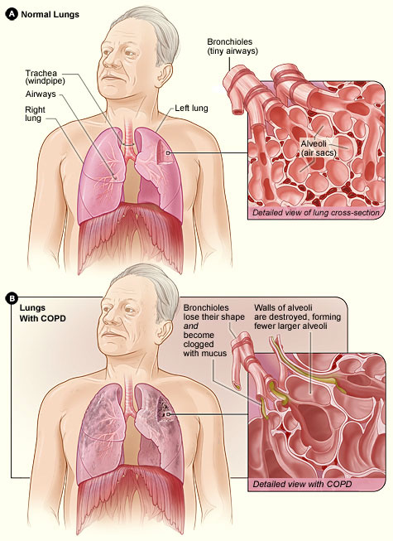(ATrainEducation, 2022)

Recommendations and Care Plan
It is highly recommended that this person is to receive smoking cessation support to minimize the number of cigarettes smoked.
Avoid environments with poor air quality such as exposure to dust, smoke, gases, and fumes.
Prevent further lung infections by frequently washing hands and applying hand sanitizer and avoiding visitors with symptoms of a cold or flu.
Oxygen therapy
Diet
Eat a well-balanced diet. Good nutrition is essential for the body's resistance to infection.
Eat smaller meals throughout the day as feeling bloated can make you feel more breathless.
Drink plenty of water. Aim for six to eight 8-ounce glasses of water per day. Water, juices, and sports drinks are the best options.

Conclusion

References
ATrainEducation (2022) Anatomy of the lungs. Available at: https://www.atrainceu.com/content/3-anatomy-and-physiology-breathing (Accessed: 28 July 2022)
Belleza, M (2021) Respiratory system Anatomy and Physiology. Available at: https://nurseslabs.com/respiratory-system/ (Accessed: 28 July 2022)
NHS (2019) Chronic obstructive pulmonary disease (COPD). Available at: https://www.nhs.uk/conditions/chronic-obstructive-pulmonary-disease-copd/ (Accessed: 28 July 2022)
Woolcock (2022) COPD. Available at: https://www.woolcock.org.au/pdf/fact-sheets/COPD.pdf (Accessed 27 July 2022)

